**Method**

**Island Integrated Energy System Model**

**Fig.9 | Island Integrated Energy System.**

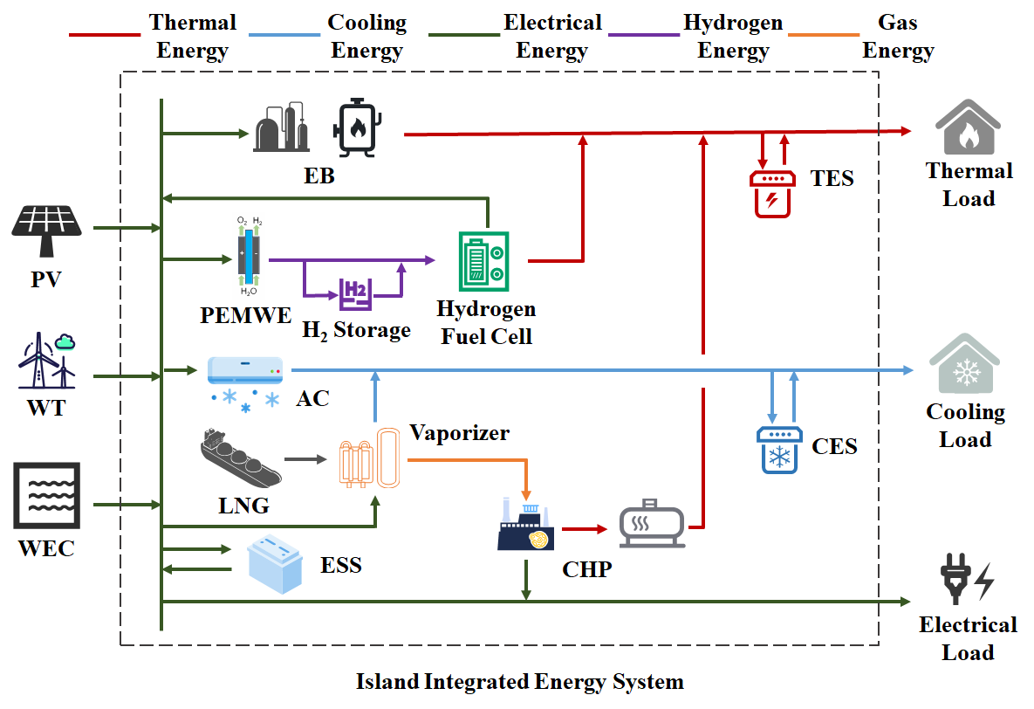

We propose an island integrated energy system (Fig.7), incorporating external energy inputs from wind, solar, wave, and liquefied natural gas (LNG). LNG is procured from the nearest base station and transported to the island (data source14). Energy conversion and storage facilities couple these sources to meet electricity, heating, and cooling demands. Model cost and operational parameters derive from the U.S. NREL's Annual Technology Baseline (ATB) medium-cost scenario15 and relevant literature, with detailed parameters provided in Supplementary Note 1. The system is scaled for a 500-person community, which represents an optimal scale for demonstrating renewable energy integration in an island context. Based on IRENA's analysis of off-grid systems (Case 7)16, this scale is particularly suitable for comprehensive hybrid renewable solutions, as it allows for meaningful capacity deployment (typically 0.5-2 MW) while remaining manageable in terms of system complexity and investment requirements. For islands with smaller populations, we scale the system accordingly using their actual population size to maintain per capita energy adequacy.

**Renewable Potential and Demand Assessment**

Hourly solar photovoltaic (PV) and wind generation profiles were simulated using the *Renewables.ninja* platform17,18 , leveraging historical meteorological data (ERA5, MERRA-2) and performance models. Simulations used 2020 data with each island represented by its centroid coordinates.

PV systems were modeled as fixed-tilt installations with tilt angles optimized for maximum annual yield. Azimuth was set southward (Northern Hemisphere) or northward (Southern Hemisphere). To avoid artificial capacity constraints during optimization, maximum AC power input was scaled proportionally to population (2.0 kW/person), with system losses set at 10%. Wind simulations used Vestas V90 2000 turbines at 80m hub height, with maximum AC power input similarly set to 2.0 kW/person.

Wave energy density (kW/m) and significant wave height (m) under SSP585 scenario were sourced from a global wave model data19, and to fully explore the configuration potential of wave energy facilities in the optimization model, the maximum wave energy facility length per island was set to 1 km.

Hourly heating and cooling demands were simulated using *Renewables.ninja* methodology20 . Heating demand initiates when ambient temperature falls below region-specific heating thresholds, while cooling demand activates when temperature exceeds cooling thresholds. Calculations incorporate regional parameters as defined in Table 1 20：

**Table 1 Cooling and heating load parameters**

|  |  |  |  |  |  |  |  |  |
| --- | --- | --- | --- | --- | --- | --- | --- | --- |
| **regions** | **Heating  threshold [°C]** | **Cooling  threshold [°C]** | **Heating  power [W/(°C · p)]** | **Cooling  power [W/(°C · p)]** | **Smooth  coef. [day-1]** | **Solar coef. [°C/(Wm-2)]** | **Wind coef. [°C/(ms-1)]** | **Humidity  coef. [°C/(gkg-1)]** |
| APAC | 11.9 | 20.4 | 127 | 52 | 0.73 | 0.014 | -0.12 | 0.036 |
| Europe | 12.7 | 20.4 | 116 | 16 | 0.62 | 0.019 | -0.13 | 0.032 |
| US | 9.7 | 18.8 | 129 | 59 | 0.35 | 0.011 | -0.1 | 0.022 |
| Others | 11.9 | 20.4 | 127 | 52 | 0.73 | 0.014 | -0.12 | 0.036 |

*APAC parameters were adopted as defaults for the "Others" region given their broad applicability and intermediate characteristics.*

The electrical load typically comprises heating/cooling-related demand and base electricity demand (e.g., lighting, appliances) independent of thermal needs. Given available heating/cooling demand data for islands, only base electricity demand was modeled. For modeling simplicity, this base demand was decomposed into illumination-dependent lighting load and time-varying activity-dependent load21 . Detailed modeling procedures are described in Supplementary Note 2.

**Island Selection Criteria**

We selected 2015 global islands meeting these criteria: 1) Inhabited (ensuring socioeconomic relevance); 2) Minimum area ≥10 km² (enabling renewable infrastructure); 3) Geographical isolation ≥10 km from mainland (minimizing continental influence); 4) Population <3.5 million (excluding mainland-like energy systems) 22. Population data came from23; island area and mainland distance from 24.

**Climate Data for Hazard Modeling**

Typhoon hazards were modeled using 3-hourly near-surface wind speed data from MRI-AGCM3-2-S_highresSST (CMIP6, SSP585 scenario) 25, accessed via Earth System Grid Federation (ESGF). This high-resolution model demonstrates enhanced tropical cyclone simulation capability.

**Bi-level Optimization Model**

A bi-level optimization framework was adopted to determine the minimum annualized cost for island energy system planning. This structure effectively balances long-term investment decisions with short-term operational scheduling.

The objective of the upper-level model is to minimize the total annual cost of the energy system. This level determines the optimal configuration capacity of energy components for each island (e.g., PV, wind, wave, storage devices, and other conventional equipment). The decision variables are the installation capacities of all devices within the system. The objective function minimizes total cost, including equivalent annual investment cost and annual operational cost. The equivalent annual equipment investment cost is: $$\begin{aligned}minC_{T}=\min{\sum_{i=1}^{l}{a_{i}}c_{i}\frac{{r\left(1+r\right)}^{y}}{{\left(1+r\right)}^{y}-1}}\#\left(1\right)\end{aligned}$$

Where $C_{T}$ is the annual equipment investment cost; $l$ is the total number of devices; $a_{i}$ is the configuration capacity of device $i$; $c_{i}$ is the unit installation price of device $i$ ; $r$  is the annual discount rate; $y$ is the equipment lifespan. The annual operational cost is defined in the lower-level model.

The upper-level model must satisfy the load demand constraint:

$$\begin{aligned}\max\left(\sum_{m}{W_{m,load}}\right)≤ \sum_{m}{W_{m,power}}\#\left(2\right)\end{aligned}$$

where $m$ represents electricity, heating, and cooling systems; $\sum_{m}{W_{m,load}}$ is the total load demand; $\sum_{m}{W_{m,power}}$ is the total configured capacity.

The objective of lower-level model is to minimize the total annual operational cost of the energy system. Decision variables are the real-time output of system components. Annual operational cost includes LNG purchase cost, equipment maintenance cost, renewable curtailment penalty, and load shedding penalty:

$$\begin{aligned}\min{C_{Y}}=\min\left(C_{LNG}+C_{\text{Eq}}+C_{\text{Pun}}+C_{\text{Dload}}\right) \#\left(3\right)\end{aligned}$$

$$\begin{aligned}C_{LNG}=\sum_{t=1}^{h}{Q_{LNG}\left(C_{LNG,m^{3}}+C_{LNG,km}D_{LNG}\right)}+C_{LNG,fix}N_{LNG} \#\left(4\right)\end{aligned}$$

$$\begin{aligned}C_{\text{Eq}}=\sum_{m=1}^{l}{c_{\text{fix}}^{m}P_{\text{fix}}^{m}}\#\left(5\right)\end{aligned}$$

$$\begin{aligned}C_{\text{Pun}}=\sum_{\text{Ele}}^{h}{λ_{Renew}P_{Renew\text{,dis}}}\#\left(6\right)\end{aligned}$$

$$\begin{aligned}C_{\text{Dload}}=\sum_{\text{load}}^{h}{α_{\text{load}}P_{\text{load}}}\#\left(7\right)\end{aligned}$$

Where $C_{Y}$ is the annual total operating cost, $C_{LNG}$ is the LNG procurement cost, $C_{Eq}$ is the equipment operation and maintenance cost, $C_{Pun}$ is the renewable energy curtailment penalty cost， $C_{Dload}$ is the load curtailment penalty cost; *h* is the total simulation time steps, $Q_{LNG}$ is the LNG procurement quantity (m3), is the LNG purchase price per cubic meter, $C_{LNG,km}$ is the transportation cost per m3-km of LNG, $D_{LNG}$ is the LNG transportation distance (assumed as 1.2×straight-line distance【】), $C_{LNG,fix}$ is the Fixed cost per procurement order, $N_{LNG}$ is the number of procurement orders; *l* is the total number of equipment types, $c_{\text{fix}}^{m}$ is the fixed O&M cost coefficient for equipment $m$ , $P_{\text{fix}}^{m}$ is the installed capacity of equipment $m$ ; $λ_{Renew}$ is the Penalty coefficient for renewable curtailment, $P_{Renew\text{,dis}}$ is the curtailed renewable power; $α_{\text{load}}$ is the penalty coefficient for load curtailment, $P_{\text{load}}$ is the curtailed load amount.

To evaluate system reliability under climate change, renewable equipment failure dynamics are incorporated. Component failure probabilities are determined by combining climate model wind data with vulnerability curves. Monte Carlo simulation generates component failure states. For computational tractability, failure states are clustered using the elbow method to identify representative states for optimization. This captures climate-induced failures and system impacts.

Vulnerability curves 7,26–33 define failure probability ($P_{fail,i}$) as functions of wind speed ($V_{t}$) or wave height ($H_{t}$):

$$\begin{aligned}P_{fail,i}=F\left(V_{t}\right)\#\left(8\right)\end{aligned}$$

$$\begin{aligned}F_{WT}\left(V_{t}\right)=\left\{\begin{aligned}0 if V_{t}≤30 \\ \frac{V_{t}-30}{60-30} if {30<V}_{t}≤60 \\ 1 if V_{t}>60\end{aligned}\right.\#\left(9\right)\end{aligned}$$

$$\begin{aligned}F_{PV}\left(V_{t}\right)=\left\{\begin{aligned}0 if V_{t}≤40 \\ \frac{V_{t}-40}{80-40} if {40<V}_{t}≤80 \\ 1 if V_{t}>80\end{aligned}\right.\#\left(10\right)\end{aligned}$$

$$\begin{aligned}F_{WAVE}\left(H_{t}\right)=\left\{\begin{aligned}0 if H_{t}≤5 \\ \frac{H_{t}-5}{20-5} if {5<H}_{t}≤20 \\ 1 if H_{t}>20\end{aligned}\right.\#\left(11\right)\end{aligned}$$

To simulate component failure events, at each time step $t$ , a random number $r$  ∈ [0,1] is generated for each component $i$ . Failure is triggered if $r$ < $P_{fail,i}$. Affected components remain inoperable until repairs are completed. The repair duration $T_{repair,i}$ is determined based on assumptions accounting for the island’s geographical constraints34,35, with maintenance restricted to periods of wind speeds below 20 m/s due to extreme weather limitations. During repairs, failed components are considered unavailable, reducing system capacity and impacting overall energy supply reliability:

$$\begin{aligned}P_{i}\left(t\right)≤ a_{i}S_{i}\left(t\right)\#\left(12\right)\end{aligned}$$

Where $P_{i}\left(t\right)$ is the actual output of component $i$ at time $t$， $a_{i}$ denotes its rated capacity, and $S_{i}(t)$ is a binary state variable ($S_{i}\left(t\right)=1$: operational， $S_{i}\left(t\right)=0$: failed).

The Average Service Availability Index (*ASAI*) quantifies the energy system’s sustained supply capability for each load type:

$$\begin{aligned}{ASAI}_{m}=\left(1-\sum_{t=1}^{h}{\frac{T_{m,cut}\left(t\right)}{h}}\right)×100\% \#\left(13\right) \\ m∈\{Elec,Heat,Cooling\}\end{aligned}$$

Where ${ASAI}_{m}$ is the average service availability index of system $m$, $h$ is the total simulation time steps, $T_{m,cut}(t)$ denotes the duration of supply deficit for system $m$ at time $t$.

This reliability constraint ( ${ASAI}_{m}$ ≥ 99%) is embedded in the lower-level optimization model, ensuring the island’s energy system meets minimum supply requirements under disaster scenarios. Detailed model formulations are provided in Supplementary Note 3.

**Data availability**

The wind and photovoltaic power generation profiles, as well as heating/cooling demand data, were obtained from the *Renewables.ninja* model and are available at <https://www.renewables.ninja/>. Wave energy and wave height data were sourced from the *Science Data Bank* repository at <https://www.scidb.cn/en/detail?dataSetId=700894282ab745d0b420fe0844c924ae&version=V2>. Population distribution data were derived from the *LandScan* database hosted by Oak Ridge National Laboratory and are accessible at <https://landscan.ornl.gov/>. Climate model data were downloaded from the *Earth System Grid Federation (ESGF)* portal (<https://esgf-ui.ceda.ac.uk/cog/search/cmip6-ceda/>).