[ Client logo / branding ]

Hyperconverged Proxmox VE + Ceph Cluster — Customer Design Brief

Document | Customer Design Brief
Project | Project Cerberus — Hyperconverged Proxmox VE + Ceph reference design
Version | 1.0
Date | October 7, 2026
Status | Draft for review
Classification | Internal / Customer

1. Executive summary
This brief describes a three-node hyperconverged cluster running Proxmox VE 9.2 for virtualization and Ceph Tentacle for shared storage. Every node runs both workloads and storage, so there is no separate SAN, no single storage controller, and no single server whose loss stops the cluster.
Every virtual-machine disk write is stored on all three nodes before the write is acknowledged. If any one node fails completely, the surviving nodes keep serving data with zero data loss, and the affected VMs are restarted automatically within minutes.
The design uses enterprise server hardware with next-business-day on-site support, redundant power on every node, mirrored boot drives, and two independent high-speed network paths between every node and the storage fabric.

2. Design overview
- Topology: 3-node hyperconverged cluster (compute and storage on every node)
- Virtualization: Proxmox VE 9.2
- Shared storage: Ceph Tentacle — 3 monitors, 3 managers, 6 OSDs (2 per node)
- Replication: synchronous, size=3 / min_size=2 — every write lands on all
three nodes before it is acknowledged to the VM
- Quorum: the cluster continues operating with any one node down
- Backup: Proxmox Backup Server on a dedicated host, with daily, weekly,
and monthly retention and tested restores
Because replication is synchronous, a node failure is not a data-recovery event. There is no replica lag to catch up, no journal to replay, and no window of unacknowledged writes. The data is already on the surviving nodes.

3. Node hardware
Each of the three nodes is a Lenovo ThinkSystem SR650 V4 built identically:
Component | Specification
Chassis | Lenovo ThinkSystem SR650 V4 (2U)
CPU | 2x Intel Xeon 6527P — 48 cores / 96 threads per node
Memory | 1 TB DDR5-6400
Ceph storage | 2x 3.84 TB Samsung PM1743 NVMe PCIe 5.0 (U.3, direct-attached, JBOD — never RAID)
Boot | 2x 960 GB M.2 NVMe in hardware RAID1
Fabric NIC | NVIDIA BlueField-3, 2x 200 GbE
Management NIC | 4x 1 GbE
Power | 2x 1300 W, N+N redundant
Support | 3-year next-business-day on-site

Identical nodes mean any VM can run on any node, and a failed node can be replaced with the same build without re-validating the configuration.

4. Cluster totals
Resource | Total (3 nodes)
CPU | 144 cores / 288 threads
Memory | 3 TB DDR5
Raw NVMe (Ceph) | 23 TB
Usable Ceph capacity | ~7.7 TB (after 3x replication)
Planned allocation | ~5 TB, leaving headroom for recovery and growth

Storage is the binding constraint of this design. The ~5 TB planned allocation leaves space for Ceph to re-replicate after a drive or node failure and for workload growth. Expansion options (additional drives or a fourth node) are covered in Section 10.

5. Architecture
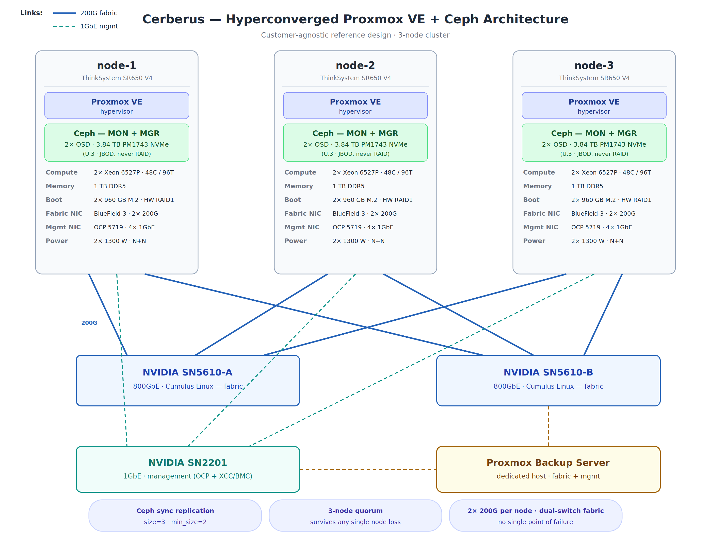
Figure 1 — Each node runs Proxmox VE for virtualization and Ceph services
(monitors, managers, and two OSDs) for shared storage. Nodes connect over two independent 200G fabric paths; management traffic uses a separate 1GbE network.*

6. Network design
Network | Purpose | Detail
Storage / Ceph fabric | Ceph replication and client I/O | Dual 200G per node, each link on a different NVIDIA SN5610 800GbE switch; MTU 9000 (jumbo frames)
Management | Proxmox management, cluster traffic, SSH | 1GbE switching, separate from storage traffic

Each node's two 200G links attach to two separate switches, so the loss of one switch or one link does not cut any node off from the storage fabric. Storage traffic and management traffic run on separate physical networks, so a management outage cannot disturb storage replication.
All addresses below are illustrative examples, not the actual addressing of any site:
Host | Management (example) | Storage fabric (example)
node-1 | 10.10.10.11 | 10.20.20.11
node-2 | 10.10.10.12 | 10.20.20.12
node-3 | 10.10.10.13 | 10.20.20.13

7. How it runs
Proxmox VE hosts the virtual machines. VMs are placed across the three nodes, and Proxmox's high-availability service watches the cluster: if a node fails, the VMs that were running on it are restarted automatically on the surviving nodes. No operator action is required.
Ceph provides the shared storage underneath. Each node runs a Ceph monitor and manager plus two OSD daemons (one per NVMe drive). Every VM disk is a Ceph block device (RBD) with three copies spread across the three nodes. Ceph also self-heals: when a drive or node fails, it re-replicates the affected data onto the healthy hardware automatically while the cluster keeps serving I/O.
Proxmox Backup Server runs on a dedicated host outside the cluster and holds daily, weekly, and monthly backup copies of the VMs. Restores are tested, not assumed — a backup that has never been restored is a hope, not a plan.

8. Protection story
What the design means in practice, failure by failure. Plain terms:

Drive failure
A failed NVMe drive is a maintenance event, not an outage. The data on that drive already exists on the other two nodes, so nothing is lost and nothing stops. Ceph detects the failure and rebuilds the missing copies onto the healthy drives on its own, while VMs keep running. The dead drive is replaced under the next-business-day on-site warranty.
Outcome: zero data loss, zero downtime.

Full node failure
If an entire node goes down — failed board, lost power, anything — the two surviving nodes keep serving every byte of data, because every write was already stored on all three nodes. Proxmox HA detects the lost node and restarts its VMs on the survivors, typically within minutes. Once a replacement node is brought up, Ceph rebalances back to three copies.
Outcome: zero data loss. Recovery point objective (RPO) is effectively zero for hardware failure — no committed write can be lost. Recovery time objective (RTO) is minutes: the time for Proxmox HA to detect the failure and boot the VMs elsewhere.

Switch or network-link failure
Each node has two 200G links, one to each of the two fabric switches. If a switch fails or a link drops, traffic continues over the remaining path with no interruption. Management traffic rides a separate network, so it is unaffected by fabric events.
Outcome: no loss of storage connectivity; the cluster keeps running on the surviving path while the failed component is replaced.

Backups, ransomware, and human error
Synchronous replication protects against hardware failure. It does not protect against a file deleted by mistake, a database corrupted by a bad update, or ransomware encrypting a VM's disks — those changes replicate faithfully to all three copies. That is what backups are for. Proxmox Backup Server keeps daily, weekly, and monthly copies on a dedicated host, and restores are tested so a recovery works when it is needed.
Outcome: hardware failures cost no data; backups bound the remaining risks (accidental deletion, corruption, ransomware) to the most recent backup.

9. Failure-tolerance summary
Failure | Data loss | Service impact | Recovery
One NVMe drive fails | None | None — VMs keep running | Ceph self-heals; drive replaced under warranty
One node fails completely | None (RPO ~ zero) | Brief — VMs auto-restart on survivors (RTO minutes) | HA restarts VMs; Ceph rebalances when node returns
One fabric switch fails | None | None — second path carries all traffic | Replace failed switch
One 200G link fails | None | None — remaining link carries traffic | Replace cable/optic
One PSU fails | None | None — N+N redundancy | Replace failed PSU
One boot drive fails | None | None — RAID1 mirror | Replace failed drive
Two nodes fail at once | Possible | Cluster stops (quorum lost) | Restore one node; data intact on surviving node, plus backups
Ransomware / deletion / corruption | Bounded by backup age | Restore from backup | Restore tested backups from PBS

10. Open decisions
- Three nodes vs. four. Three nodes meet the requirement with quorum
intact through any single-node failure. A fourth node adds capacity and lets the cluster absorb a node failure while a second maintenance event is underway. Decide based on growth expectations and maintenance windows.
- Workload profile confirmation. The storage drives are read-optimized
NVMe. Confirm the expected read/write mix so the design can be validated against it before hardware is ordered.
- Backup retention sign-off. Daily/weekly/monthly retention is the
default proposal. Confirm the required retention periods and any compliance constraints that extend them.
- Backup server placement. Proxmox Backup Server runs on a dedicated
host. Confirm the host and its location — it should not share power or failure domains with the cluster it protects.

Project Cerberus — customer-agnostic reference design. Adapt node counts, drive counts, addressing, and warranty terms per site.

