SUBMISSION REQUIREMENTS: Please submit a single document (word or PDF) for submission. Your submission should contain a summary of your results (and answers to questions asked on the homework) as well as your R code used to generate your results (please append to the end of your submission). Please use R for the calculations whenever possible. You will lose points if you are not utilizing R. You will also lose 10 points per day for late submissions unless prior arrangements are made with your facilitator.
The data in this document consists of body temperature measurements and heart rate measurements for 65 men and 65 women. Save the data to a file, and read the data file into R. Use this data to address the following questions.
(1) We are interested in whether the proportion of men and women with body temperatures greater than or equal to 98.6 degrees Fahrenheit are equal. Therefore, we need to dichotomize the body temperature variable. Create a new variable, called “temp_level” in which temp_level = 1 if body temperature >= 98.6 and temp_level=0 if body temperature < 98.6. (2 points)

(2) Summarize the data relating to body temperature level (i.e., the variable you created above) by sex. (2 points)
 | male | female | sum
0 | 51 | 30 | 81
1 | 14 | 35 | 49
 | 65 | 65 | 130

(3) Calculate the risk difference for high body temperature level between men and women. Formally test (at the alpha=0.05 level) whether the proportion of people with higher body temperatures (greater than or equal to 98.6) is the same across men and women based on this effect measure. You should be showing all 5 steps in the 5-step recipe for testing. (4 points)
Risk difference = p1 -p2 = 14/65 – 35/65 = -0.3230769
1. Set up the hypotheses and select the alpha level
H0 ∶ p1 = p2 (the proportion of people with higher body temperatures (greater than or equal to 98.6) is the same across men and women based on this effect measure)
H1 ∶ p1 ≠ p2 (the proportion of people with higher body temperatures (greater than or equal to 98.6) IS NOT the same across men and women based on this effect measure)
α = 0.05
2. Select the appropriate test statistic
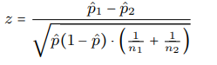
3. State the decision rule
Determine the appropriate critical value from the standard normal distribution
associated with a right-hand tail probability of α/2 = 0.05/2 = 0.025 .
Decision Rule: Reject H0 if ∣z∣ ≥ 1.960 , Otherwise, do not reject H0

4. Compute the test statistic and the associated p-value
P1=0.2154
P2=0.5385
Z=(0.2154-0.5385)/sqrt(0.3769*(1-0.3769)*(1/65+1/65))= -3.8
5. Conclusion
Reject H0 since ∣-3.8∣ ≥ 1.960.
We have significant evidence at the α = 0.05 level that p1 ≠ p2.
We reject the null hypothesis that (the proportion of people with higher body temperatures (greater than or equal to 98.6) is the same across men and women based on this effect measure
(4) Perform a logistic regression with sex as the only explanatory variable. Formally test (at the alpha=0.05 level) if the odds of having a temperature greater than or equal to 98.6 is the same between males and females. Again, please show all 5 steps. Additionally, include the odds ratio for sex and the associated 95% confidence interval in your summary, and interpret the value of the odds ratio. Lastly, what is the c-statistic for this model? (5 points)
1. Set up the hypotheses and select the alpha level H0 ∶ β1 = 0 or OR = 1
(there is no association between genders and temp_level)
H1 ∶ β1 ≠ 0 or OR1 (there is an association genders and temp_level) α = 0.05
2. Select the appropriate test statistic
z =β1/SEβ1
3. State the decision rule
Determine the appropriate value from the standard normal distribution
associated with a right hand tail probability of α/2 = 0.05/2 = 0.025
Decision Rule: Reject H0 if ∣z∣ ≥ 1.96 or Reject H0 if p ≤ α
Otherwise, do not reject H0
4. Compute the test statistic
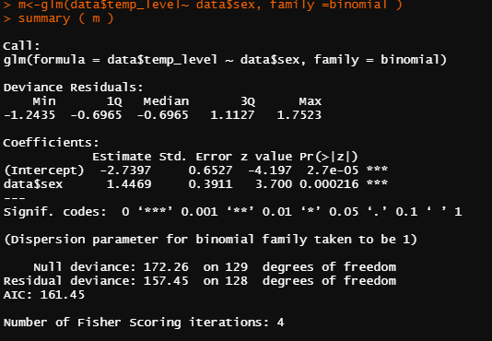
Z=3.7
5. Conclusion
Reject H0 since z ≥ 1.96 or since p − value ≤ α. We have significant evidence at
the α = 0.05 level that β1 ≠ 0. There is evidence of an association between
between genders and temp_level

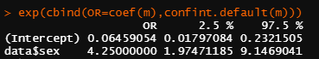
95% confidence interval of the odds ratio is [1.97,9.15]. it means we have 95% confidence that the odds ratio of sex is between 1.97 and 9.15.
The odds of females with higher body temperatures (greater than or equal to 98.6) is e^β1 = 4.25 times higher than the odds of males.
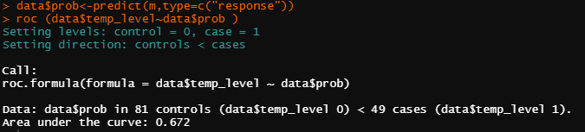
The c- statistic is 0.672.
(5) Perform multiple logistic regression predicting body temperature level from sex and heart rate. Briefly summarize the output from this mode (no need to go through all 5 steps). Give the odds ratio for sex. Also, report the odds ratio for heart rate (for a 10-beat increase). What is the c-statistic of this model? (5 points)
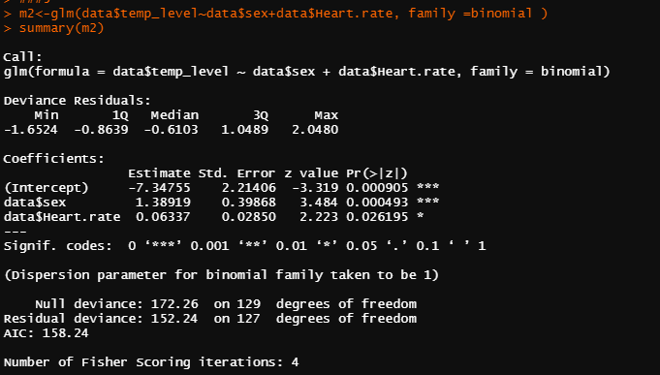

L=ln (p/1−p)=β0+β1x1+β2x2
From the summary above we can find β0 is -7.35, β1 is 1.39, β2 is 0.06.
The odds ratio for sex is : 4.01158
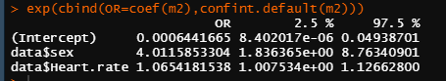
The odds ratio for heart rate (for a 10-beat increase) is :1.88452
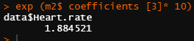
The c-statistic is : 0.7289
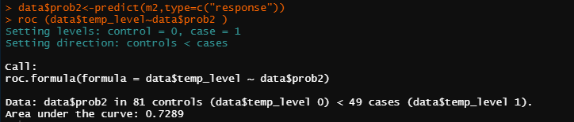
(6) Which model fit the data better? Support your response with evidence from your output. Present the ROC curve for the model you choose. (2 points)
The model with sex and heart rate as the explanatory variable is better. Because it has a higher c-statistic score(0.7289)
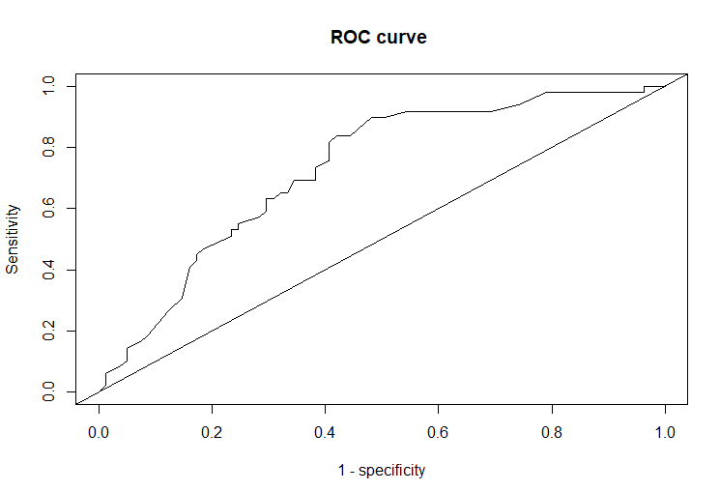

R code
###1
data<-read.csv('dataset.csv')
data$temp_level<- ifelse(data$temp >=98.6, 1 , 0)
###2
table(data$temp_level, data$sex)
###4
m<-glm(data$temp_level~ data$sex, family =binomial )
summary ( m )
exp(cbind(OR=coef(m),confint.default(m)))
install.packages('pROC')
library(pROC)
data$prob<-predict(m,type=c("response"))
roc (data$temp_level~data$prob )
###5
m2<-glm(data$temp_level~data$sex+data$Heart.rate, family =binomial )
summary(m2)
exp(cbind(OR=coef(m2),confint.default(m2)))
exp (m2$ coefficients [3]* 10)
data$prob2<-predict(m2,type=c("response"))
g<-roc (data$temp_level~data$prob2 )
plot (g)
plot (1 - g$ specificities , g$ sensitivities , type ="l", xlab ="1 - specificity", ylab =" Sensitivity ", main ="ROC curve ")
abline ( a =0 , b =1)

Data set for Assignment 6
Data (1=males, 2 =females)
temp | sex | Heart rate
96.3 | 1 | 70
96.7 | 1 | 71
96.9 | 1 | 74
97 | 1 | 80
97.1 | 1 | 73
97.1 | 1 | 75
97.1 | 1 | 82
97.2 | 1 | 64
97.3 | 1 | 69
97.4 | 1 | 70
97.4 | 1 | 68
97.4 | 1 | 72
97.4 | 1 | 78
97.5 | 1 | 70
97.5 | 1 | 75
97.6 | 1 | 74
97.6 | 1 | 69
97.6 | 1 | 73
97.7 | 1 | 77
97.8 | 1 | 58
97.8 | 1 | 73
97.8 | 1 | 65
97.8 | 1 | 74
97.9 | 1 | 76
97.9 | 1 | 72
98 | 1 | 78
98 | 1 | 71
98 | 1 | 74
98 | 1 | 67
98 | 1 | 64
98 | 1 | 78
98.1 | 1 | 73
98.1 | 1 | 67
98.2 | 1 | 66
98.2 | 1 | 64
98.2 | 1 | 71
98.2 | 1 | 72
98.3 | 1 | 86
98.3 | 1 | 72
98.4 | 1 | 68
98.4 | 1 | 70
98.4 | 1 | 82
98.4 | 1 | 84
98.5 | 1 | 68
98.5 | 1 | 71
98.6 | 2 | 77
98.6 | 1 | 78
98.6 | 1 | 83
98.6 | 2 | 66
98.6 | 1 | 70
98.6 | 1 | 82
98.7 | 2 | 73
98.7 | 1 | 78
98.8 | 1 | 78
98.8 | 1 | 81
98.8 | 2 | 78
98.9 | 1 | 80
99 | 2 | 75
99 | 2 | 79
99 | 1 | 81
99.1 | 1 | 71
99.2 | 1 | 83
99.3 | 1 | 63
99.4 | 1 | 70
99.5 | 1 | 75
96.4 | 2 | 69
96.7 | 2 | 62
96.8 | 1 | 75
97.2 | 1 | 66
97.2 | 2 | 68
97.4 | 2 | 57
97.6 | 1 | 61
97.7 | 2 | 84
97.7 | 1 | 61
97.8 | 2 | 77
97.8 | 2 | 62
97.8 | 2 | 71
97.9 | 1 | 68
97.9 | 2 | 69
97.9 | 2 | 79
98 | 2 | 76
98 | 1 | 87
98 | 2 | 78
98 | 2 | 73
98 | 2 | 89
98.1 | 2 | 81
98.2 | 2 | 73
98.2 | 2 | 64
98.2 | 2 | 65
98.2 | 2 | 73
98.2 | 2 | 69
98.2 | 2 | 57
98.3 | 2 | 79
98.3 | 2 | 78
98.3 | 2 | 80
98.4 | 2 | 79
98.4 | 2 | 81
98.4 | 2 | 73
98.4 | 2 | 74
98.4 | 2 | 84
98.5 | 2 | 83
98.6 | 2 | 82
98.6 | 2 | 85
98.6 | 2 | 86
98.6 | 2 | 77
98.7 | 2 | 72
98.7 | 2 | 79
98.7 | 2 | 59
98.7 | 2 | 64
98.7 | 2 | 65
98.7 | 2 | 82
98.8 | 2 | 64
98.8 | 2 | 70
98.8 | 2 | 83
98.8 | 2 | 89
98.8 | 2 | 69
98.8 | 2 | 73
98.8 | 2 | 84
98.9 | 2 | 76
99 | 2 | 79
99 | 2 | 81
99.1 | 2 | 80
99.1 | 2 | 74
99.2 | 2 | 77
99.2 | 2 | 66
99.3 | 2 | 68
99.4 | 2 | 77
99.9 | 2 | 79
100 | 2 | 78
100.8 | 2 | 77

