2) ASL Alphabet - https://www.kaggle.com/datasets/grassknoted/asl-alphabet

The training data set contains 87,000 images which are 200x200 pixels.

There are 29 classes, of which 26 are for the letters A-Z and 3 classes for SPACE, DELETE and NOTHING.

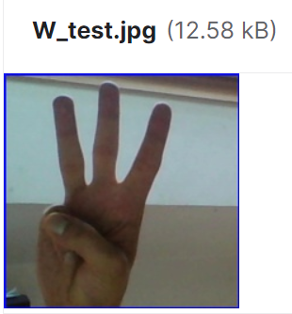

3) ASL Alphabet Test - https://www.kaggle.com/datasets/danrasband/asl-alphabet-test

There are 30 images for each symbol, A-Z, delete, space, and nothing, making 870 images in total.

The images are 200x200 8-bit photos to match the asl-alphabet data set,

asl-alphabet-test.zip



4) ASL Fingerspelling Images (RGB & Depth) - https://www.kaggle.com/datasets/mrgeislinger/asl-rgb-depth-fingerspelling-spelling-it-out

The dataset contains cropped RGB images and depth data (collected from a Microsoft Kinect) 100x140pixel

24 letters of the English alphabet (note that "X" and "Z" are excluded since they rely on movement).

asl-rgb-depth-fingerspelling-spelling-it-out.zip

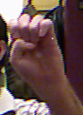

5) WLASL (World Level American Sign Language) Video - https://www.kaggle.com/datasets/risangbaskoro/wlasl-processed

there are about 12k videos each named corresponding video_id.5.4 GB

wlasl-processed.zip

not pre-processed - video

6) American Sign Language (ASL) Dataset - https://www.kaggle.com/datasets/prathumarikeri/american-sign-language-09az

self-made dataset with other small and large datasets found across GitHub and Kaggle.Version 1 (1.06 GB) 50x50 pixel

american-sign-language-09az.zip



7) ASL(American Sign Language) Alphabet Dataset - https://www.kaggle.com/datasets/debashishsau/aslamerican-sign-language-aplhabet-dataset

The Dataset has been broadly classified into Training and Testing Data. Good quality

Training Data has been classified and segregated into 29 classes,

of which 26 alphabets A-Z and 3 other classes of SPACE, DELETE, NOTHING.

The test data set contains a mere 29 images,

aslamerican-sign-language-aplhabet-dataset.zip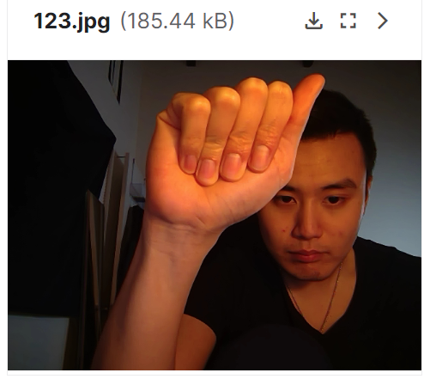

8) American Sign Language - https://www.kaggle.com/datasets/kapillondhe/american-sign-language

The dataset contains coloured images of hand signs representing different American sign language alphabets. 50x50 pixels

a-z space, nothing(5 GB)

american-sign-language.zip

