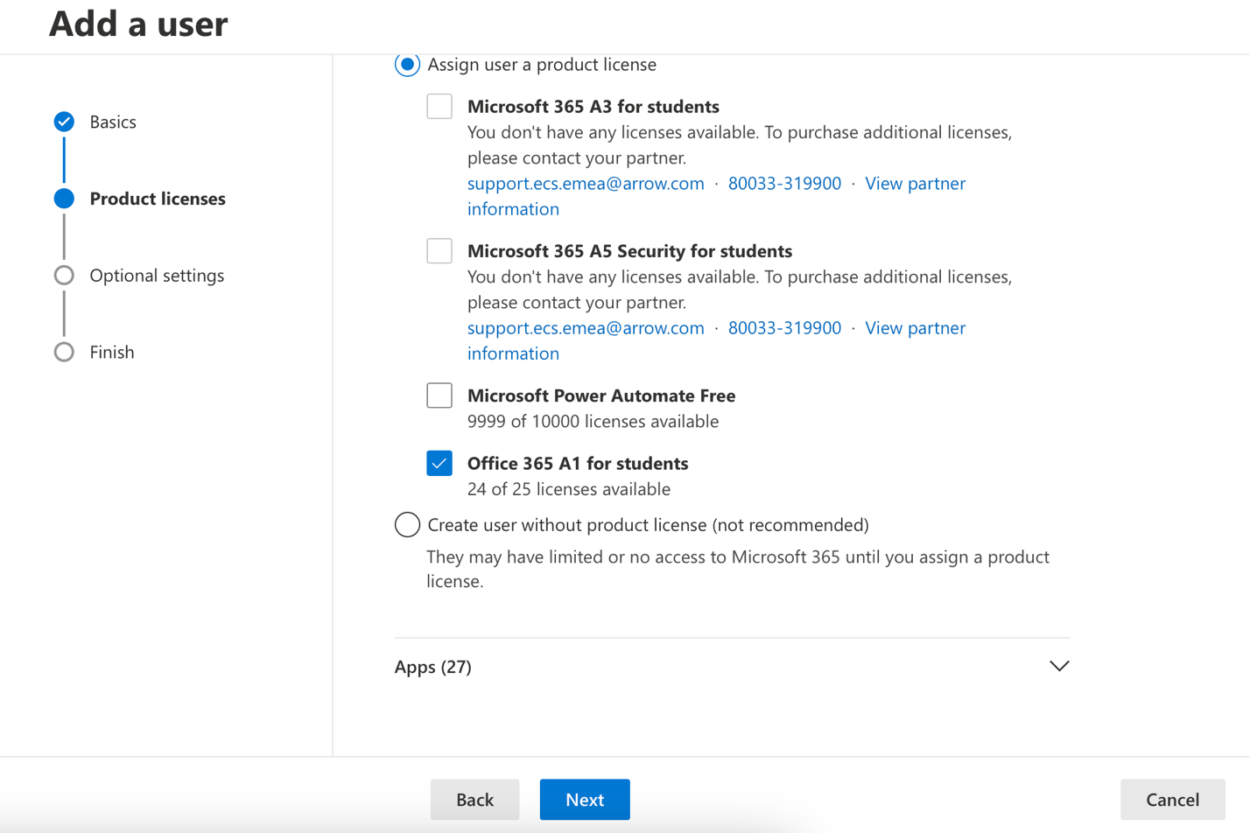
HereI'm adding A2 user Orjan and Larissa they are both belong to kontor Department
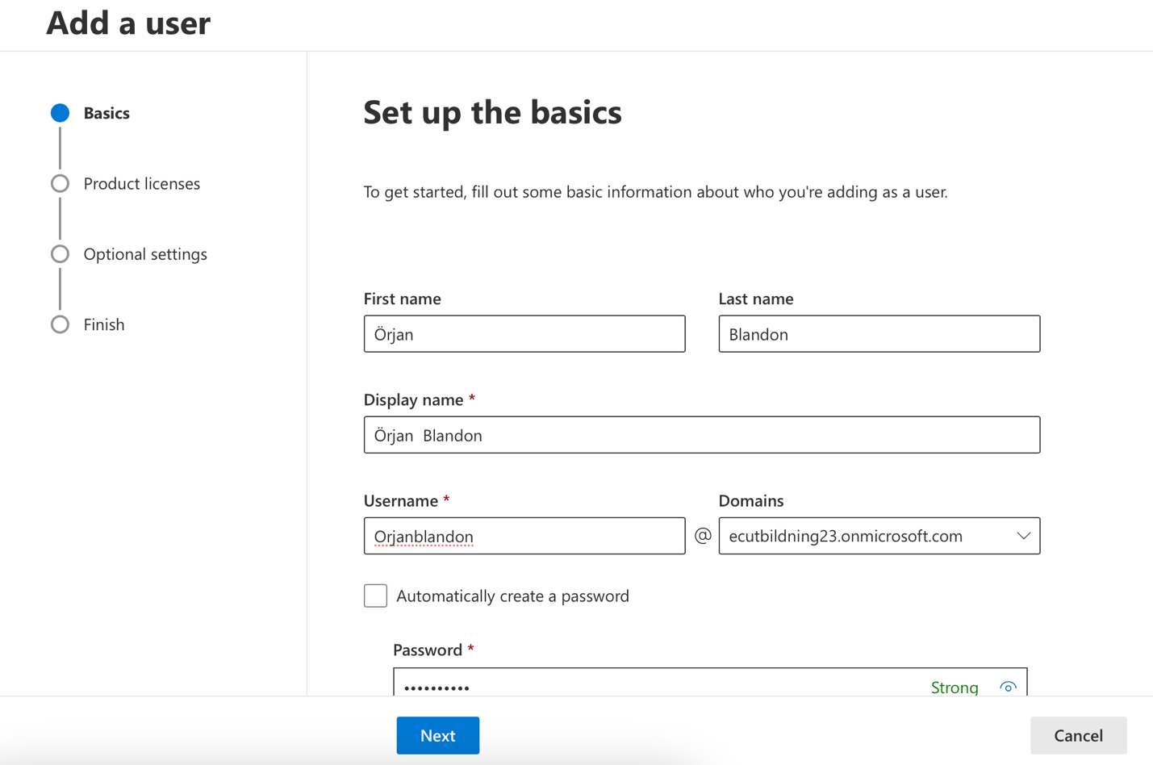
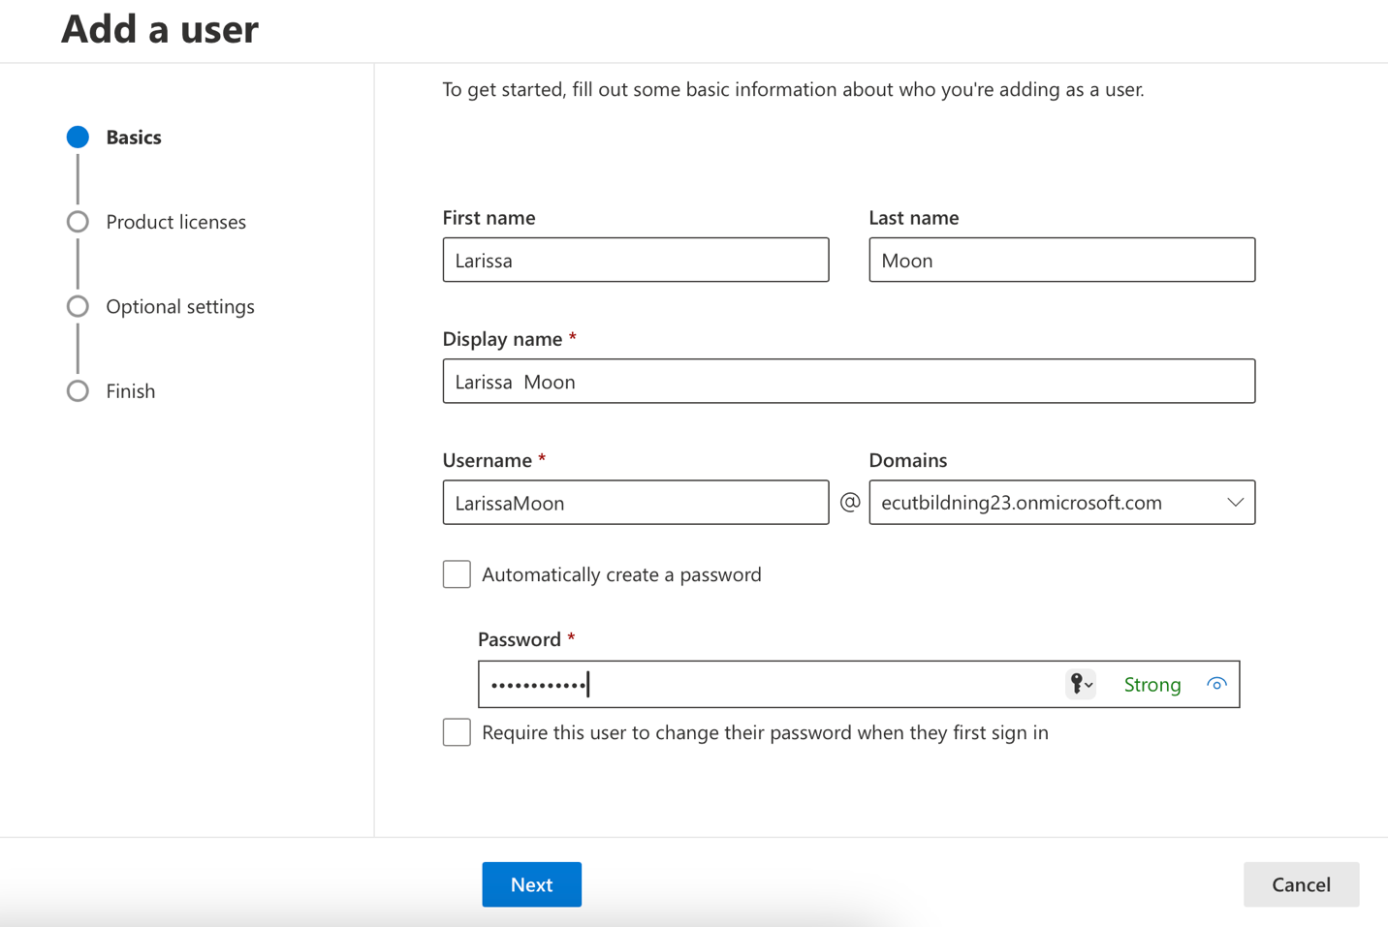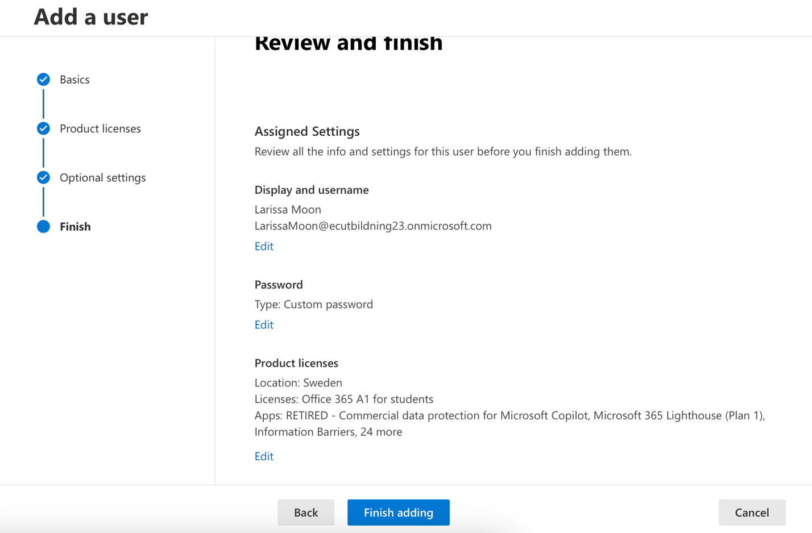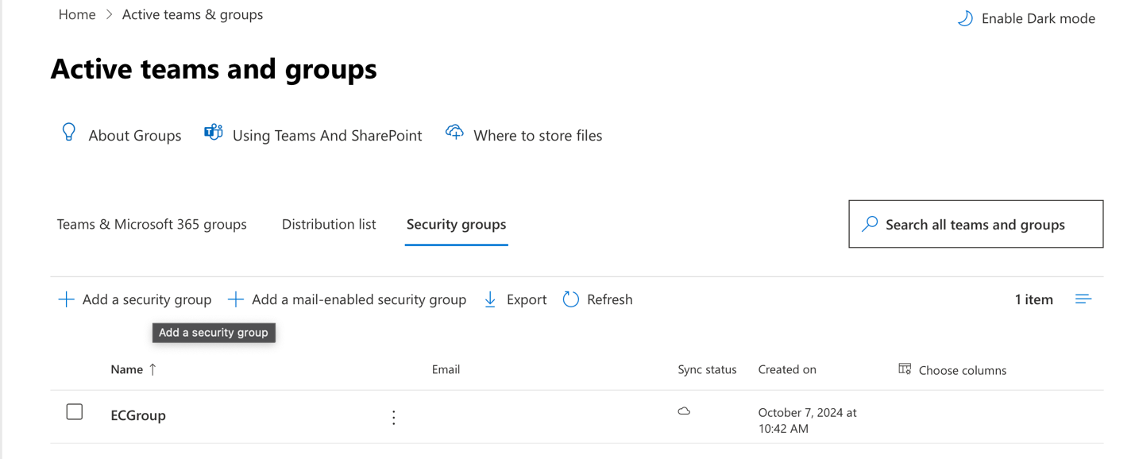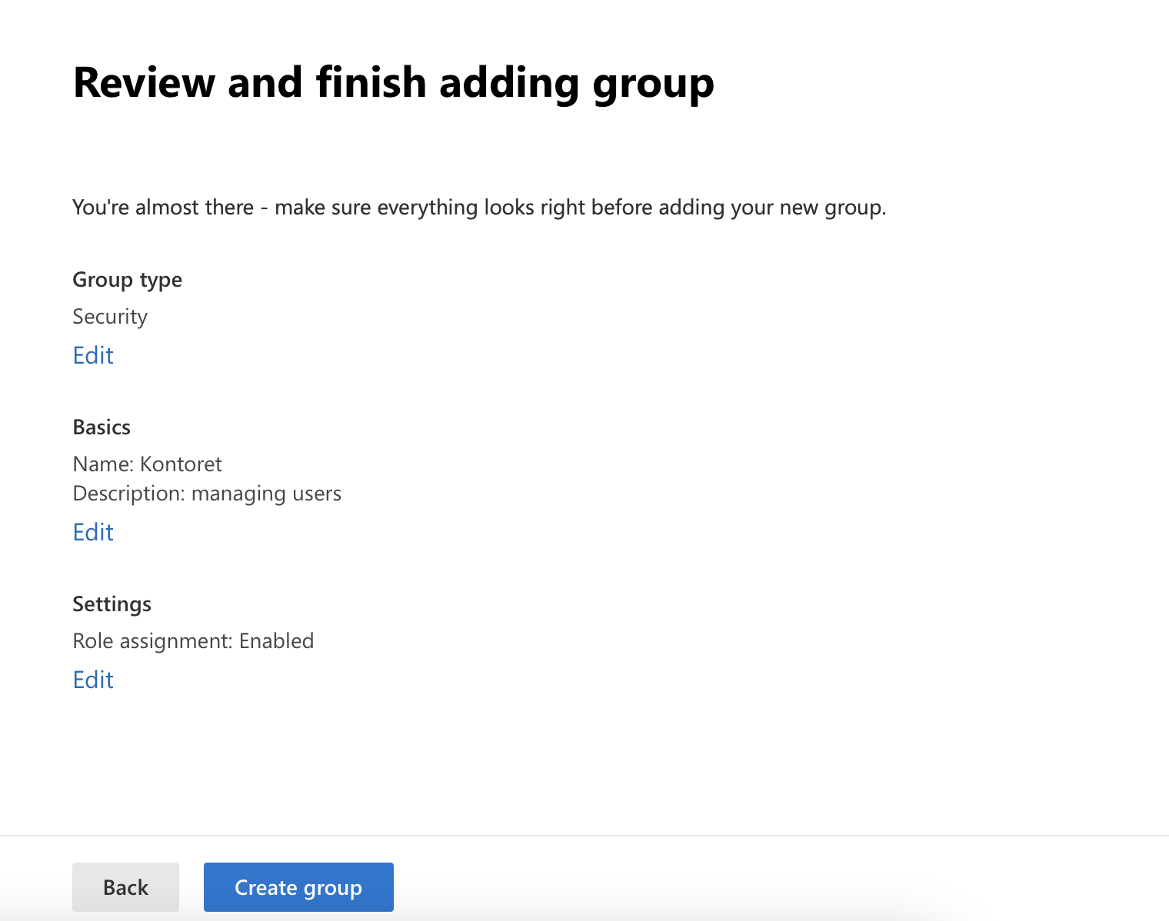
Here I'm adding the two user to the kontor department as a group

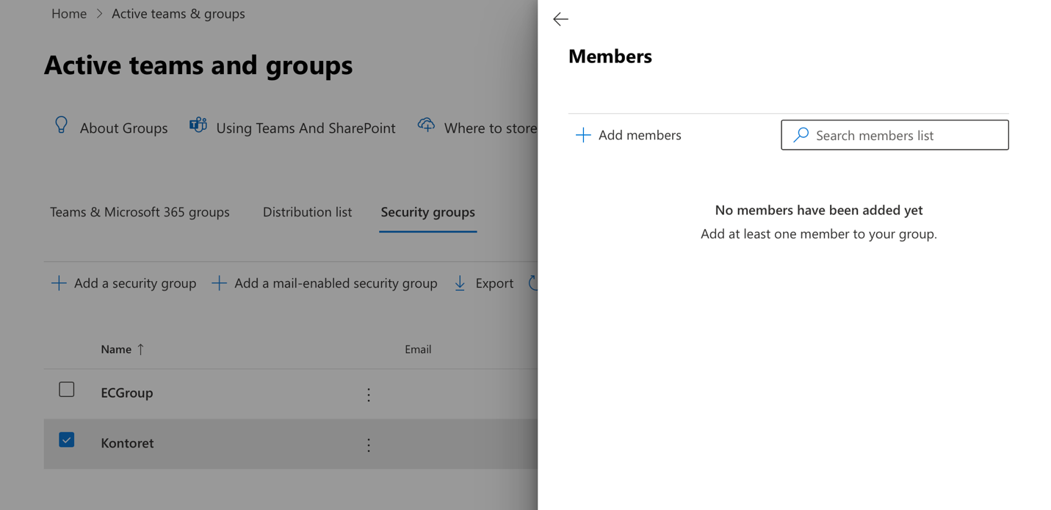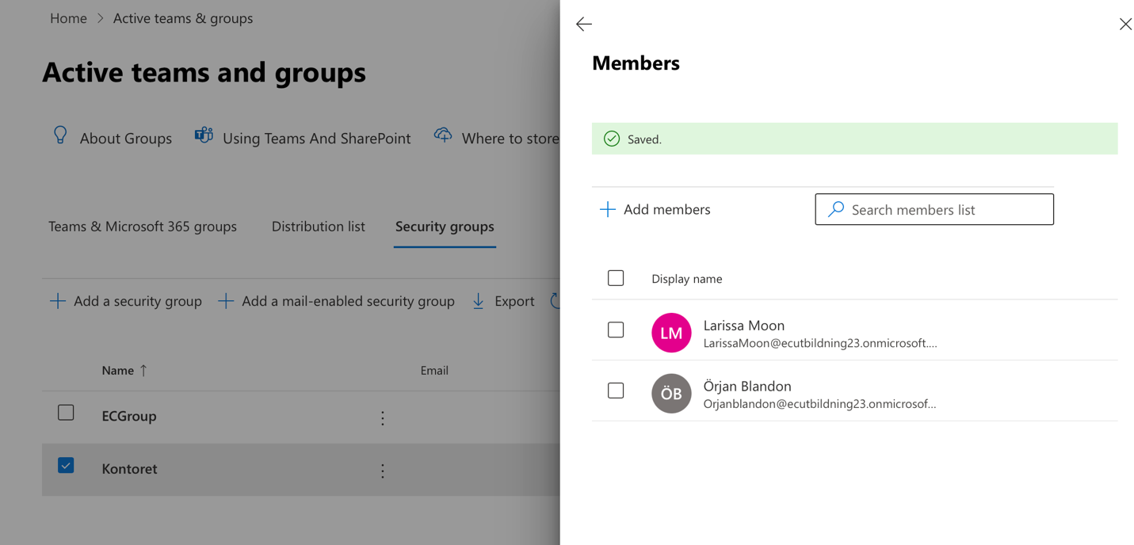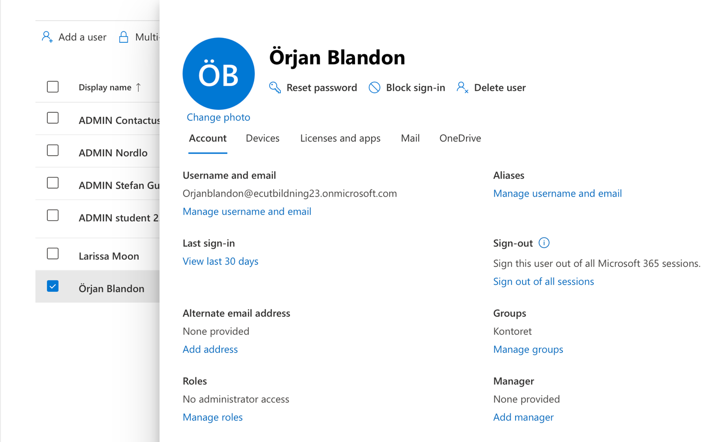

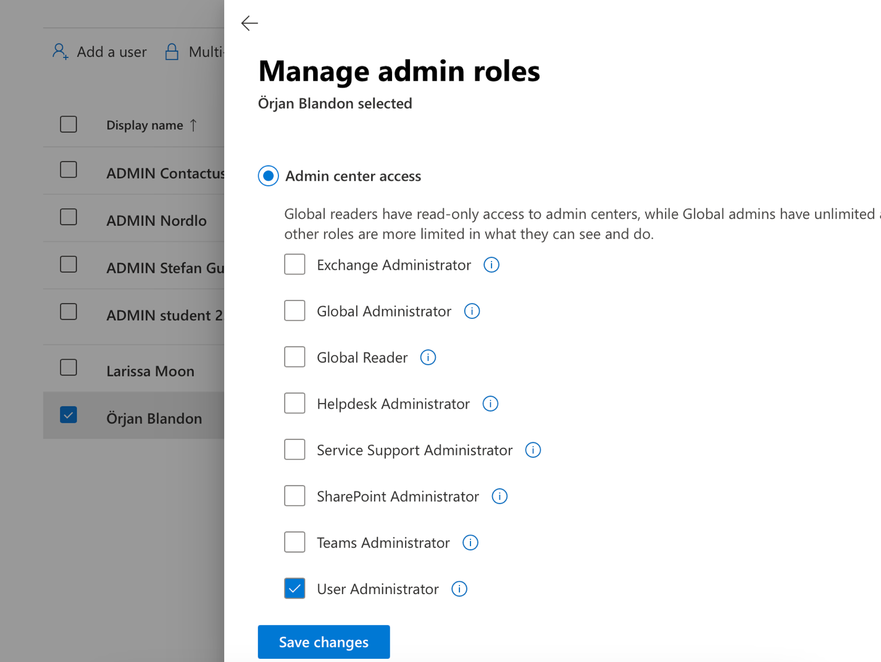
I assign this user has user administrator he can change and delete and update the password for the user and and the new user too
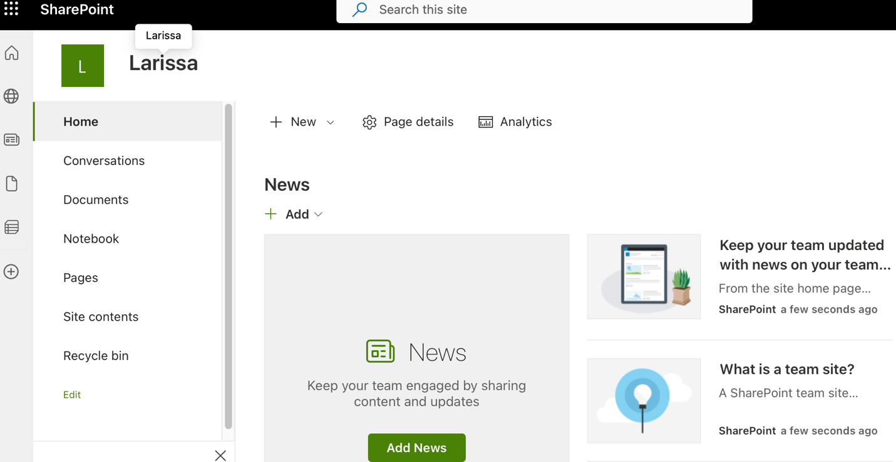
for Larissa I think an example and open the SharePoint in order to create a document and the environment and a set permission to Larissa so she can print this document from her environment from the SharePoint I mean.
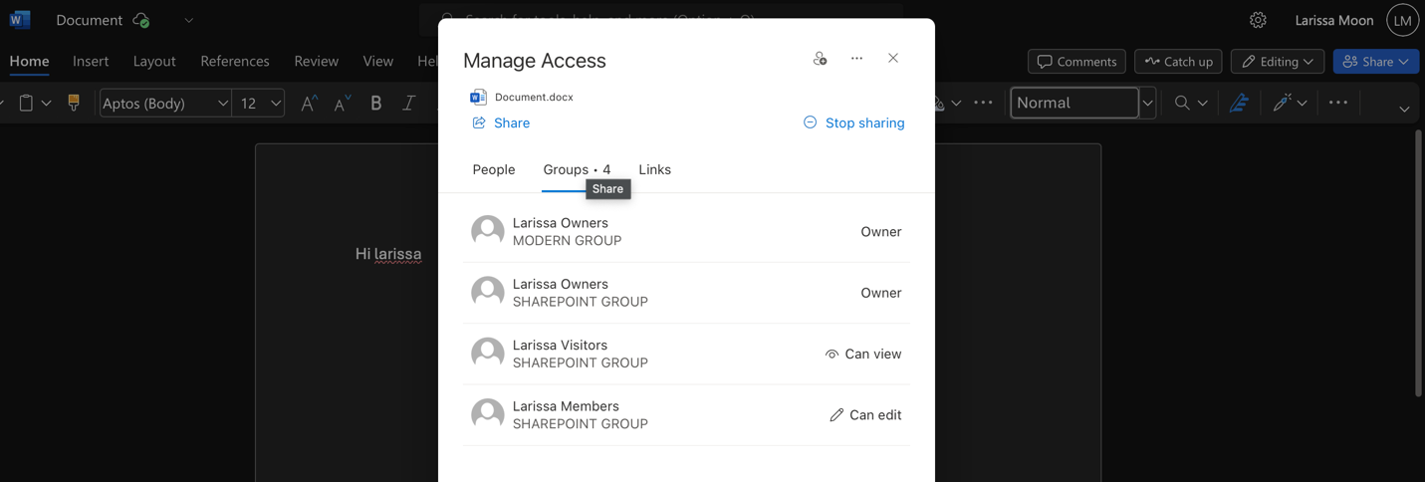
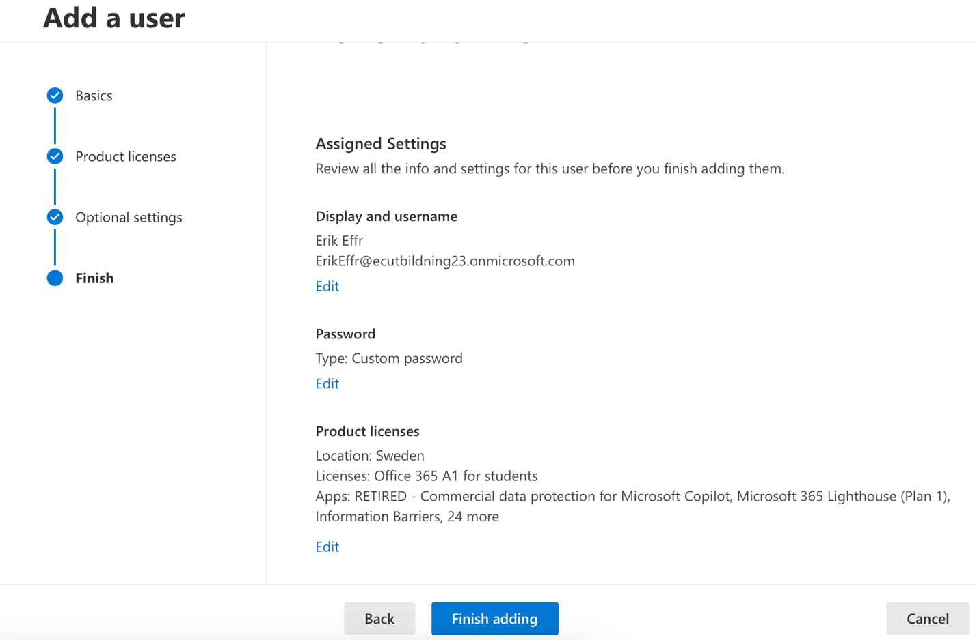
Alright add the first user Eric effr
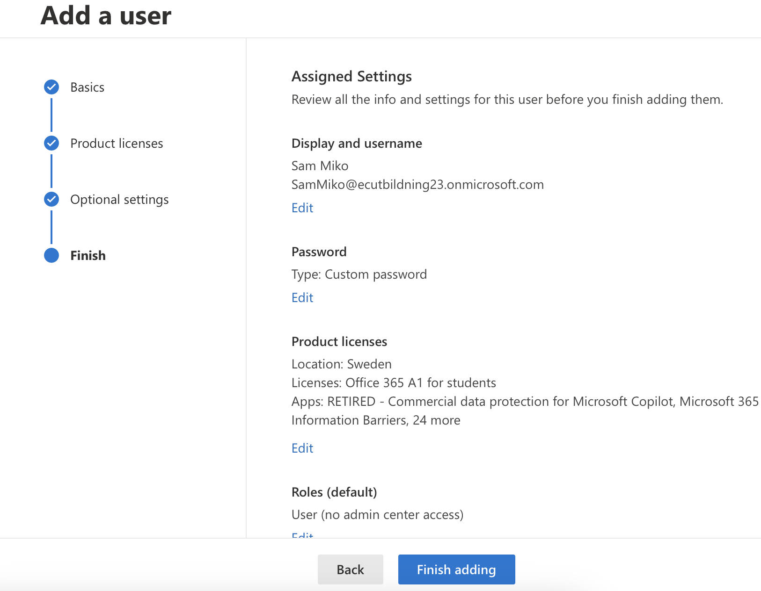
I added the second user Sam miko
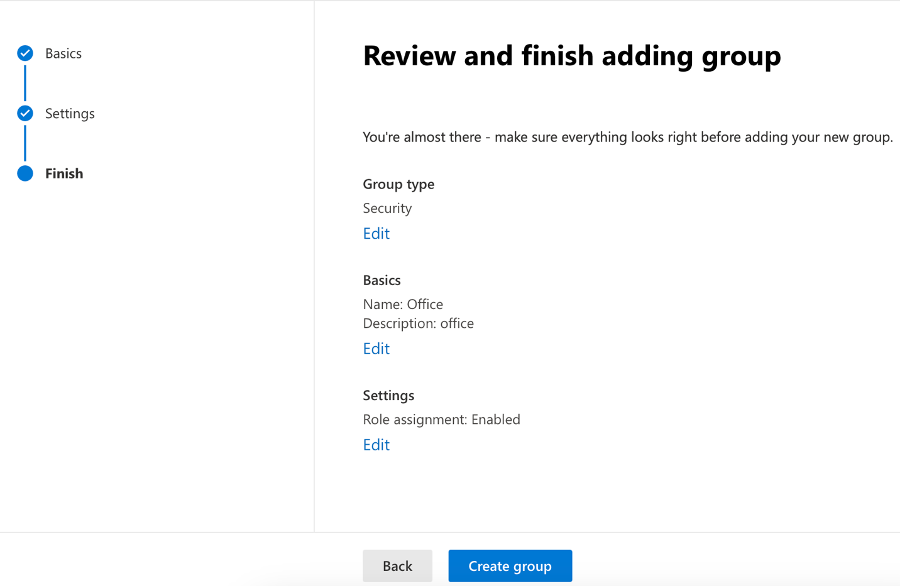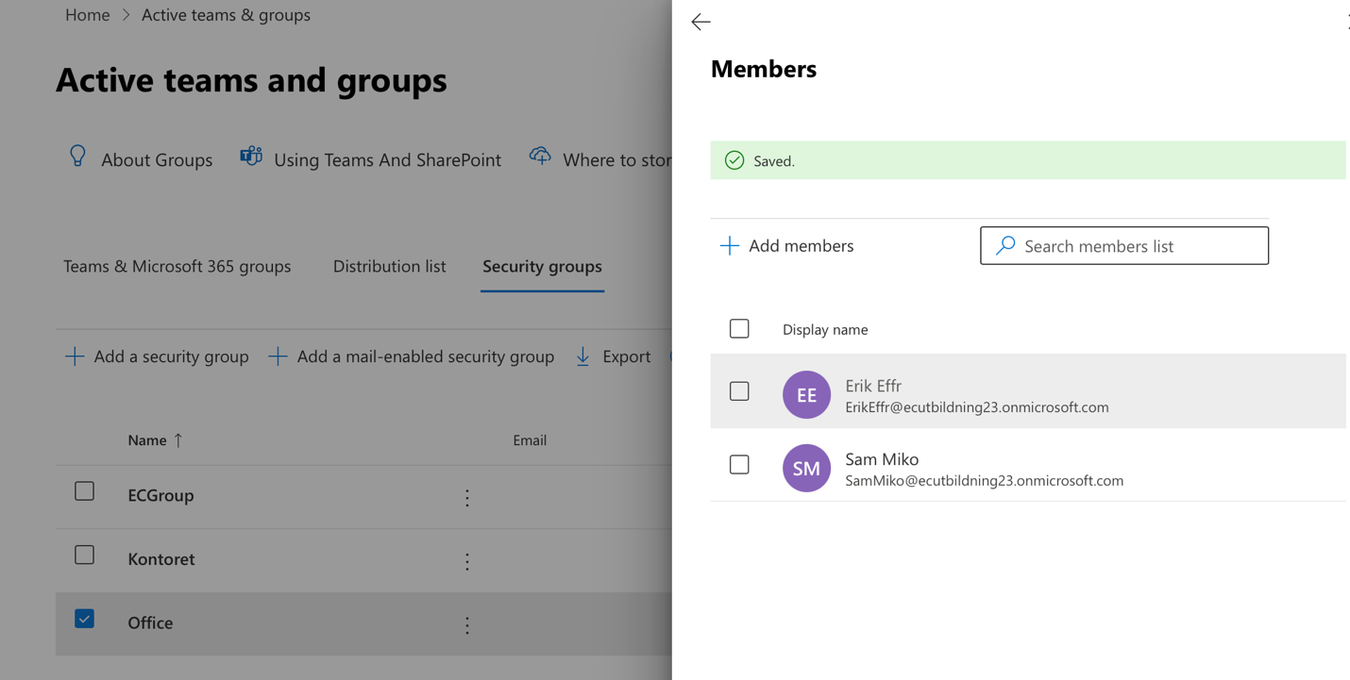
Both of them have been added to the security group
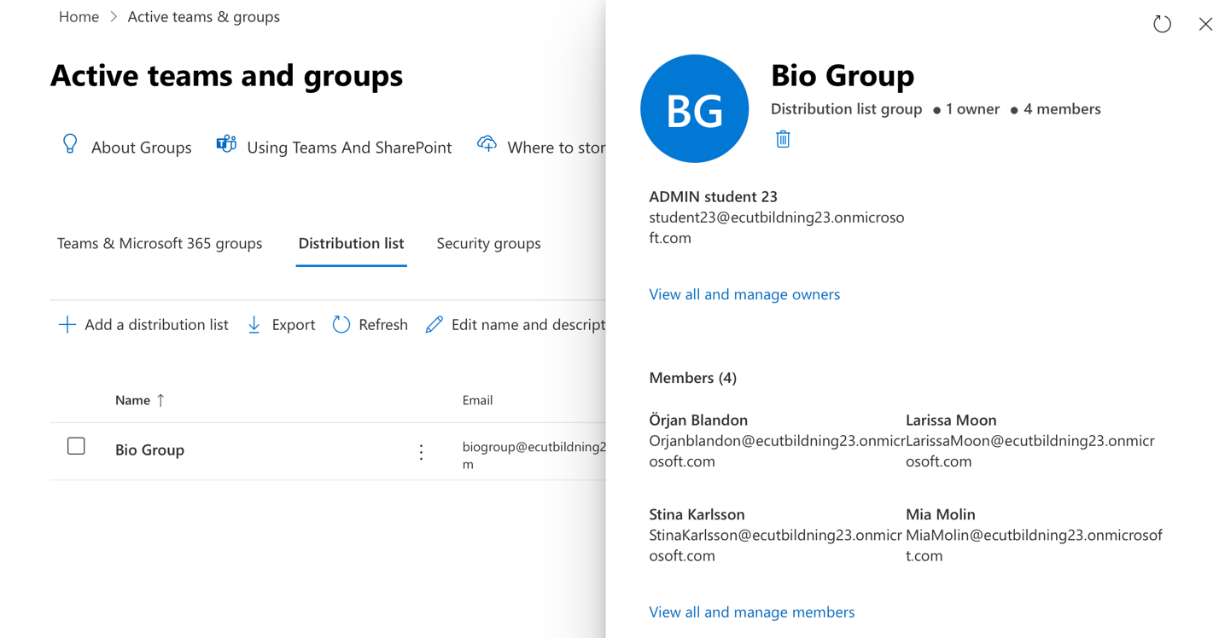
I just created a distribution list which can be all used through outlook and I add stina, Mia and Larissa and orjan
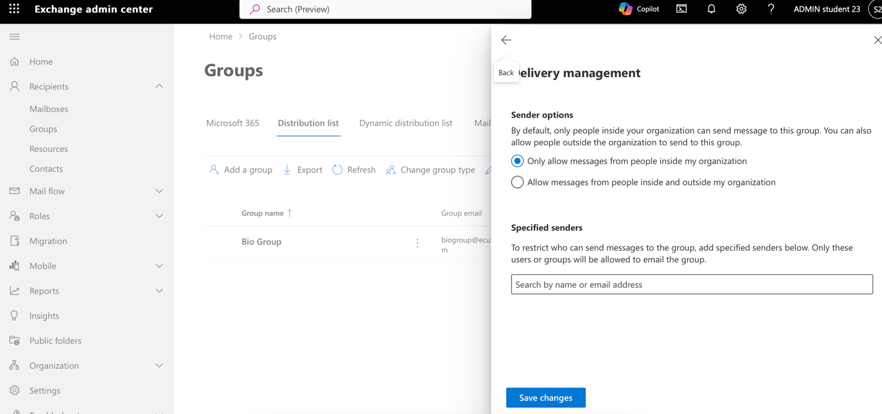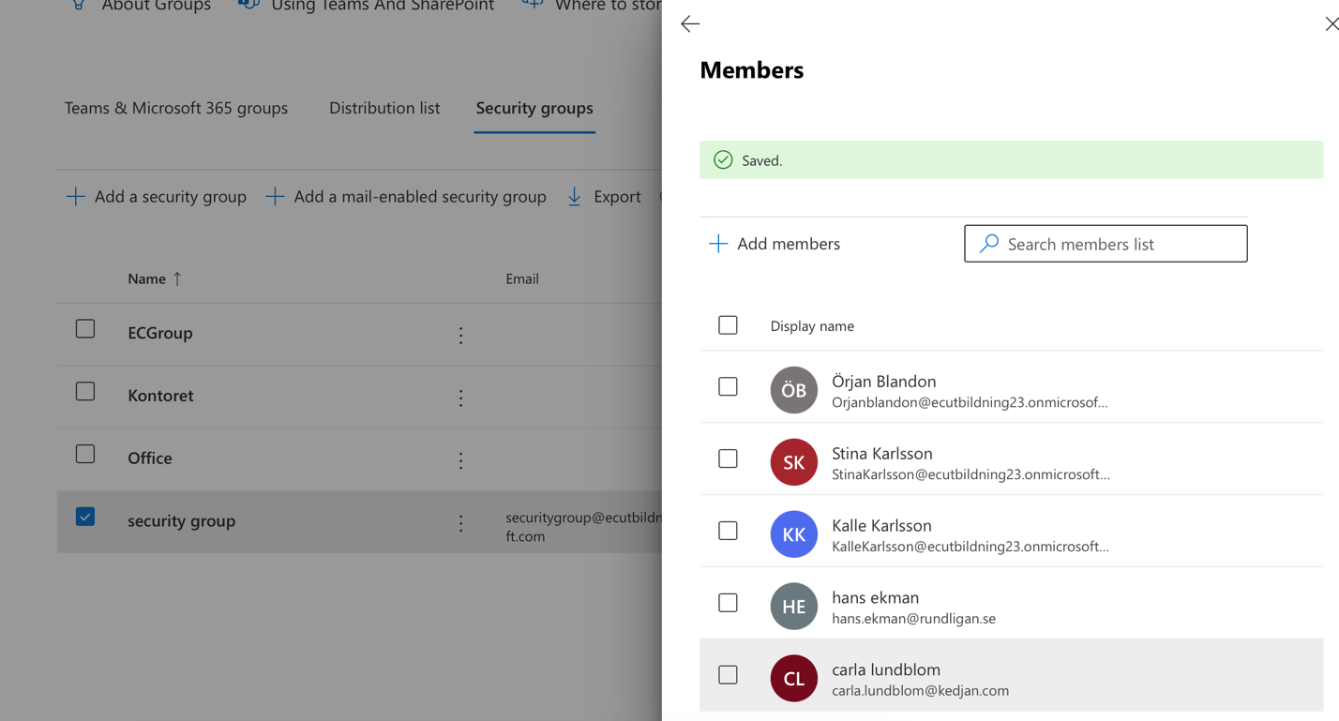
I created an e-mail for security group and I updated the list for this e-mail which included many users like Kalle , Stina , Hans, Carla, Orjan.
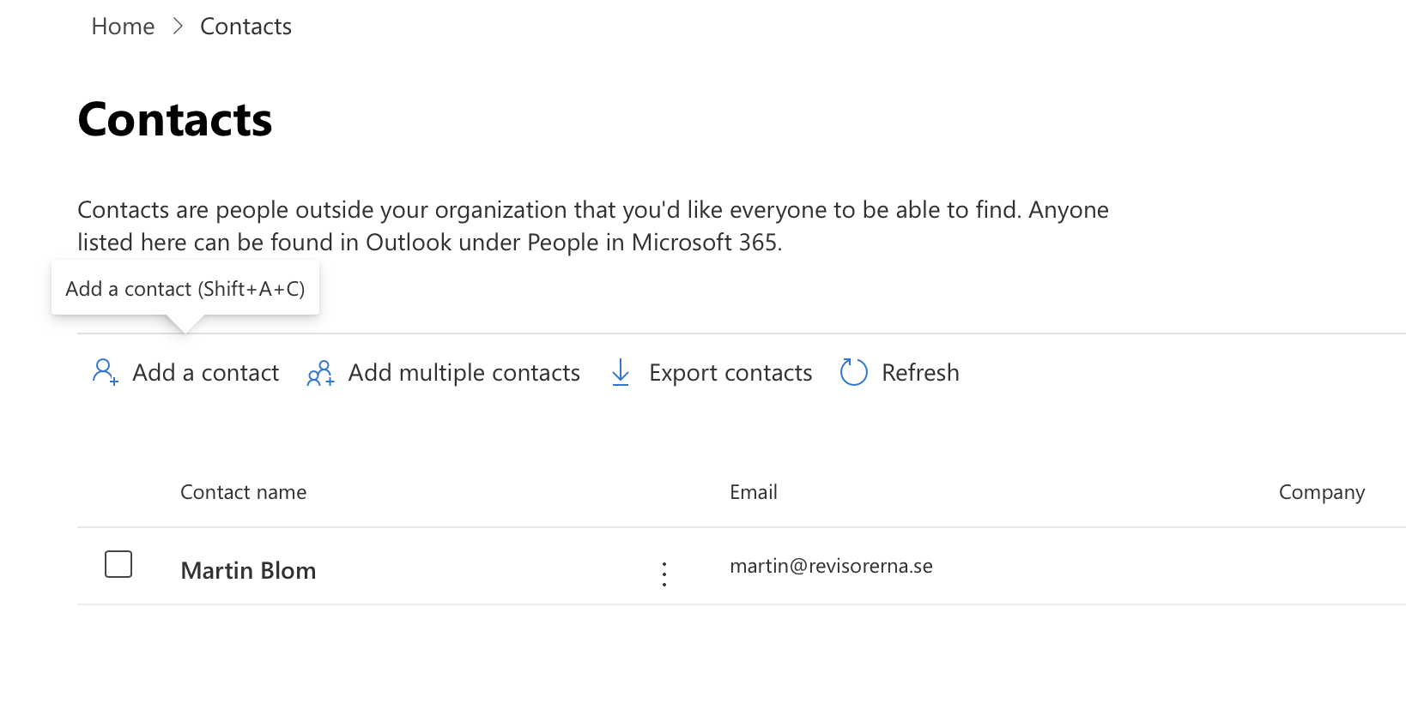
Here I add Martin blom for the company contact list with his own e-mail address
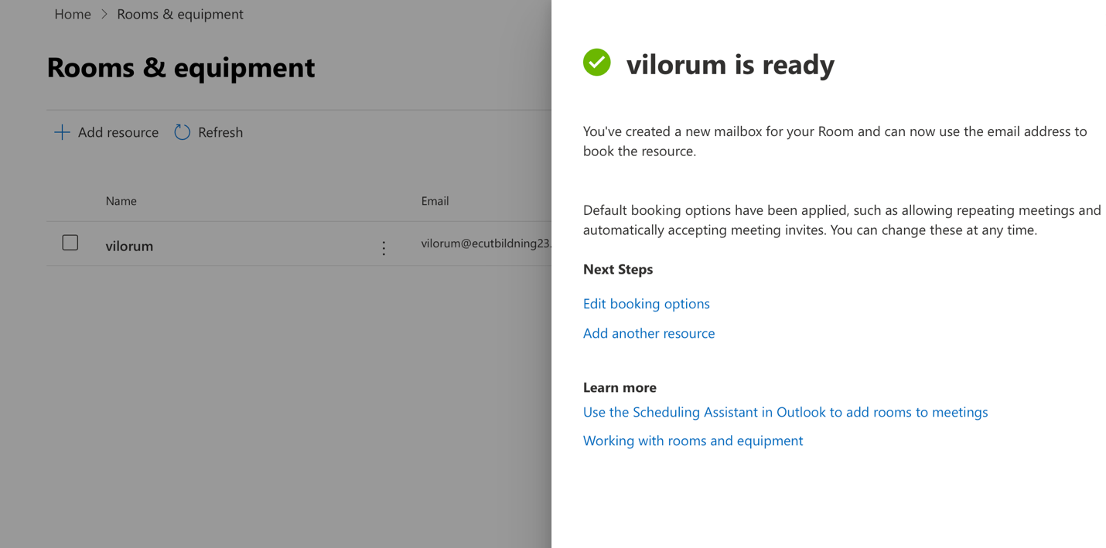
here I create the restroom by using the resources department admin center
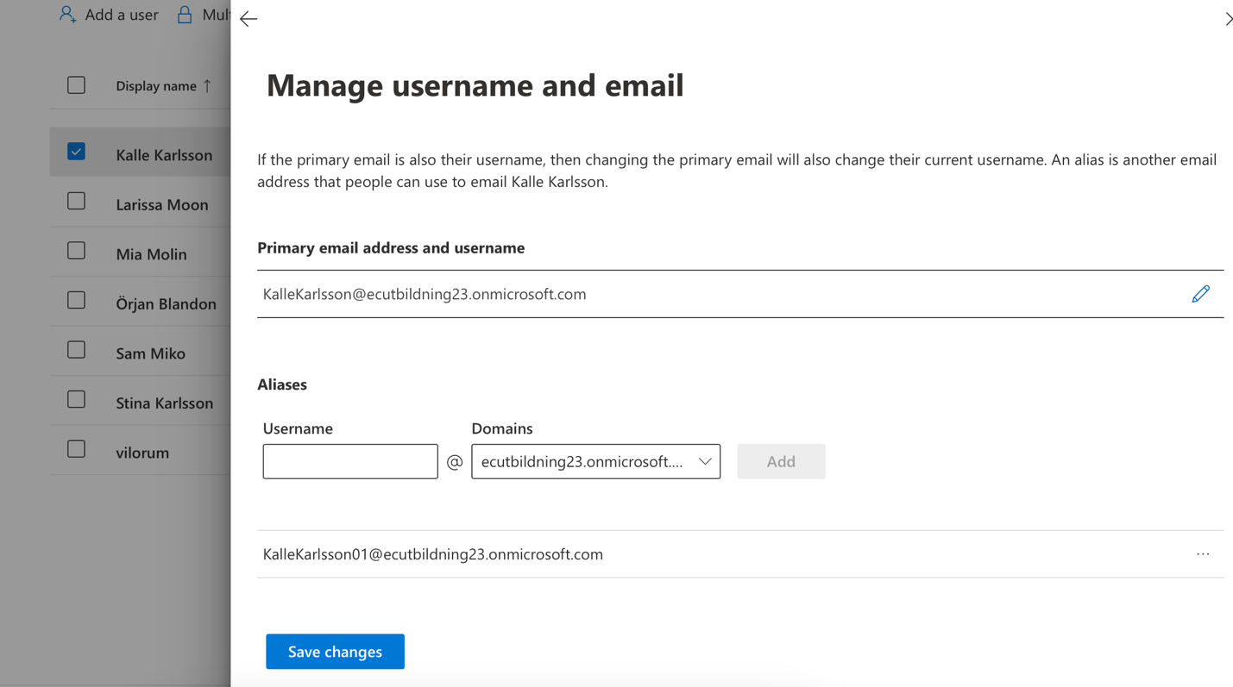
here I add an ally for karsson which can be used as a second e-mail option
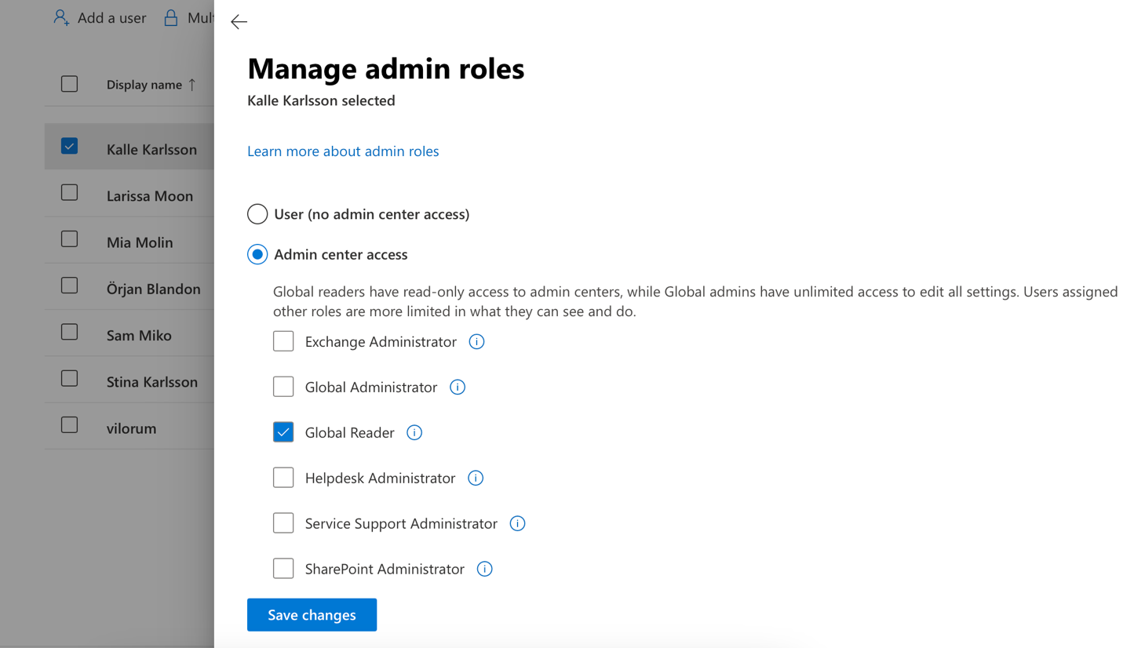
Here I update kalle roll so he can just read all the administration changes and cannot modify or manipulate it
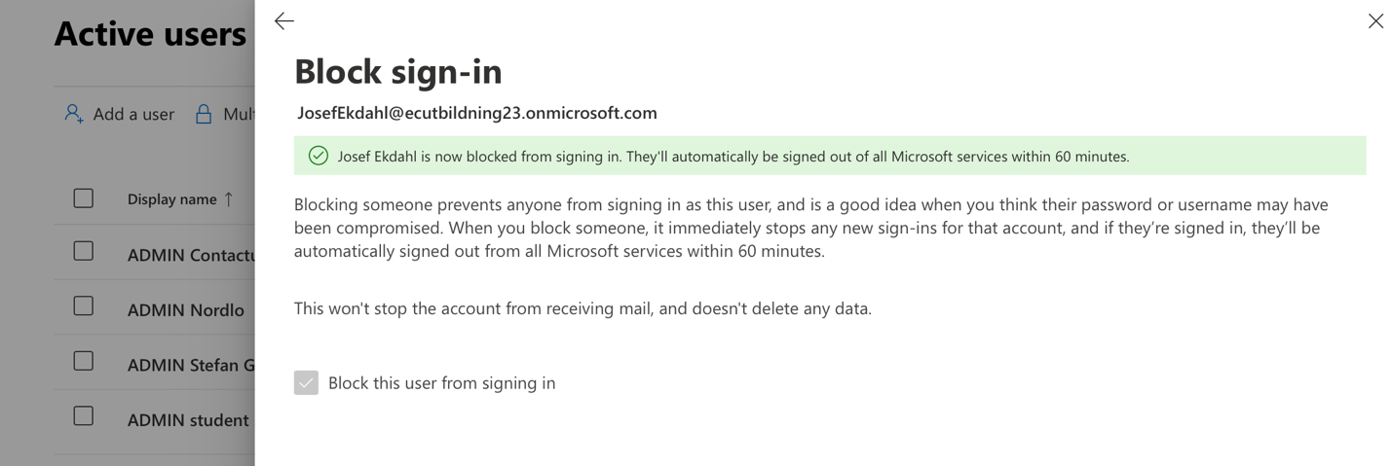
Here I deactivate Josfe account
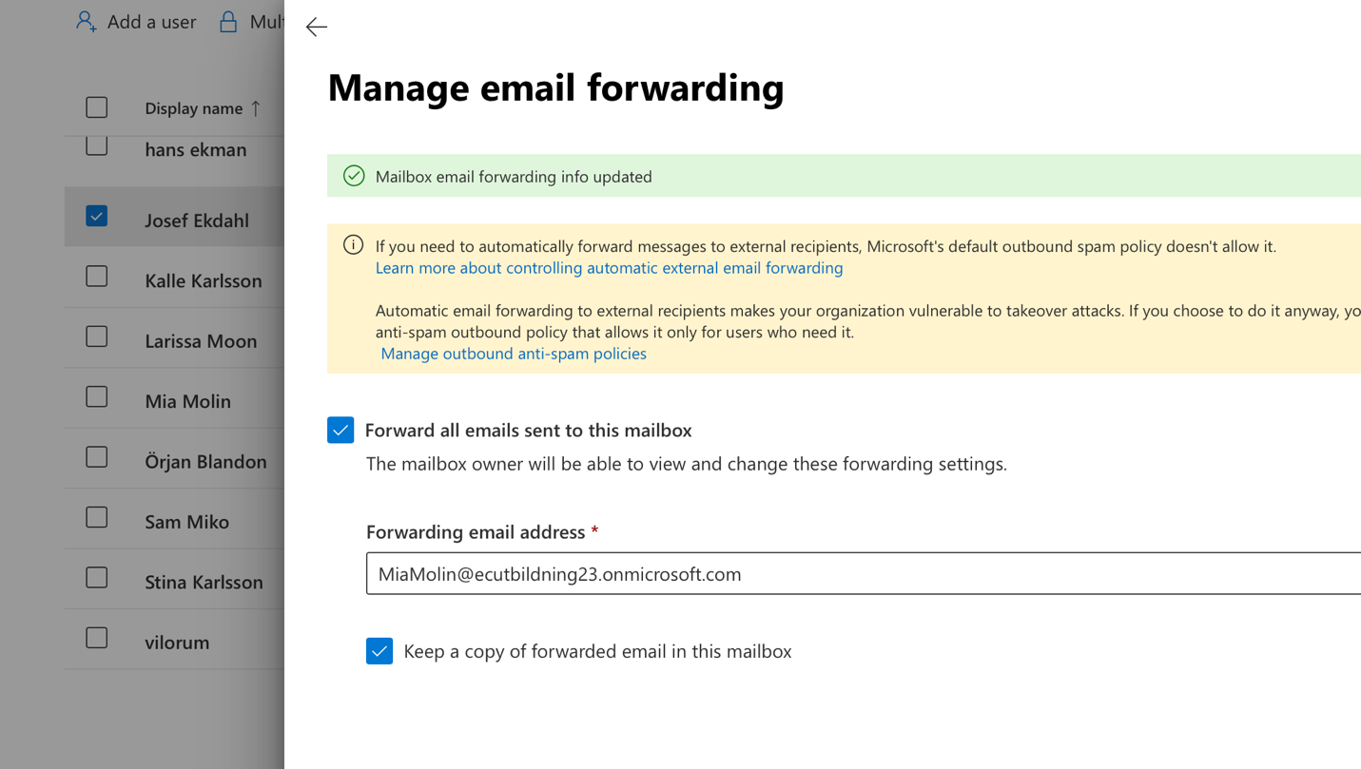
Here I just forward his e-mail box to Mia
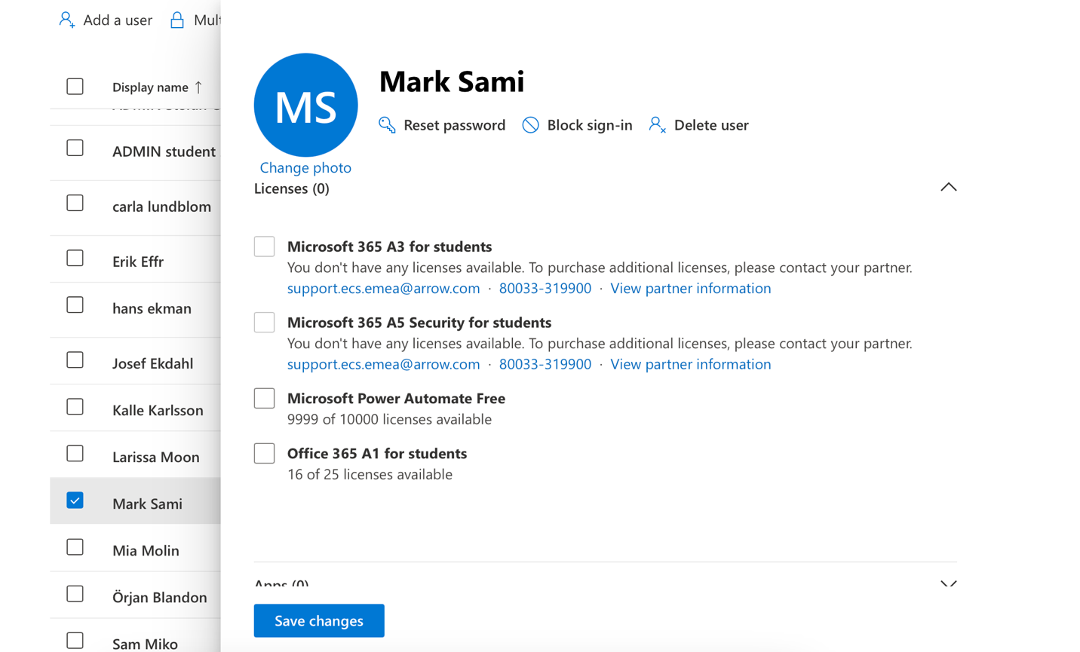
here I assigned unlicensed user to be super admin for the SharePoint

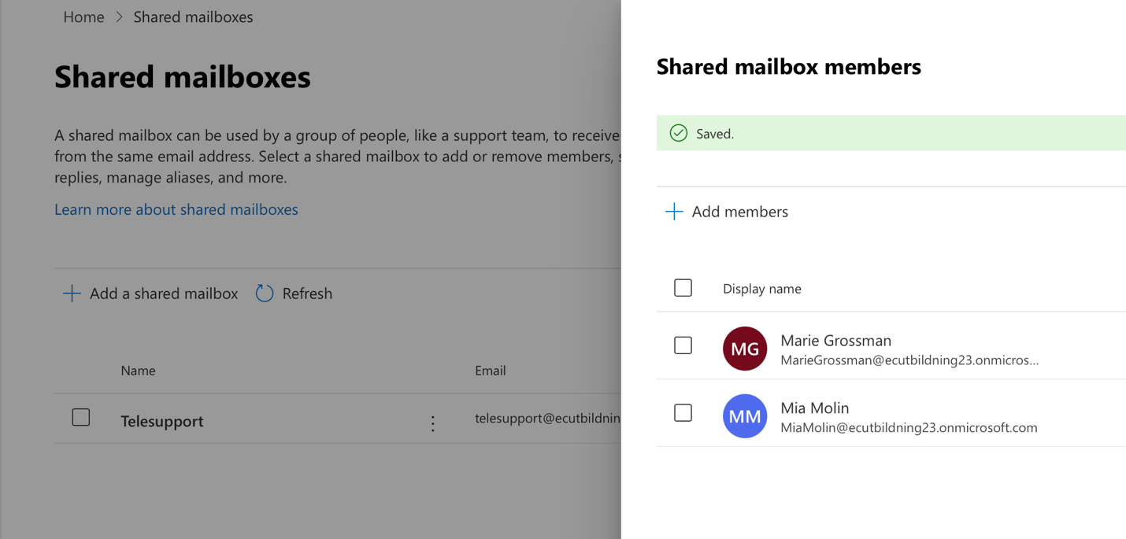
here I created a shared mailbox for Mari and Maya
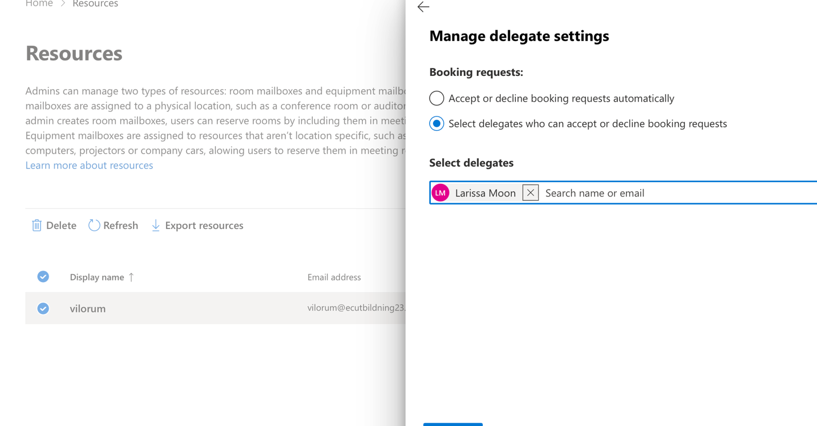
and here I just gave the permission for Larissa to be the only person can the restroom be booking through
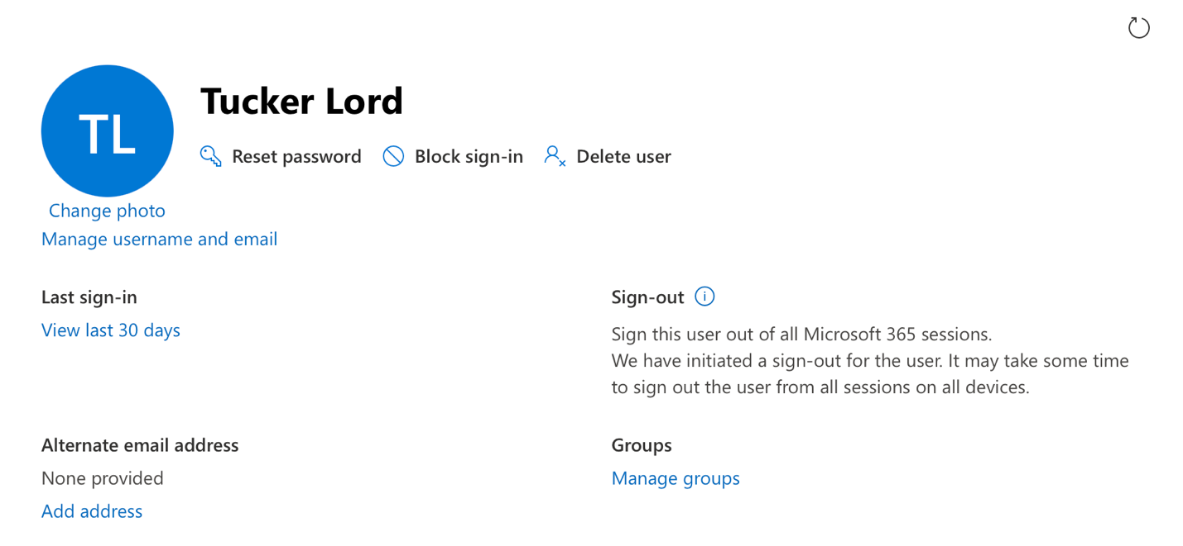
here I just sign out tucker from all the sessions and reset his password so he cannot log in again and manage his e-mail forwarding to kalle.
