1. Concepts and fundamentals:

a. What are the characteristics of future automotive compared to the traditional one with fuel engine?

1. **Electric Power: Transition from fossil fuel to electric power with modern batteries offering sufficient energy at acceptable costs.**
2. **Intelligence: Future cars are becoming smarter with advanced computing capabilities.**
3. **Networking: Vehicles are increasingly connected internally and externally.**
4. **Multi-functionality: Cars integrate diverse features beyond transportation.**
5. **Software-defined: Cars allow personalization and easy updates via software.**
6. **Higher Automation: Over 30% of vehicles will surpass Level 3 automation by 2030.**
7. **Increased Computing Power**
8. **Enhanced Network Bandwidth**
9. **IC Integration: Electric vehicles will use over 2000 ICs compared to 500 in traditional cars.**
10. **Cost and Value Shift: Cars are now electronic products combining hardware, software, and materials.**

b. What are the advantages of software defined car?

1. **Personalization: Software-defined vehicles can be customized based on user needs.**
2. **Easy Updates: Easily update features, diagnostics, and repairs through software.**
3. **Component Normalization: Standardizing components simplifies system integration and maintenance.**
4. **Computing Platform: Cars serve as computing platforms, providing the processing power needed to support application software functionalities.**

c. What are the temperature range of typical consumer, industry and

automotive IC, respectively?

1. **Consumer ICs: 0°C to 70°C.**
2. **Industrial ICs: -40°C to 85°C.**
3. **Automotive ICs: -40°C to 125°C**

d. What are the key requirements for automotive IC?

1. **High Reliability: Automotive ICs must operate reliably under harsh conditions, including extreme temperatures, vibrations, and humidity.**
2. **Wide Temperature Range**
3. **Long Lifespan**
4. **Functional Safety**
5. **High Performance**
6. **Electromagnetic Compatibility**

2. Draw the diagram of normal CMOSFET and Floating Gate CMOSFET

Transistors. Explain briefly how Flash memory stores data.

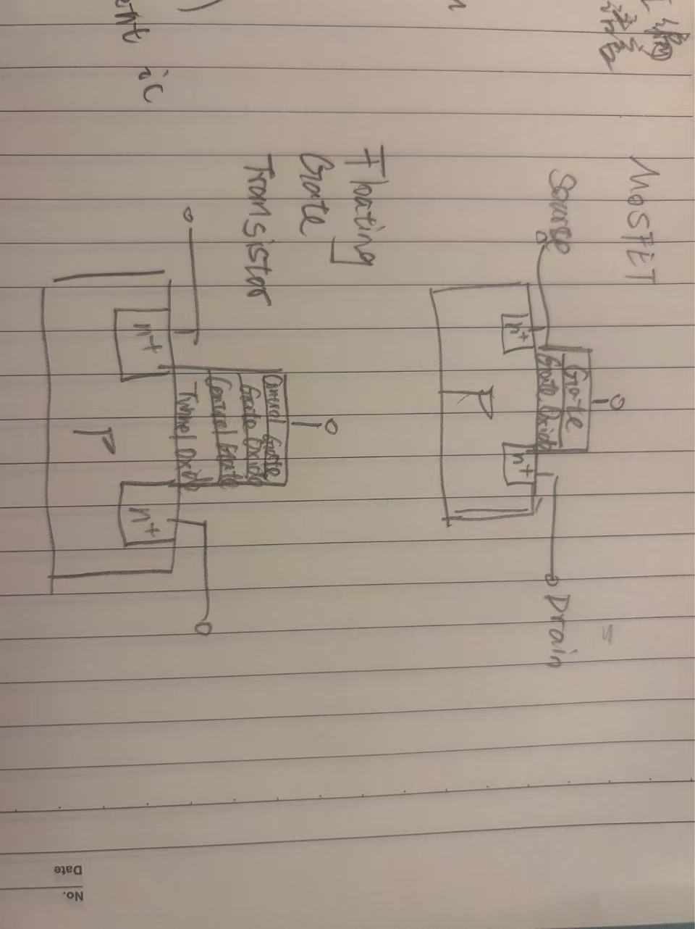

Flash storage uses floating gate transistors to store data. The data is trapped in the floating gate in the form of electrons, and by changing the voltage, the state of the electrons is altered to represent binary 0s and 1s.

3. SPI:

a. Draw the circuit architecture of SPI system with one master and two

slave devices connected in daisy chain.

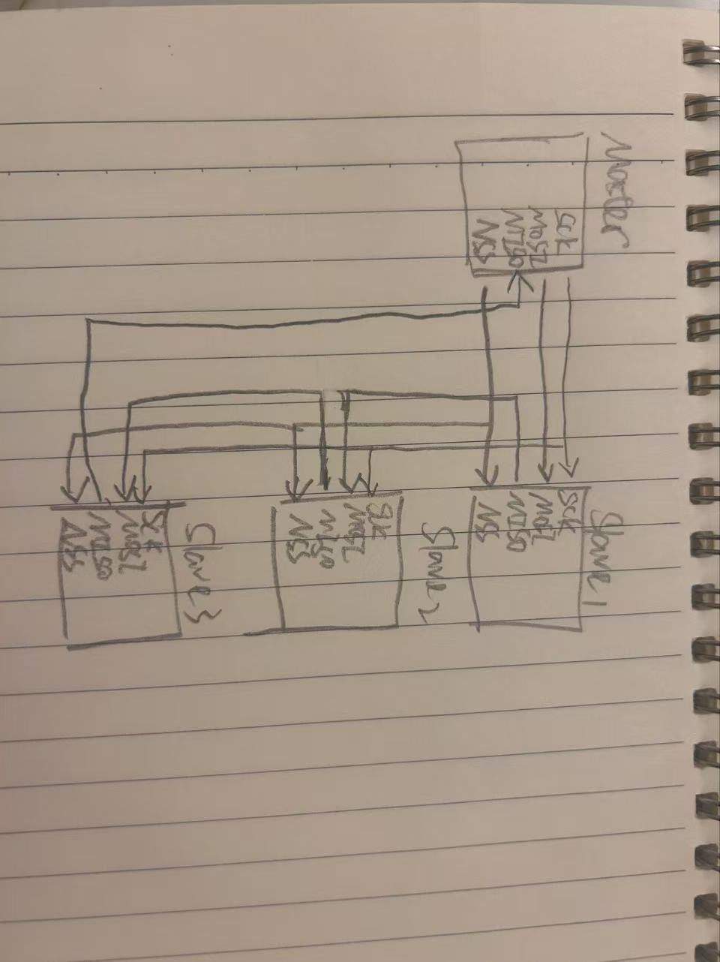

b. Draw the data transmission timing diagram with clock polarity = 1 and

clock phase = 1.



4. Show the steps in vertical format of the following modulo 2 calculation:

a. 1011 + 1001

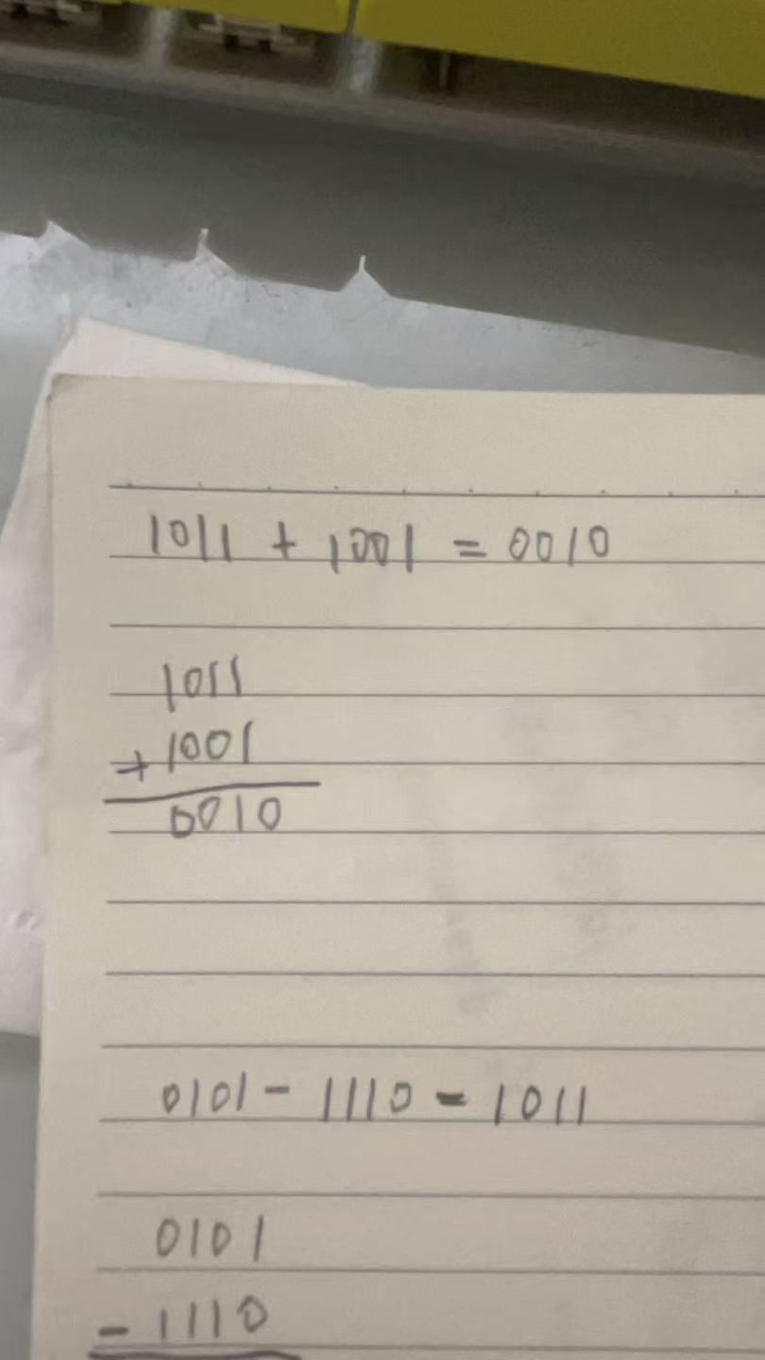

b. 0101 – 1110

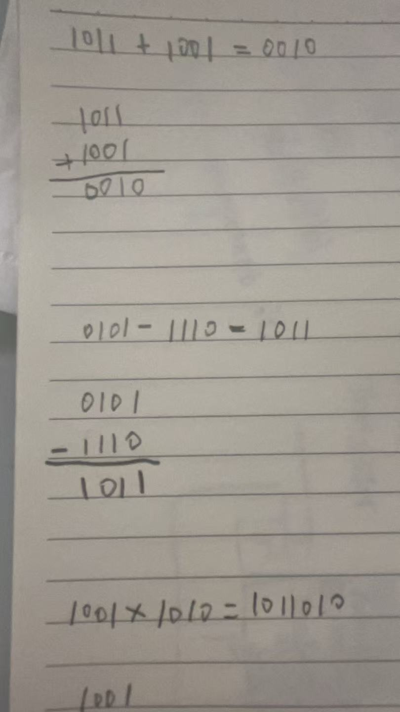

c. 1001 x 1010

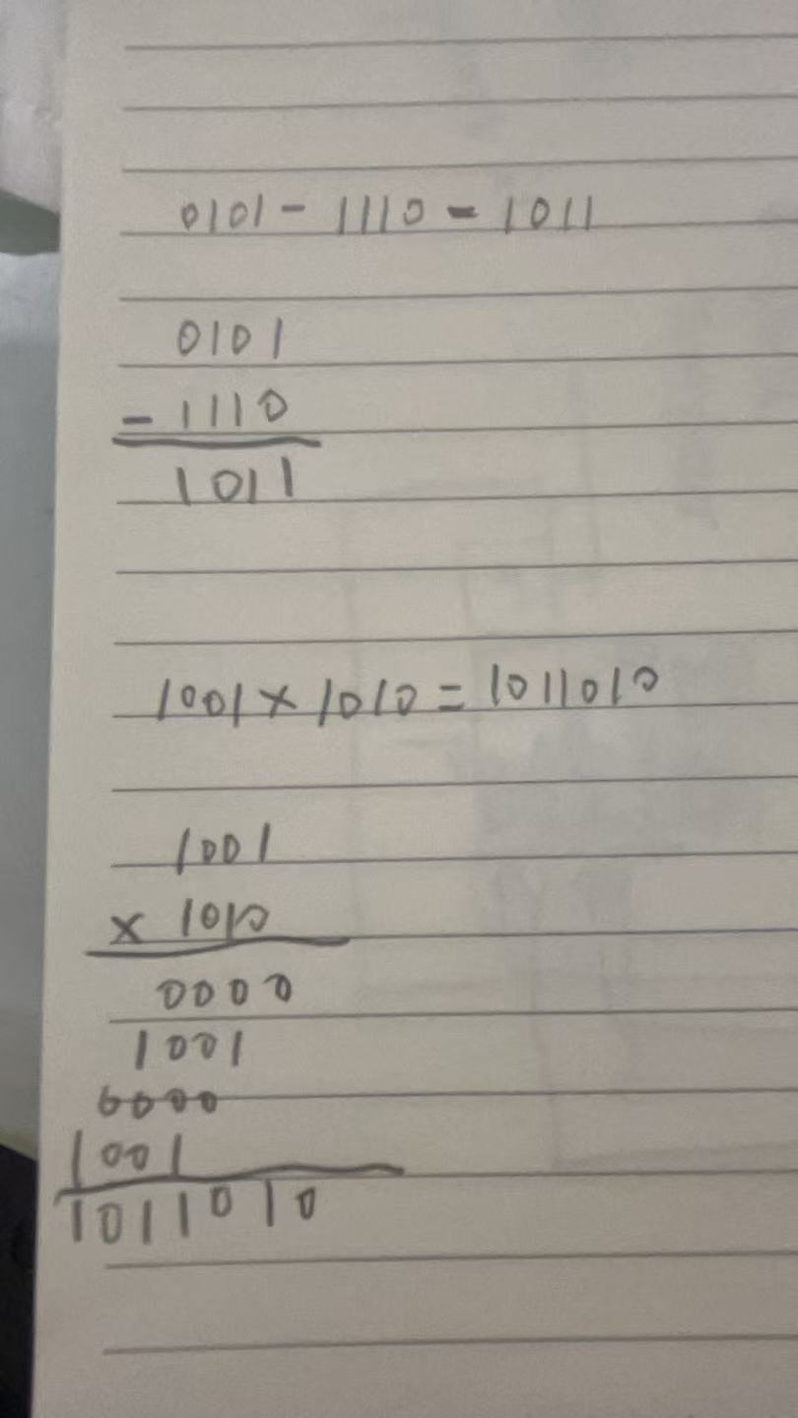

d. 100101101 / 1101

