**1, Practice 1.1**

**a) The main code of this program:**

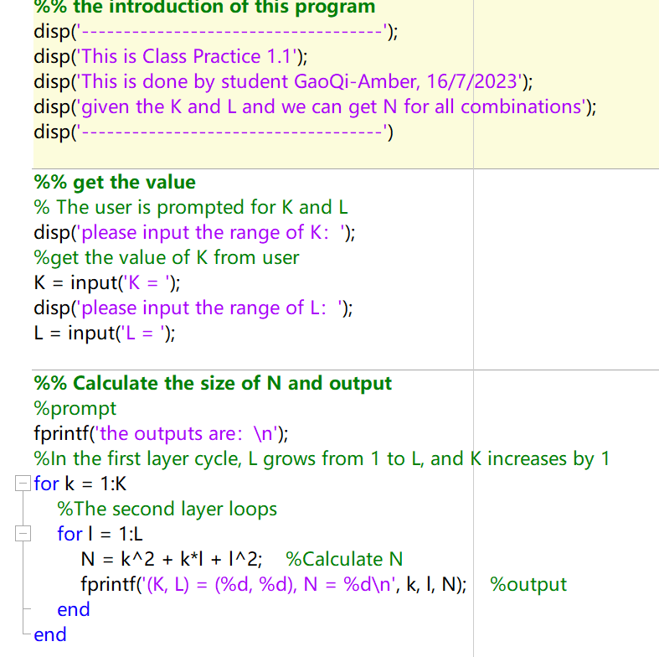

**b) The process after we run this program:**

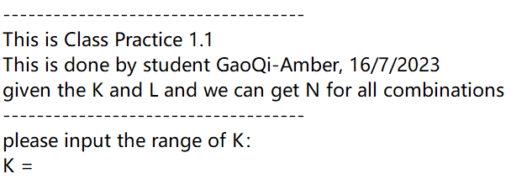

**c) Next, we can input the value of the range of K, for example 4**

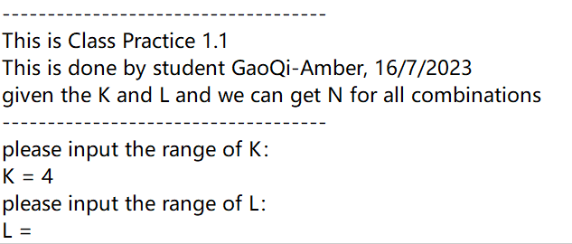

**d) Then input the value of the range of L, and we can get the result：**

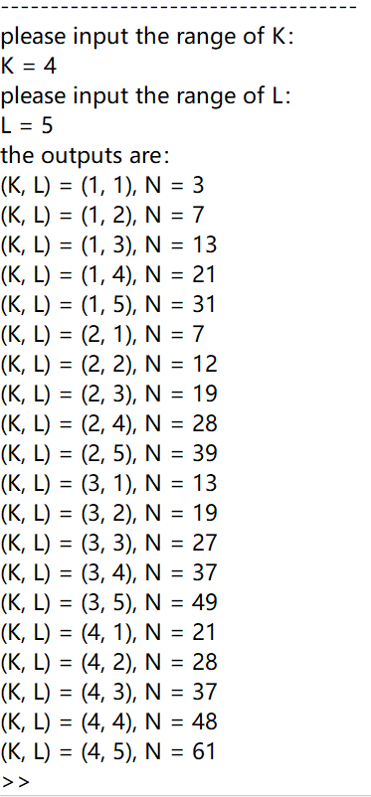

**2, Practice 1.2**

**a) the main code:**

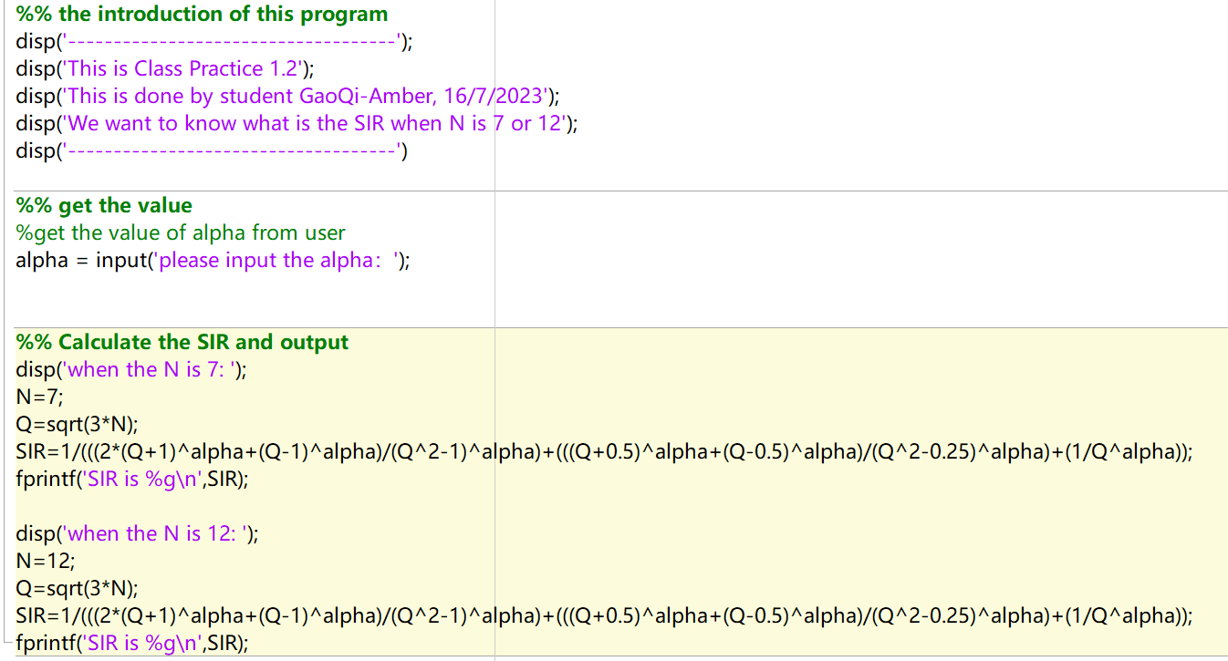

**b) then we can get the answer in the situation of the different alpha**

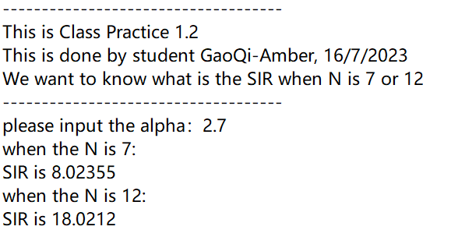

**3, Practice 1.3**

**a) the main code:**

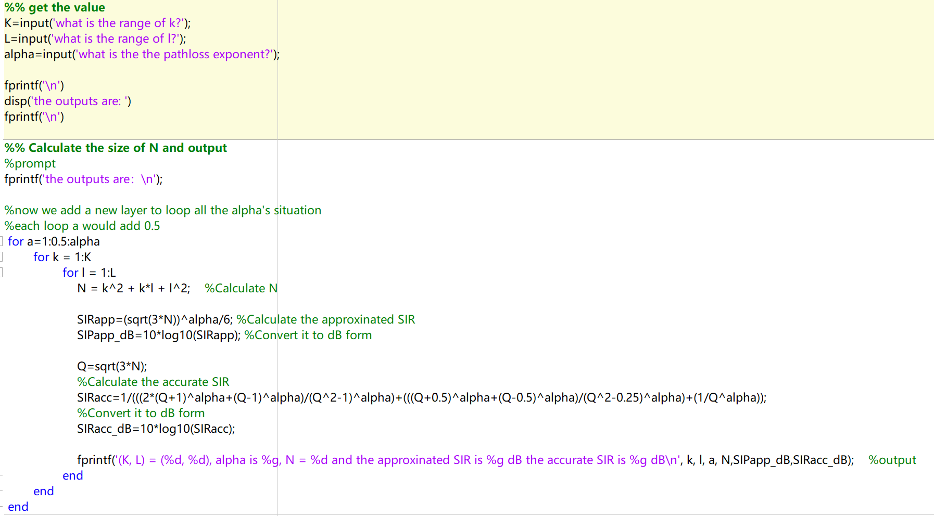

**b) the result:**

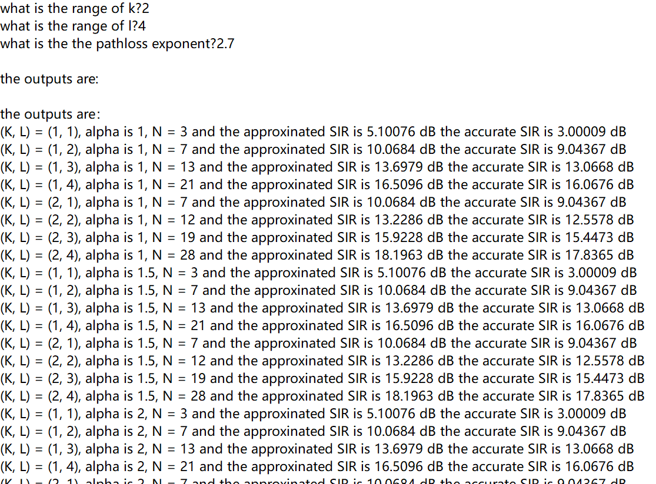

**4, For the question in the middle of class:**

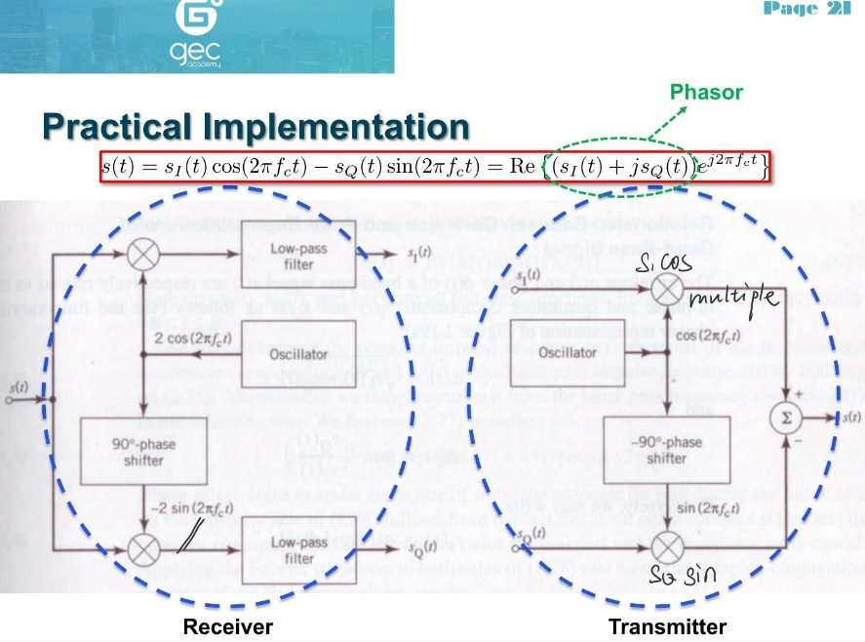

**a) Proof formula**

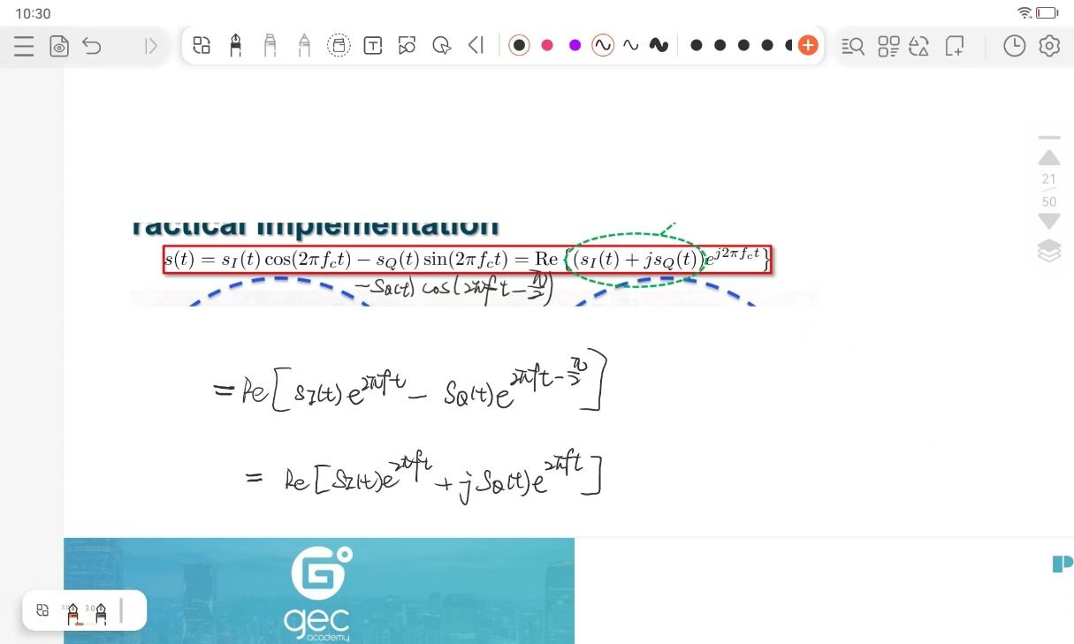

**b)** **The process by which s(t) is broken down into sI(t) and sQ(t).**

