**Correlation –**

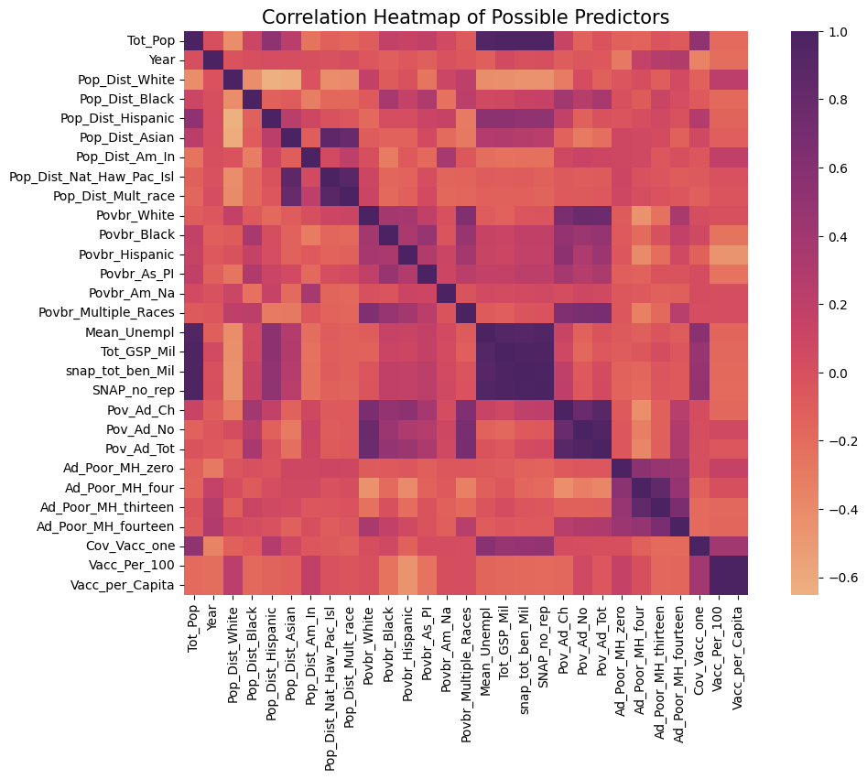Figure 1: Heatmap of socioeconomic and health predictors*.*

*Strong correlations among variables (purple clusters) illustrate potential multicollinearity, motivating the use of VIF diagnostics and LASSO regression to ensure stable estimation of relationships*

## Regression Outputs

Figure 2: Comparison of OLS and LASSO model fit across three outcomes.

Target =Tot_GSP_Mil.

*Reported values include R² for both OLS and LASSO regressions, as well as the optimal LASSO penalty (α) selected by cross-validation. Gross State Product (Tot_GSP_Mil) showed strong and stable explanatory power in both models (R² ≈ .96 for OLS, .95 for LASSO), confirming robust economic predictors. Vaccination coverage (Cov_Vacc_one) was moderately predictable (R² ≈ .37 OLS, .31 LASSO), consistent with distress-driven variation in uptake. Mental health distress (Ad_Poor_MH_fourteen) was weakly explained in both models (R² ≈ .15), reflecting the influence of unmeasured social and healthcare factors.*

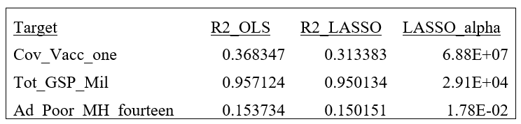

**Coefficients –**

Figure 3A: OLS regression results for Gross State Product (Tot_GSP_Mil)

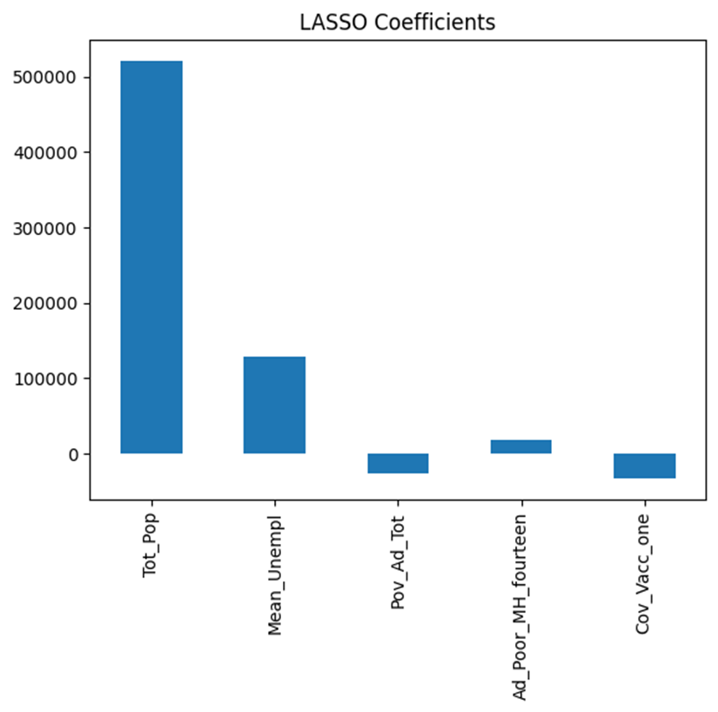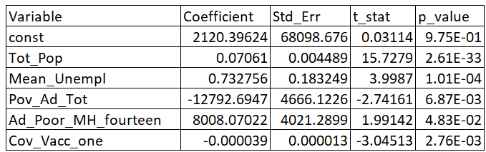

*The high explanatory power (R² ≈ .96), as shown in the regression comparison table, demonstrates that core predictors such as population, unemployment, and poverty account for nearly all variance in state economic output, while LASSO regularization confirmed the stability of these effects under penalization.*

Figure 3B: OLS regression results for Vaccination Coverage (Cov_Vacc_one)

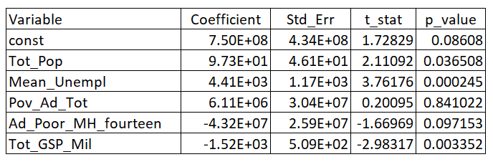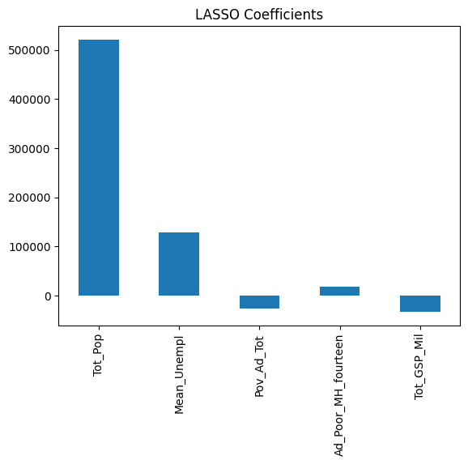

*The model explained a moderate proportion of variance (R² ≈ .37) shown on the regression comparison table, consistent with the observed association between distress and vaccination uptake. LASSO regularization reduced explanatory fit slightly (R² ≈ .31), as referenced on the comparison table. Indicating that only a subset of predictors contributes uniquely to vaccination outcomes. Some potentially unmeasured impacts here are hesitancy to see a doctor and vaccine misinformation (Loomer et al.).*

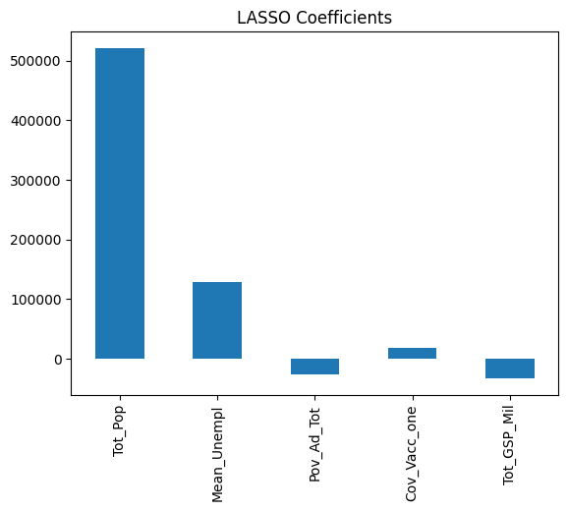

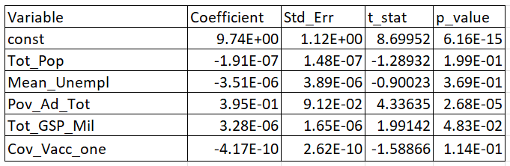Figure 3C: OLS regression results for Mental Health Distress _________.(Ad_Poor_MH_fourteen).

*The model explained only a small share of variance (R² ≈ .15), underscoring that poverty is a significant but incomplete predictor of distress. LASSO regression retained a nearly identical fit, suggesting that additional unmeasured factors are likely driving much of the variance in mental health outcomes.*

**Contextual Summary Research**

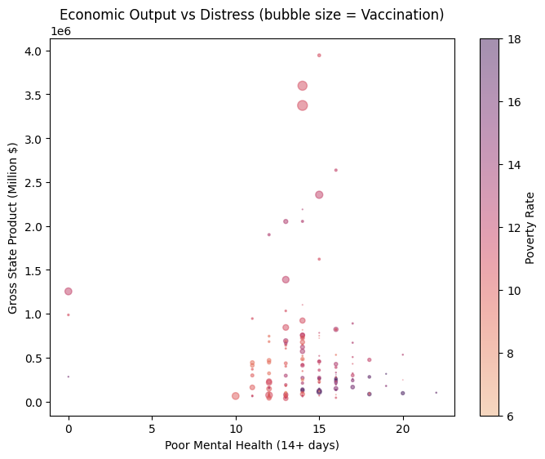 Figure 4: Economic Output vs. Distress (bubble size = Vaccination, color = Poverty)

*This scatterplot visualizes the relationship between poor mental health (14+ days) and gross state product (GSP, in millions of dollars). Bubble size represents vaccination coverage, and color represents poverty rates. The figure illustrates that states with higher economic output cluster across varying levels of mental health distress, with larger vaccination bubbles concentrated in higher-output states. The color gradient indicates that poverty is inversely associated with GSP, reinforcing how socioeconomic conditions and health behaviors interact.*

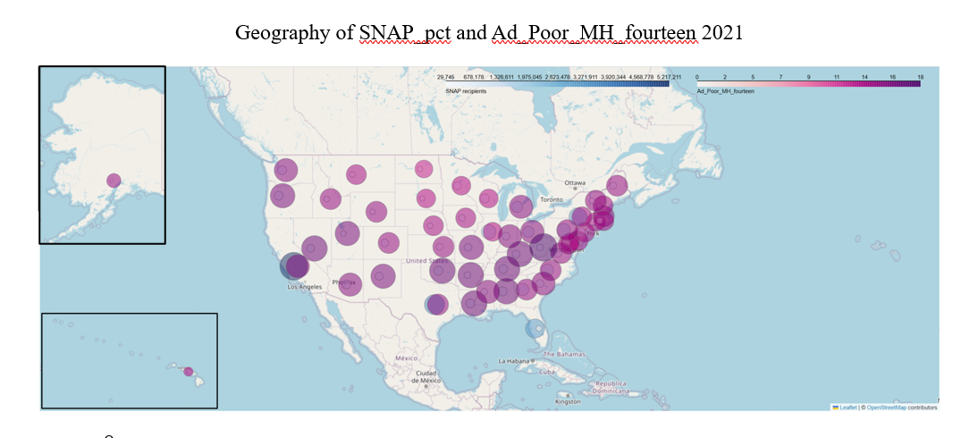Figure 5: Geography of SNAP Participation and Mental Health Distress (2021–2023)[1]

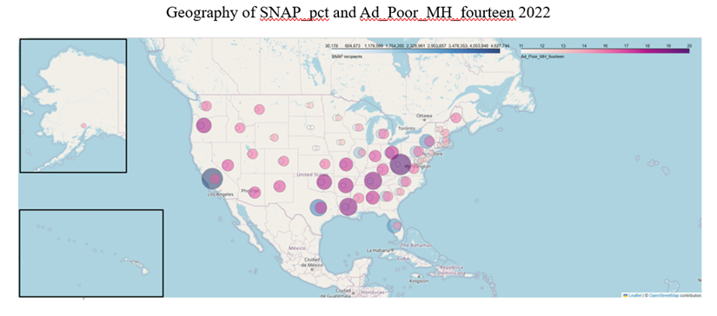

*In 2021,* [*KFF*](https://www.kff.org/mental-health/how-the-covid-19-pandemic-is-affecting-peoples-mental-health-and-substance-use/) *documented that the COVID-19 pandemic exacerbated anxiety and depression disproportionately impacts on people facing financial strain and food insecurity.*

[*CBPP*](https://www.cbpp.org/research/food-assistance/snap-is-linked-with-improved-health-outcomes-and-lower-health-care-costs?) *reported that SNAP participation rose sharply during the pandemic, particularly in low-income states, helping families buffer against sudden job and income loss.*

Geography of SNAP_pct and AD_Poor_MH_fourteen 2021

*By 2022, mental health needs remained elevated while SNAP reliance continued in many states. Improvements likely reflect the impact of federal relief programs, such as direct stimulus payments, expanded unemployment benefits, rental assistance, enhanced SNAP, and Child Tax Credit expansions—policies that* [*KFF*](https://www.kff.org/covid-19/a-look-at-the-economic-effects-of-the-pandemic-for-children/) *found significantly reduced economic hardship and child poverty.*

Geography of SNAP_pct and AD_Poor_MH_fourteen 2022

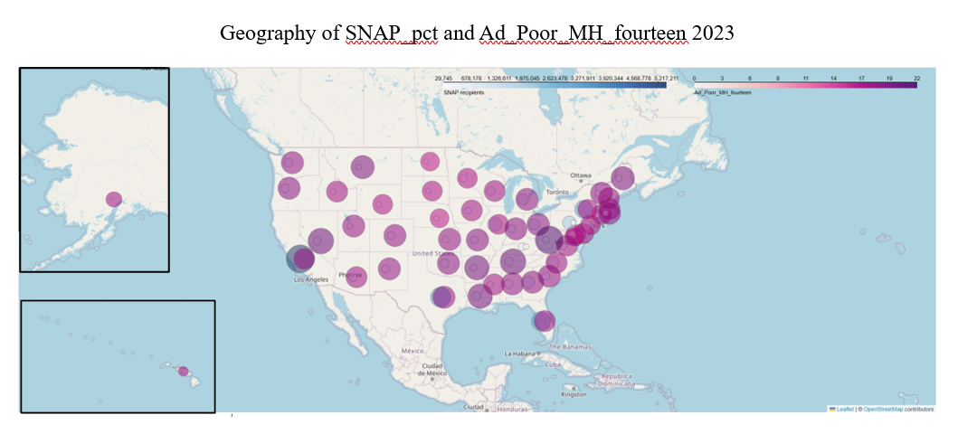

*In 2023,* [*CBPP*](https://www.cbpp.org/blog/end-of-snaps-temporary-emergency-allotments-resulted-in-substantial-benefit-cut) *reported that SNAP participation remained high in economically vulnerable states even as benefits were greatly reduced as emergency allotments expired. Resulting in substantial benefit reductions/increased food hardship. At the same time,* [*KFF*](https://www.kff.org/mental-health/the-implications-of-covid-19-for-mental-health-and-substance-use/) *analyses showed over 30% of U.S. adults reporting symptoms of anxiety or depression. This suggests that, even as the pandemic officially ended, its economic and psychological effects persisted.*

Geography of SNAP_pct and AD_Poor_MH_fourteen 2023

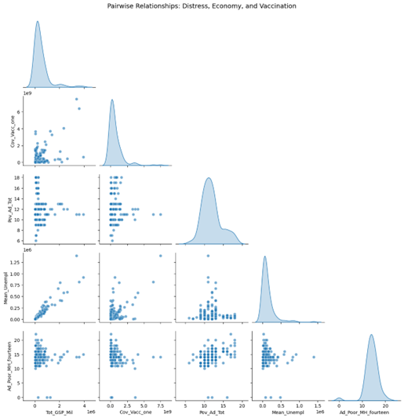Figure 6: Pairwise Relationships: Ad_Poor_MH_fourteen, Tot_GSP_Mil, Cov_Vacc_one

*This pair plot shows relationships among gross state product (Tot_GSP_Mil), vaccination coverage (Cov_Vacc_one), poverty (Pov_Ad_Tot), unemployment (Mean_Unempl), and poor mental health (Ad_Poor_MH_fourteen). Higher poverty and unemployment are associated with greater reported distress, while vaccination coverage varies widely across states. The chart highlights how economic strain and health behaviors intersect with mental health outcomes, consistent with KFF findings on disparities by social vulnerability.*

1. Click on the links to be taken to the relevant articles.