Assignment #1. HTML & CSS Basics
Abdinurova Altyn SE-2513

1. Project Information
Project Name: Digital Book Collection
Course: Front-End Development (Assignment #1)
Group: SE-2513
Student Name & Role: Abdinurova Altyn — Front-End Developer (Individual Project)
Pages Created: index.html, 2catalog.html, 3product.html, 4about.html, 5prices.html, 6contact.html
Repository URL:
https://github.com/Altyn-se2513/web1_ass1
Live Website URL:
https://altyn-se2513.github.io/web1_ass1/

2. Project Objective
The main objective of this assignment is to design, develop, and publish a structured, multi-page static website without using external frameworks (such as Bootstrap or Tailwind CSS). The project demonstrates core Front-End web development competencies, including:

Writing clean, valid, and semantic HTML5 markup.
Linking and maintaining a single shared external CSS stylesheet (css/style.css).
Applying the four essential CSS selector types (Element, Class, ID, Descendant).
Utilizing the CSS Box Model, custom color palettes, and structured typography.
Building functional interactive UI elements, including global navigation menus, data tables, and input forms.
Deploying a multi-page static web application to a live public cloud server via GitHub Pages.

3. Step-by-Step Implementation Report

Part 1. HTML Structure & Semantic Markup
Boilerplate & Metadata Setup:
Created six dedicated HTML files corresponding to key site sections (index.html, 2catalog.html, 3product.html, 4about.html, 5prices.html, and 6contact.html).
Included standard HTML5 boilerplate definitions (<!DOCTYPE html>, <html>, <head>, <title>, <body>) across all documents.
Defined custom and descriptive page titles inside <title> tags:
Home - Digital Book Collection (index.html)
Book Catalog - Digital Book Collection (2catalog.html)
Book Details - The Great Gatsby (3product.html)
About Us - Team Project (4about.html)
Pricing Plans - Reader Membership (5prices.html)
Contact Us - Digital Book Collection (6contact.html)
Included HTML comments in the <head> section identifying team membership and assignment details.
Semantic Text Hierarchy & Layout:
Organized page content logically using semantic headings (<h1> to <h3>) to enforce accessibility standards and proper document structure.
Constructed an "About Our Project" section on 4about.html detailing project goals and developer responsibilities.
Global Navigation, Lists, and Images:
Constructed a consistent header navigation bar (<nav>) containing anchor elements (<a href="...">) that allow seamless navigation across all six pages.
Utilized both ordered (<ol>) and unordered (<ul>) lists to group catalog recommendations, book categories, specifications, phone numbers, and member roles.
Embedded images with meaningful alt attributes to improve accessibility.
Data Table Implementation:
Designed a structured data table in 5prices.html using proper table semantics: <table>, <thead>, <tbody>, <tr>, <th>, and <td>.
Configured four distinct data columns: Plan Name, Monthly Fee, Book Limit, and Benefits.
Interactive Form Component:
Developed a complete interactive contact form on 6contact.html.
Integrated required inputs: text input for Name (required), email input (required), select dropdown for Favorite Genre, custom color picker for theme preferences, message <textarea>, and a submit <button type="submit">.

Part 2. External Styling with CSS
Global Reset & Box Model Configuration:
Linked a shared external stylesheet (<link rel="stylesheet" href="css/style.css">) in the <head> section of all HTML pages.
Implemented a universal CSS reset (* { margin: 0; padding: 0; box-sizing: border-box; }) to guarantee cross-browser rendering consistency and predictable sizing.
Demonstration of Four Essential CSS Selectors:
Element Selectors: Applied base styles for elements including body, main, h1, h2, h3, p, a, table, ul, ol, and footer.
Class Selectors: Styled reusable component classes including .navbar, .page-img, .profile-img, and .contact-phones.
ID Selectors: Styled unique page components including #main-header and #contact-form.
Descendant Selectors: Applied targeted rules to nested elements such as .navbar ul li a, .navbar ul li a:hover, #contact-form label, table th, table td, and footer ul.
Typography & Interactive States:
Established a modern font family stack ('Segoe UI', Tahoma, Geneva, Verdana, sans-serif) with custom line height (line-height: 1.6) and color schemes.
Styled hyperlinked text (a) with removed default underlines, transition properties, and interactive red hover effects (:hover).
Navigation Bar & Flexbox Layout:
Built a responsive top navigation bar using CSS Flexbox (display: flex; gap: 15px; justify-content: center; flex-wrap: wrap;).
Configured sticky footer positioning utilizing vertical Flexbox on body (min-height: 100vh; flex-direction: column;), setting flex: 1 on <main>, and applying margin-top: auto on footer.
Component Customization & Media:
Enforced image responsiveness using max-width: 400px; and height: auto;.
Created a circular image component (.profile-img) using fixed dimensions (160px × 160px), border-radius: 50%, and object-fit: cover.
Fully customized form controls (input, select, textarea) with explicit background colors (#ffffff), borders, padding, and distinct visual focus borders (:focus).

Part 3. Deployment & Publishing
Version Control: Managed all source files within a structured GitHub repository containing dedicated css/ and imgs/ directories.
Path Management: Verified all relative file paths (css/style.css, imgs/cat.jpg, etc.) to prevent broken assets across pages.
Live Deployment: Published the repository live to the public using GitHub Pages.

4. Website Screenshots
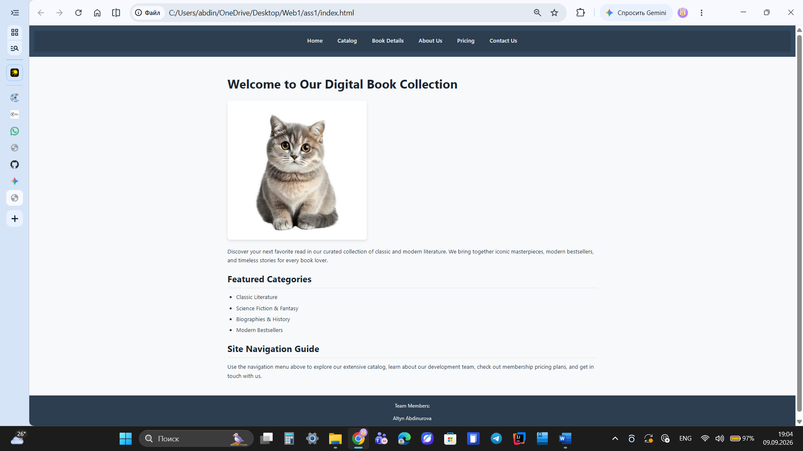1. Main Page (index.html)
Home page showcasing navigation bar, header, welcome mascot image, and feature list.

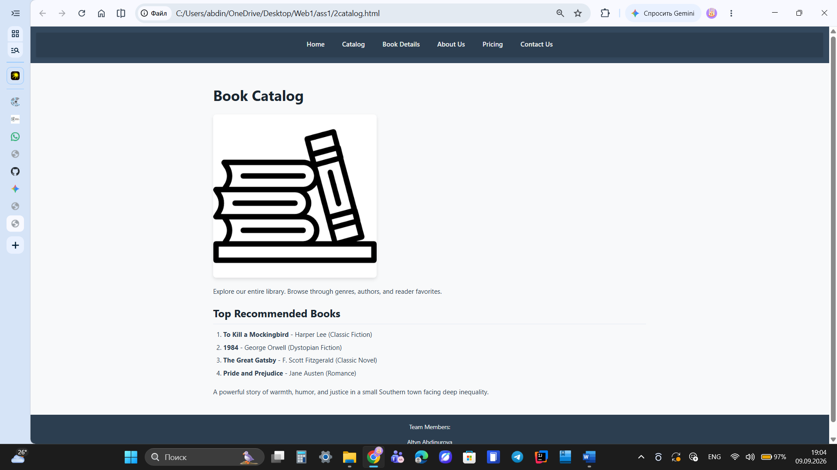
2. Catalog Page (2catalog.html)
Book catalog displaying recommended reading list and general library details.
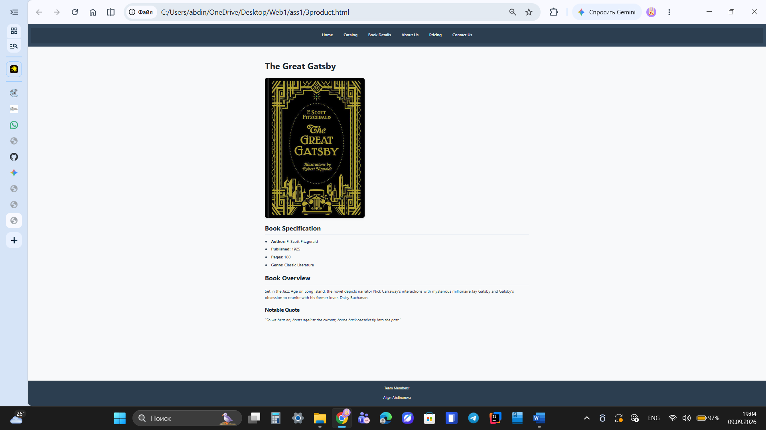
3. Product Page (3product.html)
Product view displaying book cover art, technical specifications, and summary.
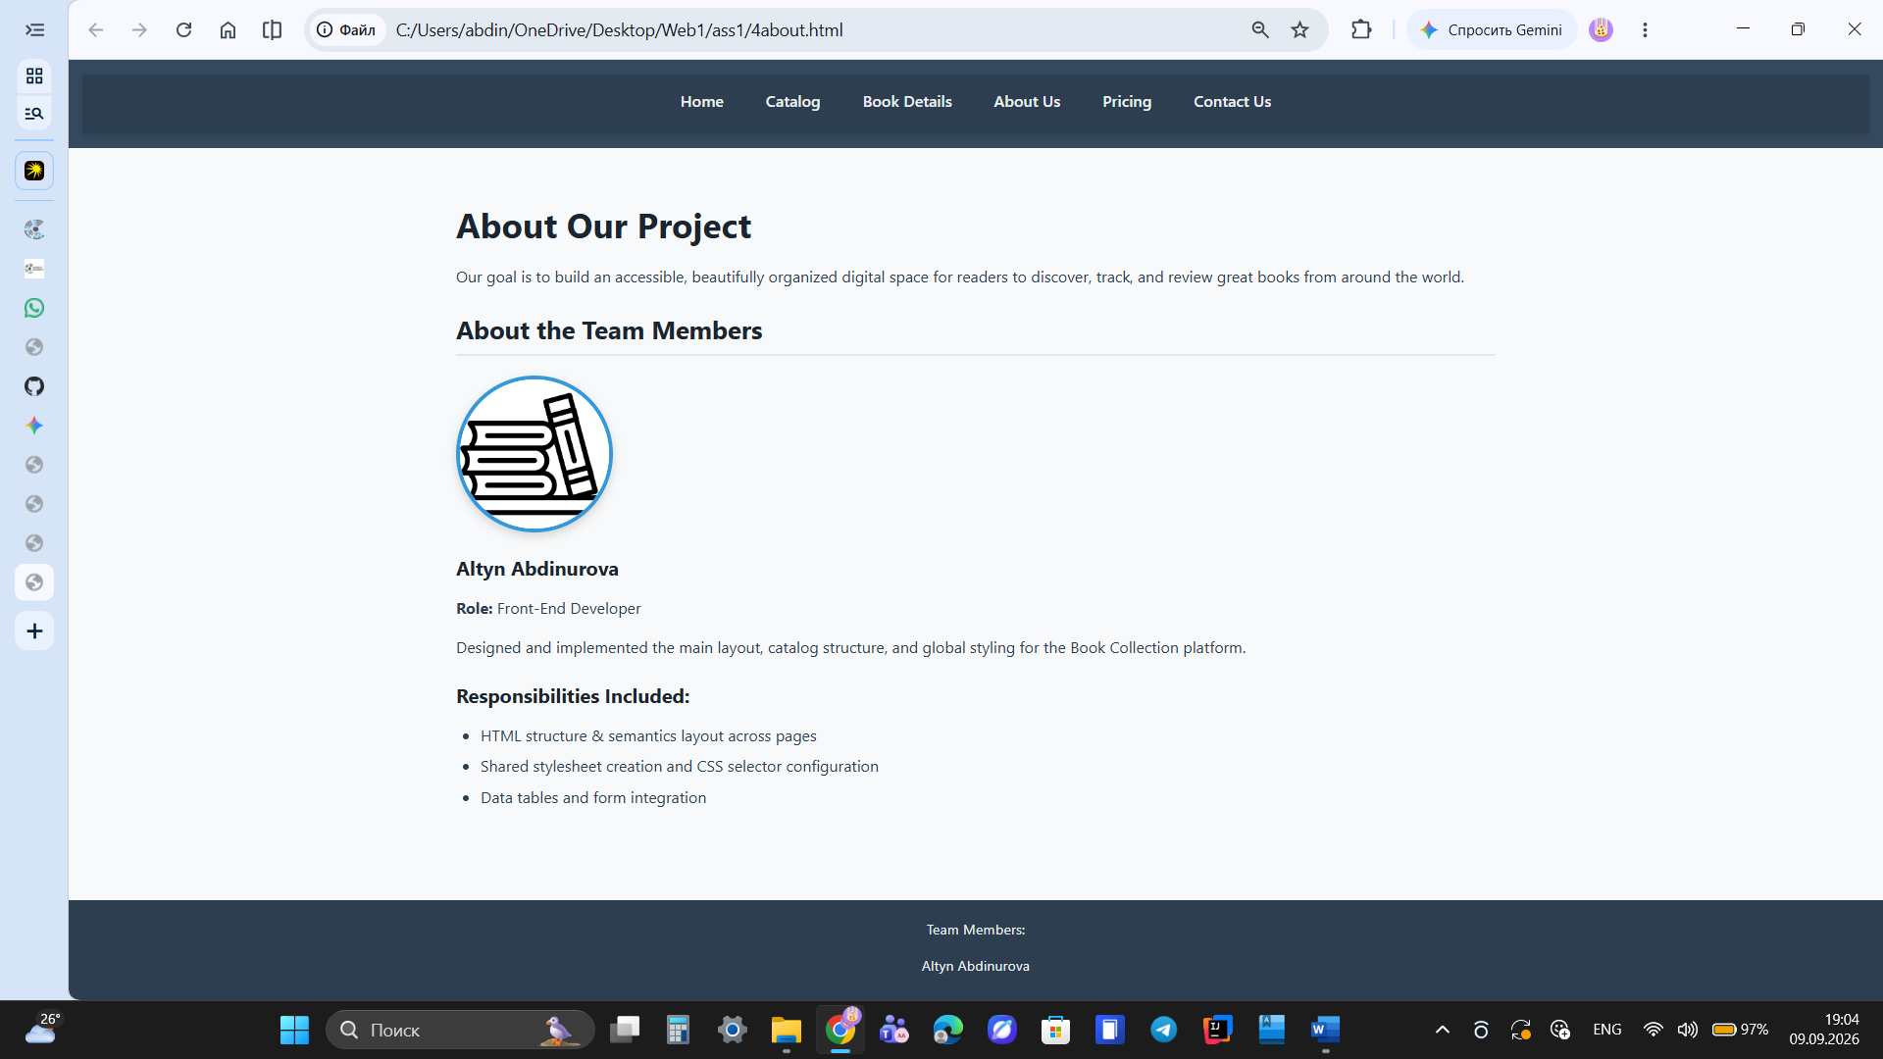
4. About Us Page (4about.html)
Figure 4: Developer biography featuring a circular project feature image (border-radius: 50%).
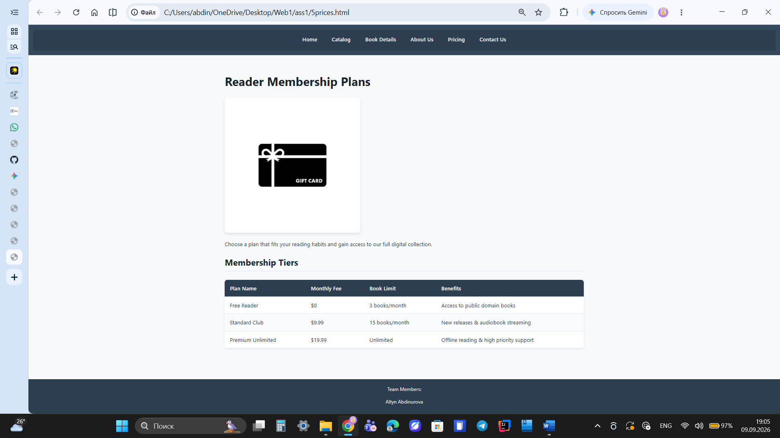
5. Prices / Schedule Page (5prices.html)
Figure 5: Membership pricing tiers formatted in a structured HTML data table with custom hover rows.
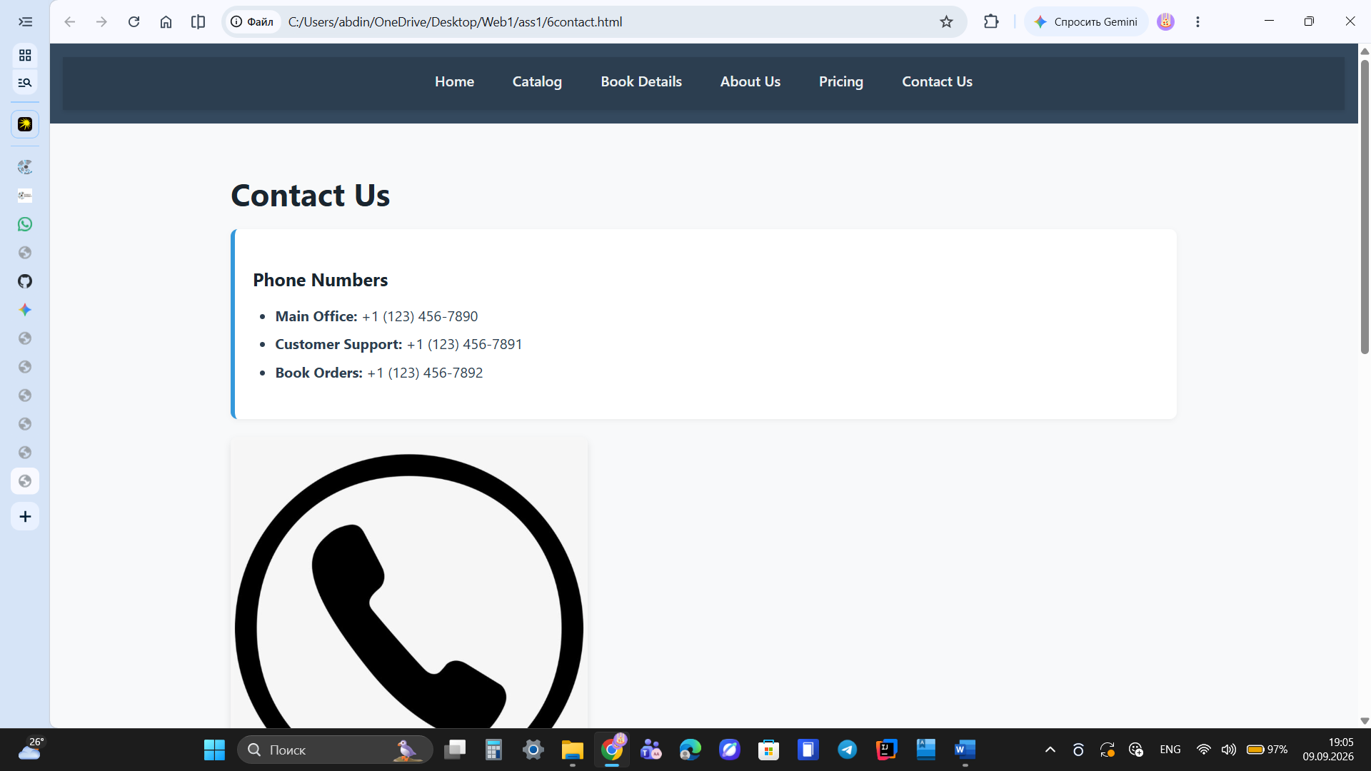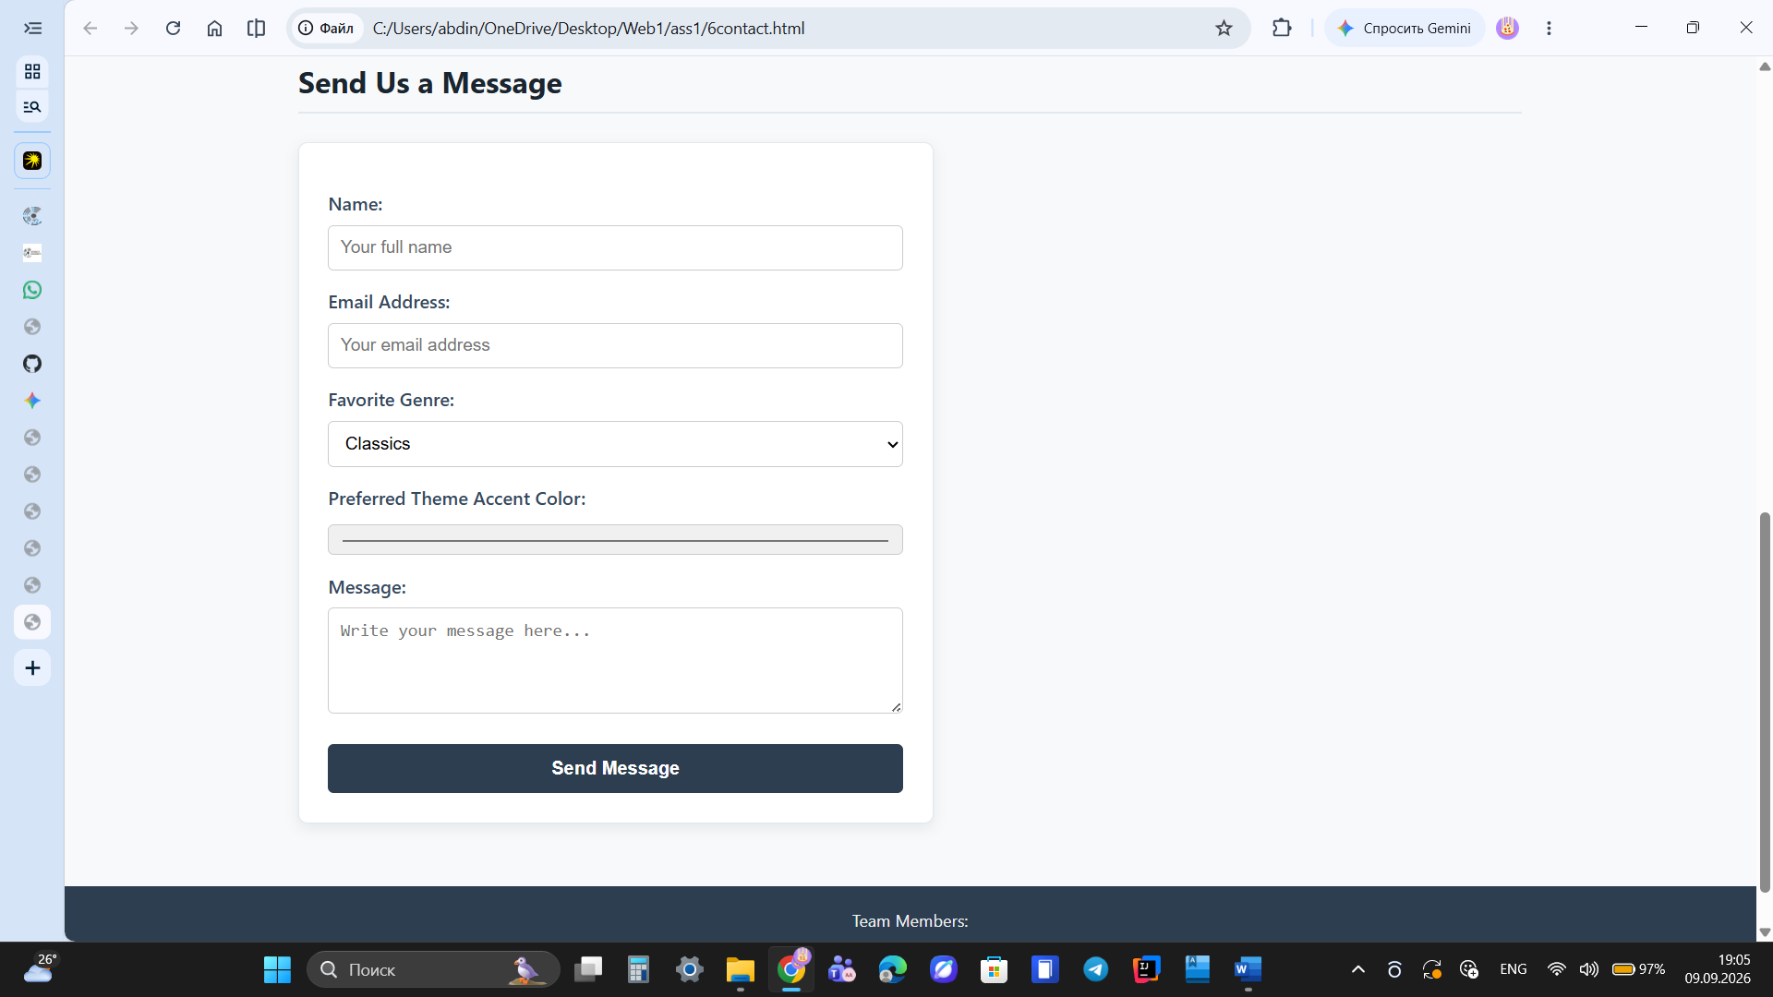

6. Contact Page (6contact.html)
Figure 6: Contact page displaying office details, phone numbers, and an interactive feedback form.

5. Reflection & Conclusion
Developing this project provided valuable hands-on experience in building a complete, accessible static web site from scratch without relying on pre-built CSS frameworks.
Key takeaways from this project include:
Understanding the fundamental separation of concerns: HTML for structural semantics and CSS for presentation.
Gaining mastery over the CSS Box Model (margin, padding, border, box-sizing) and CSS Selector Specificity.
Constructing accessible navigation layouts using Flexbox and maintaining responsive media elements.
Setting up static web deployment pipelines on GitHub Pages and managing relative file paths effectively.
All assignment requirements have been fully satisfied. The source code is clean, valid, and hosted live online.

