Национальный Исследовательский Ядерный Университет «МИФИ»

Лабораторная работа №2

по дисциплине «Теория автоматов»

Работу выполнил

Студент группы Б23-503

Тишин Виктор

Логин: В23_503_14

Пароль: CQ0oT00g

Кодированная таблица переходов и выходов

|  |  |  |  |  |  |  |  |
| --- | --- | --- | --- | --- | --- | --- | --- |
| Время t | | | | Время t+1 | | | Время t |
| X | Q2 | Q1 | Q0 | Q2 | Q1 | Q0 | Y |
| 1 | 2 | 3 | 4 | 5 | 6 | 7 | 8 |
| 0 | 0 | 0 | 0 | 1 | 1 | 0 | 0 |
| 0 | 1 | 1 | 0 | 0 | 0 | 1 | 1 |
| 0 | 0 | 0 | 1 | 1 | 1 | 1 | 0 |
| 0 | 1 | 1 | 1 | 1 | 0 | 0 | 0 |
| 0 | 1 | 0 | 0 | 0 | 0 | 0 | 0 |
| 1 | 0 | 0 | 0 | 1 | 0 | 0 | 0 |
| 1 | 1 | 0 | 0 | 1 | 1 | 0 | 0 |
| 1 | 1 | 1 | 0 | 0 | 1 | 0 | 0 |
| 1 | 0 | 1 | 0 | 1 | 1 | 1 | 0 |
| 1 | 1 | 1 | 1 | 0 | 0 | 0 | 1 |

Таблица переходов и функций возбуждения D-триггеров автомата

|  |  |  |  |  |  |  |  |  |  |  |
| --- | --- | --- | --- | --- | --- | --- | --- | --- | --- | --- |
| Номер набора | Время t | | | | Время t+1 | | | Время t | | |
| X | Q2 | Q1 | Q0 | Q2 | Q1 | Q0 | D2 | D1 | D0 |
| 1 | 2 | 3 | 4 | 5 | 6 | 7 | 8 | 9 | 10 |
| 0 | 0 | 0 | 0 | 0 | 1 | 1 | 0 | 1 | 1 | 0 |
| 6 | 0 | 1 | 1 | 0 | 0 | 0 | 1 | 0 | 0 | 1 |
| 1 | 0 | 0 | 0 | 1 | 1 | 1 | 1 | 1 | 1 | 1 |
| 7 | 0 | 1 | 1 | 1 | 1 | 0 | 0 | 1 | 0 | 0 |
| 4 | 0 | 1 | 0 | 0 | 0 | 0 | 0 | 0 | 0 | 0 |
| 8 | 1 | 0 | 0 | 0 | 1 | 0 | 0 | 1 | 0 | 0 |
| 12 | 1 | 1 | 0 | 0 | 1 | 1 | 0 | 1 | 1 | 0 |
| 14 | 1 | 1 | 1 | 0 | 0 | 1 | 0 | 0 | 1 | 0 |
| 10 | 1 | 0 | 1 | 0 | 1 | 1 | 1 | 1 | 1 | 1 |
| 15 | 1 | 1 | 1 | 1 | 0 | 0 | 0 | 0 | 0 | 0 |

Минимизация функций возбуждения и выхода автомата

|  |  |
| --- | --- |
|  |  |

|  |  |  |  |  |  |  |  |  |  |  |  |  |  |  |  |
| --- | --- | --- | --- | --- | --- | --- | --- | --- | --- | --- | --- | --- | --- | --- | --- |
|  |  | |  | |  |  |  |  |  |  |  | |  | |  |
|  | 1 | x | x | 1 | $$\underline{Q1}$$ |  |  |  |  | $$X$$ | 1 | x | x | 0 | $$\underline{Q1}$$ |
| 0 | 0 | x | 1 | Q1 |  |  |  |  | 1 | 0 | x | 1 | Q1 |
| $$\underline{X}$$ | 0 | 1 | x | x |  |  |  |  | $$\underline{X}$$ | 0 | 0 | x | x |
| 0 | x | 1 | 1 | $$\underline{Q1}$$ |  |  |  |  | 0 | x | 1 | 1 | $$\underline{Q1}$$ |
|  | $$\underline{Q0}$$ | $$Q0$$ | | $$\underline{Q0}$$ |  |  |  |  |  |  | $$\underline{Q0}$$ | $$Q0$$ | | $$\underline{Q0}$$ |  |
|  | D2-диаграмма | | | |  |  |  |  |  | D1-диаграмма | | | | |  |
| $$D2=\underline{Q1}X∨\underline{Q2}∨Q0 \underline{X}$$ | | | | | |  |  |  |  | $$D1=\underline{X}\underline{Q2}∨Q1\underline{Q2}∨X\underline{Q1}Q2$$ | | | | | |
|  | | | | | |  |  |  |  |  | | | | | |
|  | $$Q2$$ | | $$\underline{Q2}$$ | |  |  |  |  |  |  | $$Q2$$ | | $$\underline{Q2}$$ | |  |
| $$X$$ | 0 | x | x | 0 | $$\underline{Q1}$$ |  |  |  |  | $$X$$ | 0 | x | x | 0 | $$\underline{Q1}$$ |
| 0 | 0 | x | 1 | Q1 |  |  |  |  | 0 | 1 | x | 0 | Q1 |
| $$\underline{X}$$ | 1 | 0 | x | x |  |  |  |  | $$\underline{X}$$ | 1 | 0 | x | x |
| 0 | x | 1 | 0 | $$\underline{Q1}$$ |  |  |  |  | 0 | x | 0 | 0 | $$\underline{Q1}$$ |
|  | $$\underline{Q0}$$ | $$Q0$$ | | $$\underline{Q0}$$ |  |  |  |  |  |  | $$\underline{Q0}$$ | $$Q0$$ | | $$\underline{Q0}$$ |  |
|  | D0-диаграмма | | | |  |  |  |  |  |  | Y-диаграмма | | | |  |
| $$D0=\underline{X}Q1\underline{Q0}∨\underline{Q2}Q0∨Q1\underline{Q2}$$ | | | | | |  |  |  |  | $$Y=XQ0∨\underline{X}Q1\underline{Q0}$$ | | | | | |

Диаграмма Вейча для функций четырех аргументов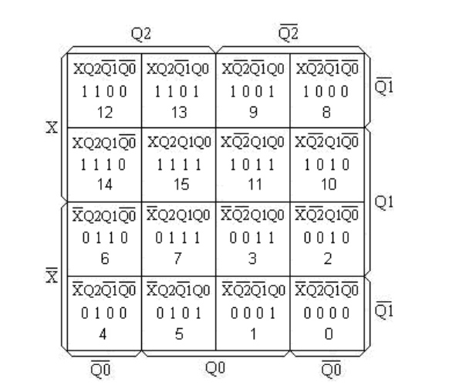

Подключение органов управления стенда

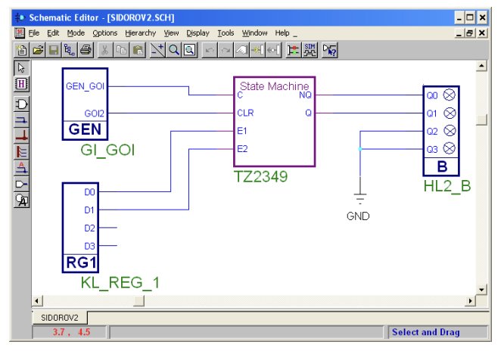

Логическая схема проектируемого автомата

