TESTING THE SIM7670G STANDALONE

DIPSWITCHES

CAM = OFF

HUB = ON

4G = ON

USB = ON

COMS;

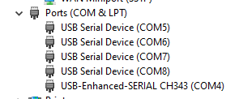

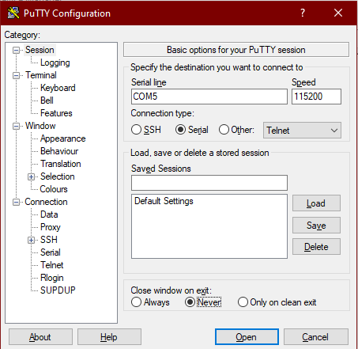

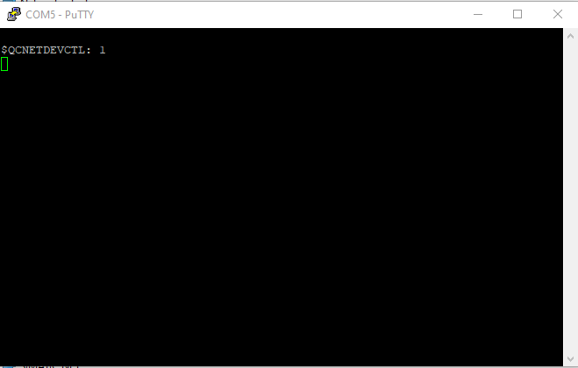

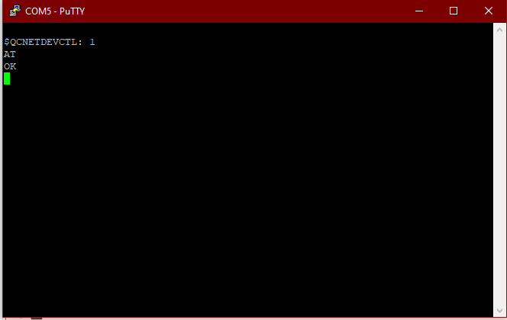

ATI SHOWS

<https://alusys.io/test/sample.bin>





