Alua Sadyrbekova

1. **Project Idea:** Weather App

2. **Small project description:**

* User can view the weather in his/her current location.
* Weather icon or background image will change depending on weather conditions.
* User can search for weather information of other places.
* Show the temperature and weather description in a local time.
* Temperature will be updated each time when open the app.
* Quite possible that data will be taken from weather.com website.

3. **Mockup of UI** :

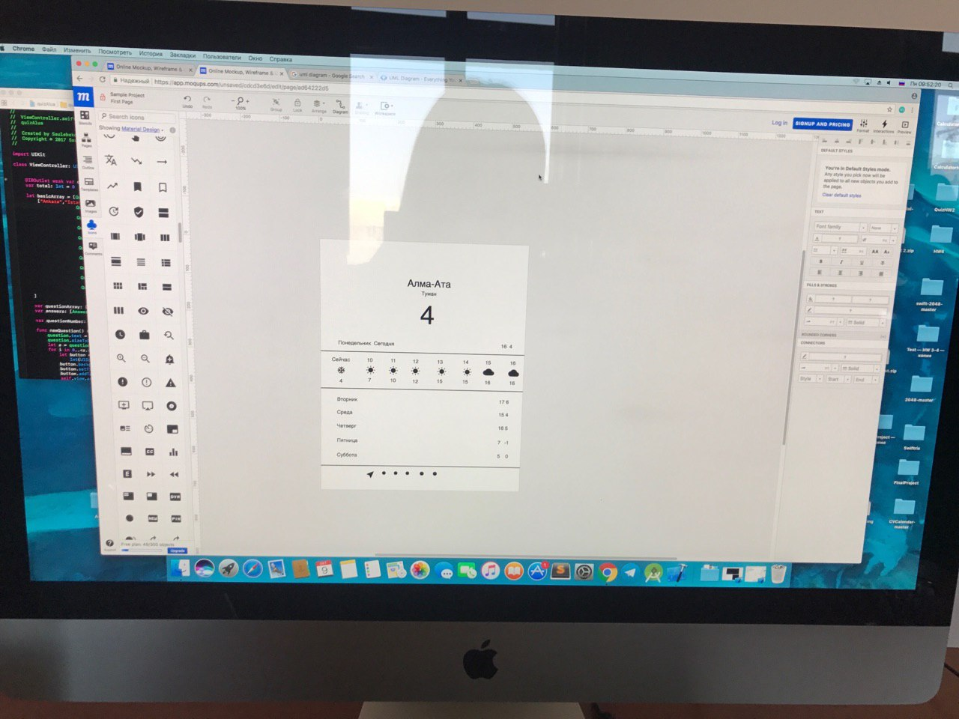

**UML diagram** of your classes and app architecture.

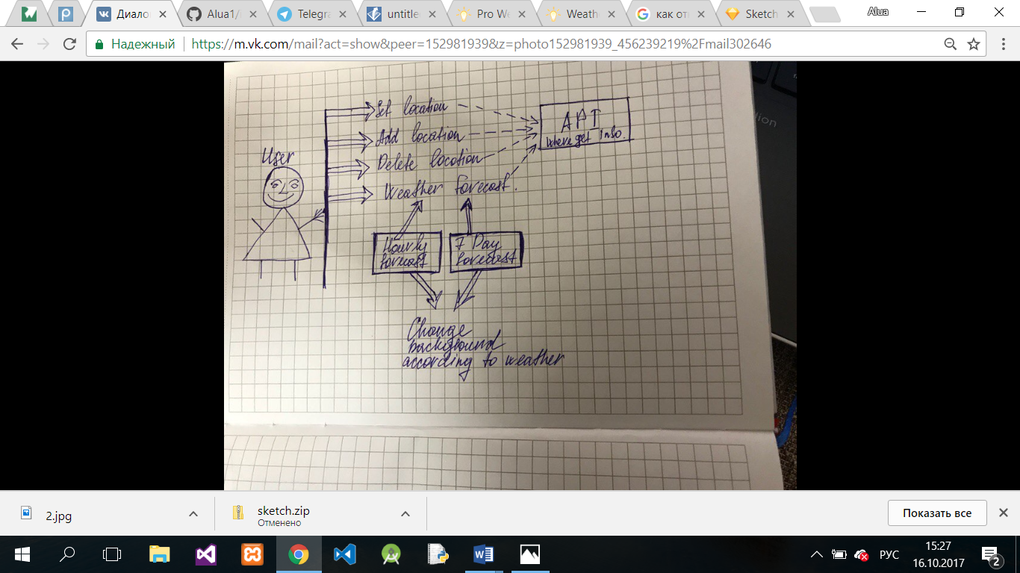

I cannot work with online uml diagram makers, so I painted it by hands and I hope that it would not affect to score.

4. Create **git repository(https://github.com/Alua1/iosProject)** for your project and share it with me - bsammy1 (on github)

5. **Plan of works** for each week (starting from Week 9 - till Week 15)

Week 9: Start a design

Week 10: Put all buttons, and possible places of information that will taken api.

Week 11: Take information from Api

Week 12:Correct all the possible mistakes and but the validate to exact place

Week 13: Add constraints

Week 14: Add animation

Week 15:Finish project(fix all bugs)