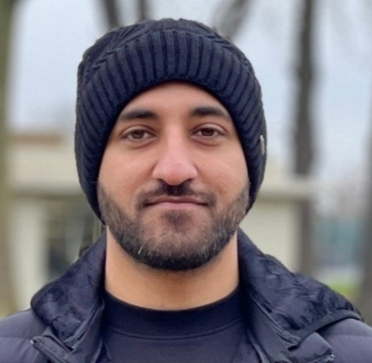          Contact  (+33) 751-479-304  abdullahmasood163@gmail.com  Paris, France  LinkedIn, GitHub, Portfolio  Skills  TypeScript | JavaScript | Python | SQL | HTML/CSS | React | Next.js | shadcn | Tailwind | Material UI | Chart.js | Node.js | FastAPI | NestJS | REST APIs | Kubernetes | Docker | Helm | GitHub Actions | CI/CD | AWS | GCP | PostgreSQL | MySQL | MongoDB | Redis | Elasticsearch | vector DBs | Retrieval-Augmented Generation (RAG) | LLM Integration | Hugging Face | microservices | Spark | Hadoop  Certifications  MERN Stack Front To Back: Full Stack React, Redux & Node.js  (By Udemy)  Wordpress for Beginners - Master Wordpress Quickly  (By Udemy) |  | Abdullah Bin Masood
 |  | Education

MSc Data Management and Artificial Intelligence (current)

École Centrale d'Électronique (ECE) [2025 – 2026]
Relevant Courses:
- Machine learning
- Deep learning
- Data Analytics with Spark
- Big Data Ecosystems

BSc in Computer Science

National University of Computing and Emerging Sciences (NUCES) [2016 – 2021]
Relevant Courses:
- Design and analysis of Algorithms
- Software Engineering
- Artificial Intelligence
- Cloud Computing
 |  | Experience

Codistan Ventures (Full time)

Fullstack Developer [Sep 2023 – Dec 2024]
- Engineered end-to-end product modules that increased API reliability and improved UX for 10K+ users.
- Optimized Node.js/FastAPI services and database queries, enhancing system performance by 30–40%.
- Integrated LLM-based RAG pipelines with Qdrant/Elasticsearch to enable low-latency semantic retrieval.

LearnOBots (Full time)

Software Engineer [Oct 2022 – Mar 2023]
- Delivered backend and frontend features that improved analytics workflows by 35%.
- Strengthened system stability through SQL optimizations, module refactoring, and CI/CD enhancements.

NCAI – National Centre for AI (Full time)

Research Assistant [Aug 2021 – Oct 2022]
- Developed ML-oriented backend pipelines supporting multi-team research operations.
- Created dashboards and APIs that improved experiment tracking and data accessibility for researchers.

Veeve (Internship)

Frontend Intern [Aug 2021 – Oct 2022]
- Implemented UI components and workflow tooling supporting data processing and ML-pipeline interactions.

Projects

Askari Chatbot (AI Agent – RAG + LLM Integration)
- Developed a FastAPI RAG pipeline with embeddings + vector search, enabling internal knowledge retrieval.
- Implemented guardrails and context filtering that reduced hallucination rates by ~40%, improving trust and safety.

Credit Butterfly (LLM-Powered Financial Insights Platform – Live
- Designed a Next.js dashboard for real-time financial risk insights, improving user decision speed by 35%.
- Implemented optimized API flows and analytics instrumentation, increasing system responsiveness by 30%.

Academic Research Platform (Search & Discovery Engine – Live)
- Engineered high-performance modules that cut search latency by 45% across large academic datasets.
- Enhanced retrieval and ranking accuracy, improving researcher productivity and content discovery efficiency.

LearnOSTeam (STEM E-Learning Platform – Live)
- Built an NLP-powered Django engine that automated curriculum tagging with 85%+ classification accuracy.
- Developed intuitive dashboards and role-based interfaces, increasing teacher workflow efficiency by 30–40%.

Judiciary Automation (Semantic Legal Search System)
- Implemented a FastAPI embedding pipeline enabling semantic legal search with high-precision case retrieval.
- Automated similarity scoring workflows, reducing manual legal document review time by 50%.

Bill Parser (Online tool for managing thousands of utility bills)

Developed a FastAPI ingestion pipeline to parse thousands of utility bills using OCR + structured extraction.

Implemented embedding-based semantic search and similarity detection, increasing retrieval accuracy by 60%+.

Designed scalable indexing workflows with PostgreSQL + vector DBs, enabling low-latency bill queries.

Volunteer Work

AI instructor (NUST – Gilgit)
Had the privilege of teaching Python programming and foundational Machine Learning concepts to university students in Gilgit as part of a government-backed initiative aimed at boosting AI literacy and skills in the region. Engaged with learners from diverse academic backgrounds, promoting inclusive and practical AI education.

Event Coordinator (NESCON – Islamabad)
Managed and curated the Bug Catcher competition at NESCON, enhancing participant experience through effective planning, coordination, and on-site supervision.

