**STEPS FOR DEPLOYMENT AND CONFIGURATIONS**

1. Update Ubuntu.
2. Install Docker
3. Install Docker compose
4. Create a project folder
5. Create a Dockerfile inside the project folder with following instructions:

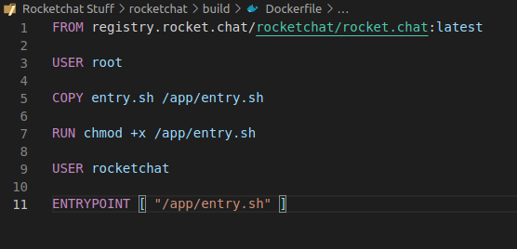

Note: I created a custom image based on the latest version of available for rocketchat

1. I created different folders to simplify the code and implement good programming practices.

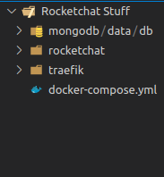

1. Create an entry.sh file with the bash instructions I want Docker to perform.

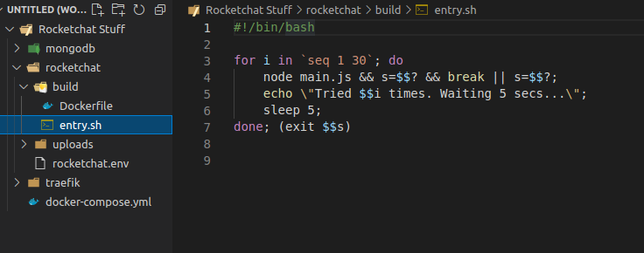

1. Run command < docker build rocketchat:2.0 .> inside project folder
2. Configure traefik
3. Edit the docker-compose.yml file so It can be easier to understand and work with it

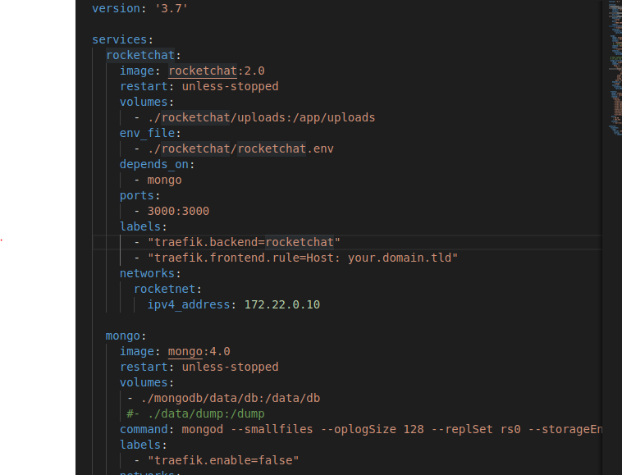

* 1. Added the modded image
  2. Moved the bash commands to a separate whiting the project
  3. Moved the environments variables to a separate folder
  4. Use the < docker-compose up > command