Exersice 1

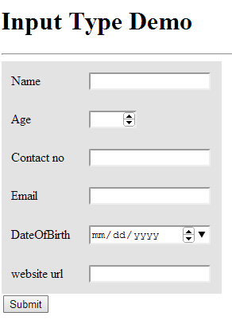

Using Html5 form tags do the following

Name, contact and email fields are manadatory

Email and date validation

Age must be 20 and 45

Contact must be 10 digits

Exercise 2

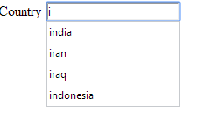

Design the suggestion box/auto completer