Exersice 1

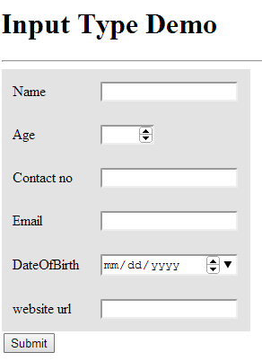

Using Html5 form tags do the following

1. Name, contact and enail fields are manadatory
2. Validate all the fields using pattern attribute using regex patterns

Exersice 2

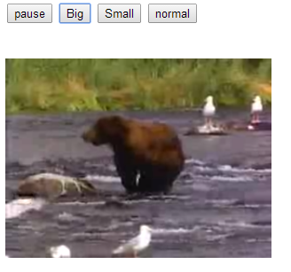

Write a java script to play and pause video, make video display size big, small and normal