# Place gift card order page:

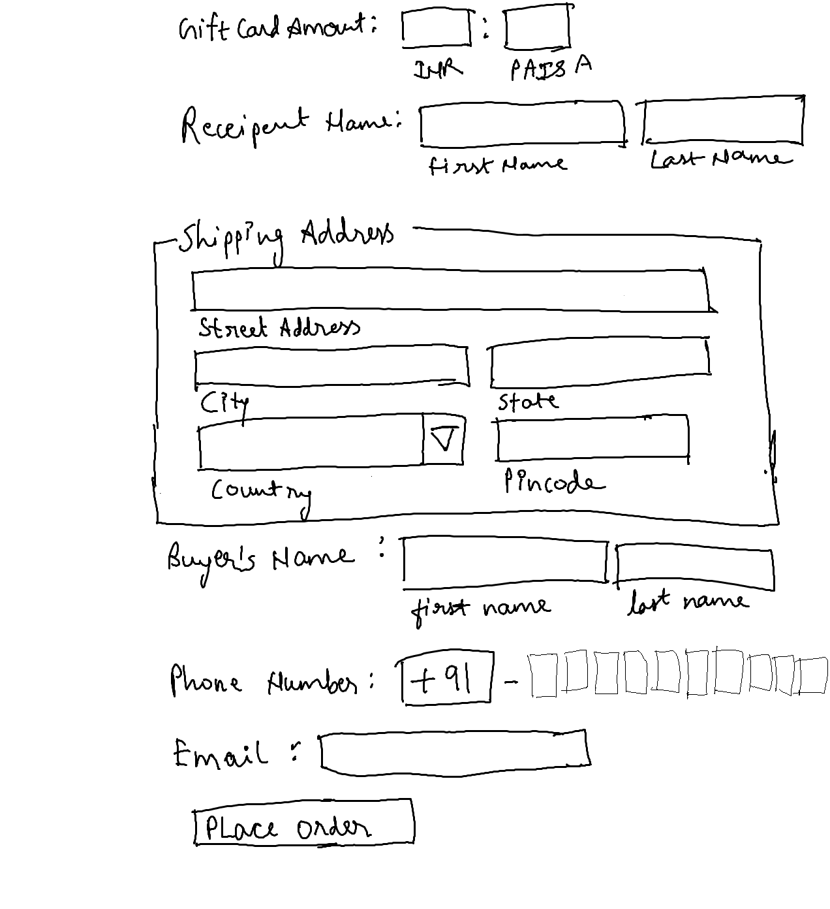

## Guidelines:

1. On the page load, input focus must come to gift card amount input field.
2. You should be able to press “TAB” key and “SHIFT + TAB” to navigate from top field to bottom field and vide-versa.
3. Gift card amount must allow numbers only
4. Minimum value for paise must be 0.
5. Maximum value for paise must be 100.
6. Firstname and Lastname must not allow numbers.
7. Use fieldset for shipping address.
8. In shipping address, input field labels must be below input fields as shown in image.
9. Pincode must allow only number. The length of number must be 6. Length less than 6 or more than 6 is not allowed.
10. Buyers name must not allow numbers.
11. Mobile no should allow 10 digits and 1st digit start with 7689
12. Use email validation for email field.