[**https://stackoverflow.com/questions/7549561/section-vs-article-html5/7549645**](https://stackoverflow.com/questions/7549561/section-vs-article-html5/7549645)

**<section>**: Used to either group different articles into different purposes or subjects, or to define the different sections of a single article.

And then displays [an image](https://i.stack.imgur.com/BTOXa.jpg) that I cleaned up:

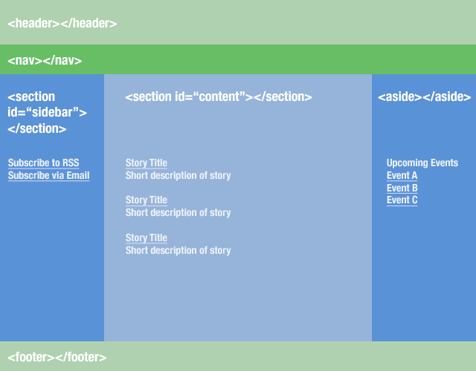

It also describes how to use the <article> tag (from same W3 link above):

<article> is related to <section>, but is distinctly different. Whereas <section> is for grouping distinct sections of content or functionality, <article> is for containing related individual standalone pieces of content, such as individual blog posts, videos, images or news items. Think of it this way - if you have a number of items of content, each of which would be suitable for reading on their own, and would make sense to syndicate as separate items in an RSS feed, then <article> is suitable for marking them up.

In our example, <section id="main"> contains blog entries. Each blog entry would be suitable for syndicating as an item in an RSS feed, and would make sense when read on its own, out of context, therefore <article> is perfect for them:

<section id="main">

<article>

<!-- first blog post -->

</article>

<article>

<!-- second blog post -->

</article>

<article>

<!-- third blog post -->

</article>

</section>

Simple huh? Be aware though that you can also nest sections inside articles, where it makes sense to do so. For example, if each one of these blog posts has a consistent structure of distinct sections, then you could put sections inside your articles as well. It could look something like this:

<article>

<section id="introduction">

</section>

<section id="content">

</section>

<section id="summary">

</section>

</article>

<article>

<h1>People</h1>

<p>text about people</p>

<section>

<h1>fat people</h1>

<p>text about fat people</p>

</section>

<section>

<h1>skinny people</p>

<p>text about skinny people</p>

</section>

</article>

<article>

<h1>Cars</h1>

<p>text about cars</p>

<section>

<h1>Fast Cars</h1>

<p>text about fast cars</p>

</section>

</article>

<section> means that the content inside is grouped (i.e. relates to a single theme), and should appear as an entry in an outline of the page.

<div>, on the other hand, does not convey any meaning, aside from any found in its class, langand title attributes.

So no: using a <div> does not define a section in HTML.

From the spec:

### <section>

The <section> element represents a generic section of a document or application. A section, in this context, is a thematic grouping of content. Each section should be identified, typically by including a heading (h1-h6 element) as a child of the <section> element.

Examples of sections would be chapters, the various tabbed pages in a tabbed dialog box, or the numbered sections of a thesis. A Web site’s home page could be split into sections for an introduction, news items, and contact information.

...

**The <section> element is not a generic container element. When an element is needed only for styling purposes or as a convenience for scripting, authors are encouraged to use the <div> element instead. A general rule is that the <section> element is appropriate only if the element’s contents would be listed explicitly in the document’s outline.**

(<https://www.w3.org/TR/html/sections.html#the-section-element>)

### <div>

The <div> element has no special meaning at all. It represents its children. It can be used with the class, lang, and title attributes to mark up semantics common to a group of consecutive elements.

**Note:** Authors are strongly encouraged to view the <div> element as an element of last resort, for when no other element is suitable. Use of more appropriate elements instead of the <div>element leads to better accessibility for readers and easier maintainability for authors.