**CMP3006**

**Embedded System Programming**

Spring 2020 Term Project

Digital Alarm Clock With Arduino

Project’s circuit design is implemented in this way.Components are 1 Arduino Uno R3,1 250kΩ Potentiometer,1 220kΩ Resistor,1 Piezo (Buzzer),4 buttons,4 10kΩ Resistors,1 LCD 16x2,1 Heat Sensor(TMP36).Used pins are 7-8-9-10 for the buttons,~6 for the buzzer,A0 for the potentiometer,2-3-4-5-11-12 for the lcd and 5V&ground.

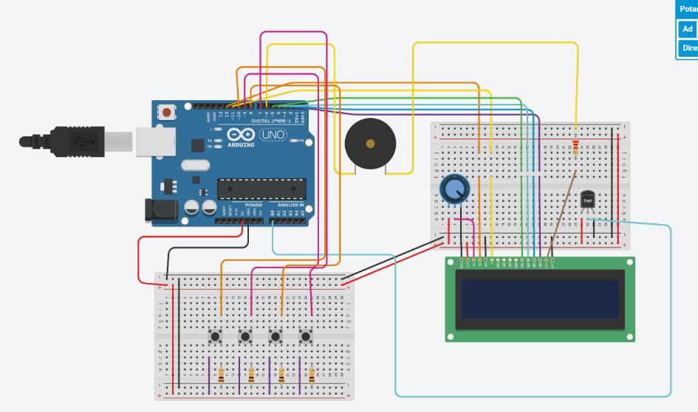

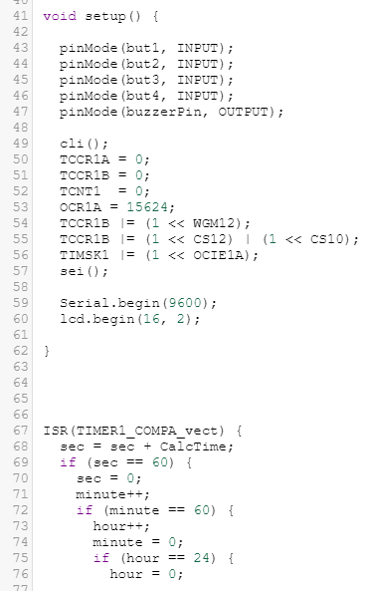I used Timer1 implementation in setup function.In here I used cli() function that Works for stop all the timers then I used another function it’s main purpose continued the all timers whose name is sei().Then,pins are setup and lcd started in setup function.

ISR(Timer1_COMPA_vect) is a special function.Arduino calls this function in every second.That’s why,contents of ISR function must be quick.

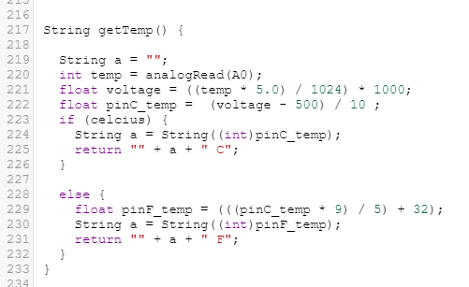I created getTemp() function to convertion of Celsius to Fahrenheit,for the calculation used data sheet equations.This function called in lcdShow() function.Because,when temperature convertion becomes,then lcd shows new format,that’s why lcd needs update the old format to new format.

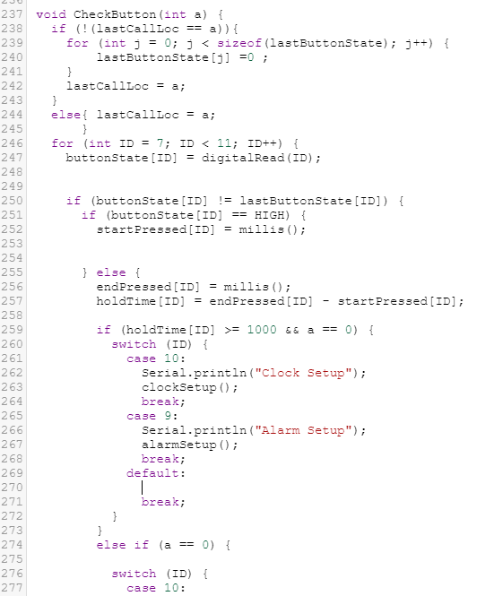

I created CheckButton function that works like , checks relation between the last called state and current state.7-8-9-10th buttons are readed using with for loop.The,if current state and last called state is different,current button set High and it starts to keeping time immediately.milis() function gives the passing time when code was started.That’s why delay cannot be used.After the code,I solved the functionality of buttons using with switch-case statements.

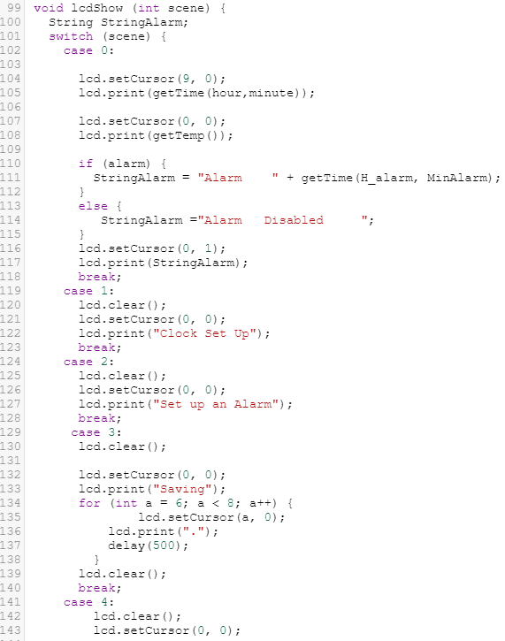Display attribute of lcd is created with lcdShow() function.Output Interface of clock application is codded in here.