**Basic ChiProfiler user guide By Sean F. Gallen , email: sean.gallen[at]erdw.ethz.ch**

**Introduction:**

ChiProfiler is a series of Matlab functions that utilize TopoToolbox version 2 (Schwanghart and Scherler, 2014) to conduct river profile analysis using the chi or integral method (Perron and Royden, 2013). The functions were written by Sean F. Gallen and briefly described applied in Gallen and Wegmann (2017). Please cite Gallen and Wegmann (in press) if you use these codes for scientific research. All users need to do is download TopoToolbox (<https://topotoolbox.wordpress.com/>) and it is easy to run ChiProfiler in Matlab.

If one if familiar with TopoToolbox, using ChiProfiler is easy. It only requires two inputs: a DEM as a GRIDobj [DEM]and a STREAMobj [S]. There are a series of optional inputs: (1) the critical drainage area used to initiate channel heads in the fluvial network [crita], (2) a reference m/n or concavity (𝜃ref) [mn], (3) a reference drainage area for the chi integration [Ao] (we suggest always using 1, as this make the slope of a chi versus elevation plot the normalized steepness index), (4) a smoothing window size in meters [smoWin], and (5) there is an flow routing option [flowOption]; however if you already have a STREAMobj the flow routing should already be done and there is no need to use the flowOption. Using “help chi_profiler” in the Matlab command window will give you more information on the inputs and the optional input default values.

An example of the inputs:

chi_profiler(DEM,S,fileTag,'crita',1e6,'mn',0.45,'Ao',1,'smoWin',100);

The ChiProfiler functions will take your through a series of questions in the Matlab command window that will allow users to interactively determine regression bounds for river profile analysis and select knickpoints along river profiles. ChiProfiler can also generate maps of the normalized steepness index and chi for the entire river network.

Note that ChiProfiler assumes that no data values (NaNs) are ≤ -9999.

**For users unfamiliar with Matlab and TopoToolbox:**

For those unfamiliar with TopoToolbox we have coded up script (RUN_ChiProfiler_STREAMobj.m) that will allow users to interactively select streams of interest and run ChiProfiler by just changing of input parameters. To use this script:

1. Put your DEM (as a tif) in the folder with the new chi profiler codes. Alternatively, you can put the chiprofiler folder in your TopoToolbox folder and just copy “Run_ChiProfiler_STREAMobj.m” to the folder with your DEM in it.
2. Open the script “RUN_ChiProfiler_STREAMobj.m” and modify the first few lines of code accordingly and add the file path to your topotoolbox folder.

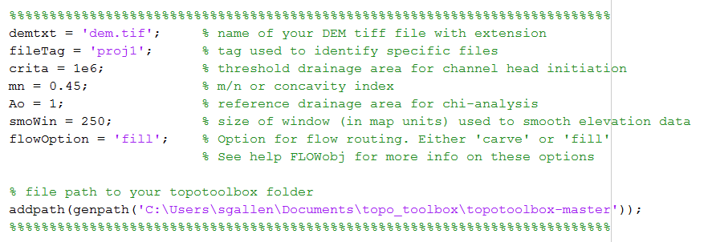

1. When you run the code a window like below will open. Select the rivers you would like to analyze by putting the cursor near the channel head and clicking the left mouse button. You can (and should) select multiple streams.
2. When you are done picking your streams go to Export→export STREAMobj to workspace and pick a variable name (something like S1 or S2) and hit okay.

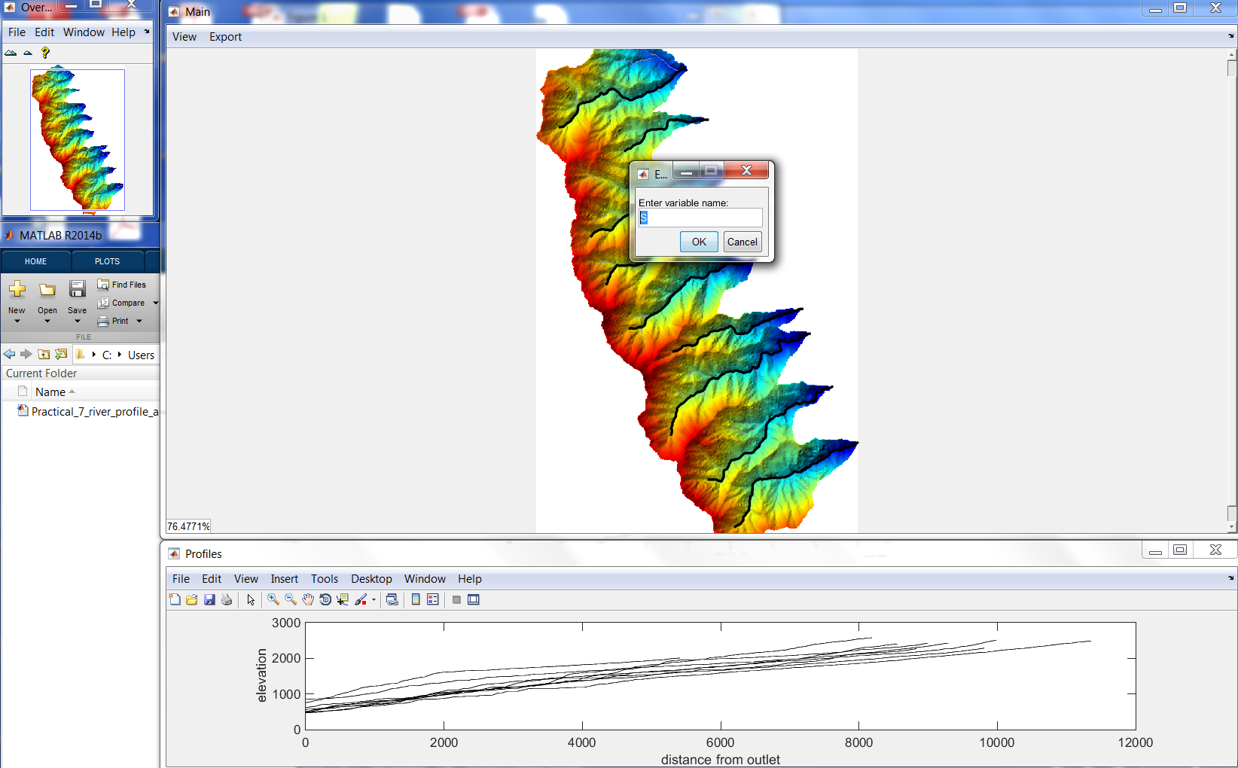

1. Click back on the main Matlab command window and you will be asked to type in the name of the STREAMobj variable you just selected (see below).

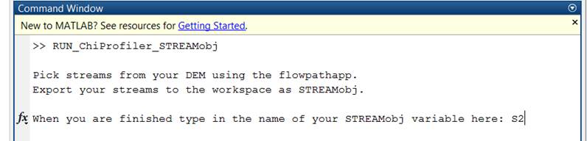

1. Hit enter and the chi profiler codes will run as before (but with some different colors). As before the software will ask questions in the command window that you will answer as you analyze each river profile.

For those that know how to use TopoToolbox just fill or carve your DEM, make a STREAMobj and you can type “help chi_profiler” in the command window to learn more about the inputs into the function.

**ChiProfiler interface:**

When your run the “chi_profiler” function two figures will open that look like this:

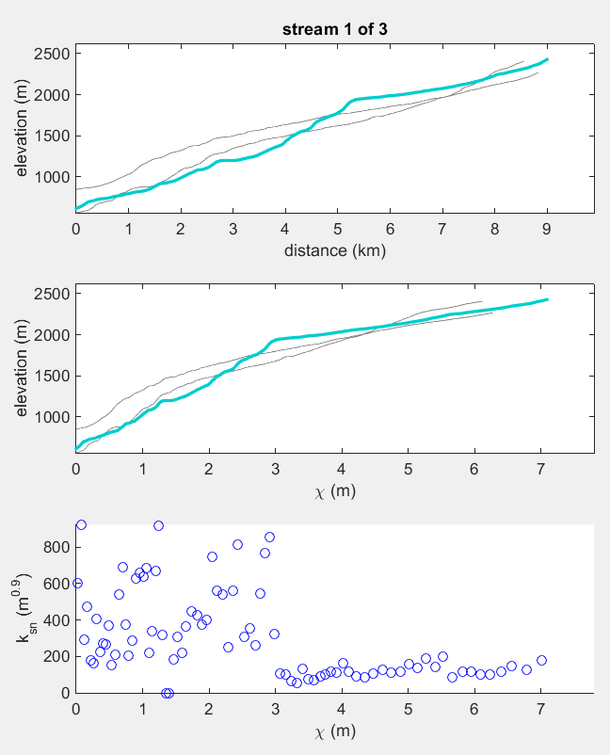 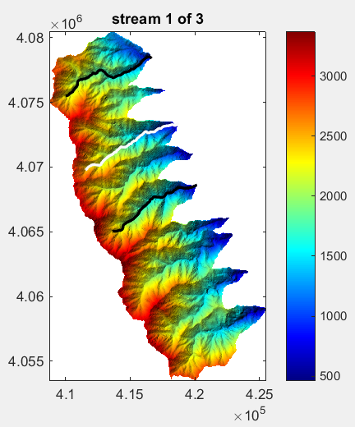

The figure on the left shows the river profiles in the top panel, the chi profiles on the middle panel and ksn calculated in even incements of distance based on the size of the smoothing window. The highlighted profile is the one being analyzed. The figure on the right shows the map view for reference and the river being analyzed is highlighted in white.

In the command window you will follow a series of user prompts.

First you will be asked:

Do you want to make regressions through river channel segments on the chi-elevation plot?

type "y" for yes or "n" for no:

Typing ‘y’ will allow you to make regressions through linear segments on the chi profile (middle plot). You can make multiple regressions. In this example, I make two regressions because I see two different linear segments separated by a knickpoint.

There will be a series of user prompts that will ask you if you want to save the fit and if you want to make another fit. Below is what my command window looks like:

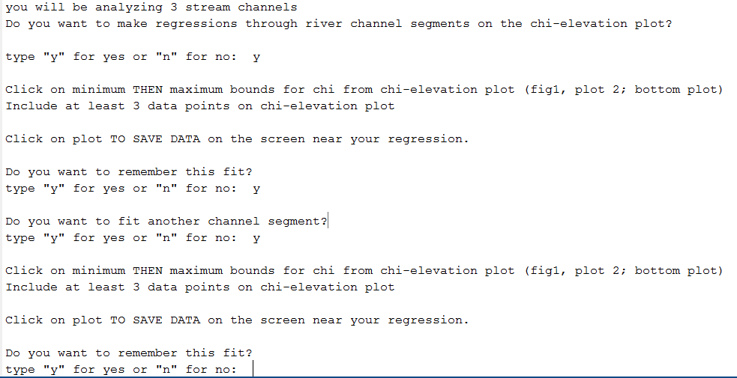

This is what the figures look like after finishing the user selected regression limits:

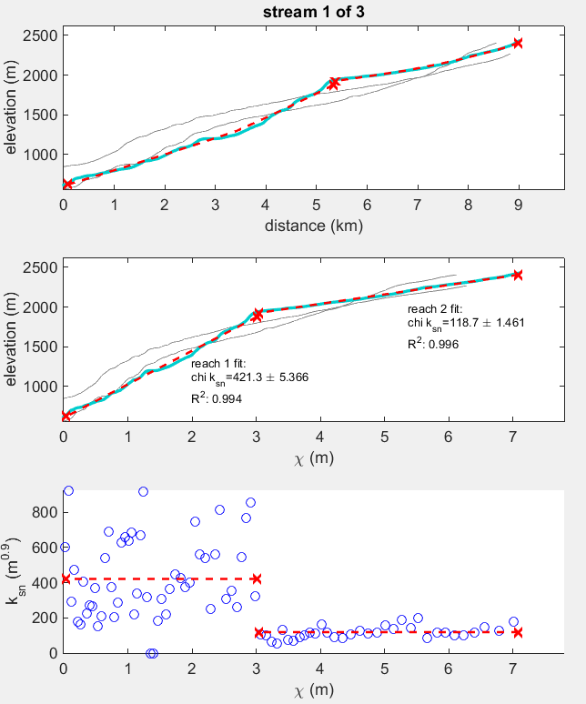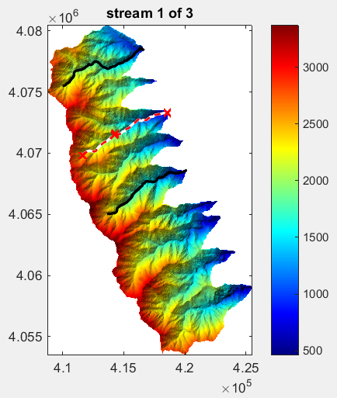

After you are satisfied with your fits on the river channel select no (‘n’) and you will be prompted to select knickpoints on the chi profile (middle plot). There is only one knickpoint on my chit profile that separates my two river channel segments. You will be prompted to classify the knickpoint. This is arbitrary, but it will allow you to keep track of the types of knickpoints you identify.

This is what it looks like after I select my knickpoint.

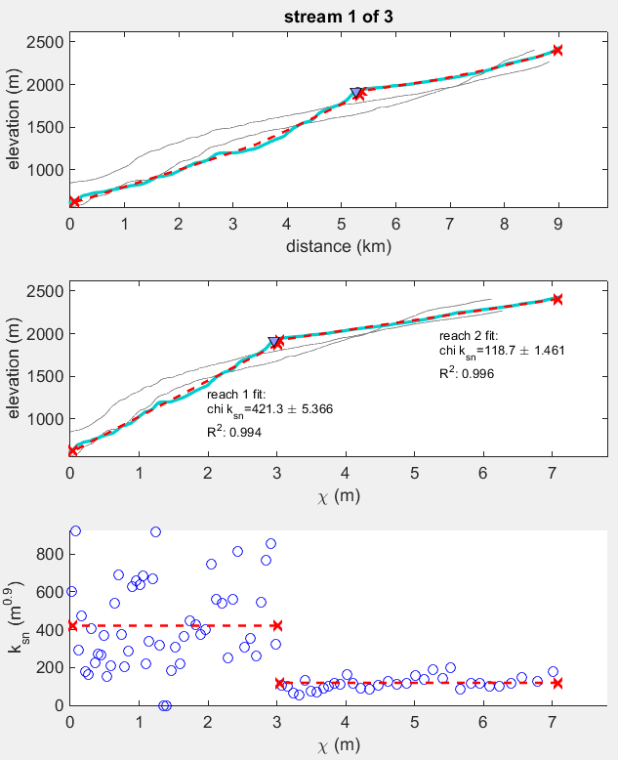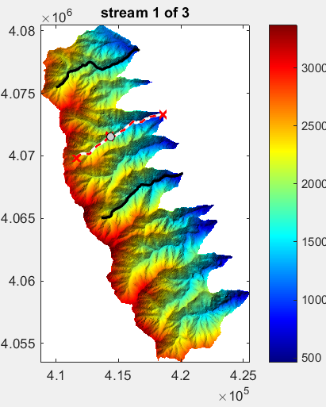

After you select all your knickpoints and save the data for the given river profile, you will be asked if you want to save the figure. Select yes ‘y’ in this case.

You will then follow the same proceedure for each river you selected until you finish.

After you analyze all of your streams you will be asked if you want to make a chi and ksn map for all of the rivers in your DEM above your threshold drainage area.

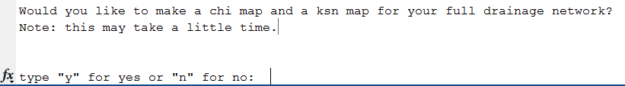

If you have a large DEM it will take some time to make this calculation.

The chi map is calculated as the intregal of the inverse of drainage area with respect to distance from base level. This is determined by the boundaries of the DEM. There are numerous caveats that go along with a chi-map. Most importantly it must be intergated from the same base level elevation. In other words, if you are using this code to make a chi-map you must clip the DEM to the same elevation contour if you are to try and interpret chi-maps in the sense of Willett et al. (2014).

The ksn maps are similar to those described by Wobus et al. (2006) and Kirby and Whipple (2012); however the ksn map produced by ChiProfiler area calculated as the derativative of the chi and elevation data rather than the y-intercept of slope-area data. Because ksn is a relative measure, unlike chi it is valid no matter the bounds of your DEM.

Chi profiler will generate a series of output files that will be saved in a newly created folder that is based on the file tag you used (see Appendix below).

**References:**

Gallen, S.F., Wegmann, K.W.: River profile response to normal fault growth and linkage: An example from the Hellenic forearc of south-central Crete, Greece, Earth Surf. Dynam., 2017, <http://www.earth-surf-dynam.net/5/161/2017/>.

Kirby, E., Whipple, K.X.: Expression of active tectonics in erosional landscapes. J. Struct. Geol., 44, 54-75, 2012. <http://dx.doi.org/10.1016/j.jsg.2012.07.009>

Perron, J.T., Royden, L.: An integral approach to bedrock river profile analysis, Earth Surf. Processes Landforms, 38, 570-576, 2013. <http://dx.doi.org/10.1002/esp.3302>

Schwanghart, W., Kuhn, N.J.: TopoToolbox: A set of Matlab functions for topographic analysis, Enviro. Modell. Software, 25, 770-781, 2010. <http://dx.doi.org/10.1016/j.envsoft.2009.12.002>

Schwanghart, W., Scherler, D.: Short Communication: TopoToolbox 2 – MATLAB-based software for topographic analysis and modeling in Earth surface sciences, Earth Surf. Dynam., 2, 1-7, 2014. <http://dx.doi.org/10.5194/esurf-2-1-2014>

Willett, S.D., McCoy, S.W., Perron, J.T., Goren, L., Chen, C.-Y.: Dynamic Reorganization of River Basins, Science, 343, 2014. <http://dx.doi.org/10.1126/science.1248765>

Wobus, C., Whipple, K.X., Kirby, E., Snyder, N., Johnson, J., Spyropolou, K., Crosby, B., Sheehan, D.: Tectonics from topography: Procedures, promise, and pitfalls, Geological Society of America Special Papers, 398, 55-74, 2006. <http://dx.doi.org/10.1130/2006.2398(04)>

**Appendix - Chi profiler output file organization:**

**Chandata.mat files**

Column:

1: distance from divide (dfd)

2: elevation (elev or z)

3: drainage area (da)

4: distance from mouth (dfm)

5: smoothed channel elevation (selev or sz)

6: row in raster (mrow)

7: column in raster (mcol)

8: linear index in raster (GridID)

9: x coordinate (x_coord)

10: y coordinate (y_coord)

11: chi (chi)

**Knickpoint shapefile attributes table:**

X: x coordinate

Y: y coordinate

strm_num: stream ID number

kp_num: knickpoint number on a given river profiler

kp_type: user identified knickpoint type

chi: chi

elev: knickpoint elevation

smo_el: knickpoint smoothed elevation

d_area: drainage area at knickpoint

dfm: distance from mouth

dfd: distance from divide

GridX: raster column

GridY: raster row.

outletX: x coordinate at river outlet or confluence

outletY: y coordinate at river outlet or confluence

**Knickpoint excel table (**'_kp_data.xlsx'**):**

1: x_coord x coordinate

2: y_coord y coordinate

3: stream_num stream ID

4: kp_num knickpoint number on given river profiler

5: kp_type user defined knickpoint type

6: chi chi

7: elev elevation

8: smo_el smoothed elevation

9: d_area drainage area

10: dfm distance from mouth

11: dfd distance from divide

12: xMatID raster column

13: yMatID raster row

14: outletX: x coordinate at river outlet or confluence

15: outletY: y coordinate at river outlet or confluence

**Knickpoint .mat tables (**.mat file output ‘_kpData.mat’**):**

1: stream_num stream ID

2: kp_num knickpoint number on given river profiler

3: kp_class user defined knickpoint type

4: chi chi

5: elev elevation

6: DA drainage area

7: dfm distance from mouth

8: dfd distance from divide

9: sm_el smoothed elevation

10: x_coord x coordinate

11: y_coord y coordinate

12: xMatID raster column

13: yMatID raster row

14: outletX: x coordinate at river outlet or confluence

15: outletY: y coordinate at river outlet or confluence

**Chi regressions excel table (**'_ksn_regessions.xlsx'**):**

1: stream_ID stream_ID

2: segment_num segment number

3: ksn ksn calculated from chi-elevation regression

4: ksn_95uc 95 percent confidence

5: r_squared r-squared of regression

6: min_chi minimum chi of regression bounds

7: max_chi maximum chi of regression bounds

8: min_elev minimum elevation of regression bounds

9: max_elev maximum elevation of regression bounds

10: outletX: x coordinate at river outlet or confluence

11: outletY: y coordinate at river outlet or confluence

**Chi regressions .mat table (**'_chiFits.mat'**):**

1: stream_ID stream_ID

2: segment_num segment number

3: ksn ksn calculated from chi-elevation regression

4: ksn_95uc 95 percent confidence of ksn

5: chi_slope slope of chi-elevation regression

6: chis _95uc 95 percent confidence of chi slope

7: r_squared r-squared of regression

8: min_chi minimum chi of regression bounds

9: max_chi maximum chi of regression bounds

10: min_elev minimum elevation of regression bounds

11: max_elev maximum elevation of regression bounds

12: outletX: x coordinate at river outlet or confluence

13: outletY: y coordinate at river outlet or confluence

**Ksn regression shapefile:**

“_ksn_regressions.shp”

Point shapefile with the X and Y coordinates of the regressions and the corresponding ksn values.

**Analyzed rivers shapefile:**

“_strmData.shp”

Polyline of the rivers analyzed. Has attributes of the stream ID, chi, and segment averaged ksn

**Optional chi ksn polyline shapefile:**

“_chi_ksn_map.shp”

Map of complete river network for the DEM that has attributes of chi and segment averaged ksn.