**Test cases:**

1. **Verify connection database is failing, and log is written.**

I change any variable from .ini file for making database fail:

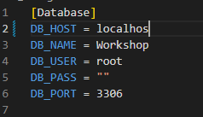



1. **Verify insert database is working, record in table and log is written.**

I insert a new reparation:

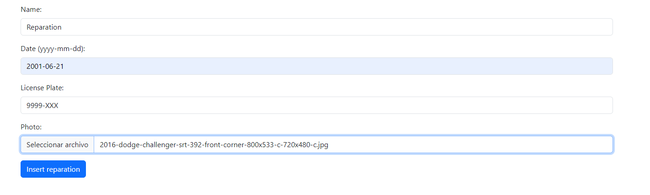

Program shows a success message and inserts into datatable:

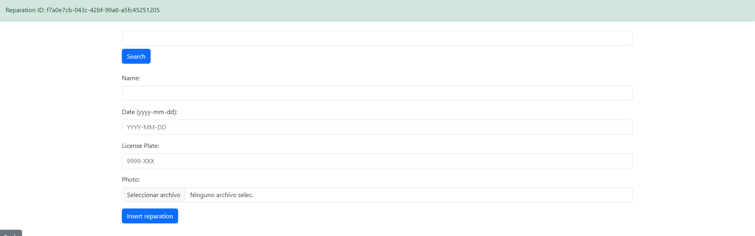





**3. Verify insert database is failing, and log is written.**

**4. Verify select database is working, and log is written.**

I search by UUID:





**5. Verify select database is failing, and log is written.**

I search a reparation which doesn’t exist:



Program shows an error message:

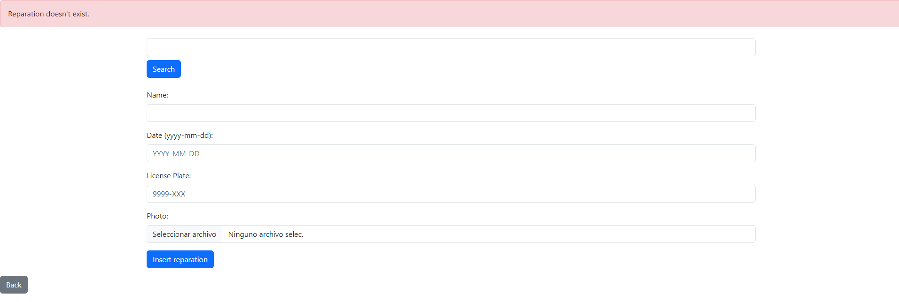



**6. Verify photo is inserted with watermark using license plate + uuid**

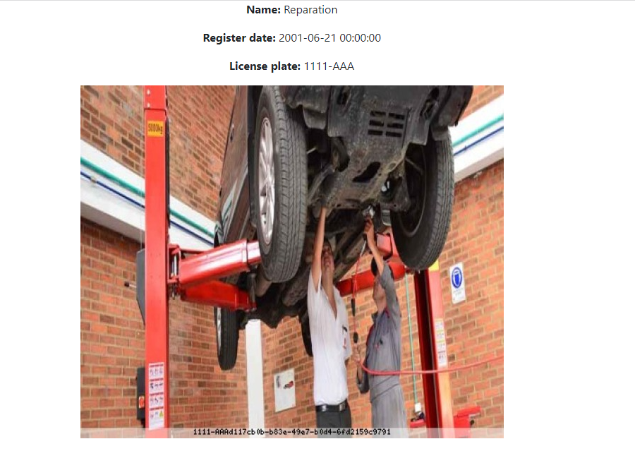

**7. Verify photo is showed with watermark in query for an employee role.**

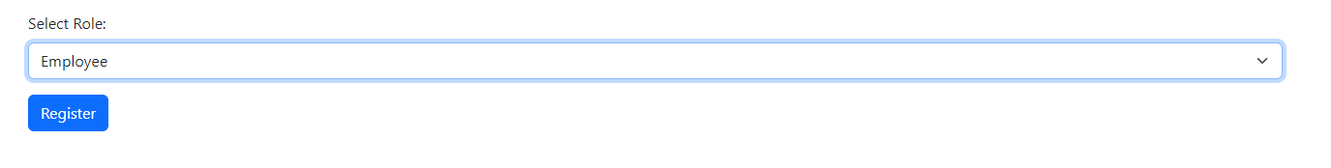



**8. Verify photo is showed masked in query for a client role.**

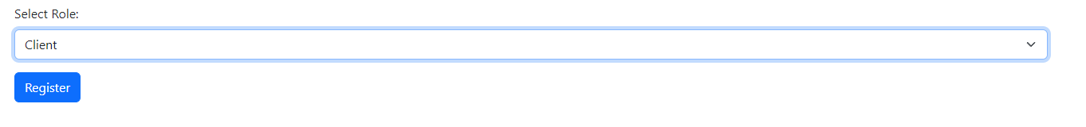

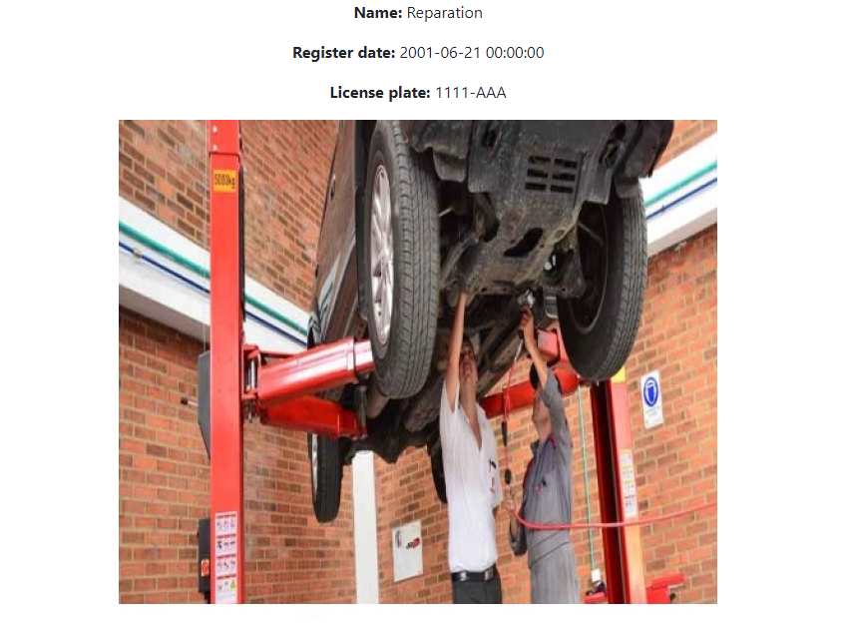

**9. Verify client role cannot access reparation form view.**

Client:



Employee:

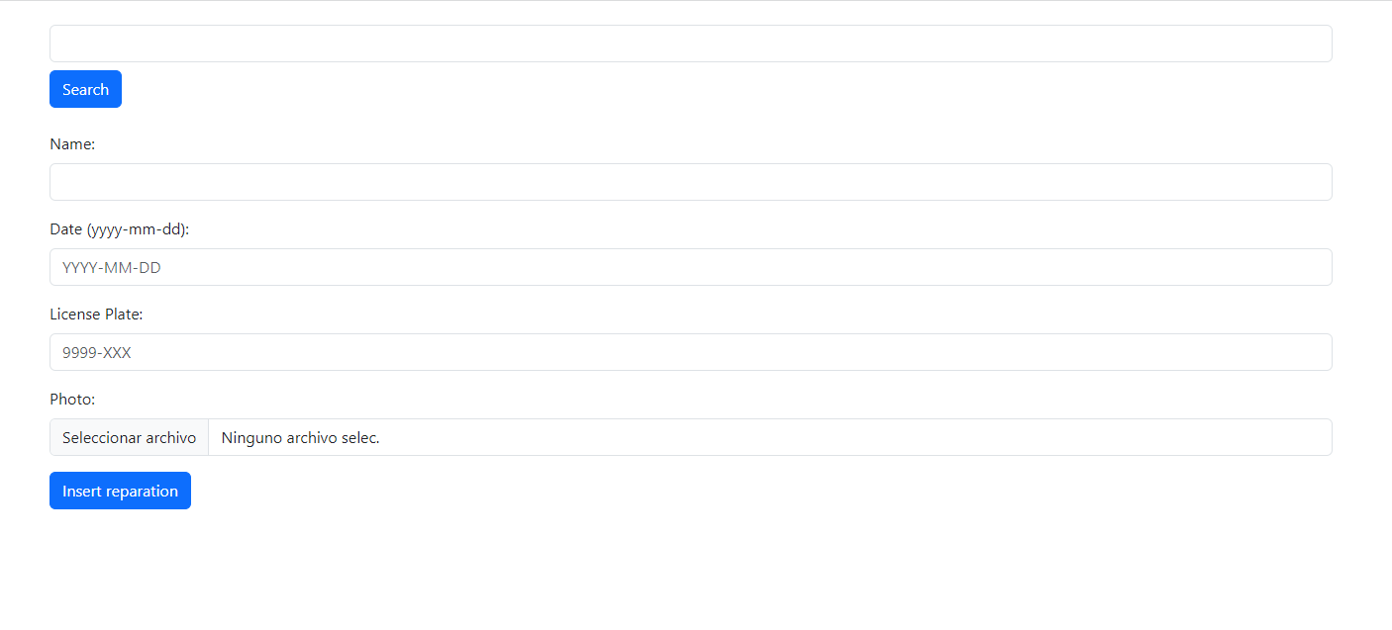

**10. Verify data is stored as defined in format and length.**

If I put any of the fields in an incorrect way, it wont let user insert reparation:

