**Bug Report:**

**1. Bug: ID-1**

**Title:** When set a negative integer on the number input then an error is returned

**Description:**

When is set a negative integer on the number input field and then Calculate button is clicked then a 500 Internal Server Error is returned instead to display a Message that states that factorial of negative numbers are not valid.

**Requirements:**

* Already navigated to https://qainterview.pythonanywhere.com/
* **Browser used:** Chrome - Version 88.0.4324.146 (Official Build) (64-bit)
* **OS:** Windows 10 Home x64 Bits

**Priority:** High

**Severity:** High

**Steps:**

1. Set 3 integer and click on Calculate button.
   1. Site displays message correctly: The factorial of 3 is: 6
2. Open Browser development tools and Go to Network Tab
3. Set -3 integer on the text input field and click the Calculate button.

**Actual Results:**

* Site continues displaying previous factorial calculation: The factorial of 3 is: 6
* A 500 Internal Server Error is returned “The server encountered an internal error and was unable to complete your request. Either the server is overloaded or there is an error in the application.”

**Expected Results:**

* There should be displayed an error message that states that factorial of negative numbers are not valid.

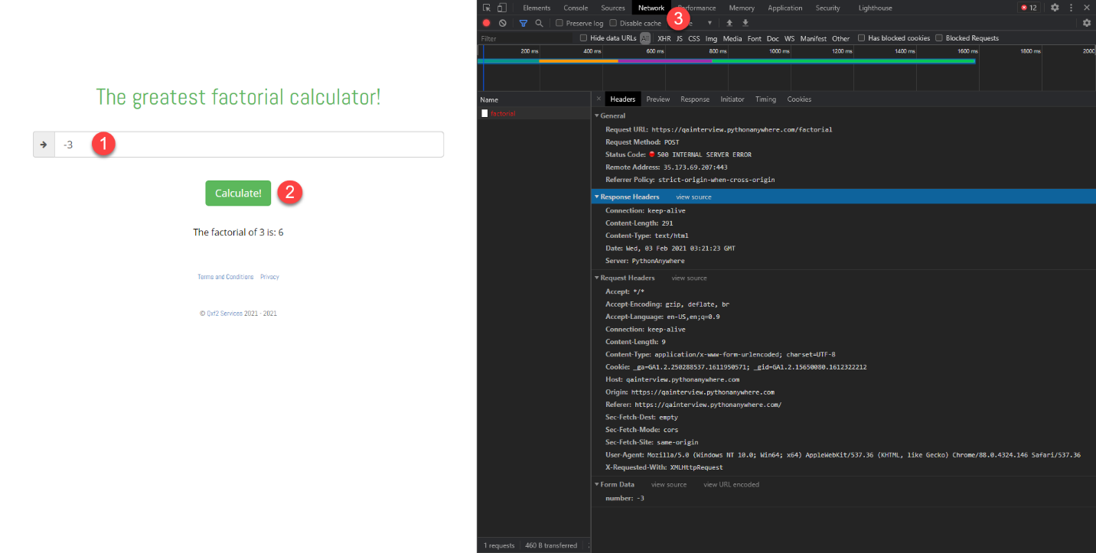

**2. Bug: ID-2**

**Title:** After open links of 'Terms and Conditions' and 'Privacy' is only displayed a text that states: ‘…document. We are not yet ready with it. Stay tuned!’

**Description:**

After open link of 'Terms and Conditions' it is redirected to a page with a message that states ‘This is the privacy document. We are not yet ready with it. Stay tuned!’

And when open link of 'Privacy' it is redirected to a page with a message that states ‘This is the terms and conditions document. We are not yet ready with it. Stay tuned!’

**Isolation Notes:**

* Link ‘Terms and Conditions’ redirects to <https://qainterview.pythonanywhere.com/privacy> instead to redirect to: <https://qainterview.pythonanywhere.com/terms>
* Link ‘Privacy’ redirects to <https://qainterview.pythonanywhere.com/terms> instead to redirect to: <https://qainterview.pythonanywhere.com/privacy>

**Requirements:**

* Already navigated to https://qainterview.pythonanywhere.com/
* **Browser used:** Chrome - Version 88.0.4324.146 (Official Build) (64-bit)
* **OS:** Windows 10 Home x64 Bits

**Priority:** High

**Severity:** Low

**Steps:**

* Click on 'Terms and Conditions' link
  + Verify that 'Terms and Conditions' document is displayed
* Click on 'Privacy' link
  + Verify that 'Privacy' document is displayed

**Actual Results:**

After open link of 'Terms and Conditions' it is redirected to a page with a message that states ‘This is the privacy document. We are not yet ready with it. Stay tuned!’

And when open link of 'Privacy' it is redirected to a page with a message that states ‘This is the terms and conditions document. We are not yet ready with it. Stay tuned!’

**Expected Results:**

* When user clicks on the link 'Terms and Conditions' then the document of 'Terms and Conditions' should be displayed
* When user clicks on the link Privacy' then the document of 'Privacy' should be displayed

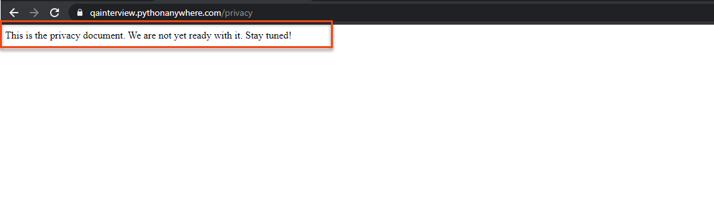

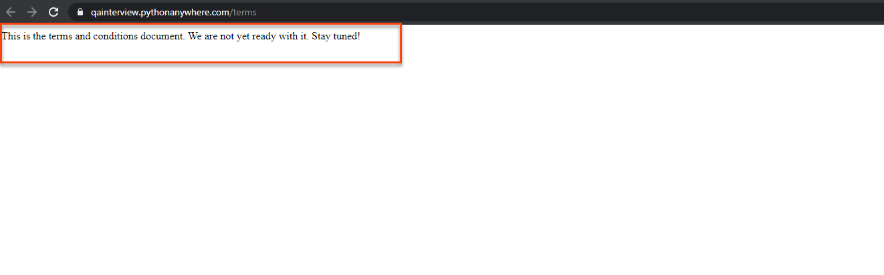

**3. Bug: ID-3**

**Title:** When set an integer bigger or equal to <171> on the number input field then is returned a message that states: The factorial of <171> is: Infinity

**Description:**

When is set an integer bigger or equal to <171> on the number input field then it is displayed a message that states: The factorial of <171> is: Infinity.

**Isolation Notes:**

By review the API response the actual factorial value is returned

**Requirements:**

* Already navigated to https://qainterview.pythonanywhere.com/
* **Browser used:** Chrome - Version 88.0.4324.146 (Official Build) (64-bit)
* **OS:** Windows 10 Home x64 Bits

**Priority:** High

**Severity:** High

**Steps:**

1. Set Bigger or equal to <171> integer and click on Calculate button.

**Actual Results:**

* Site displays message: The factorial of 171 is: Infinity

**Expected Results:**

* The actual factorial number should be displayed

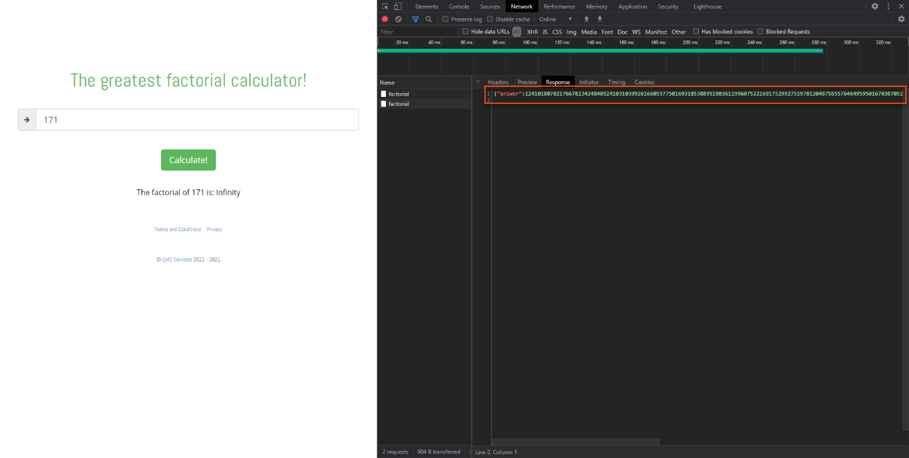

**4. Bug: ID-4**

**Title:** [Cross Browser support] Main Text Title ‘The greatest factorial calculator!’ in IE is displayed using text color black instead of green as on other browsers

**Description:**

The Text Title ‘The greatest factorial calculator!’ in Internet Explorer is displayed as color black instead of green as on other browsers

**Requirements:**

* Already navigated to <https://qainterview.pythonanywhere.com/>

**Browser used:** Internet Explorer Version 2004 (OS Build 19041.746)

**Browser used:** Chrome - Version 88.0.4324.146 (Official Build) (64-bit)

**OS:** Windows 10 Home x64 Bits

**Priority:** Low

**Severity:** Low

**Steps:**

1. Verify that Title text ‘The greatest factorial calculator!’ is green

**Actual Results:**

* The Text Title color is black

**Expected Results:**

* The Text Title color should be green

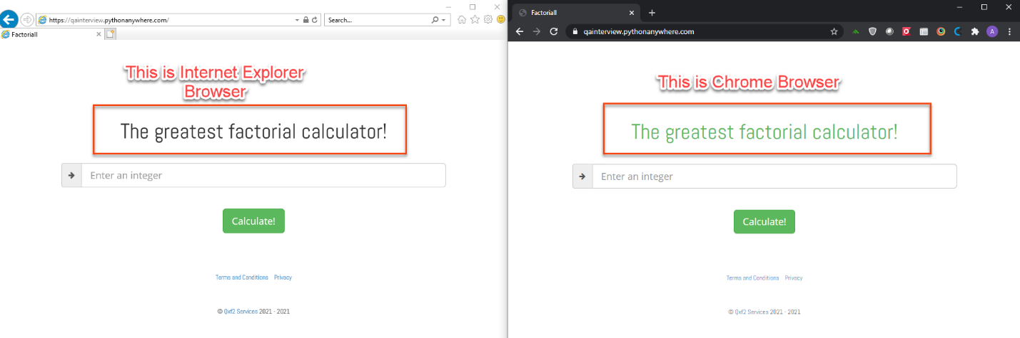

**5. Bug: ID-5**

**Title:** Landing Page Title is ‘Factoriall’ instead of ‘The Greatest Factorial Calculator!’

**Description:**

On the landing Page the Title it is displayed ‘Factoriall’ instead of ‘The Greatest Factorial Calculator!’

**Requirements:**

* Already navigated to <https://qainterview.pythonanywhere.com/>

**Browser used:** Chrome - Version 88.0.4324.146 (Official Build) (64-bit)

**OS:** Windows 10 Home x64 Bits

**Priority:** Low

**Severity:** Low

**Steps:**

1. Verify the Landing page Title text states ‘The Greatest Factorial Calculator!’

**Actual Results:**

* The Landing page title is ‘Factoriall’

**Expected Results:**

* The Landing page title is ‘The Greatest Factorial Calculator!’

