**< Comparison of FETMS Beam Efficiency Calculator versions 1.x and 2.0.x >**

< FEND-40.09.03.00-0437-A-REP >

Status: < Draft >

< 2016-03-03 >

|  |  |  |
| --- | --- | --- |
| **Prepared by:** | **Organization and Role:** | **Date and Signature:** |
| M. McLeod | NRAO | 2016-03-03 |
| **Approved by:** | **Organization and Role:** | **Date and Signature:** |
|  |  |  |
| **Released by:** | **Organization and Role:** | **Date and Signature:** |
|  |  |  |

**Change Record**

|  |  |  |  |  |
| --- | --- | --- | --- | --- |
| **Version** | **Date** | **Affected Section(s)** | **Author** | **Reason/Initiation/Remarks** |
| A1 | 2016-01-12 |  | M. McLeod | Initial draft |
| A2 | 2016-01-14 |  | M. McLeod | Minor edits and typos |
| A3 | 2016-01-26 |  | Jee | Added Executive Summary |
| A4 | 2016-01-26 |  | M. McLeod | Minor edits, comments from Saini and Effland |
| A5 | 2016-03-03 | all | M. McLeod | Comments from Alvaro Gonzalez, reprocessed band 1 data with 2.0.4 |
|  |  |  |  |  |
|  |  |  |  |  |
|  |  |  |  |  |
|  |  |  |  |  |

# Executive Summary

Software to calculate beam efficiency from measured patterns for ALMA front ends was rewritten to improve maintainability and usability, and several new features have been added. This document describes the regression test results that compares the new software to the old software and shows that generally the software duplicates the efficiency percentages to within 4 or 5 decimal places, which his at the limit of the single-precision used for most of the calculations. Comparisons for Band 1, Band 2, and Band 6 are shown.

Minor discrepancies are found in calculating the phase center and consequently phase fit and phase efficiency. The phase center is determined from an optimization routine that maximizes phase efficiency and is sensitive to the initial phase center guess (Section 4.3). Hills warns that the phase center z-distance has large uncertainty [RD3, Section 4] because the large f/D = 8 for ALMA antennas results in little phase change across the aperture for significant changes in z. Also, phase wrapping causes uncertainty and consequently, the optimization routine is sensitive to initial conditions, as described in Section 4.3. Although large discrepancies occur for the Band 1 case (Figure 8), those are likely due to different initial conditions, and differences in Band 2 (Figure 9) and Band 6 (Figure 10) are small.

The amplitude fitting function (Section 4.4) has discrepancies, but this fit to an ideal Gaussian beam is not used in any calculations and is retained in the updated software only for completeness.

**Table of Contents**

1 Executive Summary 2

2 Introduction 5

2.1 Purpose 5

2.2 Software Version History: 5

2.3 Scope 6

2.4 Applicable documents 6

2.5 Reference documents 6

2.6 Acronyms 6

3 Identification of data sets 7

3.1 Band 1 7

3.2 Band 2 7

3.3 Band 6 7

4 Comparison of analysis results 7

4.1 Spill-over and Polarization efficiencies 8

4.1.1 Band 1 9

4.1.2 Band 2 10

4.1.3 Band 6 11

4.2 Amplitude Taper, Edge Taper, and Illumination efficiency 11

4.2.1 Band 1 11

4.2.2 Band 2 12

4.2.3 Band 6 12

4.3 Phase Fit and Phase efficiency 12

4.3.1 Band 1 13

4.3.2 Band 2 14

4.3.3 Band 6 14

4.4 Amplitude Fit 15

4.4.1 Band 1 15

4.4.2 Band 2 16

4.4.3 Band 6 17

4.5 Defocus efficiency and Subreflector Shift 17

4.5.1 Band 1 18

4.5.2 Band 2 19

4.5.3 Band 6 20

4.6 Total Aperture efficiency 20

4.6.1 Band 1 20

4.6.2 Band 2 21

4.6.3 Band 6 21

4.7 Beam Squint and Phase Center Correction 21

4.7.1 Band 2 22

4.7.2 Band 6 22

4.8 Amplitude and Phase plots 22

4.8.1 Data set Band1-SN03-RF35 23

4.8.2 Data set Band2-TDH18144-RF88 26

4.8.3 Data set Band6-TDH14050-RF243 29

4.9 Pointing angle plots 31

4.9.1 Data set Band1-SN03-RF35 32

4.9.2 Data set Band2-TDH18144-RF88 33

4.9.3 Data set Band6-TDH14050-RF243 34

4.10 Dual-Z scan sets 35

# Introduction

## Purpose

This report gives the change history of the FETMS Beam Efficiency Calculator software application, also called “BeamEff” in this document, starting with the versions widely used during the FE construction phase (1.0.6, 1.0.7, 1.0.8) through the newest version, about to be released (2.0.x). Analysis results from these versions plus some intermediate versions are compared to show that the new version is suitable for use at the ALMA OSF and all ALMA partner sites. Some new features are described, along with some minor interface changes, and areas having room for more improvement.

## Software Version History:

**2010-Feb, 1.0.2:** The original Beam Efficiency Calculator was an ANSI C program developed by Todd Hunter, Josh Crabtree, and Geoff Ediss for use as part of the FETMS analysis software suite. It was developed using [Bloodshed Software Dev-C++](http://www.bloodshed.net/devcpp.html) which is a Windows port of the [GNU GCC](https://gcc.gnu.org/) toolchain. It was trivially ported to Linux using standard GCC and [GNU Make](https://www.gnu.org/software/make/) tools. The source code version 1.0.2 was released to ALMA EDM as an attachment to the user manual page at [AD1]. Version 1.0.2 is the only version ever to be distributed as source code on ALMA EDM.

**2011-Jan, 1.0.2ACA:** Developed by Masahiro Sugimoto based on the 1.0.2 source code. [RD2] describes the modifications he made to support calculating vs. the ACA 7 meter antenna optics rather than the ALMA 12 meter antenna. He used it to analyze scans of bands 3, 4, 6, 7, 8, 9, and 10.

**2012-Feb, 1.0.7:** Version deployed to EA-FEIC and used in the NA-FEIC for the majority of Front End construction at those two sites. It was built on Linux at NA-FEIC, and on Windows using [MinGW](http://www.mingw.org/) at the EA-FEIC. At both sites it was run as part of the FETMS Database/Configuration Management web application.

**2012-May, 1.0.8:** Development taken over by Morgan McLeod. First FEIC version to support band 10.

**through 2013-May, 1.0.9 - 1.1.2:** Source code control moved to GitHub; Some minor code cleanup and refactoring changes. <https://github.com/morganmcleod/ALMA-FETMS-www> These versions were only built for Linux and were tested at the NA FEIC and deployed to the ALMA OSF.

**through 2015-Dec, 1.3.6:** Source code moved out of the FETMS web app project to a dedicated GitHub project. <https://github.com/morganmcleod/ALMA-FETMS-beameff> These versions were only built for Linux and were tested at the NA FEIC and deployed to the ALMA OSF. The latest versions:

* Merged in the ACA 7 meter antenna calculation methods.
* Clarified the difference between the TICRA and “alternative” methods for computing Spillover and Polarization Efficiency, as originally documented in [AD2]. Conclusion was that the TICRA Polarization Efficiency on the Subreflector is the figure to be compared with the Front End Polarization Efficiency specification.
* Added an option to specify the scanner probe Z distance from the receiver under test. This is used as part of the starting point for the Phase Fit algorithm.
* Added a pointing option for the ASIAA band 1 test cryostat.

**2016-Jan, 2.0.x:** At this point I tried to share the code developed so far in 1.3.6 with our ASIAA colleagues for use in their band 1 testing campaign. They had previously been using modified 1.0.6 source code and compiling on Windows with [Code::Blocks](http://www.codeblocks.org/), another Windows and cross-platform GCC package. They attempted to compile the 1.3.6 sources and were having problems with the software crashing. I had also seen occasional crashes on Linux and was able to reproduce the crashes on Windows using MinGW/GCC 3.4.5. After some investigation I determined that there was some kind of heap corruption occurring. (It would crash when freeing a FILE handle, for example.) In my experience these kinds of bugs are very difficult to find without specialized memory bounds-checking tools. Since I had considerable misgivings about the quality of the existing codebase I decided at this time to do a clean port of the source code to C++ using MinGW/GCC 3.4.5. This was tested first on Windows as version 2.0.0 and then ported to Linux.

## Scope

This document compares results generated by BeamEff versions 1.0.6 on Windows (as modified by ASIAA) and 1.3.5 and 1.3.6 on Linux with version 2.0.x on Windows.

Sample data sets for Band 1 (ASIAA prototype), Band 2 (NRAO prototype), and Band 6 are compared.

## Applicable documents

The following documents are part of this document to the extent specified herein. If not explicitly stated otherwise, the latest issue of the document is valid.

|  |  |  |
| --- | --- | --- |
| [**Appl.**](http://wikis.alma.cl/bin/view/AIV/Upgrade-Retrofit-CompletionPlanForSubsystem?sortcol=0;table=1;up=0#sorted_table) | [**Document Title**](http://wikis.alma.cl/bin/view/AIV/Upgrade-Retrofit-CompletionPlanForSubsystem?sortcol=1;table=1;up=0#sorted_table) | [**ALMA Doc. Number**](http://wikis.alma.cl/bin/view/AIV/Upgrade-Retrofit-CompletionPlanForSubsystem?sortcol=2;table=1;up=0#sorted_table) |
| [AD1] | FETMS Beam Efficiency Calculator User Manual | [FEND-40.09.00.00-014-B-MAN](http://edm.alma.cl/forums/alma/dispatch.cgi/iptfedocs/docProfile/111317/) |
| [AD2] | “Calculation of Efficiencies, etc, from Beam-Scanning Data”, Richard Hills 2008-06-22 | [NRAO](https://safe.nrao.edu/wiki/pub/ALMA/FEICBeamScanningResults/Calculation_of_Efficiencies.pdf) Public Wiki Page |
|  |  |  |

## Reference documents

The following documents contain additional information and are referenced in this document.

| **Table 1 – Reference Documents** | | |
| --- | --- | --- |
| **Reference** | **Document Title** | **Document ID** |
| [RD1] | Beam Efficiency Calculator LabView GUI User Manual | [FEND-40.09.00.00-015-B-MAN](http://edm.alma.cl/forums/alma/dispatch.cgi/iptfedocs/docProfile/111322/) |
| [RD2] | 20110106Beam_efficiency_calculator_ACA7m  Masahiro Sugimito | no ALMA doc number |
| [RD3] | Analysis of FEIC Efficiency Calculator  Alvaro Gonzalez, 11 Jan 2011 | NAOJ TN9 |
| [RD4] | Antenna beam pattern evaluation of ALMA band 9 subsystem at North American Integration Center  A. Baryshev, 13 June 2008 | [NRAO](https://safe.nrao.edu/wiki/pub/ALMA/FEICBeamScanningResults/FEIC-b9-beam-report-3.pdf) Public Wiki Page |
| [RD5] | Wiki Page, FE Beam Scanning Group | [NRAO Public Wiki Page](https://safe.nrao.edu/wiki/bin/view/ALMA/FEICBeamScanningResults) |

## Acronyms

For a complete set of acronyms and abbreviations, please go to the [ALMA Acronym Finder web page](https://wikis.alma.cl/bin/view/Main/AcronymsFinder).

# Identification of data sets

## Band 1

Data sets provided by the Band 1 group at ASIAA:

* Band1-SN03-RF35 measured 2015-09-23 11:09:47
* Band1-SN03-RF42.5 measured 2015-09-22 08:39:46
* Band1-SN03-RF50 measured 2015-09-23 07:51:28

The Band 1 data sets are dual-Z scan sets which have been preprocessed by NSI2000 V4.6.3 to combine the two Z distance scans into one. Section 4.10 below will investigate using the Beam Efficiency Calculator to combine the dual-Z scans instead of using NSI2000 for that purpose.

## Band 2

Data sets for the prototype Band 2 cartridge measured in the NA FEIC test cryostat:

* Band2-TDH17429-RF90 measured Thu 2015-05-28 14:18:24
* Band2-TDH18144-RF88 measured Wed 2015-12-09 08:57:31, illustrating a dip in phase efficiency
* Band2-TDH18147-RF88 measured Wed 2015-12-09 17:06:20, illustrating a dip in phase efficiency

## Band 6

* Band6-TDH14050-RF243 measured Thu 2012-08-09 17:29:50 in FE-61

# Comparison of analysis results

The following sections each cover a subset of the Beam Efficiency Calculator application results.

## Spill-over and Polarization efficiencies

When using the “actual” pointing option, both the 1.x and 2.0.x versions use the center-of-mass of the far-field amplitude for calculating Spill-over and Polarization, as well as Amplitude Taper, Edge Taper, and Illumination efficiency. The center-of-mass is shown as ff_xcenter and ff_ycenter in the tables in this and the next section. When using the “nominal”, “ACA7meter”, or “band1test” pointing option, the efficiencies are calculated relative to the expected subreflector direction; the center-of-mass values are reported but not used for any calculations.

Figure 1 below is an excerpt from Richard Hills’ 2008 memo “Calculation of Efficiencies, etc, from Beam-Scanning Data” [AD2]. The equations we will refer to in this section are numbered. Alvaro Gonzalez, in recent correspondence points out:

(2) Should be called ‘Eta_spillover_co+xs’ This is different from the Eta_spillover usually used within ALMA. It is called ‘eta_spill_co_cross’ in the results tables below.

(3) Should be called ‘Eta_polarization_sec’. The integral is only on the secondary. It is called ‘eta_pol_on_secondary’ in the results tables below.

(5) Is the polarization efficiency to be used for computing aperture efficiency, whereas (3) is the result to use when comparing to the polarization efficiency specification.

(4) & (5) The product of the two will be the same as the product of (1) & (2) even though the individual numbers can differ considerably.

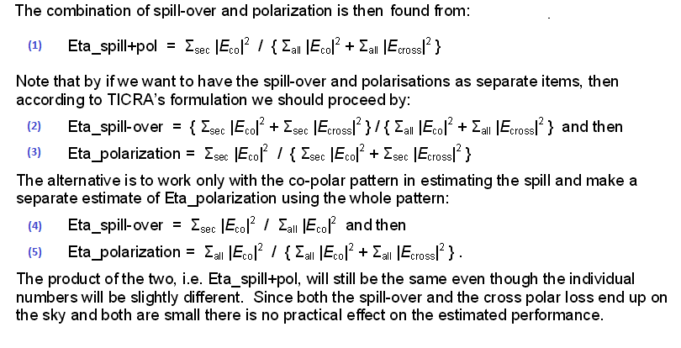

Figure 1: Spill-over and Polarization efficiency equations, excerpt from [AD2]

### Band 1

The three band 1 data sets were processed on Windows using a modified v1.0.6 calculator which uses the band 1 test cryostat nominal pointing angles as the values for “nominal” pointing. For comparison I used 2.0.4 using the pointing option “band1test”. Results are shown in Figure 2. The numbers in parentheses in the first column indicate which equation from Figure 1 is shown on each row.

Figure 2: Band 1 Spill-over and Polarization efficiencies using “band1test” pointing option

|  |  |  |  |  |  |  |
| --- | --- | --- | --- | --- | --- | --- |
| **Data Set** | **Band1-SN03-RF35** | | **Band1-SN03-RF42.5** | | **Band1-SN03-RF50** | |
| **RF sideband** | 2=LSB |  | 2=LSB |  | 2=LSB |  |
| **IFAtten diff (copol-xpol)** | 0 |  | 0 |  | 0 |  |
| **Pointing option** | nominal | band1test | nominal | band1test | nominal | band1test |
| **SW Version** | 1.0.6 modified | 2.0.4 | 1.0.6 modified | 2.0.4 | 1.0.6 modified | 2.0.4 |
| **Platform** | Windows | Windows | Windows | Windows | Windows | Windows |
|  |  |  |  |  |  |  |
| **Pol0** |  |  |  |  |  |  |
| **ff_xcenter** | -0.004813 | -0.004813 | -0.077196 | -0.077196 | 0.008936 | 0.008936 |
| **ff_ycenter** | 2.391570 | 2.391571 | 2.453457 | 2.453458 | 2.429252 | 2.429250 |
| **eta_spillover (4)** | 0.883987 | 0.883987 | 0.911300 | 0.911300 | 0.912889 | 0.912889 |
| **eta_pol (5)** | 0.994403 | 0.994403 | 0.991357 | 0.991357 | 0.986763 | 0.986763 |
| **eta_spill_co_cross (2)** | 0.879281 | 0.879281 | 0.904462 | 0.904462 | 0.902693 | 0.902693 |
| **eta_pol_on_secondary (3)** | 0.999725 | 0.999725 | 0.998852 | 0.998852 | 0.997909 | 0.997909 |
| **eta_pol_spill (1)** | 0.879040 | 0.879040 | 0.903424 | 0.903424 | 0.900805 | 0.900805 |
|  |  |  |  |  |  |  |
| **Pol1** |  |  |  |  |  |  |
| **ff_xcenter** | -0.184377 | -0.184377 | -0.184981 | -0.184981 | -0.000280 | -0.000280 |
| **ff_ycenter** | 2.342544 | 2.342542 | 2.402930 | 2.402930 | 2.319701 | 2.319702 |
| **eta_spillover (4)** | 0.876281 | 0.876281 | 0.906065 | 0.906065 | 0.912953 | 0.912953 |
| **eta_pol (5)** | 0.993066 | 0.993066 | 0.994835 | 0.994835 | 0.985524 | 0.985524 |
| **eta_spill_co_cross (2)** | 0.870551 | 0.870551 | 0.901980 | 0.901980 | 0.902486 | 0.902486 |
| **eta_pol_on_secondary (3)** | 0.999602 | 0.999602 | 0.999340 | 0.999340 | 0.996955 | 0.996955 |
| **eta_pol_spill (1)** | 0.870205 | 0.870205 | 0.901385 | 0.901385 | 0.899737 | 0.899737 |

### Band 2

The first band 2 data sets are from early prototype measurements and so do not include pol1 results. The second two are more recent measurements. In these examples, the band 2 efficiencies are calculated using “actual” beam pointing, so the beam center-of-mass pointing is shown as (ff_xcenter, ff_ycenter).

Figure 3: Band 2 Spillover and Polarization efficiencies using “actual” pointing option

|  |  |  |  |  |  |  |
| --- | --- | --- | --- | --- | --- | --- |
| **Data Set** | **Band2-TDH17429-RF90** | | **Band2-TDH18144-RF88** | | **Band2-TDH18147-RF88** | |
| **RF sideband** | 1=USB |  | 1=USB |  | 1=USB |  |
| **IFAtten diff (copol-xpol)** | 10 |  | 10 |  |  |  |
| **Pointing option** | actual | actual | actual | actual | actual | actual |
| **SW Version** | 1.3.6 | 2.0.0 | 1.3.5 | 2.0.0 | 1.3.5 | 2.0.0 |
| **Platform** | Linux | Windows | Linux | Windows | Linux | Windows |
|  |  |  |  |  |  |  |
| **Pol0** |  |  |  |  |  |  |
| **ff_xcenter** | -1.132141 | -1.132141 | -0.673845 | -0.673845 | -0.660653 | -0.660653 |
| **ff_ycenter** | 1.479218 | 1.479218 | 1.741938 | 1.741938 | 1.740237 | 1.740237 |
| **eta_spillover (4)** | 0.915341 | 0.915341 | 0.908063 | 0.908063 | 0.908383 | 0.908383 |
| **eta_pol (5)** | 0.980519 | 0.980519 | 0.983024 | 0.983024 | 0.982959 | 0.982959 |
| **eta_spill_co_cross (2)** | 0.903124 | 0.903124 | 0.897336 | 0.897336 | 0.897650 | 0.897650 |
| **eta_pol_on_secondary (3)** | 0.993783 | 0.993783 | 0.994775 | 0.994775 | 0.994713 | 0.994713 |
| **eta_pol_spill (1)** | 0.897509 | 0.897509 | 0.892648 | 0.892648 | 0.892904 | 0.892904 |
|  |  |  |  |  |  |  |
| **Pol1** |  |  |  |  |  |  |
| **ff_xcenter** |  |  | -0.452249 | -0.452249 | -0.455661 | -0.455661 |
| **ff_ycenter** |  |  | 1.702948 | 1.702948 | 1.706975 | 1.706975 |
| **eta_spillover (4)** |  |  | 0.917462 | 0.917462 | 0.917308 | 0.917308 |
| **eta_pol (5)** |  |  | 0.985306 | 0.985306 | 0.985377 | 0.985377 |
| **eta_spill_co_cross (2)** |  |  | 0.907806 | 0.907806 | 0.907661 | 0.907661 |
| **eta_pol_on_secondary (3)** |  |  | 0.995787 | 0.995787 | 0.995851 | 0.995851 |
| **eta_pol_spill (1)** |  |  | 0.903981 | 0.903981 | 0.903894 | 0.903894 |

### Band 6

The band 6 data set uses the “nominal” pointing option for efficiency calculation.

Figure 4: Band 6 Spillover and Polarization efficiencies using the “nominal” pointing option

|  |  |  |
| --- | --- | --- |
| **Data Set** | **Band6-TDH14050-RF243** | |
| **RF sideband** | 2=LSB |  |
| **IFAtten diff (copol-xpol)** | 10 |  |
| **Pointing option** | nominal | nominal |
| **SW Version** | 1.3.6 | 2.0.0 |
| **Platform** | Linux | Windows |
|  |  |  |
| **Pol0** |  |  |
| **ff_xcenter** | 2.158020 | 2.158020 |
| **ff_ycenter** | -2.023237 | -2.023238 |
| **eta_spillover (4)** | 0.919811 | 0.919811 |
| **eta_pol (5)** | 0.989766 | 0.989766 |
| **eta_spill_co_cross (2)** | 0.918398 | 0.918398 |
| **eta_pol_on_secondary (3)** | 0.991289 | 0.991289 |
| **eta_pol_spill (1)** | 0.910398 | 0.910398 |
|  |  |  |
| **Pol1** |  |  |
| **ff_xcenter** | 2.115269 | 2.115271 |
| **ff_ycenter** | -2.065860 | -2.065861 |
| **eta_spillover (4)** | 0.923252 | 0.923252 |
| **eta_pol (5)** | 0.991839 | 0.991839 |
| **eta_spill_co_cross (2)** | 0.922369 | 0.922369 |
| **eta_pol_on_secondary (3)** | 0.992788 | 0.992788 |
| **eta_pol_spill (1)** | 0.915717 | 0.915717 |

## Amplitude Taper, Edge Taper, and Illumination efficiency

### Band 1

Figure 5: Band 1 Taper, Edge, Illumination efficiency

|  |  |  |  |  |  |  |
| --- | --- | --- | --- | --- | --- | --- |
| **Data Set** | **Band1-SN03-RF35** | | **Band1-SN03-RF42.5** | | **Band1-SN03-RF50** | |
| **SW Version** | 1.0.6 modified | 2.0.4 | 1.0.6 modified | 2.0.4 | 1.0.6 modified | 2.0.4 |
| **Platform** | Windows | Windows | Windows | Windows | Windows | Windows |
|  |  |  |  |  |  |  |
| **Pol0** |  |  |  |  |  |  |
| **eta_taper** | 0.916026 | 0.916026 | 0.905239 | 0.905239 | 0.891435 | 0.891435 |
| **eta_illumination** | 0.809755 | 0.809755 | 0.824944 | 0.824944 | 0.813781 | 0.813781 |
| **edge_db** | -9.133569 | -9.134 | -9.980988 | -9.981 | -10.763277 | -10.763 |
|  |  |  |  |  |  |  |
| **Pol1** |  |  |  |  |  |  |
| **eta_taper** | 0.915318 | 0.915318 | 0.902723 | 0.902723 | 0.892080 | 0.892080 |
| **eta_illumination** | 0.802076 | 0.802076 | 0.817926 | 0.817926 | 0.814428 | 0.814428 |
| **edge_db** | -9.282266 | -9.282 | -10.099223 | -10.099 | -10.630156 | -10.630 |

### Band 2

Figure 6: Band 2 Taper, Edge, Illumination efficiency

|  |  |  |  |  |  |  |
| --- | --- | --- | --- | --- | --- | --- |
| **Data Set** | **Band2-TDH17429-RF90** | | **Band2-TDH18144-RF88** | | **Band2-TDH18147-RF88** | |
| **SW Version** | 1.3.6 | 2.0.0 | 1.3.5 | 2.0.0 | 1.3.5 | 2.0.0 |
| **Platform** | Linux | Windows | Linux | Windows | Linux | Windows |
|  |  |  |  |  |  |  |
| **Pol0** |  |  |  |  |  |  |
| **eta_taper** | 0.895675 | 0.895675 | 0.907164 | 0.907164 | 0.907099 | 0.907099 |
| **eta_illumination** | 0.819848 | 0.819848 | 0.823763 | 0.823763 | 0.823994 | 0.823994 |
| **edge_db** | -10.307546 | -10.308 | -9.900264 | -9.900 | -9.922522 | -9.923 |
|  |  |  |  |  |  |  |
| **Pol1** |  |  |  |  |  |  |
| **eta_taper** |  |  | 0.896612 | 0.896612 | 0.897027 | 0.897027 |
| **eta_illumination** |  |  | 0.822608 | 0.822608 | 0.822851 | 0.822851 |
| **edge_db** |  |  | -10.505737 | -10.506 | -10.408564 | -10.409 |

### Band 6

Figure 7: Band 6 Taper, Edge, Illumination efficiency

|  |  |  |
| --- | --- | --- |
| **Data Set** | **Band6-TDH14050-RF243** | |
| **SW Version** | 1.3.6 | 2.0.0 |
| **Platform** | Linux | Windows |
|  |  |  |
| **Pol0** |  |  |
| **eta_taper** | 0.908229 | 0.908229 |
| **eta_illumination** | 0.835399 | 0.835399 |
| **edge_db** | -9.060763 | -9.061 |
|  |  |  |
| **Pol1** |  |  |
| **eta_taper** | 0.904364 | 0.904364 |
| **eta_illumination** | 0.834956 | 0.834956 |
| **edge_db** | -9.168405 | -9.168 |

## Phase Fit and Phase efficiency

The phase fit finds the location of the phase center with respect to the measurement plane using the far field phase data. The center is expressed as (delta_x, delta_y, delta_z) in mm. The algorithm maximizes the output variable eta_phase, which is the phase efficiency. The algorithm is sensitive to finding a local minimum near the starting guess values. Beginning with version 1.3.3 the program reads the “zdistance” key from its input file and uses that to initialize the phase fit. The band 1 data sets below are not properly initializing the zdistance so there may be room for improvement in those results. Zdistance defaults to the old hard-coded value of 260 mm if not provided. Why 260 mm was chosen, whereas 200 mm was hard-coded in some of the other calculations, is unclear.

The phase fit is also sensitive to the sign of the raw phase data. The application rotates the input scan data for USB scans. In early versions it did this by checking whether the sign of the Az and El beam center-of-mass are as expected and then rotated the scan if not. This was error prone for cases where either Az or El angles are expected to be zero. Since version 1.0.7 the program requires an input key “sb=1” meaning USB, to cause scan rotation. If “sb=2” or some other value, or is not provided then the scan will not be rotated. When the scan is rotated, the sign of Az, El, and Phase are inverted. Not carefully controlling this input may be the cause of negative values for delta_z in some of the results below. The resulting delta_z is used in the defocus efficiency calculation so errors can cascade from this step to that one.

Small differences in phase fit outputs may be caused by differing fencepost conditions between the 1.x and 2.0.x implementations: The 1.x versions were iterating over indices [1...n], ignoring valid data at index [0] and including random invalid data at index [n]. The 2.0.x version properly iterates over C-style arrays in [0...n-1]. Small differences may also be caused by differing implementation details between the compilers and C standard libraries used.

### Band 1

Figure 8: Band 1 Phase fit and Phase efficiency

|  |  |  |  |  |  |  |
| --- | --- | --- | --- | --- | --- | --- |
| **Data Set** | **Band1-SN03-RF35** | | **Band1-SN03-RF42.5** | | **Band1-SN03-RF50** | |
| **RF sideband** | 2=LSB |  | 2=LSB |  | 2=LSB |  |
| **SW Version** | 1.0.6 modified | 2.0.4 | 1.0.6 modified | 2.0.4 | 1.0.6 modified | 2.0.4 |
| **Platform** | Windows | Windows | Windows | Windows | Windows | Windows |
|  |  |  |  |  |  |  |
| **Pol0** |  |  |  |  |  |  |
| **delta_x** | -0.156177 | 0.038202 | 0.448918 | -0.410590 | -0.218366 | -0.242147 |
| **delta_y** | 0.508143 | 0.062144 | -0.065562 | -0.006384 | -0.801928 | -0.790897 |
| **delta_z** | -251.856079 | -252.299026 | -67.211189 | -67.299263 | 76.280540 | 75.947166 |
| **eta_phase** | 0.999621 | 0.999519 | 0.998240 | 0.998242 | 0.996582 | 0.996581 |
|  |  |  |  |  |  |  |
| **Pol1** |  |  |  |  |  |  |
| **delta_x** | 0.663651 | 0.684766 | -0.526495 | -0.427017 | 0.156029 | -0.161215 |
| **delta_y** | 0.043917 | 0.113406 | 0.152122 | 0.219109 | -1.182380 | -1.159157 |
| **delta_z** | -273.724701 | -269.297546 | -44.204220 | -44.923901 | 59.632511 | 60.701668 |
| **eta_phase** | 0.999880 | 0.999886 | 0.997589 | 0.997596 | 0.995319 | 0.995321 |

### Band 2

Figure 9: Band 2 Phase fit and Phase efficiency

|  |  |  |  |  |  |  |
| --- | --- | --- | --- | --- | --- | --- |
| **Data Set** | **Band2-TDH17429-RF90** | | **Band2-TDH18144-RF88** | | **Band2-TDH18147-RF88** | |
| **RF sideband** | 1=USB |  | 1=USB |  | 1=USB |  |
| **SW Version** | 1.3.6 | 2.0.0 | 1.3.5 | 2.0.0 | 1.3.5 | 2.0.0 |
| **Platform** | Linux | Windows | Linux | Windows | Linux | Windows |
|  |  |  |  |  |  |  |
| **Pol0** |  |  |  |  |  |  |
| **delta_x** | 5.253736 | 5.249891 | -4.458621 | -4.449640 | -4.498350 | -4.496921 |
| **delta_y** | -6.849226 | -6.852728 | -0.251290 | -0.266534 | -0.264454 | -0.260256 |
| **delta_z** | 140.739182 | 141.108917 | 129.421463 | 130.046448 | 130.009094 | 129.961639 |
| **eta_phase** | 0.995755 | 0.995756 | 0.991454 | 0.991454 | 0.991546 | 0.991547 |
|  |  |  |  |  |  |  |
| **Pol1** |  |  |  |  |  |  |
| **delta_x** |  |  | -4.927614 | -4.929317 | -4.881707 | -4.896201 |
| **delta_y** |  |  | -1.077089 | -1.095087 | -1.071629 | -1.101976 |
| **delta_z** |  |  | 139.403305 | 139.308365 | 139.490753 | 138.960587 |
| **eta_phase** |  |  | 0.997198 | 0.997199 | 0.997178 | 0.997179 |

### Band 6

Figure 10: Band 6 Phase fit and Phase efficiency

|  |  |  |
| --- | --- | --- |
| **Data Set** | **Band6-TDH14050-RF243** | |
| **RF sideband** | 2=LSB |  |
| **SW Version** | 1.3.6 | 2.0.0 |
| **Platform** | Linux | Windows |
|  |  |  |
| **Pol0** |  |  |
| **delta_x** | -4.302466 | -4.300562 |
| **delta_y** | 1.645738 | 1.649204 |
| **delta_z** | 254.427399 | 254.353271 |
| **eta_phase** | 0.999692 | 0.999692 |
|  |  |  |
| **Pol1** |  |  |
| **delta_x** | -4.472124 | -4.469915 |
| **delta_y** | 1.648429 | 1.649992 |
| **delta_z** | 254.664230 | 254.545670 |
| **eta_phase** | 0.999570 | 0.999570 |

## Amplitude Fit

The far field amplitude is fitted to a theoretical Gaussian beam, but as explained in [RD3, Section 3] it is unclear whether the method here is typical or best for the purpose. The resulting value, ampfit_amp plus five other parameters, express how well the far field matches the Gaussian model. Richard Hill writes in [RD3, Section 3]: “One can also do things like fit a Gaussian and find how wide that is (for comparison with theory)” so these results are included in the output but are not used for any subsequent efficiency calculations. The important edge taper is calculated using a different method.

As with the Phase Fit, small errors may be accounted for by differing fencepost conditions between the 1.x and 2.0.x algorithms. Small differences may also be caused by differing implementation details between the compilers and C standard libraries used.

### Band 1

Figure 11: Band 1 Amplitude Fit

|  |  |  |  |  |  |  |
| --- | --- | --- | --- | --- | --- | --- |
| **Data Set** | **Band1-SN03-RF35** | | **Band1-SN03-RF42.5** | | **Band1-SN03-RF50** | |
| **RF sideband** | 2=LSB |  | 2=LSB |  | 2=LSB |  |
| **SW Version** | 1.0.6 modified | 2.0.4 | 1.0.6 modified | 2.0.4 | 1.0.6 modified | 2.0.4 |
| **Platform** | Windows | Windows | Windows | Windows | Windows | Windows |
|  |  |  |  |  |  |  |
| **Pol0** |  |  |  |  |  |  |
| **ampfit_amp** | 0.904550 | 0.907915 | 0.912948 | 0.911655 | 0.863167 | 0.863936 |
| **ampfit_width_deg** | 2.796225 | 2.786794 | 2.714162 | 2.714826 | 2.668487 | 2.667616 |
| **ampfit_u_off_deg** | -0.024225 | 0.006460 | -0.073749 | 0.000910 | 0.006290 | -0.005249 |
| **ampfit_v_off_deg** | -0.101580 | -0.012251 | -0.028002 | -0.002463 | -0.048167 | -0.003016 |
| **ampfit_d_0_90** | 0.000426 | 0.011082 | -0.007426 | -0.012557 | -0.117894 | -0.116096 |
| **ampfit_d_45_135** | 0.010064 | 0.007677 | -0.000230 | -0.000664 | 0.007268 | 0.007921 |
|  |  |  |  |  |  |  |
| **Pol1** |  |  |  |  |  |  |
| **ampfit_amp** | 0.901536 | 0.907535 | 0.902467 | 0.904276 | 0.890520 | 0.874327 |
| **ampfit_width_deg** | 2.815391 | 2.796830 | 2.723751 | 2.715622 | 2.632942 | 2.668068 |
| **ampfit_u_off_deg** | -0.182562 | -0.002223 | -0.185902 | -0.004943 | -0.019499 | 0.009124 |
| **ampfit_v_off_deg** | -0.146568 | -0.016154 | -0.085281 | -0.009839 | -0.182308 | -0.014746 |
| **ampfit_d_0_90** | -0.013208 | -0.010906 | 0.032804 | 0.035841 | 0.066948 | 0.084092 |
| **ampfit_d_45_135** | 0.012297 | 0.001379 | -0.002577 | -0.004672 | 0.025876 | 0.010926 |

### Band 2

Figure 12: Band 2 Amplitude Fit

|  |  |  |  |  |  |  |
| --- | --- | --- | --- | --- | --- | --- |
| **Data Set** | **Band2-TDH17429-RF90** | | **Band2-TDH18144-RF88** | | **Band2-TDH18147-RF88** | |
| **RF sideband** | 1=USB |  | 1=USB |  | 1=USB |  |
| **SW Version** | 1.3.6 | 2.0.0 | 1.3.5 | 2.0.0 | 1.3.5 | 2.0.0 |
| **Platform** | Linux | Windows | Linux | Windows | Linux | Windows |
|  |  |  |  |  |  |  |
| **Pol0** |  |  |  |  |  |  |
| **ampfit_amp** | 0.917362 | 0.917361 | 0.904073 | 0.904179 | 0.904937 | 0.904902 |
| **ampfit_width_deg** | 2.685581 | 2.685634 | 2.739820 | 2.739568 | 2.739286 | 2.739384 |
| **ampfit_u_off_deg** | 0.008526 | 0.008507 | -0.001978 | -0.002267 | -0.004008 | -0.004195 |
| **ampfit_v_off_deg** | -0.007758 | -0.008045 | -0.000330 | 0.000019 | 0.002575 | 0.002761 |
| **ampfit_d_0_90** | 0.032462 | -0.032112 | -0.004193 | -0.004385 | -0.005897 | -0.005623 |
| **ampfit_d_45_135** | -0.144370 | -0.144393 | -0.058025 | -0.057936 | -0.056946 | -0.056973 |
|  |  |  |  |  |  |  |
| **Pol1** |  |  |  |  |  |  |
| **ampfit_amp** |  |  | 0.912972 | 0.913056 | 0.920222 | 0.920247 |
| **ampfit_width_deg** |  |  | 2.672367 | 2.672015 | 2.671852 | 2.671773 |
| **ampfit_u_off_deg** |  |  | 0.007128 | 0.006710 | 0.006788 | 0.006576 |
| **ampfit_v_off_deg** |  |  | 0.007308 | 0.007678 | 0.006312 | 0.006561 |
| **ampfit_d_0_90** |  |  | -0.032866 | -0.032729 | -0.033130 | -0.033064 |
| **ampfit_d_45_135** |  |  | -0.060931 | -0.061019 | -0.061351 | -0.061483 |

### Band 6

Figure 13: Band 6 Amplitude Fit

|  |  |  |
| --- | --- | --- |
| **Data Set** | **Band6-TDH14050-RF243** | |
| **RF sideband** | 2=LSB |  |
| **SW Version** | 1.3.6 | 2.0.0 |
| **Platform** | Linux | Windows |
|  |  |  |
| **Pol0** |  |  |
| **ampfit_amp** | 0.975581 | 0.973423 |
| **ampfit_width_deg** | 2.888116 | 2.898223 |
| **ampfit_u_off_deg** | 0.507183 | 0.046521 |
| **ampfit_v_off_deg** | -0.372522 | -0.039420 |
| **ampfit_d_0_90** | 0.005092 | 0.006907 |
| **ampfit_d_45_135** | -0.025427 | -0.027616 |
|  |  |  |
| **Pol1** |  |  |
| **ampfit_amp** | 0.971604 | 0.970095 |
| **ampfit_width_deg** | 2.863711 | 2.870235 |
| **ampfit_u_off_deg** | 0.465844 | 0.040181 |
| **ampfit_v_off_deg** | -0.406785 | -0.034250 |
| **ampfit_d_0_90** | 0.000630 | -0.000207 |
| **ampfit_d_45_135** | 0.028266 | 0.021248 |

## Defocus efficiency and Subreflector Shift

These calculations are based on the average of the two polarizations delta_z from the Phase Fit, which is given in the results as nominal_z_offset. The discussion in the Phase Fit section above about sources for error in delta_z therefore also affects these values. The other results are:

* defocus_efficiency is calculated based on the difference between each polarization’s delta_z and the average of the two delta_z, so this result is not sensitive to the magnitude of nominal_z_offset. In the case of data set Band2-TDH17429-RF90 where the pol1 data is not valid, this value is also invalid.
* shift_from_focus_mm is the difference between delta_z and the probe distance. For 1.x the probe distance is a hard-coded 200 mm. For 2.0.x it is the “zdistance” parameter from the input file which defaults to 260 mm if not provided. So at least 60 mm of discrepancy is expected. This calculation does not seem correct in either version of the software.
* subreflector_shift_mm is the subreflector shift needed to achieve the shift_from_focus_mm. This value is therefore also problematic in all versions of the software.
* defocus_efficiency_due_to_moving_the_subreflector has a long name and still might not express what it really means. I think it is the defocus efficiency if the subreflector could not be shifted.

Version 2.0.x of the software expresses defocus_efficiency and defocus_efficiency_due... in [0...1] like the other efficiencies rather than in percent. Presentation software will have to adapt to this change.

### Band 1

Figure 14: Band 1 Defocus efficiency

|  |  |  |  |  |  |  |
| --- | --- | --- | --- | --- | --- | --- |
| **Data Set** | **Band1-SN03-RF35** | | **Band1-SN03-RF42.5** | | **Band1-SN03-RF50** | |
| **RF sideband** | 2=LSB |  | 2=LSB |  | 2=LSB |  |
| **SW Version** | 1.0.6 modified | 2.0.4 | 1.0.6 modified | 2.0.4 | 1.0.6 modified | 2.0.4 |
| **Platform** | Windows | Windows | Windows | Windows | Windows | Windows |
|  |  |  |  |  |  |  |
| **nominal_z_offset** | -262.790405 | -260.798279 | -55.707703 | -56.11158 | 67.956528 | 68.324417 |
|  |  |  |  |  |  |  |
| **Pol0** |  |  |  |  |  |  |
| **defocus_efficiency** | 99.998158 | 0.999989 | 99.997067 | 0.999972 | 99.997824 | 0.999982 |
| **shift_from_focus_mm** | -451.856079 | -512.299011 | -267.211182 | -327.299255 | -123.719460 | -184.052826 |
| **subreflector_shift_mm** | 1.569599 | 1.779558 | 0.928203 | 1.136930 | 0.429761 | 0.639339 |
| **defocus_efficiency_due_to_moving_the_subreflector** | 97.399834 | 0.969610 | 98.801048 | 0.981609 | 99.634369 | 0.991913 |
|  |  |  |  |  |  |  |
| **Pol1** |  |  |  |  |  |  |
| **defocus_efficiency** | 99.998158 | 0.999989 | 99.997067 | 0.999972 | 99.997824 | 0.999982 |
| **shift_from_focus_mm** | -473.724701 | -529.297546 | -244.204224 | -304.923889 | -140.367493 | -199.298340 |
| **subreflector_shift_mm** | 1.645563 | 1.838605 | 0.848285 | 1.059205 | 0.487590 | 0.692297 |
| **defocus_efficiency_due_to_moving_the_subreflector** | 97.399834 | 0.967590 | 98.997726 | 1.059205 | 99.529564 | 0.990524 |

### Band 2

Figure 15: Band 2 Defocus efficiency

|  |  |  |  |  |  |  |
| --- | --- | --- | --- | --- | --- | --- |
| **Data Set** | **Band2-TDH17429-RF90** | | **Band2-TDH18144-RF88** | | **Band2-TDH18147-RF88** | |
| **RF sideband** | 1=USB |  | 1=USB |  | 1=USB |  |
| **SW Version** | 1.3.6 | 2.0.0 | 1.3.5 | 2.0.0 | 1.3.5 | 2.0.0 |
| **Platform** | Linux | Windows | Linux | Windows | Linux | Windows |
|  |  |  |  |  |  |  |
| **nominal_z_offset** | 492.675049 | 493.346313 | 134.412384 | 134.677399 | 134.749924 | 134.461121 |
|  |  |  |  |  |  |  |
| **Pol0** |  |  |  |  |  |  |
| **defocus_efficiency** | 87.391633 | 0.873700 | 99.997574 | 0.999979 | 99.997813 | 0.999980 |
| **shift_from_focus_mm** | -59.260818 | -118.891083 | -70.578537 | -129.953552 | -69.990906 | -130.038361 |
| **subreflector_shift_mm** | 0.205853 | 0.412988 | 0.245167 | 0.451416 | 0.243125 | 0.451710 |
| **defocus_efficiency_due_to_moving_the_subreflector** | 99.727707 | 0.989081 | 99.630898 | 0.987536 | 99.637009 | 0.987520 |
|  |  |  |  |  |  |  |
| **Pol1** |  |  |  |  |  |  |
| **defocus_efficiency** |  |  | 99.997574 | 0.999979 | 99.997813 | 0.999980 |
| **shift_from_focus_mm** |  |  | -60.596695 | -120.691635 | -60.509247 | -121.039413 |
| **subreflector_shift_mm** |  |  | 0.210493 | 0.419243 | 0.210189 | 0.420451 |
| **defocus_efficiency_due_to_moving_the_subreflector** |  |  | 0.997278 | 0.989241 | 99.728584 | 0.989179 |

### Band 6

Figure 16: Band 6 Defocus efficiency

|  |  |  |
| --- | --- | --- |
| **Data Set** | **Band6-TDH14050-RF243** | |
| **RF sideband** | 2=LSB |  |
| **SW Version** | 1.3.6 | 2.0.0 |
| **Platform** | Linux | Windows |
|  |  |  |
| **nominal_z_offset** | 254.545807 | 254.449463 |
|  |  |  |
| **Pol0** |  |  |
| **defocus_efficiency** | 99.999988 | 1 |
| **shift_from_focus_mm** | 54.427399 | -5.646729 |
| **subreflector_shift_mm** | 0.189063 | 0.019615 |
| **defocus_efficiency_due_to_moving_the_subreflector** | 98.336090 | 0.999820 |
|  |  |  |
| **Pol1** |  |  |
| **defocus_efficiency** | 99.999988 | 1 |
| **shift_from_focus_mm** | 54.664230 | 54.545670 |
| **subreflector_shift_mm** | 0.189885 | 0.189474 |
| **defocus_efficiency_due_to_moving_the_subreflector** | 98.321686 | 0.983289 |

## Total Aperture efficiency

The total aperture efficiency is the product:

total_aperture_eff = eta_phase • eta_spillover • eta_taper • eta_pol • defocus_efficiency

### Band 1

Figure 17: Band 1 Total Aperture efficiency

|  |  |  |  |  |  |  |
| --- | --- | --- | --- | --- | --- | --- |
| **Data Set** | **Band1-SN03-RF35** | | **Band1-SN03-RF42.5** | | **Band1-SN03-RF50** | |
| **SW Version** | 1.0.6 modified | 2.0.4 | 1.0.6 modified | 2.0.4 | 1.0.6 modified | 2.0.4 |
| **Platform** | Windows | Windows | Windows | Windows | Windows | Windows |
|  |  |  |  |  |  |  |
| **Pol0** |  |  |  |  |  |  |
| **total_aperture_eff** | 0.804903 | 0.804827 | 0.816351 | 0.816353 | 0.800247 | 0.800250 |
|  |  |  |  |  |  |  |
| **Pol1** |  |  |  |  |  |  |
| **total_aperture_eff** | 0.796404 | 0.796414 | 0.811715 | 0.811722 | 0.798863 | 0.798867 |

### Band 2

Figure 18: Band 2 Total Aperture efficiency

|  |  |  |  |  |  |  |
| --- | --- | --- | --- | --- | --- | --- |
| **Data Set** | **Band2-TDH17429-RF90** | | **Band2-TDH18144-RF88** | | **Band2-TDH18147-RF88** | |
| **SW Version** | 1.3.6 | 2.0.0 | 1.3.5 | 2.0.0 | 1.3.5 | 2.0.0 |
| **Platform** | Linux | Windows | Linux | Windows | Linux | Windows |
|  |  |  |  |  |  |  |
| **Pol0** |  |  |  |  |  |  |
| **total_aperture_eff** | 0.699539 | 0.699366 | 0.802838 | 0.802841 | 0.803087 | 0.803089 |
|  |  |  |  |  |  |  |
| **Pol1** |  |  |  |  |  |  |
| **total_aperture_eff** |  |  | 0.808230 | 0.808233 | 0.808512 | 0.808515 |

### Band 6

Figure 19: Band 6 Total Aperture efficiency

|  |  |  |
| --- | --- | --- |
| **Data Set** | **Band6-TDH14050-RF243** | |
| **SW Version** | 1.3.6 | 2.0.0 |
| **Platform** | Linux | Windows |
|  |  |  |
| **Pol0** |  |  |
| **total_aperture_eff** | 0.826595 | 0.826595 |
|  |  |  |
| **Pol1** |  |  |
| **total_aperture_eff** | 0.827786 | 0.827785 |

## Beam Squint and Phase Center Correction

Beam squint was not fully or correctly calculated by the BeamEff 1.x applications. It was not corrected for rotational asymmetry of the scanner probe. Instead the FETMS Database web application (PHP) software would call the BeamEff application twice: first with the Pol0 and Pol1 scans and a then with only an 180-degree copol scan (from either polarization). The PHP code would then perform the probe asymmetry correction and compute squint.

BeamEff 2.0.x now accepts up to five input scans per ScanSet, one of which may be marked as “type=copol180”. It uses this to perform the probe asymmetry correction and calculate the squint in the first pass. The PHP software no longer must call the application twice.

The results below compare data sets where the two-pass method was used with 1.x and the one-pass method with 2.0.x. The Band 1 and some of the Band 2 data sets do not include a “copol180” scan and so are not included in this section.

The phase center correction is represented by the following results:

* corrected_pol indicates which polarization’s phase center was corrected. If the “copol180” scan is pol0 then pol1 will be corrected, and vice-versa.
* x_corr, y_corr are the amount of phase center correction in mm.
* dist_between_centers_mm is the distance between the phase centers after correction.

### Band 2

Figure 20: Band 2 Beam Squint and Phase Center Correction

|  |  |  |  |  |
| --- | --- | --- | --- | --- |
| **Data Set** | **Band2-TDH18144-RF88** | | **Band2-TDH18147-RF88** | |
| **SW Version** | 1.3.5 | 2.0.0 | 1.3.5 | 2.0.0 |
| **Platform** | Linux | Windows | Linux | Windows |
|  |  |  |  |  |
| **corrected_pol** | 1 | 1 | 1 | 1 |
| **x_corr** | 0.28 | 0.289 | 0.25 | 0.265 |
| **y_corr** | 0.41 | 0.407 | 0.44 | 0.448 |
| **dist_between_centers_mm** | 0.45 | 0.463 | 0.39 | 0.416 |
| **squint_percent** | 1.44 | 1.480 | 1.23 | 1.330 |
| **squint_arcseconds** | 0.97 | 0.994 | 0.83 | 0.894 |

### Band 6

Figure 21: Band 6 Beam Squint and Phase Center Correction

|  |  |  |
| --- | --- | --- |
| **Data Set** | **Band6-TDH14050-RF243** | |
| **SW Version** | 1.3.6 | 2.0.0 |
| **Platform** | Linux | Windows |
|  |  |  |
| **corrected_pol** | 0 | 0 |
| **x_corr** | 0.02 | 0.021 |
| **y_corr** | -0.13 | -0.126 |
| **dist_between_centers_mm** | 0.23 | 0.229 |
| **squint_percent** | 2.03 | 2.010 |
| **squint_arcseconds** | 0.49 | 0.491 |

## Amplitude and Phase plots

Only one data set is shown per band. Only Pol0 plots are shown.

1.x plots are on the left. 2.0.x plots on the right.

The 2.0.x plots were made using Gnuplot 4.2.6 on Windows. A newer version might be a bit better behaved about centering. Clearly some improvement is still needed in spacing the axis markers.

### Data set Band1-SN03-RF35

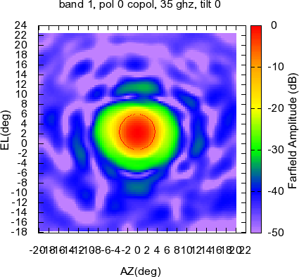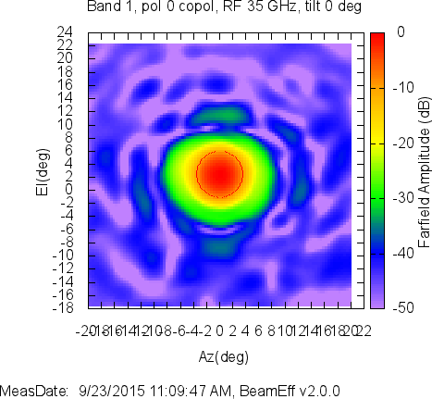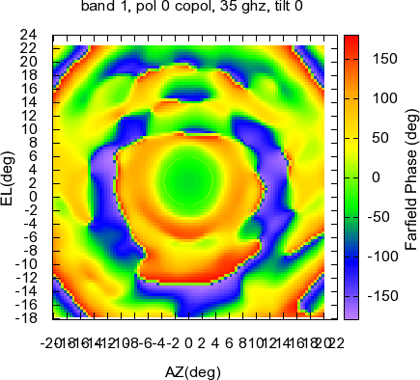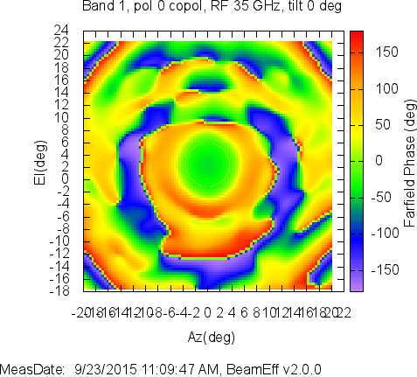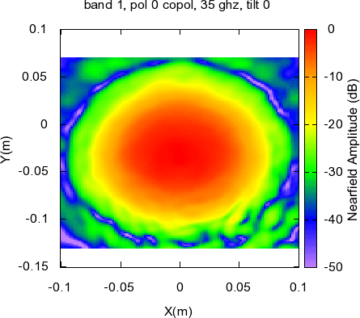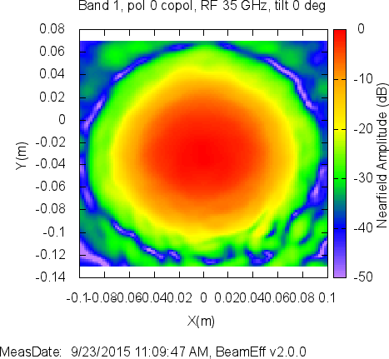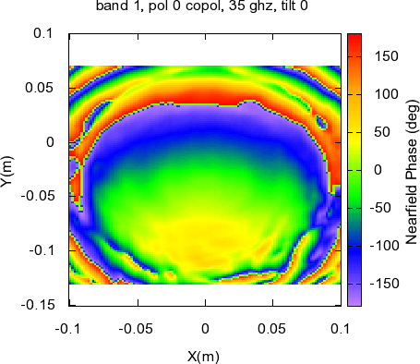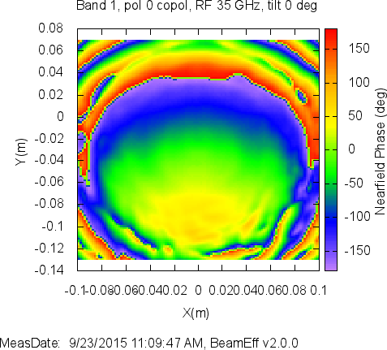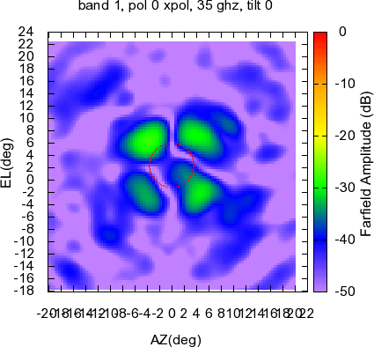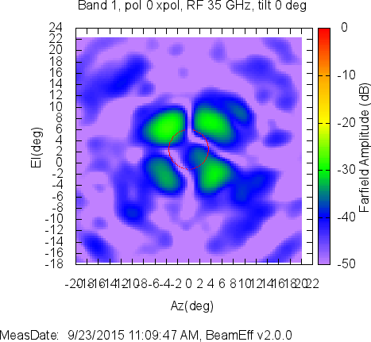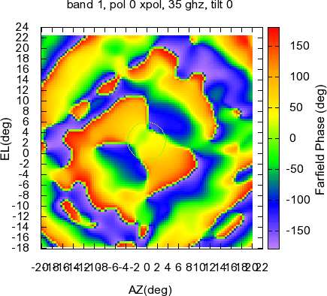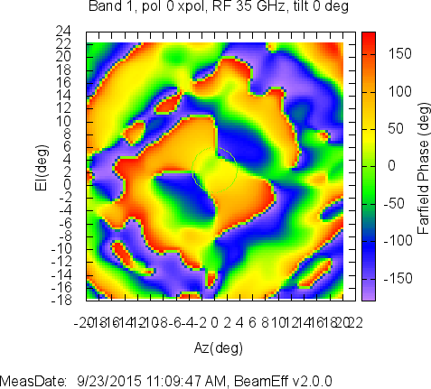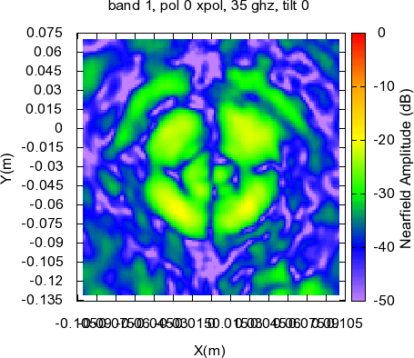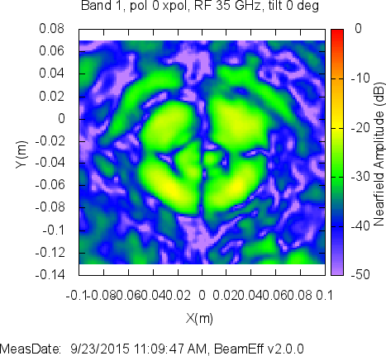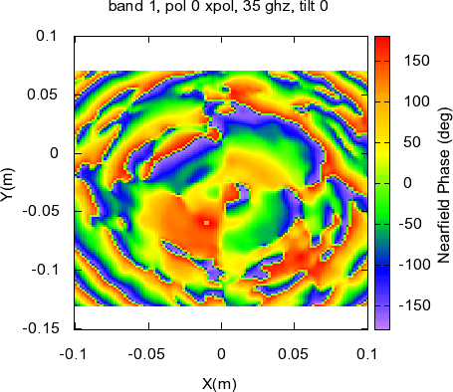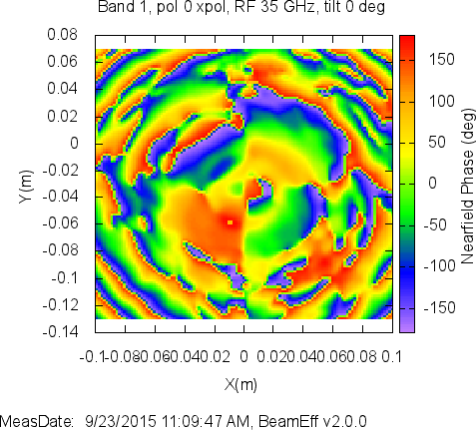

### Data set Band2-TDH18144-RF88

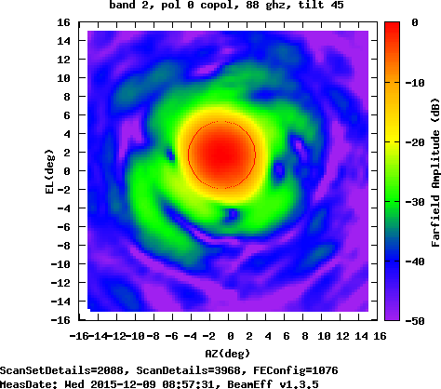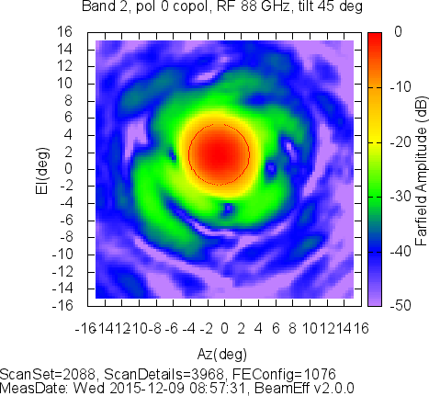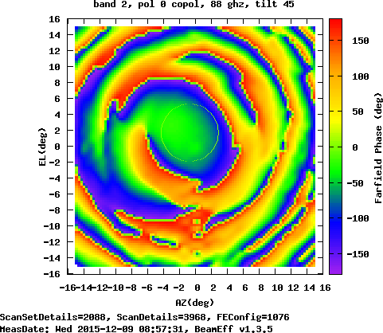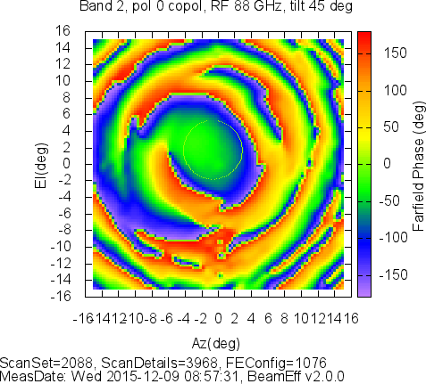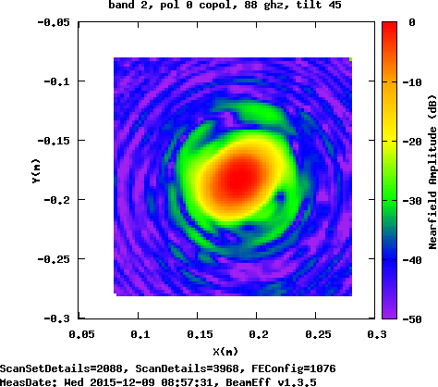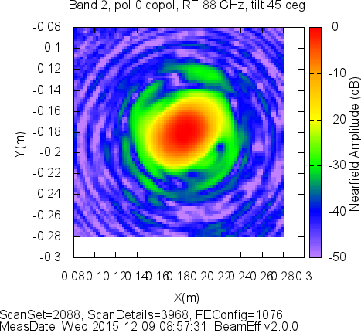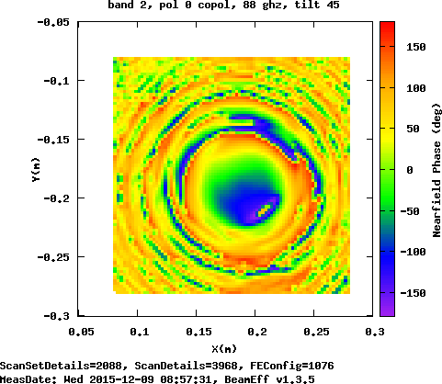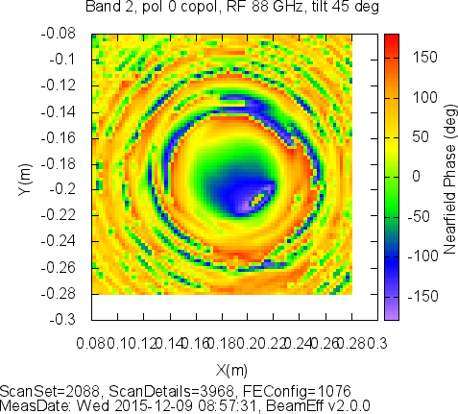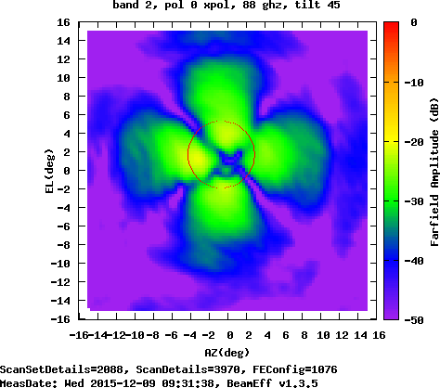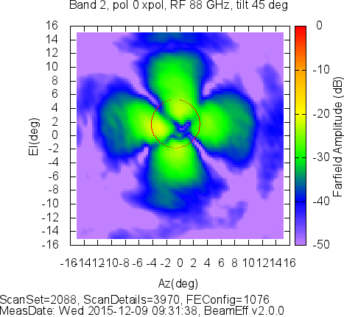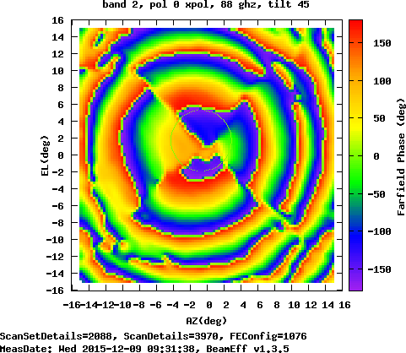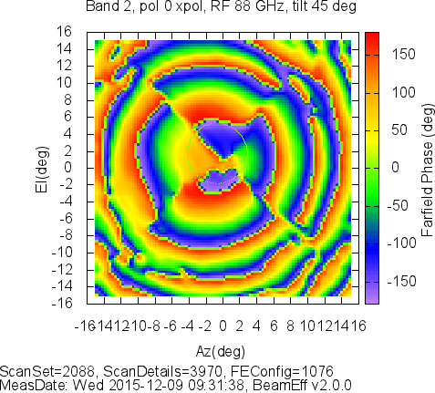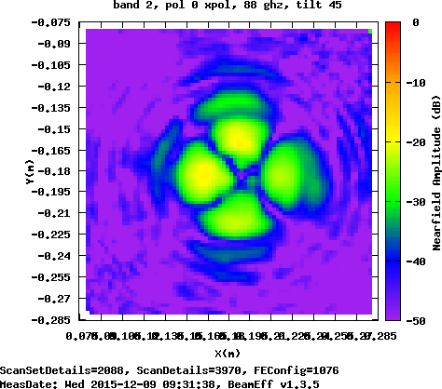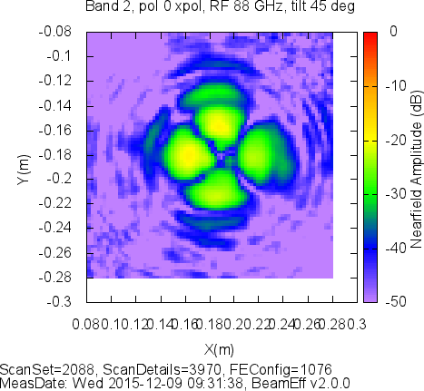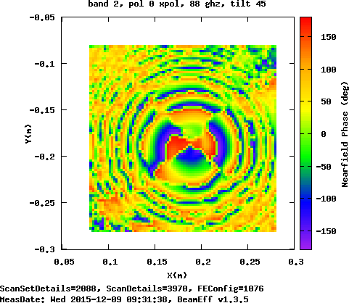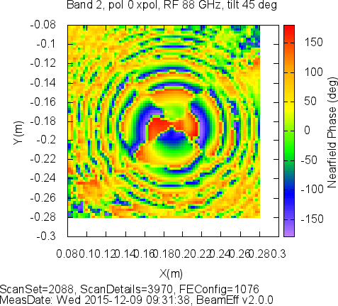

### Data set Band6-TDH14050-RF243

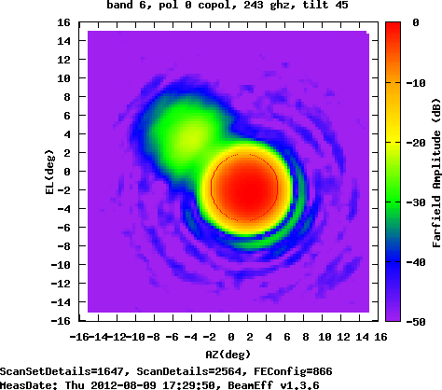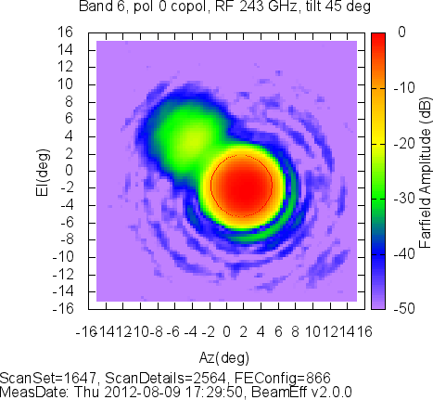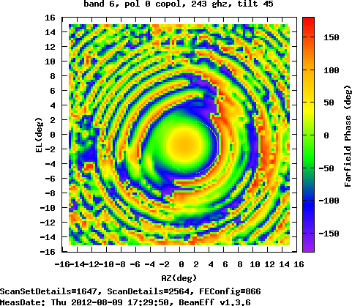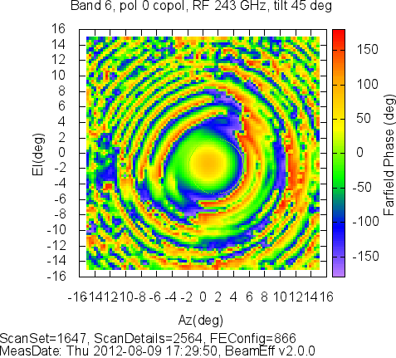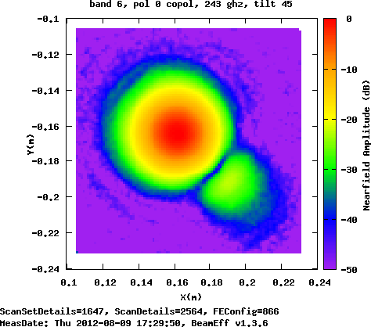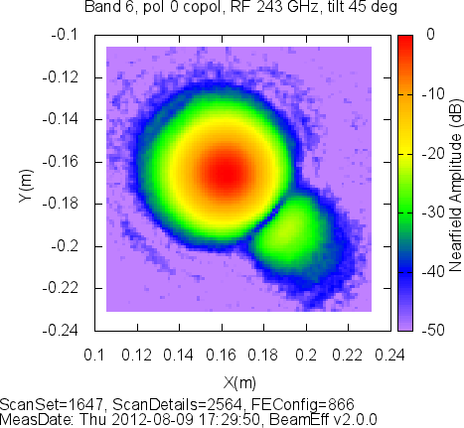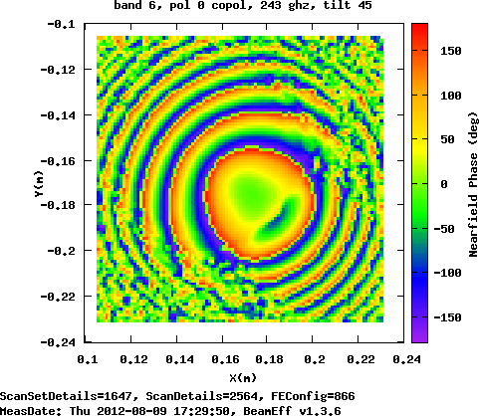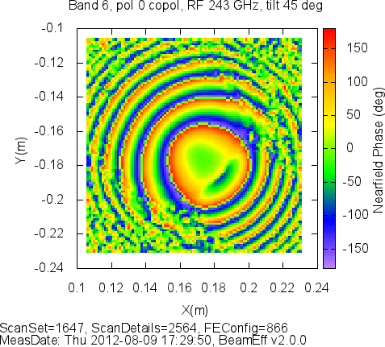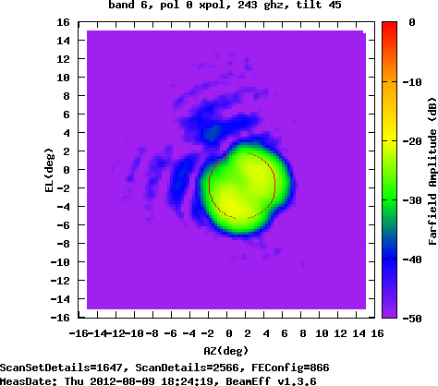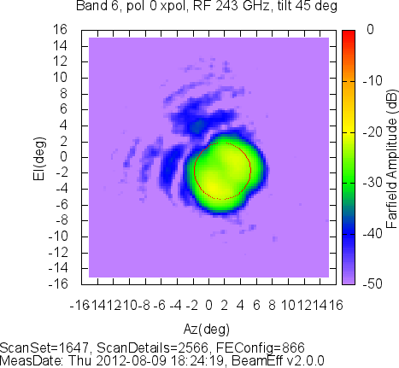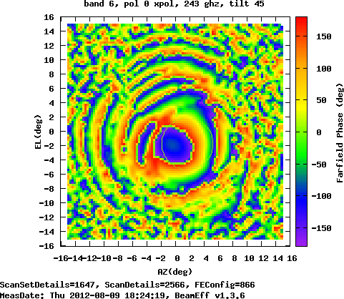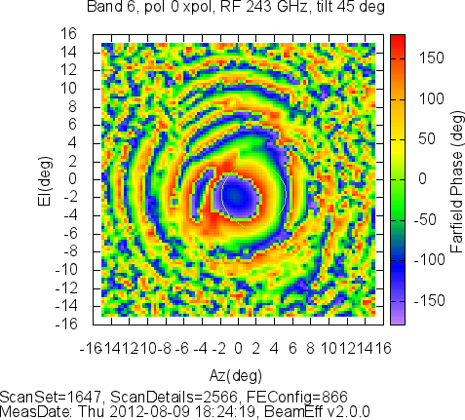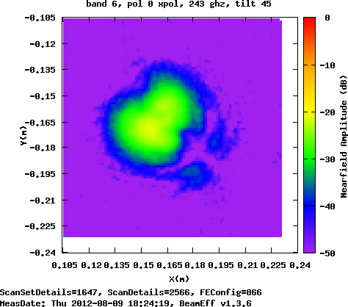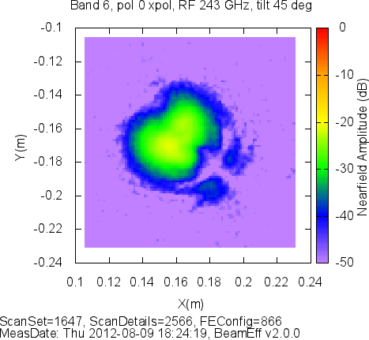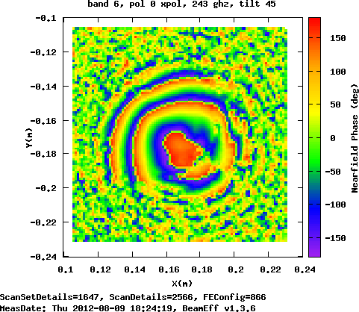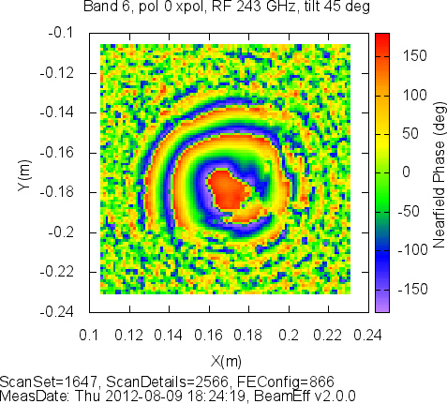

## Pointing angle plots

The 1.x pointing angle plots are above. The 2.0.x plots are below.

### Data set Band1-SN03-RF35

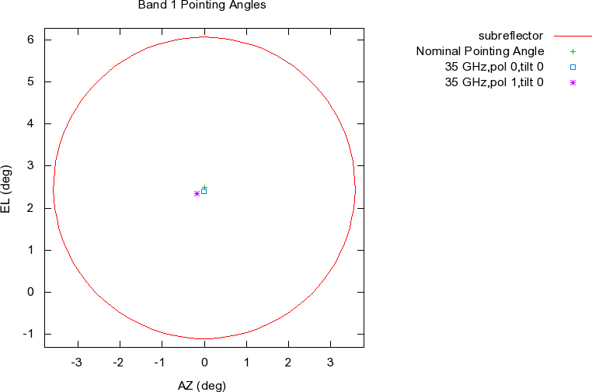

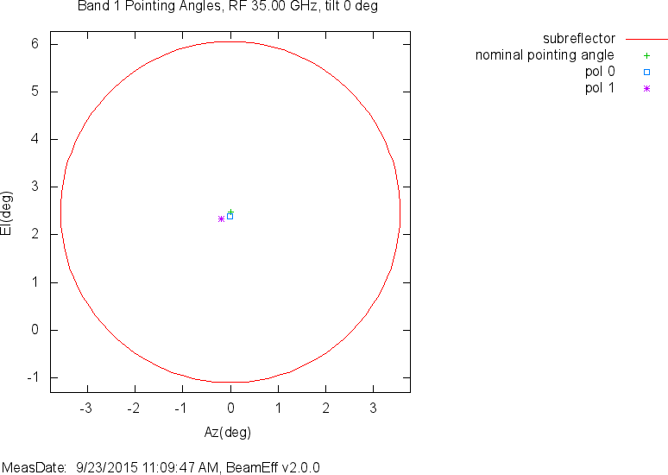

### Data set Band2-TDH18144-RF88

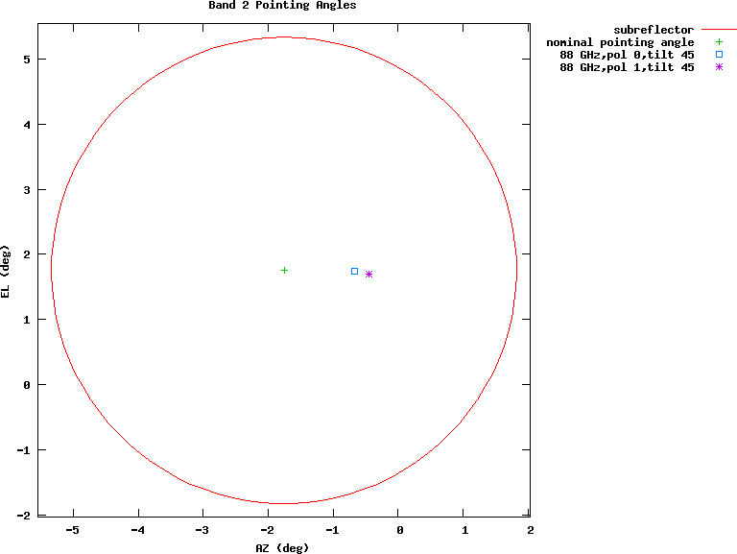

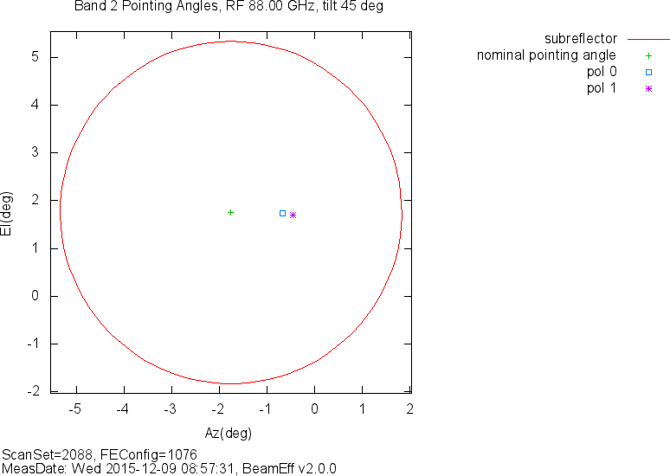

### Data set Band6-TDH14050-RF243

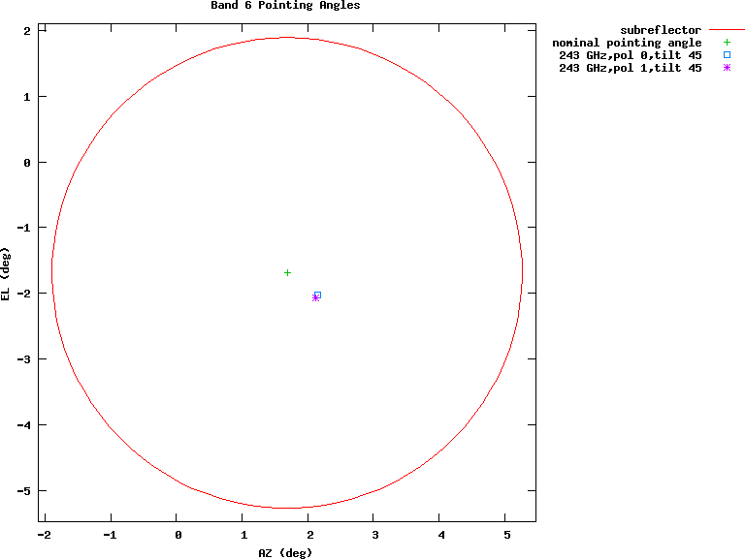

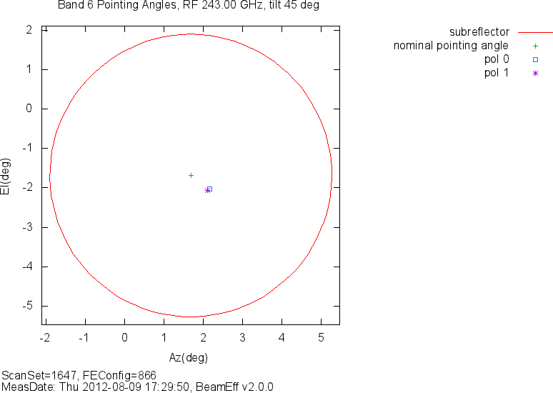

## Dual-Z scan sets

No data yet. Plan is to figure out how to split out the two Z scans from the band 1 data and reprocess it so that BeamEff combines the dual Z scans. In [RD4], A. Baryshev notes that when NSI2000 combines the dual-Z beams it uses average (a1+a2)/2 instead of (a1+i*a2)/2 or (a1-i*a2)/2 depending on the sideband used in detection. The dual-Z algorithm in BeamEff, both 1.x and 2.0.x simply finds the correction having the greater magnitude rather than using the “sb” input variable as it probably should.