Objective
This session teaches students how HTTP protocols works between a client browser and web server; how HTML forms are used to capture and submit user input; what Tomcat is; how to install and use Tomcat for server side programming.

HTTP (Hypertext Transfer Protocol)
In distributes application development, the application communication protocol drives the nature of clients and servers. This is true for web applications as well. HTTP is the protocol for communication on the web. It is an application level protocol based on requests and responses that determines the complexity of features possible in the application. In this paradigm, client application (like a web browser) sends requests to the server (like a web server of an online toy shop) and receives information (such as a toy catalog) from the server in response. HTTP is stateless (which makes it difficult to maintain information from page to page) and generally implemented over TCP/IP. HTTP 1.1 defined in Request for Comments (RFC) 2616 and is available at www.faqs.org/rfcs.

An example of HTTP conversion would be when a user enters http://www.cs.nyu.edu/csweb/index.html in Web Browser. The following things happen:

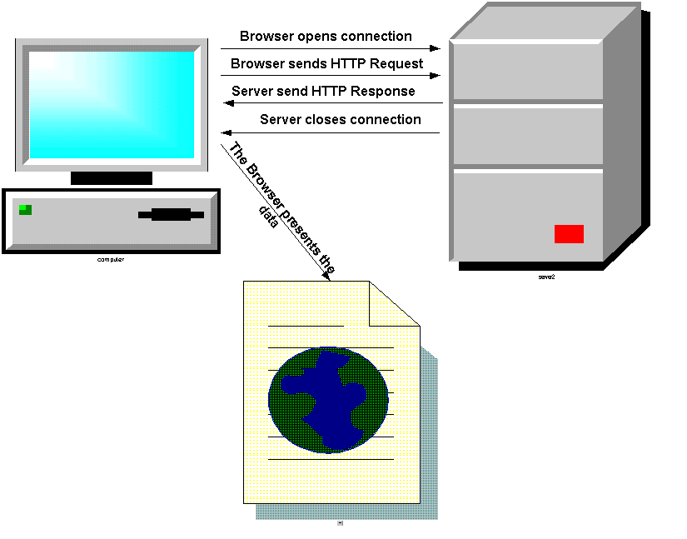

Browser Opens Connection
The browser opens a TCP/IP Socket connection with the server www.cs.nyu.edu. The browser automatically assumes that the server is listening to the default http port 80. If the server is listening to a different port you have to specify as: http://www.cs.nyu.edu:9090/csweb/index.html (assuming the server is listening to port number 9090).

Browser Sends HTTP Request
The browser (Client) converts the URL into an HTTP Request and sends it out to the server. An HTTP Request message is composed of:

- Request Line : describes HTTP Command
- Header: browser information
- Message Body: contents of message

In this example:

1) Request Line would look like this:

HTTP method Resource Name Protocol/Version

GET /csweb/index.html HTTP/1.1

2) The browser will provide the Header.

3) The Message Body will be empty.

Here is the complete request:

GET /csweb/index.html HTTP/1.1 ← Request Line
Accept: application/vnd.ms-excel, application/msword, application |
/vnd.ms-powerpoint, image/gif, image/x-xbitmap, image/jpeg, image/pjpeg, */* |
Accept-Language: en-us |
Accept-Encoding: gzip, deflate |
User-Agent: Mozilla/4.0 (compatible; MSIE 4.01; Windows NT) | ← Header
Host: localhost:9090 |
Connection: Keep-Alive |

Here are the HTTP methods appear on the Request Line:

HTTP Methods:
GET
POST
HEAD
OPTION
TRACE
……

These methods (Specifically GET and POST) will be discussed in details later.

Of course, most often, we really type something like www.cs.nyu.edu without any protocol or specific file name. In that case, the browser assumes it as a HTTP request by default and sends a HTTP Request as follows:

GET / HTTP/1.1

Since the server does not find a page request (the page name is empty after the slash) it forwards this request to the default page like “index.html” or “default.html” (part of the web application setup on the server) and browser shows that page. In our example it actually forwards to “/csweb/index.html”.

Here is an HTTP Server that receives an HTTP Request and displays it on a swing frame:

import java.io.BufferedReader;
import java.io.IOException;
import java.io.InputStreamReader;
import java.net.ServerSocket;
import java.net.Socket;

/** This class waits for socket connection with any client.
When it gets connected it displays the connection header on a frame.
*/
public class HttpServer
{

/** main method to instantiate the gui*/
public static void main(String args[])
{
try
{

// convert server port number received as command
// line argument to int.
int port=Integer.parseInt(args[0]);

// create a server socket object with
// server port number.
ServerSocket serversocket = new ServerSocket(port);

// create a GUI instance
HttpServerGUI httpservergui= new HttpServerGUI();

while (true)
{
//wait for the client
Socket socket = serversocket.accept();

// print after connection.
System.out.println("Client connected.");

// get the inputstream and convert to buffered character stream.
BufferedReader in = new BufferedReader(new InputStreamReader(socket.getInputStream()));

// holds one line of request at a time.
String requestline;

// stores the request as it comes line by line.
StringBuffer request = new StringBuffer();

// read all the request header lines.If an empty line means end of header.
// and it exits the loop.
while(!(requestline = in.readLine()).equals(""))
{
request.append(requestline + "\n");
}

// display the request header on a frame.
httpservergui.display(request.toString());

// close the connection.
in.close();
socket.close();
System.out.println("Client disconnected.");

}
}
// catch exceptions.
catch (IOException e)
{
System.out.println(e);
System.exit(-1);
}
catch (Exception e)
{
System.out.println(e + "\nUsage: java HttpServer [port]");
}
}
}

Here is the swing frame:

import java.awt.BorderLayout;
import java.awt.Font;
import java.awt.event.WindowAdapter;
import java.awt.event.WindowEvent;

import javax.swing.JFrame;
import javax.swing.JScrollPane;
import javax.swing.JTextArea;

/** This this the GUI for HttpServer class.*/
public class HttpServerGUI extends JFrame
{
// private fields GUI objects.
private JTextArea txtMain;

/** Constructor.*/
public HttpServerGUI()
{
System.out.print("Please wait...");

// instantiate a mono spaced fort.
Font courier = new Font("monospaced", Font.PLAIN, 12);

// set the title.
setTitle("HTTP Server");

// instantiate a text area.
txtMain = new JTextArea(20,80);
txtMain.setFont(courier);

// instantiate a scroll pane with the text area.
JScrollPane txtPane = new JScrollPane(txtMain);

// add the scroll pane to the frame.
getContentPane().setLayout(new BorderLayout());
getContentPane().add(txtPane, BorderLayout.CENTER);

// add anonymous window listener
addWindowListener(new WindowAdapter()
{
public void windowClosing(WindowEvent ev)
{
System.exit(0);
}
}
);

// adjust the size of the frame and make it visible.
pack();
setVisible(true);
}

/** public method that displays the string it receives.*/
public void display(String request)
{
txtMain.setText(request);
}

}

If you just run it in Eclipse, you will get the following error:

java.lang.ArrayIndexOutOfBoundsException: 0
Usage: java HttpServer [port]

Right click on HttpServer and select Run As - > Run Configurations, Click on Arguments Tab and type 9000 on Program Arguments selection and click on Run at the bottom.

This is equivalent of typing:

java HttpServer 9090

At command prompt.

You will see a blank window pops up.

From a browser, type:

http://localhost:9000/index.html

Here is what the request looks like on our swing frame when the server runs on port 9000 on the same machine and the user types http://localhost:9000/index.html on the browser. Of Course, the browser will show an error message since no response was returned to the browser.

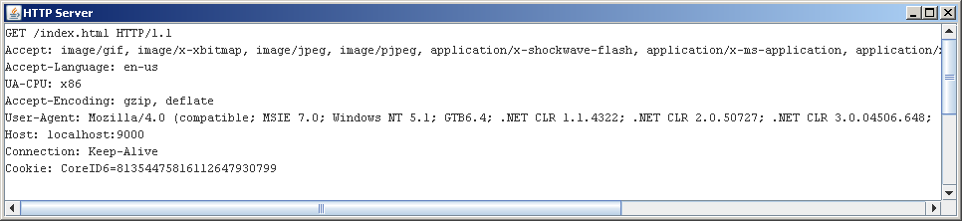

Server Sends HTTP Response
The Server reads and interprets the request and sends an HTTP Response message back to the browser (Client). An HTTP Response message is composed of:

- Response Line: Server protocol and status line
- Header: Response Metadata
- Message Body: Content of Message

Here is what the response will look like:

HTTP/1.1 200 OK ← Response Line
Date: Wed, 14 Feb 2001 20:28:59 GMT |
Server: Apache/1.3.6 (Unix) PHP/3.0.9 |
Last-Modified: Tue, 09 Jan 2001 15:07:24 GMT |
ETag: "36654-f99-3a5b292c" |
Accept-Ranges: bytes |← Header
Content-Length: 3993 |
Connection: close |
Content-Type: text/html |
X-Pad: avoid browser bug |

<html> |
|
<head> |
<title>Computer Science Department</title> |← Message Body
…… |
…… |

The html page that the server returns may have links to other html pages. When the user clicks on those links the browser sends another request to the server, the server sends the response and browser displays the new page and so on.

Here are the status codes used by the server on Response Line:

Status Codes:
Code Range | Category
100-199 | Information
200-299 | Successful (200 OK)
300-399 | Redirection
400-499 | Client Error(404 File Not found,400 Bad Request)
500-599 | Server Error

These status codes will be discussed in details later.

Here are the Multipurpose Internet Mail Extension (MIME) content types used by the server for Header:

MIME Content Types:
text/html
text/plain
text/xml
application/octet-stream
…….

These content types will be discussed in details later.

Here is a Swing Frame that establishes connection with the server and port specified on command prompt and sends out HTTP Requests to the server and displays HTTP Response from the server:

import java.awt.BorderLayout;
import java.awt.FlowLayout;
import java.awt.Font;
import java.awt.Panel;
import java.awt.event.ActionEvent;
import java.awt.event.ActionListener;
import java.awt.event.WindowAdapter;
import java.awt.event.WindowEvent;

import javax.swing.JButton;
import javax.swing.JFrame;
import javax.swing.JLabel;
import javax.swing.JScrollPane;
import javax.swing.JTextArea;
import javax.swing.JTextField;

/** This this the GUI for HttpClient class.*/
public class HttpClientGUI extends JFrame
{
// private fields GUI objects.
private JTextField tbRequest;
private JTextArea txtMain;
private JButton btnSend;

// private field for HttpClient.
private HttpClient httpclient;

/** Constructor that receives HttpClient.*/
public HttpClientGUI(HttpClient p_httpclient)
{
System.out.print("Please wait...");

// save the HttpCient object.
httpclient=p_httpclient;

// instantiate a mono spaced fort.
Font courier = new Font("monospaced", Font.PLAIN, 12);

// set the title.
setTitle("HTTP Client");

// instantiate textfield, button and text area.
tbRequest = new JTextField("GET /index.html HTTP/1.0");
tbRequest.setFont(courier);
tbRequest.addActionListener(new InnerActionListener());

btnSend = new JButton("Send");
btnSend.setMnemonic('S');
btnSend.addActionListener(new InnerActionListener());

txtMain = new JTextArea(20,80);
txtMain.setFont(courier);

// instantiate a panel and add things to it.
Panel northPanel = new Panel();
northPanel.setLayout(new FlowLayout(FlowLayout.LEFT, 6, 6));
northPanel.add(new JLabel("HTTP Request:"));
northPanel.add(tbRequest);
northPanel.add(btnSend);

// instantiate a scroll pane.
JScrollPane txtPane = new JScrollPane(txtMain);

// add objects to the frame.
getContentPane().setLayout(new BorderLayout());
getContentPane().add(northPanel, BorderLayout.NORTH);
getContentPane().add(txtPane, BorderLayout.CENTER);

// add anonymous window listener
addWindowListener(new WindowAdapter()
{
public void windowClosing(WindowEvent ev)
{
System.exit(0);
}
}
);

// adjust the size of the frame and make it visible.
pack();
setVisible(true);
}

/** Inner action listener for the button and text field. */
private class InnerActionListener implements ActionListener
{
public void actionPerformed(ActionEvent ev)
{
String response=httpclient.send(tbRequest.getText());
txtMain.setText(response);
}

}
}

Here is the TCP/IP Client Socket program that actually does the job behind the scene:

import java.io.BufferedReader;
import java.io.InputStreamReader;
import java.io.PrintWriter;
import java.net.Socket;

/** This class establishes socket connection with any server and sends HTTP requests
and receives HTTP responses.
*/
public class HttpClient
{

// fields to hold host and port number received by the constructor.
private String host;
private int port;

/** Constructor that receives host and port number.*/
public HttpClient(String p_host, int p_port)
{
port = p_port;
host = p_host;
}

/** This method send HTTP request and returns the response from server.*/
public String send(String request)
{

// holds one line of response at a time.
String responseline;

// stores the response as it comes line by line.
StringBuffer response = new StringBuffer();

try
{

// 1. Connect to the server
Socket socket = new Socket(host, port);

// 2. send the request
PrintWriter pw = new PrintWriter(socket.getOutputStream());
pw.println(request + "\n");
pw.flush();

// 3. receive the response from the server
BufferedReader br = new BufferedReader(new InputStreamReader(socket.getInputStream()));
while((responseline = br.readLine())!= null)
{
response.append(responseline + "\n");
}
}
catch (Exception e)
{
System.out.println("Exception sending request: " + e);
}

// 4. return response back to the caller.
return response.toString();

}

/** main method to instantiate the gui*/
public static void main(String args[])
{
try
{
// instantiate HttpClient object with command line arguments.
HttpClient httpclient = new HttpClient(args[0], Integer.parseInt(args[1]));

// instantiate the GUI with HttpClient object.
HttpClientGUI httpclientgui = new HttpClientGUI(httpclient);
}
catch (Exception e)
{
System.out.println(e + "\nUsage: java HttpClient [host] [port]");
}
}
}

If you just run HttpClient, you will get the following error:

java.lang.ArrayIndexOutOfBoundsException: 0
Usage: java HttpClient [host] [port]

Right click on HttpClient and select Run As -> Run Configurations and Click on Arguments Tab and type “cs.nyu.edu 80” on Program Arguments selection and click on Run at the bottom

You will see a window will pop-up, click on Send Button.

Here is what it looks like after we click on send button:
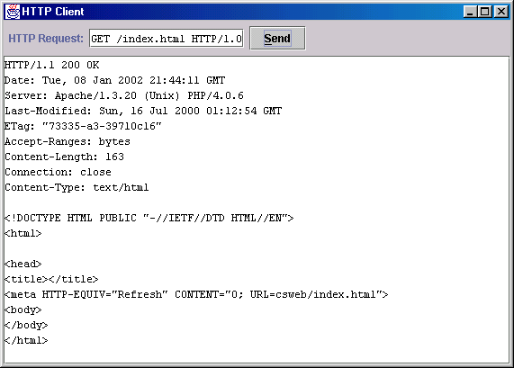

One interesting thing to know about HTTP protocol is that the server generally does not care what type of file is requested. As long the file is publicly available (which basically means the permission setup on the server) the server will return the content of the file as stream of bytes (right now I am assuming the server only supports static pages). The browser looks at the MIME content type of the file and decides whether and how it should display the file on the browser or it should ask user to save it in a file as download. Of course, Microsoft Internet Explorer violates this rule and tries to interpret the content of the file regardless of its MIME content type.

My GUI will display the content of the file regardless of the content type. In fact, every windows machine already has such a GUI tool – it is called Telnet. Try your Telnet to do the
same job.

Fiddler Tool
There is quite a few free tools out there that allows you to monitor the data you are sending and the data you are receiving over TCP/IP socket. In other words, these tools allow you to see the raw request and the raw response. Fiddler is one of them. Here is how you get it to work.

a) Download Fiddler
b) Install Fiddler

c) Start Fiddler from your startup menu. You will have a Fiddler console available to you at this point.

c) Open your browser and hit any url. Fiddler automatically plugs into your browser as a proxy server and will record your requests and responses in Fiddler console. If it does not, please read Fiddler documentation to find how to manually put the proxy setting in your browser.

Tomcat
Tomcat is the servlet container that is used in the official Reference Implementation for the Java Servlet and JavaServer Pages technologies.
There are several versions of Tomcat currently available for download. Which version you will install depends on which version of Java do you have installed on your machine. To figure out the dependency between Java and Tomcat go to the following page:

https://tomcat.apache.org/whichversion.html

Needless to say, if you don’t have Java or Tomcat either one, you can simply close your eyes and install the latest version of Java first and then the latest version of Tomcat and you will be in business without any issues.

For windows machine, download the zip version and unzip it. You are done installing.

Starting and Stopping Tomcat
You start Tomcat by clicking on startup.bat in Tomcat’s bin folder.
To stop Tomcat simply click on shutdown.bat

Testing Tomcat
Tomcat by default starts on port “8080” which means for every request from a browser you have to specify the port number since the browser assumes that the server is listening on port “80” not “8080”.
Let’s follow the following steps to a do little sanity check on Tomcat:
- Start Tomcat.
- Open up your favorite browser and type:
http://localhost:8080
This should load the page shown below. If you are using IE and you are not connected to the internet, you will have a little problem. First on the “Work Offline” window you have to click on “Try Again” button and then you have click on “Connect” on the next window.
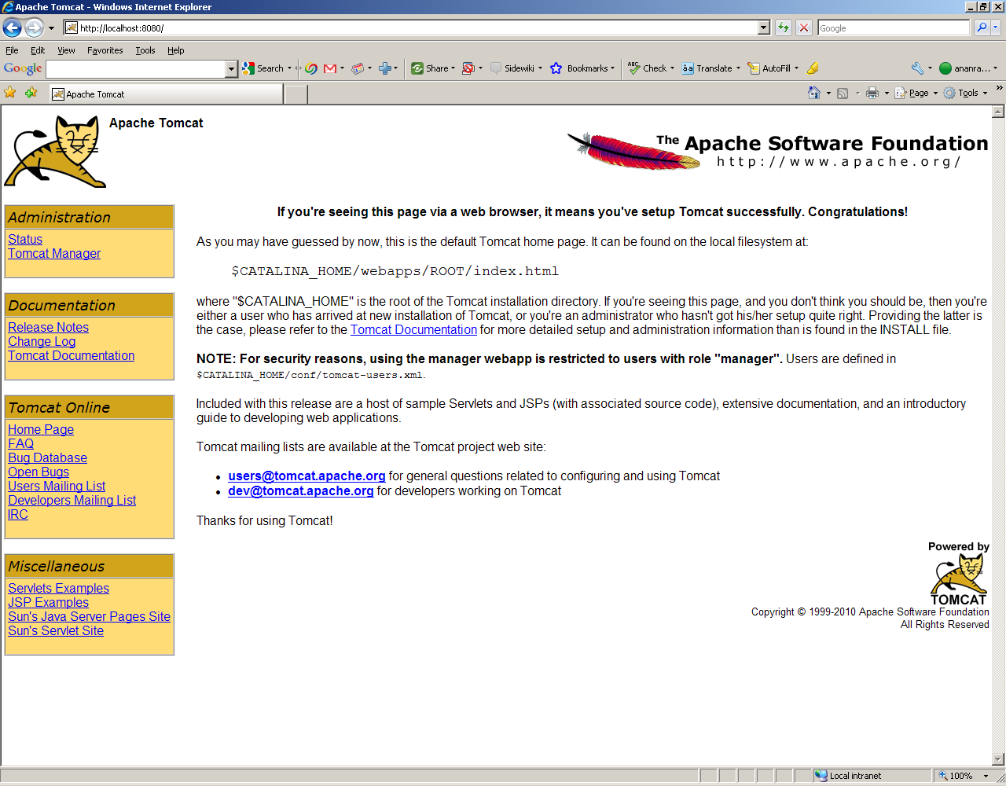

If you see this page, you should pour yourself a glass of wine (beer will do just fine) and celebrate. You just made your life (not to mention mine too) a whole lot easier going forward.

Using Fiddler with localhost
Type:

http://localhost:8080

Fiddler will capture traffic to local Tomcat

Creating Dynamic Web Project in Eclipse

In Eclipse, we will select File -> New -> Project and type ‘Dynamic’ , select Dynamic Web Project. Name the project as JPIDemo7

Developing a static web component
On JPIDemo7 project, right click on WebContent and select New –> File and type index.html as the file name.

Right click on index.html and select Open With -> Html Editor. This will open index.html on the right side of the screen.

Type the following on the page:

<html>
<head><title>My first page</title></head>
<body>
Hi everybody, how is the class going?
</body>
</html>

Starting Tomcat from Eclipse
Please make sure Tomcat is NOT running already. On the bottom right side of Tomcat, click on the servers tab. It should be completely empty. Right click on the blank area, select New -> Server, Select Tomcat 6.0 Server under Apache. Click on browse and find your folder where Tomcat is unzipped. Finish the task. Tomcat server will be created and listed at the bottom.

Right click on the newly created server and select start.

Go to a web browser and type:

http://localhost:8080

Please make sure tomcat is still starting and you get the same view you got before.

Starting your Project in Tomcat from Eclipse
Right click on y our project, Select Run As and Select Run on Server. Your application would start and you will see your page displayed on Eclipse since index.html is already configured as a default page in your application (in web.xml under WEB-INF folder - we will talk about this later).

Adding Fiddler into the mix
Please make sure that Fidder2is up and running. Start your browser and type:

http://localhost:8080/JPIDemo7/index.html

You will see “Hi everybody, how is the class going?” in your browser but if you open up Fiddler and click on Raw Tab on right hand side Top and Bottom window, you will see the Raw Request and Raw Reponse in Fiddler as follows:

Request:
----------------------------
GET http://192.168.1.3:8080/JPIDemo7/index.html HTTP/1.1
Accept: image/gif, image/x-xbitmap, image/jpeg, image/pjpeg, application/x-shockwave-flash, application/x-ms-application, application/x-ms-xbap, application/vnd.ms-xpsdocument, application/xaml+xml, */*
Accept-Language: en-us
UA-CPU: x86
Accept-Encoding: gzip, deflate
User-Agent: Mozilla/4.0 (compatible; MSIE 7.0; Windows NT 5.1; GTB6.4; .NET CLR 1.1.4322; .NET CLR 2.0.50727; .NET CLR 3.0.04506.648; .NET CLR 3.5.21022)
Host: 192.168.1.3:8080
Connection: Keep-Alive

Response:
-------------------------
HTTP/1.1 200 OK
Server: Apache-Coyote/1.1
Accept-Ranges: bytes
ETag: W/"114-1270891112109"
Last-Modified: Sat, 10 Apr 2010 09:18:32 GMT
Content-Type: text/html
Content-Length: 114
Date: Sat, 10 Apr 2010 09:26:39 GMT

<html>
<head><title>My first page</title></head>
<body>
Hi everybody, how is the class going?
</body>
</html>

Starting Tomcat from Eclipse
Please make sure Tomcat is not running already. On the bottom right side of Tomcat, click on the servers tab. It should be completely empty. Right click on the blank area, select New -> Server, Select Tomcat 6.0 Server under Apache. Right click on the newly created server and select start.

Go to a web browser and type:

http://localhost:8080

Please make sure tomcat is still starting and you get the same view you got before.

HTML Form
HTML forms let you create a user interface to collect user input using controls and submit them to the server. The submission can happen in one of the two ways:

- Using HTTP GET method that appends the user input at the end of the URL of the page as string, after a question mark.
- Using HTTP POST method that sends the user input in the body of the request message.

The <FORM> tag has the following useful attributes:

- ACTION – The URL where the data is going out to (Usually a Servlet/JSP page). If you don’t put any ACTION the same page returns.
- METHOD – The HTTP method for sending (GET, POST etc.)

Each of two methods has certain advantages and disadvantages as follows:

- GET method:

Advantages:
- Good for debugging, the data appears in the URL.
- URL with data can be book-marked or e-mailed.
Disadvantages:
- Data is visible (including password type data).
- Although HTTP/1.1 does not impose any limit on the length, browsers/servers complying only with HTTP/1.0 may have a limitation on the URL length (mostly it is 1024). In that case anything after the maximum URL length will be truncated.

- POST method:

Advantages:
- No limitation on data length.
- Data is not visible.
- Good for sending binary data.
Disadvantages:
- URL with data cannot be book-marked or e-mailed.

Here are the HTML tags that we can use to capture and send user input:

- The <INPUT> Tag of the following types:
- text
- password
- checkbox
- radio
- submit
- reset

b) The <TEXTAREA> tag for multi-line user input

- The <SELECT> tag for drop down combo and list box

Here is a sample HTML page with FORM tag:

signup.html

<!DOCTYPE HTML PUBLIC "-//W3C//DTD HTML 4.0 Transitional//EN">
<HTML>
<HEAD><TITLE>HTML Form Demo</TITLE></HEAD>
<BODY>
<H3>Please enter the following information:</H3>
<FORM method="GET" action="thankyou.html">
<TABLE>
<TR>
<TD>Name</TD>
<TD><INPUT type="text" name="user_name" value="" size="40"/></TD>
</TR>
<TR>
<TD>Password</TD>
<TD><INPUT type="password" name="user_password" size="20"/></TD>
</TR>
</TABLE>
Member of class e-mail list <INPUT type="checkbox" name="email_account"
value="true"/> <BR/>
<BR/>
Grading policy:
<TABLE border="1" cellspacing="15">
<TR>
<TD>Letter Grade<INPUT type="radio" name="grade" value="LG"/></TD>
<TD>Pass/Fail<INPUT type="radio" name="grade" value="PF"/></TD>
<TD>Non-Evaluative<INPUT type="radio" name="grade" value="NE"/></TD>
<TD>Incomplete<INPUT type="radio" name="grade" value="IC"/></TD>
</TR>
</TABLE>
<BR/>
Programming Skill <BR/>
<SELECT name="skill">
<OPTION value="E">Experienced Programmer</OPTION>
<OPTION value="I">Intermediate Programmer</OPTION>
<OPTION value="B">Beginner</OPTION>
</SELECT> <BR/>
<BR/>
Web Server <BR/>
<SELECT name="webserver" size="3" multiple>
<OPTION value="T">Just Tomcat</OPTION>
<OPTION value="A">Tomcat and Apache</OPTION>
<OPTION value="I">Tomcat and IIS</OPTION>
<OPTION value="O">Others</OPTION>
</SELECT> <BR/>
<BR/>
Comments <BR/>
<TEXTAREA name="Comments" rows="5" cols="50"></TEXTAREA>
<BR/>
<BR/>
<INPUT type="submit" value="Send"/>
<INPUT type="reset" value="Clear"/>
</FORM>
</BODY>
</HTML>

Here is thankyou.html:

<!DOCTYPE HTML PUBLIC "-//W3C//DTD HTML 4.0 Transitional//EN">
<HTML>
<HEAD><TITLE> Thank you</TITLE></HEAD>
<BODY><H2>Thank you for your submission</H2></BODY>
</HTML>

However, if we change the method to POST in register.html the data will disappear from the URL and will be send as the body of the request.

Deploying the pages in Web App
Let’s copy:

- signup.html
- thankyou.html

files to WebContent folder of JPIDemo7 project. Right click on the project, select Run As -> Run on Server.

Type:

http://<your ip address>:8080/JPIDemo7/signup.html

It should load the page. Please be careful about the filename – Tomcat is case-sensitive – even for html files.

If you are offline and using IE you may see a dialog stating the web page is unavailable. Click on Connect and a select dialog will appear stating work offline. Click on Try Again – you should see the page now.

Here is how it looks:
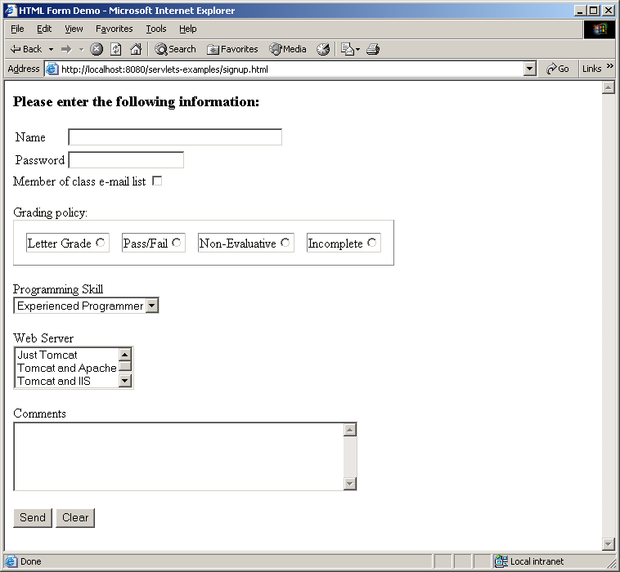

Type your name and click on the Send Button. You should see the thankyou.html page as shown below:
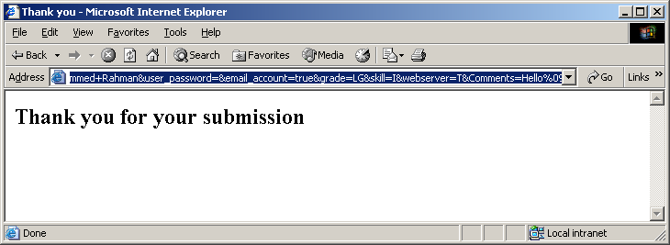

Please look at the URL and you will notice that user input is appended on the URL as follows:
http://localhost:8080/servlets-examples/thankyou.html?user_name=Mohammed+Rahman&user_password=&email_account=true&grade=LG&skill=I&webserver=T&Comments=Hello%09%09

J2EE Architecture – Containers
A typical Java program starts with a main() method. Also, as typical Java programmer we are used to instantiating our objects on our own as we need them. However, J2EE architecture is based on the idea that an application is composed of a number of application components (for example EJBs, Servlets, JSPs etc.) and the programmers of these components are not responsible for instantiating, invoking and managing these components.

Central to the J2EE component-based development model in the notion of container. Containers are JVMs that provides component services. In other words the life-cycle of an application component will be managed by container. The container will create and initialize component, invoke methods on them and destroy, serialize, de-serialize them as and when necessary.

This concept is not new and is very similar to event driven programming in AWT and Swing. In event driven programming we write these event handlers but never invoke any of these methods. The JVM invokes these methods as and when necessary. Our Job is to provide the code for these methods. The same concept is extended to J2EE components – the container does everything. Examples of such containers are Tomcat, WebLogic etc.

If you are familiar with Applets – you are already familiar with this concept. In case of Applet, the web browser is the container and it manages the life cycle of the Applet – you never instantiate or invoke methods of Applet – you only write them.

However, in order for the container to be able to do this job – the application components must implement certain interfaces specified in J2EE. Implementing these interfaces may not always be straightforward – therefore, J2EE provides certain classes that have already implemented these interfaces and our job is to subclass these classes and override methods for customization.

Servlet Interface
Servlets are java programs that run on a web server, acting as a middle layer between a request coming from the web browser and a response going out of web server. Servlets are particularly useful for generating dynamic content.

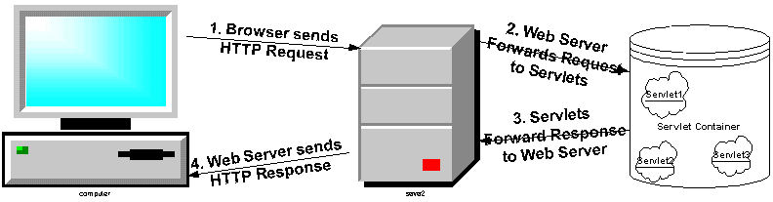

In general, what we mean by Servlet is that Servlet is an application component that implements Servlet interface. Servlet interface has the following methods:

Method | Return Type | Description
init(ServletConfig config) | void | Called by the servlet container – right after the constructor call - to indicate to a servlet that the servlet is being placed into service.
service(ServletRequest req, ServletResponse res) | void | Called by the servlet container to allow the servlet to respond to a request.
destroy() | void | Called by the servlet container to indicate to a servlet that the servlet is being taken out of service.
getServletConfig() | ServletConfig | Returns a ServletConfig object, which contains initialization and startup parameters for this servlet.
getServletInfo() | String | Returns information about the servlet, such as author, version, and copyright.

Obviously, there is more to it – the init() method receives and getServletConfig() method returns an object that implements ServletConfig interface, the service method receives two objects that implements ServletRequest and ServletResponse interface respectively. Clearly – the whole architecture is interface based since the container can’t and doesn’t enforce any rule on the actual components other that making sure that they implement certain interfaces.

Before, we get carried away by these interfaces, let’s just try to understand what these 5 methods do. Servlet interface defines methods to initialize a servlet, to service requests, and to remove a servlet from the server. These are known as life-cycle methods and are called in the following sequence:

- First time the Servlet is required for servicing a client, the container constructs the servlet object then initialized with the init() method. The init()method is never called once the Servlet object is instantiated.
- Any calls from clients to the servlet goes to the service() method. This is the method that is called repeatedly during the lifecycle of a Servlet – every time there is a request to the Servlet from a client.
- When the container feels like removing the servlet (since there is no request for it for a long time) the destroy() method of the Servlet is called, then garbage collected and finalized.

In addition to the lifecycle methods, this interface provides the getServletConfig() method, which the servlet can use to get any startup information provided by the container, and the getServletInfo() method allows the servlet to return basic information about itself, such as author, version, and copyright.

Our First Servlet
Since we know that a servlet is nothing but a class that implements Servlet Interface, why don’t we write such a class . In JPIDemo7, under Java Resources – src, create a new class Servlet1. Below is the code:

import java.io.IOException;

import javax.servlet.Servlet;
import javax.servlet.ServletConfig;
import javax.servlet.ServletException;
import javax.servlet.ServletRequest;
import javax.servlet.ServletResponse;
public class Servlet1 implements Servlet
{
public void init(ServletConfig servletconfig) throws ServletException
{
System.out.println("In init");
System.out.println("ServletConfig Class: " + servletconfig.getClass().getName());
System.out.println("Finished init");
}

public ServletConfig getServletConfig()
{
System.out.println("In getServletConfig");
return null;
}

public void service(ServletRequest request, ServletResponse response) throws ServletException, IOException
{
System.out.println("In service");
System.out.println("ServletRequest Class: " + request.getClass().getName());
System.out.println("ServletResponse Class: " + response.getClass().getName());
System.out.println("Finished service");
}
public String getServletInfo()
{
System.out.println("In getServletInfo");
return null;
}
public void destroy()
{
System.out.println("In destroy");
}
}

Configuring the Servlet to Run
Please go to the WebContent folder of the project. Go to the WEB-INF folder and override web.xml with the following content:

<?xml version="1.0" encoding="UTF-8"?>
<web-app xmlns:xsi="http://www.w3.org/2001/XMLSchema-instance" xmlns="http://java.sun.com/xml/ns/javaee" xmlns:web="http://java.sun.com/xml/ns/javaee/web-app_2_5.xsd" xsi:schemaLocation="http://java.sun.com/xml/ns/javaee http://java.sun.com/xml/ns/javaee/web-app_2_5.xsd" id="WebApp_ID" version="2.5">
<display-name>JPIDemo7</display-name>

<servlet>
<servlet-name>Servlet1</servlet-name>
<servlet-class>Servlet1</servlet-class>
<load-on-startup>1</load-on-startup>
</servlet>
<servlet-mapping>
<servlet-name>Servlet1</servlet-name>
<url-pattern>/Servlet1</url-pattern>
</servlet-mapping>

<welcome-file-list>
<welcome-file>index.html</welcome-file>
</welcome-file-list>
</web-app>

Running the Servlet
Right click on JPIDemo7, Select Run As -> Run on Server. Tomcat will restart with the application running. From a browser, type:

http://localhost:8080/JPIDemo7/Servlet1

Of course, the browse will show empty but in Eclipse, if you click on the console tab, you will see the following:

INFO: Starting Servlet Engine: Apache Tomcat/6.0.26
In init
ServletConfig Class: org.apache.catalina.core.StandardWrapperFacade
Finished init
Apr 10, 2010 7:19:46 AM org.apache.coyote.http11.Http11Protocol start
INFO: Starting Coyote HTTP/1.1 on http-8080
Apr 10, 2010 7:19:46 AM org.apache.jk.common.ChannelSocket init
INFO: JK: ajp13 listening on /0.0.0.0:8009
Apr 10, 2010 7:19:46 AM org.apache.jk.server.JkMain start
INFO: Jk running ID=0 time=0/15 config=null
Apr 10, 2010 7:19:46 AM org.apache.catalina.startup.Catalina start
INFO: Server startup in 300 ms
In service
ServletRequest Class: org.apache.catalina.connector.RequestFacade
ServletResponse Class: org.apache.catalina.connector.ResponseFacade
Finished service

Now, refresh your browser several times, each time you do, on Tomcat console you will see:
In service
ServletRequest Class: org.apache.catalina.connector.RequestFacade
ServletResponse Class: org.apache.catalina.connector.ResponseFacade
Finished service

In other words, the service method is executed everytime but the init was only invoked once.

Starting and Stopping Application (When Tomcat is running outside of Eclipse)
The following section only applied, if you are running Tomcat using Startup.bat from Tomcat’s bin folder.

Please go to Tomcat’s conf folder and copy paste the following content in tomcat-users.xml:

<?xml version='1.0' encoding='utf-8'?>
<tomcat-users>
<role rolename="tomcat"/>
<role rolename="manager"/>
<role rolename="role1"/>
<user username="tomcat" password="tomcat" roles="tomcat,manager"/>
<user username="both" password="tomcat" roles="tomcat,role1"/>
<user username="role1" password="tomcat" roles="role1"/>
</tomcat-users>

This will ensure that you have:

Userid: tomcat
Password: tomcat
Role: manager.

Launch Tomcat’s admin page using the following url:

http://localhost:8080/manager/html (you can also select the Tomcat Manager link from http://localhost:8080 – Tomcat’s main page)

Tomcat will challenge you for id and password (type in ‘tomcat’ and ‘tomcat’).

You will see the following screen:

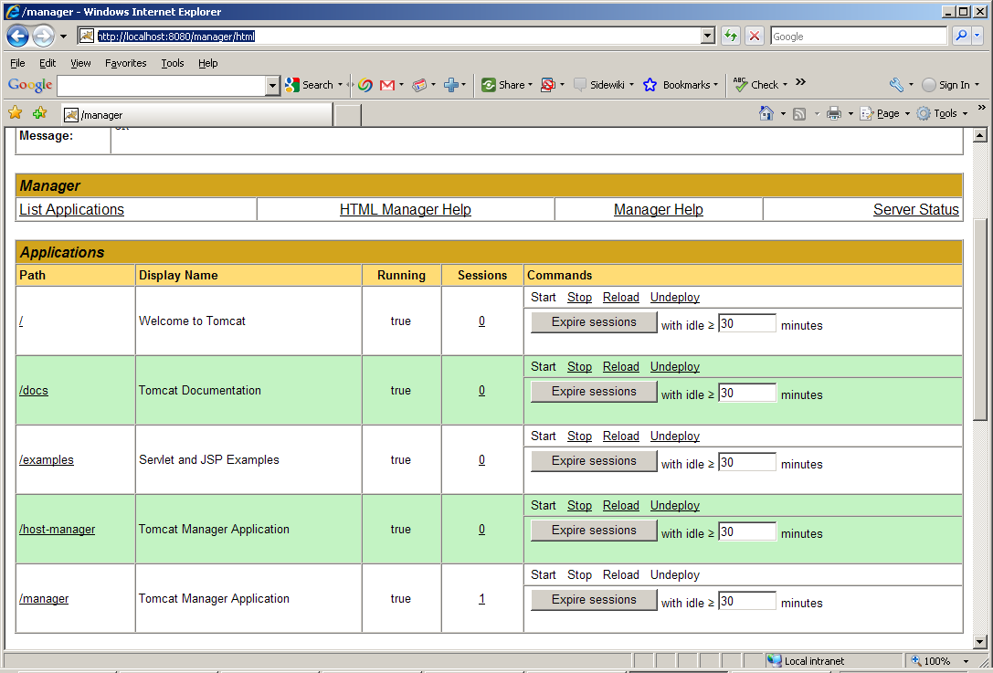

From this screen, you can stop, start or reload any application. For example, if you just made a change to Serlvet1 in ROOT app, click on Reload link of ‘/.’ (/ stands for ROOT in Tomcat) and confirm on the popup dialog. The changes will be in effect. Similarly, if you changed something in servlets-examples, just clink on reload of servlets-example and confirm on the popup dialog.

GenericServlet Class
People don’t like the idea of implementing all Servlet interface methods, everytime they need to create servlet. There should be some base class that has the basic implementation of Servlet interface and we should subclass from this class – after all, that’s the beauty of inheritance. GenericServlet class is the first step towards that direction. GenericServlet class provides the basic implementation of Servlet interface except for the service() method which is abstract. Since the service() method is the core of a servlet – it is the method that will be called by the container everytime some client makes a request for the servlet – this method would dramatically vary from one servlet to another and there is no generic implementation of it. Therefore, it does not make any sense to even make any attempt to write the service() method in GenericServlet class since it will be overridden by every subclass anyway. This is the classical case when we leave a method as abstract. Because of this abstract method the whole GenericServlet class is abstract. Our job is to subclass it to a non-abstract class and override the service() method.

Here is what the declaration of GenericServlet looks like:
public abstract class GenericServlet implements Servlet, ServletConfig, java.io.Serializable
Important to notice that in addition to implementing Servlet interface, GenericServlet, strangely enough, also implements ServletConfig interface. By implementing ServletConfig – GenericServlet reduced a level of indirection – you don’t have to call getServletConfig() any more to get to the methods of ServletConfig() interface – GenericServlet will have these methods already.

GenericServlet also introduced an overloaded init() method that does note take any argument. The original init(ServletConfig config) method is overridden so that it calls this init() method. If we need to write our own initialization we should override init() instead of overriding init(ServletConfig config).

GenericServlet also implements Serializable interface – this interface is a markup interface in Java that has no method to implement and it allows object to be persistent.

In addition to implementing the 3 interfaces mentioned above, GenericServlet also introduces two overloaded log() methods for writing errors to a servlet log. The name and location of the log file will vary from container to container. In Tomcat it is a file under the folder c:\Tomcat5028\logs.

Since our main focus is the service method of a servlet, lets examine the service() method more carefully. The servlet container sends two objects to the service method. An object that implements ServletRequest interface and another object that implement ServletResponse interface. We certainly need to look at these two interfaces more carefully.
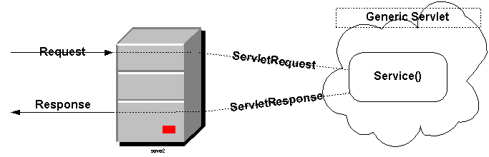

ServletRequest Interface
Defines an object to provide client request information to a servlet. We know already that the client request data comes in text form from the browser to the web server. When a request from a browser is handed over to the servlet container - the container creates an object that transforms row text data into object fields. This object, created by the container, must implement ServletRequest interface and is being passed as an argument to the servlet's service method.

A ServletRequest object contains request data including parameter name and values, attributes, and an input stream.

Unfortunately ServletRequest interface has many methods that need to be implemented. Here are some useful methods of this interface:

Useful Methods:
Method | Return Type | Description
getParameterNames() | Enumeration | Returns an Enumeration of String objects containing the names of the parameters contained in this request. We already know that http request sends HTML Form data as parameters.
getParameter(String name) | String | Returns the value of a request parameter as a String, or null if the parameter does not exist. If there are multiple values for a given parameter, then this method will return the first value in the list. In that case, use getParameterValues() instead.
getParameterValues(String name) | String[] | Returns an array of String objects containing all of the values the given request parameter has, or null if the parameter does not exist. Please keep in mind that although parameters normally have one value, it is allowed that parameters have multiple values. Using this method with getParameterNames() we can examine all parameter names and their values (HTML Form data) within the service() method.
getContentLength() | int | Returns the length, in bytes, of the request body and made available by the input stream, or -1 if the length is not known.
getContentType() | String | Returns the MIME type of the body of the request, or null if the type is not known.
getReader() | BufferedReader | Retrieves the body of the request as character data using a BufferedReader.
getInputStream() | ServletInputStream | Retrieves the body of the request as binary data using a ServletInputStream.
getRemoteAddr() | String | Returns the Internet Protocol (IP) address of the client that sent the request.
getRemoteHost() | String | Returns the fully qualified name of the client that sent the request, or the IP address of the client if the name cannot be determined.
getServerName() | String | Returns the host name of the server that received the request.
getServerPort() | Int | Returns the port number on which this request was received.
getProtocol() | String | Returns the name and version of the protocol the request uses in the form protocol/majorVersion.minorVersion, for example, HTTP/1.1.
getScheme() | String | Returns the name of the scheme used to make this request, for example, http, https, or ftp.
isSecure() | boolean | Returns a boolean indicating whether this request was made using a secure channel, such as HTTPS.
setAttribute(String name, Object o) | Void | Stores an attribute in this request. This is a very useful method when one servlet forwards a request to another servlet or JSP. Servlets/JSPs can add additional data to the request object before forwarding to the next servlet. Also servlet container can add attributes to the request object using this method.
getAttributeNames() | Enumeration | Returns an Enumeration containing the names of the attributes available to this request.
getAttribute(String name) | Object | Returns the value of the named attribute as an Object, or null if no attribute of the given name exists. Using this method with getAttributeNames() a servlet can retrieve all attribute names and values added by other servlets.
removeAttribute(String name) | Void | Removes an attribute from this request.
getRequestDispatcher(String path) | RequestDispatcher | Returns a RequestDispatcher object that acts as a wrapper for the resource located at the given path.

ServletResponse Interface
Now we know that we get the request data from the browser in the form of ServletRequest object. What about the data going back to the browser from the web server? Well, that’s the response. ServletResponse interface defines an object to assist a servlet in sending a response back to the client. The servlet container creates a ServletResponse object that is mostly empty (other than initializing a couple of fields to default values) and passes it as an argument to the servlet's service() method. This way, the response is already in progress and the service method doesn’t have to create the response from scratch. Sending a response turns out to be extremely simple. Basically, you have to get the PrinteWriter object of the ServletResponse by calling getWriter() method on it and then call the print()/println() method on it repeatedly.

Unfortunately ServletResponse interface also has many methods that need to be implemented. Here are some useful methods of this interface:

Useful Methods:
Method | Return Type | Description
setContentType(String type) | Void | Sets the content type of the response being sent to the client.
setContentLength(int len) | Void | Sets the length of the content body in the response In HTTP servlets, this method sets the HTTP Content-Length header. You normally don’t have to set it manually – the container will.
getWriter() | PrintWriter | Returns a PrintWriter object that can send character text to the client.
getOutputStream() | ServletOutputStream | Returns a ServletOutputStream suitable for writing binary data in the response.
SetBufferSize(int size) | Void | Sets the preferred buffer size for the body of the response.
getBufferSize() | Int | Returns the actual buffer size used for the response.
flushBuffer() | Void | Forces any content in the buffer to be written to the client.
IsCommitted() | Boolean | Returns a boolean indicating if the response has been committed.
reset() | Void | Clears any data that exists in the buffer as well as the status code and headers.

Our First Servlet – that actually works
Finally, we are ready to write a servlet that will actually send a response back to the browser.

Here is the code:

import java.io.IOException;
import java.io.PrintWriter;

import javax.servlet.GenericServlet;
import javax.servlet.ServletException;
import javax.servlet.ServletRequest;
import javax.servlet.ServletResponse;
public class Servlet2 extends GenericServlet
{

public void service(ServletRequest request, ServletResponse response)
throws ServletException, IOException{

System.out.println("In service");

String name = null;
PrintWriter out = null;

// getting request parameter
name = request.getParameter("name");
if (name!=null){
System.out.println("Parameter 'name'= " + request.getParameter("name"));
}

//set the content type to html
response.setContentType("text/html");

// get the writer object and write.
out = response.getWriter();

System.out.println("Sending response");

out.println("<HTML>");
out.println("<HEAD>");
out.println("<TITLE>");
out.println("Welcome to Servlet");
out.println("</TITLE>");
out.println("</HEAD>");
out.println("<BODY>");
if (name==null){
out.println("<H1>Welcome to the wonderful world of servlet</H1>");
}
else{
out.println("<H1> Hello " + name + ", Welcome to the wonderful world of servlet</H1>");
}
out.println("</BODY>");
out.println("</HTML>");
out.close();
System.out.println("Finished service");
}
}

Please go to the WebContent folder of the project. Go to the WEB-INF folder and add the following in web.xml:

<servlet>
<servlet-name>Servlet2</servlet-name>
<servlet-class>Servlet2</servlet-class>
<load-on-startup>1</load-on-startup>
</servlet>
<servlet-mapping>
<servlet-name>Servlet2</servlet-name>
<url-pattern>/Servlet2</url-pattern>
</servlet-mapping>

From your web browser type:

http://localhost:8080/servlet/Servlet2?name=John

Here is the output:

type:

http://localhost:8080/JPIDemo7/Servlet2?name=John

Here is the output:
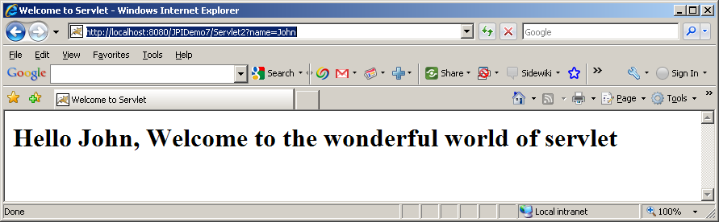

Here is Tomcat’s console output:

In service
Parameter 'name'= John
Sending response
Finished service

If you have Fiddler running and hit the same servlet with your IP Address instead of localhost and you check the raw tab of request and response, you will see the following:

Request:
-------
GET http://192.168.1.3:8080/JPIDemo7/Servlet2?name=John HTTP/1.1Accept: image/gif, image/x-xbitmap, image/jpeg, image/pjpeg, application/x-shockwave-flash, application/x-ms-application, application/x-ms-xbap, application/vnd.ms-xpsdocument, application/xaml+xml, */*
Accept-Language: en-us
UA-CPU: x86
Accept-Encoding: gzip, deflate
User-Agent: Mozilla/4.0 (compatible; MSIE 7.0; Windows NT 5.1; GTB6.4; .NET CLR 1.1.4322; .NET CLR 2.0.50727; .NET CLR 3.0.04506.648; .NET CLR 3.5.21022)
Host: 192.168.1.3:8080
Connection: Keep-Alive

Response:
--------
HTTP/1.1 200 OK
Server: Apache-Coyote/1.1
Content-Type: text/html
Content-Length: 155
Date: Sat, 10 Apr 2010 13:04:35 GMT

<HTML>
<HEAD>
<TITLE>
Welcome to Servlet
</TITLE>
</HEAD>
<BODY>
<H1> Hello John, Welcome to the wonderful world of servlet</H1>
</BODY>
</HTML>

HttpServlet Class
GenericServlet is nice but it is protocol-independent. In order to provide different response for different type of HTTP requests (GET, POST, OPTIONS etc.) we have to lookup the request method in service() method and act differently. Also, there is no method to read HTTP request header information. In order to avoid these problems J2EE provides a sub-class of GenericServlet that is specifically designed to handle HTTP protocol – HttpServlet.

HttpServlet introduces a set of new methods. Interestingly, HttpServlet is an abstract class but all it’s methods are already implemented. Why is this class abstract then? The reason is simple but not obvious. The default implementation of all the important methods of HttpServlet object actually return HTTP error – nothing useful. Hence, it is expected that we will always subclass HttpServlet and override one or more of these methods. In order to ensure that we do – HttpServlet class has been defined abstract.

Here are the new methods introduced and implemented in HttpServlet:

Method | Return Type | Description
service(HttpServletRequest req, HttpServletResponse resp) | protected void | The original public service() method (that receives ServletRequsest and ServletResponse) calls this protected service() method. This method – after receiving standard HTTP requests from the public service method - dispatches them to the doXXX methods defined in this class.  You should not override this method.
doGet(HttpServletRequest req, HttpServletResponse resp) | protected void | Called by the server (via the service method) to allow a servlet to handle a GET request.  The default implementation reports an HTTP BAD_REQUEST error.  Servelets that support HTTP GET request should override this method.
doPost(HttpServletRequest req, HttpServletResponse resp) | protected void | Called by the server (via the service method) to allow a servlet to handle a POST request.  The default implementation reports an HTTP BAD_REQUEST error.  Servelets that support HTTP POST request should override this method.
doHead(HttpServletRequest req) | protected void | Returns HTTP header information.  The default implementation runs doGet() and returns the header only.  Servlets that support HTTP GET requests should override this method to accomplish efficient response.
getLastModified(HttpServletRequest req) | protected long | Returns the time the HttpServletRequest object was last modified, in milliseconds since midnight January 1, 1970 GMT. This method is called by browsers and proxies that cache pages to check if the cached page is still good.  The default implementation returns a negative number, indicating that the modification time is unknown and hence should not be used for conditional GET operations or for other cache control operations as this implementation will always return the contents.  Servlets that support HTTP GET requests should override this method to accomplish efficient response.
doOptions(HttpServletRequest req, HttpServletResponse resp) | protected void | Called by the server (via the service method) to allow a servlet to handle OPTIONS request.  The default implementation determines which HTTP methods the server supports and returns an appropriate header. For example, if a servlet overrides doGet, this method returns the following header: Allow: GET, HEAD, TRACE, OPTIONS  There's no need to override this method.
doPut(HttpServletRequest req, HttpServletResponse resp) | protected void | Called by the server (via the service method) to allow a servlet to handle a PUT request.  The default implementation reports an HTTP BAD_REQUEST error.  Servelets that support HTTP PUT request should override this method.
doDelete(HttpServletRequest req, HttpServletResponse resp) | protected void | Called by the server (via the service method) to allow a servlet to handle a DELETE request.  The default implementation reports an HTTP BAD_REQUEST error.  Servelets that support HTTP DELETE request should override this method.
doTrace(HttpServletRequest req, HttpServletResponse resp) | protected void | Called by the server (via the service method) to allow a servlet to handle a TRACE request.  The default implementation of this method causes a response with a message containing all of the headers sent in the trace request.  There is no need to override this method.

Notice that HttpServlet actually introduces an overloaded protected service() method that receives HttpServletRequest and HttpServletResponse as arguments. But we already know that servlet container calls the other public service() method that receives ServletRequest and ServletResponse as arguments. So who calls this method? The answer is a bit complicated.

HttpServlet overrides the original public service(ServletRequest req, ServletResponse res) method so that it calls the protected service(HttpServletRequest req, HttpServletResponse resp). HttpServletRequest and HttpServletResponse are two new interfaces that are extended from ServletRequest and ServletResponse respectively.

service(HttpServletRequest req, HttpServletResponse resp) method, in turn, checks the HTTP request type (by calling getMethod() on HttpServletRequest) and forwards the request to the appropriate doXXX method (for example doGet(), doPost() etc.).

Typically we would want to send the same response to the user regardless of whether the request is a GET or POST request. In that case, we simple overwrite the doGet() method and call it from doPost() method or vice versa.
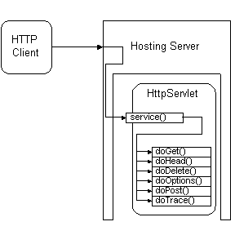

HttpServletRequest Interface
This interface extends the ServletRequest interface to provide request information for HTTP servlets.
The servlet container actually creates an object that implements HttpServletRequest (we were not precisely correct when we said it creates ServletRequest object) and passes it as an argument to the servlet's service method. HttpServletRequest interface has a number of new methods. Here are some useful methods in HttpServletRequest interface:

Useful Methods:
Method | Return Type | Description
getHeader(String name) | String | Returns the value of the specified request header as a String.
getHeaders(String name) | Enumeration | Returns all the values of the specified request header as an Enumeration of String objects. Using this method with getHeaderNames() a servlet can retried all header names and values.
getIntHeader(String name) | int | Returns the value of the specified request header as an int. This method is identical to getHeader() – it merely does an additional String to int conversion.
getDateHeader(String name) | long | Returns the value of the specified request header as a long value that represents a Date object. This method is identical to getHeader() – it merely does an additional String to long conversion.
getMethod() | String | Returns the name of the HTTP method with which this request was made, for example, GET, POST, or PUT.
getHeaderNames() | Enumeration | Returns an enumeration of all the header names this request contains.
getRequestURI() | String | Returns the part of this request's URL that uniquely identifies the servlet on a server.  For example, if my URL looks like:  http://localhost:8080/testapp/servlet/RequestInfoExample  The requested URI would be:  /testapp/servlet/RequestInfoExample
getServletPath() | String | Returns the part of this request's URL that calls the servlet.  For example, if my URL looks like:  http://localhost:8080/testapp/servlet/RequestInfoExample  The servlet path would be:  /servlet/RequestInfoExample
getContextPath() | String | Returns the portion of the request URI that indicates the context of the request.  For example, if my URL looks like:  http://localhost:8080/testapp/servlet/RequestInfoExample  The context path would be:  /testapp
getQueryString() | String | Returns the query string that is contained in the request URL after the path.  For example, if my URL looks like:  http://localhost:8080/testapp/servlet/RequestInfoExample ?user_name=Mohammed&password=1234  The query string would be:  user_name=Mohammed&password=1234
getCookies() | Cookie[] | Returns an array containing all of the Cookie objects the client sent with this request.
getRequestedSessionId() | String | Returns the session ID specified by the client.
isRequestedSessionIdFromCookie() | boolean | Checks whether the requested session ID came in as a cookie.
isRequestedSessionIdFromURL() | boolean | Checks whether the requested session ID came in as part of the request URL.
isRequestedSessionIdValid() | boolean | Checks whether the requested session ID is still valid.
getSession() | HttpSession | Returns the current session associated with this request, or if the request does not have a session, creates one.
getSession(boolean create) | HttpSession | Returns the current HttpSession associated with this request or, if if there is no current session and create is true, returns a new session.
getAuthType() | String | Returns the name of the authentication scheme used to protect the servlet, for example, "BASIC" or "SSL," or null if the servlet was not protected.
getRemoteUser() | String | Returns the login of the user making this request, if the user has been authenticated, or null if the user has not been authenticated.

HttpServletResponse Interface
This interface extends the ServletResponse interface to provide response information for HTTP servlets. The servlet container creates an object that implements HttpServletResponse (again we were not precisely correct when we said ServletResponse) and passes it as an argument to the servlet's service method. HttpServletResponse interface has a number of new methods. Here are some useful methods in HttpServletResponse interface:

Useful Methods:

Method | Return Type | Description
setStatus(int sc) | void | Sets the status code for this response.
addHeader(String name, String value) | void | Adds a response header with the given name and value.
setHeader(String name, String value) | void | Sets a response header with the given name and value.
addIntHeader(String name, int value) | void | Adds a response header with the given name and integer value.
setIntHeader(String name, int value) | void | Sets a response header with the given name and integer value.
addDateHeader(String name, long date) | void | Adds a response header with the given name and date-value.
setDateHeader(String name, long date) | void | Sets a response header with the given name and date-value.
containsHeader(String name) | boolean | Returns a boolean indicating whether the named response header has already been set.
addCookie(Cookie cookie) | void | Adds the specified cookie to the response.
encodeRedirectURL(String url) | String | Encodes the specified URL for use in the sendRedirect method or, if encoding is not needed, returns the URL unchanged.
encodeURL(String url) | String | Encodes the specified URL by including the session ID in it, or, if encoding is not needed, returns the URL unchanged.
sendError(int sc) | void | Sends an error response to the client using the specified status.
sendError(int sc, String msg) | void | Sends an error response to the client using the specified status code and descriptive message.
sendRedirect(String location) | void | Sends a temporary redirect response to the client using the specified redirect location URL.

Servlet – Again!
So, what is Servlet again? Servlets are server-side component that runs in a servlet container like JRun, Tomcat. Servlet container is typically integrated with a web server (like Tomcat can be integrated with Apache Web Server or IIS). Although Servlets can be used in any application it is typically used with web applications. Servlet provides web developers with a simple mechanism for extending the functionality of a web server. Complex web sites often need to provide HTML pages that are tailored for each visitor, or even for each hit. Servlets can be written to process HTML pages and customize them as they are sent to a client. For example, a client may need information from a database; a servlet can be written that receives the request, gets and processes the data as needed by the client, and then returns it to the client.

Servlets have access to the entire family of Java APIs, including the JDBC API to access enterprise databases. Servlets can also access a library of HTTP-specific calls and receive all the benefits of the mature Java language. Today, servlets are a popular choice for building interactive web applications.

Servlet classes and interfaces are defined in two packages

- javax.servlet
- javax.servlet.http

Here is a servlet that examines a request and sends back all the information is gathers from the request:

import java.io.IOException;
import java.io.PrintWriter;
import java.util.Enumeration;

import javax.servlet.ServletException;
import javax.servlet.http.HttpServlet;
import javax.servlet.http.HttpServletRequest;
import javax.servlet.http.HttpServletResponse;

public class RequestExaminerServlet extends HttpServlet {

protected void doGet(HttpServletRequest request, HttpServletResponse response)
throws ServletException, IOException
{
Enumeration headerNames = null;
String headerName = null;
Enumeration headerValues =null;
String headerValue = null;
PrintWriter out = null;
Enumeration parameterNames = null;
String parameterName = null;
String[] parameterValues =null;
String parameterValue = null;

// get the writer and set output content type
out = response.getWriter();

//set content type
response.setContentType("text/plain");

// print request info.
out.println("Protocol: " + request.getProtocol());
out.println("Scheme: " + request.getScheme());
out.println("Server Name: " + request.getServerName());
out.println("Server Port: " + request.getServerPort());
out.println("Remote Addr: " + request.getRemoteAddr());
out.println("Remote Host: " + request.getRemoteHost());
out.println("Content Length: " + request.getContentLength());
out.println("Content Type: "+ request.getContentType());
out.println("Locale: "+ request.getLocale());
out.println("Default Response Buffer: "+ response.getBufferSize());
out.println("HTTP Method: " + request.getMethod());
out.println("Request URI: " + request.getRequestURI());
out.println("Context Path: " + request.getContextPath());
out.println("Servlet Path: " + request.getServletPath());
out.println("Request Is Secure: " + request.isSecure());
out.println("Query String: " + request.getQueryString());
out.println();

// print request header
out.println("Headers in this request:");
headerNames = request.getHeaderNames();
while (headerNames.hasMoreElements()) {
headerName = (String)headerNames.nextElement();
headerValues = request.getHeaders(headerName);
out.print(" " + headerName + " = ");
while (headerValues.hasMoreElements()) {
headerValue = (String) headerValues.nextElement();
out.print(headerValue + "\t");
}
out.println();

}
out.println();

// print request parameter
out.println("Parameter names in this request:");
parameterNames = request.getParameterNames();
while (parameterNames.hasMoreElements()) {
parameterName = (String) parameterNames.nextElement();
parameterValues = request.getParameterValues(parameterName);
out.print(" " + parameterName + " = ");
for(int i = 0; i < parameterValues.length; i++) {
parameterValue = parameterValues[i];
out.print(parameterValue + "\t");
}
out.println();
}
out.println();
}
}

Here is the segment to be added to web.xml:

<servlet>
<servlet-name>RequestExaminerServlet</servlet-name>
<servlet-class>RequestExaminerServlet</servlet-class>
<load-on-startup>1</load-on-startup>
</servlet>
<servlet-mapping>
<servlet-name>RequestExaminerServlet</servlet-name>
<url-pattern>/RequestExaminerServlet</url-pattern>
</servlet-mapping>

From your web browser type:
http://192.168.1.3:8080/JPIDemo7/RequestExaminerServlet?name=John&age=30

Here is the output you get:

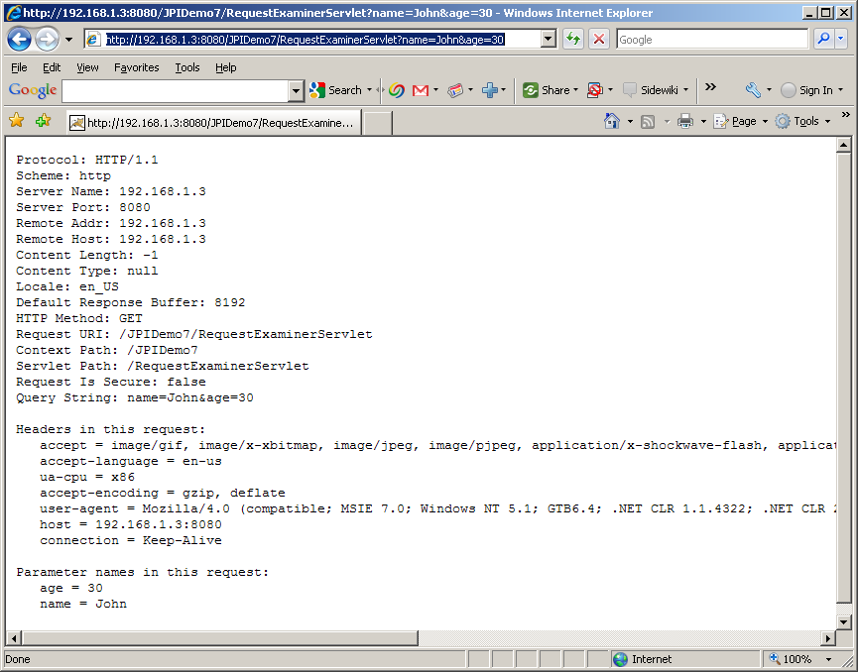

Notice the query string and parameter name & values above.

J2EE Web Terminology
Web Components:
Java Servlet and JSP (which is essentially another form Servlet) are the building blocks for developing web applications. In J2EE – these are called web components.

Web Application:
In J2EE, a web application is a collection of web components like Java Servlets, JSP pages, other helper classes as well as static resources like HTML, XML documents. Web applications reside on web container.

Web Container:
in J2EE, a web container is essentially a Java runtime environment that supports Java Servlets and JSPs. The web container is responsible for initializing, invoking and managing the life cycle of Java Servlets and JSPs. In other words, web container is where web applications reside and run.

Web Server:
In J2EE, a web server is an HTTP server that either serves static page requests or delegates the requests to the web container. Tomcat is an extraordinary web container that can be plugged into many web servers (like IIS or Apache) or it can also server as a web server.

Structure of Web Application
A web application has the following parts:

- A public directory – this is the root directory of the web application. If you are familiar with HTTP servers like IIS this is the wwwroot directory. In case of Apache this would be htdocs direcory. In case of Tomcat – is it the root directory of the web application. This is where you keep your HTML files.
- A “WEB-INF” directory – this directory is private. The container will not directly serve any contain of this directory.
- A “web.xml” file in WEB-INF directory. This is the deployment descriptor for the servlets.
- A “classes” subdirectory under WEB-INF. This is the directory where you put your servlet class files in development mode. Tomcat is case sensitive. Please make sure that the “classes” folder is in lowercase for the application you are working on.
- A “lib” directory under WEB-INF. This is where you keep your packaged JAR files.

Creating a new Web Application in Tomcat
Let’s consider that we want to create a new Web Application called “testapp” in your Tomcat web container.

First, please make sure that you are not running Tomcat from Eclipse or from startup.bat. Using Windows Explorer please navigate to Tomcat folder on your disk and:

- create a “testapp” folder under Tomcat’s webapps folder.
- create a WEB-INF folder under testapp. All uppercase letters in “WEB-INF”.
- create a classes folder under WEB-INF. All lowercase lettters in “classes”.
- copy the RequestExaminerServlet.class (NOT .java) from Eclipse’s JPIDemo7’s ‘build\classes’ folder to testapp’s classes folder.
copy web.xml from Eclipse’s JPIDemo7’s WEB-INF folder to testapp’s WEB-INF folder

- Re-start Tomcat using startup.bat. This is essential for your application to be visible.
- type http://localhost:8080/testapp/RequestExaminerServlet – it will take a few seconds and bring back the response from RequestExaminerServlet.
- Let’s now try to name “RequestExaminerServlet” as “displayrequest.html”
- goto “c:\tomcat5028\webapps\testapp\WEB-INF and open web.xml in wordpad.
- Let’s override the content of web.xml with the following:

<?xml version="1.0" encoding="ISO-8859-1"?>

<!DOCTYPE web-app
PUBLIC "-//Sun Microsystems, Inc.//DTD Web Application 2.3//EN"
"http://java.sun.com/dtd/web-app_2_3.dtd">

<web-app>
<servlet>
<servlet-name>
feedback
</servlet-name>
<servlet-class>
RequestExaminerServlet
</servlet-class>
</servlet>
<servlet-mapping>
<servlet-name>
feedback
</servlet-name>
<url-pattern>
/displayrequest.html
</url-pattern>
</servlet-mapping>
</web-app>

- Stop Tomcat and re-start Tomcat. Again, this is essential for Tomcat to kick-in the changes.

- http://localhost:8080/testapp/displayrequest.html

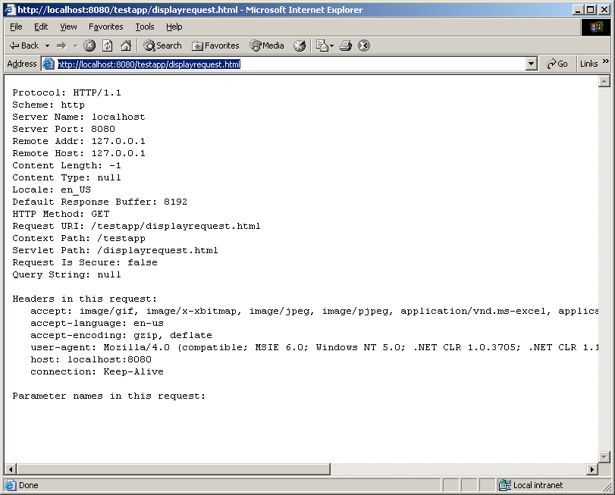
It should bring back following response:

- If you want to deploy some static pages like signup.html and thankyou.html, please copy those two files directly in testapp folder under Tomcat and hit the following url:

http://localhost:8080/testapp/signup.html

When you are ready hit send and you will hit the following url:

http://localhost:8080/testapp/thankyou.html

I gave you the whole testapp folder structure with web.xml configured. You can simply copy and paste the folder structure under Tomcat’s webapps folder and you got the new application deployed.

Sequence of events related to a HTTP Request

When an HTTP request comes to web server (that has web container plugged in) the following sequence of event occurs:

The web server figures out whether the incoming request corresponds to a resource that it can handle (like html page) or it is part of a web application. If the web server does not find it as a resource that it can serve, then it consults the web container. A web container may have more than one web application running at any given time. Therefore, the web container uses the notion of context to identify resources that belong to web applications. You have to specify this context when you deploy a new web application on a web container. So far, we have used two web applications – JPIDemo7 and testapp.

- Once, the web application has been decided, now it is time to decide on the resource. In a J2EE web application, an URL can be mapped to a servlet, JSP or static resource like HTML page, an image, an XML document etc using a component deployment descriptor. The component deployment descriptor is web.xml file located in Web-inf folder of the web application. Here is an example of mapping RequestExaminerServlet to displayrequest.html:

<servlet>
<servlet-name>
feedback
</servlet-name>
<servlet-class>
RequestExaminerServlet
</servlet-class>
</servlet>
<servlet-mapping>
<servlet-name>
feedback
</servlet-name>
<url-pattern>
/displayrequest.html
</url-pattern>
</servlet-mapping>

All other resouces map to exactly where there are physically located.

- Once the web container figures out the resource as part of a web application, the HTTP server delegates the request to the web container.

- If the web container determines, based on the deployment descriptors of web application and web component that the request should be handled by a servlet, the container:

- Converts the byte steam of request to an HttpServletRequest object. It creates an HttpServletResponse object (almost empty – except for a few default attributes)
- Either creates a brand new servlet instance or re-uses one of the existing servlet instances and delegates the HttpServeltRequest and HttpServletResponse object to the service() method of the servlet.

- The service() method of the servlet delegates the request to the appropriate doXXX method.

- The doXXX method reads the HttpServletRequest object and writes to the HttpServletResponse object. This is where all the custom code goes. Each servlet looks for its own set of parameters in the request object and assembles the response objects – totally dynamically.

- When the service method returns, the web-container decomposes the HttpServletResponse object into a stream of bytes and forwards it to the web server as response.

- The web server sends the response stream of bytes to the browser.

- The browser on the client machine reads the response stream of bytes and presents it the user.

Reading a HTTP Request
We already know that request is composes of three things:
- Request Line
- Request Header
- Request Body

Here is how to read them:

Reading Request Line
The getMethod() method returns the HTTP request method (GET, POST etc). The getRquestURI() method returns the part of the URL that comes after the host and port but before the form data. For example if the request looks like:

http://localhost:8080/thankyou.html?user_name=Mohammed+Rahman&user_password=12345&email_account=true&grade=LG&skill=B&webserver=A&webserver=I&Comments=I+am+sending+a+get+request.%0D%0A%0D%0ALet%27s+see+what+happens+to+the+url%09

The URI is “thankyou.html”

The getProtocol() method returns the third part of the request line, which is generally HTTP/1.0 or HTTP/1.1.

Reading Request Headers
Reading request headers is straightforward, just call the getHeader() method of HttpServletRequest with the header name and the method will return the header value as String if the specified header was supplied on the request, null otherwise.

If the Header can have multiple values use getHeaders() instead.

Unlike parameter, Header names are not case-sensitive. So, for example getHeader(“Connection”) and getHeader(“connection”) are interchangeable. If the header is expected to be int or Date use getIntHeader() or getDateHeader() which will read the specified header convert it to int or Date values respectively.

getIntHeader() returns –1 if the header is not included in the request and throws NumberFormatException if the header can not be converted to int.
getDateHeader() returns – 1 id the header is not included in the request and throws IllegalArgumentException if the header can not be converted to Date.

In addition, getHeaderNames(), getHeaders() methods can be used to find out the names of all the headers and their values.

Although getHeader() is the general-purpose way to read incoming headers – certain headers are so commonly used that they have separate access methods in HttpServletRequest. Here are those:

- getContentType() and getContentLength() – Returns the value of content type(String) and length(int) header.

- getAuthorType() and getRemoteUser() – These two methods break the Authorization headed into its component piece. Authorization will be discussed later.

- getCookies() – Returns the contents of the Cookie header, parsed and stored in an array of Cookie objects. Cookies will be discussed later.

Reading Request Body
One of the nice features of Servlet is that the Query String (Form Data) parsing is handled automatically, regardless whether it is located in the body (POST) or on the url itself (GET). Therefore, you don’t really have to read the body. You simply call the getParameter() method of the HttpServletRequest with the parameter name and the method will return the parameter value as String if the specified parameter was supplied on the request , null otherwise.

If the parameter can have multiple values use getParameterValues() instead.

Unlike Headers, Parameter names are case-sensitive. So, for example, getParameter(“Password”) and getParameter(“password”) are two different things.

Unless, the request message is binary data (which is very rare) you don’t have to look at the input stream of the request.

Writing HTTP Response
We already know that a Response consists of three things:

- Status Line
- Response Header
- Response Message

Here is how to write them:

Writing Response Status Line
A HTTP response status line consists of an HTTP version(like HTTP/1.1), a status code(like 200) and an associated message(like Ok). Since the status message is directly associated with the status code - all a servlet needs to do is to set the status code. The way to do this is by the setStatus() method of HttpServletResponse object. HTTP version is determined and set by the server.

However, most of the time you don’t have to set the status at all. A value of 200(SC_OK) means that everything is fine and this status is automatically set on the response object as default. If you don’t specify the status the response will get 200 status.

If you do want to return a special status code and a document, please be sure to call setStatus() before you write the body of the response. That’s because an HTTP response consists of the status line, one or more headers, a blank line and the actual document, in that order. Although servlet specification version 2.2 allows buffering of response – the size of the buffer is left unspecified. Therefore, the safest thing to do is to set the status first.

The setStatus() method takes int as an argument(as status code) but instead of using explicit numbers, it is clearer and more readable to use the constants defined in HttpServletResponse.

Although the general method of setting status codes is simply to call setStatus(), there are two common cases where a shortcut method in HttpServletResponse can be used. Both of these methods throw IOException, whereas setStatus() doesn’t.

- public void sendError(int code, String message)
The sendError() method sends a status code, usually 404(constant SC_NOT_FOUND) – “Not Found” - along with a short message that is automatically formatted inside an HTML document and sent to the client.

- public void sendRedirect(String url)
The sendRedirect() method sends a status code 302(constant SC_MOVED_TEMPORARILY) along with Location header giving the URL of the new document. The status message was “Moved Temporarily” in HTTP 1.0 but it is “Found” in HTTP 1.1.With servlets specification version 2.1 the String must be an absolute URL but in 2.2 either absolute or relative URL is permitted and the system automatically translates relative URL into absolute URL before putting them in the Location header.

If the response has already been committed, this method throws an IllegalStateException. After using this method, the response should be considered to be committed and should not be written to.

Writing Response Header
Writing response headers is straightforward too, just call the setHeader() method of HttpServletResponse with the header name and header value. Please be sure to call setStatus() (if you must set the status) before you write the header of the response. That’s because an HTTP response consists of the status line, one or more headers, a blank line and the actual document, in that order. Although servlet specification version 2.2 allows buffering of response – the size of the buffer is left unspecified. Therefore, the safest thing to do is to set the headers first.

If the Header can have multiple values use addHeader() instead since setHeader() that overwrites the header value (in servlet specification 2.1 setHeader() always added new values – leaving no option to unset a header). If you want to check whether a specific header is already been set, use containsHeader() method.

As Request Headers, Response Header names are not case-sensitive. So, for example setHeader(“Connection”, “Closed”) and setHeader(“connection”,”Closed”) are interchangeable. If the header is int or Date use setIntHeader() or setDateHeader() respectively. To add multiple values of int or Date header use addIntHeader() or addDateHeader() respectively.

Although setHeader() is the general-purpose way to set outgoing headers – certain headers are so commonly used that they have separate methods in HttpServletResponse. Here are those:

- public void setContentType(String type)
This method sets the content-type header (for example text/html, text/xml, text/plain etc.). This method should be called in a servlet as one of the very first step.

b) public void setContentLength(int len)
This method sets the content-length header and is only useful if the browser supports persistent(keep-alive) connection and the servlet wants to take advantage of it.

c) public void addCookie(Cookie cookie)
This method inserts a cookie into the Set-Cookie header. This method can be called multiple times to set more than one cookie. There is no corresponding setCookie() method. Cookies will be discussed later.

Writing Response Message
Writing Response message is straightforward too. In order to write simple text/html or text/plain message simply call the getWriter() method of HttpServletResponse. This will return a PrintWriter (16 bit – Unicode) object. Use the print() or println() method of the PrintWriter object to write. Finally close the PrintWriter.

In case of binary output you need to call the getOutPutSteam() method of HttpServletResponse. This will return ServletOutputSteam (8 bit – ASCII). Use the print() or println() method of the ServletOutputStream object to write. Finally close the ServletOutputStream.

Here is an html page name.html that captures user input that goes in JPIDemo7 folder:

<html>
<head><title>Name Entry Screen</title></head>
<body>
<form method="GET" action="HelloServlet">
Please enter your name here:<br/>
<hr/>
Last Name <input type="text" name="lastname" size="15" /><br/>
First Name <input type="text" name="firstname" size="15" /><br/><br/>
<input type="checkbox" name="programmer" >Java Programmer<br>
<hr/>
<input type="submit" name="submit" value="Send" />
<input type="reset" name="cancel" value="Cancel" />
<p/>
</form>
</body>
</html>

Right click on JPIDemo7 project and select New -> Other and Select ‘Servlet’ from Web category. Type ‘HelloServlet’ as the servlet name. This will ensure that the servlet and it’s mapping is automatically defined in web.xml.

Here is the content of doGet and poPost that you need:

protected void doGet(HttpServletRequest request, HttpServletResponse response) throws ServletException, IOException {
// get the writer and set output content type
PrintWriter out = response.getWriter();
response.setContentType("text/html");

// print response
out.println("<html>");
out.println("<head>");
out.println("<title>");
out.println("Response from HelloServlet");
out.println("</title>");
out.println("</head>");
out.println("<body>");
if ((request.getParameter("firstname").equals("")) || request.getParameter("lastname").equals("")){
out.println("<h1>You did not enter your name properly</h1>");
}
else{
out.println("<h1>Hello " + request.getParameter("firstname") + " " + request.getParameter("lastname") + "</h1>");
if (request.getParameter("programmer")==null){
out.println("<h3>I am sorry, you are in the wrong class. You must know Java for this class</h3>");
}
else{
out.println("<h3>Wonderful, since you know Java, we can start talking Java now.</h3>");
}
}
out.println("</body>");
out.println("</html>");
}

/**
* @see HttpServlet#doPost(HttpServletRequest request, HttpServletResponse response)
*/
protected void doPost(HttpServletRequest request, HttpServletResponse response) throws ServletException, IOException {
doGet(request,response);
}

Run the application. Let’s hit the html page as follows :

http://localhost:8080/JPIDemo7/name.html

Here is what it looks like:
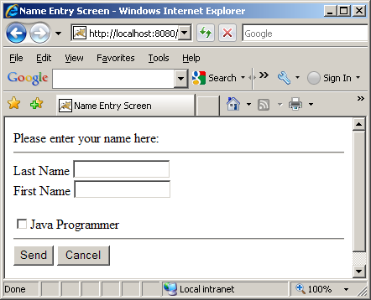

Here is the response when you hit the send button:
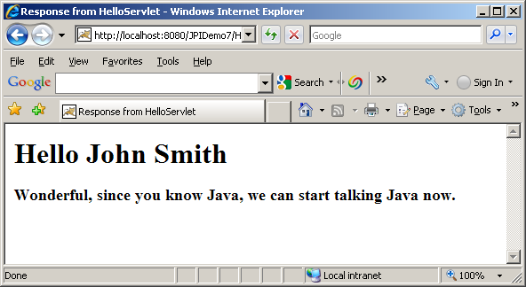

Please note one interest thing about checkboxes. Checkboxes don’t get transmitted as input parameter unless they are checked off. Unchecked check box simply disappears from the input data. You will save yourself a lot of trouble if you know this.

Homework Assignment
Write a servlet “RandomServlet” that generates 5 unique random numbers between 20 and 90 and returns them to the browser.

You can use the following formula to get random numbers between a range:

(int) ((Upperbound - Lowerbound+ 1) * Math.random() + Lowerbound)

Please use TreeSet from java collection classes so that the numbers are sorted and duplicate numbers are avoided. Usage of TreeSet is mandatory.

