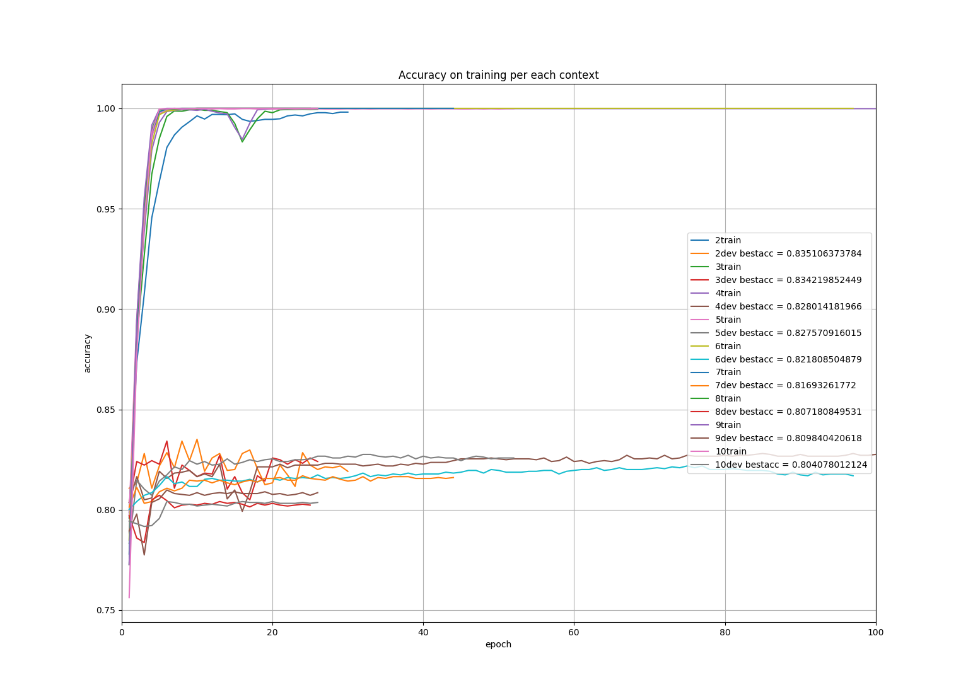
% max Accuracy on Dev for each context best model*
2context | 3context | 4context | 5context | 6context | 7context | 8context | 9context | 10context
83,5% | 83,42% | 82,80% | 82,75% | 82,18% | 81,69% | 80,71% | 80,98% | 80,40%

*i.e: best model per each context means that we trained 100 neural networks with variable input size 1:5:500 and we chose the one that performed a better accuracy over the 100 per each context. Xcontext mean, X words before and after the named entity, 2context means that we have 4 words in total per each named entity.
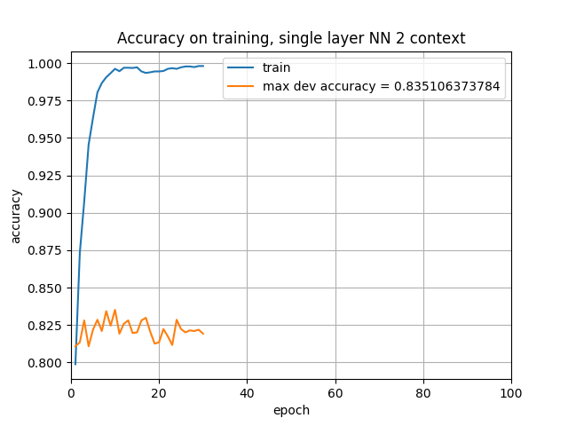

Normalized confusion matrix on test set

Prediction

[[ 0.14893617 0.31914894 0.53191489]
Ground truth –-> [ 0.00233645 0.85514019 0.14252336]
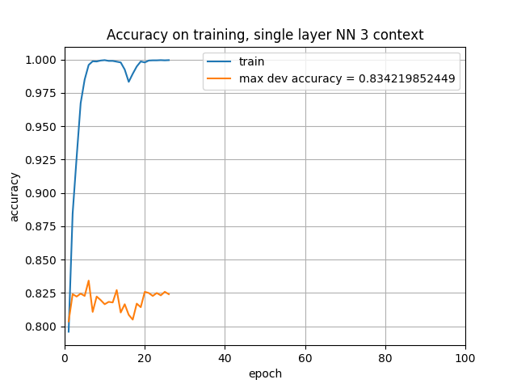
[ 0.01500938 0.12382739 0.86116323]]

[[ 0.17021277 0.27659574 0.55319149]
[ 0.00934579 0.84813084 0.14252336]
[ 0.00938086 0.15572233 0.83489681]]

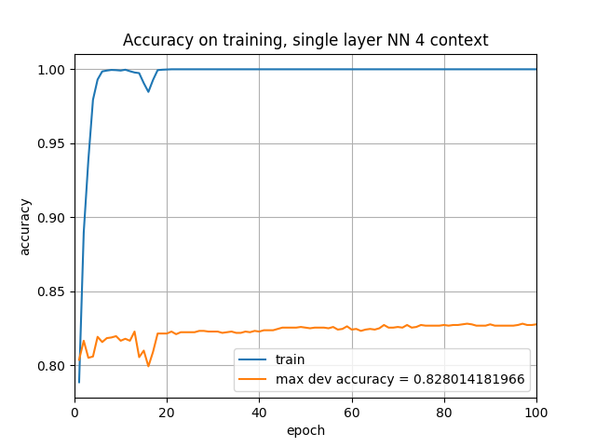
[[ 0.14893617 0.27659574 0.57446809]
[ 0.0046729 0.82943925 0.16588785]
[ 0.00938086 0.12945591 0.86116323]]
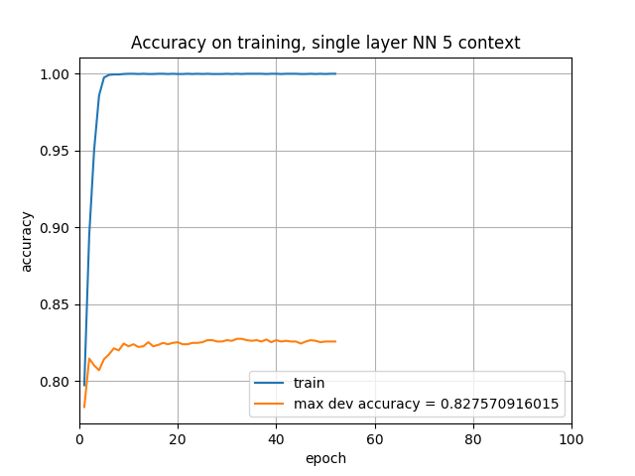
[[ 0.19148936 0.34042553 0.46808511]
[ 0.0046729 0.8271028 0.1682243 ]
[ 0.00562852 0.11444653 0.87992495]]
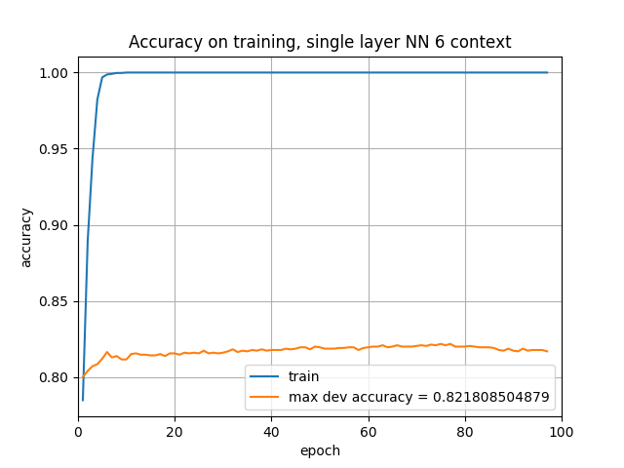
[[ 0.19148936 0.23404255 0.57446809]
[ 0.0046729 0.82476636 0.17056075]
[ 0.00938086 0.10881801 0.88180113]]
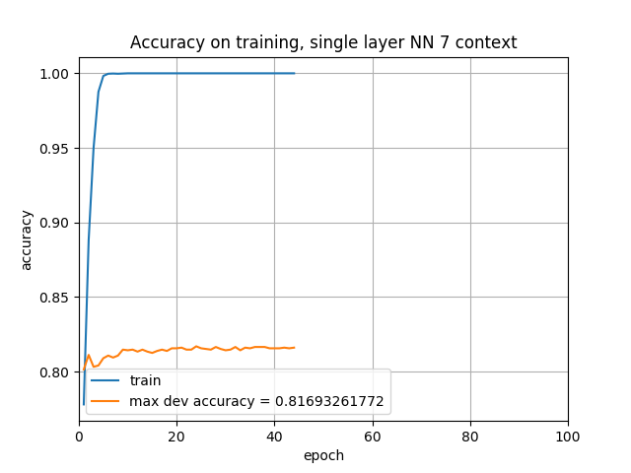

[[ 0.14893617 0.27659574 0.57446809]
[ 0.00700935 0.78037383 0.21261682]
[ 0.00750469 0.12007505 0.87242026]]

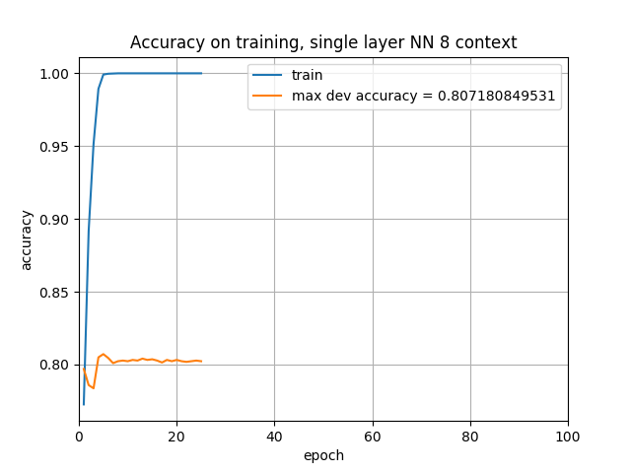
[[ 0.12765957 0.23404255 0.63829787]
[ 0.0046729 0.79205607 0.20327103]
[ 0.01125704 0.14071295 0.84803002]]
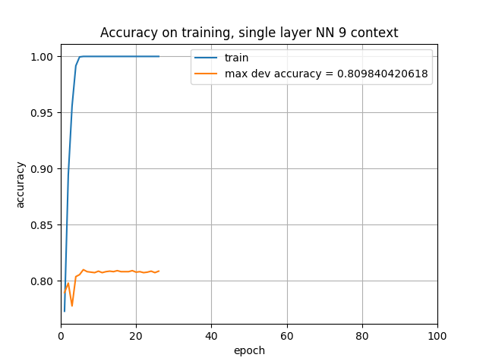
[[ 0.17021277 0.29787234 0.53191489]
[ 0.0046729 0.80841121 0.18691589]
[ 0.00375235 0.15009381 0.84615385]]

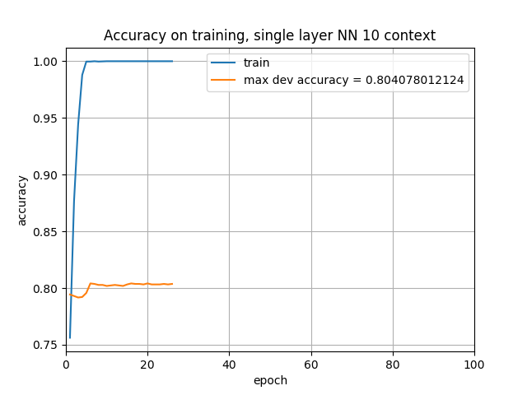
[[ 0.14893617 0.27659574 0.57446809]
[ 0.00700935 0.80140187 0.19158879]
[ 0.00938086 0.14446529 0.84615385]]

CONTINUACION :

ANOTACIONES DE CADA CLASE :

PRIMERA TEMPORADA :
1 60
X 55838
2 469
3 648

TODAS :

X 697019
1 545
2 4761
3 6587

TEMPORADAS 2 Y 3 (DEVELOPMENT)

temporada 2

1 65
X 69270
2 650
3 634

 | 1 | 2 | 3 | 4 | 5 | 6 | 7 | 8 | 9 | 10
X | 55838 | 69270 | 71357 | 76390 | 76155 | 76091 | 78649 | 75534 | 77164 | 40571
1 | 60 | 65 | 77 | 78 | 87 | 54 | 38 | 19 | 44 | 23
2 | 469 | 650 | 584 | 620 | 600 | 469 | 451 | 340 | 369 | 209
3 | 648 | 364 | 710 | 902 | 678 | 682 | 616 | 593 | 777 | 347

 | 1 | 2 | 3 | 4 | 5 | 6 | 7 | 8 | 9 | 10
X | 55838 | 69270 | 71357 | 76390 | 76155 | 76091 | 78649 | 75534 | 77164 | 40571
1 | 60 | 65 | 77 | 78 | 87 | 54 | 38 | 19 | 44 | 23
2 | 261 | 373 | 290 | 328 | 347 | 265 | 245 | 176 | 185 | 105
3 | 345 | 489 | 423 | 462 | 420 | 368 | 313 | 253 | 248 | 153
4 | 648 | 364 | 710 | 902 | 678 | 682 | 616 | 593 | 777 | 347

FINAL RESULTS ON ACCURACY

 | Cluster(max score) |  | No-Cluster
 | GlobalAcc | LocalAcc | GlobalAcc | LocalAcc
NNnoweights | 7,47% | 52,42% | 6,94% | 49,25%
NNnoweights4classes | 3,82% | 64,61% | 3,58% | 38,16%
NNweights | 7,20% | 49,11% | 6,94% | 47,46%
NNweights4classes | 3,74% | 47,43% | 3,19% | 34,92%
NNperclass | 2,40% | 1,52% | 1,23% | 0,86%
LSTMnoweights | 7,54% | 62,22% | 6,94% | 46,18%
LSTMnoweights4classes | 3,72% | 56,09% | 3,53% | 43,60%
LSTMweights | 7,26% | 47,12% | 6,70% | 47,05%
LSTMweights4classes | 7,25% | 47,10% | 6,68% | 46,97%
LSTMperclass | 6,87% | 41,62% | 6,56% | 34,38%
OracleSystem | 17.51896256422804%

