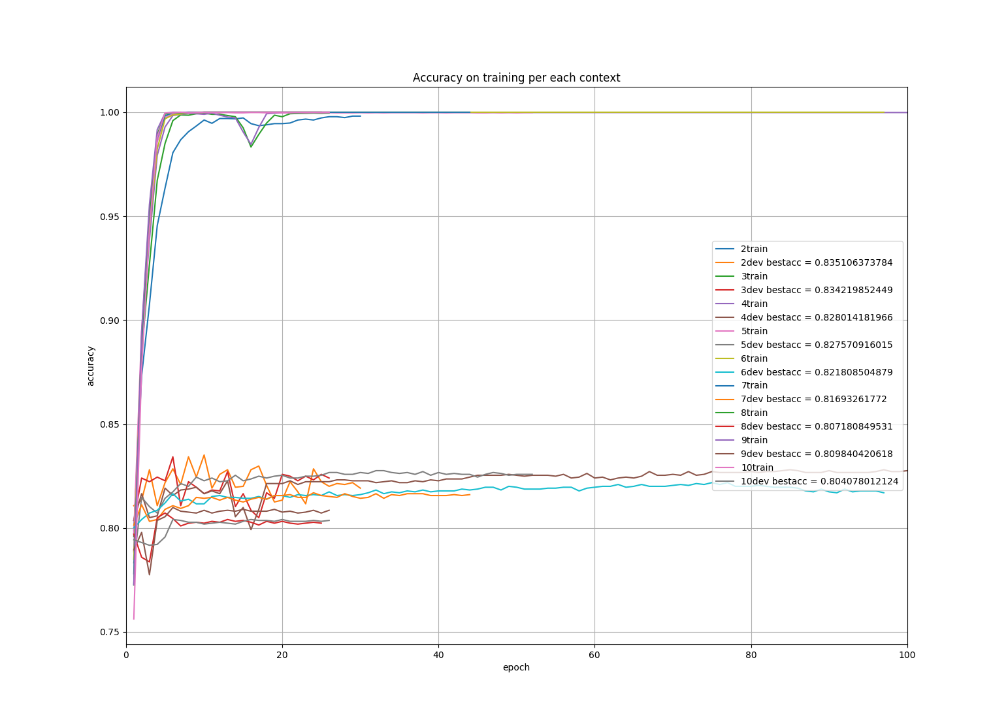
% max Accuracy on Dev for each context best model*
2context | 3context | 4context | 5context | 6context | 7context | 8context | 9context | 10context
83,5% | 83,42% | 82,80% | 82,75% | 82,18% | 81,69% | 80,71% | 80,98% | 80,40%

*i.e: best model per each context means that we trained 100 neural networks with variable input size 1:5:500 and we chose the one that performed a better accuracy over the 100 per each context. Xcontext mean, X words before and after the named entity, 2context means that we have 4 words in total per each named entity.
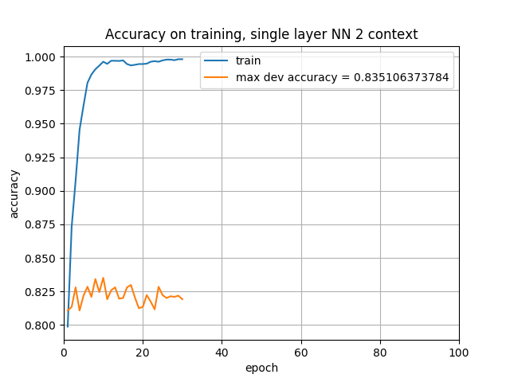

Normalized confusion matrix on TEST set

Prediction
1class 2class 3class
[[ 0.14893617 0.31914894 0.53191489]
Ground truth –-> [ 0.00233645 0.85514019 0.14252336]
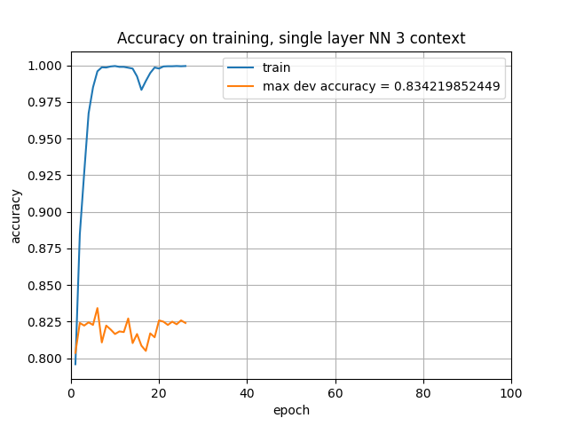
[ 0.01500938 0.12382739 0.86116323]]

[[ 0.17021277 0.27659574 0.55319149]
[ 0.00934579 0.84813084 0.14252336]
[ 0.00938086 0.15572233 0.83489681]]

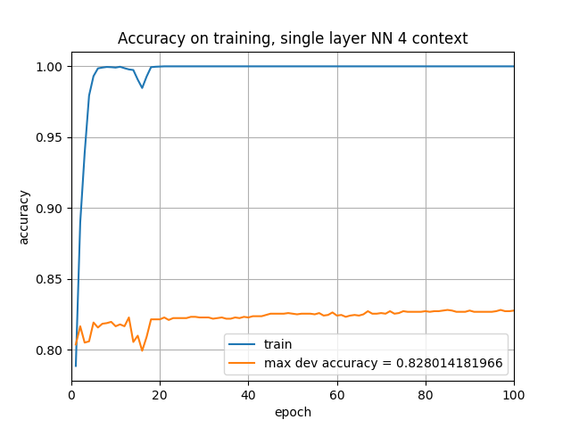
[[ 0.14893617 0.27659574 0.57446809]
[ 0.0046729 0.82943925 0.16588785]
[ 0.00938086 0.12945591 0.86116323]]
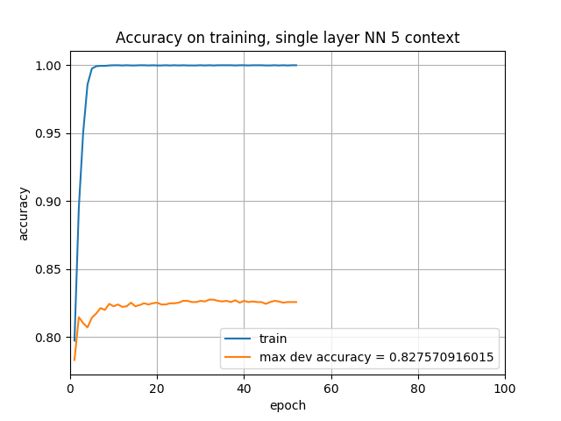
[[ 0.19148936 0.34042553 0.46808511]
[ 0.0046729 0.8271028 0.1682243 ]
[ 0.00562852 0.11444653 0.87992495]]
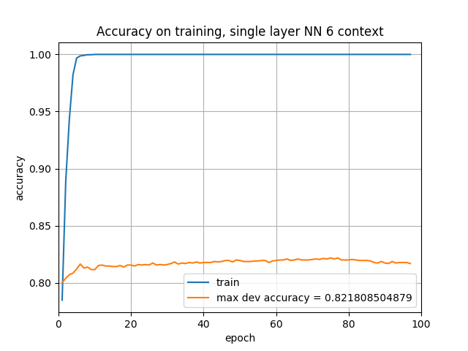
[[ 0.19148936 0.23404255 0.57446809]
[ 0.0046729 0.82476636 0.17056075]
[ 0.00938086 0.10881801 0.88180113]]
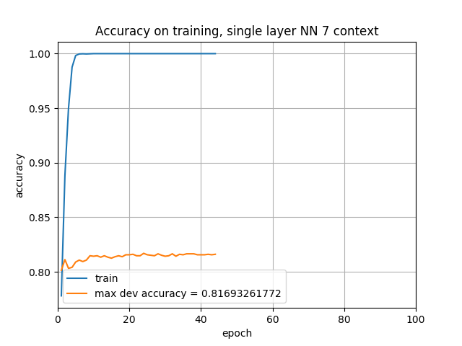

[[ 0.14893617 0.27659574 0.57446809]
[ 0.00700935 0.78037383 0.21261682]
[ 0.00750469 0.12007505 0.87242026]]

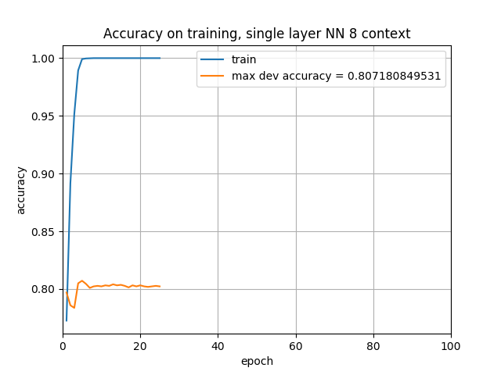
[[ 0.12765957 0.23404255 0.63829787]
[ 0.0046729 0.79205607 0.20327103]
[ 0.01125704 0.14071295 0.84803002]]
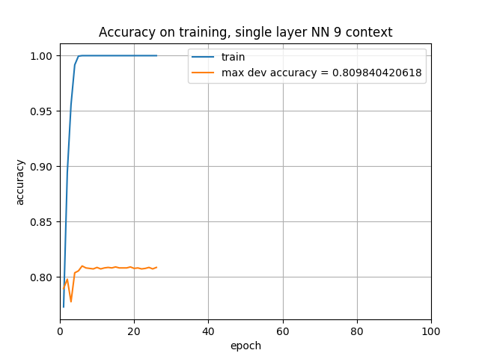
[[ 0.17021277 0.29787234 0.53191489]
[ 0.0046729 0.80841121 0.18691589]
[ 0.00375235 0.15009381 0.84615385]]

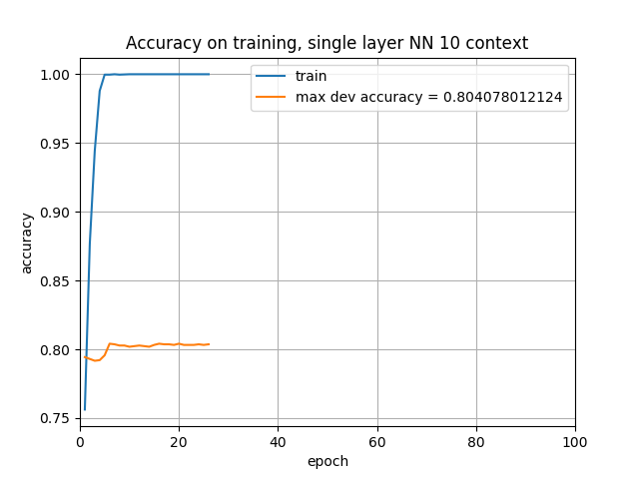
[[ 0.14893617 0.27659574 0.57446809]
[ 0.00700935 0.80140187 0.19158879]
[ 0.00938086 0.14446529 0.84615385]]

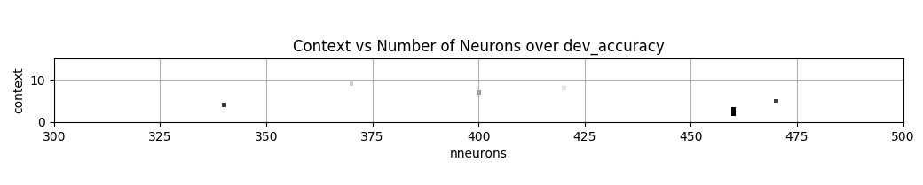
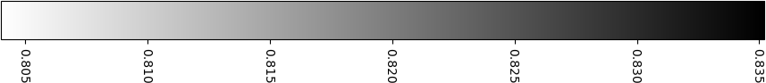

Context | BestNumberOfNeurons | MaxAcc over Dev
2 | 460 | 0,8351
3 | 460 | 0,8342
4 | 340 | 0,8280
5 | 470 | 0,8275
6 | 290 | 0,8218
7 | 400 | 0,8169
8 | 420 | 0,8071
9 | 370 | 0,8098
10 | 370 | 0,8040

LSTM

2
[[ 0.14893617 0.34042553 0.5106383 ]
[ 0.0046729 0.8411215 0.15420561]
[ 0.01313321 0.11819887 0.86866792]]
3
[[ 0.19148936 0.31914894 0.4893617 ]
[ 0.01168224 0.83878505 0.14953271]
[ 0.01313321 0.1163227 0.87054409]]
4
[[ 0.21276596 0.31914894 0.46808511]
[ 0.01168224 0.80373832 0.18457944]
[ 0.01876173 0.12195122 0.85928705]]
5
[[ 0.17021277 0.25531915 0.57446809]
[ 0.00934579 0.79906542 0.19158879]
[ 0.01313321 0.12757974 0.85928705]]
6
[[ 0.19148936 0.38297872 0.42553191]
[ 0.01869159 0.79439252 0.18691589]
[ 0.03001876 0.15196998 0.81801126]]
7
[[ 0.17021277 0.19148936 0.63829787]
[ 0.02102804 0.74766355 0.23130841]
[ 0.0206379 0.16510319 0.81425891]]
8
[[ 0.17021277 0.34042553 0.4893617 ]
[ 0.01401869 0.77570093 0.21028037]
[ 0.01313321 0.17448405 0.81238274]]
9
[[ 0.12765957 0.34042553 0.53191489]
[ 0.02336449 0.75 0.22663551]
[ 0.01876173 0.18011257 0.8011257 ]]
10
[[ 0.06382979 0.31914894 0.61702128]
[ 0.01869159 0.72897196 0.25233645]
[ 0.0206379 0.17636023 0.80300188]]

