1.1 Softmax and Cross Entropy

Summary
Why artificial neural network works? 1
Artificial neural network structure 1
How neural network predicts: forward propagation 5
How neural network learns: back propagation 7
Cost/error function 8
Gradient vector 9
Math behind network learning 11
Using the matrix’s power to calculate the gradient vector 16
Bibliography 18

What is Softmax?

Softmax is an special activation function only used at the output layer of a neural network, which allows classification neural networks to assign a “probability” value to each class, a decimal value between 0 and 1. The sum of all values in output layer is always equal to 1.
This is the formula:
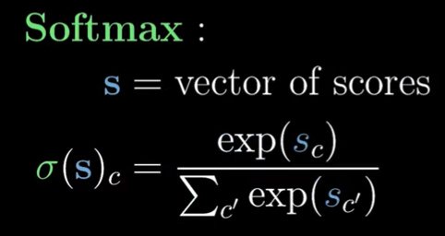
S is the output layer, c is the index of the node in that output layer, and exp(x) equals f(x) = e^{x}. For each value in every neuron in output layer, we calculate the exponentiation of that value divided by the sum of the exponentiation of all values in the output layer.
Why exponentiation is used instead of another power? It has many advantages like guarantee the sum of errors will never be below 0. Here is more explained: https://www.youtube.com/watch?v=p-6wUOXaVqs

What is Cross Entropy?

First

En resumen, es igual que la red básica con todo funciones sigmoid y función de coste error cuadrático medio, pero solamente cambia la derivada del coste con respecto al valor de salida de las neuronas de la capa de salida, y la función de coste
Recordemos esos si que la función de la capa de salida es softmax, que es la que sale arriba
Para la derivada del coste con respecto al valor de salida de una neurona, siendo a_{i}(L) el valor de salida de la neurona en la posición i de la capa de salida, si su valor de salida esperado es 0, la derivada es a_{i}(L), y si el valor de salida esperado es 1, la derivada es (a_{i}(L) – 1).
La función de coste es el sumatorio de y_{i} * -log_nepeniano( a_{i}(L) ), siendo y_{i} el valor de salida de la neurona esperado

How are both combined? Cost function

A

Bibliography

Common activation functions: https://www.v7labs.com/blog/neural-networks-activation-functions
Why do we need activation functions? (Spanish): https://www.youtube.com/watch?v=_0wdproot34
How gradient vector works in ann (Spanish): https://www.youtube.com/watch?v=A6FiCDoz8_4
Key concepts for understanding better ann (Spanish): https://medium.com/metadatos/todo-lo-que-necesitas-saber-sobre-el-descenso-del-gradiente-aplicado-a-redes-neuronales-19bdbb706a78
Nice video explaining math behind back propagation algorithm: https://www.youtube.com/watch?v=tIeHLnjs5U8

