Instructions for the Roman Agronomic Model of Chebba
Objective: To define a methodology for estimating the potential agricultural surface area and the production of wheat, wine and olive oil of the rural settlements in the Chebba region, integrating archaeological evidence, environmental variables, empirical size distributions, labour force, and simulations of climatic and demographic scenarios.
*1 iugerum = 0.25 ha, 1 culleus = 521 L, 1 Roman pound = 0.329g, 1 modius = 8.73 L

1. Starting point: from Córdoba to Chebba
In the Córdoba model, a distinction was first made between the total surface area of estates and the cultivated areas within them. In the case of villas, this distinction was based on the archaeological evidence for oil and wine presses, as well as on the dolia used for wine storage.

2. FUTURE DEVELOPMENT

As I have generated a grid map of c. 635,000 cells of 50 × 50 m, approximately one iugerum each, a future step will consist of creating a competition model between settlements —villas and farms— in which these settlements compete to acquire the best cells, based on their geological, hydrological, and locational characteristics, including distance to roads and watercourses. Each villa and farm will have different competitive values, so the map generated will reach a stationary or equilibrium point in which the areas of each settlement are determined not only by competition with neighbouring settlements, as expressed in a Voronoi model, but also by land suitability. This approach requires more computing power than is currently available to me, as well as a level of programming complexity that I do not yet possess. I will therefore try to publish this part of the study with a programmer after my thesis is completed, in order to avoid any problems.
One of the main objectives is to implement what could not be completed in the previous model: to make each settlement compete for cells representing the agricultural space of Chebba. These cells have values defined by several environmental and spatial factors:
- agricultural potential of the soil;
- proximity to rivers or drainage areas, especially through the variable Near_3000;
- productivity or potential of the aquifers;
- distance to roads, not as a fertility variable but as an indicator of accessibility.
Settlements will not compete in strictly equal terms. Each settlement will be assigned weights according to its type —villa or farm— so that the model does not depend solely on a simple geometry based on proximity. Each settlement will attempt to reach an ideal size based on an empirical distribution of plausible surface areas.

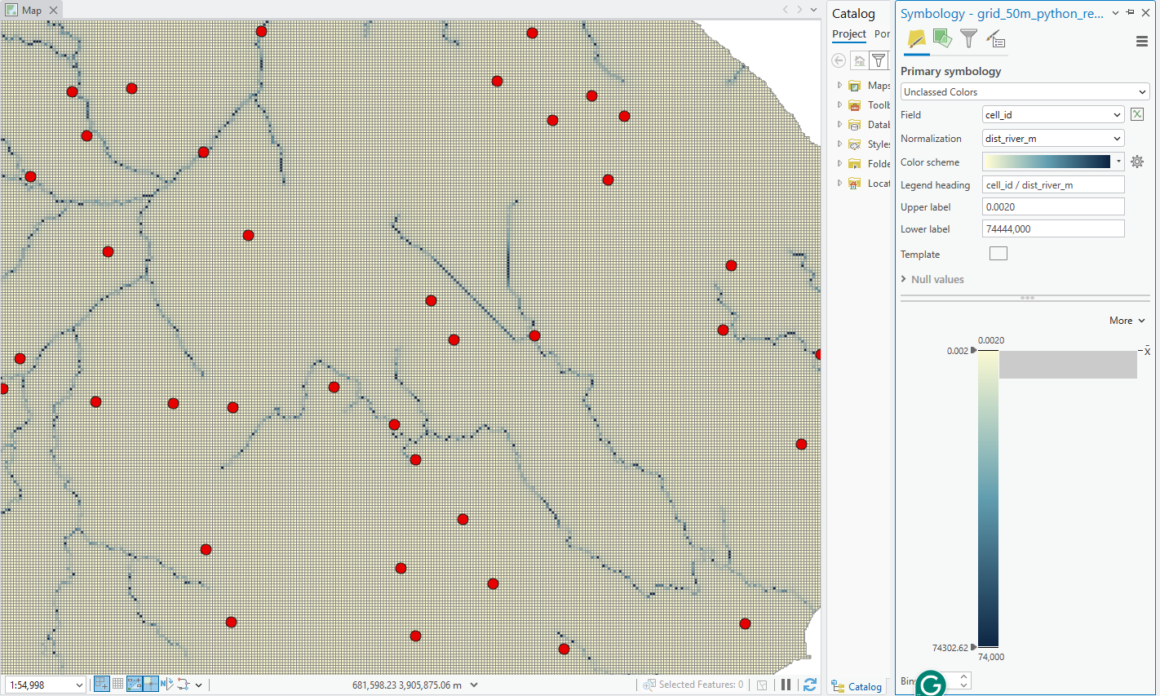
Screenshot: This is an example of the cell map. ArcGIS cannot represent in colour the hundreds of thousands for river distance depicted in the map. Each of these squares or cells has a value for the soil, aquifer, road and water stream/drainage area. The grid for this study accounts c. 635,000 cells.
3. Empirical size distributions from the “non-Chebba sites” (if Voronoi is not sufficient)
If the Voronoi diagram does not provide a plausible area for each settlement, the minimum, and if necessary maximum, size of each settlement could be estimated from empirical distributions for villas and farms. These distributions can be built using data from other regions of Tunisia, based on the recorded surface areas of comparable archaeological sites outside Chebba.
The centuriation of Chebba is not used as a direct reconstruction of estate ownership, since a cadastral grid does not necessarily correspond to individual properties. Instead, it is used as a control parameter for assessing the plausibility of the estimated surfaces and the spatial density of settlements. Since a 20 × 20 actus centuria corresponds to approximately 200 iugera, or c. 50 ha, the areas assigned to farms and villas can be checked against fractions or multiples of this cadastral module. The centuriated grid is also useful for evaluating whether neighbouring settlements are unusually concentrated within the same or adjacent centuriae. This is not treated deterministically, since some apparent clustering may reflect chronological overlap between settlements that were not contemporary. Nevertheless, it would be unusual for an independent villa to share the same centuria with another settlement, unless the latter represented a dependent farmstead, service unit or secondary installation linked to the villa. In this sense, centuriation provides not only a scale control for estate size, but also a means of identifying potentially anomalous settlement densities that require archaeological interpretation.
Since the available data are limited and probably uneven, some statistical pre-processing will be needed before they can be used in the model:
- remove or control outliers in the database;
- use the interquartile range and percentiles to define minimum and maximum values for villas and farms;
- assess whether settlement areas are better represented by a log-normal distribution;
- apply bootstrapping if the sample is small or not very robust.
$$A_{\text{final}}=min⁡(A_{\text{stochastic,type}},A_{\text{max,cluster}})$$
$A_{\text{stochastic,type}}$ represents an area drawn from the empirical distribution of the relevant settlement type, either villa or farm. $A_{\text{max,cluster}}$represents the maximum available land according to the DBSCAN cluster and the agricultural potential of the surrounding cells.

If this does not yield good results, I can follow the procedure used in Córdoba: apply DBSCAN to identify clusters of settlements and assign a median area, or a modal area if appropriate, calculated within each cluster of farms and/or villas, to those settlements whose Voronoi areas are excessively small. Another, simpler solution is to assume that each farm or villa requires a minimum area, on the grounds that the Voronoi result may be biased because some settlements were not contemporary and therefore artificially reduce the area of chronologically distinct settlements that did not coexist with them.

4. Distribution of space and crops
The working map is composed of 50 × 50 m cells. Each cell is equivalent to 2,500 m², or 0.25 ha, a surface area very close to 1 iugerum. This cell can therefore be treated as the minimum productive unit of the model.
Cell state | Description | Consequence for wheat
Vineyard | Cell devoted entirely to vine cultivation. | Does not allow intercropped cereal cultivation: β_v = 0.
Olive grove | Cell devoted to dry-farmed olive trees. | Allows intercropped wheat with reduced capacity: β_o = 0.45.
Olive grove + cereal | Mixed cell in which the olive grove remains the principal crop, but part of the space is used for wheat. | Wheat is calculated as a fraction of the theoretical cereal potential of the cell.

For vineyards, a system of vines without trellising or with low training is assumed (sine pedamentis), consistent with a tradition of intensive Punic cultivation of Chebba and with the absence of sufficient riparian vegetation for making supports as Columella notes. In this scenario, one hectare could contain approximately 5,000 vines. This density maximises viticultural production per unit of surface area, but makes the cultivation of wheat between vines impossible.
For dry-farmed olive groves, an operational estimate of about 100 olive trees per hectare will be used. This is a modern estimate rather than a figure derived from the classical agronomists. In this case, part of the space may be used for cereal, with a factor β_o = 0.45. Olive trees are not modelled through a biennial rotation in the same way as wheat. Although olive trees can bear fruit every year, their production may fluctuate considerably from one year to another, especially under dry-farming conditions. This alternation is therefore treated as interannual yield variability rather than as a fixed one-year-on/one-year-off cycle.
Note on internal coherence
Since a 50 × 50 m cell contains only 0.25 ha, β_o = 0.45 should not be understood as 0.45 absolute hectares within a single cell, but as a factor: 45% of the theoretical cereal potential of that cell. Thus, in a mixed cell of 0.25 ha, intercropped wheat would be equivalent to 0.25 × 0.45 = 0.1125 ha of effective wheat before the rotation factor is applied.

Following Erdkamp (2005), it is also true that smaller farms might have preferred to cultivate oats, perhaps instead of wheat, for their own subsistence. This is an interesting possibility, but it will not be considered in the present version of the model.
The general production objectives of villas and farms may be fixed as an oil-dominated orientation, with an approximate ratio of 60% olive groves and 40% vineyards. These ratios derive from the comparison, in Chapter 3, of African amphora assemblages for wine and oil across different datasets. Farms must first secure their cereal subsistence, whereas villas must guarantee the subsistence of their workers while also expanding their productive capacity.
A_i = A_o + A_v + A_w + A_s
Variable | Meaning
A_i | Total surface area assigned to settlement i.
A_o | Surface area under olive groves.
A_v | Surface area under vineyards.
A_w | Surface area under pure wheat cultivation.
A_s | Functional margin, provisionally estimated at 20% of the estate area, assigned to gardens, processing infrastructure, service areas, storage and spaces not strictly under cultivation.

The annual rotation of wheat and fallow must also be considered. For Chebba, a biennial model is proposed, which is more plausible than a triennial model: one year of wheat followed by one year of fallow or legumes, which are not modelled explicitly at this stage. The wheat rotation factor is therefore R_w = 0.50. A
A_w,pot,i = (A_w,i + β_w,o A_o,i + β_w,v A_v,i)
Parameter | Operational value | Comment
A_w,pot,i |  | Potential area for wheat before harvest.
β_w,v | 0.00 | Dense vineyards leave no functional space for intercropped wheat.
β_w,o | 0.45 | Olive groves allow part of the surface to be used for cereal.
R_w | 0.50 | Biennial rotation: one year of harvest and one year of fallow or legumes.
Then we obtain the harvest of wheat considering the fallow factor.
A_w,harv,i,t = A_w,pot,i × R_w
Parameter | Operational value | Comment
A_w,harv,i,t |  | Wheat harvest in year t for settlement i
R_w | 0.50 | Fallow or legumes rotation

Then define wheat yield per hectare per year per settlement as follows (Y_w,i,t)
Y_w,i,t = Y_w,base × Soil_factor_w,i × Water_factor_w,i × Rainfall_factor_w,t × Temperature_factor_w,t × Management_factor_w,i × Extreme_penalty_t
Then we obtain the gross production of wheat per settelemtn I per year t from the next equation:
Q_w,gross,i,t = A_w,harv,i,t × Y_w,i,

4.2. Net production of wheat, olive oil and wine
Q_w,net,i,t = Q_w,gross,i,t × (1 − λ_w) − σ_w A_w,harv,i,t
Symbol | Meaning
Q_w,net,i,t | Net wheat production of settlement i in year t.
Q_w,gross,i,t | Gross wheat production before losses and seed reserve.
λ | Post-harvest losses in wheat (10%, for wine and olive oil 3%)
σ_w | Seed required per hectare.
A_w,harv,i,t | Surface area of wheat effectively harvested.

Q_o,i,t = A_o,i × Y_o,i,t × (1− λ)×Alt_{o}
​
Symbol | Meaning
Q_o,i,t | Olive-oil production.
A_o,i | Surface area under olive groves.
Y_o,i,t | Olive-oil yield per hectare.
Alt_{o} | Represents the annual alternation factor for olive production. It does not mean that olive trees produce only every two years, but that production may be lower in some years and higher in others. Equal probability between these factors happening every year: x 0.7, x 1 and x 1.2.

Q_v,i,t = A_v,i × Y_v,i,t × (1− λ)
Wine production depends on vineyard surface area and annual viticultural yield, corrected by the climatic, environmental and management factors defined below.

5. Villas, farms and production regimes
For farms, the model can follow a logic similar to that of the original Córdoba ABM. For villas, however, an adaptation is required, since for Chebba we do not have such direct indicators as presses. Villas should be modelled as units with greater access to land, a larger labour force and a greater capacity to generate surplus.

5.1. Working scenarios for villas
Scenario | Description | Methodological implication
Conservative scenario | Villas assume initial values derived from the empirical distribution of comparative villas outside Chebba. | Villas compete with farms and other villas under almost equal conditions.
Preferred scenario | Villas have priority over the best cells and expand towards land of higher quality. | It is necessary to quantify the extent to which villas have a greater expansion capacity than farms.

6. Climatic component of the model
In the Córdoba model, rainfall was treated as equiprobable and used as a crop-efficiency factor. For Chebba, the climatic model can be expanded by incorporating temperature as well, since this factor has an important effect on production, especially in the case of vineyards.
In the ABM, each simulated year will have a climatic combination defined by rainfall and temperature. Simple categories can be established for rainfall — dry, normal or humid year — and for temperature — cool, normal, warm or very warm. These combinations will affect wheat, vines and olive trees differently.
Yield = base_yield × rainfall_factor × temperature_factor × soil_water_factor

6.1. Rainfall factor
Crop | Dry year | Normal year | Humid year
Wheat | 0.65 | 1.00 | 1.15
Grapes | 0.85 | 1.00 | 1.05
Olive trees | 0.80 | 1.00 | 1.10

7.2. Temperature factor
Crop | Cool | Normal | Warm | Very warm
Wheat | 1.05 | 1.00 | 0.92 | 0.80
Grapes | 0.90 | 1.00 | 1.03 | 0.85
Olive trees | 0.95 | 1.00 | 1.00 | 0.90

6.3. Penalty for extreme climatic stress
When a year is both very dry and very warm, an additional production penalty should be applied, since the combination of water stress and extreme heat may reduce yield more than the separate multiplicative factors indicate. Provisionally, this penalty could be set between 10% and 20%.
If year = very dry + very warm: final_yield = yield × extreme_penalty
In this case, extreme_penalty = 0.80–0.90.

6.4. Simple climatic probabilities
The model could be run with equiprobable scenarios. However, it seems preferable to construct a simple probability system based on modern temperature and rainfall series, hypothetically adjusted to approximate the conditions of the Roman Climatic Optimum, characterised by slightly higher temperatures and, above all, greater humidity.
Climatic combination | Probability
Normal temperature + normal rainfall | 30%
Warm + normal rainfall | 20%
Warm + humid | 20%
Normal temperature + dry | 15%
Very warm + dry | 10%
Cool + humid | 5%

7. Base crop production
Agricultural productivity estimates vary across ancient authors and depend heavily on the region taken as a point of reference. The following figures should therefore not be used as universal values, but rather as indicative ranges that will subsequently be adjusted through soil, water, climate and management factors.

7.1. Wheat (Triticum aestivum)
Author / reference | Figure | Interpretation
Varro, Rerum rusticarum 1.44.1 | 5 modii/iugerum on medium-quality land; up to 10 on fertile land. | Useful mainly as an indicator of seed sown, not as final harvest.
Cicero, In Verrem 2.3.112 | 6–8 modii/iugerum. | Another indicator of intensity or seed sown.
Columella, De re rustica 2.9.1–2 | 8–10 modii/iugerum on good soils or in good harvests. | A high value, appropriate only for fertile land.
Columella and Varro | Dependence on soil, topography and cultivation intensity. | No single figure should be used as a universal value.

In the Córdoba case, seed-to-harvest ratios of 8:1 to 10:1 were used — that is, for each unit of seed sown, eight to ten units were returned — equivalent to approximately 2,230–2,780 kg/ha. That case corresponded to relatively fertile alluvial soils. At Chebba, by contrast, the expected yield should be lower, since Petric Calcisols and other less favourable soils predominate.

7.2. Wine
Ancient or modern source | Figure | Approximate conversion or use
Varro | 15 cullei/iugerum. | Too high to be used as a baseline for the model.
Cato | 10 cullei/iugerum. | High value.
Pliny | 7 cullei/iugerum. | High value.
Columella | 3 cullei/iugerum. | Better as a cautious high baseline.
Simone / Córdoba model | 3 cullei/iugerum in a good harvest; 1.5 in a poor harvest. | Approximately 6,200 L/ha and 3,100 L/ha.

7.3. Olive oil
Source | Figure | Use in the model
Pliny, Naturalis Historia 15.4.14 | 6 pounds of oil per modius of olives. | Implies an extraction rate of approximately 23%, probably too high.
Brun | 1,500–2,000 L/year per press. | Useful when press evidence is available.
Mattingly | 8,500–12,000 kg of olives per press; approximately 1,275–1,875 L of oil per press with a 15% extraction rate. | Useful when press evidence is available.
Brun, estimate by surface area | 43.1 L/iugerum. | Equivalent to approximately 171 L/ha.

7.4. Combined range of base yields
Crop | Low baseline | Medium baseline | High baseline | Exceptional ceiling
Wheat | 700–1,000 kg/ha | 1,100–1,400 kg/ha | 1,500–1,800 kg/ha | c. 2,000 kg/ha
Wine | 3,100 L/ha | 4,500–5,000 L/ha | 6,200 L/ha | Avoid except in special cases.
Olive oil | 130–150 L/ha | c. 170 L/ha | 220–250 L/ha | Avoid except in special cases.

Compared with Córdoba, Chebba should present lower production, mainly because most soils are calcareous and, in many cases, shallow or subject to greater water limitations.

8. Environmental and social multipliers

8.1. Multipliers according to soil type
Soil type | Wheat | Vineyard | Olive tree | Comment
Alluvial fluvisol | 1.00 | 0.95–1.00 | 1.00 | Best case for wheat.
Petric Calcisol | 0.65–0.75 | 0.80–0.90 | 0.85–0.95 | Penalises wheat above all.
Arenosol | 0.50–0.65 | 0.65–0.75 | 0.60–0.75 | Low water retention.

8.2. Multipliers according to settlement type
Following the interpretation derived from Erdkamp and the distinction between small farms, large farms and villas, differentiated factors of management and productive capacity can be applied. Here, a small farm is understood as an estate of 10 iugera or less.
Settlement type | Wheat | Vineyard | Olive tree | Interpretation
Small farm | 0.85–0.95 | 0.70–0.85 | 0.75–0.90 | Less capital and less specialisation.
Large farm | 1.00 | 0.85–0.95 | 0.90–1.00 | Mixed production.
Villa | 1.10 | 1.15–1.25 | 1.15–1.25 | Greater investment capacity: more capital, external labour and commercial orientation.

9. Recommended base values for Chebba
Crop | Recommended baseline for Chebba | Main limitation | Most important factor
Wheat | 1,100–1,400 kg/ha | Drought, heat and shallow soil. | Water.
Wine | 4,500–5,000 L/ha | Extreme heat, lack of capital and absence of visible installations. | Temperature and management.
Olive oil | c. 170 L/ha | Prolonged drought and initial investment. | Management and water.

10. General equation of the system
In synthetic terms, the final production of a given settlement and crop can be expressed as the product of cultivated land and a base yield, corrected by environmental, climatic and management factors.
Production_i,c,t = Land_i,c × Base_yield_c × Soil_factor_i,c × Water_factor_i × Rainfall_factor_c,t × Temperature_factor_c,t × Management_factor_i,c × Extreme_penalty_t
In this equation, the management factor should only be activated when it is possible to distinguish small properties, large farms or villas. If this distinction cannot be justified with sufficient confidence, the management factor can be fixed at 1.00 in order to avoid introducing an artificial social difference.

11. Labour force
The labour force can be modelled by distinguishing between farms and villas. In the case of farms, productive capacity will depend above all on household composition and on the number of adult labour equivalents. In the case of villas, a greater capacity for labour mobilisation must be allowed, including enslaved labour, wage labourers or other forms of external labour.

11.1. Farms: household size and adult labour equivalents
Farm type | Total persons | Adult labour equivalents (ALE) | Comment
Low initial farm | 4 persons | 1.5–2 ALE | Weak or young household unit.
Standard farm | 5–6 persons | 2.5–3 ALE | Best baseline option.
Expanded farm | 8–10 persons | 4–5 ALE | Mature household unit.
Maximum limit | 10–12 persons | 5–6 ALE | Maximum equivalent to two nuclear families.

If some farms prove especially large, an internal subdivision may be considered: estates of more than 10 iugera could correspond to expanded farms, while those of more than 40–50 iugera could approximate the maximum limit of two-family units. From this point, a standard value for adult labour equivalents can be assigned or, alternatively, labour weights by age and sex can be applied.
Person | Labour weight
Adult male | 1.00
Adult female | 0.50
Male adolescent | 0.50
Female adolescent | 0.30
Child | 0.00–0.10
Elderly person | 0.20–0.30

11.2. Villas: agricultural labour and expansion
For villas, an initial value of about 15 agricultural workers can be established; these may have been enslaved people, wage labourers or dependent workers. The key issue is that the villa, unlike the farm, does not depend on its domestic reproduction rate in order to grow. It can also increase the number of workers when sufficient land is available and when the model assigns it a greater capacity for expansion.
Villas would also have included non-agricultural workers, such as domestic or specialised staff. These workers are not incorporated at this stage of the model, since the aim is to calculate agricultural productive capacity.

11.3. Annual labour capacity by crop
Crop | Capacity per adult equivalent/year | In iugera | Source or model
Wheat | c. 3 ha/year | c. 12 iugera | Columella, De re rustica 2.12 / Erdkamp.
Vineyard | c. 1.5–1.6 ha/year | c. 6.25 iugera | Cato, De agricultura 11 / Bernigaud.
Olive grove | c. 4.5–4.8 ha/year | c. 18–19 iugera | Cato, De agricultura 10 / Bernigaud.

12. Food consumption and wheat requirements
Wheat consumption can be modelled through an annual base ration and differentiated weights according to person type. The Córdoba appendix already used similar ranges: adult male, 270–321 kg/year; adult female, 215–259 kg/year; and children, 106–237 kg/year.
Erdkamp offers another way to arrive at a similar value: according to Cato, De agricultura 56, the ration of agricultural slaves would have been about 50 modii of wheat per worker per year. If an approximate equivalence of 1 modius ≈ 6.5 kg of wheat is used, this gives about 325 kg/year. As an operational value, a baseline of 300 kg/year can be adopted and consumption weights applied.
Person | k_p
Adult male / enslaved worker | 1.00
Adult female | 0.80
Adolescent | 0.65
Child | 0.45
Elderly person | 0.70

Wheat_consumption_person = 300 kg/year × k_p
The total consumption of the household unit or villa is obtained by summing the weighted consumption of all persons dependent on the productive system.

13. Demography of farms
The demographic dynamics of farms can be linked to their productive capacity and, especially, to the relationship between food availability and consumption requirements. A FoodRatio is therefore defined in order to classify the annual situation of each farm.
FoodRatio_i,t = Food_production_i,t / Food_requirements_i,t
FoodRatio | Situation
> 1.20 | Clear surplus.
1.00–1.20 | Sufficient subsistence.
0.80–1.00 | Mild shortage.
0.60–0.80 | Severe shortage.
< 0.60 | Food crisis.

13.1. Mortality by age
Age | Recommended base annual mortality
0 years | 25–35%
1–4 years | 4–8%
5–14 years | 0.5–1.5%
15–39 years | Low Gompertz–Makeham.
40–59 years | Medium Gompertz–Makeham.
60+ years | High Gompertz–Makeham.

For adults, a Gompertz–Makeham function can be used:
μ(x) = A + B · e^(C·x)
Parameter | Meaning
A | Age-independent mortality: accidents, infections, violence or other risks not strictly related to senescence.
B · e^(C·x) | Mortality component that increases with age.
x | Age of the person.

q_x = 1 − e^(−μ(x))
q_x is the annual probability of dying at age x.
In the Córdoba model, Gompertz–Makeham was applied to the full age spectrum. For Chebba, by contrast, it seems preferable to separate infant mortality, because in ancient demographic regimes it was very high and a simple Gompertz–Makeham function would not model it sufficiently well.

13.2. Mortality adjustment according to the FoodRatio
q′_p,t = min(q_max, q_age,sex × StressMultiplier_age(FoodRatio_i,t))
FoodRatio | Children | Adults | Elderly persons
> 1.20 | ×0.95 | ×0.95 | ×1.00
1.00–1.20 | ×1.00 | ×1.00 | ×1.00
0.80–1.00 | ×1.20 | ×1.10 | ×1.15
0.60–0.80 | ×1.60 | ×1.25 | ×1.50
< 0.60 | ×2.20 | ×1.60 | ×2.00

13.3. Fertility
Fertility can be modelled in a simple manner. Each woman of fertile age, approximately between 16 and 40 years, can be assigned a base annual probability of childbirth of 0.25, that is, 0.25 children per year. This probability is affected by the FoodRatio and by the maximum capacity of the household unit.
p_birth_i,t = p_birth_base × FertilityStress(FoodRatio_i,t) × HouseholdCapacity_i
FoodRatio | Fertility multiplier
> 1.20 | 1.05
1.00–1.20 | 1.00
0.80–1.00 | 0.75
0.60–0.80 | 0.40
< 0.60 | 0.10 or 0

The maximum household size can be fixed at 6 adults of working age, equivalent to two nuclear families with three labouring adults each. Farms should therefore not grow beyond about 12 individuals, of whom approximately 6 would be adults of working age.

14. Workflow to fill and abandon cells

The agricultural settlement grows filling cells as follows:
1) Fill productive cells according to the commercial target ratio: 60% olive groves and 40% vineyards. If possible, follow for each cell-soil the multipliers according to soil type (8.1)
2) Calculate available wheat from pure wheat cells and from wheat intercropped within olive-grove cells.
3) If the FoodRatio is ≥ 1.20 for three or more consecutive years, the settlement is considered stable and may continue expanding into available cells.
4) If the FoodRatio falls below 1.20, the settlement first converts olive-grove cells into mixed olive-grove + wheat cells.
5) If mixed olive-grove + wheat cells are not sufficient to restore a FoodRatio of 1.20, the settlement assigns available cells to pure wheat.
6) If this still does not suffice, and no further available cells can be added without exceeding the settlement’s land or labour capacity, the model begins to reassign commercial cells to pure wheat. Vineyard cells are converted first, since they do not contribute to cereal production. If this remains insufficient, pure olive-grove cells are converted next, and finally mixed olive-grove + wheat cells may also be converted into pure wheat.
7) This process continues until a FoodRatio of ≥ 1.20 is restored. If this equilibrium is sustained for three or more consecutive years, demographic or labour growth may resume.
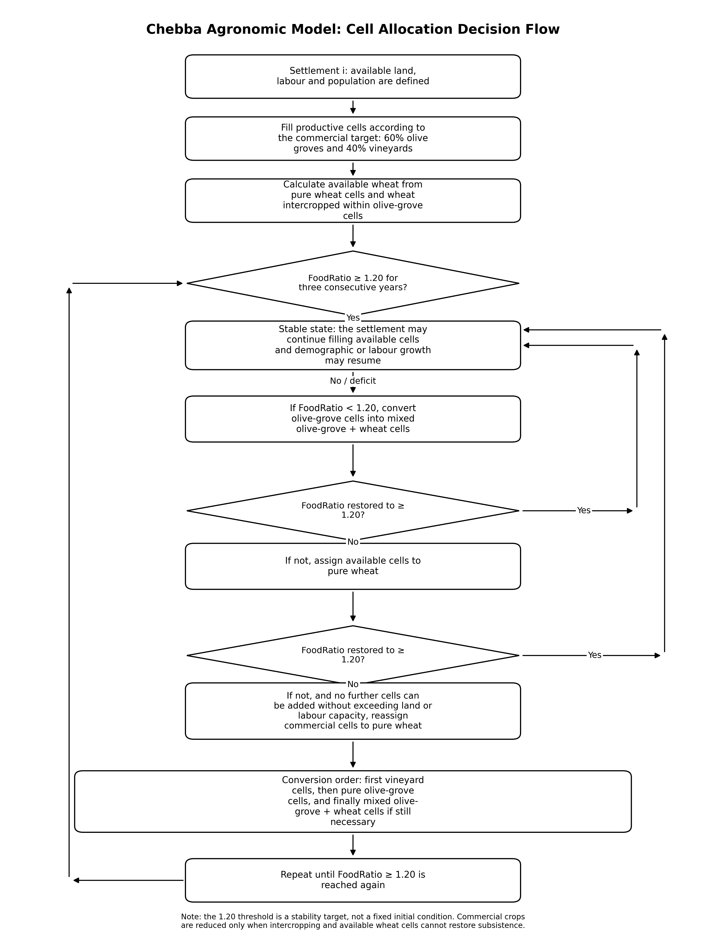

14. Synthesis
The implementable version of the model can be reduced to a chain of calculations in which each settlement receives a potential surface area, competes for cells of different quality, and transforms that land into annual agricultural production corrected by climate, soil, water, labour force and demography.
- Assign each settlement an initial type: small farm, large farm, probable villa or secure villa.
- Calculate areas for each settlement using Voronoi. Employ the “non-Chebba sites” database to compare and DBSCAN if needed.
- Distribute cells between vineyards, olive groves, pure wheat and functional spaces.
- Apply the factors for soil, water, climate, management and competition between crops.
- Calculate gross and net production of wheat, olive oil and wine.
- Compare food production with consumption requirements through the FoodRatio.
- Update mortality, fertility and household growth for farms.
- Repeat the process over the simulated years and compare scenarios.

