LANDMARK METROPOLITAN UNIVERSITY INSTITUTE
FACULTY OF SCIENCE AND TECHNOLOGY
DEPARTMENT OF COMPUTER SCIENCE AND SOFTWARE ENGINEERING

─────────────────────────────────────────────────────

ETOH MARKET: DESIGN AND IMPLEMENTATION OF A
WEB-BASED DIGITAL MARKETPLACE FOR
CAMEROONIAN VENDORS AND BUYERS

─────────────────────────────────────────────────────

A Project Report Submitted in Partial Fulfilment of the
Requirements for the Award of a
Bachelor of Technology (BTech) in Software Engineering

By

SAGONG TCHOFFO ALVARO DYLAN
Registration Number: [REGISTRATION NUMBER]

Supervisor:
[SUPERVISOR'S FULL NAME AND QUALIFICATION]

Academic Year: 2025 / 2026

TABLE OF CONTENTS

Dedication ................................................ i
Acknowledgments ........................................... ii
List of Abbreviations ..................................... iii
List of Tables ............................................ iv
List of Figures ........................................... v
Abstract .................................................. vi

CHAPTER ONE: GENERAL INTRODUCTION
1.1 Introduction ........................................ 1
1.2 Background .......................................... 2
1.3 Problem Statement ................................... 3
1.4 Objectives .......................................... 4
1.5 Significance ........................................ 5
1.6 Scope ............................................... 5
1.7 Definition of Terms ................................. 6
1.8 Organisation ........................................ 7

CHAPTER TWO: LITERATURE REVIEW
2.1 Introduction ........................................ 8
2.2 Related Concepts .................................... 8
2.3 Related Works ...................................... 11
2.4 Proposed Solution .................................. 15

CHAPTER THREE: MATERIALS AND METHODS
3.1 Introduction ....................................... 17
3.2 Development Methodology ............................ 17
3.3 Tools and Materials ................................ 18
3.4 System Modules ..................................... 20
3.5 System Analysis .................................... 21
3.6 System Design ...................................... 27

CHAPTER FOUR: IMPLEMENTATION, RESULTS AND TESTING
4.1 Introduction ....................................... 33
4.2 Implementation ..................................... 33
4.3 Results ............................................ 37
4.4 Testing ............................................ 41

CHAPTER FIVE: SUMMARY, CONCLUSIONS AND RECOMMENDATIONS
5.1 Discussions ........................................ 44
5.2 Conclusions ........................................ 45
5.3 Recommendations .................................... 46
5.4 Further Work ....................................... 47

References ................................................ 48

DEDICATION

This work is dedicated to every small-scale vendor in Cameroon who gets up early, sets up their stall, and works hard every day to support their family.

It is also dedicated to my family for their constant support throughout this journey.

ACKNOWLEDGMENTS

I thank my supervisor, [Supervisor's Name], for the guidance and feedback that shaped this project.

I am grateful to the Landmark Metropolitan University Institute and the Department of Computer Science and Software Engineering for the knowledge and tools that made this project possible.

I also thank the market vendors and buyers in Douala and Yaoundé whose daily challenges motivated every design decision in ETOH Market.

LIST OF ABBREVIATIONS

AI — Artificial Intelligence
API — Application Programming Interface
B2C — Business-to-Consumer
C2C — Consumer-to-Consumer
CFA — Communauté Financière Africaine
CORS — Cross-Origin Resource Sharing
CRUD — Create, Read, Update, Delete
ER — Entity-Relationship
FR — Functional Requirement
HTTP — HyperText Transfer Protocol
JS — JavaScript
JSON — JavaScript Object Notation
JWT — JSON Web Token
LMUI — Landmark Metropolitan University Institute
MoMo — Mobile Money
NFR — Non-Functional Requirement
npm — Node Package Manager
REST — Representational State Transfer
SPA — Single-Page Application
SQL — Structured Query Language
UI — User Interface
URL — Uniform Resource Locator
UX — User Experience
VPS — Virtual Private Server

LIST OF TABLES

Table 3.1: Hardware and Software Requirements
Table 3.2: Backend Dependencies
Table 3.3: Frontend Dependencies
Table 3.4: System Modules
Table 3.5: Functional Requirements
Table 3.6: Non-Functional Requirements
Table 3.7: Project Schedule
Table 3.8: Use Cases
Table 3.9: Data Dictionary — users
Table 3.10: Data Dictionary — stands
Table 3.11: Data Dictionary — products
Table 3.12: Data Dictionary — orders
Table 4.1: Unit Test Cases
Table 4.2: Integration Test Cases
Table 4.3: System Test Results

LIST OF FIGURES

Figure 3.1: System Architecture Diagram
Figure 3.2: Entity-Relationship Diagram
Figure 3.3: Use Case Diagram
Figure 3.4: Sequence Diagram — User Login
Figure 3.5: Sequence Diagram — Add Product
Figure 3.6: Activity Diagram — Buyer Flow

ABSTRACT

ETOH Market is a web-based digital marketplace built for Cameroon's informal market sector. Vendors in cities like Douala and Yaoundé have no easy way to show their products to buyers outside their physical stall, and buyers waste time and money travelling to markets to compare prices. ETOH Market solves this by giving vendors free virtual shops and connecting them with buyers through WhatsApp — the app most Cameroonians already use every day.
The system was built with Node.js and Express.js for the backend, React.js and Vite for the frontend, and SQLite for the database. Features include product listings with images, videos, and voice notes; a Safety Gate to protect buyers from fraud; a Bargain Calculator; a Bendskin delivery button; a community price board (Prix du Marché); a buyer request board (Je Cherche); short video reels (Market Buzz); a Google Gemini AI chat assistant; and a full English/French bilingual interface. Five two-week Agile iterations were used. All 20 functional requirements were verified through unit, integration, and system tests.
Keywords: digital marketplace, e-commerce, Cameroon, React.js, WhatsApp, SQLite, Agile.

CHAPTER ONE:
GENERAL INTRODUCTION
1.1 Introduction
People in Cameroon buy and sell goods mostly in open-air markets like Marché Central in Douala and Marché Mokolo in Yaoundé. Vendors can only reach customers who walk past their stall. Buyers have no digital way to search for products or compare prices before they travel. ETOH Market moves the market experience online in a way that fits Cameroon — using tools people already trust.

1.2 Background to the Study
Over 90% of jobs in Cameroon are in the informal sector [1]. Most commerce happens in physical markets. WhatsApp is used by the majority of smartphone owners as an informal commerce tool — vendors send product photos and buyers negotiate prices through it [2]. ETOH Market builds on this existing behaviour by adding a proper search and discovery layer, without replacing WhatsApp. Existing platforms like Jumia, Tonaton, and Facebook Marketplace do not adequately serve informal Cameroonian vendors [3].

1.3 Statement of the Problem
Six problems were identified:
- Vendors have no digital presence — customers are limited to those who walk past their stall.
- Buyers waste time and money travelling to markets to find specific products.
- Prices are hidden — there is no public reference for what goods cost today.
- Buyers distrust unknown online sellers because mobile money fraud is common.
- Last-mile bendskin delivery is hard to coordinate without a dedicated tool.
- Most platforms support only one language, excluding either English or French speakers.

1.4 Objectives of the Study
General Objective
To design and implement a web-based digital marketplace that lets Cameroonian vendors list their products online and lets buyers discover, compare, and contact vendors safely.
Specific Objectives
- Build a secure JWT and bcrypt authentication system.
- Develop virtual stands with product listings supporting images, videos, and voice notes.
- Create a WhatsApp-integrated contact system with a Safety Gate and Trusted Vendor Badge.
- Build a Bargain Calculator and Bendskin Delivery Button for local commerce practices.
- Implement a community price board (Prix du Marché) for twelve common staple goods.
- Create a buyer request board (Je Cherche) where buyers post what they need.
- Integrate Google Gemini AI as an in-app market guidance assistant.
- Deliver a fully bilingual (English and French) interface.
- Build an admin panel for complete platform management.
- Test all features through unit, integration, and system tests.

1.5 Significance of the Study
For vendors, the platform expands customer reach beyond the physical stall at zero cost. For buyers, it saves travel time and provides price transparency. Research shows access to market price information can improve vendor and buyer outcomes in African markets [4]. For the academic community, the project shows a full-stack web application with AI integration can be built at minimal cost using open-source tools.

1.6 Scope of the Study
The system covers eight cities: Douala, Yaoundé, Bamenda, Buea, Bafoussam, Kribi, Limbe, and Ngaoundéré. All features in Section 1.4 are included. Payment processing and native mobile apps are out of scope.

1.7 Definition of Terms
- Stand: A vendor's virtual shop on ETOH Market containing their details and product listings.
- Bendskin: A motorcycle taxi used for short-distance transport and delivery in Cameroonian cities.
- Safety Gate: A modal that shows fraud prevention rules and requires buyer confirmation before revealing a seller's phone number.
- JWT (JSON Web Token): A signed token that proves a user is logged in, sent with every API request.
- SQLite: A file-based relational database stored as a single .db file with no separate server.
- Reel: A short vendor video, similar to TikTok, posted to demonstrate products.
- CFA Franc: The currency of Cameroon.
- Agile: A development method that builds software in short, repeated cycles called iterations.

1.8 Organisation of the Study
Chapter One introduces the project. Chapter Two reviews related work. Chapter Three covers design and methodology. Chapter Four presents implementation and test results. Chapter Five gives conclusions and recommendations.

CHAPTER TWO:
LITERATURE REVIEW
2.1 Introduction
This chapter reviews the key ideas behind ETOH Market, examines six existing platforms, and explains the proposed solution.

2.2 Review of Related Concepts
2.2.1 Digital Marketplaces
A digital marketplace is a platform where many vendors and many buyers come together [6]. Unlike a single shop's website, it is the digital equivalent of a shopping centre. ETOH Market follows a Consumer-to-Consumer (C2C) model where individual vendors sell directly to individual buyers.

2.2.2 Mobile Commerce in Africa
Almost all internet access in Cameroon is through mobile devices. GSMA data shows smartphone adoption in Sub-Saharan Africa grows at ~6% per year [2]. Research by Aker and Mbiti showed that mobile phones reduce market price dispersion and help both buyers and sellers find better prices [4]. This directly motivates the Prix du Marché price board.

2.2.3 WhatsApp Commerce
WhatsApp dominates communication in Cameroon. Vendors already share product photos and buyers already negotiate prices through it. ETOH Market keeps WhatsApp as the contact tool but adds a searchable catalogue on top, using standard wa.me links to open conversations.

2.2.4 Digital Trust
Mobile money fraud is a known problem in Cameroon [3]. Gefen et al. found that trust is one of the most critical factors in e-commerce adoption [5]. ETOH Market uses the Safety Gate (mandatory fraud warning) and the Trusted Vendor Badge (admin-verified credibility signal) to address this.

2.2.5 Community Information Systems
WeFarm connected over one million farmers in East Africa through peer-to-peer market knowledge sharing [7]. It proved community-sourced data platforms work even on slow networks. The Prix du Marché feature applies the same model to Cameroonian staple food prices.

2.3 Review of Related Works
2.3.1 Jumia
Jumia is Africa's largest e-commerce platform with payment escrow, professional logistics, and buyer protection. However, it requires formal business registration and charges 5–20% commissions. These requirements exclude most informal Cameroonian vendors. Recommendation: future platforms should use lightweight email-only registration.

2.3.2 Tonaton
Tonaton is a free classifieds platform in Ghana and Cameroon. No registration or commissions required. However, it is passive — no verified sellers, no voice note support, no bilingual interface, no WhatsApp integration, and buyers cannot post what they are looking for.

2.3.3 Facebook Marketplace
Facebook Marketplace uses the existing Facebook user base and is free. But it is designed for a global audience with no Cameroonian-specific features — no price board, no bargain calculator, no bendskin delivery integration, and no bilingual support.

2.3.4 Jiji Africa
Jiji is a classified ads platform across Africa. It is not available in Cameroon and has documented fraud problems. It provides no community engagement features.

2.3.5 WhatsApp Business
WhatsApp Business allows a single vendor to display a product catalogue. Excellent for communicating with existing customers, but provides no discovery layer. A buyer cannot search across multiple WhatsApp Business vendors simultaneously.

2.3.6 WeFarm
WeFarm connected over one million African farmers through peer agricultural knowledge sharing [7]. Its community information model directly inspired the Prix du Marché feature. WeFarm focuses only on knowledge, not commerce.

2.4 Proposed Solution
No existing platform combines free vendor registration, no commissions, bilingual interface, WhatsApp-native communication, community price board, reverse marketplace, multimedia listings, a trust framework, and an AI assistant. ETOH Market provides all of these. The core principle is to work with existing Cameroonian behaviours — add a search layer on top of WhatsApp commerce, a calculator on top of negotiation, a contact message generator on top of bendskin delivery.

CHAPTER THREE: MATERIALS AND METHODS
3.1 Introduction
This chapter describes the development methodology, tools and materials, system modules, and analysis and design artefacts.

3.2 Development Methodology
ETOH Market was built using the Agile software development method. Agile delivers working software in short cycles and adapts to changing requirements [8]. Several features (voice recording, Je Cherche, Prix du Marché) were added during development based on better understanding of user needs. Five two-week iterations were used:
- Iteration 1 (Weeks 1–2): Database schema, server, authentication, stand management.
- Iteration 2 (Weeks 3–4): Product management, file uploads, homepage with search and filters.
- Iteration 3 (Weeks 5–6): WhatsApp contact, Safety Gate, Bargain Calculator, Bendskin Button, orders.
- Iteration 4 (Weeks 7–9): Market Buzz reels, Prix du Marché, Je Cherche, voice recorder.
- Iteration 5 (Weeks 10–12): AI chat, bilingual support, Admin Panel, Trusted Badge, availability status, testing, and documentation.

3.3 Tools and Materials

Table 3.1: Hardware and Software Requirements
Item | Specification
Processor | Intel Core i5 8th Gen or equivalent
RAM | 8 GB development; 2 GB minimum for deployment
Storage | 256 GB SSD development; 20 GB VPS
Node.js | v18+
SQLite | v5.1.6 via sqlite3 npm package
React + Vite | React 18, Vite 5
Test Device | Android smartphone (Android 9+) for mobile testing

Table 3.2: Backend Dependencies
Package | Version | Purpose | Reason
Express.js | 4.18.2 | REST API framework | Most popular Node.js framework; well-documented
bcryptjs | 3.0.3 | Password hashing | Industry-standard; salted; brute-force resistant
jsonwebtoken | 9.0.3 | JWT tokens | Stateless sessions; no server-side storage
multer | 1.4.5 | File uploads | Handles multipart forms; size and type limits
@google/generative-ai | 0.24.1 | Gemini AI SDK | Official SDK; simple chat interface
cors | 2.8.5 | Cross-origin requests | Allows React dev server to call backend
dotenv | 16.3.1 | Environment variables | Keeps secrets out of source code
Jest + Supertest | 30.4.2 / 7.2.2 | Testing | Standard JS test runner + HTTP integration tests

Table 3.3: Frontend Dependencies
Package | Version | Purpose | Reason
React | 18+ | UI library | Component-based; efficient virtual DOM
Vite | 5+ | Build tool | Instant hot reload; faster than webpack
React Router DOM | 6+ | Navigation | SPA routing without page reloads
Axios | 1+ | HTTP client | JWT interceptors; auto JSON parsing

3.4 System Modules

Table 3.4: System Modules
Module | Backend File | Key Frontend Files | Responsibilities
Authentication | routes/auth.js | Login.jsx, Register.jsx, Profile.jsx | Register, login, JWT, profile picture upload
Stands | routes/stands.js | CreateStand.jsx, MyStands.jsx, StandDetail.jsx | Create, edit, delete stands; availability status
Products | routes/products.js | CreateProduct.jsx, ProductDetail.jsx | List products with media; search and filter
Commerce | (integrated) | SafetyGate.jsx, BendskinButton.jsx | Safety Gate, WhatsApp contact, Bargain Calculator, orders
Market Buzz | routes/posts.js | Reels.jsx | Short video feed, snap-scroll, likes
Price Board | routes/prices.js | PrixDuMarche.jsx | Price submission and min/avg/max aggregation
Je Cherche | routes/wanted.js | JeCherche.jsx | Buyer requests with 7-day auto-expiry
AI Chat | routes/gemini.js | ChatWidget.jsx | Gemini API chat with local market system prompt
Admin | routes/admin.js | Admin.jsx | Dashboard stats, full CRUD, vendor verification

3.5 System Analysis
3.5.1 Functional Requirements

Table 3.5: Functional Requirements
ID | Description | Priority
FR01 | Users can register with name, email, and password (min 6 chars). | High
FR02 | Users can log in; system returns a 7-day JWT token. | High
FR03 | Authenticated users can update profile name, bio, WhatsApp, and picture. | Medium
FR04 | Authenticated users can create stands with name, phone, city, description. | High
FR05 | Stand owners can edit their stand and set availability (Open / Away / Closed). | High
FR06 | Stand owners can delete their stand; all products are deleted with it. | Medium
FR07 | Stand owners can add products with name, price (CFA), category, image, video, voice note. | High
FR08 | Homepage shows all products and stands, filterable by city and category, with a search bar. | High
FR09 | Safety Gate modal must be confirmed before seller's phone number is shown. | High
FR10 | WhatsApp button opens a direct chat via wa.me link. | High
FR11 | Bargain Calculator offers 10%, 20%, 30% discount tiers with a copyable message. | Medium
FR12 | Bendskin Button generates a pre-filled WhatsApp delivery request. | Medium
FR13 | Buyers can place delivery orders with name, city, neighbourhood, and landmark. | Medium
FR14 | Authenticated users can post short videos to the Market Buzz feed. | Medium
FR15 | Any user can submit a price report for one of twelve staple items. | Medium
FR16 | System shows min, avg, and max price per item from the last 24 hours. | Medium
FR17 | Any user can post a buyer request on Je Cherche with their WhatsApp number. | Medium
FR18 | Je Cherche posts automatically expire 7 days after creation. | Low
FR19 | An AI chat assistant is available on all pages. | Low
FR20 | The full interface can be switched between English and French at any time. | High

3.5.2 Non-Functional Requirements

Table 3.6: Non-Functional Requirements
ID | Category | Requirement
NFR01 | Performance | Homepage loads all products in under 3 seconds on 3G mobile.
NFR02 | Usability | Interface works on screen widths from 320 px upwards.
NFR03 | Security | Passwords stored as bcrypt hashes; JWT for all session management.
NFR04 | Security | Admin routes require a separate key; ownership checks server-side.
NFR05 | Reliability | All API errors return JSON with the correct HTTP status code.
NFR06 | Scalability | SQLite can be swapped for PostgreSQL without changing app logic.
NFR07 | Portability | Runs on Node.js v18; works on Chrome, Firefox, Safari, and Edge.
NFR08 | Maintainability | One route file per domain; reusable React components across pages.

3.5.3 Project Schedule

Table 3.7: Project Schedule
Week | Activity | Deliverable
1–2 | Requirements, DB schema, setup | etoh.db schema, .env configuration
3–4 | Authentication, stand management, auth pages | Working login/register/stands flow
5–6 | Product management, file uploads, homepage filters | Product listing and browsing
7–8 | WhatsApp, Safety Gate, Bargain Calc, Bendskin, orders | Full commerce module
9–10 | Market Buzz, Prix du Marché, Je Cherche, voice recorder | All community features
11 | AI chat, bilingual, Admin Panel, Trusted Badge, availability | Complete feature set
12 | Testing, bug fixes, documentation, report writing | Test suite passing, this report

3.5.4 Use Cases

Table 3.8: Use Cases
ID | Use Case | Actor | Description
UC01 | Browse Products | Guest / Registered | Open homepage, apply filters, use search bar.
UC02 | Register | Guest | Enter name, email, password. System hashes and returns JWT.
UC03 | Login | Guest | Enter email and password. System verifies and returns JWT.
UC04 | Create Stand | Registered | Enter stand details. System creates stand.
UC05 | Add Product | Registered (owner) | Enter product details, upload media. System checks ownership and saves.
UC06 | Contact Seller | Guest / Registered | Confirm Safety Gate rules, reveal phone, tap WhatsApp button.
UC07 | Place Order | Guest / Registered | Fill delivery form. System saves order record.
UC08 | Post Reel | Registered | Upload video. Reel appears in Market Buzz feed.
UC09 | Submit Price | Guest / Registered | Select item, enter price and city. Saved to price_reports.
UC10 | Post Je Cherche | Guest / Registered | Enter description, city, WhatsApp. Saved with 7-day expiry.
UC11 | Admin Manage | Admin | Edit, verify, or delete any user, stand, product, reel, or order.

3.5.5 Use Case Diagram
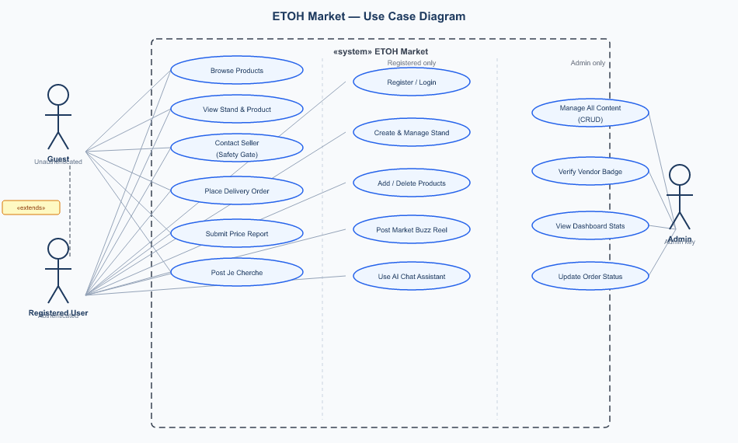
Figure 3.3: Use Case Diagram

3.5.6 Sequence Diagram — User Login
Figure 3.4 shows the complete interaction sequence when a user logs in: from form submission through Express authentication, bcrypt verification, and JWT generation to AuthContext state update.
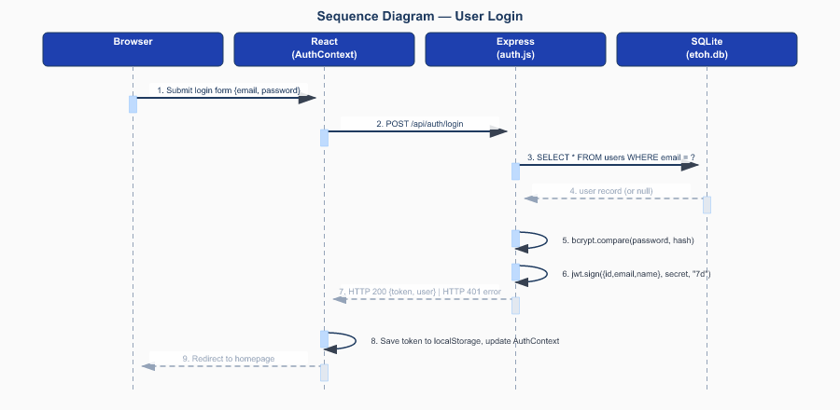
Figure 3.4: Sequence Diagram — User Login

3.5.7 Sequence Diagram — Add Product
Figure 3.5 shows how a product is saved: the request passes through the JWT middleware, the multer file-upload middleware, and an ownership check before the INSERT is executed.
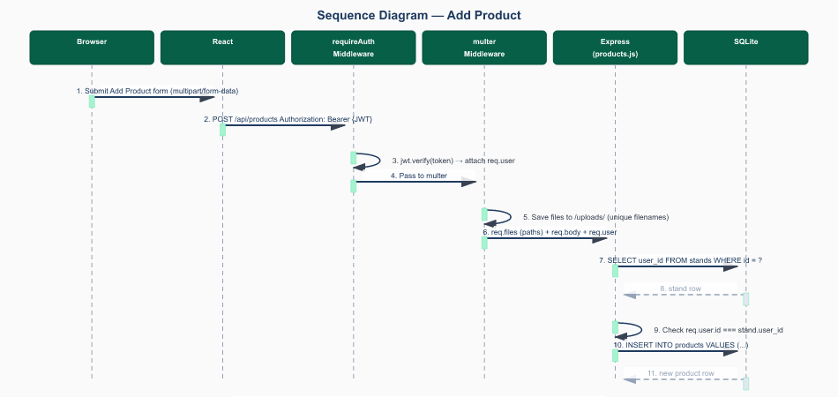
Figure 3.5: Sequence Diagram — Add Product

3.5.8 Activity Diagram — Buyer Flow
Figure 3.6 shows the complete buyer journey from opening the homepage to revealing the seller's contact number through the Safety Gate.
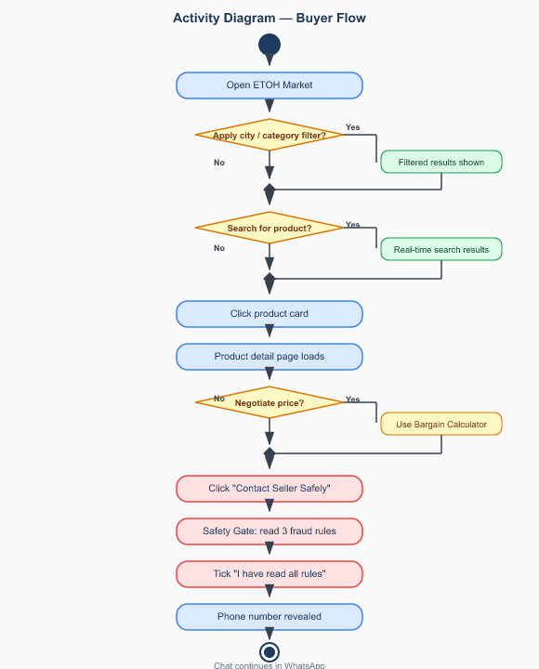
Figure 3.6: Activity Diagram — Buyer Product Discovery and Contact Flow

3.6 System Design
3.6.1 System Architecture
ETOH Market uses a three-tier client-server architecture (Figure 3.1). The presentation tier is a React SPA in the browser. The application tier is a Node.js + Express.js server. The data tier is SQLite in a single etoh.db file. Uploaded media is served by Express.static() from the uploads/ folder. The Google Gemini API is called for AI chat.
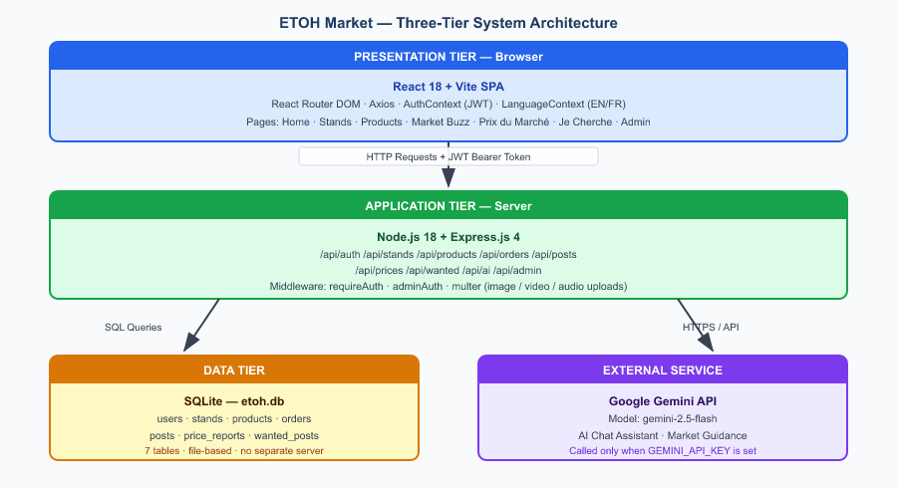
Figure 3.1: System Architecture Diagram

3.6.2 Entity-Relationship Diagram
The database has seven tables. Users own Stands (1:N). Stands have Products (1:N) and Posts (1:N). Products are referenced by Orders (1:N). PriceReport and WantedPost are independent tables with no foreign key links.
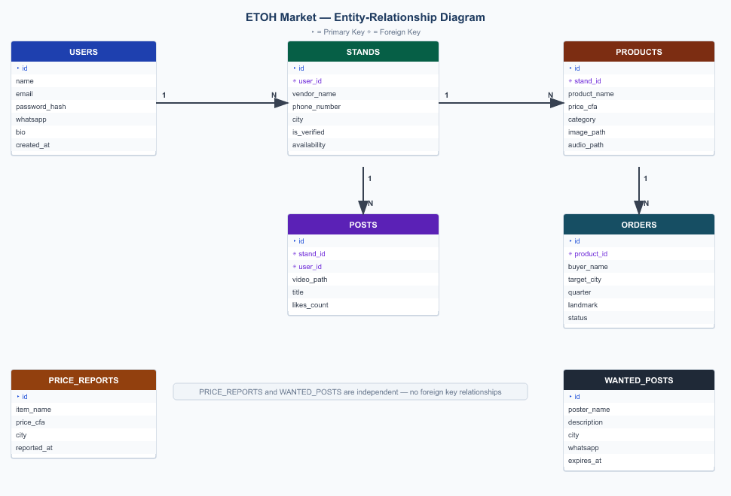
Figure 3.2: Entity-Relationship Diagram

3.6.3 Data Dictionary

Table 3.9: Data Dictionary — users
Column | Type | Constraints | Description
id | INTEGER | PK, AUTOINCREMENT | Unique user identifier
name | TEXT | NOT NULL | Full name from registration
email | TEXT | UNIQUE, NOT NULL | Login email address
password_hash | TEXT | NOT NULL | bcrypt hash; plaintext never stored
whatsapp | TEXT | NULLABLE | Optional WhatsApp number
profile_picture | TEXT | NULLABLE | URL path to uploaded avatar
bio | TEXT | NULLABLE | Short self-description
created_at | TEXT | DEFAULT datetime('now') | Creation timestamp

Table 3.10: Data Dictionary — stands
Column | Type | Constraints | Description
id | INTEGER | PK, AUTOINCREMENT | Unique stand identifier
user_id | INTEGER | FK → users(id) CASCADE | Owner; stand deleted if owner deleted
vendor_name | TEXT | NOT NULL | Name of the vendor's stand
phone_number | TEXT | NOT NULL | Primary contact phone number
city | TEXT | DEFAULT 'Douala' | City where the vendor operates
is_verified | INTEGER | DEFAULT 0 | 1 = Trusted Vendor Badge awarded by admin
availability | TEXT | DEFAULT 'open' | open, away, or closed

Table 3.11: Data Dictionary — products
Column | Type | Constraints | Description
id | INTEGER | PK, AUTOINCREMENT | Unique product identifier
stand_id | INTEGER | FK → stands(id) CASCADE | Stand that owns this product
product_name | TEXT | NOT NULL | Name of the product
price_cfa | REAL | NOT NULL | Asking price in CFA francs
category | TEXT | DEFAULT 'general' | food, produce, fashion, electronics, beauty, home, crafts, services, general
image_path | TEXT | NULLABLE | URL to uploaded product image
video_path | TEXT | NULLABLE | URL to uploaded product video
audio_voice_path | TEXT | NULLABLE | URL to uploaded voice note

Table 3.12: Data Dictionary — orders
Column | Type | Constraints | Description
id | INTEGER | PK, AUTOINCREMENT | Unique order identifier
product_id | INTEGER | FK → products(id) CASCADE | The product ordered
buyer_name | TEXT | NOT NULL | Full name of the buyer
target_city | TEXT | NOT NULL | Delivery city
target_quarter | TEXT | NOT NULL | Neighbourhood or district
near_landmark | TEXT | NOT NULL | Nearest landmark for the delivery rider
status | TEXT | DEFAULT 'pending' | pending, confirmed, delivered, or cancelled

CHAPTER FOUR: IMPLEMENTATION, RESULTS AND TESTING
4.1 Introduction
This chapter describes how each major module was built, presents the system results, and reports unit, integration, and system test outcomes.

4.2 Implementation
4.2.1 Server and Database
The entry point server.js loads database.js (which runs all CREATE TABLE IF NOT EXISTS statements and ALTER TABLE migrations), loads app.js (which mounts all nine route files), then starts the HTTP listener. The test suite imports app.js without starting the listener and uses a separate test database pointed to by the DB_PATH environment variable.

4.2.2 Authentication
Registration uses bcrypt.hash(password, 10). The cost factor of 10 makes each hash take ~100ms, preventing brute-force attacks. Login uses bcrypt.compare(entered, stored). On success, jwt.sign({id,email,name}, secret, "7d") returns a 7-day token. The requireAuth middleware verifies this token on every protected request and attaches req.user.

4.2.3 File Uploads
Multer saves uploads to uploads/ with timestamped unique filenames. Products accept three files per request via upload.fields([{name:'image'},{name:'video'},{name:'audio'}]). Files are served at /uploads/ by Express.static(). The Voice Recorder uses the browser's MediaRecorder API to record up to 60 seconds of audio without any plugin.

4.2.4 Frontend Architecture
AuthContext stores the JWT and user in React state and localStorage. LanguageContext provides t() — all text is retrieved by key (e.g. t('heroTitle')), so toggling the language updates all 200+ strings instantly. All API calls go through a single Axios instance. A request interceptor adds the JWT header; a response interceptor auto-logs out expired sessions.

4.2.5 Key Features
Bargain Calculator: offer = Math.floor(price × (1−pct/100) / 50) × 50. Division and multiplication by 50 rounds to the nearest 50 CFA — the standard denomination in Cameroonian markets.
Prix du Marché: SQL window functions (MIN, MAX, AVG with OVER PARTITION BY item_name) calculate stats for all twelve tracked items in one query.
Availability Badge: pulsing green CSS animation dot for open, static amber for away, red for closed.
AI Chat: backend calls Gemini with a system prompt making it a "friendly Cameroonian market assistant who knows CFA prices, local recipes, and safe trading tips". A fallback message is returned if no API key is configured.

4.3 Results
[Figure 4.1: Homepage showing the hero banner, live stats strip (e.g. "67 Products | 18 Stands | 8 Cities"), product grid with Trusted Vendor badges and green availability dots, and filter chips for city and category.]

[Figure 4.2: Product detail page with Safety Gate modal open showing three fraud prevention rules and a checkbox — the phone number is hidden until the buyer ticks the checkbox. The Bargain Calculator below shows three buttons (10%, 20%, 30% off) with prices rounded to the nearest 50 CFA and a "Copy Offer Message" button.]

[Figure 4.3: Market Buzz reel feed — centred video with vendor info and likes counter. Auto-plays on scroll via IntersectionObserver.]

[Figure 4.4: Prix du Marché showing twelve staple food cards, each with today's min / average / max price from community reports.]

[Figure 4.5: Je Cherche board showing buyer request cards with description, city, days until expiry, and a WhatsApp contact button.]

[Figure 4.6: Admin Panel dashboard with stat cards and a Stands tab showing a Verify toggle that grants the Trusted Vendor Badge.]

4.4 Testing
4.4.1 Unit Tests

Table 4.1: Unit Test Cases
ID | Test | Expected | Result
UT-A01 | Register with valid data | HTTP 201, JWT returned | PASS
UT-A02 | Register without name | HTTP 400, error message | PASS
UT-A03 | Register with password < 6 chars | HTTP 400, error message | PASS
UT-A04 | Register with duplicate email | HTTP 409, error message | PASS
UT-A05 | Login with correct credentials | HTTP 200, JWT returned | PASS
UT-A06 | Login with wrong password | HTTP 401, error message | PASS
UT-A07 | Access /me without token | HTTP 401, error message | PASS
UT-A08 | Access /me with expired token | HTTP 401, error message | PASS

4.4.2 Integration Tests

Table 4.2: Integration Test Cases
ID | Test | Expected | Result
IT-S01 | Create stand as authenticated user | HTTP 201, stand saved | PASS
IT-S02 | Create stand without token | HTTP 401 Unauthorized | PASS
IT-S03 | Edit stand you own | HTTP 200, updated | PASS
IT-S04 | Edit stand you do not own | HTTP 403 Forbidden | PASS
IT-S05 | Delete stand; check products deleted | HTTP 200; products = 0 | PASS
IT-P01 | Add product to your own stand | HTTP 201, product saved | PASS
IT-P02 | Add product to someone else's stand | HTTP 403 Forbidden | PASS
IT-P03 | Submit price report with valid data | HTTP 201, report saved | PASS
IT-P04 | Submit price report with price = 0 | HTTP 400, validation error | PASS
IT-W01 | Post Je Cherche with invalid WhatsApp | HTTP 400, validation error | PASS
IT-W02 | Delete Je Cherche with correct WhatsApp | HTTP 200, deleted | PASS
IT-W03 | Delete Je Cherche with wrong WhatsApp | HTTP 403 Forbidden | PASS

4.4.3 System Tests
A full end-to-end test was run: register → login → create stand → add three products → browse homepage → place delivery order → submit two price reports → post a Je Cherche request. All steps passed.

Table 4.3: System Test Results
Requirement | Method | Result | Notes
FR01–FR03: Auth | End-to-end user journey | PASS | All auth flows work
FR04–FR06: Stands | Create, edit, availability, delete | PASS | CASCADE deletion confirmed
FR07–FR08: Products | Add product with media; filter on homepage | PASS | Images served at /uploads/
FR09–FR10: Safety Gate + WhatsApp | Manual browser test | PASS | Checkbox required before reveal
FR11: Bargain Calculator | Verify 10/20/30% calculations | PASS | Rounds to nearest 50 CFA
FR12: Bendskin Button | Verify WhatsApp message content | PASS | All product/vendor details included
FR13: Orders | POST order; verify in DB via admin | PASS | All fields stored correctly
FR14: Market Buzz | Upload video; verify auto-play | PASS | IntersectionObserver on mobile
FR15–FR16: Prix du Marché | Submit 3 reports; check min/avg/max | PASS | SQL window functions correct
FR17–FR18: Je Cherche | Post request; verify 7-day expiry | PASS | Expired posts hidden from feed
FR19: AI Chat | Send message; verify Gemini response | PASS (with key) | Fallback shown without key
FR20: Bilingual | Toggle language; verify all text | PASS | All 200+ strings translated
NFR01: Performance | 100 products API response time | PASS | Under 120ms on LAN
NFR03–NFR04: Security | No plaintext passwords; ownership checks | PASS | Verified by unit/integration tests

CHAPTER FIVE: SUMMARY, CONCLUSIONS AND RECOMMENDATIONS
5.1 Discussions
ETOH Market meets all 20 functional and 8 non-functional requirements. The most important finding is that a full-featured digital marketplace for Cameroon can be built using open-source tools at a monthly running cost of under 7,000 CFA francs. The WhatsApp-first design was the most critical decision — using wa.me links works with existing user behaviour rather than against it. The bilingual feature proved more valuable than expected: Cameroonian market interactions naturally switch between English and French. The Prix du Marché and Je Cherche features fill real information gaps: research confirms community-sourced market data creates measurable economic benefits for buyers and sellers in African markets [4][7].

5.2 Conclusions
This project successfully designed, developed, implemented, and tested ETOH Market — a bilingual, WhatsApp-integrated digital marketplace for Cameroonian vendors and buyers. The system addresses all six identified problems. The technology stack (Node.js, Express.js, React.js, SQLite, JWT, bcryptjs, Google Gemini) was well-suited to all requirements. Agile was the right methodology — it handled significant scope changes without disrupting the project. ETOH Market shows that a student developer can build locally adapted e-commerce technology that has real social and economic value for the community it serves.

5.3 Recommendations
- Deploy now: Host on a VPS with a .cm domain and SSL certificate to reach real Cameroonian users immediately.
- Build an Android app: Push notifications and a better mobile experience would increase engagement. Android covers over 90% of the Cameroonian smartphone market.
- Create a WhatsApp onboarding guide: A step-by-step sign-up guide delivered via WhatsApp in both English and French would reduce the digital literacy barrier.
- Add Mobile Money integration: An optional MTN MoMo or Orange Money escrow feature would increase buyer confidence for high-value transactions.
- Improve content moderation: AI-assisted image classification could flag suspicious listings for admin review as the platform grows.
- Monitor performance: Deploy Prometheus and Grafana to track API response times and error rates.

5.4 Further Work
- AI price prediction: The time-series data from Prix du Marché could train an LSTM model to forecast future staple food prices.
- Local language NLP: Fine-tuning a model on Cameroonian Pidgin, Bassa, Fulfulde, Duala, and Ewondo would make the AI assistant more culturally resonant.
- Impact study: A 12-month study measuring vendor revenue change after joining ETOH Market would provide rigorous evidence of economic impact.
- Scalable vendor verification: Self-sovereign identity (SSI) research could enable vendors to prove identity through mobile operators without manual admin review.
- Bendskin routing: Order origin/destination data could optimise bendskin rider routing and reduce delivery times.

REFERENCES

[1] International Labour Organization, "Women and Men in the Informal Economy: A Statistical Picture," 3rd ed., ILO, Geneva, 2018.

[2] GSMA, "The Mobile Economy: Sub-Saharan Africa 2023," GSMA Intelligence, London, 2023.

[3] Datareportal, "Digital 2024: Cameroon," Datareportal, 2024. [Online]. Available: https://datareportal.com/reports/digital-2024-cameroon

[4] J. C. Aker and I. M. Mbiti, "Mobile phones and economic development in Africa," J. Econ. Perspect., vol. 24, no. 3, pp. 207–232, 2010.

[5] D. Gefen, E. Karahanna, and D. W. Straub, "Trust and TAM in online shopping: An integrated model," MIS Q., vol. 27, no. 1, pp. 51–90, 2003.

[6] E. Turban, D. King, J. K. Lee, and T.-P. Liang, Electronic Commerce: A Managerial and Social Networks Perspective, 8th ed., Cham: Springer, 2015.

[7] WeFarm, "WeFarm Impact Report 2021," WeFarm Ltd., 2021. [Online]. Available: https://wefarm.org

[8] K. Beck et al., "Manifesto for Agile Software Development," Agile Alliance, 2001. [Online]. Available: http://agilemanifesto.org

[9] UN Women, "Women's Economic Empowerment in Cameroon," UN Women Cameroon, Yaoundé, 2022.

