LM741
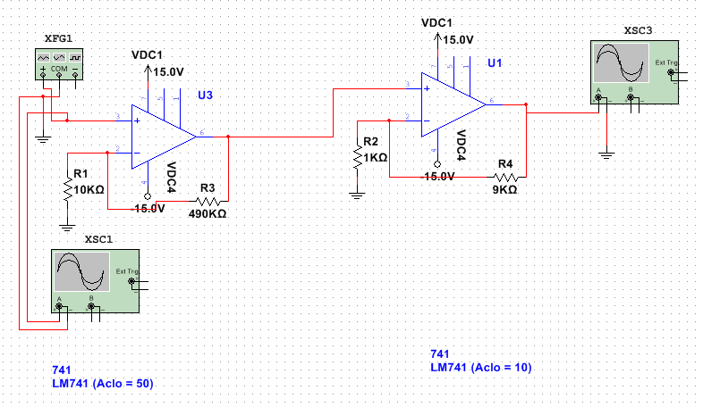
Figure 1. Schematic for LM741 amplifier simulation.

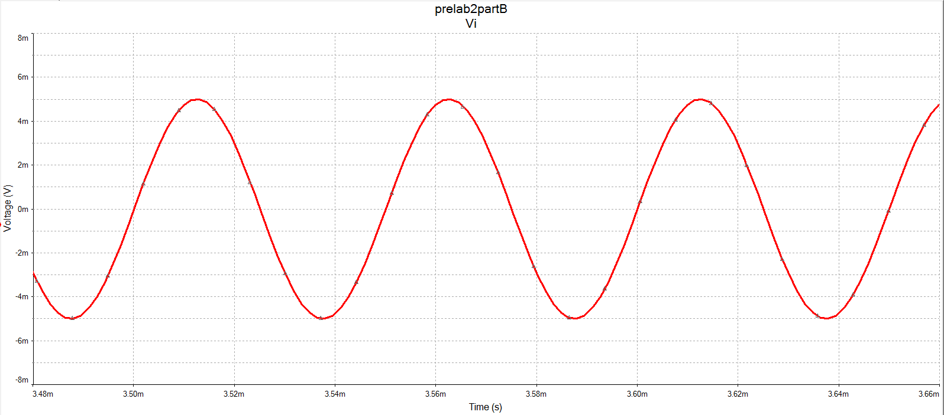
Figure 2. Input waveform signal for LM714 amplifier circuit.

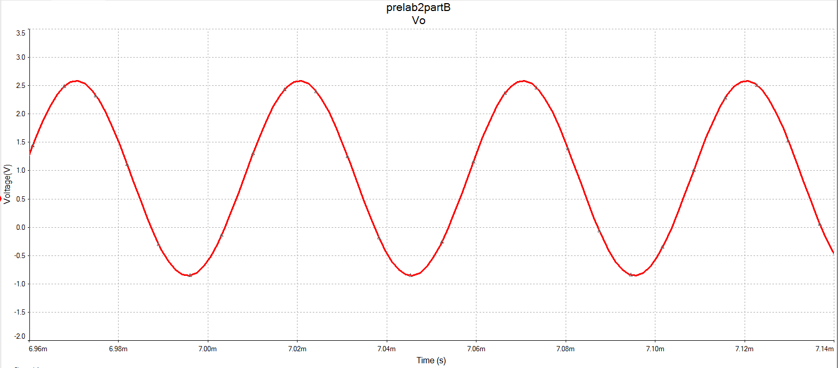
Figure 3. Amplified output waveform signal.

