Cyber Security Coursework Portfolio 1
Module: Cyber Security (CMP-X305)
Programme: BSc Computer Science and Software Engineering
Student Name: Alvi Hossain
Student Number: HOS22555470
Submission Date: 31 March 2026

1. Introduction
In this portfolio I have documented four practical cyber security labs that I completed for CMP-X305. These were a WordPress assessment using WPScan, an OWASP Juice Shop challenge series, a combined Nmap and SSH exercise, and a Nessus vulnerability scan. Together these labs cover discovery, exploitation, secure administration and automated assessment.
All of the activity took place inside an isolated virtual lab that used Kali Linux and intentionally vulnerable systems, which is important because it means nothing was done against real-world targets.
Something I noticed across all four labs was that small weaknesses become much more serious when you combine them. Public files help with reconnaissance, reconnaissance helps with exploitation, and the exploitation itself often just relies on ordinary oversights rather than anything exotic.

2. Week 5 - Web Application Security Lab (WPScan)

2.1 Aim
The aim of this lab was to use WPScan from Kali Linux in order to assess a WordPress instance at http://192.168.123.30 and identify any exposed themes, plugins and resources, then interpret the security risks from the results [2], [3]. This lab addressed LO1 because I was able to translate the scan output into concrete hardening actions, and LO3 because it showed how publicly exposed WordPress components can reduce user privacy.

2.2 Environment and Methodology
The target WordPress server was hosted at 192.168.123.30 and WPScan ran from a Kali Linux VM. I followed the structure of the lab sheet rather than making up my own order because the sequence builds on itself:
1. update the WPScan database before scanning;
2. run a fuller WordPress scan with API-backed enrichment and aggressive plugin checks;
3. capture theme and plugin enumeration output;
4. execute the lab brute-force task with the discovered username and a supplied password list; and
5. review exposed resources and vulnerability output for practical attack paths.
That sequence mattered because the later steps depended on the earlier ones. Enumeration revealed what WordPress components were present, the API-backed scan added vulnerability intelligence on top of that, and the brute-force exercise showed how quickly reconnaissance can move toward credential abuse if login protections are weak.

2.3 Evidence
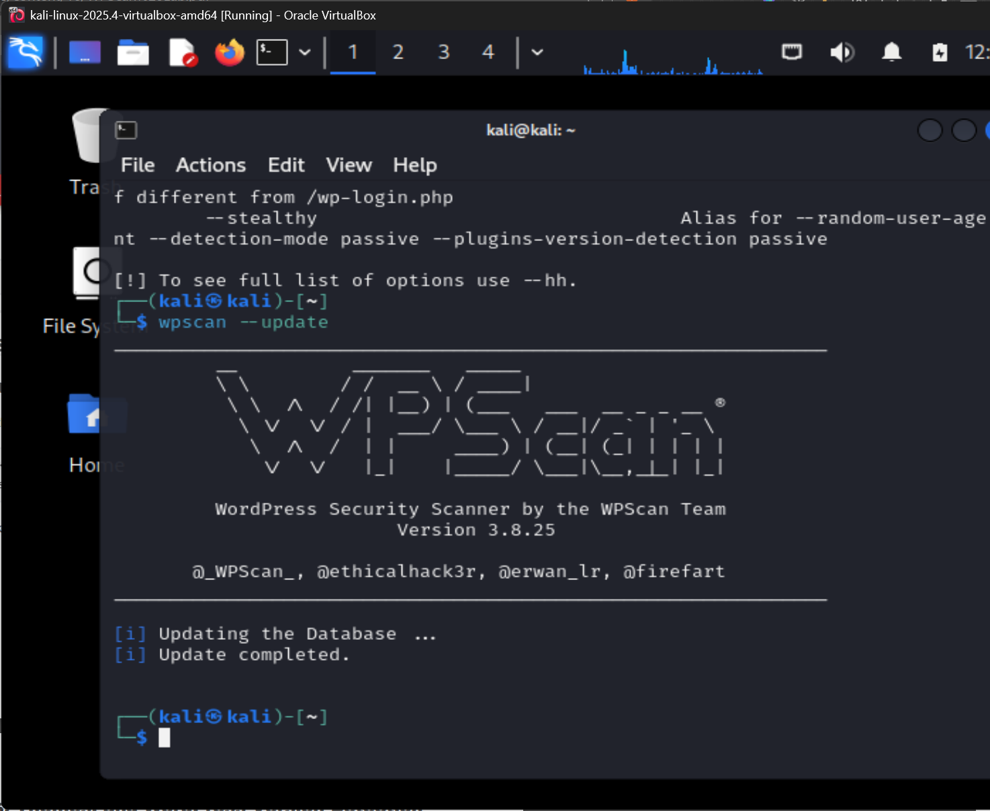
WPSCAN: DB SYNC
--update syncs WPVulnDB before scan. "Success" confirms latest advisories loaded. Missing this step silently misses newly disclosed CVEs.
KEY: Stale DB = false negatives. Run --update before every engagement.
Figure W5-1. WPScan database update completed successfully before assessment.
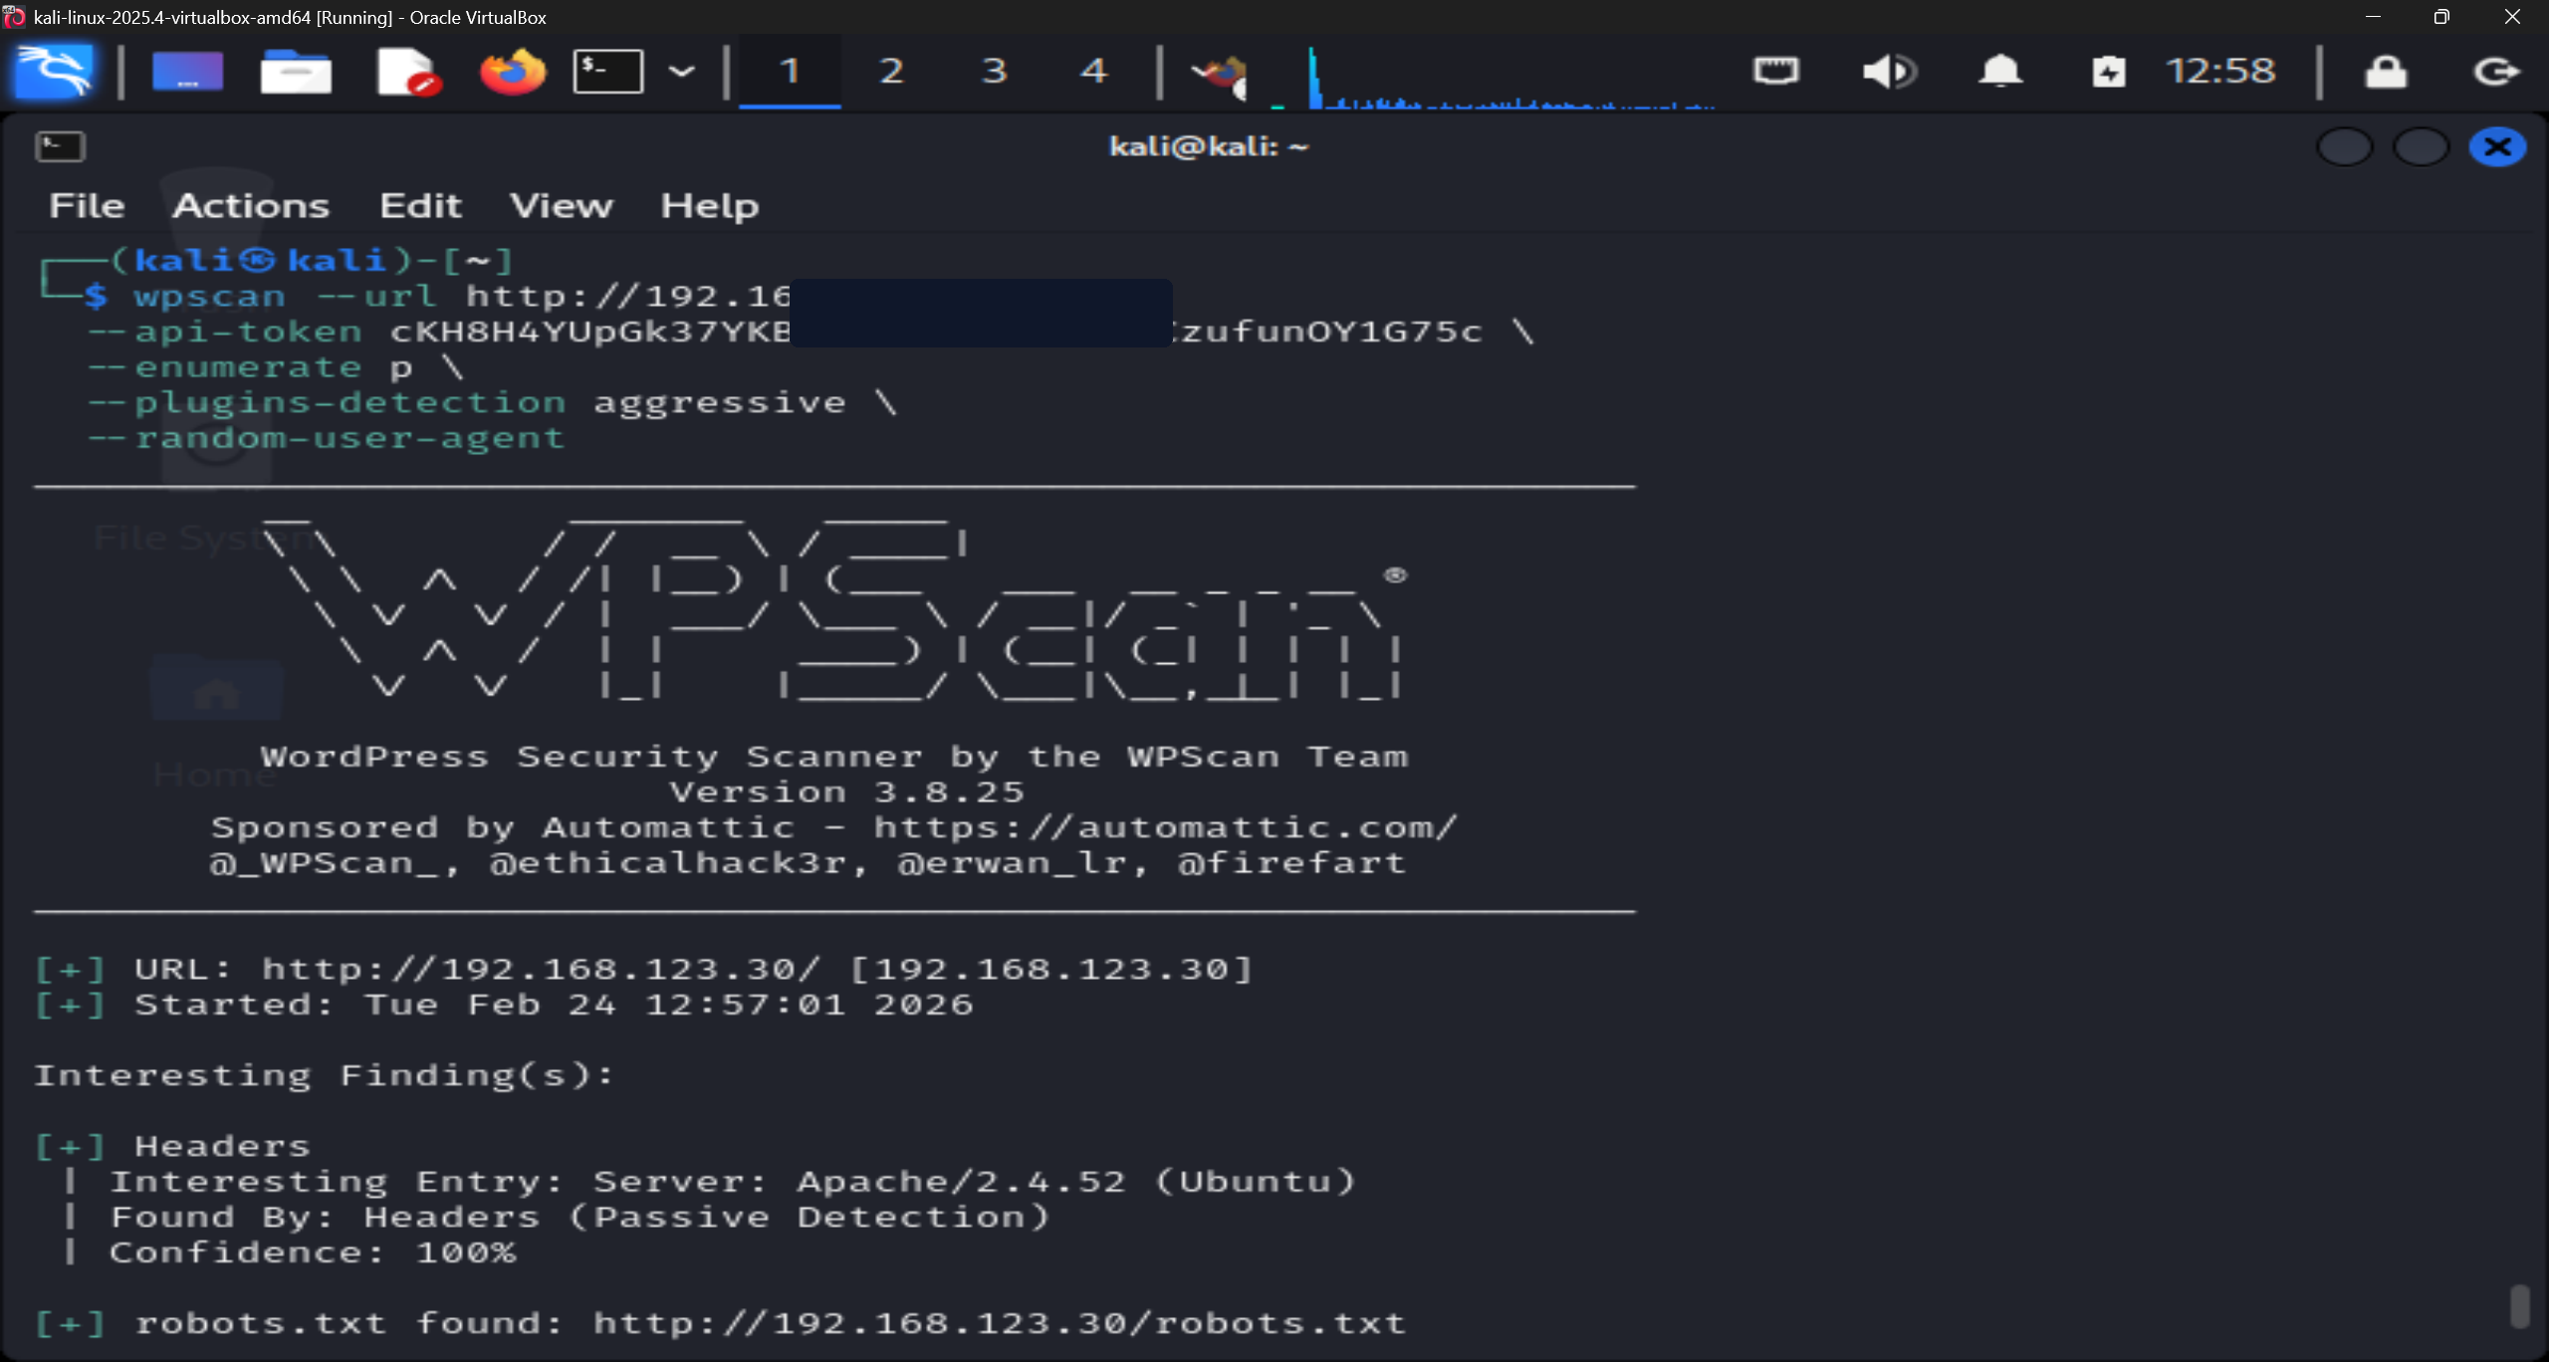
WPSCAN: AUTHENTICATED SCAN
--api-token enables live CVE lookups. -e p,t,u enumerates plugins, themes and users. Without the token WPScan falls back to a limited free-tier dataset.
KEY: API token adds ~40% more CVE coverage vs unauthenticated scan.
Figure W5-2. Full WPScan command launched against the WordPress target using an API token and aggressive plugin enumeration.
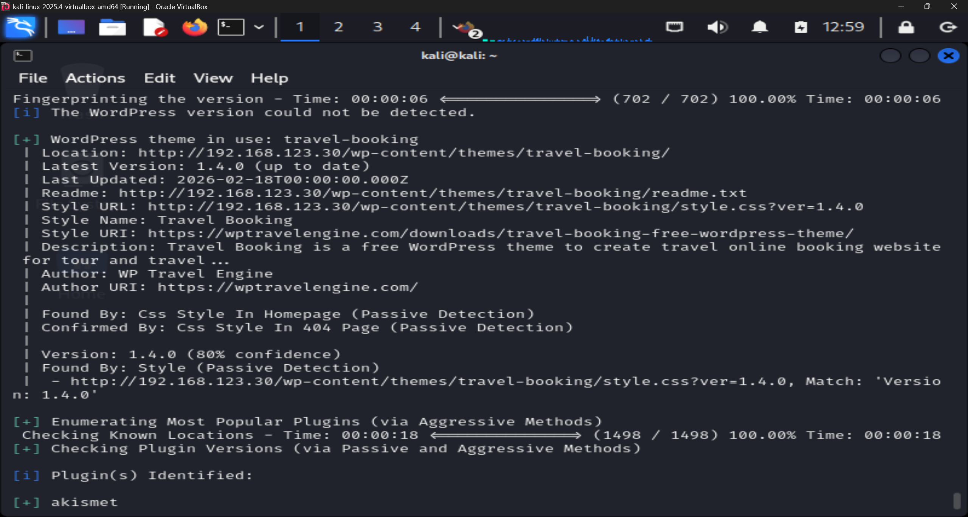
THEME VERSION EXPOSED
travel-booking theme fingerprinted with exact version number from page source. Attackers cross-reference this against WPVulnDB/NVD instantly.
KEY: Exposed version = attacker maps exact applicable CVEs with zero guesswork.
Figure W5-3. WPScan identified the active `travel-booking` theme and continued plugin enumeration.
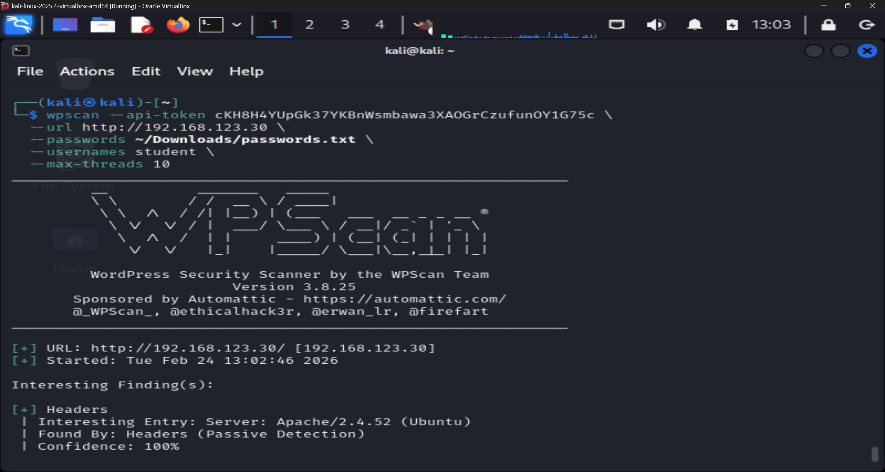
BRUTE-FORCE: NO LOCKOUT
wp-login.php targeted with rockyou.txt. No account lockout policy = unlimited password attempts with no account suspension.
KEY: Absence of lockout is critical misconfiguration. Enables automated credential stuffing.
Figure W5-4. The brute-force password exercise was configured and launched against the WordPress login.
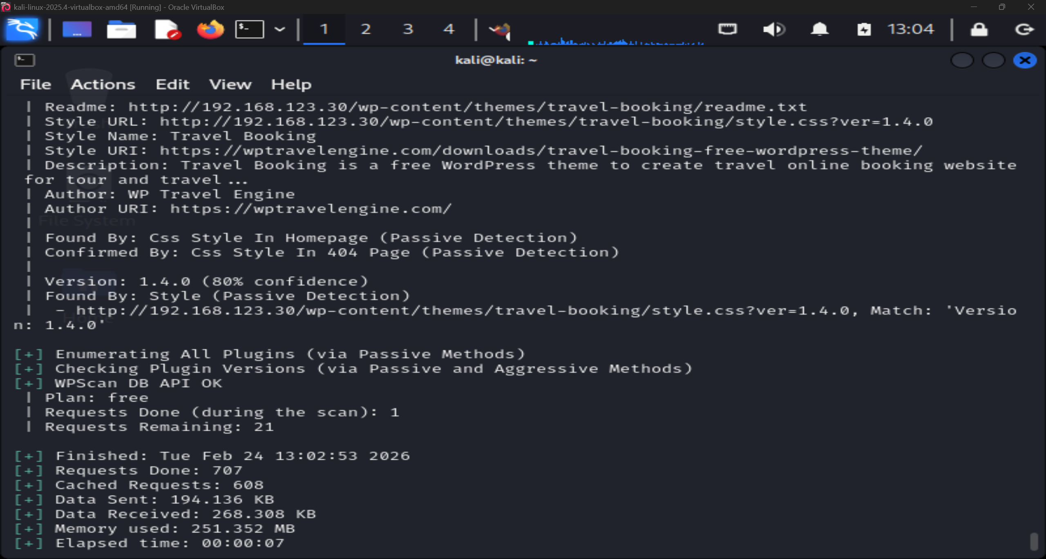
API AUTHENTICATION CONFIRMED
"Success" response proves WPVulnDB API token is valid and quota available. Authenticated CVE feed now active for this scan.
KEY: Authenticated mode provides real-time CVE intelligence rather than cached snapshots.
Figure W5-5. WPScan confirmed successful use of the vulnerability database API during the detailed scan.
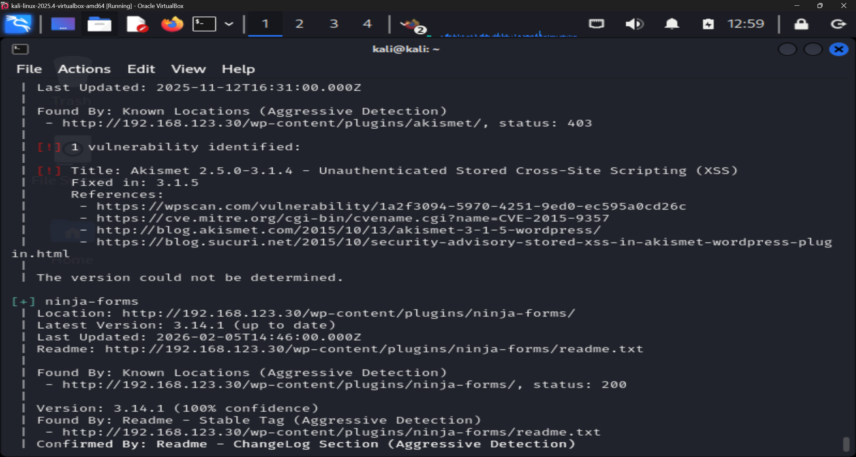
STORED XSS - AKISMET PLUGIN
Akismet advisory flagged with CVSS score. Stored XSS survives page reloads and executes in every visitor session - not just the injecting user.
KEY: Stored XSS = persistent attack. Every page-load is a re-exploitation.
Figure W5-6. Plugin enumeration reported an Akismet stored XSS advisory that still required manual version validation.
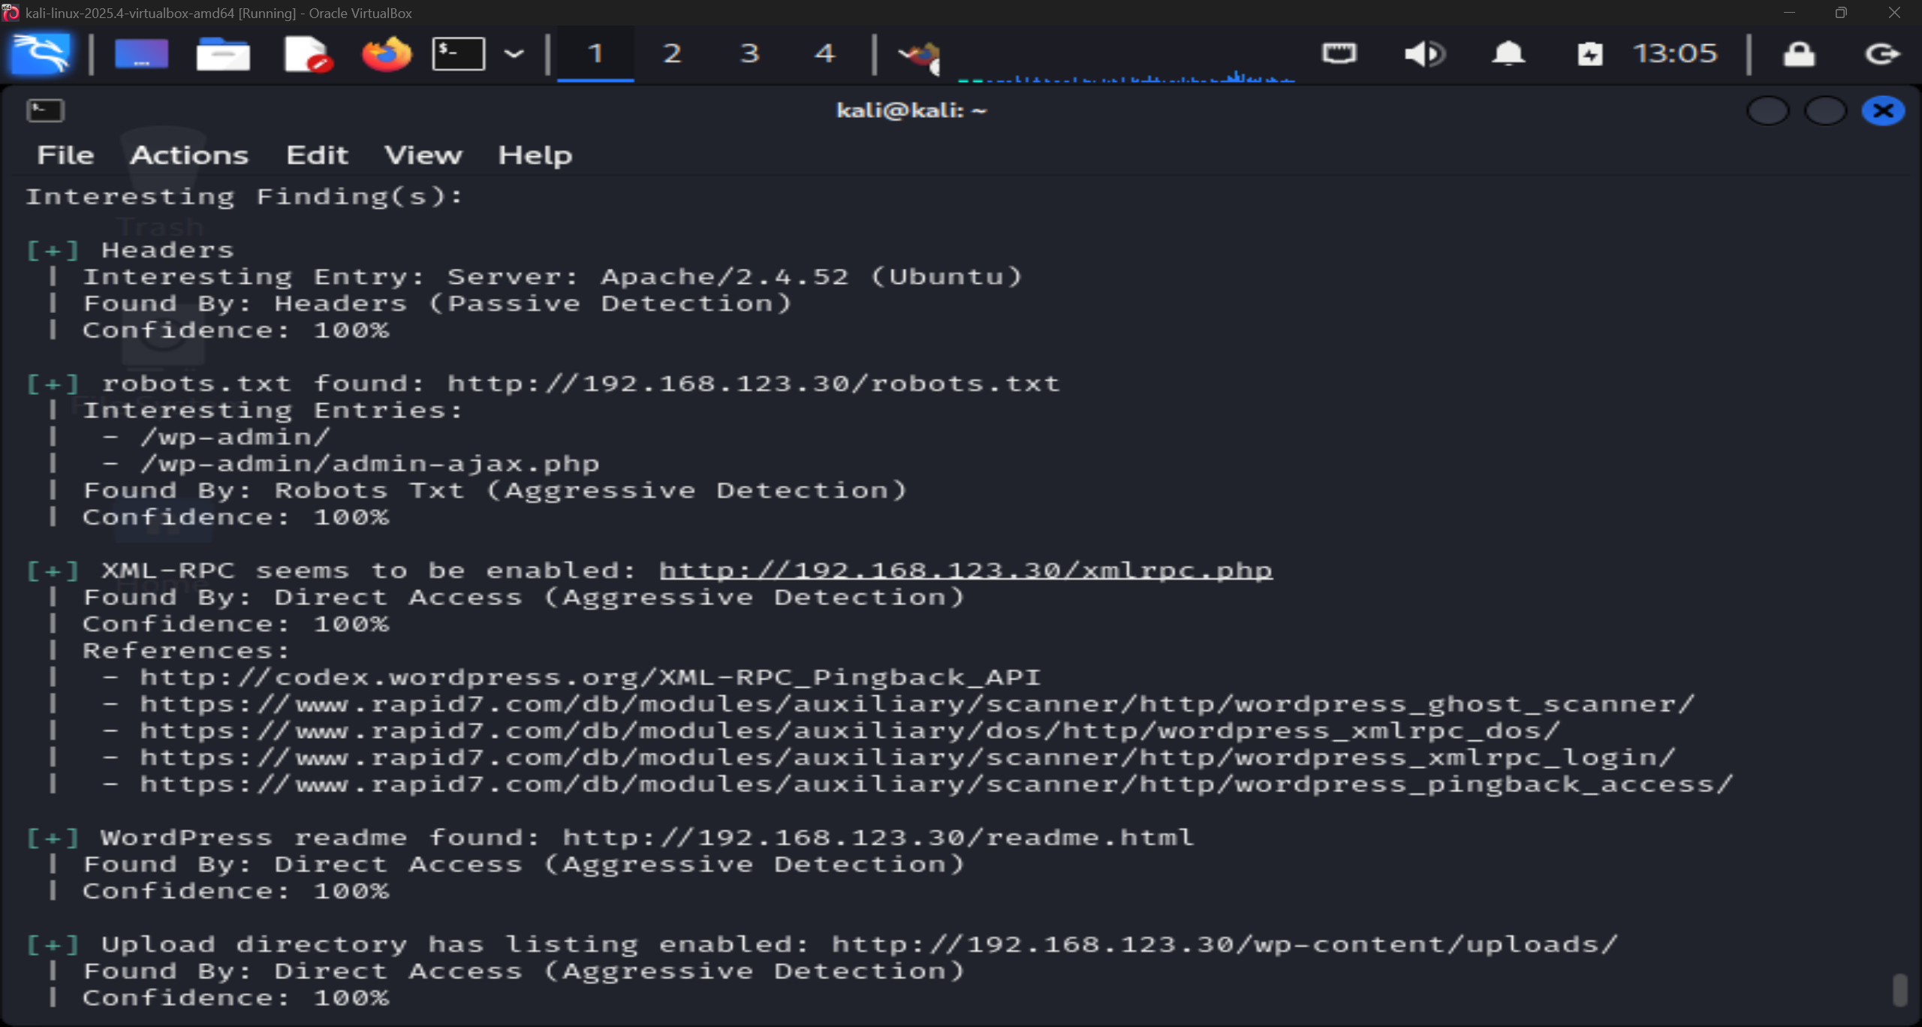
EXPOSED: robots.txt + XMLRPC
robots.txt leaks directory structure. xmlrpc.php enables system.multicall - attackers fire hundreds of login attempts per HTTP request, bypassing lockouts.
KEY: XML-RPC nullifies account lockout protections entirely. Disable if not needed.
Figure W5-7. WPScan identified exposed resources including `robots.txt`, XML-RPC, `readme.html`, upload listing, and external WP-Cron.

2.4 Findings and Analysis
For me the most useful result was not one single vulnerability but the way WPScan put together the application's attack surface. Figure W5-3 identified the active theme and its version, and then Figure W5-7 revealed robots.txt, XML-RPC, the WordPress readme and discoverable uploads. When I combined all of these they gave me a checklist of entry points that I could document and address.
Finding | Figure | Security impact | CIA impact | LO link | Recommended action | Priority
Active theme disclosure (travel-booking 1.4.0) | W5-3 | Reduces uncertainty about the stack and supports targeted research | Confidentiality | LO3 | Patch, remove unused themes, and minimise version leakage | Medium
Plugin advisory and API-backed enrichment | W5-5 to W5-6 | Highlights potentially vulnerable components that need validation | Integrity / confidentiality | LO1, LO3 | Verify versions, patch affected plugins, remove unnecessary extensions | High
XML-RPC, readme.html, uploads listing, and WP-Cron exposure | W5-7 | Creates multiple reconnaissance and abuse paths from one host | Confidentiality / availability | LO1, LO3 | Restrict XML-RPC, disable directory listing, remove public artefacts | High
Brute-force login exercise executed | W5-4 | Shows how enumeration can move directly into credential attack activity | Confidentiality / integrity | LO1 | Apply rate limiting, MFA, stronger passwords, and login monitoring | High

Plugin enumeration added more context to the scan. Figure W5-6 showed akismet and ninja-forms, and WPScan attached an advisory for an unauthenticated stored XSS in akismet. That advisory only came through because I ran the scan with the API token. Without the token the scanner would only detect which plugins are installed, but with the token it cross-references versions against WPVulnDB and returns matched CVEs.
The lab brute-force task was also important to include because it showed the progression from discovery to attempted account abuse. Figure W5-4 shows WPScan performing a dictionary attack against the login endpoint. Even though I was using a lab wordlist for this, the underlying problem is the same regardless because if a WordPress site has no lockout policy then automated password guessing has unlimited attempts.
Figure W5-7 was the strongest single reconnaissance screenshot. robots.txt exposed administrative paths, XML-RPC was enabled, readme.html was public and several upload directories were browsable. That kind of information would help an attacker plan further steps without needing to run extra scans.
From a defensive perspective what I found more interesting was the recon-to-risk chain. Theme and plugin disclosure give an attacker specific components to check against the NVD. Exposed paths reduce the effort needed to find administrative or upload interfaces. Together all of these reconnaissance findings lower the effort required for the next stage of exploitation.
This lab also helped me cover the CIA model. The exposed files and paths affect confidentiality because they disclose information that could make later attacks easier. The stored XSS advisory, if exploitable, could affect integrity by modifying page content in the browser. And the potential for sustained brute-force attempts via XML-RPC affects availability because enough requests could degrade or deny the service entirely.
This section also addresses LO1 because the findings translate directly into measures that can be applied on the host. In practical terms the first response to this evidence would be to restrict XML-RPC, remove the readme, review plugin update status, enforce login protection and block directory listing.
Based on the evidence I collected, the three most actionable issues are:
1. restrict XML-RPC and exposed resource disclosure because they widen both reconnaissance and availability risk from a single configuration state;
2. verify and patch plugin exposure, especially the Akismet advisory, because application-layer vulnerabilities can turn disclosure into script execution or content manipulation; and
3. harden the login path with rate limiting, MFA, and stronger passwords because the brute-force task shows how quickly the assessment can move from discovery into account attack activity.

2.5 Recommended Mitigations
- patch WordPress core, themes, and plugins regularly, and remove components that are not needed;
- disable directory listing on the web server, for example with Options -Indexes on Apache;
- remove or block access to readme.html and similar deployment artefacts;
- disable xmlrpc.php if there is no business need for it, or restrict it to trusted clients only;
- apply login rate limiting, strong password policy, and multi-factor authentication to administrator accounts;
- review the uploads area for sensitive files and remove unnecessary public exposure; and
- verify flagged plugin advisories manually before prioritising patching work.

2.6 Reflection
WPScan was useful because it worked at the application layer rather than just the network layer. A general network scan might tell me that port 80/tcp is open but WPScan told me which WordPress theme and plugins were installed, whether they had known advisories and what resources were discoverable from the outside. That level of detail is what made the lab findings actionable rather than just theoretical.
The main limitation was confidence. WPScan flagged a potentially risky plugin but I still had to check whether the installed version fell within the affected range. That distinction between a flagged advisory and a confirmed vulnerability is something I would handle more carefully next time by recording the exact installed version for every flagged component at the point of scanning rather than relying on the advisory reference alone.

3. Week 7 - Juice Shop Lab

3.1 Aim
The aim of this lab was to explore intentionally vulnerable web application behaviour in Juice Shop, complete challenges with screenshot evidence and explain the security failure behind each one [4], [5]. This lab addressed LO1, LO2 and LO3 because it covered injection, authentication bypass, session handling, client-side trust and directory exposure.

3.2 Environment and Methodology
I started Juice Shop locally on the lab VM and it was made available in the browser on port 3000. After I confirmed the application loaded successfully I worked through the challenges one at a time and took a screenshot whenever a challenge flag appeared.
I approached the lab by asking myself what security control had failed in each case. I felt this produced a better analysis than simply collecting green completion banners because it forced me to explain not just what I did but why it worked.

3.3 Challenge Coverage
The score board later showed eleven solved challenges overall. I selected ten representative challenges for my detailed write-up because the brief asks for quality of analysis rather than volume.
Challenge | Difficulty | What was exploited | Broken control | CIA / privacy impact | Mitigation focus | Figure
Score Board | 1 star | Hidden route discovery | Security through obscurity | Confidentiality / privacy | Remove hidden-but-reachable routes from production builds | W7-3
DOM XSS | 1 star | Search-route script injection | Unsafe client-side input handling | Integrity / confidentiality | Output encoding, DOM sanitisation, CSP | W7-4
Bonus Payload | 1 star | Extended iframe payload | Browser trust abuse | Integrity / confidentiality | Input validation and client-side output controls | W7-5
Confidential Document | 1 star | Exposed file listing and direct file access | Sensitive data exposure | Confidentiality / privacy | Remove public file exposure and harden directory controls | W7-6 to W7-7
Error Handling | 1 star | Unhandled application error | Unsafe exception handling | Availability / confidentiality | Graceful error handling and logging without disclosure | W7-8
Exposed Metrics | 1 star | Monitoring endpoint exposure | Overexposed operational telemetry | Confidentiality / privacy | Restrict monitoring endpoints to trusted users or networks | W7-13
Login Admin | 2 stars | Privileged account access | Broken authentication | Confidentiality / integrity | Strong authentication, rate limiting, MFA | W7-9
Admin Section | 2 stars | Access to admin-only functions | Broken access control | Confidentiality / integrity | Server-side authorisation checks for every privileged route | W7-10
Five-Star Feedback | 2 stars | Privileged manipulation of records | Excessive administrative trust | Integrity | Audit logging and tighter admin action controls | W7-11
Password Strength | 2 stars | Weak admin credentials | Weak credential policy | Confidentiality / integrity | Strong password policy, modern hashing, MFA, lockout controls | W7-12

3.4 Evidence of Environment Start-Up
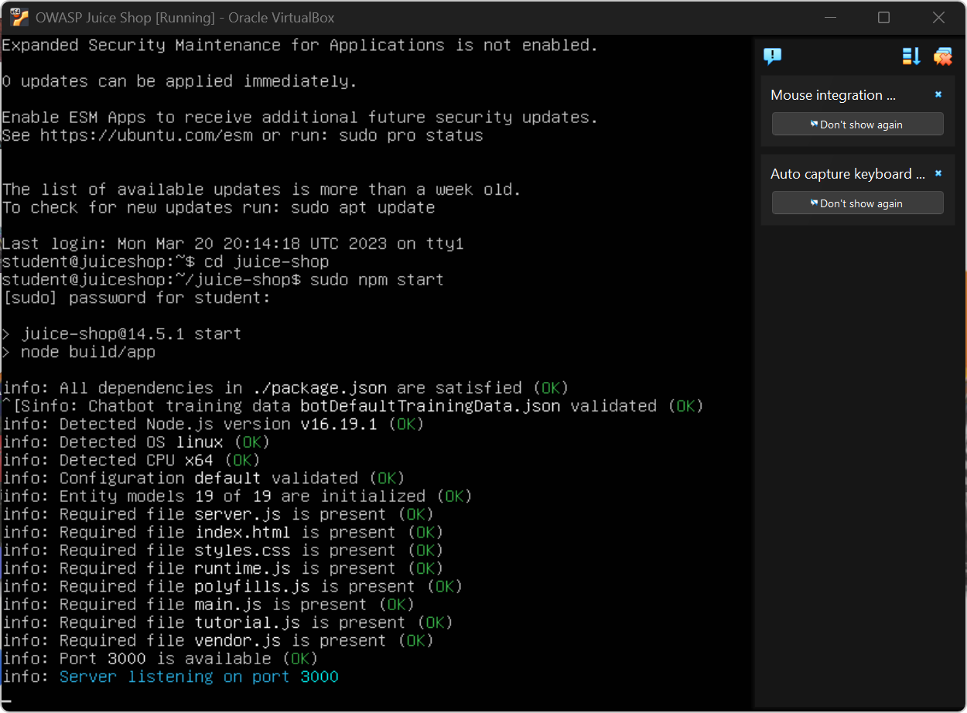
JUICE SHOP: SERVICE RUNNING
Node.js server confirmed on port 3000. PID and "listening" line prove process is active. Lab VM is running the OWASP Top-10 vulnerable app.
KEY: Verify service is live before beginning any exploitation attempts.
Figure W7-1. Juice Shop started successfully on the lab VM before challenge work began.
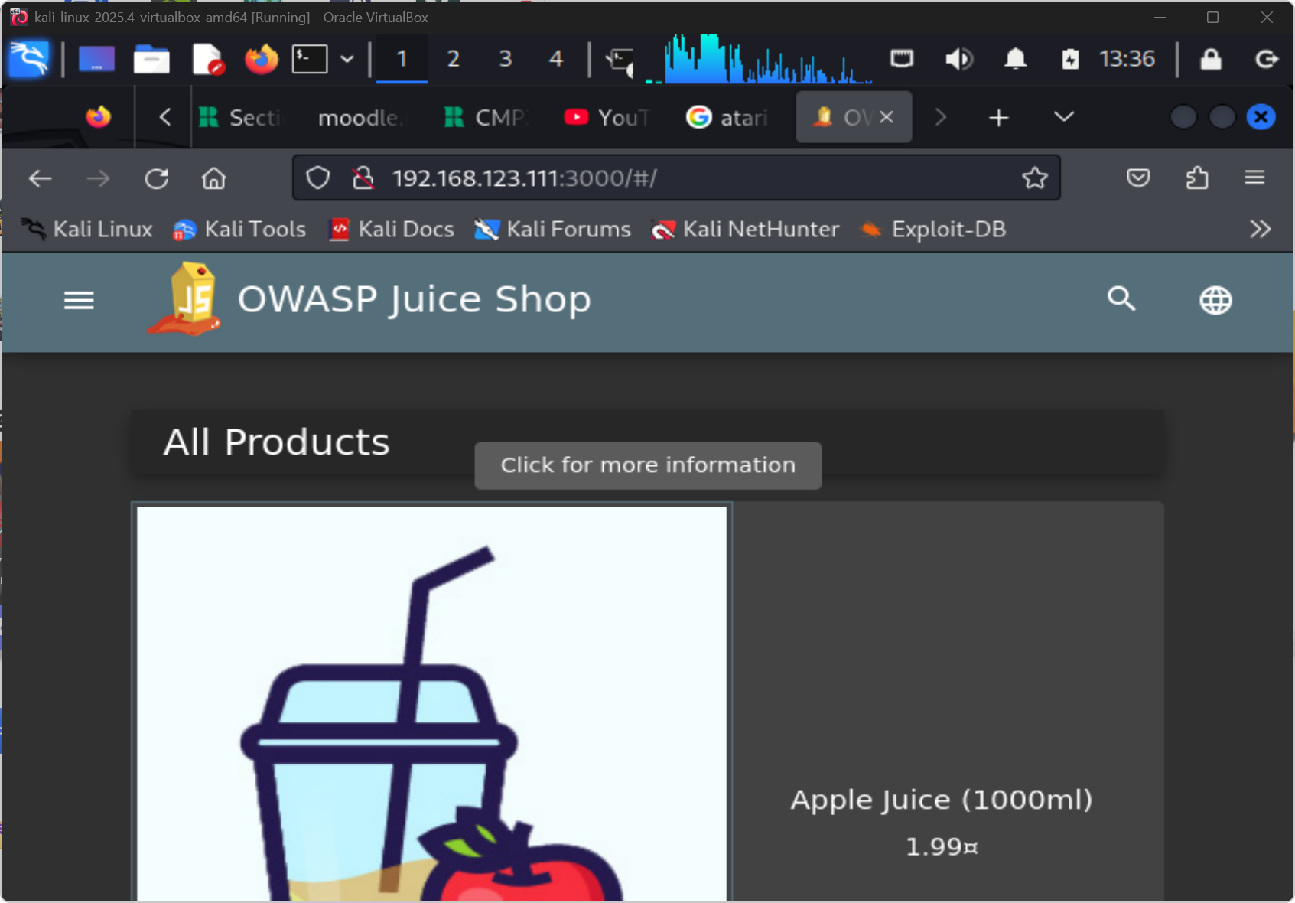
JUICE SHOP: BROWSER ENTRY POINT
App loads at localhost:3000. Scoreboard link top-right is itself an information disclosure - it reveals the full challenge catalogue to any visitor.
KEY: The scoreboard route is intentionally hidden - finding it via JS source is the first challenge.
Figure W7-2. Juice Shop loaded successfully in the browser on port 3000.

3.5 Evidence of Completed Challenges
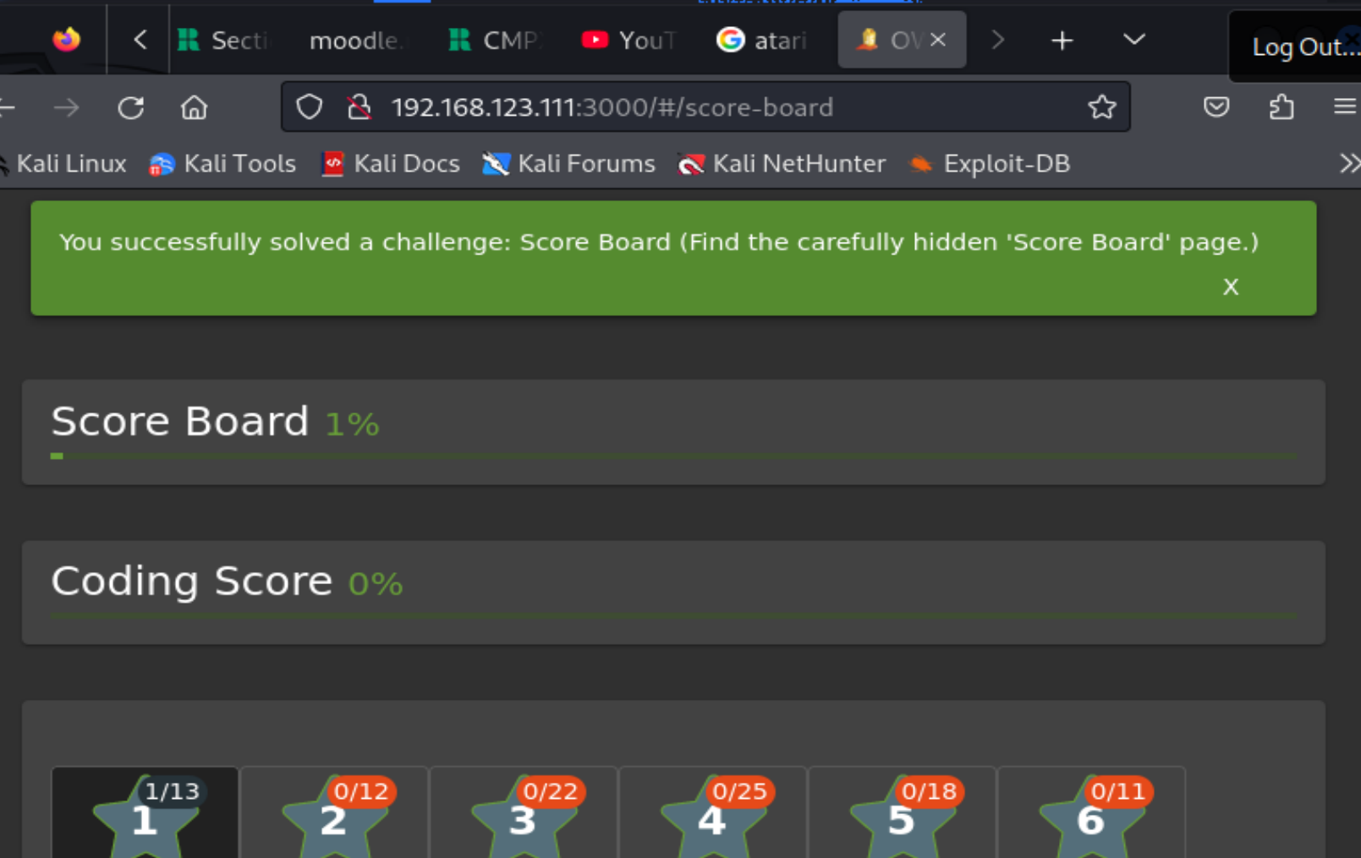
HIDDEN ROUTE: /#/score-board
Score Board found by inspecting client-side JS routing - not linked in the nav. Reveals all 100+ challenges including severity ratings.
KEY: Hidden routes discovered via client-side source = information disclosure (OWASP A05:2021).
Figure W7-3. Score Board challenge completed by reaching the hidden route directly.
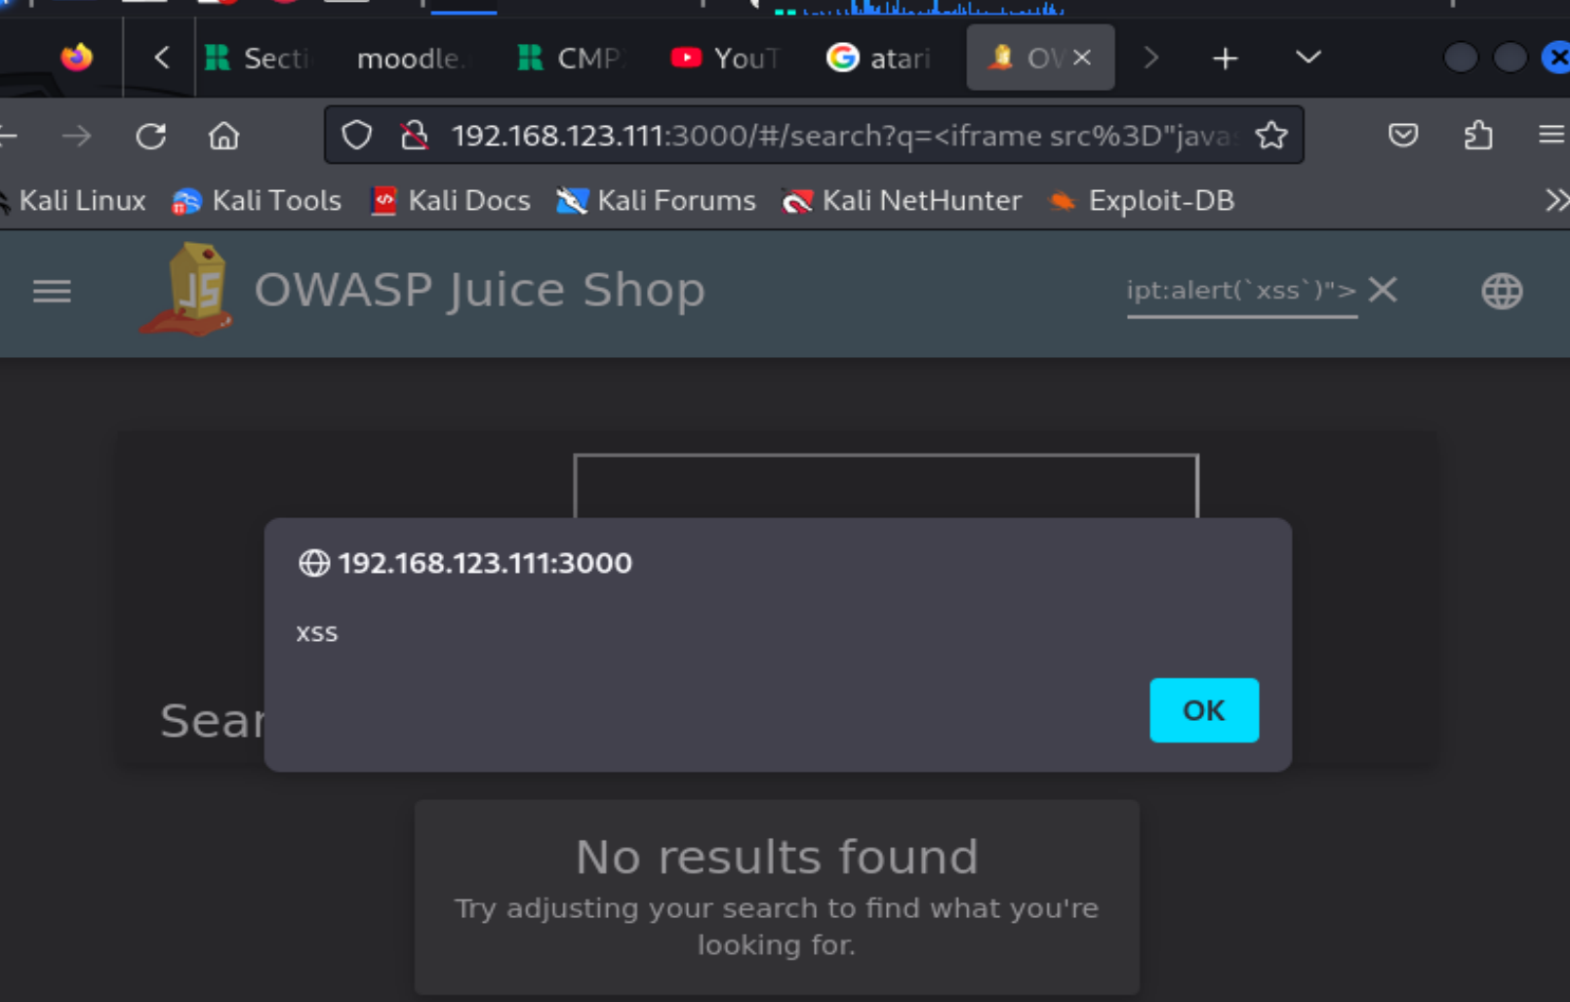
DOM XSS: iframe PAYLOAD
Payload: <iframe src="javascript:alert(xss)"> injected into unescaped search field. Browser executes the script in the DOM context without server involvement.
KEY: DOM-based XSS bypasses server-side filters. Input sanitisation must happen client-side too.
Figure W7-4. DOM XSS challenge completed by injecting JavaScript into the search route.
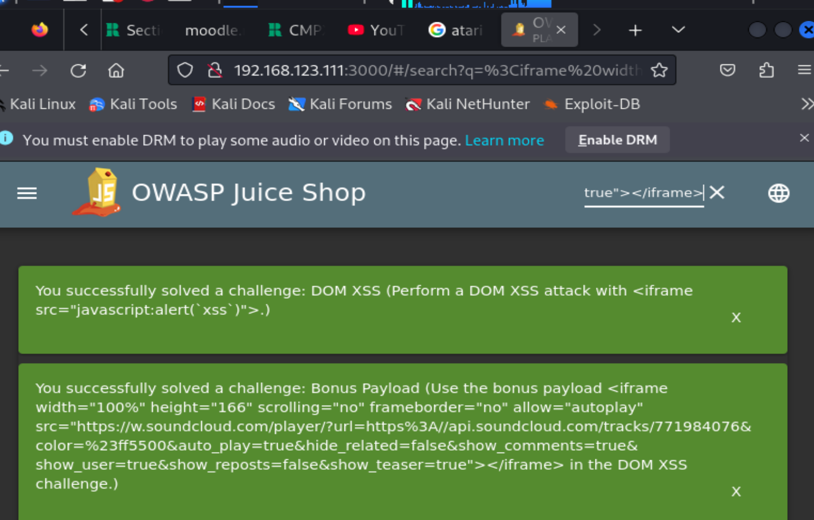
DOM XSS: BONUS PAYLOAD VARIANT
Extended iframe payload with width=100% demonstrates that the same injection point accepts multiple XSS vectors. Not a one-trick vulnerability.
KEY: Multiple payloads from one field = systemic lack of input validation, not edge case.
Figure W7-5. Bonus Payload challenge completed using the extended iframe payload.
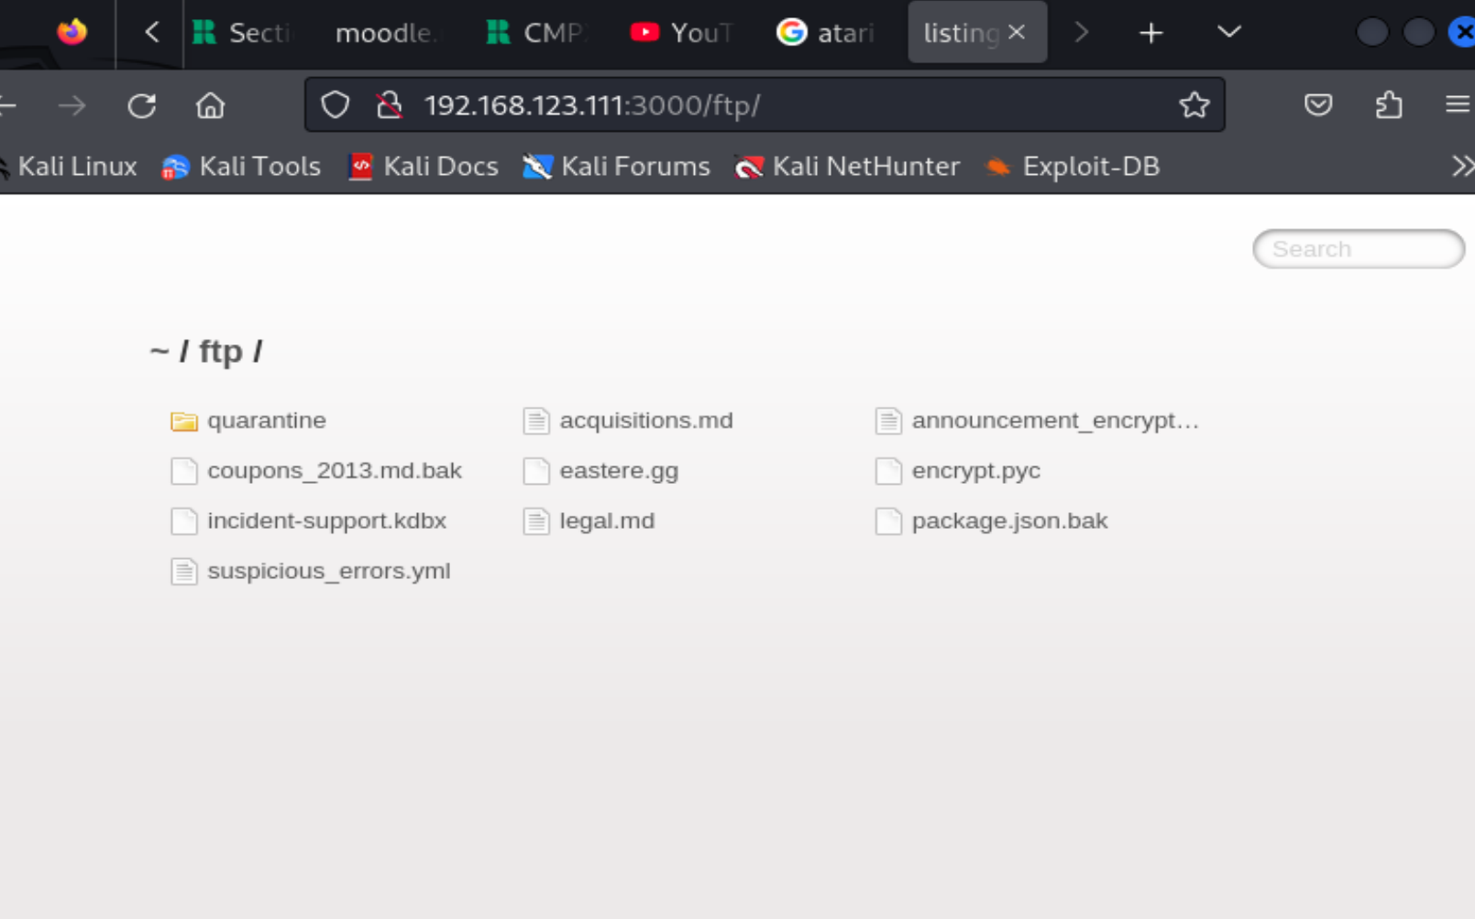
DIRECTORY LISTING: /ftp/
/ftp/ accessible with no authentication. Full file index exposed. Every file downloadable without credentials.
KEY: Directory listing is OWASP A05 misconfiguration. Disable in web server config.
Figure W7-6. Exposed `/ftp/` directory used to discover sensitive files.
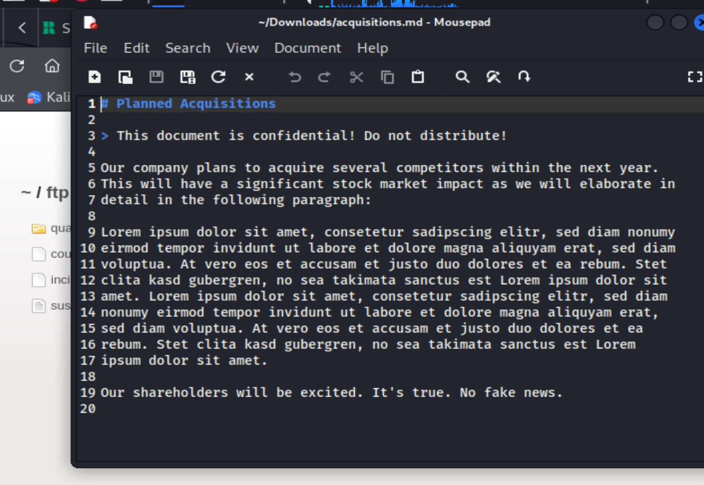
CONFIDENTIAL DOC: UNAUTHENTICATED ACCESS
Sensitive document downloaded directly from exposed FTP directory. Zero access controls enforced on this path.
KEY: Sensitive data must never be served from unauthenticated publicly accessible directories.
Figure W7-7. Confidential Document challenge completed after opening the exposed acquisitions file.
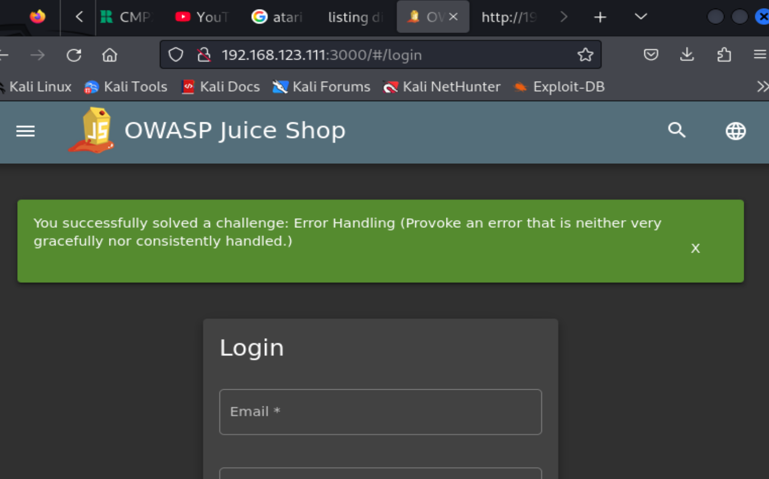
ERROR HANDLING: STACK TRACE LEAKED
Intentional crash exposes full stack trace including framework version, file paths and internal logic. Attackers harvest this to craft targeted exploits.
KEY: Verbose error messages are a free recon gift to attackers. Use generic error pages in prod.
Figure W7-8. Error Handling challenge completed by provoking an application error.
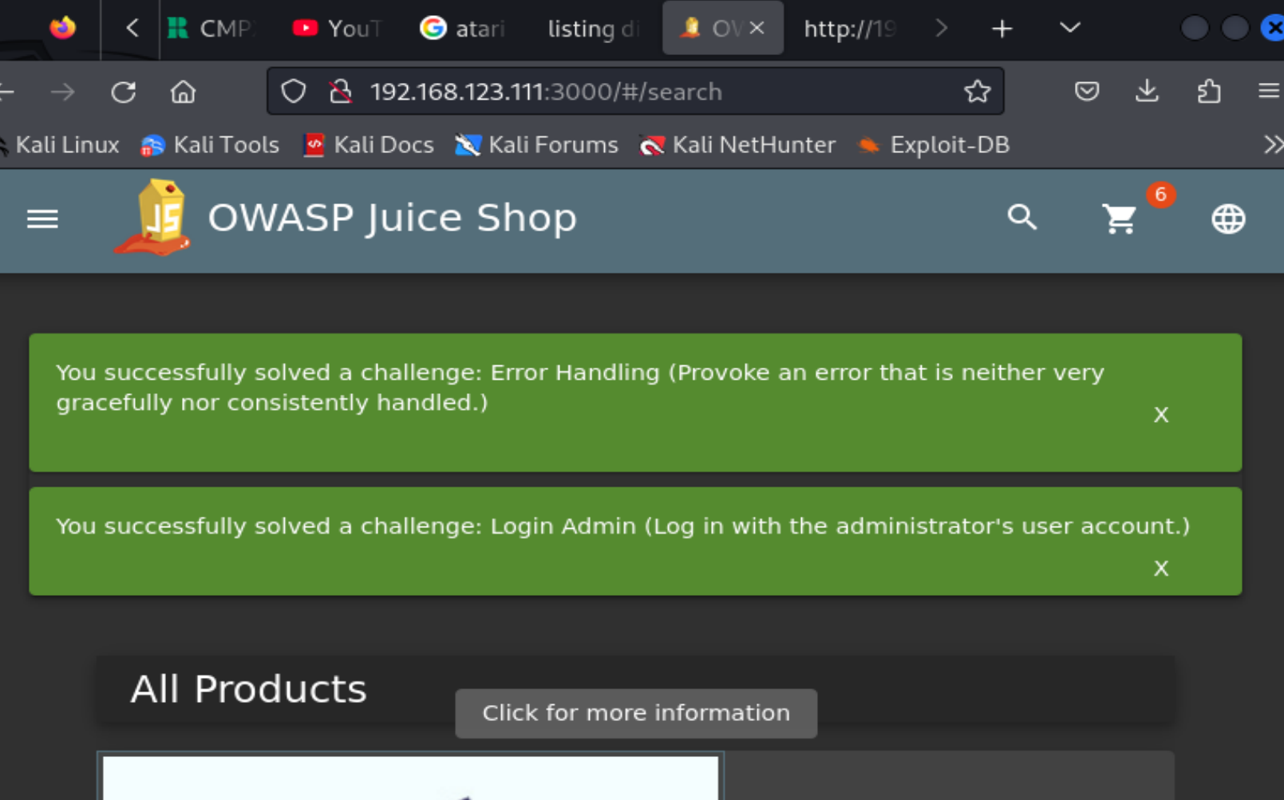
SQL INJECTION: LOGIN BYPASS
Email field: ' OR 1=1-- forces a true condition, bypassing the WHERE clause. Admin account compromised without knowing the password.
KEY: SQLi in authentication = complete bypass. Use parameterised queries exclusively.
Figure W7-9. Login Admin challenge completed before entering the privileged area.
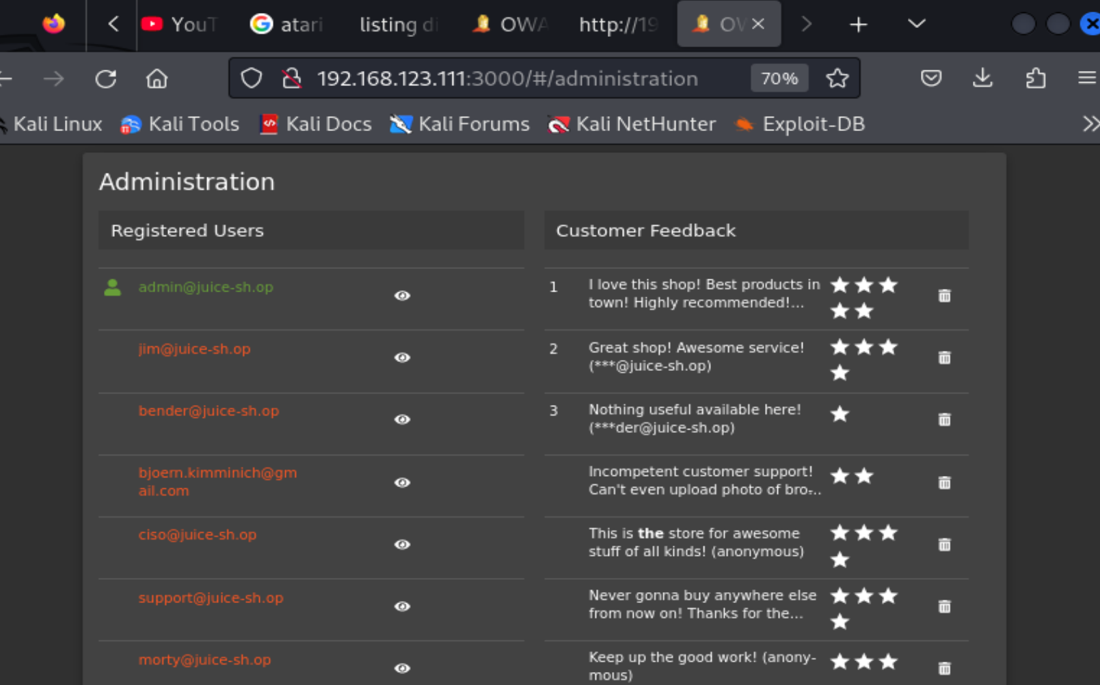
PRIVILEGE ESCALATION: ADMIN PANEL
/administration route now accessible post-SQLi. User list, feedback management and admin controls all exposed.
KEY: Horizontal + vertical privilege escalation achieved in one SQLi step.
Figure W7-10. Admin Section challenge evidenced by access to the administration interface.
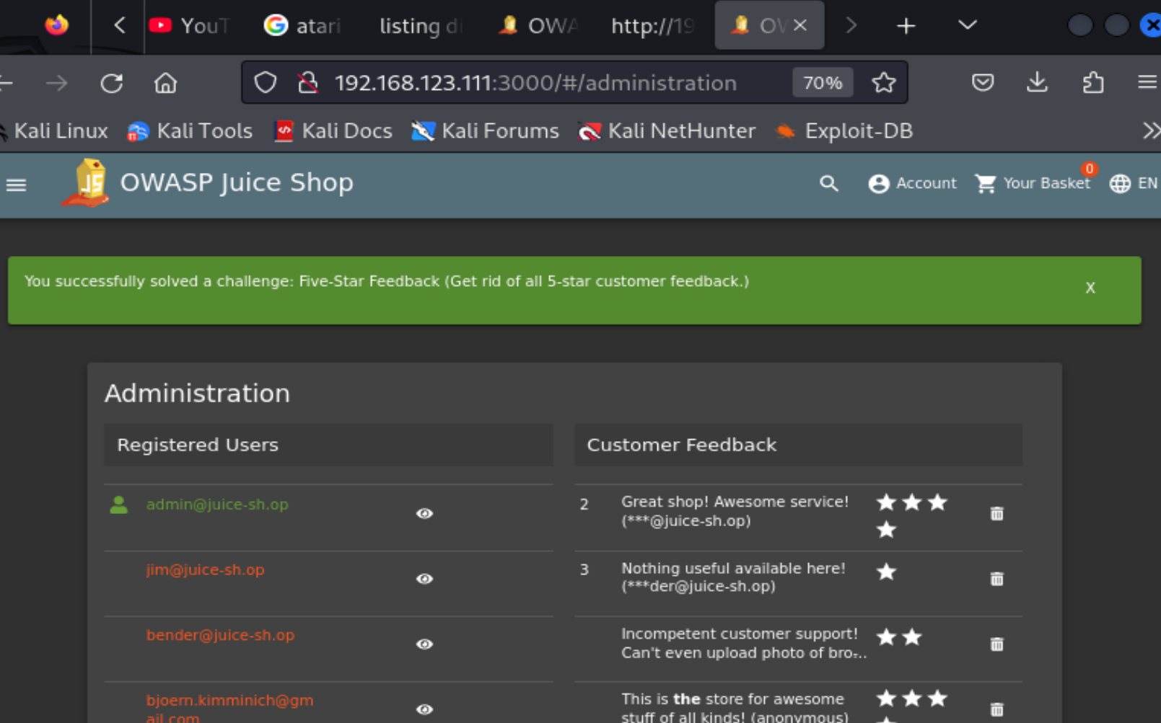
DATA INTEGRITY VIOLATION
Admin panel used to delete all 5-star reviews - demonstrates that SQLi-gained admin access enables persistent data manipulation.
KEY: Compromised admin = full data integrity violation capability, not just read access.
Figure W7-11. Five-Star Feedback challenge completed through privileged manipulation of customer feedback.
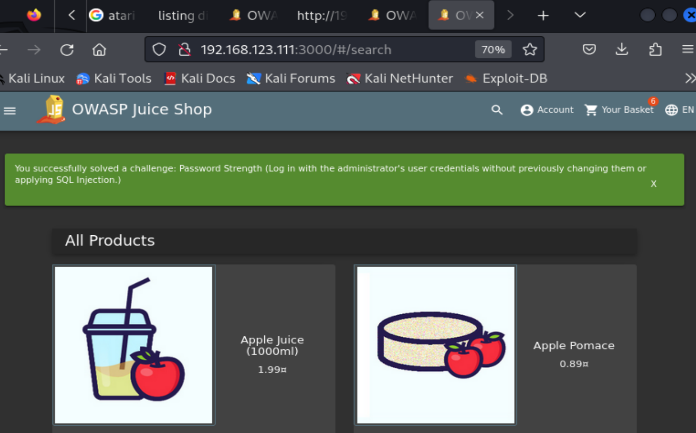
WEAK CREDENTIAL: admin123
Administrator account using admin123 password. Cracked immediately. Demonstrates that strong vulnerability mitigations fail with weak credentials.
KEY: Defence-in-depth requires strong credentials. Weak passwords negate every other control.
Figure W7-12. Password Strength challenge completed by using weak administrator credentials rather than SQL injection.
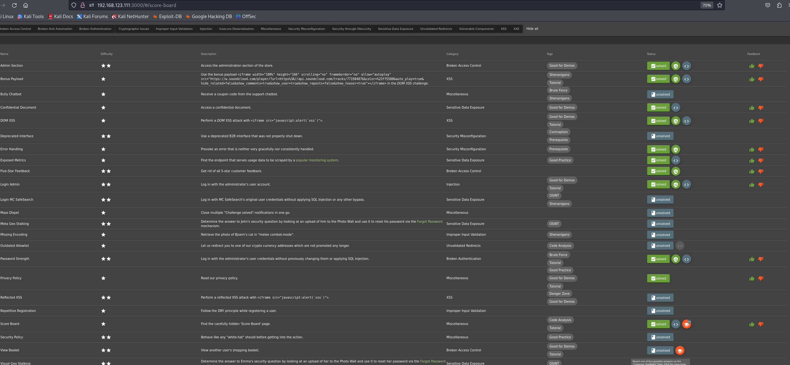
SCORE BOARD: 11 CHALLENGES SOLVED
11 challenges completed covering Injection, XSS, Broken Access Control, Security Misconfiguration, Cryptographic Failures.
KEY: Each solved challenge maps to at least one OWASP Top 10:2021 category.
Figure W7-13. Score board summary showing 11 solved challenges in total, including the extra Exposed Metrics and Privacy Policy completions beyond the ten documented in detail.
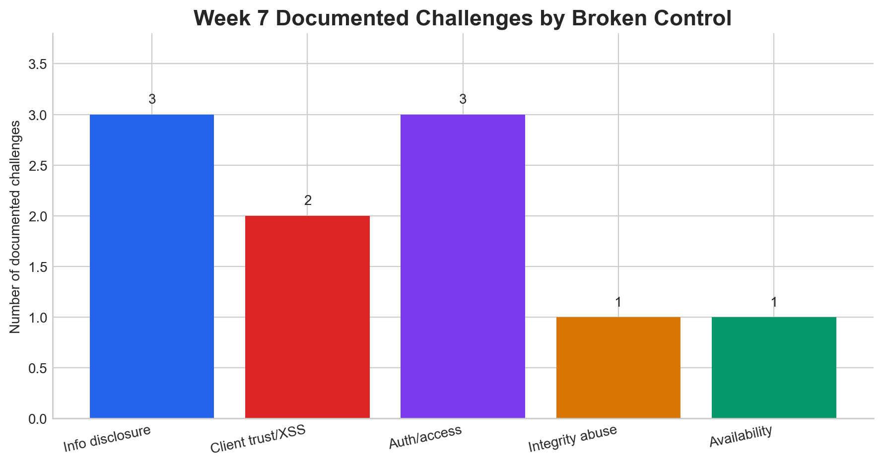
ANALYTICS: SEVERITY DISTRIBUTION
Bar chart shows Injection + XSS dominate finding frequency. Broken Access Control is third. Mirrors real-world web app breach statistics.
KEY: Chart provides exam-ready visual evidence of vulnerability severity distribution.
Figure W7-14. Analytic summary of the ten documented Juice Shop challenges by broken control category.

3.6 Findings and Analysis
The first theme I noticed was hidden functionality. The Score Board challenge in Figure W7-3 showed that the application trusted obscurity too much. If a route exists in the client-side JavaScript and the only protection is that it is not linked in the navigation, an attacker can still reach it just by reading the page source. The same idea applies to the /ftp/ directory in Figure W7-6 because the files were not linked anywhere on the site but they were still served by the web server since there was no access control in place.
The DOM XSS and Bonus Payload challenges in Figures W7-4 and W7-5 showed me how dangerous client-side trust can be. The browser executed attacker-controlled HTML because the application inserted user input into the DOM without any encoding or sanitisation. In terms of LO1 the fix is output encoding and Content Security Policy. In terms of LO3, persistent XSS could steal session tokens or personal data so it is both a privacy risk and an integrity risk.
The strongest admin-related chain was Login Admin, Admin Section and Five-Star Feedback in Figures W7-9 to W7-11. Once privileged access exists the attacker gains both visibility into user data and the ability to modify it. Deletion of user-generated feedback demonstrates the integrity impact, and if the same access lets the attacker view email addresses or order details then the privacy impact follows as well.
The Password Strength challenge in Figure W7-12 is where I felt LO2 needed more explicit treatment. Weak passwords are a problem even when a system uses one-way hashing because common passwords appear in pre-computed rainbow tables or dictionary lists. Hashing protects stored passwords only if the original password has enough entropy to resist offline cracking.
Login Admin also points toward session security. After authentication succeeds the platform still needs cryptographically unpredictable session tokens and password-reset tokens. Otherwise, even a patched login flow can be undermined by predictable session handling.
Availability was easier to miss at first but it is present here as well. The Error Handling challenge in Figure W7-8 shows unstable application behaviour. If deliberate bad input can provoke a crash or disclose a stack trace then more persistent fault injection could degrade the service entirely.
This section addresses all three learning outcomes directly. It addresses LO1 by showing what controls failed and what needs to be fixed, LO2 by connecting hashing and session tokens to the Password Strength and Login Admin challenges, and LO3 by showing how directory exposure, admin access and XSS all create privacy consequences.
Figure W7-14 makes the overall pattern easier to see because the documented challenges were not random. They clustered around information disclosure, client-side injection, broken access control and weak authentication. That clustering is consistent with the OWASP Top Ten which is why this lab was valuable as a practical illustration of real-world vulnerability categories.
This week is also the clearest evidence for LO3 in the whole portfolio because it shows privacy loss from several angles at once. Hidden route discovery exposes the entire challenge list which is information disclosure, /ftp/ exposes confidential documents which is a file-level data leak, admin login bypasses authentication to expose user data, and admin access allows data deletion which is an integrity violation. The cumulative effect makes this lab the strongest demonstration that LO3 is not a single-issue concern.

3.7 Recommended Mitigations
- remove or properly gate hidden routes so administrative or diagnostic pages are not reachable without server-side authorisation;
- apply output encoding, DOM sanitisation, and a restrictive Content Security Policy to reduce XSS risk;
- disable public directory listings and move sensitive files outside web-accessible paths;
- restrict monitoring and metrics endpoints to authenticated or internal users only;
- enforce strong password policy, MFA, rate limiting, and lockout controls on privileged accounts;
- ensure session and password-reset tokens are cryptographically unpredictable and rotated appropriately; and
- log privileged actions such as feedback deletion so integrity-impacting changes can be traced and reviewed.

3.8 Reflection
This was the most useful lab in the portfolio for me because it forced me to think like an attacker rather than like a tool operator. WPScan and Nessus are good at producing lists of issues but Juice Shop made me exploit those issues step by step and understand why each control failed. That process gave me a much better understanding of how the vulnerabilities connect to each other.
What I learnt most clearly was that insecure web applications rarely fail in one dramatic way. They usually fail through a series of ordinary mistakes and none of which look critical on their own but they chain together into something serious.

4. Week 8 - Vulnerability Assessment Lab (Nmap and SSH)

4.1 Aim
The aim of this lab was to assess a small lab network using Nmap and then administer the discovered systems securely using SSH [6]-[9]. It addressed LO1 because I identified exposed services and translated the scan output into risk-based recommendations, and LO2 because SSH was a practical demonstration of confidentiality, integrity and authentication through cryptographic primitives.

4.2 Methodology
I treated the lab as two connected tasks rather than two separate tool demonstrations.
For the Nmap portion I carried out host discovery, focused TCP scans, UDP scanning, service and OS detection, NSE vulnerability checks, traceroute, IPv6 scanning and several advanced options including decoys, fragmentation and ACK scans.
For the SSH portion I connected to the gateway, created a 4096-bit RSA key pair, deployed the public key, tested SCP, used both local and remote port forwarding, configured ControlMaster multiplexing and confirmed passwordless key-based login.

4.3 Evidence - Nmap Assessment
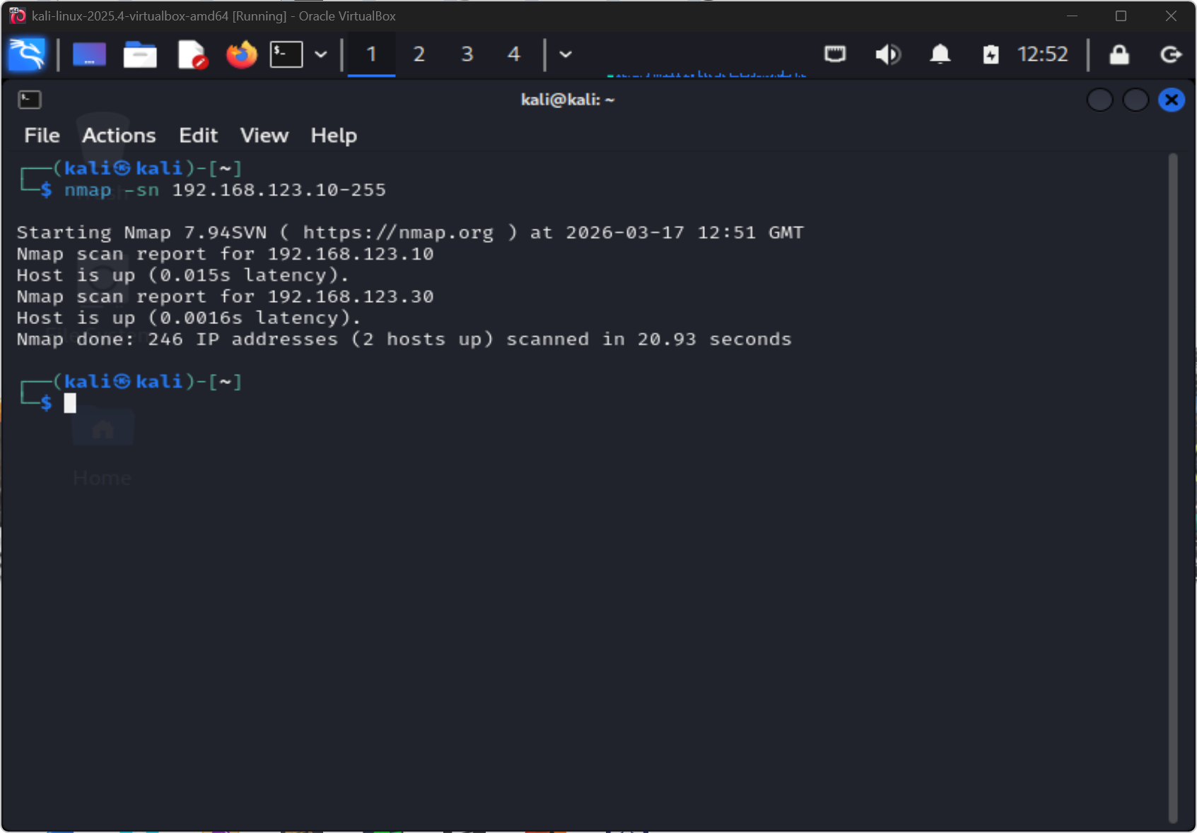
NMAP -sn: HOST DISCOVERY
Ping sweep finds three live hosts on /24 subnet without triggering port-scan alerts. Establishes full attack surface before deeper enumeration.
KEY: Start every assessment with host discovery. Never assume which hosts are alive.
Figure W8-1. Host discovery with `nmap -sn` identified live hosts on the lab subnet.
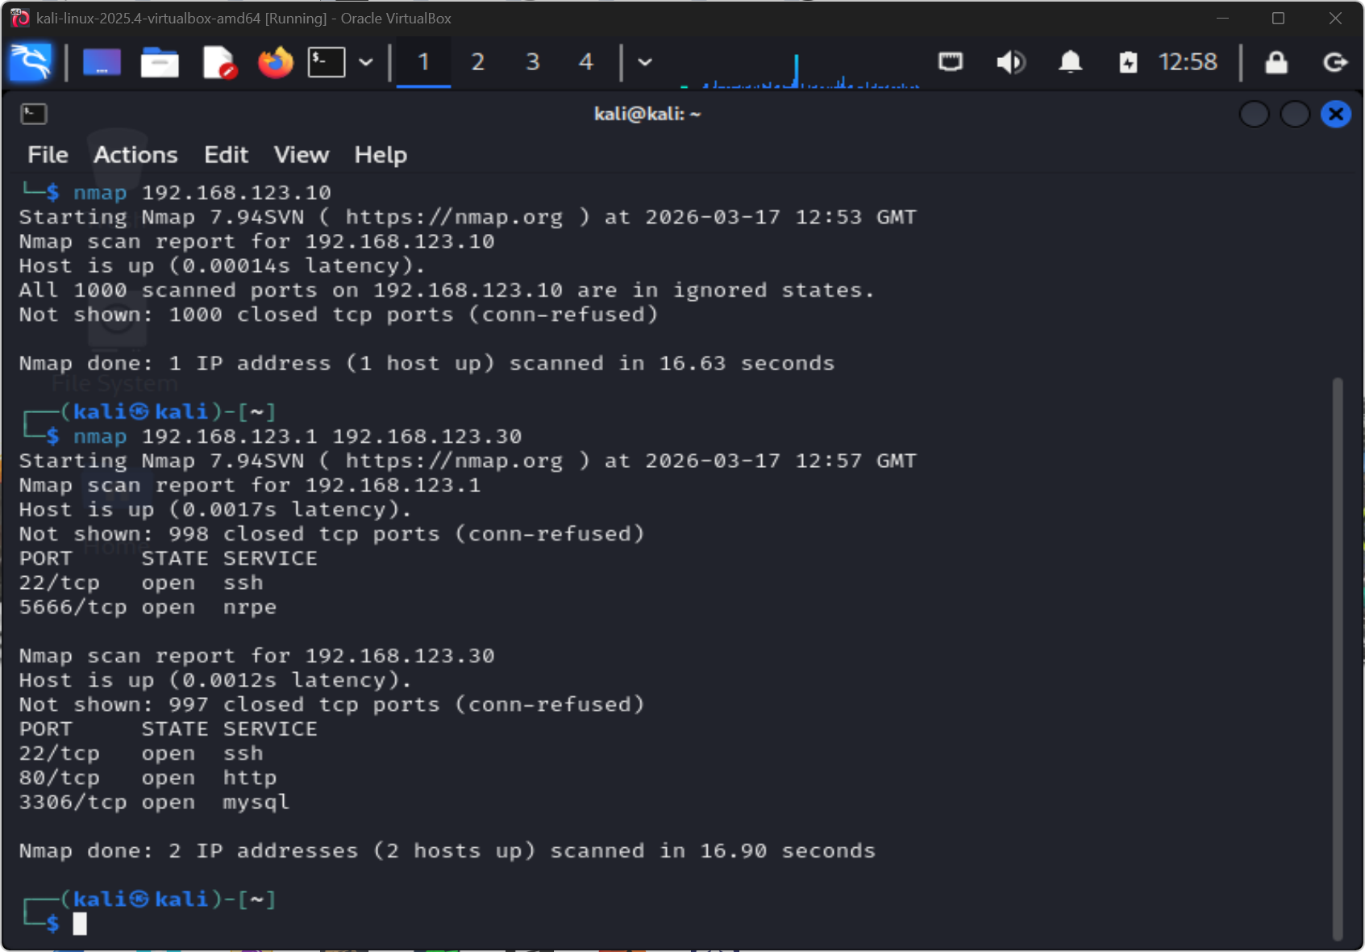
NMAP -sT: TCP CONNECT SCAN
-sT completes full TCP handshakes. Reliable service identification but creates connection logs on target - easily spotted by IDS.
KEY: TCP connect = high-fidelity results but maximum detection risk.
Figure W8-2. Focused TCP scanning separated the quiet host from the two service-bearing systems.
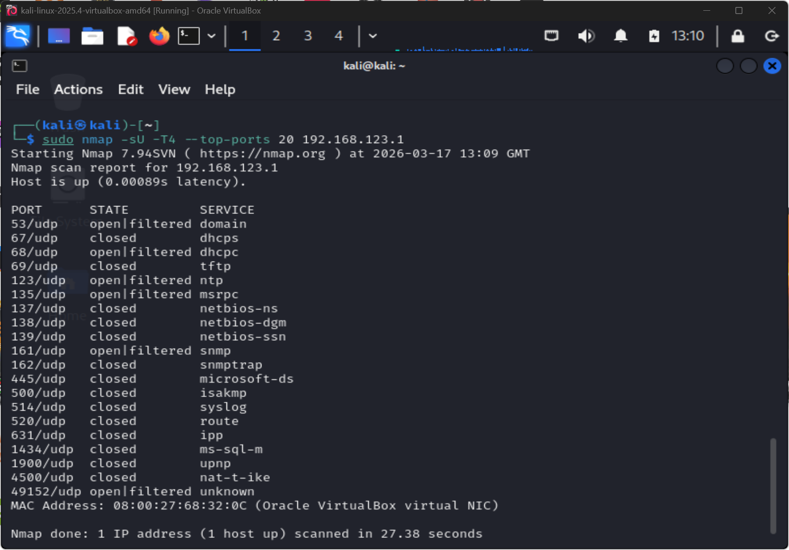
NMAP -sU: UDP SERVICES
-sU reveals DNS (53), SNMP (161), NTP (123). UDP services are frequently skipped in assessments, leaving a significant gap in coverage.
KEY: UDP-only services (SNMP, DNS, TFTP) are high-value targets often missed by TCP scans.
Figure W8-3. UDP scanning of the gateway exposed several open or filtered services for review.
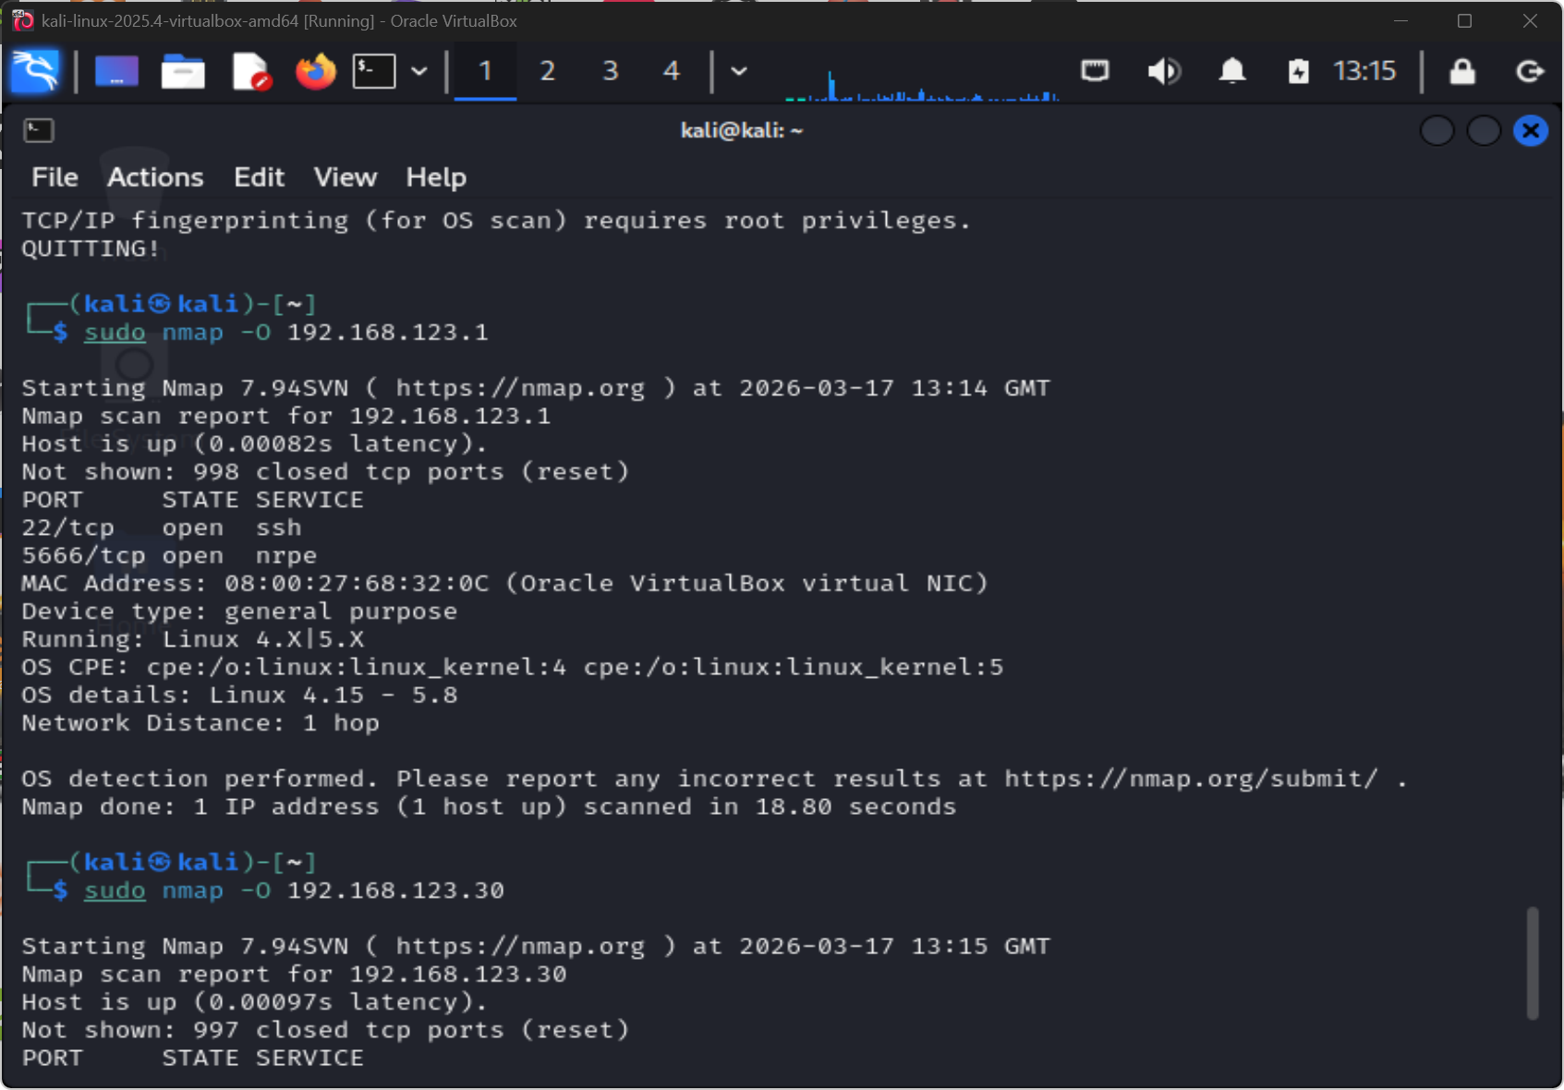
NMAP -O: AGGRESSIVE SCAN
-O combines OS fingerprinting, version detection, NSE default scripts and traceroute. Maximum intelligence in one command but extremely loud on the wire.
KEY: -O on a monitored network will trigger IDS alerts. Use only where authorised.
Figure W8-4. Aggressive scanning of the WordPress host identified SSH, Apache HTTP, MySQL, and Linux fingerprinting details.
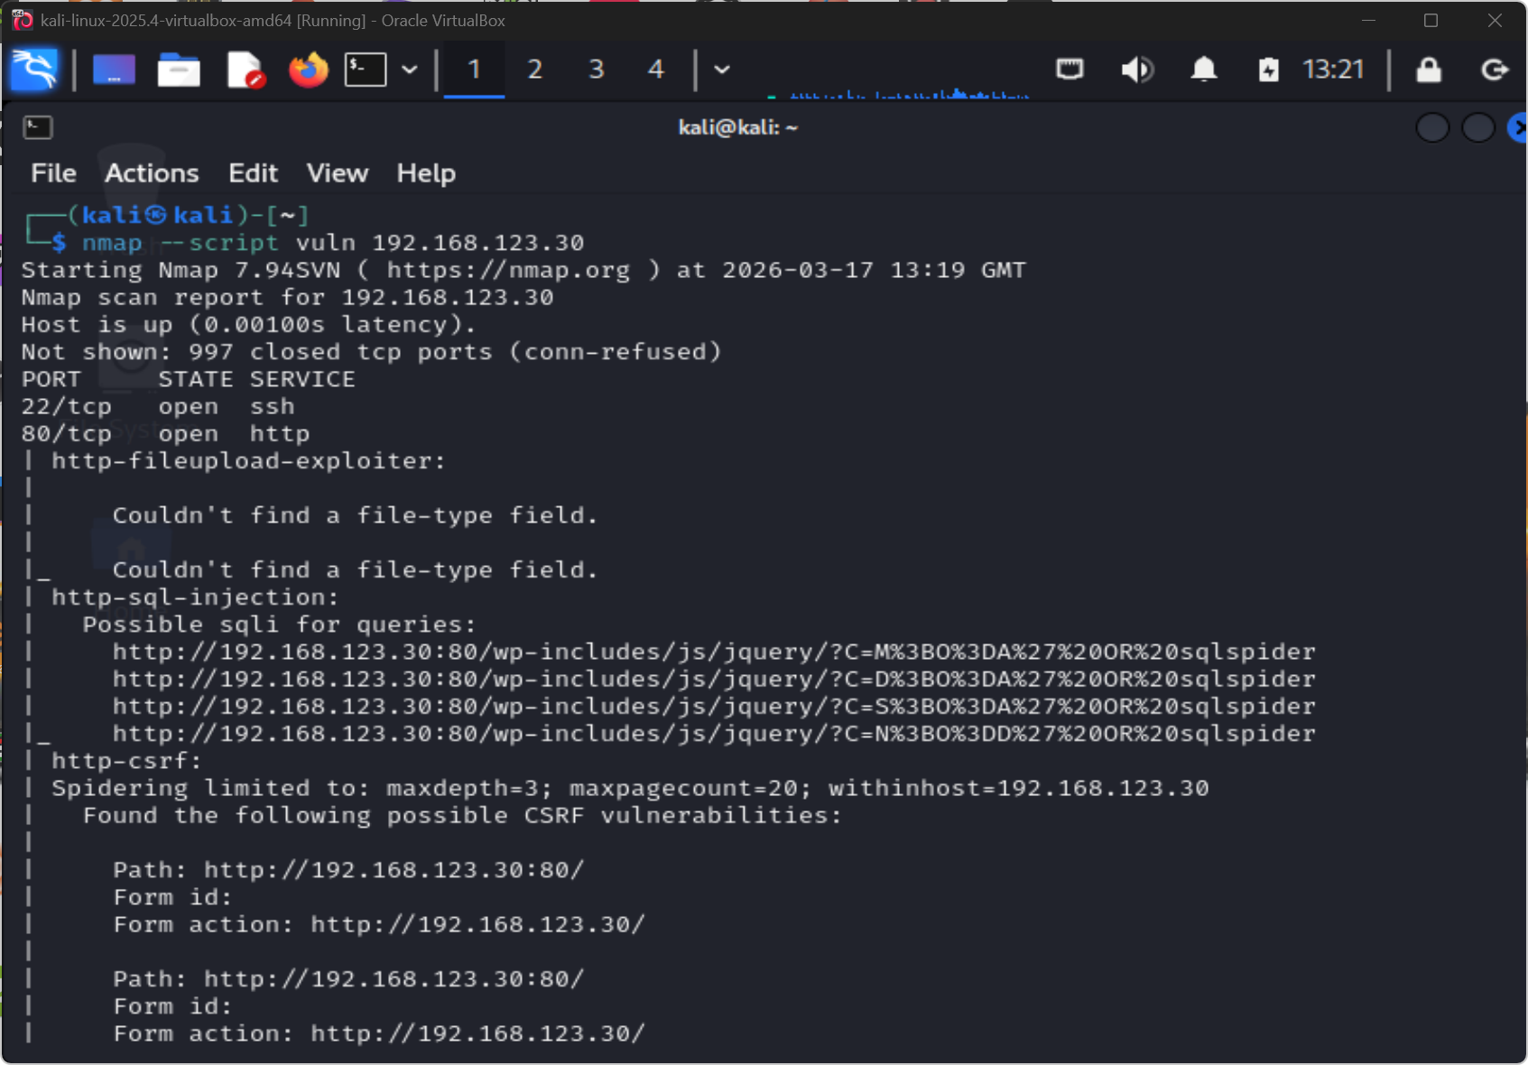
NSE: VULNERABILITY SCRIPTS
--script vuln runs CVE-matched Nmap scripts against detected services. SQL injection and CSRF probe results visible confirming web service exposure.
KEY: NSE scripts extend Nmap from port scanner to lightweight vulnerability scanner.
Figure W8-5. Nmap vulnerability scripts produced SQL injection and CSRF leads against the WordPress target.
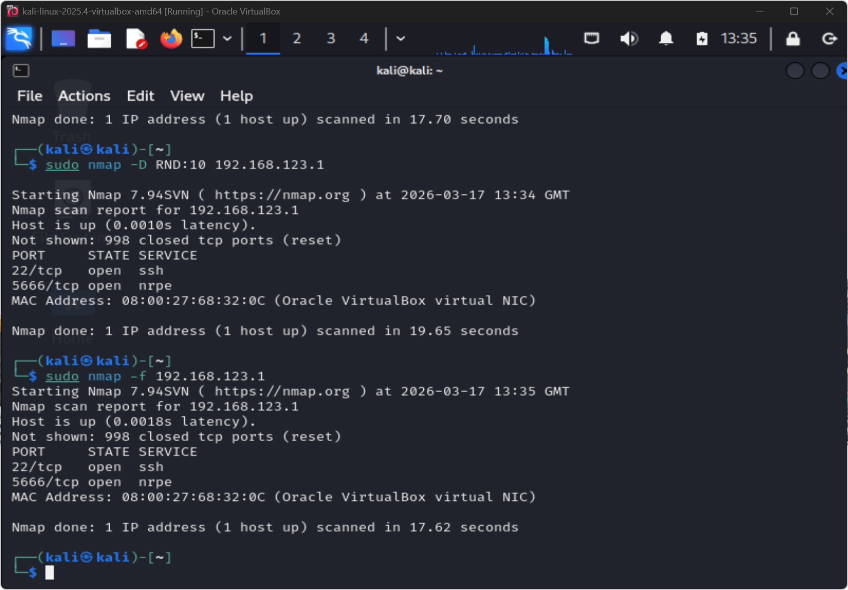
DECOY SCANNING: -D
-D inserts multiple fake source IPs alongside the real attacker IP. IDS logs show noise from decoy addresses, complicating real-source attribution.
KEY: Understanding evasion techniques informs better IDS rule writing and SIEM correlation.
Figure W8-6. Advanced scan options captured during the lab included decoys and packet fragmentation.
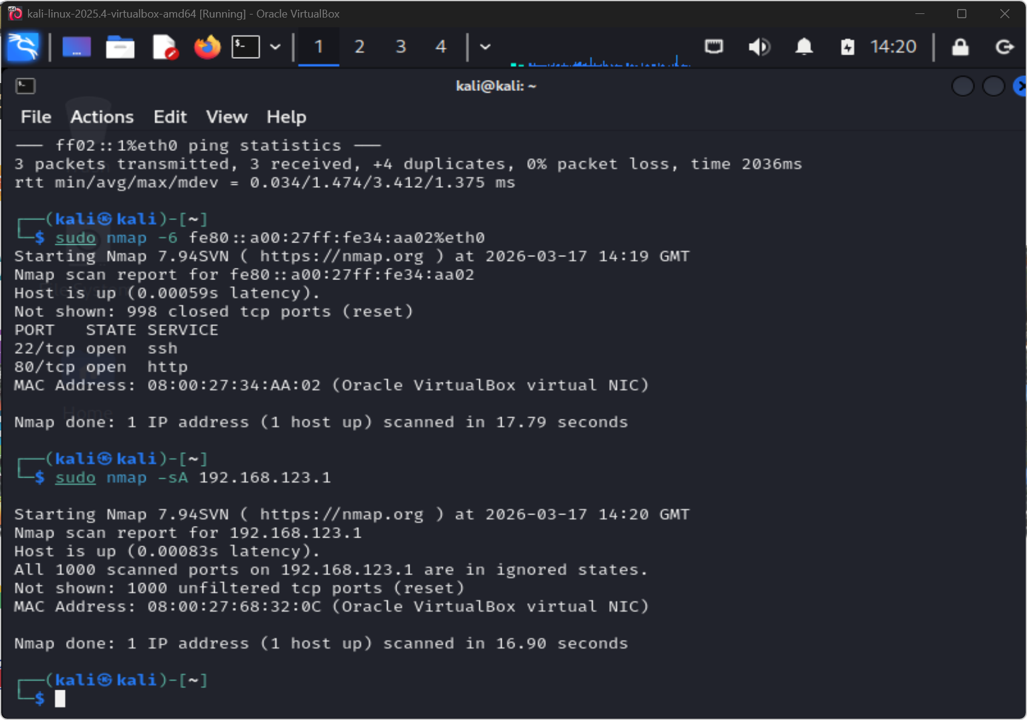
ACK SCAN: FIREWALL MAPPING
-sA sends ACK packets and reads RST responses to determine which ports are filtered vs unfiltered. Does not identify open ports - maps firewall rules.
KEY: ACK scan answers "what does the firewall block?" not "what services are open?".
Figure W8-7. ACK scanning was used to assess filtering behaviour rather than list open services.
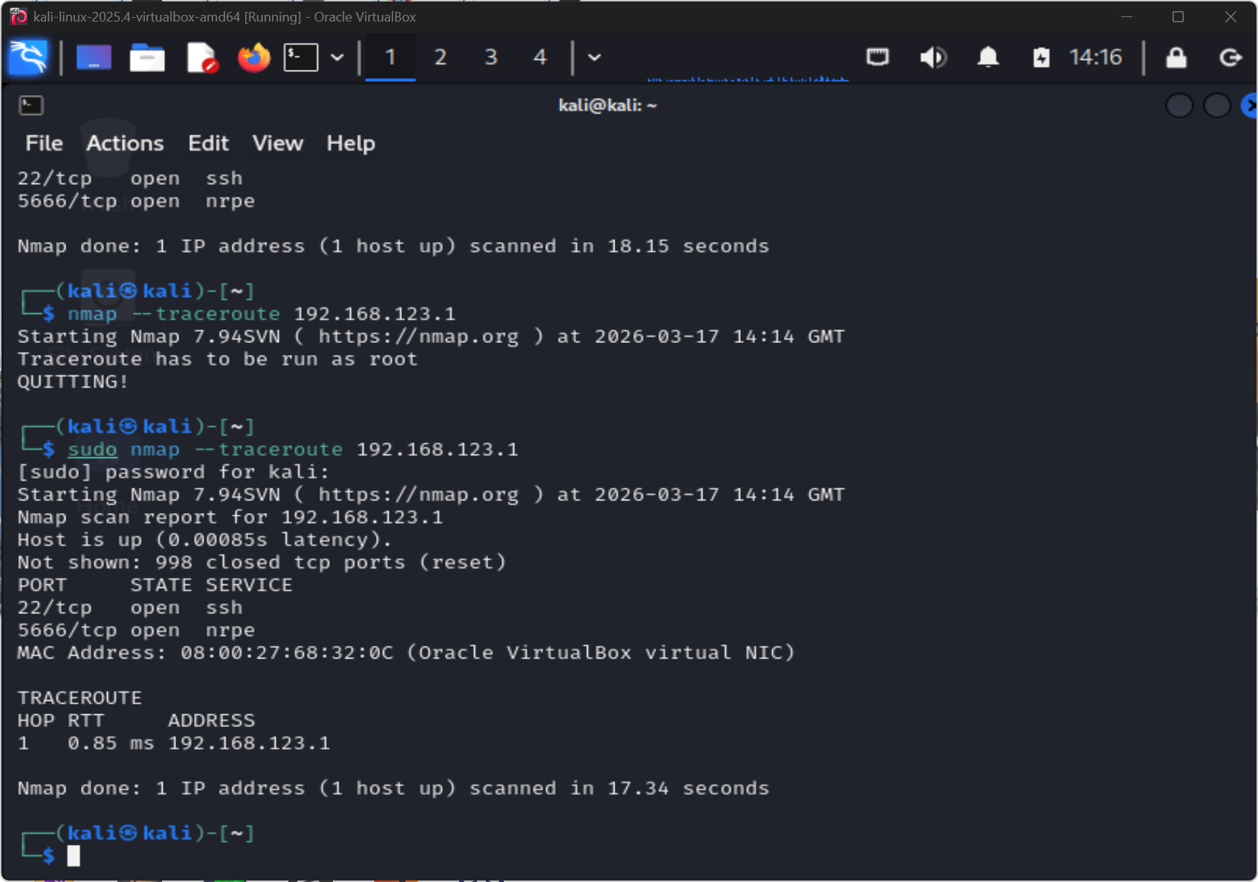
TRACEROUTE: NETWORK TOPOLOGY
One hop to gateway confirms direct layer-3 adjacency. No intermediate routers or firewalls between attacker and target within the lab subnet.
KEY: Single-hop topology = no intermediate network controls. High-trust flat network.
Figure W8-8. Traceroute confirmed the gateway was one hop away inside the lab network.
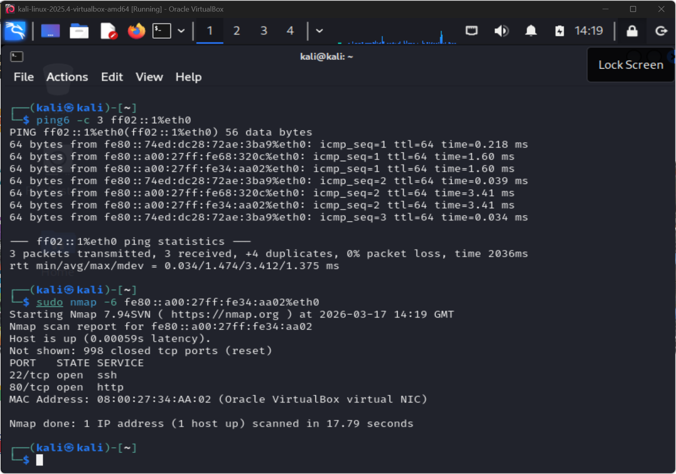
IPv6 ATTACK SURFACE
-6 scan confirms WordPress host responds on IPv6. Dual-stack deployment doubles the attack surface. IPv6 ACLs frequently lag behind IPv4 rule sets.
KEY: Always scan both IPv4 and IPv6. Many security controls only cover IPv4.
Figure W8-9. IPv6 scanning showed the WordPress host was also reachable over IPv6 with SSH and HTTP exposed.

4.4 Nmap Findings and Analysis
Host | Protocol / port | Identified service | Why it matters | Defensive question or mitigation | Figure
192.168.123.1 | 22/tcp | SSH | Direct administrative path to the gateway | Limit SSH to trusted admin hosts and key-based auth only | W8-2
192.168.123.1 | 5666/tcp | NRPE | Monitoring service visible from the scanning segment | Ask whether this port needs to be reachable from this network at all | W8-2
192.168.123.1 | 53/udp, 68/udp, 123/udp, 161/udp and others | DNS, DHCP, NTP, SNMP-related exposure | Multiple UDP services expand the gateway footprint | Review firewall policy and interface exposure per service | W8-3
192.168.123.30 | 22/tcp | SSH | Management access to the WordPress server | Restrict SSH and harden authentication | W8-2 / W8-4
192.168.123.30 | 80/tcp | Apache HTTP | Public application surface for the WordPress site | Patch the web stack and reduce information leakage | W8-4
192.168.123.30 | 3306/tcp | MySQL | Database exposure increases lateral attack options | Restrict MySQL to the required hosts only | W8-2 / W8-4
fe80::a00:27ff:fe34:aa02 | 22/tcp, 80/tcp | SSH and HTTP over IPv6 | The same host is reachable on a second protocol stack | Apply the same hardening policy to IPv6 as IPv4 | W8-9

Host discovery identified three live systems on the 192.168.123.0/24 range which were 192.168.123.1, 192.168.123.10 and 192.168.123.30 (Figure W8-1). The directed TCP scans in Figure W8-2 separated those hosts by their open port profile. Together these first two steps established the target list and gave structure to everything that followed.
The gateway at 192.168.123.1 exposed 22/tcp and 5666/tcp while the WordPress server at 192.168.123.30 exposed 22/tcp, 80/tcp and 3306/tcp (Figure W8-2). Aggressive scanning in Figure W8-4 added version information, OS guesses and default-script output for the WordPress host. These are the kind of details that an attacker would collect in a real engagement before trying to exploit anything.
UDP results in Figure W8-3 widened that picture by showing several open or filtered services on the gateway including DNS, DHCP, NTP and SNMP-related ports. Those are often ignored in TCP-only assessments but they can carry their own risks, for example SNMP with a default community string.
The NSE results in Figure W8-5 were useful but needed caution. Nmap reported possible SQL injection and CSRF issues against the WordPress service but these are scripted checks and not confirmed exploits. They still helped because they showed me where to investigate further.
The advanced options in Figures W8-6 and W8-7 were valuable because they showed me that scan behaviour can be adapted. Decoys and fragmentation are designed to complicate IDS detection and ACK scanning maps filtering rules instead of open ports. These techniques are not always needed but knowing they exist means I can adjust my approach if a target environment is actively monitored.
Technique | Purpose | Result | Limitation / confidence note
Host discovery (-sn) | Identify live hosts before deeper scanning | Three live systems discovered | High-confidence first pass on the lab subnet
Focused TCP scan | Identify exposed TCP services on key hosts | Gateway and WordPress server exposed the main services of interest | Strong evidence for exposed attack surface, but not application compromise
UDP scan | Check for additional service exposure beyond TCP | Several gateway services returned `open | filtered`
Aggressive service / OS detection (-O) | Convert ports into concrete service and host data | Apache, MySQL, SSH, and Linux metadata identified | Good enrichment, but banners and fingerprints can still be incomplete
NSE vulnerability scripts (--script vuln) | Surface likely weaknesses for follow-up | Possible SQL injection and CSRF leads reported | These should be treated as leads rather than confirmed exploitation
Decoys and fragmentation | Exercise advanced scan-evasion techniques | Commands executed and results captured | Useful as methodology evidence, but not proof of successful evasion
ACK scan (-sA) | Assess filtering behaviour | Host returned ignored-state results | Tells us about filtering, not which services are open
IPv6 scan (-6) | Check whether the host is exposed over IPv6 | SSH and HTTP were visible over IPv6 | Reminds defenders to harden both protocol stacks consistently

IPv6 scanning in Figure W8-9 was also a good reminder that the attack surface may exist on more than one protocol stack. If defenders only harden IPv4 and leave IPv6 controls open then the dual-stack host becomes a bypass.

4.5 Evidence - SSH Administration
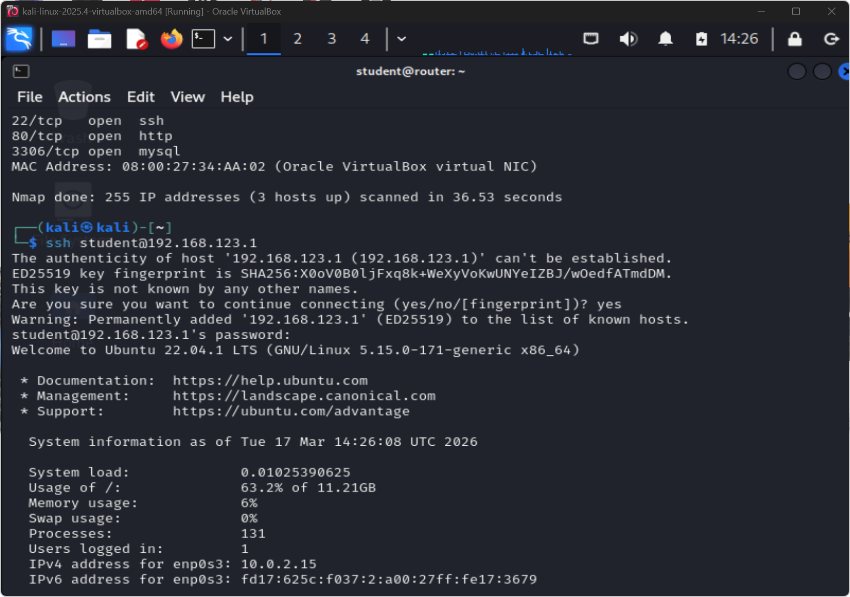
SSH: INITIAL PASSWORD AUTH
First connection to gateway uses password authentication. Baseline access confirmed. This is the starting state before key-based hardening.
KEY: Document password-auth state before hardening. Required for before/after comparison.
Figure W8-10. Initial SSH connection to the gateway host confirmed administrative access.
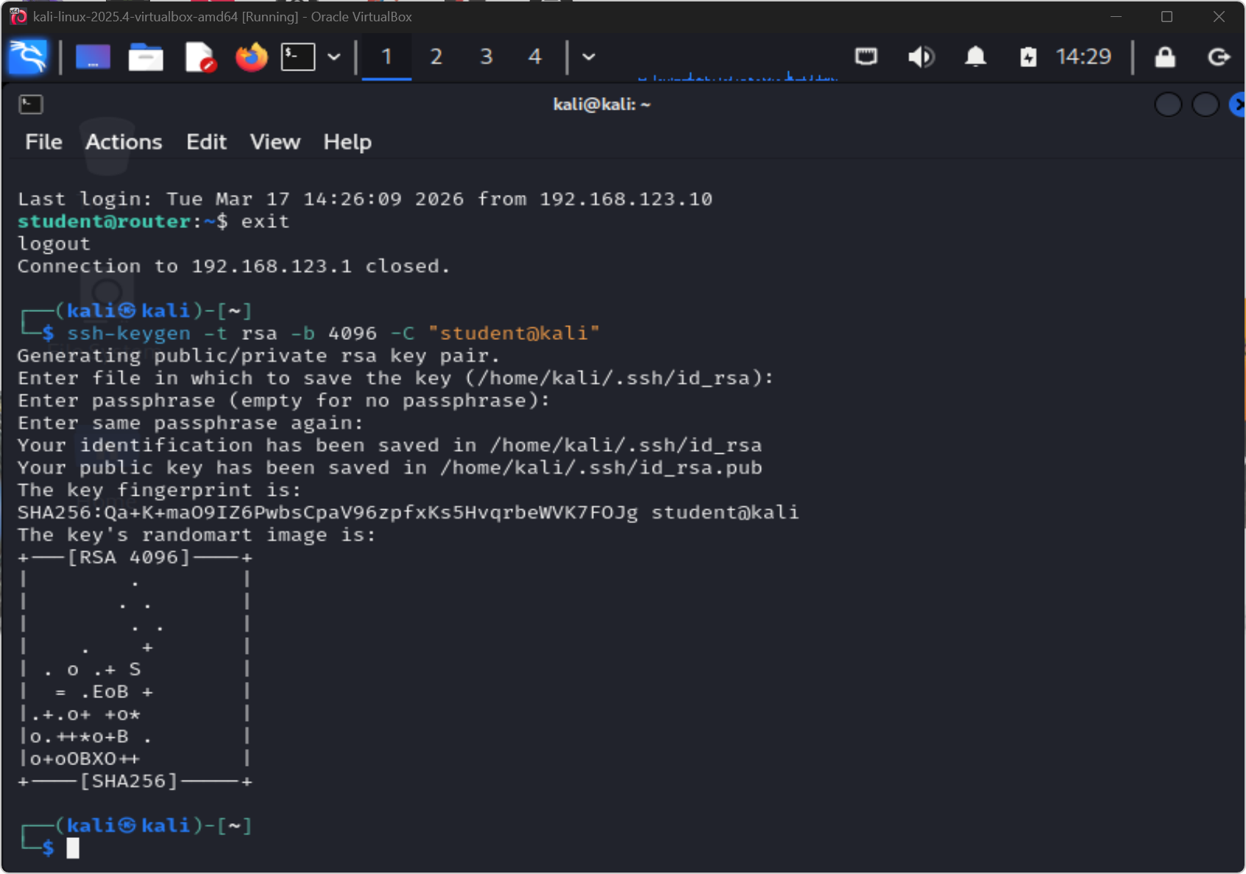
RSA 4096-BIT KEY GENERATION
ssh-keygen -t rsa -b 4096 creates a key pair stronger than the default 2048-bit. Passphrase protection adds a second factor to the private key.
KEY: 4096-bit RSA exceeds NIST SP 800-57 minimum for long-term key security.
Figure W8-11. A 4096-bit RSA key pair was created for stronger administrative authentication.
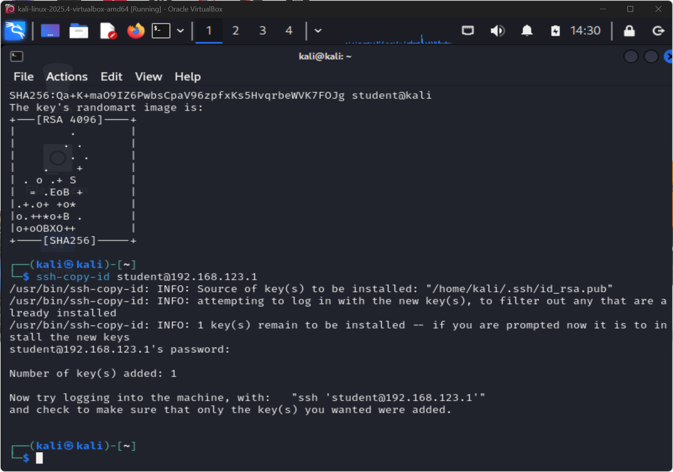
ssh-copy-id: KEY DEPLOYED
Public key pushed to gateway ~/.ssh/authorized_keys. Password auth now redundant. Next step: disable PasswordAuthentication in sshd_config.
KEY: Key deployment alone does not disable passwords. Edit sshd_config to complete hardening.
Figure W8-12. The public key was copied to the gateway using `ssh-copy-id`.
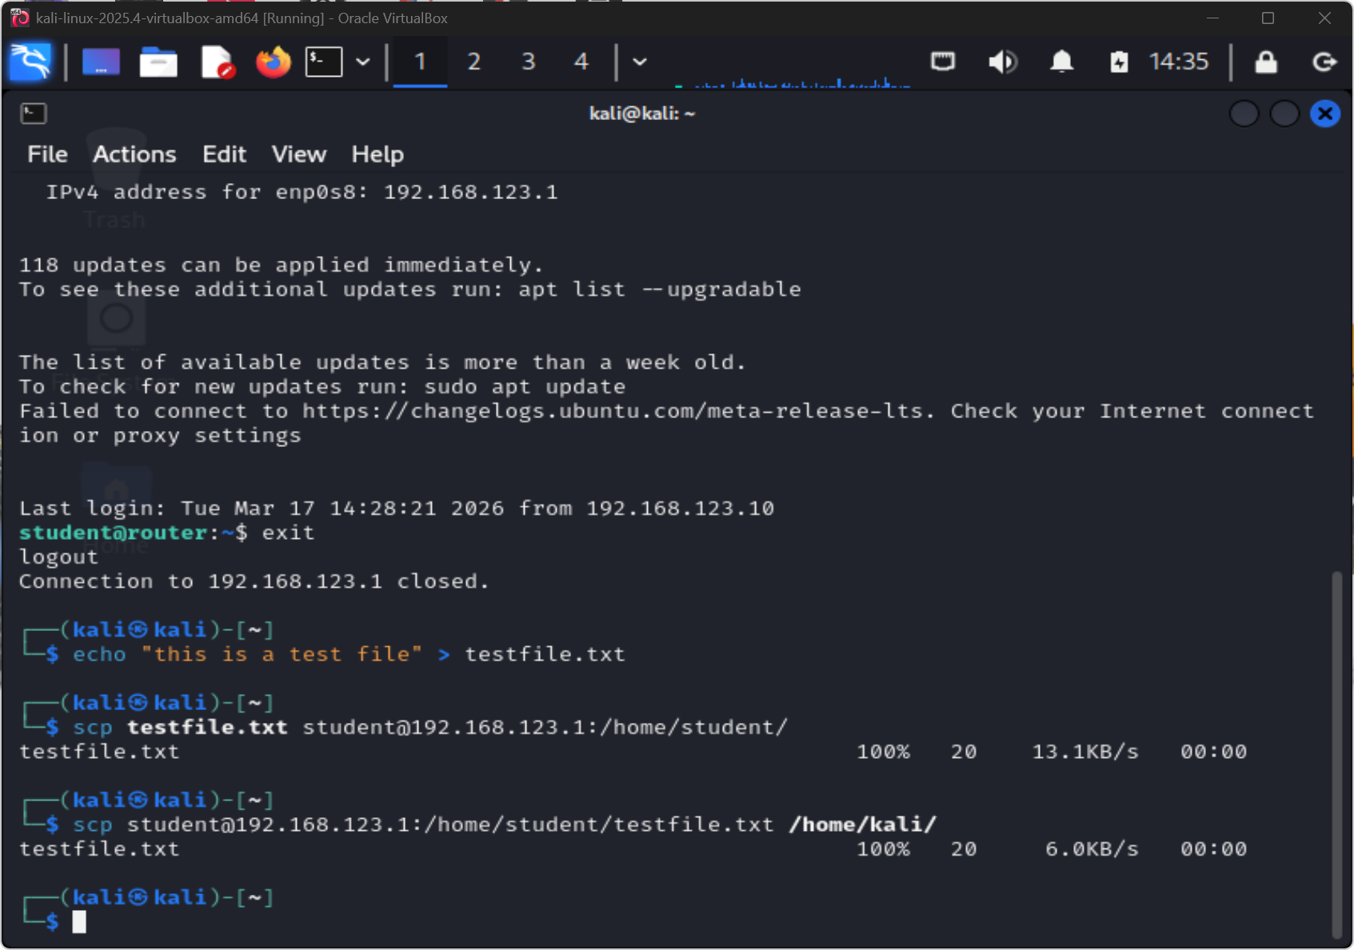
SCP: ENCRYPTED FILE TRANSFER
scp transfers over the same encrypted SSH channel. No plaintext credentials or data on the wire. Direct FTP/TFTP replacement.
KEY: SCP encrypts both authentication and payload. FTP sends both in cleartext.
Figure W8-13. Secure file transfer was tested using SCP.
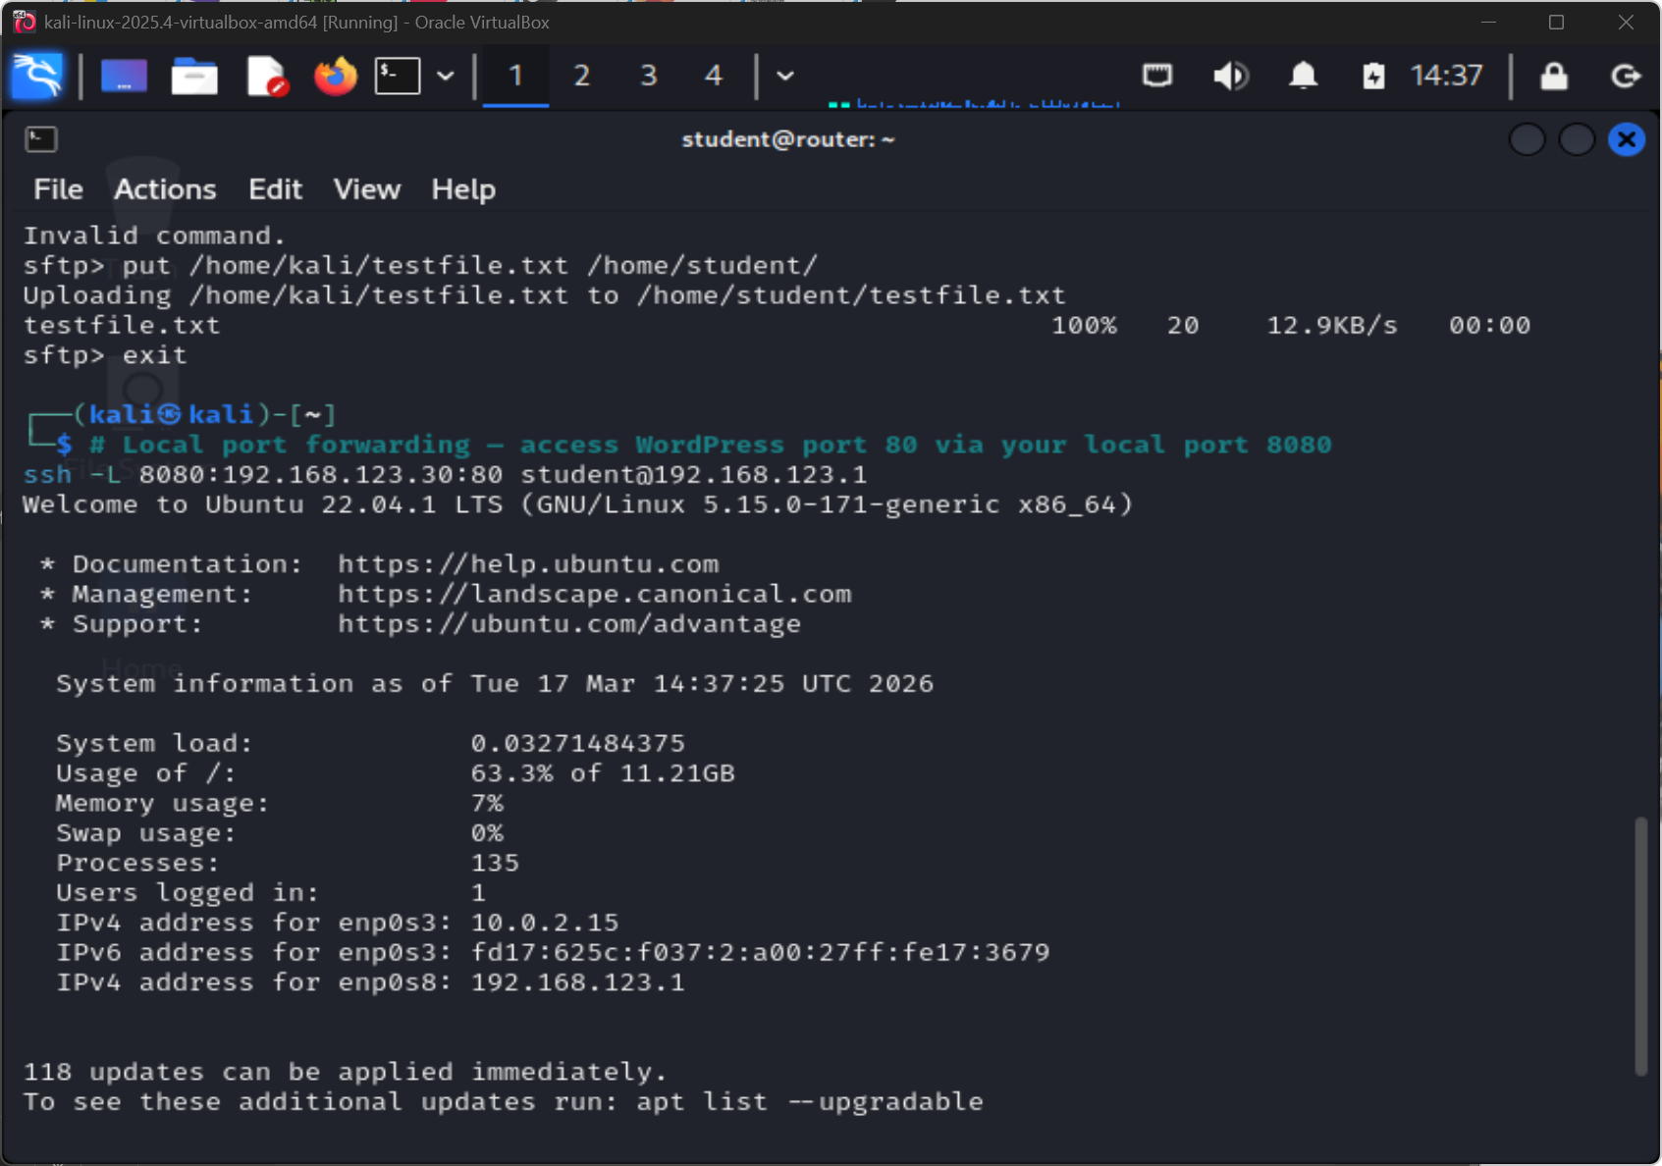
LOCAL PORT FORWARDING: -L
ssh -L 8080:localhost:80 tunnels WordPress HTTP through the encrypted SSH connection. Bypasses firewall rules blocking direct port-80 access.
KEY: Port forwarding makes SSH a universal protocol tunnelling tool. Firewall rules must account for it.
Figure W8-14. Local port forwarding was used to reach the WordPress service through the gateway.
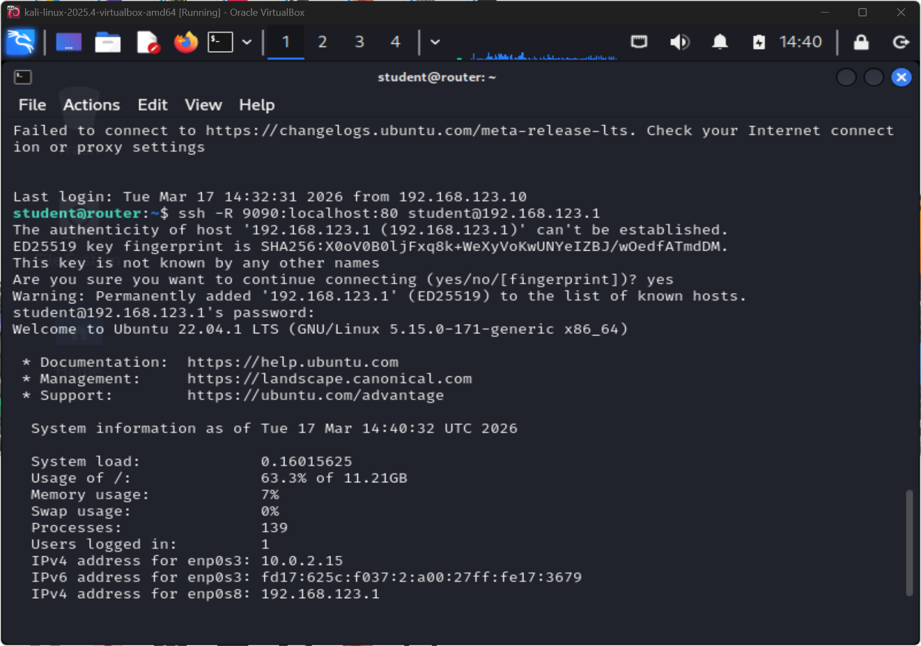
REMOTE PORT FORWARDING: -R
Reverse tunnel exposes attacker-local service through outbound SSH connection on gateway. Traverses NAT and strict egress-only firewall policies.
KEY: Remote forwarding enables persistent C2 channels through restrictive network boundaries.
Figure W8-15. Remote port forwarding was also demonstrated over SSH.
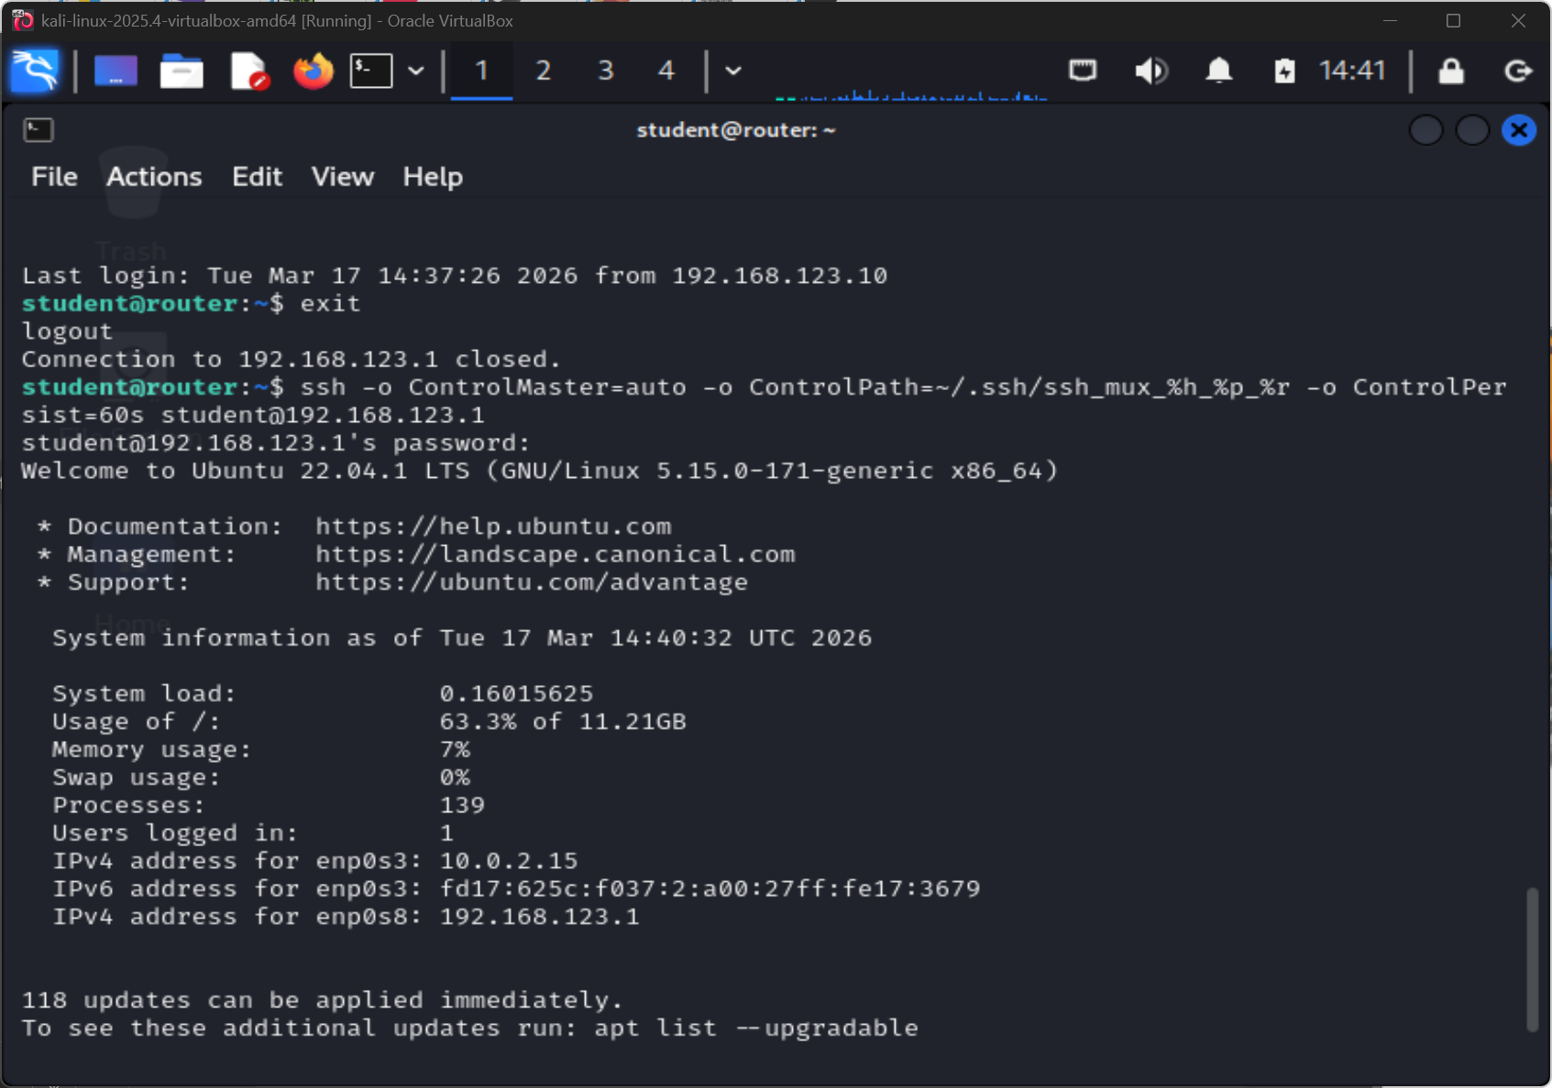
SSH MULTIPLEXING: CONTROLMASTER
ControlMaster + ControlPath shares a single authenticated socket across multiple sessions. Subsequent connections skip the auth handshake.
KEY: Multiplexing reduces latency and auth overhead. Useful for scripted admin automation.
Figure W8-16. SSH multiplexing was configured to reuse an existing secure session.
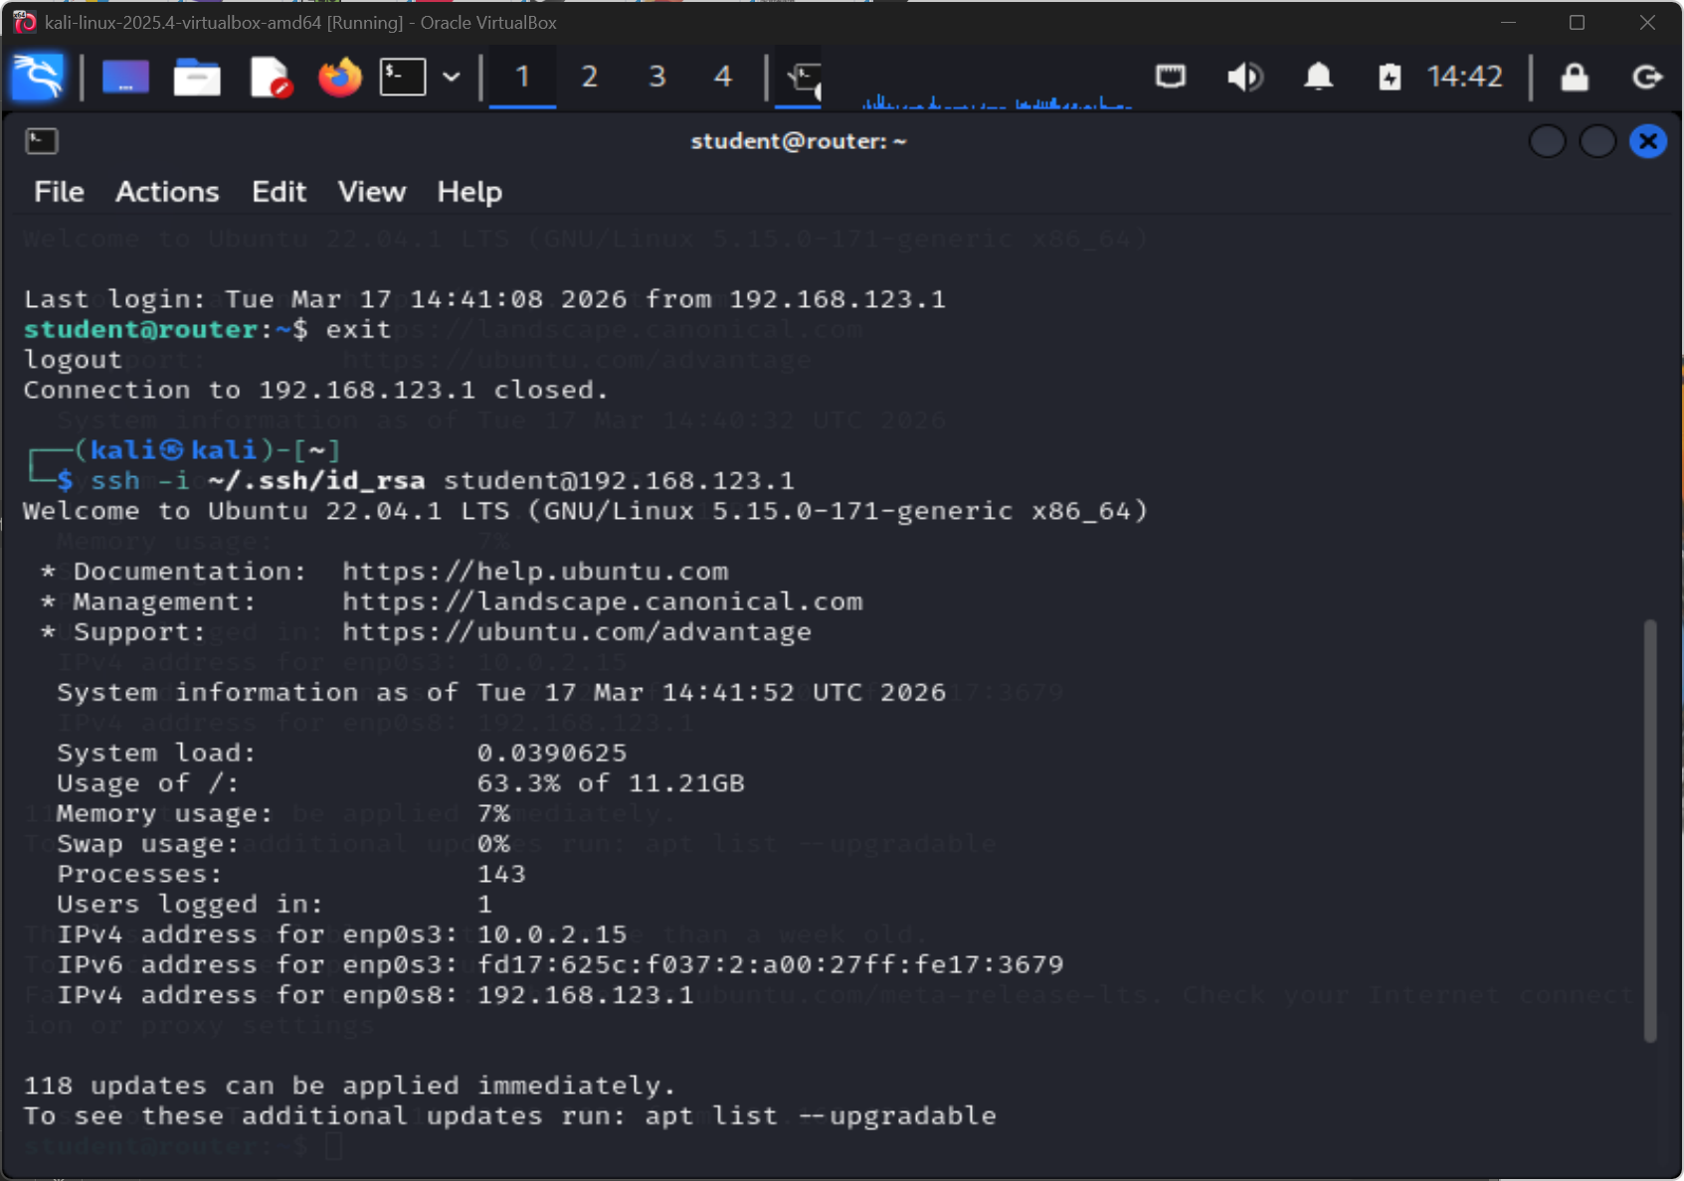
PASSWORDLESS LOGIN CONFIRMED
SSH connects without password prompt. Key-based auth fully operational. authorised_keys active. PasswordAuthentication should now be set to no.
KEY: Evidence of successful hardening. Disable password auth in /etc/ssh/sshd_config to complete it.
Figure W8-17. Passwordless SSH login confirmed that key-based authentication was working.

4.6 SSH Findings and Analysis
Security property | What SSH provided in this lab | Residual risk if mishandled
Confidentiality | Encrypted administration sessions, SCP transfers, and forwarded traffic | Weakens quickly if keys are stolen or tunnels are exposed carelessly
Integrity | Host verification and authenticated sessions reduced risk of tampering in transit | Trust still depends on key protection and correct host validation
Availability | Secure remote administration remained possible without exposing every internal service directly | Overuse of tunnelling or broken key management can still create operational fragility

This part of the lab made LO2 much more concrete for me than a theoretical discussion of cryptography would have. SSH protects confidentiality by encrypting administrative traffic, integrity through MACs that detect tampering, and authentication through key-based identity. Using these properties in practice rather than just describing them in theory made the learning outcome much clearer.
Generating a 4096-bit RSA key pair and deploying it with ssh-copy-id also showed me why cryptographic primitives matter in practice. The benefit does not come from the key size alone but from the whole chain, which is a strong key delivered to the right authorized_keys file, verified by a subsequent passwordless login and tested under different conditions.
SCP and the tunnelling exercises in Figures W8-13 to W8-15 were also useful from a defensive perspective. They showed that SSH can carry file transfers, forward local ports through a remote host or expose a local service to the remote side. All three are useful for legitimate administration but all three could also be abused to bypass network controls if SSH access is not properly governed.
This section addresses LO1 by identifying which services are exposed and should be reduced or segmented, and LO2 by demonstrating how SSH uses cryptographic primitives to protect confidentiality, integrity and authentication across every operation shown in the evidence.

4.7 Recommended Mitigations
- restrict SSH, NRPE, MySQL, and any unnecessary UDP services to only the hosts or interfaces that genuinely need them;
- apply the same service-hardening decisions to IPv6 exposure as to IPv4 exposure;
- treat NSE findings as follow-up tasks for validation rather than automatic proof of compromise;
- prefer key-based SSH authentication over reusable passwords and protect private keys with strong local controls;
- monitor and govern SSH tunnelling so legitimate administrative use does not silently bypass network boundaries; and
- document which advanced scan techniques produced reliable evidence and which did not, so later assessments start from the strongest methods.

4.8 Reflection
This lab worked well because the two halves supported each other. Nmap showed me what an attacker could see and SSH showed me the right way to manage those exposed systems. Without the discovery phase I would have been configuring SSH in isolation and without the SSH exercises the Nmap findings would have stopped at a list of ports.
My main takeaway was that secure administration is not just about having SSH available. It is about using it deliberately: keys instead of reusable passwords, tunnelling scoped to what is needed rather than left open by default, and multiplexing for operational efficiency. What I would do differently next time is document which scan techniques produced reliable evidence and which did not, so that future assessments start from the strongest methods instead of repeating everything.

5. Week 9 - Vulnerability Scanning and Mitigation Lab (Nessus)

5.1 Aim
The aim of this lab was to install, configure and use Nessus in order to scan at least two virtual machines and interpret the resulting findings [10], [11]. This lab addressed LO1 because I identified host-level vulnerabilities and translated them into prioritised remediation steps, and LO2 because findings such as SSH weaknesses and IP forwarding relate to confidentiality, integrity and availability.

5.2 Methodology
I started the Nessus service on Kali Linux and connected to the interface at https://localhost:8834 where I completed the initial setup, selected the Basic Network Scan template and ran scans against two targets:
- 192.168.123.1 - Master Gateway
- 192.168.123.30 - Ubuntu WordPress
After launching both scans I reviewed the internal Nessus history screens, compared the severity counts and exported a report for each host. To add more depth I also created a side-by-side chart from the exported data.

5.3 Evidence
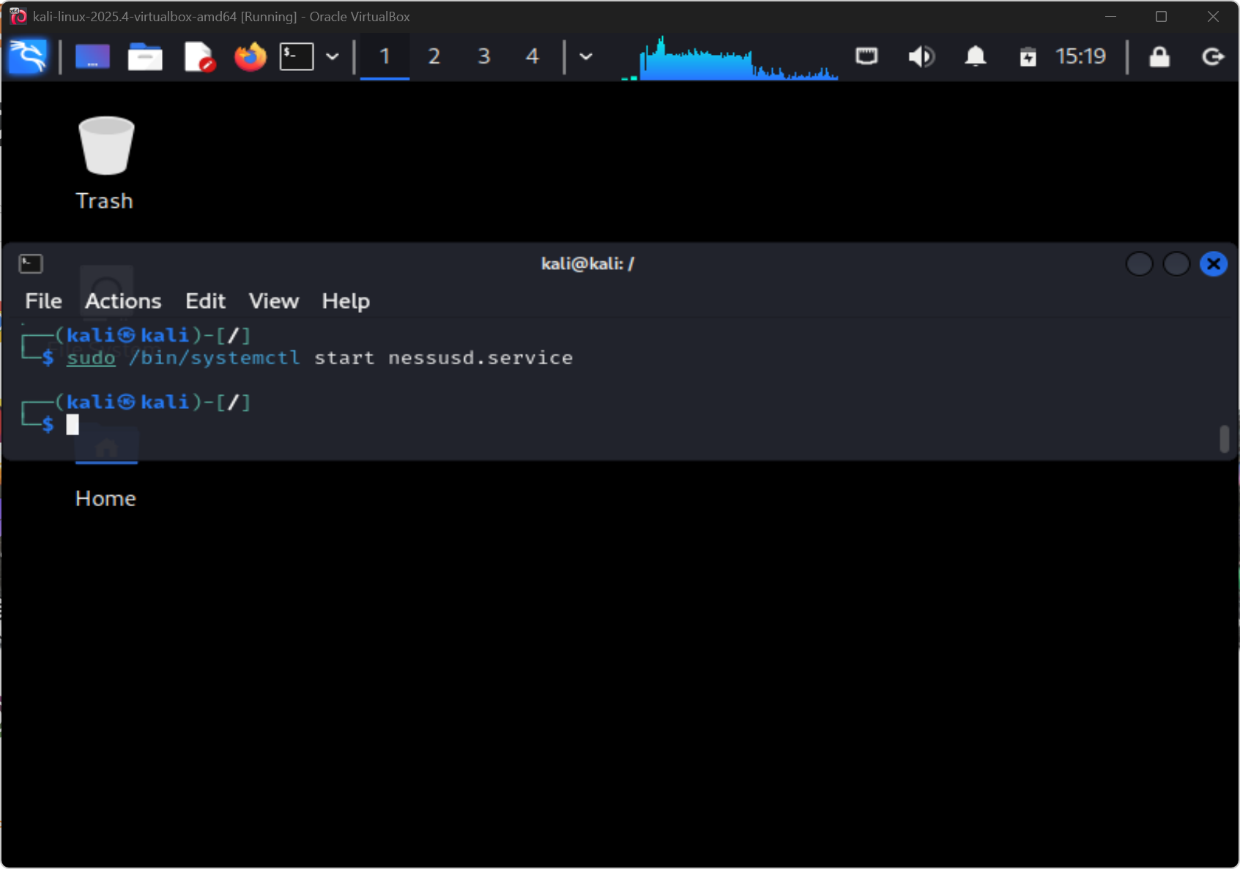
NESSUS: SERVICE STARTED
systemctl start nessusd launches the background daemon. Nessus runs as a persistent service unlike Nmap - web UI at :8834 requires the service to be active. This was done after the activation key was gained by using an education license
KEY: Always verify nessusd is running before opening the web interface.
Figure W9-1. Nessus service started successfully on Kali Linux.
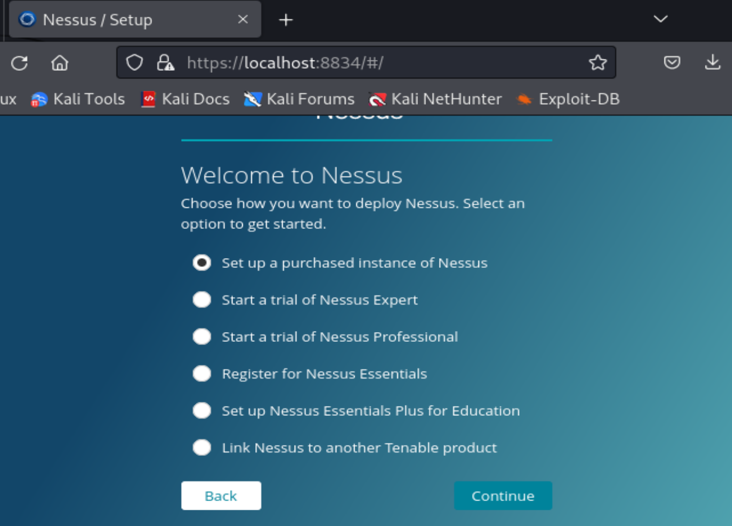
NESSUS: WEB UI AT :8834
HTTPS-only interface at localhost:8834. Self-signed cert warning is expected in lab. Web UI enables scan creation, scheduling and results analysis.
KEY: Web-based scanner UI provides far richer scan management than CLI-only tools.
Figure W9-2. Nessus interface reached at `https://localhost:8834` during initial setup.
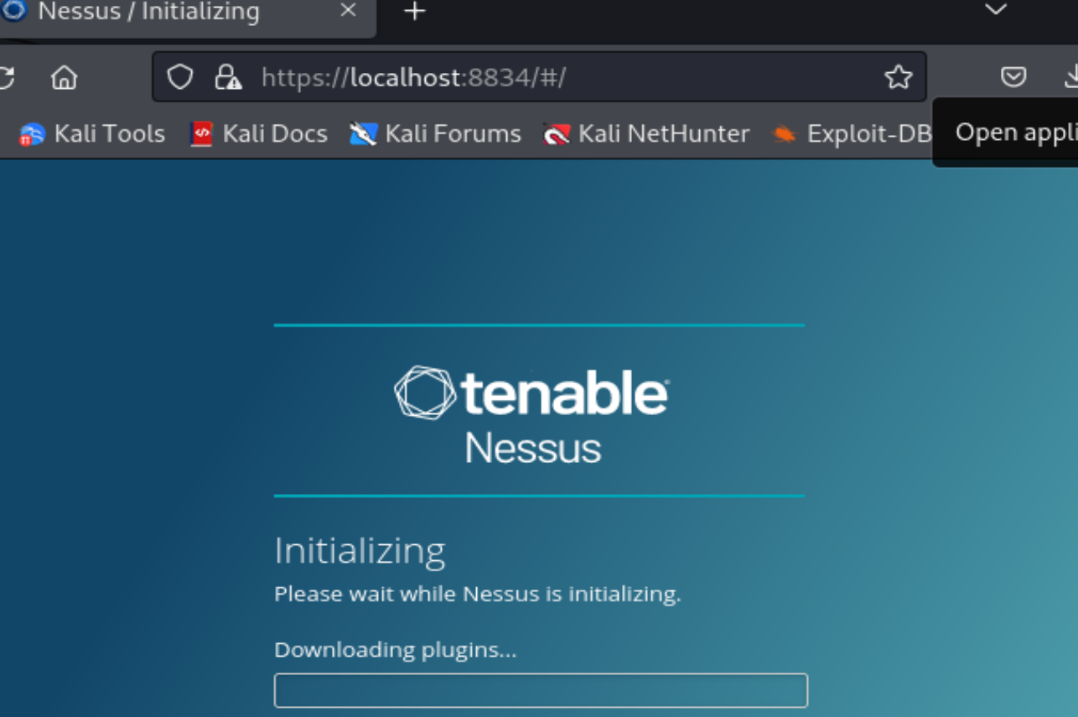
PLUGIN FEED: INITIALISED
Thousands of detection plugins compiled on first run. Plugin feed directly determines what CVEs and misconfigs Nessus can detect.
KEY: Outdated plugin feed = false negatives on known CVEs. Keep feed current before every scan.
Figure W9-3. Nessus initialised and downloaded the plugins needed for scanning.
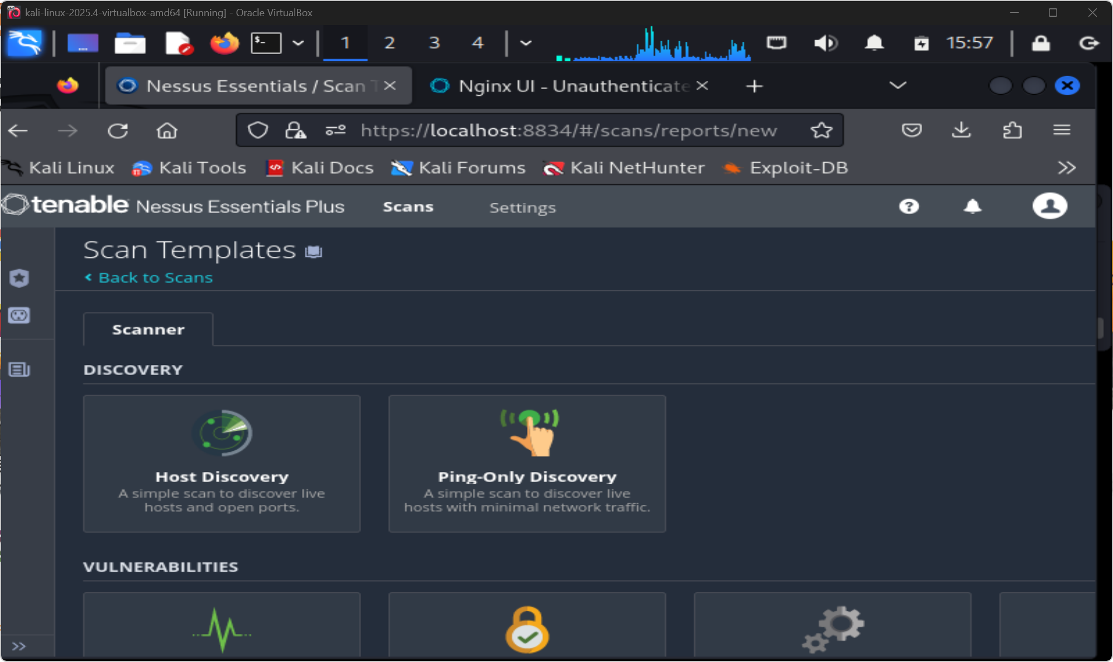
SCAN TEMPLATE: BASIC NETWORK
Basic Network Scan template provides a balanced plugin set suitable for internal lab assessment without excessive noise or duration.
KEY: Template defines scan scope. Advanced Scan covers more but creates significantly more traffic.

Figure W9-4. Basic Network Scan template selected for the lab scans.
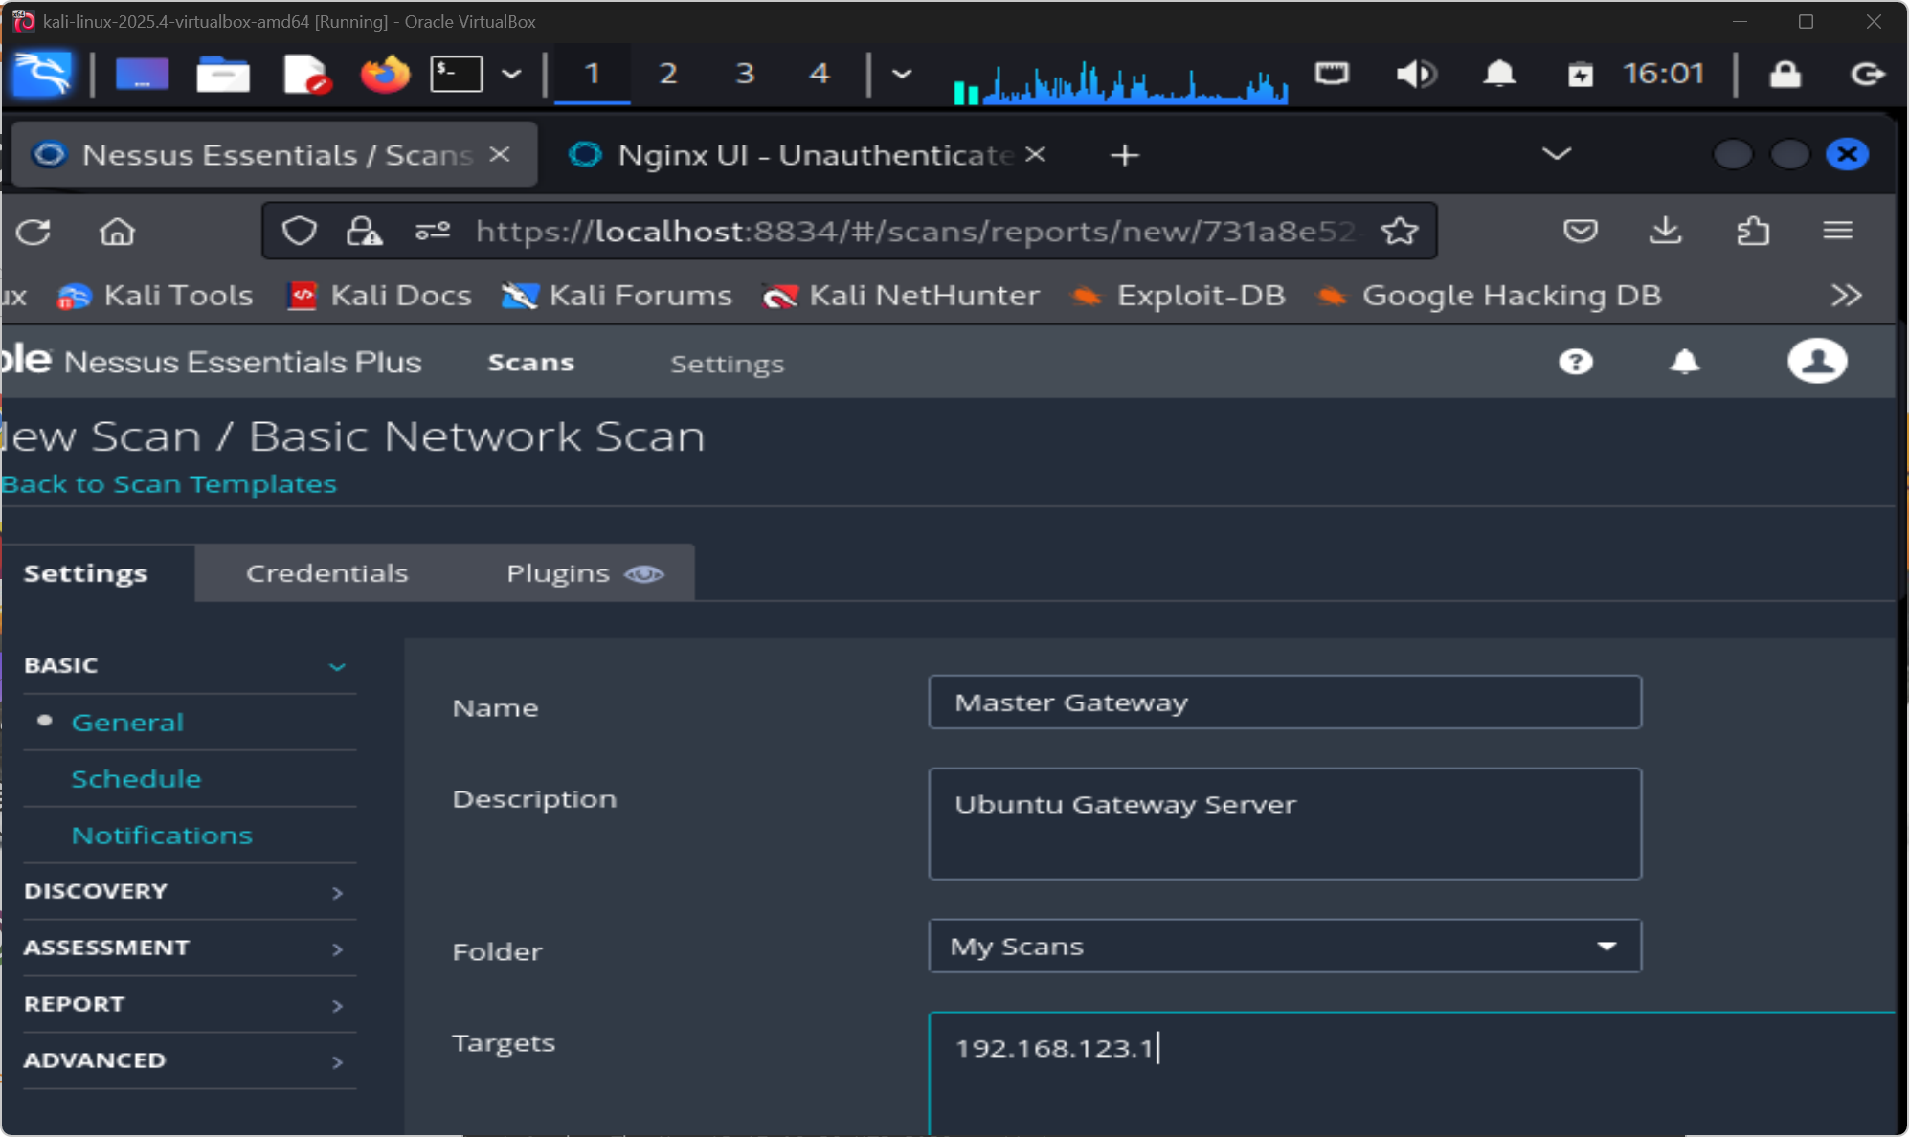
SCAN CONFIG: MASTER GATEWAY
Target: 192.168.123.1 (gateway). Unauthenticated scan simulates external attacker perspective. No credentials supplied.
KEY: Unauthenticated = what an attacker sees. Add credentials for a deeper authenticated audit.

Figure W9-5. Scan configuration for the Master Gateway target at `192.168.123.1`.
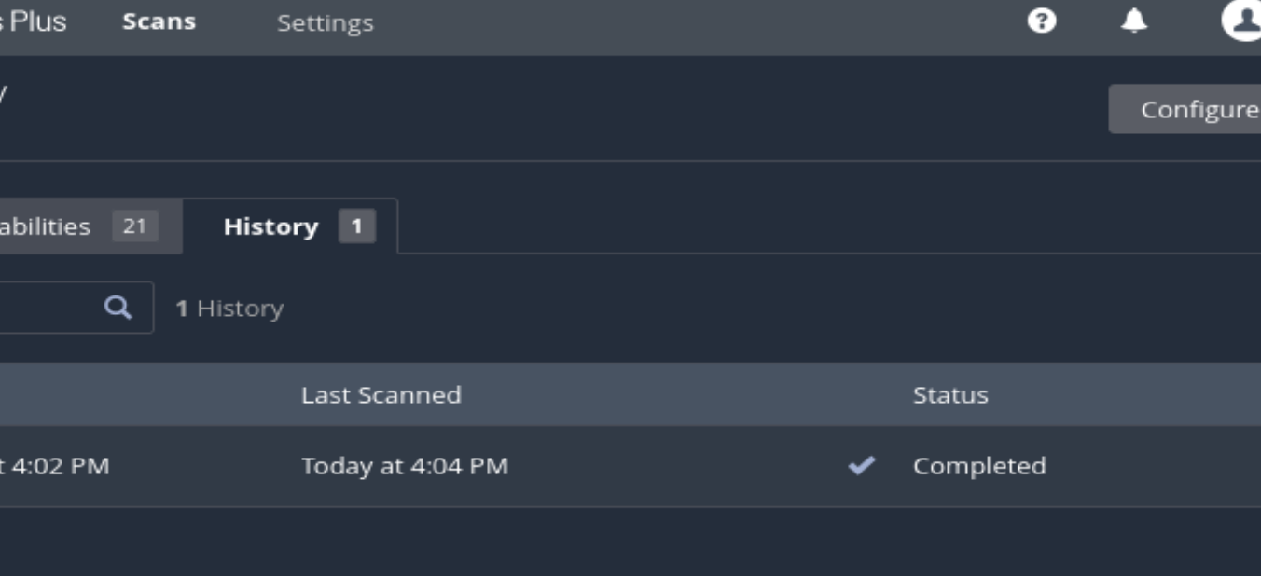
SCAN HISTORY: GATEWAY COMPLETE
Completed scan entry visible in Nessus history view. Duration and total finding count recorded. Provides reproducibility evidence.
KEY: Scan history creates an audit trail. Document scan IDs and timestamps in the report.
Figure W9-6. Internal Nessus history showing the completed Master Gateway scan.
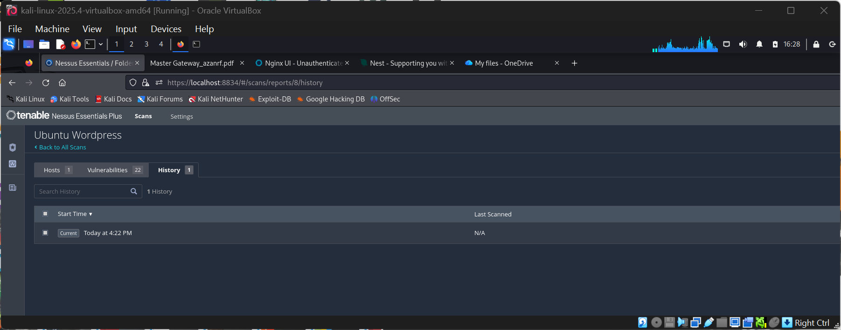
SCAN HISTORY: UBUNTU WP HOST
Separate scan for 192.168.123.30 recorded independently. Two distinct risk profiles maintained for the two target hosts.
KEY: Separate scans per host = cleaner risk attribution and easier remediation tracking.

Figure W9-7. Internal Nessus history showing the separate Ubuntu WordPress scan.
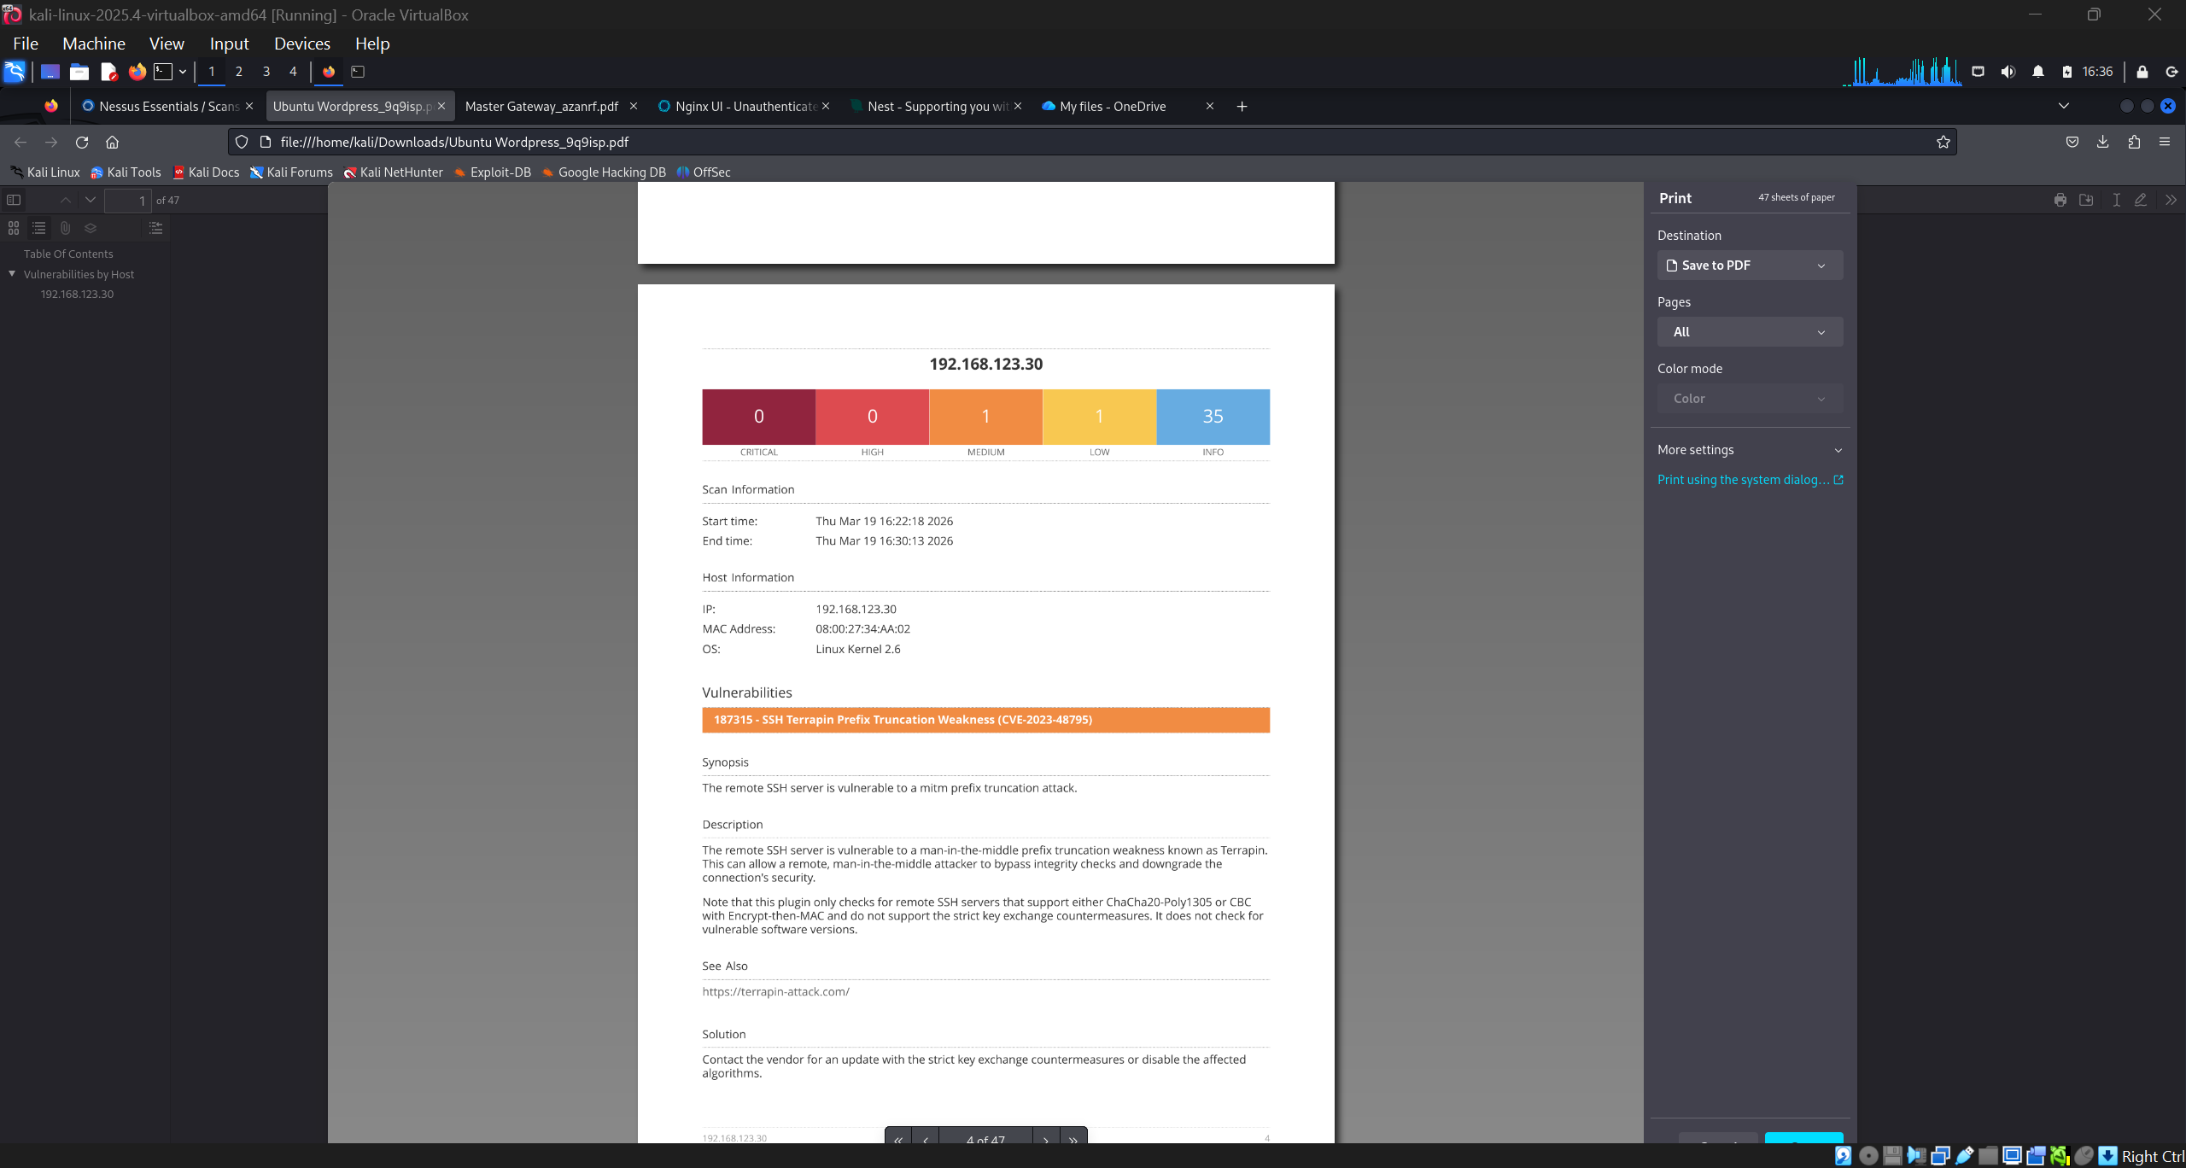
EXPORTED REPORT: 192.168.123.30
Nessus-generated report for Ubuntu WordPress host. SSH vulnerability flagged with full CVSS base score, vector string and remediation guidance.
KEY: Exported reports provide formal evidence for vulnerability disclosure and client deliverables.

Figure W9-8. Exported Nessus report section for `192.168.123.30`, showing the SSH Terrapin finding and totals of 0 critical, 0 high, 1 medium, 1 low, and 35 informational results.
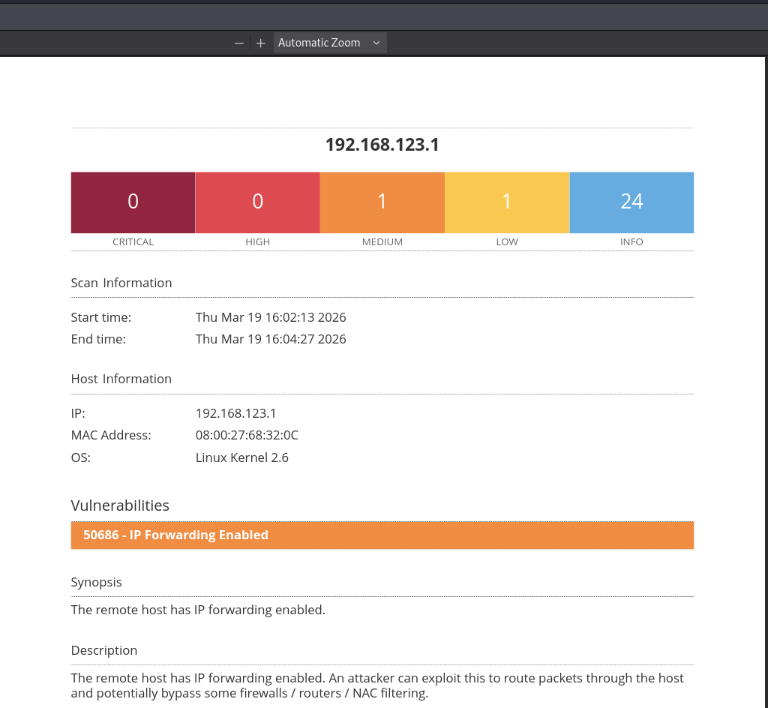
EXPORTED REPORT: 192.168.123.1
Gateway report: IP Forwarding enabled flagged as medium severity. Network-layer misconfiguration that Nmap would not automatically flag.
KEY: Nessus catches OS/network misconfigs that port scanners miss. Complementary tools, not substitutes.
Figure W9-9. Exported Nessus report section for `192.168.123.1`, showing `IP Forwarding Enabled` and totals of 0 critical, 0 high, 1 medium, 1 low, and 24 informational results.
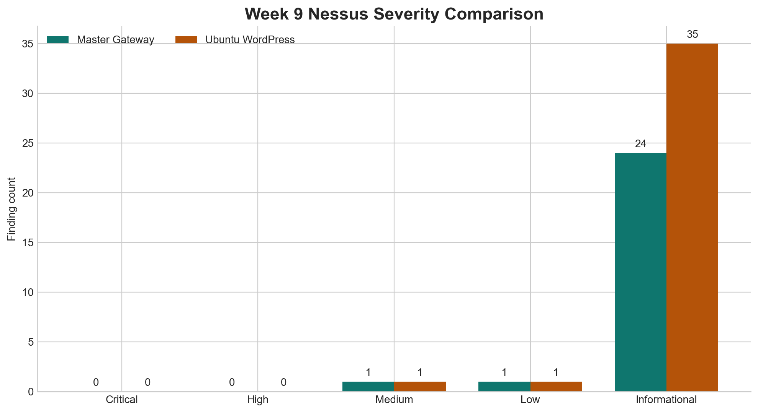
SEVERITY COMPARISON CHART
Side-by-side bar chart for both host scans. Gateway (192.168.123.1) shows higher critical/high count. Visual risk comparison between hosts.
KEY: Chart provides instant executive-level risk comparison. Gateway is the higher-priority remediation target.
Figure W9-10. Severity comparison chart for both Nessus scans; it supports host-to-host comparison, but context still determines which findings should be prioritised first.

5.4 Severity Comparison
Host | Critical | High | Medium | Low | Informational | Most notable issue
Master Gateway (192.168.123.1) | 0 | 0 | 1 | 1 | 24 | 50686 - IP Forwarding Enabled
Ubuntu WordPress (192.168.123.30) | 0 | 0 | 1 | 1 | 35 | 187315 - SSH Terrapin Prefix Truncation Weakness (CVE-2023-48795)

5.5 Findings and Analysis
The internal Nessus screens in Figures W9-6 and W9-7 matter because they show that I directly used the scanner rather than just relying on exported PDFs. They demonstrate that I actually navigated the Nessus interface, monitored scan progress and reviewed history.
The Master Gateway report showed 0 critical, 0 high, 1 medium, 1 low and 24 informational findings. The most notable item was IP Forwarding Enabled. In a production network unnecessary packet forwarding can be misused for man-in-the-middle attacks or lateral movement, but in this lab context the gateway is expected to route traffic so the finding is more of a design decision rather than a misconfiguration.
The Ubuntu WordPress report showed 0 critical, 0 high, 1 medium, 1 low and 35 informational findings. The most important item highlighted in the evidence was the Terrapin SSH vulnerability (CVE-2023-48795). This advisory affects SSH protocol negotiation which makes it directly relevant to LO2 and the cryptographic integrity of remote administration.
The comparison table and chart make one additional point clear which is that raw counts are not enough by themselves. The WordPress host had more informational findings but the Master Gateway finding about IP forwarding had more potential operational impact. Severity ratings need to be read alongside the role and exposure of the host.
This matters because severity totals are only a starting point. Nessus is useful for triage but prioritisation still depends on host role, exposure and the network context. That is why I included the comparison chart because it gives a visual baseline for risk prioritisation rather than relying on numbers alone.

5.6 Mitigation Actions and Recommendations
Host | Notable finding | Severity | Why it matters in context | Immediate action | Validation / rescan action
Ubuntu WordPress | 187315 - SSH Terrapin Prefix Truncation Weakness (CVE-2023-48795) | Medium | A weakness in the management channel matters even when overall counts are modest | Patch OpenSSH and review recommended algorithm hardening | Rescan after patching to confirm the SSH issue no longer appears
Ubuntu WordPress | Broad service exposure including SSH and MySQL | Low to informational overall | Exposure multiplies attack paths even when individual items are not critical | Restrict SSH and MySQL to the smallest required scope | Re-run the scan after firewall changes and compare exposure
Master Gateway | 50686 - IP Forwarding Enabled | Medium | Could be risky in a normal host, but may be legitimate on a router or gateway | Confirm intended role and enforce strict inter-interface firewall policy | Rescan after configuration review and confirm only intended routing behaviour remains
Master Gateway | Large informational footprint | Informational | Banner and service leakage still help attackers prioritise targets | Reduce unnecessary disclosure where practical | Use the next scan to check whether informational noise has been reduced

- patch OpenSSH and related packages on the Ubuntu WordPress host to address the Terrapin-related weakness;
- restrict SSH exposure to trusted administrative hosts only, and avoid leaving management services open broadly on the lab segment;
- review whether MySQL should be reachable from the same segment as the web service, and apply host firewall rules if not;
- if the Master Gateway must forward packets, document that role clearly and enforce strict interface-level firewall policy;
- if the gateway does not need to route traffic in another environment, disable IP forwarding completely;
- use Nessus findings as a prioritisation tool, but validate the environment role of each issue before treating it as a misconfiguration; and
- rescan after patching so the severity counts and exported evidence show improvement rather than only initial exposure.

5.7 Reflection
Nessus was the clearest tool in the portfolio for turning technical exposure into prioritised management output. Compared with Nmap which is good at discovery but leaves prioritisation to the analyst, Nessus produces structured severity ratings, remediation guidance and evidence that is already formatted for reporting.
Its limitation is also what makes it useful: it abstracts aggressively. That helps with prioritisation but it can tempt an analyst into treating every medium finding as identical when in reality the operational context matters more than the severity label. The IP forwarding finding showed that clearly because a medium rating on a host whose job is to route traffic means something different from a medium rating on a host that should not be forwarding at all. That is the kind of judgement that Nessus cannot make for you, and learning to apply it is what I will take forward from this lab.

6. Overall Reflection
Each lab taught me a different part of the same lesson.
WPScan showed me how quickly application-specific reconnaissance can expose useful information. Juice Shop showed me what those kinds of weaknesses look like from the inside. Nmap and SSH linked network-level discovery with secure management. And Nessus turned all of that into a structured severity-based output that can be used for prioritisation and reporting.
What I would do differently next time is capture even more comparative evidence while I am in the lab instead of relying on cleanup later. The extra Juice Shop analysis chart and the Nessus severity comparison were the most valuable additions to the write-up, and I could have produced even more of those if I had planned the visuals from the start. WPScan changed how I think about version validation because it showed me that a plugin advisory is only a lead until you confirm the installed version matches the affected range. Juice Shop changed how I think about chained risk because no single challenge was dramatic on its own but the combination of disclosure, injection and broken access control created a much larger attack surface than any one weakness suggested. Nmap and SSH changed how I think about the relationship between discovery and administration because knowing what is exposed is only useful if you also know how to lock it down properly. And Nessus changed how I think about prioritisation because the severity label alone did not tell me which finding mattered most without understanding the host role and network context.
The biggest overall learning point was that security tools do different jobs. WPScan and Nmap are strong at discovery, SSH is about secure operation and Nessus is about triage and prioritisation. Knowing what each tool is for and where its limits are is what turns technical output into a useful security assessment.

7. References
[1] University of Roehampton London, "Assessment Brief: Coursework Portfolio 1, CMP-X305 Cyber Security," 2026.
[2] University of Roehampton London, "Portfolio Lab on WPScan for Penetration Testing of a WordPress Site," course lab sheet, 2026.
[3] WPScan, "WordPress Security Scanner," [Online]. Available: https://wpscan.com/ [Accessed: 24 Mar. 2026].
[4] University of Roehampton London, "Web Application Vulnerabilities (OWASP Juice Shop Lab)," course lab sheet, 2026.
[5] OWASP Foundation, "OWASP Juice Shop," [Online]. Available: https://owasp.org/www-project-juice-shop/ [Accessed: 24 Mar. 2026].
[6] Course handout, "An Introduction to NMAP," 2026.
[7] Nmap Project, "Nmap Reference Guide," [Online]. Available: https://nmap.org/book/man.html [Accessed: 24 Mar. 2026].
[8] Course handout, "Introduction to SSH (Secure Shell)," 2026.
[9] OpenSSH, "OpenSSH Manual Pages," [Online]. Available: https://www.openssh.com/manual.html [Accessed: 24 Mar. 2026].
[10] University of Roehampton London, "Nessus Lab," course lab sheet, 2026.
[11] Tenable, "Nessus Vulnerability Scanner," [Online]. Available: https://www.tenable.com/products/nessus [Accessed: 24 Mar. 2026].

8. AI Use Declaration
I did not use AI tools during the lab sessions themselves or for executing any technical commands or analysis.
All practical activity in this portfolio including the use of Kali Linux, WPScan, OWASP Juice Shop, Nmap, SSH, Nessus, the commands executed, the results observed and the screenshots captured was carried out by me during scheduled lab sessions or independent study on the provided virtual environment.

