library(readxl)  
library(tidyverse)

## -- Attaching packages -------------------------------------------------------------------------------------------------- tidyverse 1.3.0 --

## v ggplot2 3.3.0 v purrr 0.3.4  
## v tibble 3.0.1 v dplyr 0.8.5  
## v tidyr 1.0.3 v stringr 1.4.0  
## v readr 1.3.1 v forcats 0.5.0

## -- Conflicts ----------------------------------------------------------------------------------------------------- tidyverse_conflicts() --  
## x dplyr::filter() masks stats::filter()  
## x dplyr::lag() masks stats::lag()

library(lubridate)

##   
## Attaching package: 'lubridate'

## The following objects are masked from 'package:dplyr':  
##   
## intersect, setdiff, union

## The following objects are masked from 'package:base':  
##   
## date, intersect, setdiff, union

library(funModeling)

## Loading required package: Hmisc

## Loading required package: lattice

## Loading required package: survival

## Loading required package: Formula

##   
## Attaching package: 'Hmisc'

## The following objects are masked from 'package:dplyr':  
##   
## src, summarize

## The following objects are masked from 'package:base':  
##   
## format.pval, units

## funModeling v.1.9.3 :)  
## Examples and tutorials at livebook.datascienceheroes.com  
## / Now in Spanish: librovivodecienciadedatos.ai

library(sf)

## Linking to GEOS 3.8.0, GDAL 3.0.4, PROJ 6.3.1

library(rnaturalearth)  
library(rnaturalearthdata)

ONCE THE LIBRARIES ARE LOADED, OUR NEXT STEP WILL BE LOADING THE DATASET AND TAKING A LOOK AT THE DATA

df = read_xlsx("ANZ synthesised transaction dataset.xlsx", col_names = TRUE)

## Warning in read_fun(path = enc2native(normalizePath(path)), sheet_i = sheet, :  
## Expecting numeric in C3052 / R3052C3: got 'THE DISCOUNT CHEMIST GROUP'

## Warning in read_fun(path = enc2native(normalizePath(path)), sheet_i = sheet, :  
## Expecting numeric in C4360 / R4360C3: got 'LAND WATER & PLANNING East Melbourne'

df_status(df)

## variable q_zeros p_zeros q_na p_na q_inf p_inf type  
## 1 status 0 0.00 0 0.00 0 0 character  
## 2 card_present_flag 1523 12.65 4326 35.92 0 0 numeric  
## 3 bpay_biller_code 883 7.33 11160 92.67 0 0 numeric  
## 4 account 0 0.00 0 0.00 0 0 character  
## 5 currency 0 0.00 0 0.00 0 0 character  
## 6 long_lat 0 0.00 0 0.00 0 0 character  
## 7 txn_description 0 0.00 0 0.00 0 0 character  
## 8 merchant_id 0 0.00 4326 35.92 0 0 character  
## 9 merchant_code 883 7.33 11160 92.67 0 0 numeric  
## 10 first_name 0 0.00 0 0.00 0 0 character  
## 11 balance 0 0.00 0 0.00 0 0 numeric  
## 12 date 0 0.00 0 0.00 0 0 POSIXct/POSIXt  
## 13 gender 0 0.00 0 0.00 0 0 character  
## 14 age 0 0.00 0 0.00 0 0 numeric  
## 15 merchant_suburb 0 0.00 4326 35.92 0 0 character  
## 16 merchant_state 0 0.00 4326 35.92 0 0 character  
## 17 extraction 0 0.00 0 0.00 0 0 character  
## 18 amount 0 0.00 0 0.00 0 0 numeric  
## 19 transaction_id 0 0.00 0 0.00 0 0 character  
## 20 country 0 0.00 0 0.00 0 0 character  
## 21 customer_id 0 0.00 0 0.00 0 0 character  
## 22 merchant_long_lat 0 0.00 4326 35.92 0 0 character  
## 23 movement 0 0.00 0 0.00 0 0 character  
## unique  
## 1 2  
## 2 2  
## 3 1  
## 4 100  
## 5 1  
## 6 100  
## 7 6  
## 8 5725  
## 9 1  
## 10 80  
## 11 12006  
## 12 91  
## 13 2  
## 14 33  
## 15 1609  
## 16 8  
## 17 9442  
## 18 4457  
## 19 12043  
## 20 1  
## 21 100  
## 22 2703  
## 23 2

df$bpay_biller_code = as.character(df$bpay_biller_code)

plot_num(df)

## Warning: attributes are not identical across measure variables; they will be  
## dropped

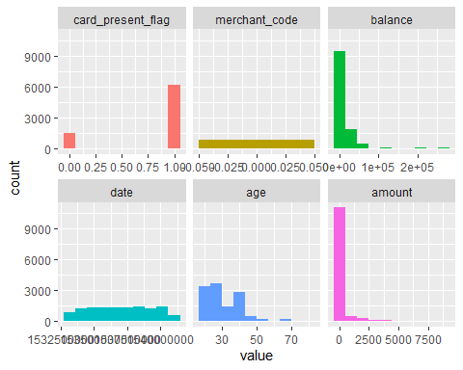

EXTRACTING INFORMATION FROM THE DATES (using libridate library)

#EXTRACTING WEEKS AND HOURS FROM DATE AND EXTRACTION RESPECTIVELY  
df$weekday = weekdays(df$date)  
df$hour = as.character(df$extraction)  
df$hour = substr(df$hour,12,19)  
df$hour = hour(as.POSIXct(df$hour, format = "%H:%M:%S"))

WE NOW LOOK AT THE TRANSACTIONAL TRENDS

#AVERAGE MONTHLY TRANSACTION DISTRIBUTION  
df_mon <- df %>% group_by(customer_id) %>% summarise(mon_avg_vol = round(n()/3,0))  
  
hist(df_mon$mon_avg_vol,  
 xlab= 'Monthly transaction volume', ylab='No. of customers', main = "Histogram of customers' monthly transaction volume",col = "#27ba9f")

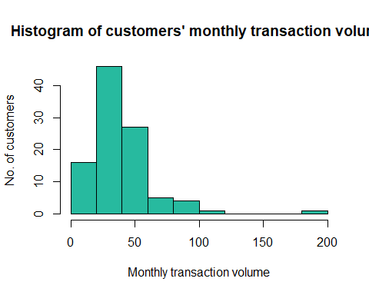

#AVERAGE DAILY TRANSACTION DISTRUBUTION  
df_day <- df %>% group_by(customer_id) %>% summarise(da_avg_vol = round(n()/91,0))  
  
hist(df_day$da_avg_vol, xlab= 'Daily transaction volume', ylab='No. of customers', main = "Histogram of customers' Daily transaction volume",col = "#27ba9f")

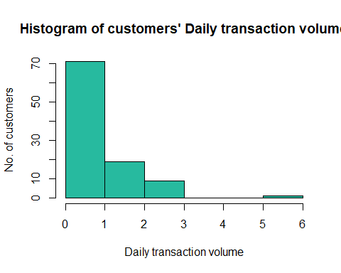

#AVERAGE TRANSACTION BY WEEKDAY  
df_wk <- df%>% select(date, weekday) %>%  
 group_by(date, weekday) %>%  
 summarise(daily_avg_vol =n()) %>%  
 group_by(weekday) %>%  
 summarise(avg_vol=mean(daily_avg_vol,na.rm=TRUE ))  
df_wk <- df_wk %>% mutate(weekday = factor(weekday, levels = c("Monday","Tuesday","Wednesday","Thursday","Friday","Saturday","Sunday"))) %>% arrange(weekday)  
   
ggplot(df_wk,aes(x=weekday, y=avg_vol)) +geom_point(colour = "#CC0000")+geom_line(aes(group = 1), colour = "Steelblue") +   
 ggtitle('Average transaction volume by weekday') +  
 labs(x='Weekday',y='Transaction volume')

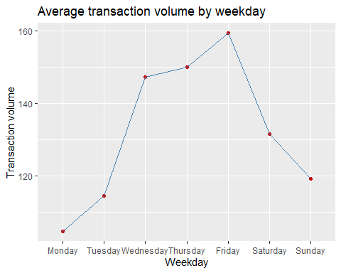

#AVERAGE TRANSACTION PLOTTED BY HOURS  
df_hr <- df %>%  
 select(date,hour) %>%  
 group_by(date,hour) %>%  
 summarise(trans_vol=n()) %>%  
 group_by(hour) %>%  
 summarise(trans_vol_per_hr = mean(trans_vol,na.rm=TRUE))  
  
ggplot(df_hr,aes(x=hour,y=trans_vol_per_hr))+geom_point(colour ="Red")+geom_line(aes(group = 1), colour ="Steelblue")+ ggtitle('Average transaction volume by hour') + labs(x='Hour',y='Transaction volume') + expand_limits( y = 0)

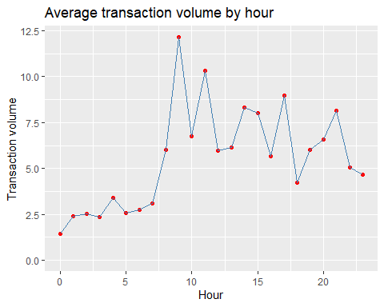

PLOTTING OUTLIERS IN THE TRANSACTIONAL DATA

tapply(df$amount, df$movement, summary)

## $credit  
## Min. 1st Qu. Median Mean 3rd Qu. Max.   
## 576 1014 1626 1899 2539 8836   
##   
## $debit  
## Min. 1st Qu. Median Mean 3rd Qu. Max.   
## 0.10 15.19 26.93 52.57 45.00 7081.09

ggplot(data = df, aes(x=movement, y=amount)) +  
 geom_point(aes(color=movement), alpha=0.2, position ="jitter") +  
 geom_boxplot(outlier.size=4, outlier.colour='blue', alpha=0.1)

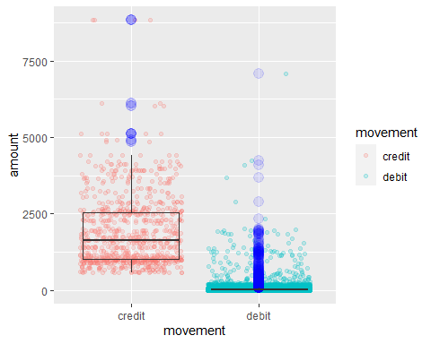

WE CAN GET THE LONGITUDE AND LATITUDE FOR THE CUSTOMERS AND THE MERCHANTS

#Extracting Latitude and Longitudes  
#1. Customer location  
cust_loc = data.frame(df$long_lat)  
cust_loc = data.frame(separate(cust_loc, col = df.long_lat, into = c("cust_long","cust_lat"), sep = " "))  
  
#2. Merchant location  
merc_loc = data.frame(df$merchant_long_lat)  
merc_loc = data.frame(separate(merc_loc, col = df.merchant_long_lat, into = c("merc_long","merc_lat"), sep = " "))  
  
df_loc <- cbind(df$customer_id,cust_loc,merc_loc)  
colnames(df_loc)[which(names(df_loc)=="df$customer_id")] <- "customer_id"  
  
df_loc$cust_long = as.numeric(df_loc$cust_long)  
df_loc$cust_lat = as.numeric(df_loc$cust_lat)  
df_loc$merc_lat = as.numeric(df_loc$merc_lat)  
df_loc$merc_long = as.numeric(df_loc$merc_long)

#PLOTTING THE CUSTOMER AND THE MERCHANT  
merc_map <- function (id ){  
   
 l = subset (df_loc[,c("customer_id","merc_long","merc_lat")], customer_id == id)  
 l <- l[c("merc_long","merc_lat")]  
   
 k = subset (df_loc[,c("customer_id","cust_long","cust_lat")], customer_id == id)  
 k <- unique(k[c("cust_long","cust_lat")])  
   
 ggplot(data = ne_countries(scale = "medium", returnclass = "sf")) +  
 geom_sf(fill = "#5a5a5a") +  
 coord_sf(xlim = c(113,154), ylim = c(-44,-10), expand = FALSE) +  
 geom_point(data = l, aes(x = merc_long, y = merc_lat),na.rm=TRUE, size = 1, shape = 4, colour ="#08e8de" ) +  
 geom_point(data = k, aes(x = cust_long, y = cust_lat),na.rm=TRUE, size = 2, shape = 24, fill = "#f13f09") + xlab("Longitude") + ylab("Latitude") + scale_color_manual(values = c("steelblue", "red"),labels = c("Merchant", "Customer"))  
}

merc_map(id ='CUS-1669695324') #EXAMPLE

