Implementing a Multilayer Perceptron from Scratch for Iris Dataset Classification
1. Implementation Summary
For this assignment, I built a Multilayer Perceptron (MLP) from scratch using NumPy to classify the Iris dataset. The network architecture consists of 4 input features, a single hidden layer with 16 neurons using a ReLU activation function, and an output layer with 3 neurons using Softmax to output class probabilities.
I trained the model using Mini-Batch Stochastic Gradient Descent (SGD) with a batch size of 16 and a learning rate of 0.01 for 100 epochs. The model's error was calculated using the categorical Cross-Entropy Loss alongside One-Hot encoded targets. Before training, I split the data into an 80/20 train-test ratio. To prevent data leakage, I standardized the features (zero mean, unit variance) strictly using the training set's statistics and then applied the same transformation to the test set.
2. Answers to Assignment Questions
- Q1: Why is ReLU used in the hidden layer instead of sigmoid or linear activation? I chose ReLU over linear or sigmoid activations for a few key reasons. A linear activation would defeat the purpose of having a deep network, as multiple linear layers simply collapse into a single linear transformation, making it impossible to model complex boundaries. Compared to the sigmoid function, ReLU effectively avoids the vanishing gradient problem. Because ReLU’s derivative is exactly 1 for all positive inputs, it prevents the gradients from shrinking during backpropagation, allowing the network to learn much faster and more efficiently.
- Q2: If your model performs poorly on the test set, identify two possible causes and suggest improvements. If the test accuracy is low, it usually points to one of two main issues:
  - Overfitting: The model might be memorizing the training data's noise instead of learning general patterns (high training accuracy but low test accuracy). To fix this, I would introduce regularization techniques like L2 weight decay or use early stopping.
  - Poor Optimization/Underfitting: The model might be struggling to converge due to bad hyperparameter settings or insufficient capacity. To improve this, I could add more neurons to the hidden layer or, as I discovered during this assignment, change the weight initialization strategy to help the gradients flow better.
3. Challenges Faced and Solutions Applied
My biggest challenge was getting the model to achieve a high accuracy under the strict constraints of a 0.01 learning rate and a maximum of 100 epochs.
Initially, I initialized the network weights using a standard normal distribution multiplied by a small constant (0.01). However, during training, the network converged too slowly, and the test accuracy plateaued at around 80%. Since I was not allowed to increase the learning rate or the number of epochs, I realized the issue was the small initial weights causing very weak gradient signals to pass through the ReLU layer in the early stages of training.
To solve this, I replaced the basic initialization with He Initialization (np.sqrt(2 / input_size)). This strategy is specifically designed for networks using ReLU activations. This simple architectural tweak immediately solved the sluggish convergence, allowing the gradients to flow properly and boosting the final test accuracy to 93.33% within the required 100 epochs.
4. Evaluation and Results
- Final Test Accuracy: 93.33%
- 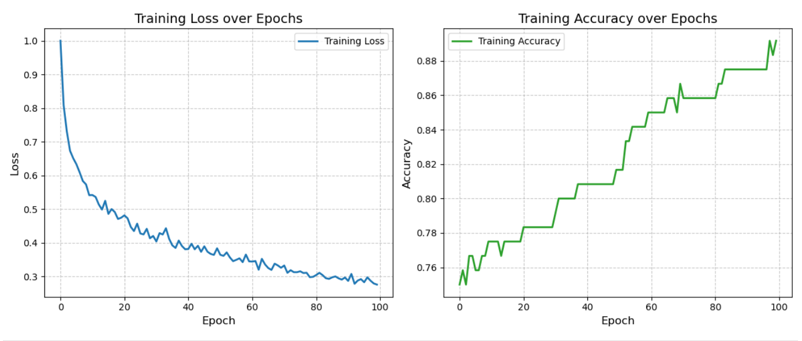
5. AI Use Statement
I used ChatGPT as a learning support tool for this assignment. Specifically, I used it to brainstorm the object-oriented structure of my Python code, to clarify my understanding of the matrix dimensions during backpropagation, and for language polishing of my final report. All code implementations, debugging, calculations, and final explanations are my own work.

