Assignment 2 Report
Building a Simple Convolutional Neural Network (CNN) from Scratch — MNIST

1. Implementation Summary
The CNN was implemented entirely with NumPy (no torch.nn / tf.keras.layers). The architecture follows the assignment brief exactly:
Layer | Output shape | Notes
Input | 1×28×28 | normalised to [0,1]
Conv1 (6 filters, 3×3) + ReLU | 6×26×26 | valid convolution, stride 1
MaxPool1 (2×2) | 6×13×13
Conv2 (16 filters, 3×3) + ReLU | 16×11×11
MaxPool2 (2×2) | 16×5×5
Flatten | 400
FC1 (128) + ReLU | 128
FC2 (10) + Softmax | 10 | cross-entropy loss

Key implementation details
- Convolution and pooling are both implemented using the im2col / col2im technique: sliding windows are unfolded into a matrix so the convolution becomes a single matrix multiplication (col @ W.T). This makes the forward pass fast (BLAS-backed) instead of using four nested Python loops per pixel/filter/channel.
- The backward pass for Conv2D derives dW, db and dx analytically from the same im2col matrix (standard CNN backprop derivation), then folds the gradient back into image coordinates with col2im (which correctly accumulates overlapping contributions).
- MaxPool2D caches the argmax index of each pooling window during the forward pass and routes the incoming gradient only to that index during backward (gradient is zero everywhere else in the window).
- Weights are initialised with He initialisation (N(0, 2/fan_in)), appropriate for ReLU networks, to help avoid vanishing/exploding activations early in training.
- Training uses mini-batch SGD (batch size 32, learning rate 0.01) with a combined softmax + cross-entropy layer for numerical stability.
- Correctness check: before training, the backward pass was verified with a numerical gradient check (finite differences, epsilon = 1e-6) on every parameter tensor. All analytical gradients matched the numerical estimate to within ~1e-8 relative error, confirming the forward/backward math is implemented correctly.

2. Challenges Faced and Solutions
- Deriving backprop for convolution. Writing correct gradients for a convolution manually (rather than relying on autograd) is easy to get subtly wrong. Solution: implemented convolution as im2col + matmul, which reduces the conv backward pass to the same equations as a fully connected layer, then reused a col2im function to scatter gradients back into the original image shape. This was validated with a numerical gradient check rather than trusting it by inspection.
- Max-pooling backward routing. It is easy to accidentally send gradient to the wrong location once the pooled feature map has been flattened. Solution: cached the argmax index per pooling window at forward time and used array-based fancy indexing to scatter gradients precisely to that index at backward time.
- Training speed in pure NumPy. A hand-written CNN in pure NumPy is much slower than a cuDNN-backed PyTorch model, so 5 epochs over 60,000 images takes noticeable wall-clock time on CPU. Solution: vectorised every layer with im2col/matmul instead of raw Python loops over pixels, and used a small-subset smoke test to catch bugs cheaply before committing to a full run.
- Odd feature-map dimensions. An 11×11 feature map pooled with a 2×2/stride-2 window does not divide evenly, leaving one border row/column unused. This is standard 'valid' pooling behaviour and was left as-is (5×5 output), matching the 16×5×5 = 400 flattened size used by FC1.

3. Results
Training was run for 5 epochs with mini-batch SGD (batch size 32, learning rate 0.01) on the full 60,000-image MNIST training set:
Epoch | Loss | Accuracy | Time
1 | 0.4151 | 0.8745 | 22.7s
2 | 0.1478 | 0.9548 | 22.5s
3 | 0.1078 | 0.9676 | 22.5s
4 | 0.0878 | 0.9728 | 22.4s
5 | 0.0755 | 0.9769 | 22.4s

Test Accuracy: 0.9777

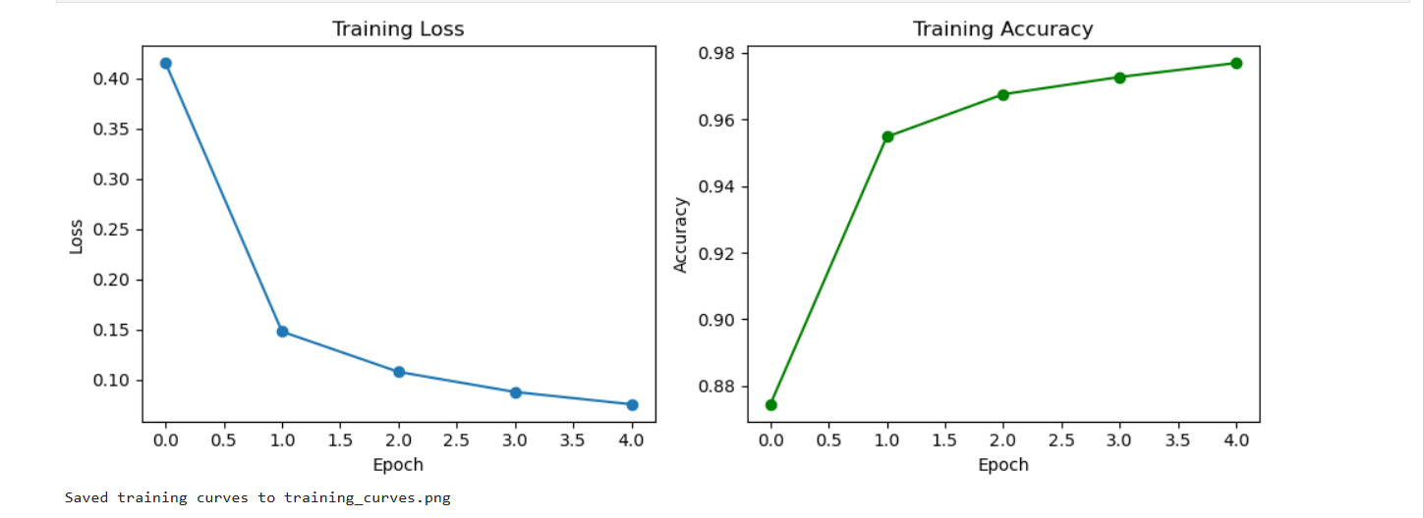
Figure 1: Training loss and accuracy over 5 epochs.

Observations
Most of the learning happens in the first two epochs — training accuracy jumps from 87.45% to 95.48% after epoch 1 alone, then improvement slows and the curve flattens from epoch 3 onward as the model converges. The final test accuracy of 97.77% exceeds the 94%–96% range suggested in the assignment brief, and the small gap between final training accuracy (97.69%) and test accuracy (97.77%) suggests the model is not overfitting at this stage.

4. Answers to Questions

Q1. Why are convolutional layers more effective than fully connected layers for image data?
A fully connected layer treats every pixel as an independent, unordered feature: it has no notion that two pixels are neighbours, and it needs a separate weight for every (input pixel, output unit) pair. This throws away the spatial structure of an image and requires huge numbers of parameters (e.g. a single FC layer mapping 784 pixels to a hidden layer of moderate width already needs hundreds of thousands of weights).
Convolutional layers exploit two properties of images instead:
- Spatial locality / local feature extraction — a small filter (e.g. 3×3) only looks at a local neighbourhood of pixels at a time, matching the fact that meaningful visual patterns (edges, strokes, corners) are local.
- Parameter sharing (parameter efficiency) — the same filter is slid across the whole image, so the number of parameters depends only on the filter size and channel count, not on the image size. This also gives translation invariance: a stroke pattern is detected the same way regardless of where it appears in the image.
- Hierarchical feature learning — stacking conv + pool layers lets early layers detect simple local patterns (edges/curves) while deeper layers combine them into more abstract, larger-receptive-field features (parts of digits, then whole digit shapes), a hierarchy an FC network has no structural bias toward learning.

Q2. If your model achieves low accuracy, identify two potential reasons and suggest improvements.
- Underfitting from too few training epochs / an unsuitable learning rate. With only a handful of epochs and a fixed learning rate, the model may not fully converge, or SGD may oscillate instead of descending steadily. Improvement: train for more epochs, add a learning-rate schedule (decay the LR over time), or tune the LR with a small grid search (e.g. 0.001–0.1).
- Poor weight initialisation or vanishing gradients through the stacked conv/pool/ReLU layers. If weights are initialised too large or too small, activations can saturate or die (ReLU units stuck at zero), stalling learning. Improvement: confirm He/Xavier-style initialisation is used (as done here), and consider adding batch normalisation or monitoring the fraction of dead ReLU units during training.
(Other plausible causes: too small a model capacity for the task, or a bug in the backward pass silently corrupting gradients — which is why the numerical gradient check described above is worth doing before blaming hyperparameters.)

Q3. Suggest one regularization technique to improve generalisation and explain its impact.
Dropout is a straightforward fit here: during training, randomly zero out a fraction of the activations (e.g. 20–50%) in the fully connected layer(s) on each forward pass, then scale appropriately (or use inverted dropout) so no rescaling is needed at test time. This prevents units from co-adapting to one another too strongly — the network cannot rely on any single neuron always being present, so it is forced to learn more redundant, distributed representations. The practical effect is a smaller gap between training and test accuracy (less overfitting), usually at the cost of slightly slower convergence and slightly lower training accuracy, in exchange for better test accuracy. Weight decay (L2 regularisation) and data augmentation (small rotations/shifts of the digit images) are also good alternatives, and could be combined with dropout for a bigger effect.

5.Generative AI (GenAI) Use for This Assignment
- The tool(s) used
I used the Gemini 3pro and ChatGPT.
- What you used it for
- Since I hadn't used CNNs for a long time, I used GPT to help me conceptualize the entire model, such as where to start and what modules to prepare before training. I also had him help me optimize my code construction language and some syntax.
- Because the training load for this model is very large to save time and identify problems promptly, I had him construct a simple code calculation after each code block. This way, I can find any issues immediately.
- When writing the report, I used AI to help me improve the grammar and clarity of expression without changing the original content.
- One or two example prompts you used.
- If I need to quickly determine if there are any errors in this code, what should I do?
- Could you please walk me through the entire model's workflow from beginning to end?

