Split 70/30

Tested on reef knot data set.

5 classes:

Reef_1

Reef_2

Reef_3

Reef_4

Reef_5

Exp 2



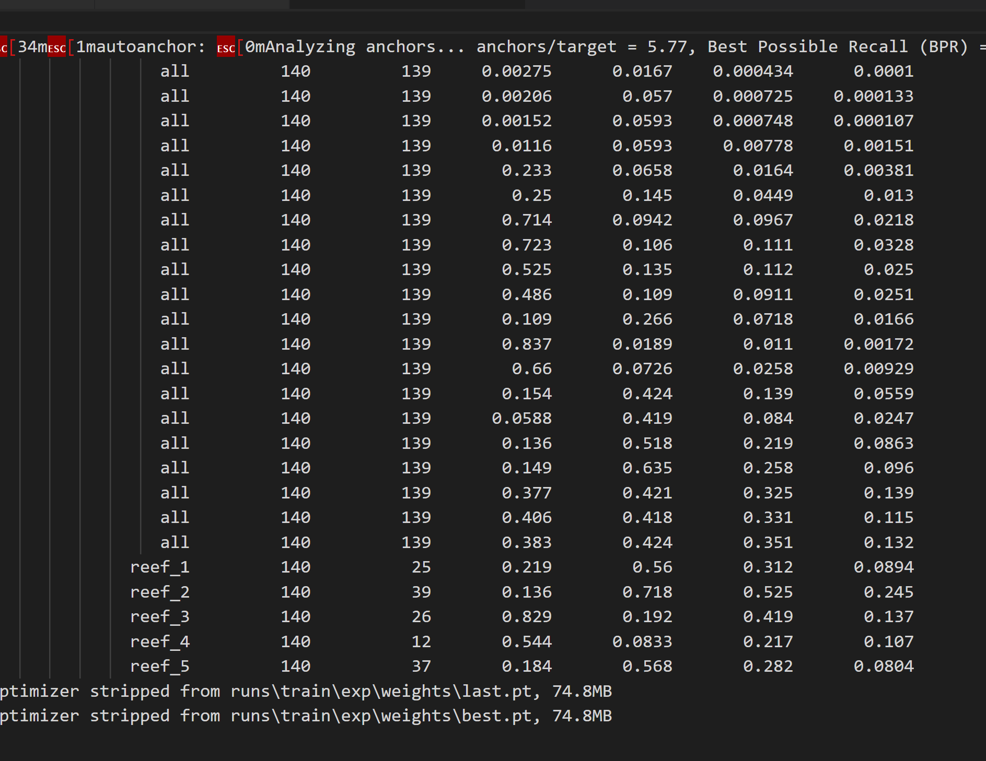

Exp 3



Still bad results here:



300 epochs – batch 8, workers 3 (file train/exp7, test/exp1)

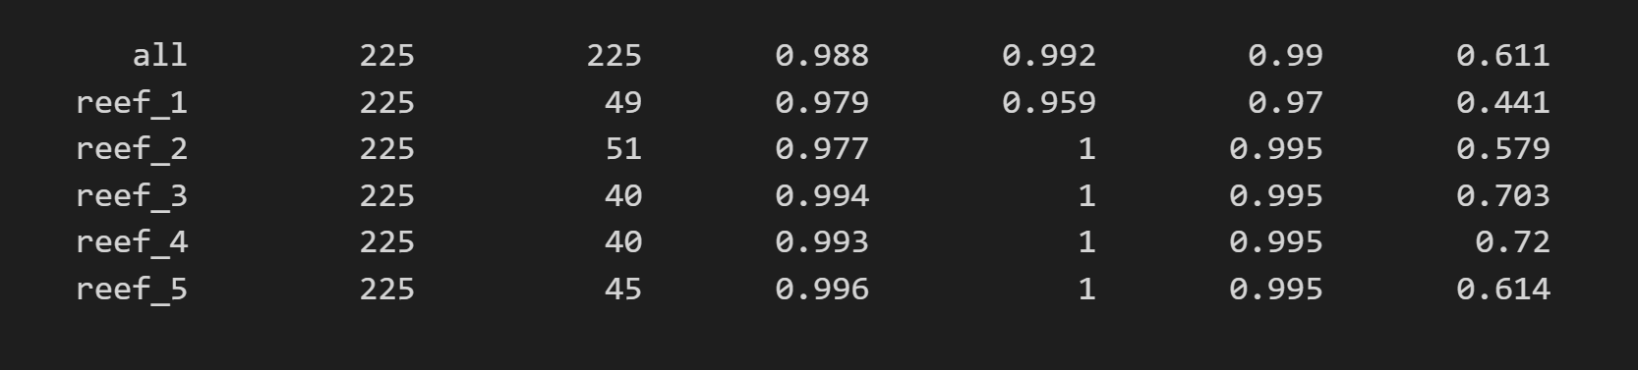

200 epochs – batch 10, workers 1 (file train/exp16, test/exp2)

