AZURE DATA FACTORY
Real-World Scenarios & Production Use Cases

A hands-on implementation guide covering real ADF pipeline patterns — from dynamic file movement to event-driven ingestion, incremental loads, and production error handling.
Core Skills Demonstrated
Metadata-driven & parameterized pipelines
Dynamic expressions & runtime file naming
Event-driven ingestion (Storage Event Triggers)
Incremental loads via watermarking
Production-grade error logging & monitoring
TECH STACK
Azure Data Factory · ADLS Gen2 · Azure SQL Database

Alvin David
Data Engineer
GitHub: github.com/AlvinDavid225
Index Page
Section 1 — File Movement & Copy Patterns
- How to Copy All the Files from One ADLS Folder to Another
- How to Copy a Specific File from One ADLS Folder to Another Using Parameterized Dataset
- How to Copy Only Files of Specific Format from One ADLS Folder to Another
- How to Copy the Last Modified File from an ADLS Folder
Section 2 — Dynamic & Parameterized Pipelines
- Dynamic Table Loads Using Lookup and ForEach
- How to Provide Dynamic Name to the Target File Based on Pipeline Run Date
Section 3 — Event-Driven & Trigger Patterns
- How to Monitor File Status from SQL Table and Copy Data When Status Changes from N to Y
- File Arrival Trigger — Automated Event-Driven File Ingestion
Section 4 — Incremental & Advanced Load Patterns
- Incremental Data Load Using Watermarking
- 10. How to Load All ADLS Folder Names and Count of Files Inside Each Folder into SQL Table
Section 5 — Monitoring & Error Handling
- Error Handling with Custom Logging

Questions
Section 1 — File Movement & Copy Patterns
- How to Copy All the Files from One ADLS Folder to Another in Azure Data Factory
Use Case
Copy all files dynamically from one ADLS Gen2 folder to another using Get Metadata, ForEach, and Copy Activity in Azure Data Factory.

Pipeline Components
Step | Activity |  |  | Purpose
1 | Get Metadata |  |  | Retrieves the full list of files from the source ADLS folder using childItems
2 | ForEach |  |  | Iterates through each file returned by Get Metadata
3 | Copy Activity |  |  | Copies each file dynamically to the target ADLS folder

Step 1 — Get Metadata Activity
Retrieves the list of all files available inside the source ADLS folder using the childItems argument. Passes the complete file list to the ForEach activity.

Step 2 — ForEach Activity
Iterates through each file returned by Get Metadata and executes the Copy Activity dynamically for every file in the folder.
Items Expression:
@activity('Get Metadata1').output.childItems
- Loops through each file one by one
- Executes Copy Activity per file dynamically
- Automates bulk file movement without hardcoding file names

Step 3 — Copy Activity
Copies each file dynamically from the source ADLS folder to the target ADLS folder during each ForEach iteration.

Output
Pipeline executed successfully. All files were copied from the source ADLS folder to the target ADLS folder dynamically using Get Metadata, ForEach, and Copy activities.

- How to Copy a Specific File from One ADLS Folder to Another using Parameterized Dataset in Azure Data Factory

Use Case
Copy a specific file dynamically from one ADLS Gen2 folder to another using parameterized datasets in Azure Data Factory.

Pipeline Parameters

Parameter |  |  | Description
Source |  |  | ADLS Gen2 source folder path containing the input files
Target |  |  | ADLS Gen2 target folder path where the copied files are stored

Pipeline Components
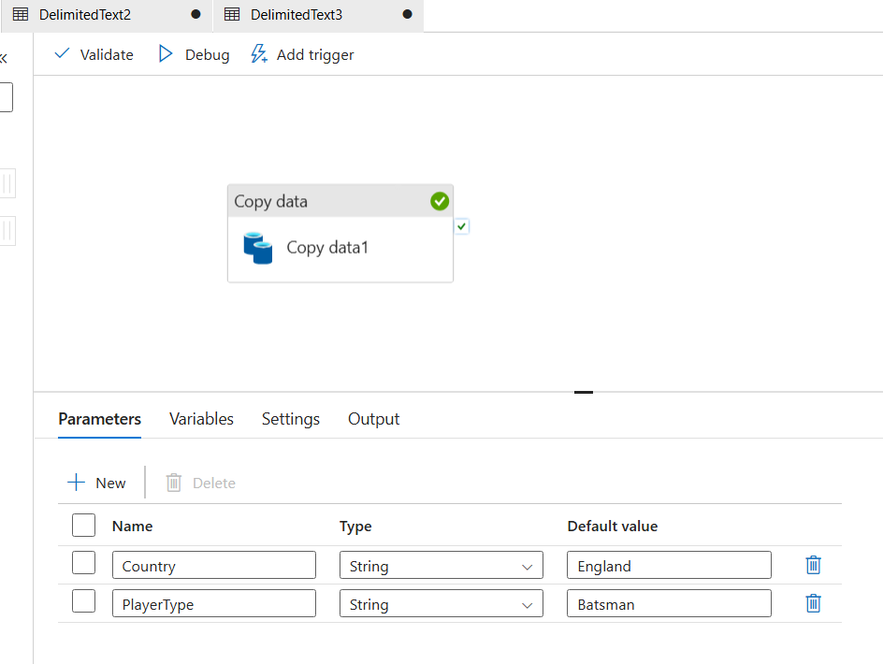

Step 1 — Source Configuration

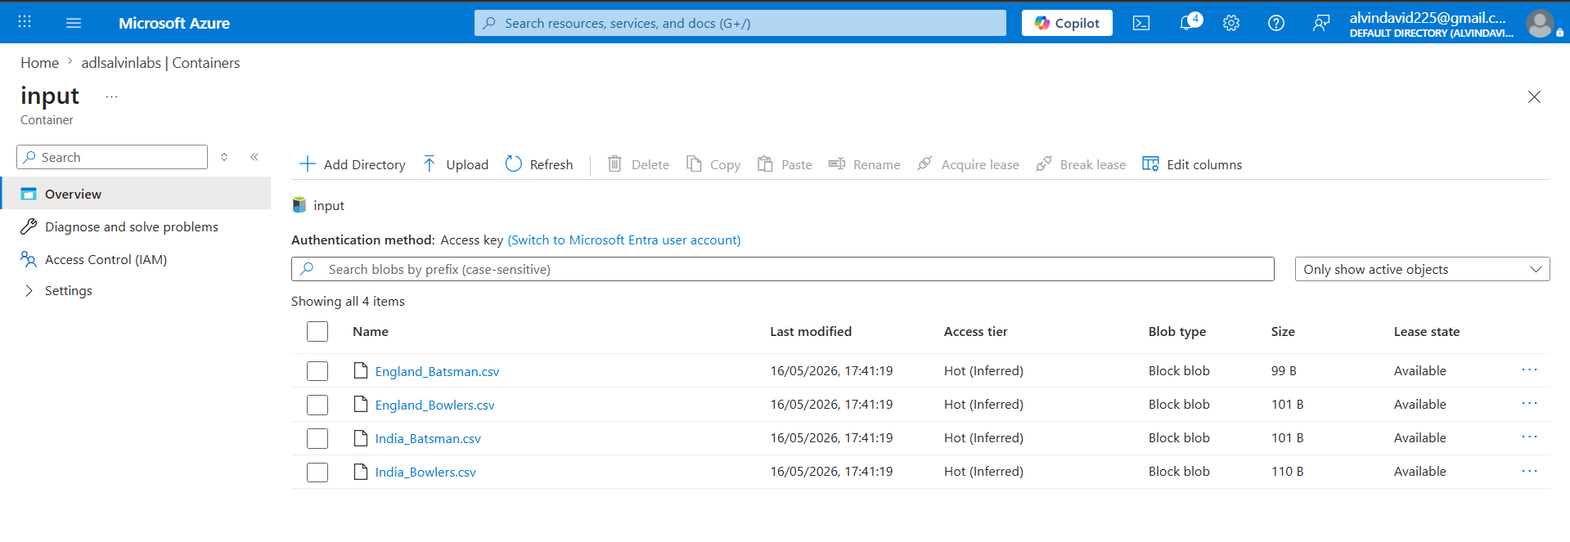
The source ADLS Gen2 folder contains input files that are copied dynamically based on file name and folder parameters passed at runtime.

Step 2 — Sink Configuration
The target ADLS Gen2 folder receives the copied files. Pipeline parameters are mapped dynamically to dataset parameters inside the Copy Activity sink configuration.
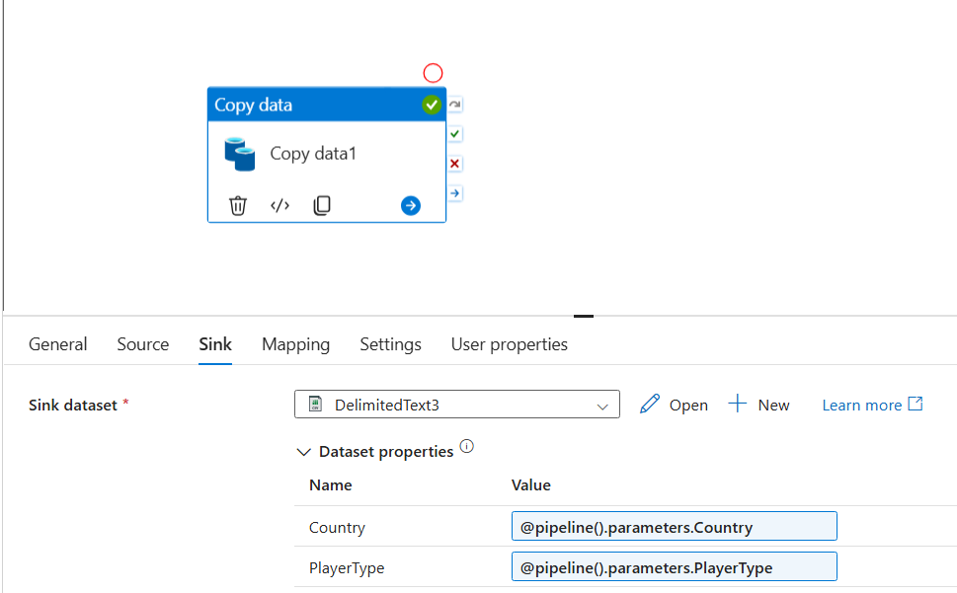

Step 3 — Dynamic File Name Expression
A dynamic expression generates the file name using dataset parameters:
@concat(dataset().Country,'_',dataset().PlayerType,'.csv')
Part |  |  |  |  | Description
dataset().Country |  |  |  |  | Country parameter passed to the dataset
dataset().PlayerType |  |  |  |  | Player type parameter passed to the dataset
Result |  |  |  |  | Dynamically constructs the file name at runtime — e.g. India_Batsman.csv

Output
Pipeline executed successfully. The required file was dynamically copied between ADLS Gen2 folders using parameterized datasets and dynamic expressions in Azure Data Factory.
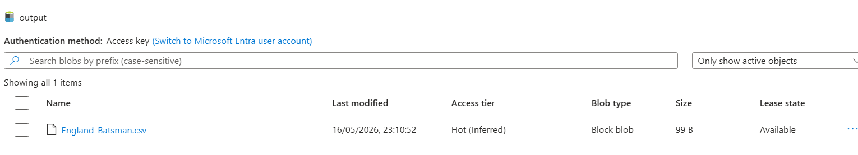

- How to Copy Only Files of Specific Format from One ADLS Folder to Another using ADF Pipeline

Use Case
Copy only .json files from one ADLS Gen2 folder to another dynamically using Azure Data Factory pipeline activities.
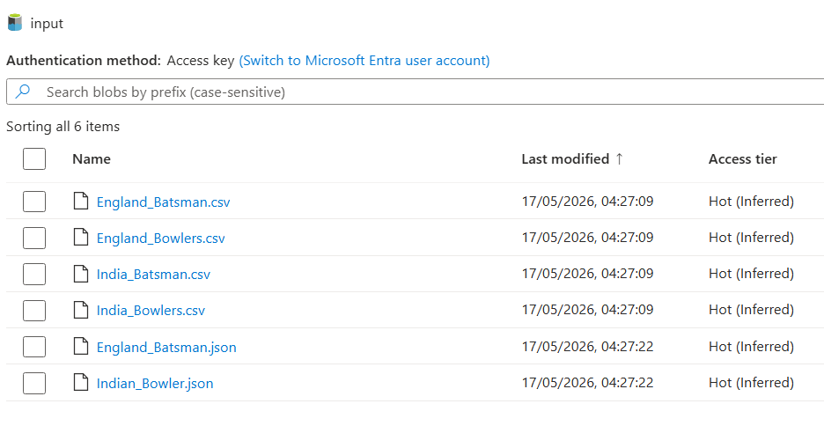
Pipeline Components
Step | Activity |  |  | Purpose
1 | Get Metadata |  |  | Retrieves all files from the source ADLS folder using childItems
2 | Filter |  |  | Filters only .json files from the retrieved file list
3 | ForEach |  |  | Iterates through the filtered JSON files one by one
4 | Copy Activity |  |  | Copies each filtered file to the target ADLS folder

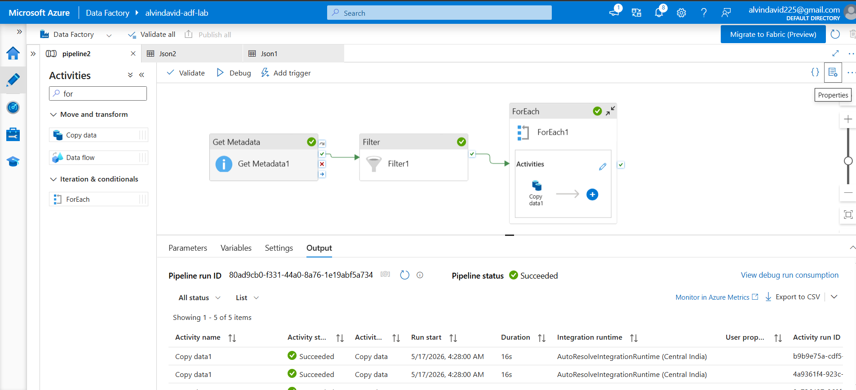

Step 1 — Get Metadata Activity
Retrieves the full list of files available in the source ADLS folder using the childItems field. Passes the complete file list to the Filter activity.

Step 2 — Filter Activity
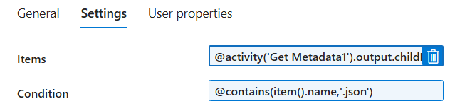
Checks all files retrieved from the source ADLS folder and selects only .json files dynamically.
Field | Value
Items | Output from Get Metadata (childItems)
Condition | File name ends with .json
Output | Filtered list containing only JSON files

Step 3 — ForEach Activity
Iterates through each file in the filtered JSON file list returned by the Filter activity, processing them one by one.

Step 4 — Copy Activity
Copies each filtered .json file dynamically from the source ADLS folder to the target ADLS folder.

Output
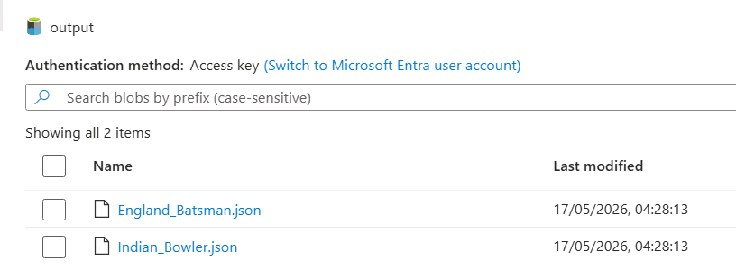
Pipeline executed successfully. Only .json files were copied from the source ADLS folder to the target ADLS folder.

- How to Copy the Last Modified File from an ADLS Folder Using Azure Data Factory
- Use Case
This pipeline copies only the most recently modified file from an ADLS folder into another ADLS location using Azure Data Factory.
- Input
The raw-data ADLS container contains multiple CSV files. The pipeline scans all files, compares their last modified timestamps, and dynamically selects the latest modified file for processing and copying.
Latest File Identified: Global_SalesIND2020.csv
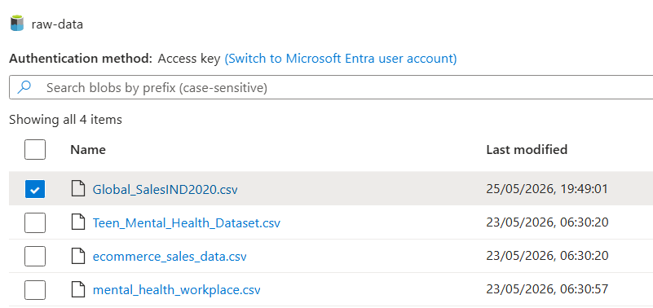

Pipeline Components

Variables Used
Variable | Purpose
LatestFile | Stores the name of the latest modified file. Used in Copy Activity to dynamically copy the newest file.
RefDateTime | Stores the latest modified timestamp during execution. Used in If Condition to compare file timestamps.
Step 1 — Get Metadata Activity (Outer)
Retrieves the list of all files inside the ADLS source folder using the Child Items field.
- Reads all files from the source folder
- Sends the file list to the ForEach activity
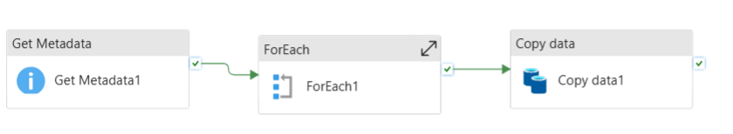
Step 2 — ForEach Activity
Loops through each file returned from the Get Metadata activity.
Items Expression:
@activity('Get Metadata1').output.childItems
- Iterates through every file in the folder
- Processes files one by one


Step 3 — Get Metadata Activity (Inside ForEach)
Retrieves metadata for each individual file dynamically using @item().name.
- Fetches file name and last modified timestamp per file
- Passes information to the If Condition activity

Step 4 — If Condition Activity
Compares the current file's last modified timestamp against the stored RefDateTime variable.
Expression:
activity('GetMetadata2').output.lastModified
retrieves the last modified timestamp of the current file.
variables('RefDateTime')
contains the previously stored latest timestamp.
greater()
Result | Action
TRUE | Updates RefDateTime and stores the file name in LatestFile using Set Variable
FALSE | Ignores the file, loop continues to next file

Step 5 — Copy Data Activity
Copies the latest modified file from source ADLS folder to target ADLS folder.
Dynamic Expression:
@variables('LatestFile')
- Copies only the latest modified file
- Avoids copying old or duplicate files
- Reduces unnecessary data movement

Output

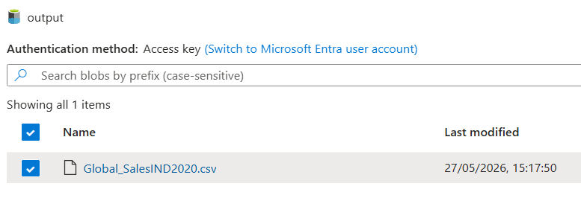
Pipeline executed successfully. The latest file Global_SalesIND2020.csv was identified and copied into the target ADLS output folder.

Section 2 — Dynamic & Parameterized Pipelines

- Dynamic Table Loads Using Lookup and ForEach
Use Case
A company needs to load data from multiple SQL tables (Customers, Orders, Products, Employees) into ADLS. Instead of building separate pipelines per table, a configuration table dbo.TableConfig is maintained with table names, sink paths, and load types. ADF reads this configuration dynamically using Lookup, processes each table through ForEach, and copies data into the respective ADLS locations. This metadata-driven approach scales to hundreds of tables without additional development effort.

Input

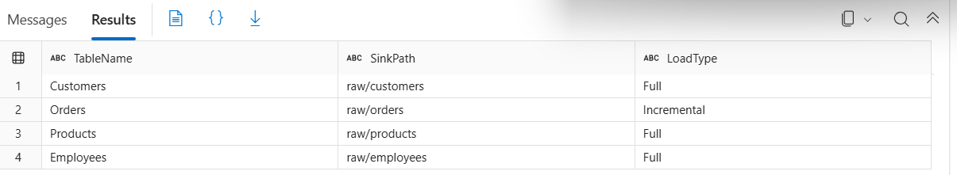
Configuration table dbo.TableConfig contains the list of tables to be processed.
Column | Description
TableName | Name of the SQL table to be copied
SinkPath | Target ADLS path for the output file
LoadType | Type of load (Full / Incremental)

Pipeline Components

Step | Activity | Purpose
1 | Lookup | Reads all table configurations from dbo.TableConfig
2 | ForEach | Iterates through each table record returned by Lookup
3 | Copy Activity | Dynamically copies each table from SQL to ADLS

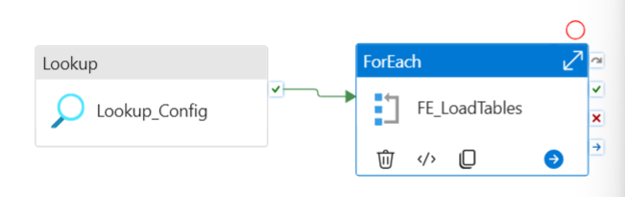

Step 1 — Lookup Activity
Reads all table names and configurations from the control table.
Query Used:
sql
SELECT * FROM dbo.TableConfig
- Retrieves all table configuration records
- Provides the full list as input to the ForEach activity

Step 2 — ForEach Activity

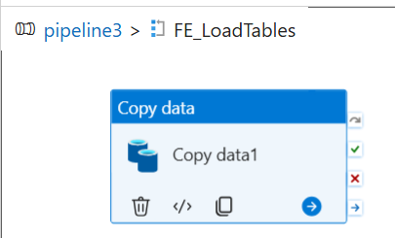
Iterates through each table record returned by the Lookup activity.
Items Expression:
@activity('Lookup_Config').output.value
- Processes multiple tables dynamically in a single pipeline
- Passes each table's configuration to the Copy Activity per iteration

Step 3 — Copy Activity

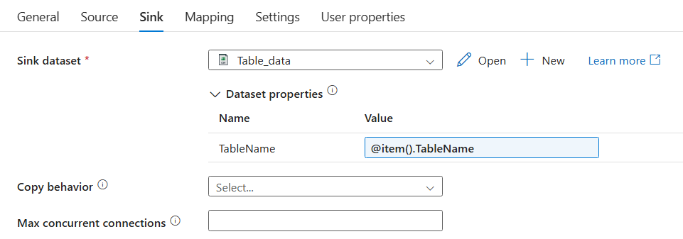
Source Configuration
Dynamically selects the SQL table being processed in each ForEach iteration.
Expression:
@item().TableName
- Dynamically selects the source SQL table per iteration
- Eliminates the need for separate datasets or pipelines per table
Sink Configuration
Dynamically generates the output file name using the table name.
Expression:
@concat(dataset().TableName,'.csv')
- Creates a separate CSV file per table in ADLS
- No hardcoded file names — fully dynamic

Output
Pipeline executed successfully. Separate CSV files were generated dynamically for Customers, Orders, Products, and Employees using a single reusable pipeline.
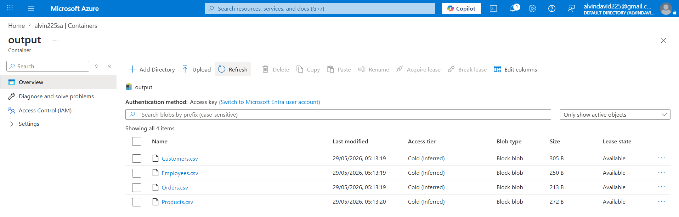

- How to Provide Dynamic Name to the Target File Based on Pipeline Run Date in Azure Data Factory

Use Case
Generate dynamic revenue filenames in ADLS Gen2 using revenue starting date, revenue ending date, and current pipeline run date in Azure Data Factory.

Pipeline Components
Component | Description
Source | Azure SQL Database — revenue data
Sink | ADLS Gen2 — dynamically named CSV file
Activity | Copy Activity with dynamic sink filename expression

Pipeline Design

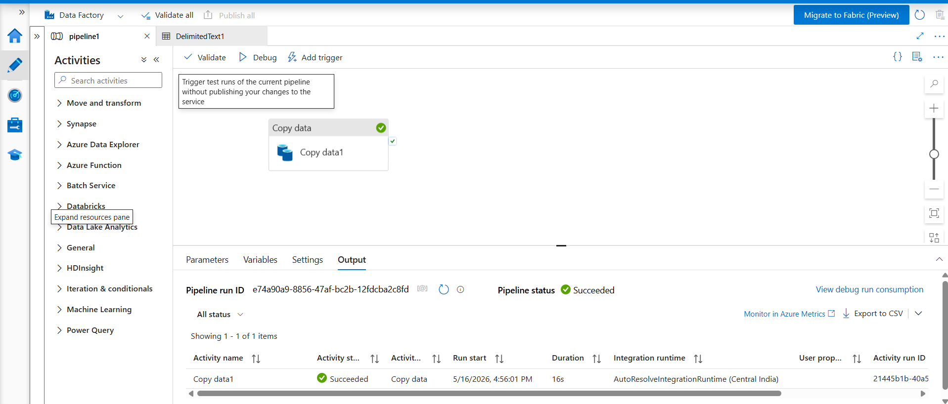
- A Copy Activity pipeline moves data from Azure SQL Database to ADLS Gen2
- ADF dynamic expression generates the target filename using the previous month end date and the current pipeline run date
- No hardcoded filename — file name is fully constructed at runtime

Dynamic Expression Used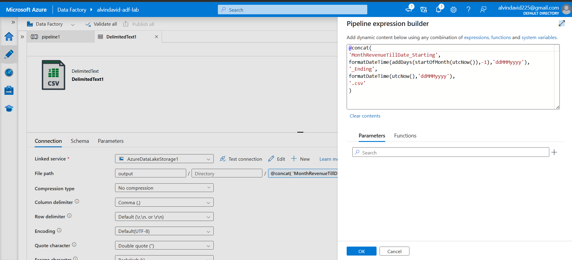
@concat(
'MonthRevenueTillDate_Starting',
formatDateTime(addDays(startOfMonth(utcNow()),-1),'ddMMMyyyy'),
'_Ending',
formatDateTime(utcNow(),'ddMMMyyyy'),
'.csv'
)
Expression Breakdown
Part | Function | Output Example
startOfMonth(utcNow()) | Gets the first day of the current month | 2024-01-01
addDays(..., -1) | Subtracts 1 day to get the last day of previous month | 2023-12-31
formatDateTime(...,'ddMMMyyyy') | Formats the date into readable format | 31Dec2023
formatDateTime(utcNow(),'ddMMMyyyy') | Gets the current pipeline run date | 15Jan2024
Full Result | Dynamically constructed filename | MonthRevenueTillDate_Starting31Dec2023_Ending15Jan2024.csv

Output

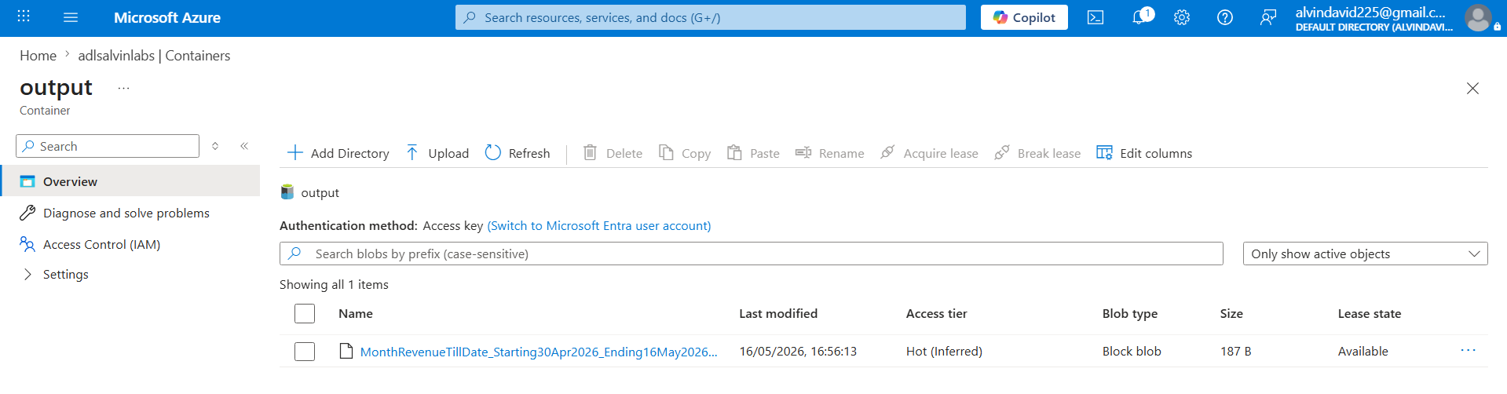
The output CSV file was successfully generated in ADLS Gen2 with a dynamic filename constructed from the pipeline run date.

Section 3 — Event-Driven & Trigger Patterns

- How to Monitor File Status from SQL Table and Copy Data from Input Blob to Output Blob When Status Changes from 'N' to 'Y' Using Azure Data Factory Pipeline

Use Case
Continuously check the status of a file from a SQL table and copy the file only when the status changes from N to Y using the Until activity in Azure Data Factory.

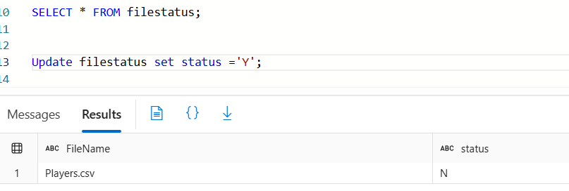

Pipeline Components
Step | Activity |  | Purpose
1 | Lookup |  | Checks the current file status from the SQL table
2 | Until |  | Keeps looping until the file status becomes Y
3 | If Condition |  | Validates whether the file status is Y
4 | Set Variable |  | Updates the Flag variable to stop the Until loop
5 | Copy Activity |  | Copies the file from source ADLS to target ADLS

Step 1 — Lookup Activity
Checks the current file status from the SQL table on each loop iteration.
- Reads the status column value from the SQL table
- Passes the result to the If Condition activity inside the Until loop

Step 2 — Until Activity

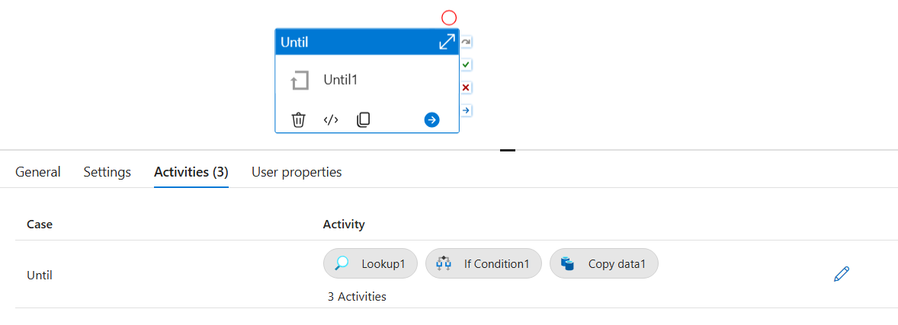
Keeps the pipeline running repeatedly until the exit condition becomes TRUE.
Exit Condition:
@equals(variables('Flag'), true)
- Loops continuously until Flag variable is set to true
- All monitoring logic (Lookup, If Condition, Set Variable) runs inside this loop

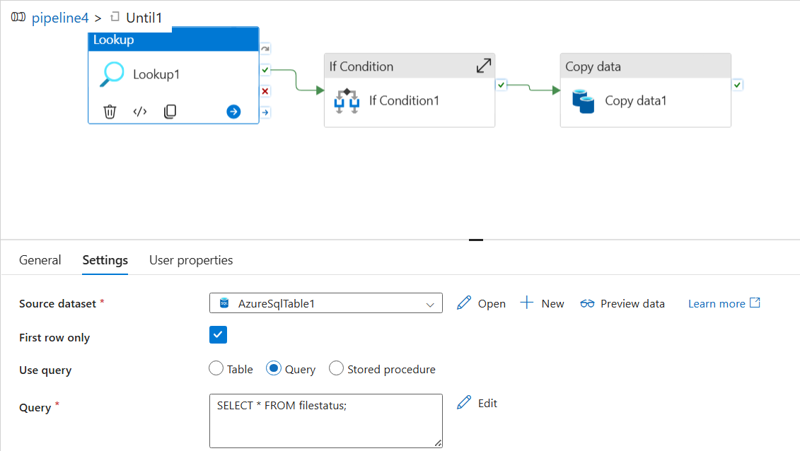

Step 3 — If Condition Activity
Validates whether the file status has changed to Y.
Expression:
@equals(activity('Lookup1').output.firstRow.status,'Y')
Result | Action
TRUE | Executes Set Variable and Copy Activity inside the True block
FALSE | Loop continues, Lookup runs again on the next iteration

Step 4 — Set Variable Activity (Inside True Block)
Updates the pipeline variable to stop the Until loop once status is Y.
Field | Value
Variable Name | Flag
Value | True
- Setting Flag to true satisfies the Until exit condition
- Prevents the loop from running again after the file is found

Step 5 — Copy Activity (Inside True Block)
Copies the file from the source ADLS folder to the target ADLS folder once status is confirmed as Y.

Output

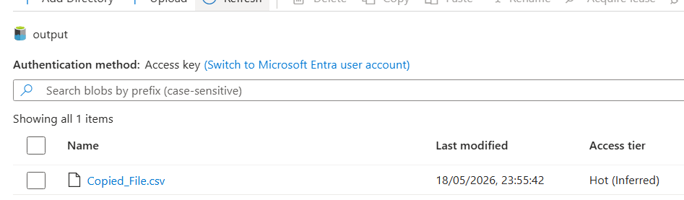
Pipeline executed successfully. The Until activity continuously monitored the SQL table for file status changes. Once the status changed from N to Y, the loop stopped and the Copy Activity copied the file successfully from source to target ADLS folder.

- File Arrival Trigger — Automated Event-Driven File Ingestion Using Azure Data Factory

Use Case
A company receives data files from external vendors and source systems throughout the day. Instead of waiting for a scheduled pipeline run or manually triggering the pipeline, ADF automatically detects when a new file is uploaded to the storage account and starts the data ingestion process immediately. This enables near real-time processing, reduces operational effort, and ensures data is available for downstream analytics as quickly as possible.

Pipeline Components
Component | Description
Pipeline | PL_FileArrival — contains a Copy Activity to read and copy the incoming file
Trigger | trigger1 — Storage Event Trigger monitoring the raw-data container
Source | ADLS Gen2 raw-data container
Sink | ADLS Gen2 output container

Pipeline Design

- PL_FileArrival pipeline is triggered automatically by a Storage Event Trigger whenever a new file is uploaded to the source ADLS container
- The pipeline contains a Copy Activity that reads the incoming file and copies it to the target ADLS location
- No manual execution or scheduled trigger required — fully event-driven

Storage Event Trigger Configuration
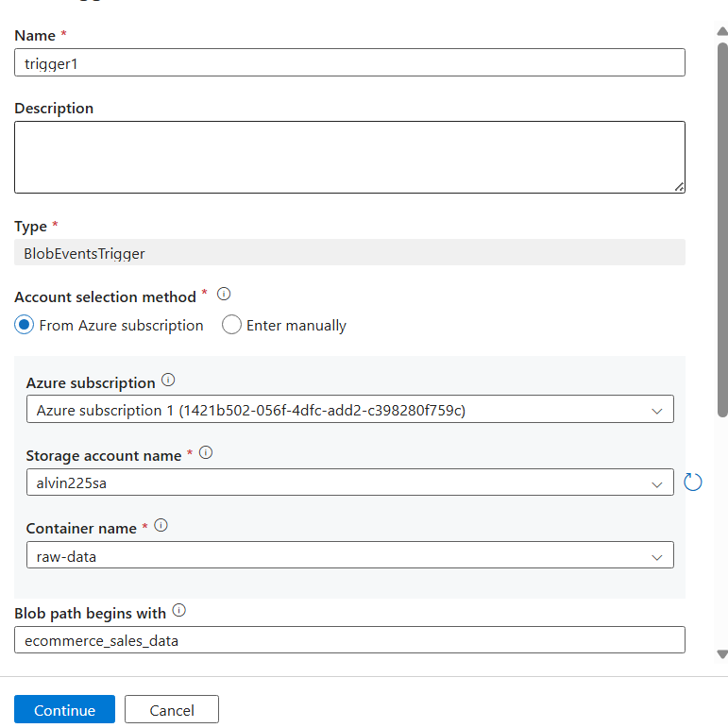
Field | Value
Trigger Name | trigger1
Trigger Type | Storage Event Trigger
Container Monitored | raw-data
Event Type | Blob Created
File Name Filter | Begins with ecommerce_sales_data

Execution Flow

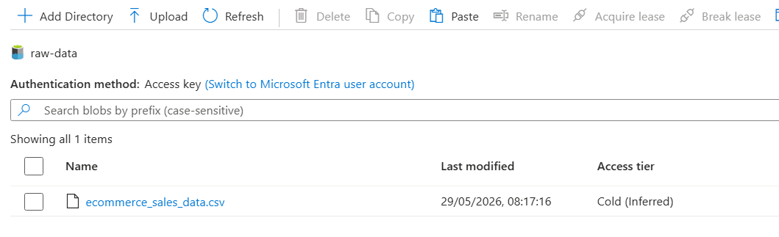
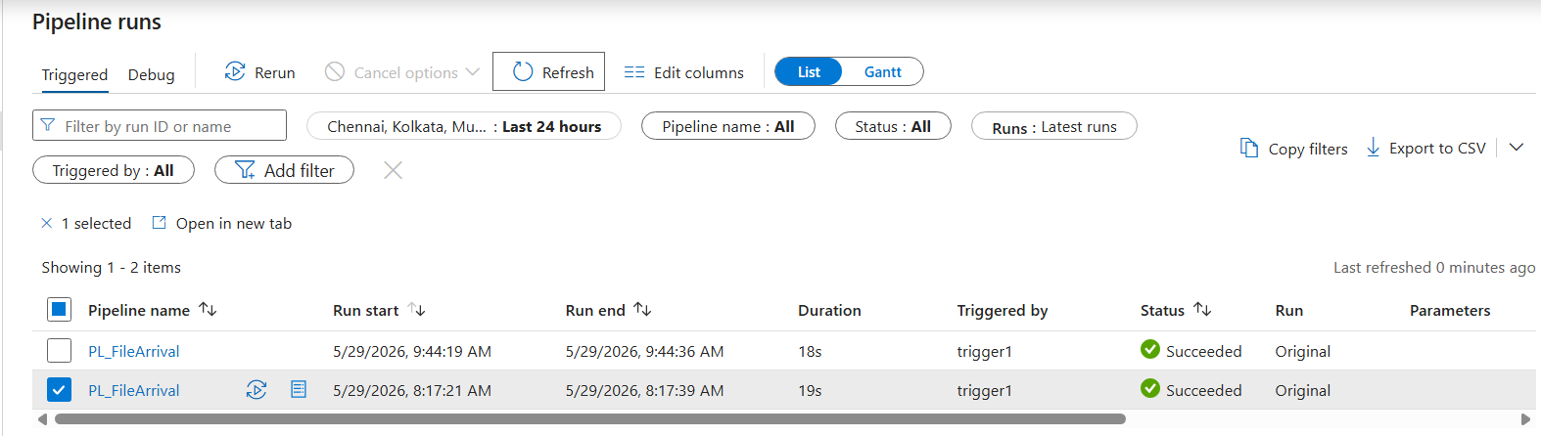
Step | Action
1 | File ecommerce_sales_data.csv is uploaded to the raw-data container in ADLS Gen2
2 | File upload generates a Blob Created event
3 | Azure Event Grid detects the event
4 | Event Grid automatically triggers PL_FileArrival pipeline via trigger1
5 | Copy Activity reads the file and copies it to the output container as CopiedFile.csv

Output


The file ecommerce_sales_data.csv was uploaded to the raw-data container, generating a Blob Created event. Azure Event Grid detected the event and automatically triggered the PL_FileArrival pipeline. The pipeline executed successfully and copied the file to the output container as CopiedFile.csv, validating the event-driven ingestion framework.

Section 4 — Incremental & Advanced Load Patterns

- Incremental Data Load Using Watermarking

Use Case
Load only new or updated records from a SQL source into Azure Data Lake by using a watermark column LastModifiedDate. This avoids full table scans and prevents loading duplicate records on every pipeline run.

Pipeline Components
Step | Activity | Purpose
1 | Lookup | Reads the latest processed watermark value from the control table
2 | Copy Activity | Loads only delta records where LastModifiedDate is greater than the watermark

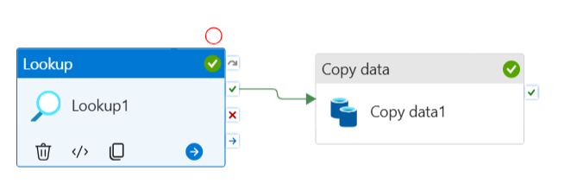

Step 1 — Lookup Activity
Reads the last processed watermark value from the control table before the Copy Activity runs.
Query:
sql
SELECT LastWatermark
FROM Control_Table
WHERE TableName = 'Sales'
- Retrieves the previously stored watermark timestamp
- Passes the value to the Copy Activity as a dynamic expression

Step 2 — Copy Activity
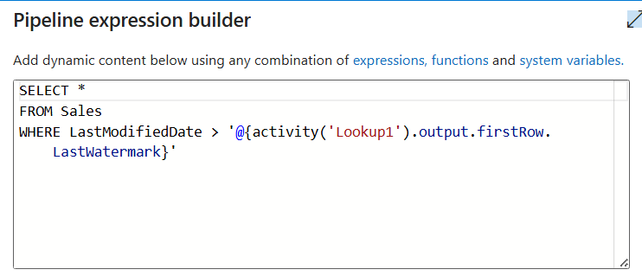
Dynamically loads only new or updated records from SQL Server using the watermark value retrieved from the Lookup activity.
Source Query Logic:
sql
SELECT * FROM Sales
WHERE LastModifiedDate > '@{activity('Lookup1').output.firstRow.LastWatermark}'
Field | Description
Watermark Column | LastModifiedDate
Filter Condition | LastModifiedDate greater than last stored watermark value
Sink | ADLS Gen2 output container
Output File | LastModifiedData.csv
- Copies only delta records — no duplicates, no full table reload
- Reduces data movement and improves pipeline efficiency

Output
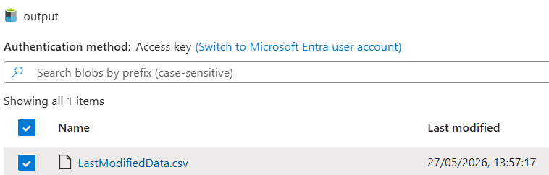
Pipeline executed successfully. Only newly modified records from the SQL Sales table were loaded into the ADLS output container using watermark-based incremental loading. Output file LastModifiedData.csv was created successfully in the target ADLS folder.

- How to Load All ADLS Folder Names and Count of Files Inside Each Folder into SQL Table using ADF

Use Case
Load all ADLS folder names and count the number of files available inside each folder dynamically, then store the results into an Azure SQL table using Azure Data Factory.
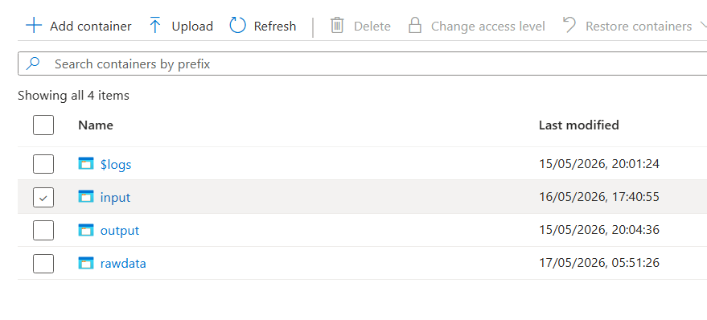

Pipeline Components
Step | Activity | Purpose
1 | Get Metadata1 | Retrieves all folder names from the ADLS container
2 | ForEach1 | Iterates through each folder one by one
3 | Get Metadata2 | Retrieves all files inside the current folder
4 | Filter1 | Processes files returned from Get Metadata2 to calculate file count
5 | Lookup1 | Inserts folder name and file count into the Azure SQL table
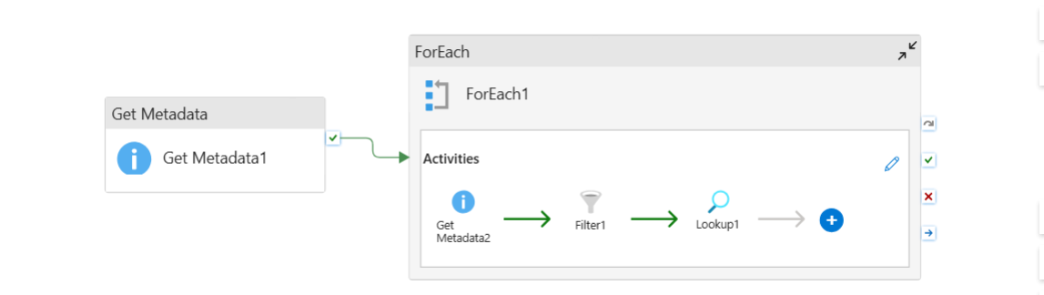
Step 1 — Get Metadata1 Activity
Retrieves all folder names available inside the ADLS container using the childItems field.
- Returns the full list of folders
- Passes the folder list to the ForEach activity

Step 2 — ForEach1 Activity
Iterates through each folder returned by Get Metadata1 dynamically one by one.
Items Expression:
@activity('Get Metadata1').output.childItems

Step 3 — Get Metadata2 Activity (Inside ForEach)
Retrieves all files available inside the current folder being processed in each ForEach iteration.
- Dynamically reads files from the current folder using @item().name
- Passes the file list to the Filter activity

Step 4 — Filter1 Activity (Inside ForEach)
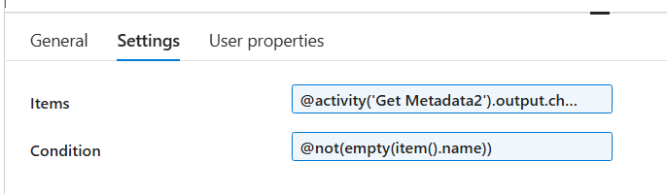
Processes the files returned from Get Metadata2 and calculates the count of files available inside the current folder.
- Filters the file list for counting purposes
- Output is used by the Lookup activity to get the file count

Step 5 — Lookup1 Activity (Inside ForEach)
Executes a SQL INSERT query to load the folder name and file count dynamically into the Azure SQL table.
SQL Query:
sql
INSERT INTO dbo.countoffiles
SELECT '@{item().name}',
@{length(activity('Filter1').output.value)};

SELECT 1 AS output;
Field | Description
@{item().name} | Current folder name from ForEach iteration
length(activity('Filter1').output.value) | Count of files inside the current folder
Target Table | dbo.countoffiles

Output

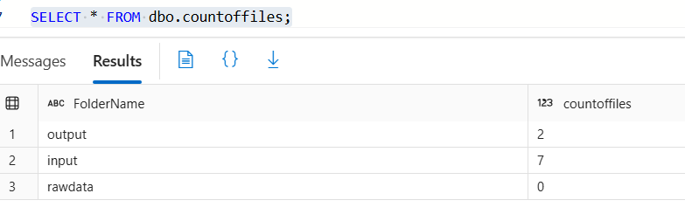
Pipeline executed successfully. All ADLS folder names and their respective file counts were loaded dynamically into the dbo.countoffiles SQL table using Get Metadata, ForEach, Filter, and Lookup activities.

Section 5 — Monitoring & Error Handling

- Error Handling with Custom Logging

Use Case
In production environments, pipeline failures must be logged for monitoring and troubleshooting. This solution automatically records error details into a SQL table whenever a pipeline activity fails.

Pipeline Components

Step | Activity | Purpose
1 | Lookup | Retrieves table configuration records from the config table
2 | ForEach | Iterates through each configuration record dynamically
3 | Copy Activity | Copies data from source SQL table to ADLS
4 | Stored Procedure Activity | Triggered on failure — logs error details into ErrorLog table

Pipeline Flow

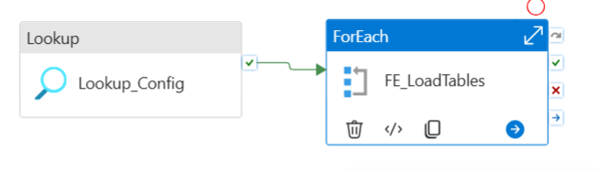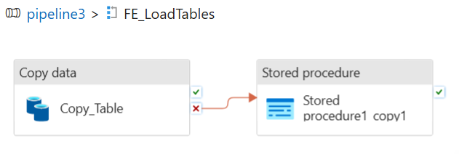
- Lookup retrieves table configuration records and passes them to ForEach
- ForEach iterates through each record and executes the Copy Activity dynamically
- Copy Activity copies data from the source SQL table to ADLS
- If Copy Activity fails, the On Failure dependency automatically triggers the Stored Procedure Activity to log the error into the ErrorLog table
Dependency:
Copy Activity
|-- [On Success] --> continues pipeline
|-- [On Failure] --> Stored Procedure Activity (usp_LogError)

Stored Procedure — usp_LogError
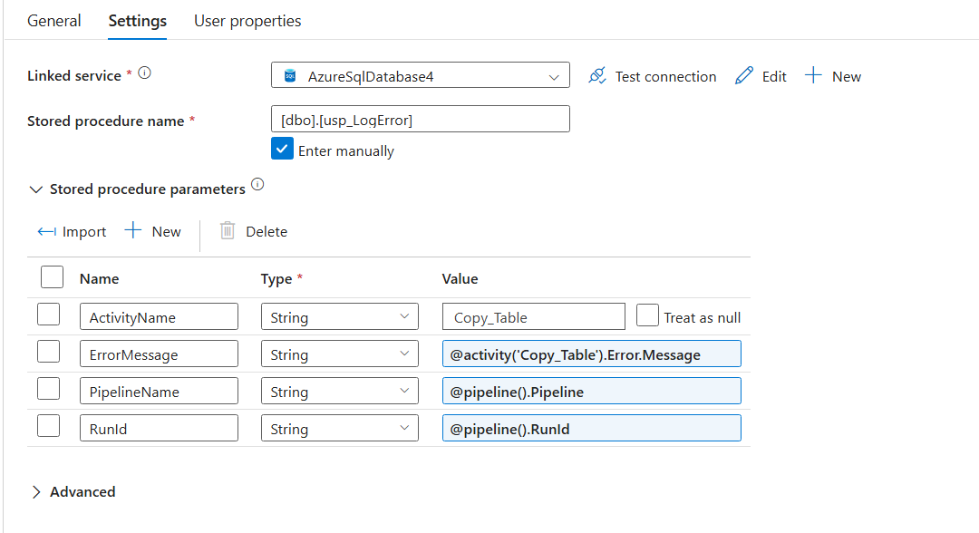
A custom stored procedure that captures and stores pipeline execution failures in the ErrorLog table.
sql
CREATE PROCEDURE dbo.usp_LogError
(
@PipelineName VARCHAR(200),
@ActivityName VARCHAR(200),
@RunId VARCHAR(200),
@ErrorMessage VARCHAR(MAX)
)
AS
BEGIN
INSERT INTO dbo.ErrorLog
(PipelineName, ActivityName, RunId, ErrorMessage)
VALUES
(@PipelineName, @ActivityName, @RunId, @ErrorMessage);
END;
GO

Stored Procedure Activity Configuration
Field | Value
Stored Procedure | usp_LogError
Dependency | On Failure from Copy Activity
Input Parameters & Dynamic Expressions:
Parameter | Dynamic Expression | Description
@PipelineName | @pipeline().Pipeline | Name of the failed pipeline
@ActivityName | @pipeline().ActivityName | Name of the failed activity
@RunId | @pipeline().RunId | Unique run ID of the pipeline execution
@ErrorMessage | @activity('Copy_Table').ErrorMessage | Actual error message from the failed Copy Activity
Purpose:
- Logs pipeline execution failures automatically
- Stores error details in a centralized SQL table
- Simplifies monitoring, troubleshooting, and auditing
- Provides operational visibility for production data integration processes

Output

The pipeline execution failed as expected due to an invalid source table name (CustomersXYZ). The Stored Procedure Activity was triggered through the On Failure path and successfully logged the pipeline name, activity name, run ID, and error message into the ErrorLog table — confirming the custom error handling framework was working correctly.

