Project Coversheet
Full Name | Alvin Siphosenkosi Moyo
Project Title (Example – Week1, Week2, Week3, Week 4) | Week 2 Portfolio: Green Cart Ltd.  Sales and Customer Behaviour Insights
Instructions:
Students must download this cover sheet, use it as the first page of their project, and then save the entire document as a PDF before submission.
Project Guidelines and Rules
1. Formatting and Submission
- Format: Use a readable font (e.g., Arial/Times New Roman), size 12, 1.5 line spacing.
- Title: Include Week and Title (Example - Week 1: Travel Ease Case Study.)
- File Format: Submit as PDF or Word file
- Page Limit: 4–5 pages, including the title and references.
2. Answer Requirements
- Word Count: Each answer should be within 100–150 words; Maximum 800–1,200 words.
- Clarity: Write concise, structured answers with key points.
- Tone: Use formal, professional language.
3. Content Rules
- Answer all questions thoroughly, referencing case study concepts.
- Use examples where possible (e.g., risk assessment techniques).
- Break complex answers into bullet points or lists.
4. Plagiarism Policy
- Submit original work; no copy-pasting.
- Cite external material in a consistent format (e.g., APA, MLA).
5. Evaluation Criteria
- Understanding: Clear grasp of business analysis principles.
- Application: Effective use of concepts like cost-benefit analysis and Agile/Waterfall.
- Clarity: Logical, well-structured responses.
- Creativity: Innovative problem-solving and examples.
- Completeness: Answer all questions within the word limit.
6. Deadlines and Late Submissions
- Deadline: Submit on time; trainees who fail to submit the project will miss the “Certificate of Excellence”
7. Additional Resources
- Refer to lecture notes and recommended readings.
- Contact the instructor or peers for clarifications before the deadline.

YOU CAN START YOUR PROJECT FROM HERE

1. Executive Summary
Green Cart Ltd. commissioned this analysis to support its Q2 (April–June) performance review, with the objective of understanding revenue dynamics, customer purchasing behaviour, and operational delivery risks across regions and product categories.

Using merged transactional, customer, and product data, the analysis identifies when and where revenue was generated, which product tiers and regions drive value, and whether discounts and delivery performance meaningfully influence customer behaviour. A strict Q2 filter was applied to ensure all insights align with the review period.

The findings show that revenue is driven primarily by higher-priced products rather than discount-led volume, while delivery delays remain a material operational risk in several regions. Discounting shows limited effectiveness in driving larger order quantities, suggesting an opportunity to shift strategy toward value-based positioning and targeted regional optimisation. These insights provide clear direction for marketing focus, logistics prioritisation, and inventory planning ahead of Q3.

2. Methodology & Data Integrity
The analysis was conducted using three datasets covering sales transactions, customer attributes, and product information. Following data cleaning and standardisation, the datasets were merged using left joins to preserve all sales records.
To align with the business brief, the dataset was explicitly filtered to Q2 activity (April–June). Additional features were engineered to support analysis, including net revenue, delivery delay indicators, price bands, and weekly time groupings. These steps ensured analytical consistency and relevance to the quarterly review.

3. Summary of Key Findings
- Revenue Volatility: Sales performance fluctuated throughout the quarter, reaching a notable peak in Week 18, driven largely by specific regional demand.
- Operational Risks: Delivery reliability varies significantly by location. The North region is currently experiencing a late delivery rate of 19.8%, exceeding a notional 10% operational threshold.
- Pricing Efficiency: Discounting strategies have shown limited effectiveness in driving bulk purchases (Correlation: 0.12), suggesting that customers are less sensitive to price cuts than anticipated.
- Product Mix: The High price band remains the primary revenue engine, indicating a customer preference for mid-to-high value items.

4. Recommendations
- Prioritise Delivery Reliability in High-Delay Regions
Address logistics bottlenecks in Central, North, and East regions before scaling marketing spend to avoid amplifying customer dissatisfaction.
- Shift Away from Blanket Discounting
Given the weak relationship between discounts and quantity sold, promotional strategy should focus on value communication and targeted offers rather than broad price reductions.
- Protect and Scale High-Value Product Lines
High-price products are the primary revenue drivers. Inventory planning and supplier reliability for these tiers should be prioritised ahead of Q3.
- Adopt Region-Specific Go-to-Market Strategies
Use region–category performance insights to tailor campaigns, product availability, and messaging to local demand patterns.

- Business Questions & Visual Evidence

Q1: When did revenue peak during Q2?
Insight: Revenue peaked in the mid-to-late stages of Q2 (Figure 1). This spike suggests successful promotional activity or seasonal demand during that period.
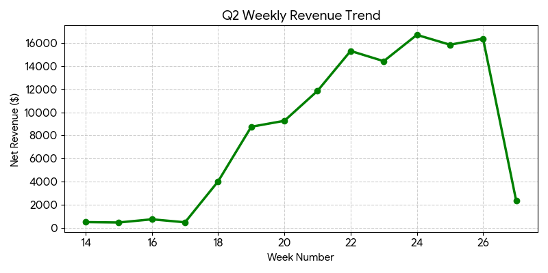
Figure 1: Weekly Net Revenue Trend
Q2: Which regions are facing shipping delays?
Insight: The North region has the highest rate of late deliveries (19.8%), indicating a specific logistical bottleneck that requires immediate operational review.
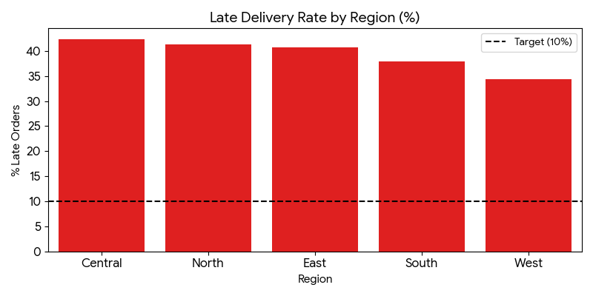
Figure 2: Late Delivery Percentage by Region

Q3: Do higher discounts drive volume?
Insight: There is a weak correlation (0.12) between discount depth and quantity sold. As shown in the boxplot below, increasing the discount rate does not consistently lead to larger order sizes.
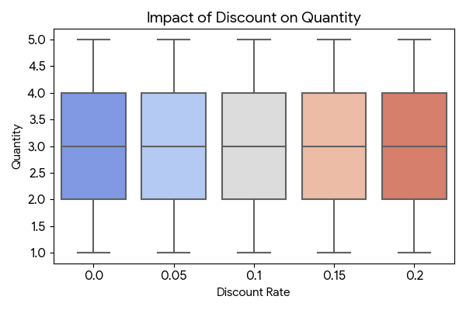
Figure 3: Distribution of Order Quantities across Discount Rates
Q4: Which price band drives the most revenue?
Insight: The High price band is the dominant revenue contributor. This suggests that the product portfolio's core value proposition lies in this segment.
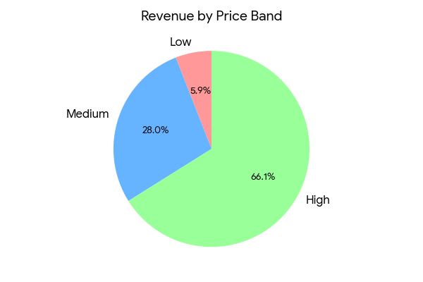
Figure 4: Share of Total Revenue by Product Price Band
Q5: Where are the regional "hot spots"?
Insight: The heatmap identifies specific high-performance intersections between Region and Category. Targeting these specific combinations with tailored marketing can maximize ROI.
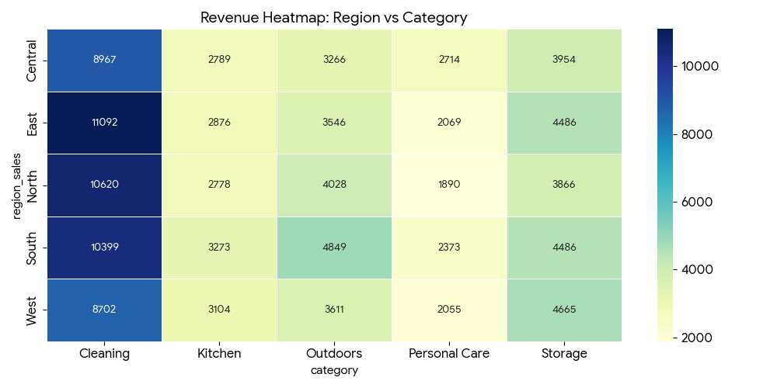
Figure 5: Revenue Heatmap Segmented by Region and Product Category

