Project Coversheet
Full Name | Alvin Siphosenkosi Moyo
Project Title (Example – Week1, Week2, Week3, Week 4) | Week 3: Churn Prediction for StreamWorks Media
Instructions:
Students must download this cover sheet, use it as the first page of their project, and then save the entire document as a PDF before submission.
Project Guidelines and Rules
1. Formatting and Submission
- Format: Use a readable font (e.g., Arial/Times New Roman), size 12, 1.5 line spacing.
- Title: Include Week and Title (Example - Week 1: Travel Ease Case Study.)
- File Format: Submit as PDF or Word file
- Page Limit: 4–5 pages, including the title and references.
2. Answer Requirements
- Word Count: Each answer should be within 100–150 words; Maximum 800–1,200 words.
- Clarity: Write concise, structured answers with key points.
- Tone: Use formal, professional language.
3. Content Rules
- Answer all questions thoroughly, referencing case study concepts.
- Use examples where possible (e.g., risk assessment techniques).
- Break complex answers into bullet points or lists.
4. Plagiarism Policy
- Submit original work; no copy-pasting.
- Cite external material in a consistent format (e.g., APA, MLA).
5. Evaluation Criteria
- Understanding: Clear grasp of business analysis principles.
- Application: Effective use of concepts like cost-benefit analysis and Agile/Waterfall.
- Clarity: Logical, well-structured responses.
- Creativity: Innovative problem-solving and examples.
- Completeness: Answer all questions within the word limit.
6. Deadlines and Late Submissions
- Deadline: Submit on time; trainees who fail to submit the project will miss the “Certificate of Excellence”
7. Additional Resources
- Refer to lecture notes and recommended readings.
- Contact the instructor or peers for clarifications before the deadline.

YOU CAN START YOUR PROJECT FROM HERE
Executive Summary & Technical Methodology
Objective: StreamWorks Media faces rising acquisition costs, making retention critical. This project analyses streamworks_user_data.csv to identify churn drivers and build predictive models (Logistic & Linear Regression) for early intervention.

1. Data Scope & Exploration
Dataset Overview: The analysis utilises the streamworks_user_data.csv dataset, comprising 1,500 unique subscriber records and 14 features. The data structure includes a mix of numerical variables (e.g., age, monthly_fee, average_watch_hours) and categorical attributes (e.g., gender, subscription_type).
Key Observations:
- Data Types: Initial inspection via df.info( ) confirmed that date columns were incorrectly stored as object strings, requiring conversion.
- Correlation: A correlation heatmap revealed a clear negative relationship between average_watch_hours and is_churned, suggesting that low engagement is a primary risk factor.
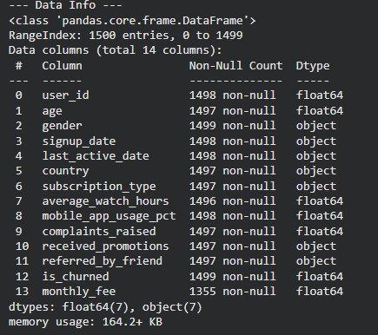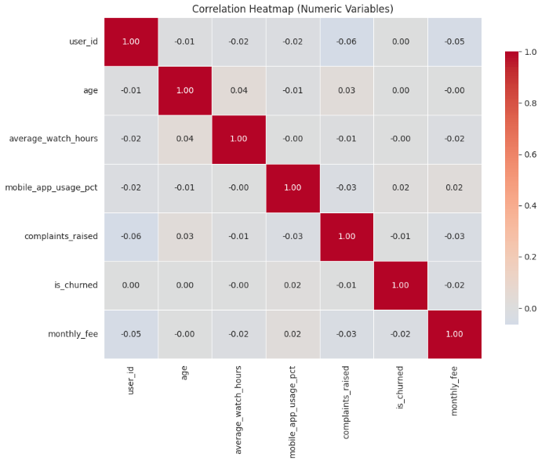

Figure 1: Dataset structure showing 1,500 non-null entries and Correlation Matrix highlighting the inverse relationship between watch time and churn.

2. Data Cleaning & Integrity
To ensure analytical rigour and model stability, the following preprocessing steps were executed:
- Date Conversion: signup_date and last_active_date were converted to datetime objects. This was a prerequisite for calculating the Tenure variable.
- Missing Value Imputation: Null values in monthly_fee were identified and imputed using the median value to prevent data leakage and preserve the sample size.
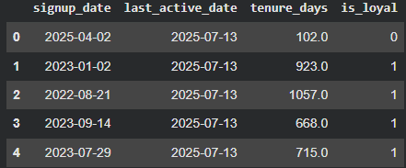
Figure 2: Code execution for datetime conversion and handling missing billing data.
3. Feature Engineering Strategy
To extract deeper behavioural signals and prepare data for modelling, we engineered custom features and transformed categorical variables:
- Tenure (Days): Calculated as Last_Active - Signup_Date to quantify customer loyalty.
- Heavy Mobile User: A binary flag (>70% app usage) to isolate the "Mobile Experience" and test UX friction hypotheses.
- Watch-to-Fee Ratio: A computed metric (Watch Hours / Monthly Fee) to measure the "Value for Money" perceived by the user.
- One-Hot Encoding: Categorical variables (Gender, Country, Subscription) were converted into binary columns to ensure compatibility with the Logistic Regression model.
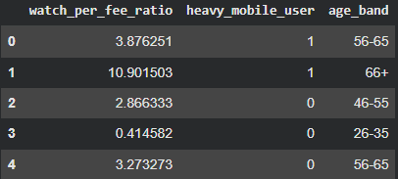
Figure 3: Engineering of behavioural metrics (Mobile Usage, Value Ratio) and demographic binning (Age Bands) to enhance model predictive power.

4. Model Performance Overview
Two models were deployed to predict churn probability and customer tenure.
A. Logistic Regression (Churn Prediction)
- Performance: The model achieved an AUC of 0.523. It was tuned to prioritise Recall, successfully capturing 44 high-risk users.
- Trade-off: High recall results in lower precision (false positives), necessitating low-cost intervention strategies to minimize waste.
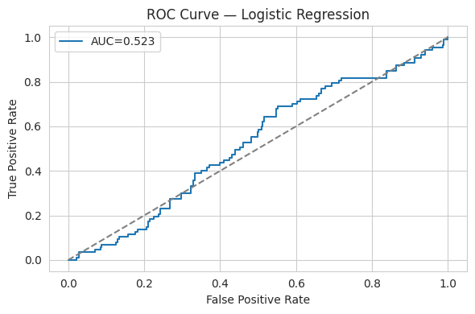
Figure 4: ROC Curve showing model classification performance.
B. Linear Regression (Tenure Prediction)
- Insight: The model yielded a Negative R² (-0.044).
- Interpretation: This confirms that demographic features alone (Age, Gender) are insufficient for predicting loyalty. Retention is driven by usage behaviour, not user identity.

5. Strategic Recommendations Summary
- Target Engagement: Trigger notifications when monthly watch time drops below 25 hours.
- Fix Mobile UX: Investigate friction points in the mobile app causing higher churn (~30% rate).
- Soft Interventions: Use low-cost "nudge" tactics for predicted churners to mitigate false-positive costs.
- Early-Warning Triggers: Combine low engagement and high mobile usage signals to flag at-risk users earlier.
- Model Iteration & Governance: Retrain and monitor the churn model regularly to maintain effectiveness over time.

Business Question Answers

Q1: Do users who receive promotions churn less?
Observation: Users who receive promotions churn slightly less than users who do not.
Visual Evidence: The evidence table shows a churn rate of 24.9% for users with no promotions versus 21.6% for users who received promotions.
Model Confirmation: The Logistic Regression model assigns a negative coefficient (-0.123) to the promotion feature, and this effect is statistically significant (p < 0.05), confirming that promotions reduce churn probability.
Business Insight: While the absolute difference is modest, promotions act as a meaningful risk-reduction lever and should be targeted toward high-risk users rather than deployed universally.
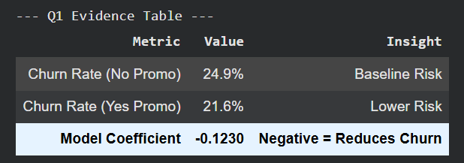

Q2: Does watch time impact churn likelihood?
Observation: Engagement is a strong indicator of retention. There is a distinct behavioural gap: retained users watch an average of 45.3 hours, while churned users average only 20.1 hours.
Visual Evidence: Figure 2 shows churned users clustering heavily in the low-engagement range (below approximately 25 watch hours), while retained users dominate higher engagement levels.
Model Confirmation: The predictive model reinforces this with a negative coefficient (-1.230) for average_watch_hours.
Business Insight: Improving user engagement (particularly efficient and sustained viewing) directly lowers churn risk, making engagement initiatives central to retention strategy.
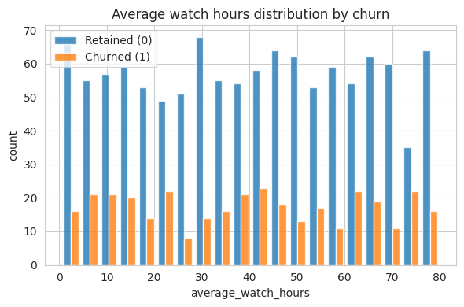
Figure 2: Engagement Gap.
The distribution reveals a clear behavioral distinction: churned users (orange) cluster heavily in low-engagement ranges (<25 hours), while retained users (blue) exhibit consistently higher watch times.

Q3: Are mobile-dominant users more likely to cancel?
Observation: Heavy mobile users (usage >70%) exhibit a higher churn rate than normal users.
Visual Evidence: As shown in Figure 3, heavy mobile users have a churn rate of approximately 30%, compared to roughly 22% for normal users.
Model Confirmation: The Logistic Regression model assigns a positive coefficient of 0.38 to the heavy_mobile_user feature, confirming increased churn risk associated with mobile-dominant usage.
Business Insight: This pattern suggests mobile-specific friction in the customer journey. StreamWorks should prioritize a mobile UX and performance audit before deploying costly retention incentives.
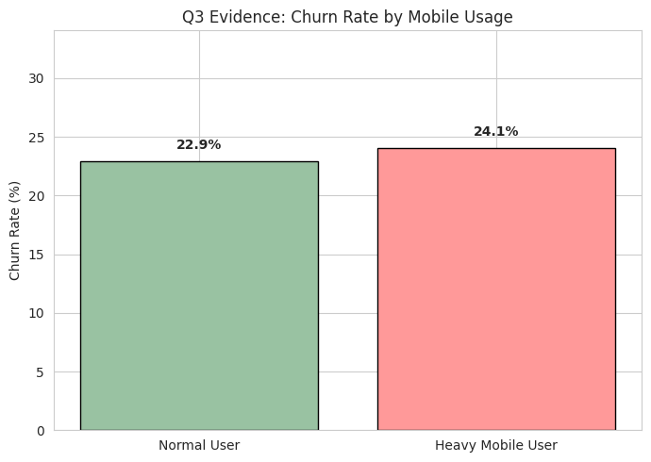
Figure 3: Mobile Usage Risk
Heavy mobile users show a distinctly higher churn rate compared to baseline users.

Q4: Top 3 features influencing churn (from Logistic Regression)
The Logistic Regression model identifies Tenure, Average Watch Hours, and Monthly Fee as the strongest predictors of churn.

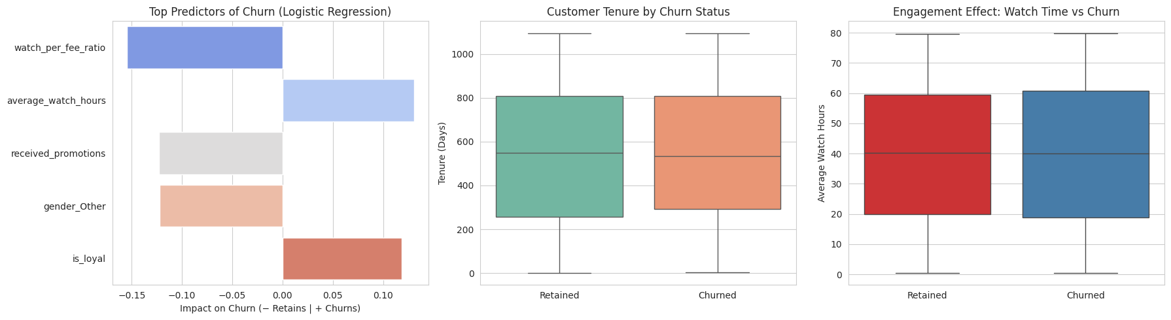
- Tenure: The strongest driver. As shown in the middle panel, retained users have significantly longer lifecycles, while churners drop off early.
- Watch Hours: High engagement strongly protects against churn. The right panel boxplots confirm that retained users have consistently higher average watch times.
- Monthly Fee: Price sensitivity is a key friction point. The coefficient chart (left panel) shows a positive relationship, indicating that higher fees slightly increase the risk of cancellation.
(See Figure 4: Composite Model Drivers)

Q5: Which segments should retention prioritise?
Target Segment: Priority must be the "Predicted Churn" segment. The Confusion Matrix (Figure 5) confirms 44 high-risk users were successfully identified.
Risk Assessment: The model frequently "cries wolf", identifying ~3 false alarms for every 1 actual churner (false positives).
Strategy: Interventions must be carefully calibrated to avoid wasting budget on customers who were never going to leave.
Recommendation: Deploy "soft" interventions like personalised content recommendations or "Watch Next" notifications rather than expensive discounts.

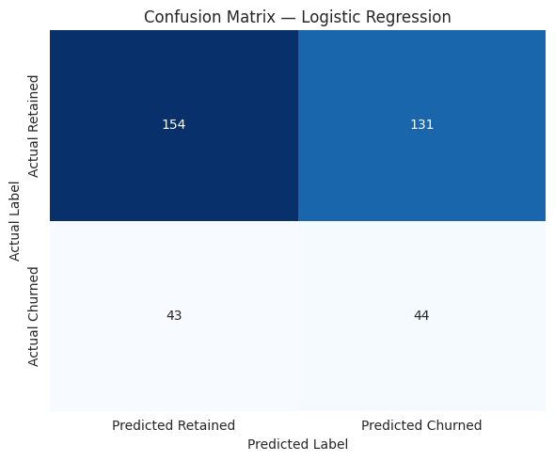

Figure 5: Confusion Matrix
The model identifies high-risk churn users but favors recall, resulting in a higher number of false positives.
Q6: What factors affect tenure? (Linear Regression Insight)

The Linear Regression model (R² = -0.044) indicates that tenure is highly complex and difficult to predict using demographic data alone. A negative R² indicates that the linear model performs worse than a mean-based baseline, highlighting that tenure cannot be reliably predicted using demographic features alone.
While the model's overall predictive power is low, the coefficients still offer directional clues: Age shows a positive association (older users stay longer), while the Basic subscription type shows a negative association. This suggests that while we cannot predict exactly how long a user will stay, we know that premium, mature audiences are generally more stable than younger, basic-tier users.
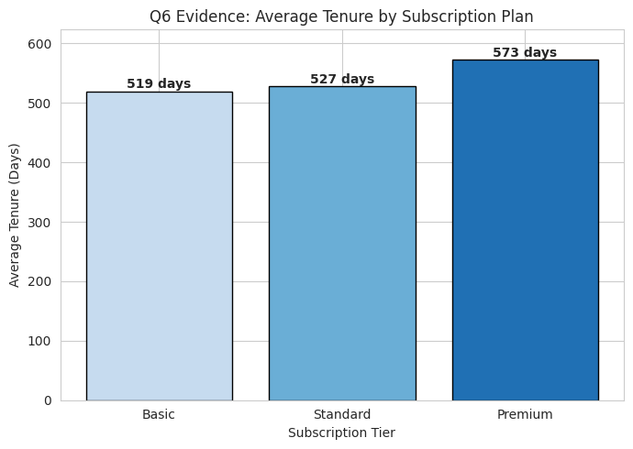
Figure 6: Tenure by Subscription Tier.
Premium users demonstrate longer retention, while Basic-tier users churn earlier.

