**Nemox Doc**

You use the [SMS API](https://www.nexmo.com/products/sms) to send and receive a high volume of SMS anywhere in the world. The workflow for sending outbound messages using the SMS API is:

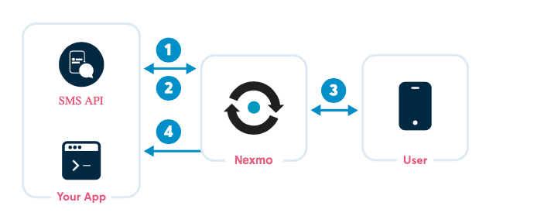

1. Create a [request](https://docs.nexmo.com/messaging/sms-api/api-reference#request) to send an SMS.
2. Check the [response codes](https://docs.nexmo.com/messaging/sms-api/api-reference#status-codes) and ensure that you sent the request correctly.
3. Your message is delivered to the handset. The user's handset returns a delivery receipt.
4. If you set [callback](https://docs.nexmo.com/messaging/sms-api/api-reference#callback) in the request, check that your user received your SMS correctly.

If you rent one or more virtual numbers from Nexmo, Inbound Messages to that number are sent to your webhook endpoint.

To ensure that your traffic is send over the best possible route, use [Conversion API](https://docs.nexmo.com/messaging/conversion-api) to tell us about the reliability of your 2FA communication. Adding your conversion data means Nexmo delivers your messages faster and more reliably.

By default, your Nexmo account is configured for REST. If you already use SMPP and want to use Nexmo, see how to configure [SMPP Access](https://docs.nexmo.com/messaging/sms-api/smpp-access)

By default all text SMS sent by Nexmo are in UTF-8 with URL encoding. A message saying Hello World, Bonjour monde or Hola mundo is delivered seamlessly. However, sending Привет мир, שלום עולם or مرحبا بالعالم requires more thought. Languages such as Arabic, Chinese, Korean, Japanese, or Cyrillic alphabet languages need the 16-bit characters available in unicode. You can also send messages in binary, wappush, vcal and vcard formats.