**Business Scope**

* + - 1. Bills Business
         1. Acting as an underwriter, broker or proprietary trader with respect to short-term bills (including USD bills)
         2. Acting as a guarantor or endorser of CP2.
      2. Bonds Business
         1. Proprietary trading of government bonds
         2. Acting as a certifier, underwriter, broker or proprietary trader with respect to bank debentures
         3. Proprietary trading of corporate bonds
         4. Proprietary trading and investment of fixed income securities
         5. Proprietary trading and investment of foreign bonds
      3. Equity investment business
      4. Others

**Organizational chart**

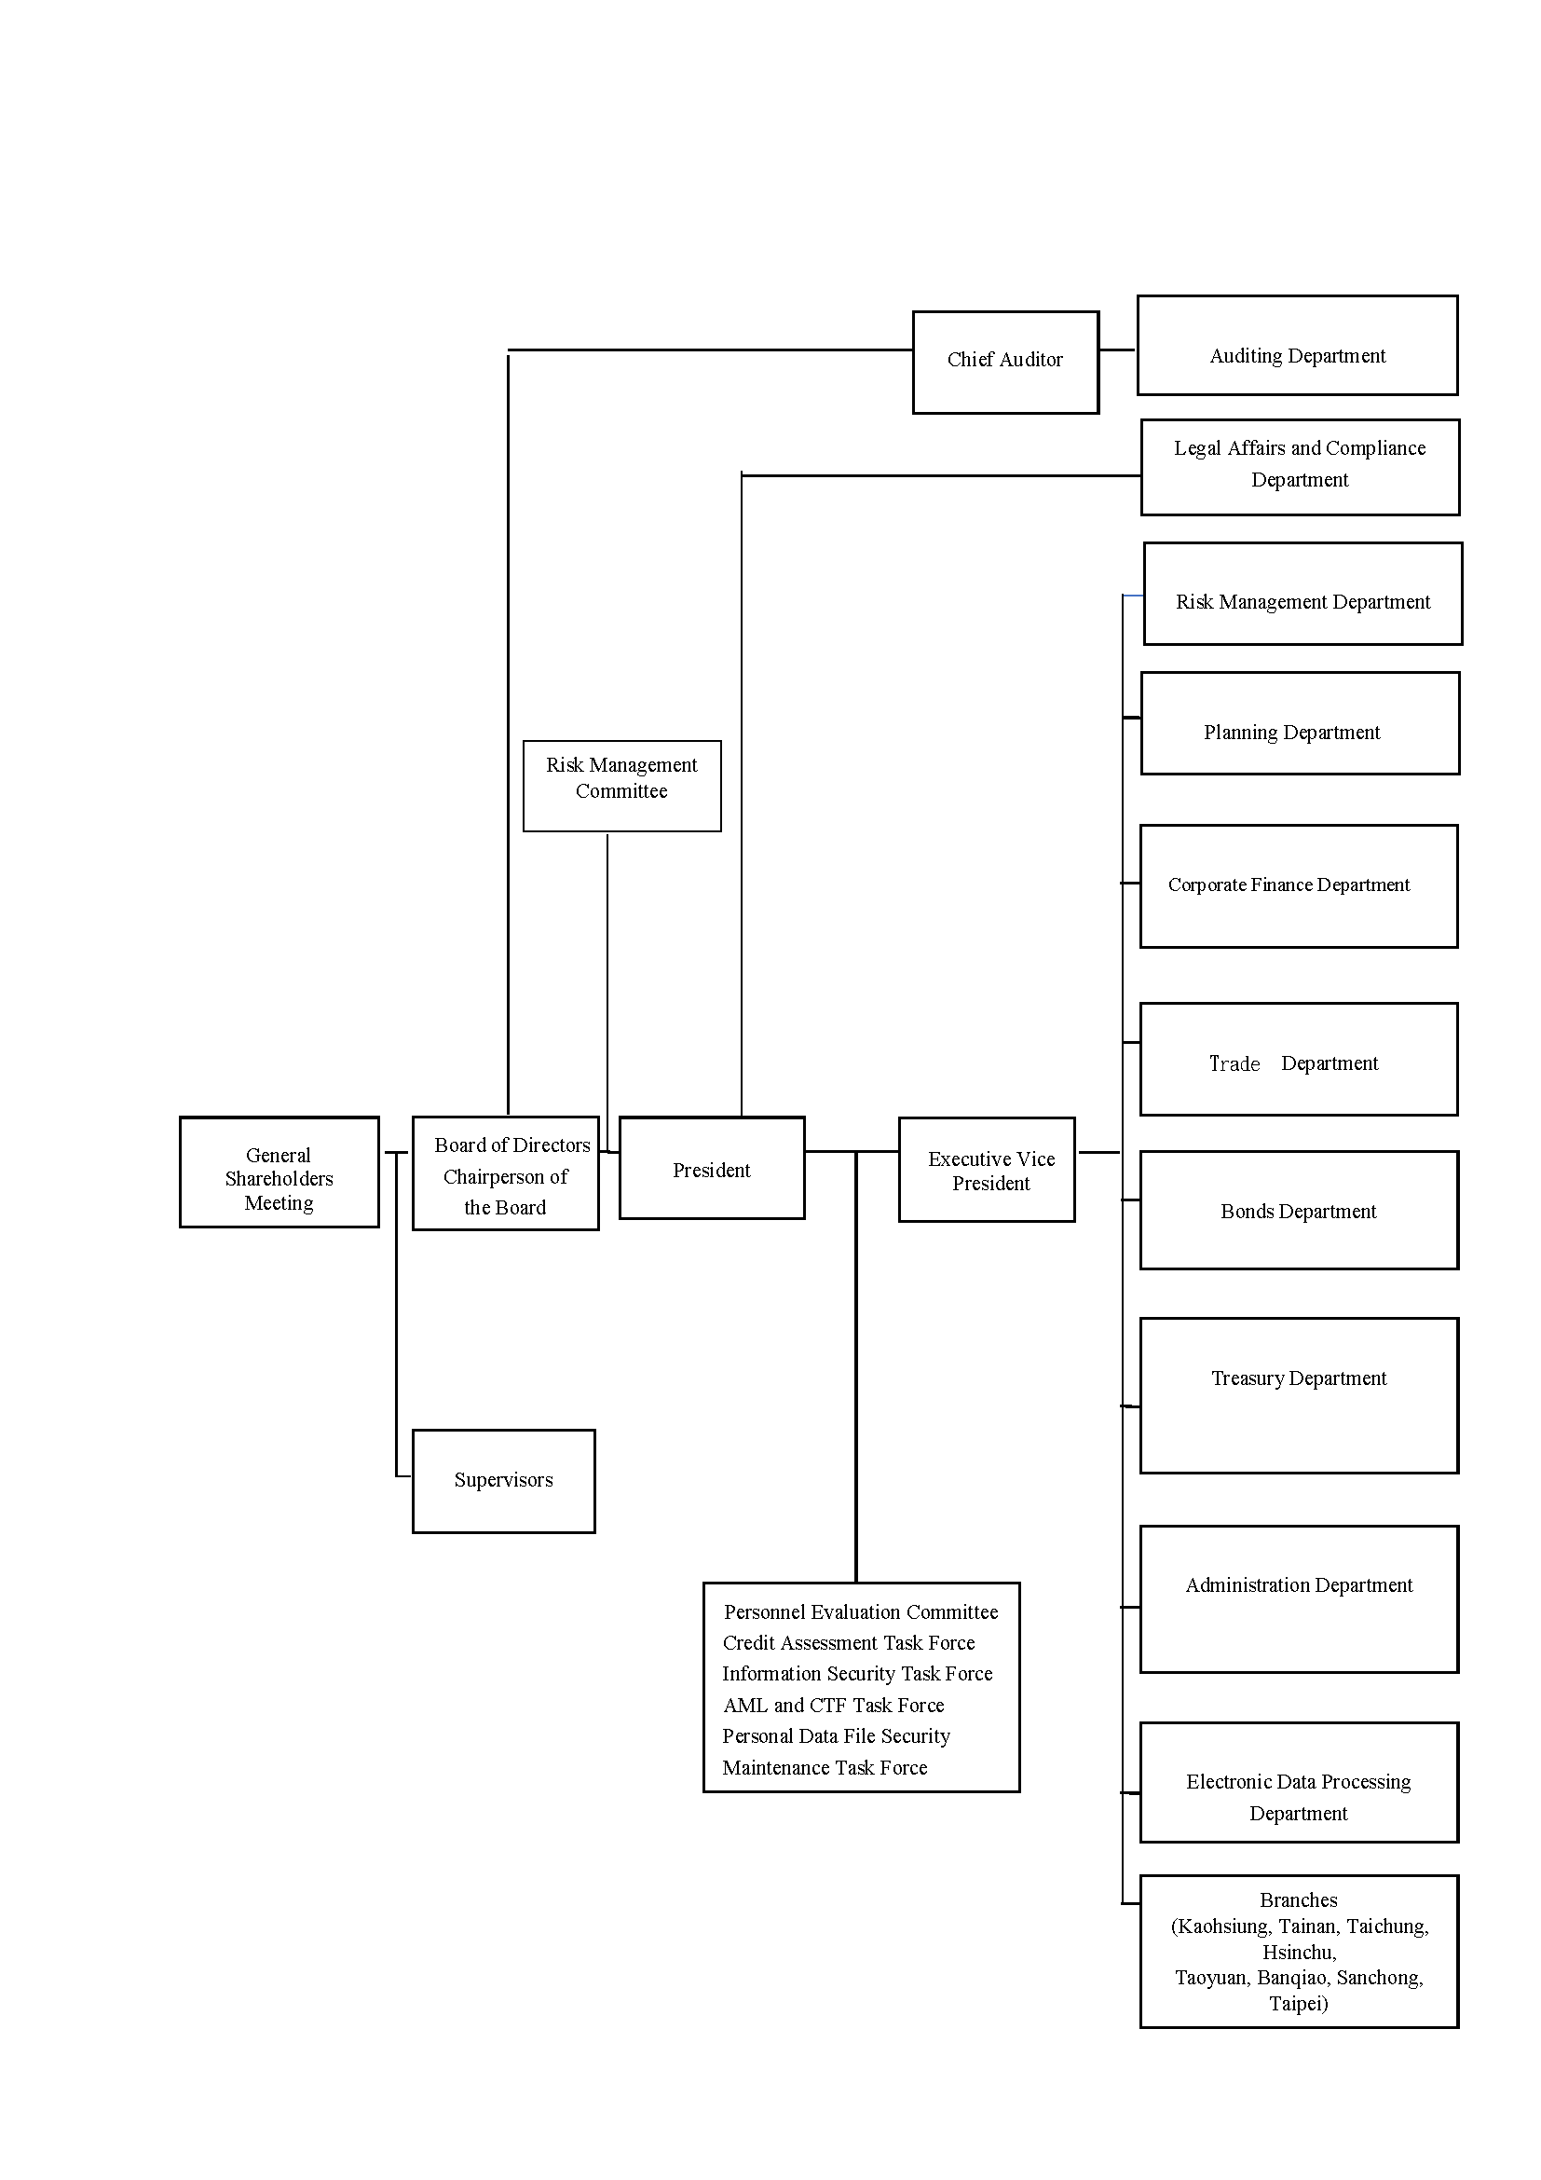

**Addresses and Telephone Numbers of the Head Office and Branches**

|  |  |  |
| --- | --- | --- |
| Head Office | Address:  Tel. No.:  Fax No.: | 2-5F, No. 91 Hengyang Road, Taipei City  (02) 2383-1616 (Representative)  (02) 2382-2878 (Administration Department) |
| Kaohsiung Branch | Address:  Tel. No.:  Fax No.: | 3F, No. 420, Cheng Kung 1st Road, Kaohsiung City  (07) 282-5171(5 Lines)  (07) 215-1887 |
| Tainan Branch | Address:  Tel. No.:  Fax No.: | 14F-1, No. 307, Sec. 2, Minsheng Road, Tainan City  (07) 228-3131(5 Lines)  (06) 229-3654 |
| Taichung Branch | Address:  Tel. No.:  Fax No.: | 4F-1, No.268, Sec. 1, Taiwan Blvd., Taichung City  (04) 2220-2176(5 Lines)  (04) 2222-5424 |
| Hsinchu Branch | Address:  Tel. No.:  Fax No.: | 3F, No. 307 Peida Road, Hsinchu City  (05) 526-6022(5 Lines)  (03) 524-5544 |
| Taoyuan Branch | Address:  Tel. No.:  Fax No.: | 3F, No. 32, Sec. 1, Cheng Kung Road, Taoyuan City  (05) 335-8877(5 Lines)  (03) 333-6137 |
| Panchiao Branch | Address:  Tel. No.:  Fax No.: | 3F, No. 69, Zhongzhen Road, Panchiao District, New Taipei City  (05) 2965-2836(5 Lines)  (02) 2965-2819 |
| Sanchong Branch | Address:  Tel. No.:  Fax No.: | 4F, No. 192, Sec. 3, Chongyang Road, Sanchong District, New Taipei City  (05) 2981-1931(5 Lines)  (02) 2980-0374 |
| Taipei Branch | Address:  Tel. No.:  Fax No.: | 6F, No.123, Sec 2, Zhongxiao East Road, Taipei  (02) 2356-9696(5Lines)  (02) 2391-1717 |