Intellectual Property Notice

Intellectual Property Notice

This template is an exclusive property of Mapua-Malayan Digital College and is protected under Republic Act No. 8293, also known as the Intellectual Property Code of the Philippines (IP Code). It is provided solely for educational purposes within this course. Students may use this template to complete their tasks but may not modify, distribute, sell, upload, or claim ownership of the template itself. Such actions constitute copyright infringement under Sections 172, 177, and 216 of the IP Code and may result in legal consequences. Unauthorized use beyond this course may result in legal or academic consequences.

Additionally, students must comply with the Mapua-Malayan Digital College Student Handbook, particularly with the following provisions:
- Offenses Related to MMDC IT:
  - Section 6.2 – Unauthorized copying of files
  - Section 6.8 – Extraction of protected, copyrighted, and/or confidential information by electronic means using MMDC IT infrastructure
- Offenses Related to MMDC Admin, IT, and Operations:
  - Section 4.5 – Unauthorized collection or extraction of money, checks, or other instruments of monetary equivalent in connection with matters pertaining to MMDC
Violations of these policies may result in disciplinary actions ranging from suspension to dismissal, in accordance with the Student Handbook.

For permissions or inquiries, please contact MMDC-ISD at isd@mmdc.mcl.edu.ph.

📝 Capstone 1 Paper Template


MAPUA MALAYAN DIGITAL COLLEGE
Academic Year 2025-2026

Cross-Sector Next-Day Stock Price Forecasting of Selected PSE-Listed Companies: A Comparative Study of Lag-Informed Regression, ARIMA, and LSTM

ABEGAIL IMEE R. ENRIQUEZ
ALVIN J. TUBTUB
JEREMIAH M. ALZONA
MICHAEL E. GALARIO

JOHN EDMON A. ALCOMENDAS

A Capstone Project Submitted
In Partial Fulfillment of the Requirements for the Degree of

Bachelor of Science in Information Technology
Major in Data Analytics

APPROVAL SHEET

This is to certify that the capstone project proposal entitled:

“Cross-Sector Next-Day Stock Price Forecasting of Selected PSE-Listed Companies: A Comparative Study of Lag-Informed Regression, ARIMA, and LSTM”

prepared and submitted by:

Abegail Imee R. Enriquez
Alvin J. Tubtub
Jeremiah M. Alzona
Michael E. Galario

in partial fulfillment of the requirements for the degree of Bachelor of Science in Information Technology Major in Data Analytics, has been examined and is hereby recommended for approval and acceptance.

Panel Evaluators:

Maureen Mae Terminez, MBA Aldrin John Tamayo
_______________________ _______________________ _______________________
Panel Chair Panel Member Panel Member

APPROVED:

Accepted and approved in partial fulfillment of the requirements for the degree of Bachelor of Science in Information Technology.

John Edmon A. Alcomendas
_______________________
Mentor/Adviser

Mario S. Pison Jr., MIT
_______________________
Program Head

Date of Project Proposal Oral Defense: May 29, 2026

DECLARATION OF ORIGINAL WORK

We, the undersigned from Section H3103, enrolled in MO-IT200D1 - Capstone 1 for Term 3, under the supervision of our adviser, John Edmon A. Alcomendas, hereby affirm that this paper, titled Cross-Sector Next-Day Stock Price Forecasting of Selected PSE-Listed Companies: A Comparative Study of Lag-Informed Regression, ARIMA, and LSTM, is an original product of our research investigation.

To the best of our knowledge, this work neither contains any material that is previously published, built, or written by another person or by any of the authors nor does it contain falsified, fabricated, or plagiarized content.

The use of graphs, images, text, and/or frameworks is with the permission of the copyright owner.

We agree that should Mapua-Malayan Digital College, through its faculty and/or administrators, eventually prove fault, regardless of our intent, or anything contrary to this attestation, the college has the right to impose reasonable sanctions including the cancellation of the degree conferred to us.

Signed:

Abegail Imee R. Enriquez
Alvin J. Tubtub
Jeremiah M. Alzona
Michael E. Galario

Conforme:
John Edmon A. Alcomendas

ACKNOWLEDGEMENT

Deepest gratitude is expressed to the individuals, organizations, and groups whose support, guidance, and contributions made the completion of this capstone project possible.
Foremost, sincerest appreciation is extended to the capstone adviser, Mr. John Edmon A. Alcomendas, for his unwavering patience, continuous guidance, and valuable technical insights. His mentorship was instrumental in shaping the direction and methodology of this study.
Profound gratitude is also given to the Panel Evaluators, Ms. Maureen Mae Terminez, MBA, and Mr. Aldrin John Tamayo, for their rigorous review, constructive criticisms, and expert recommendations that significantly improved the quality and academic rigor of this paper.
Special thanks are directed to the Information Technology Program Head, Mr. Mario S. Pison Jr., MIT, and the faculty and administration of Mapúa Malayan Digital College for providing the platform, resources, and opportunity to conduct this data analytics research.
Acknowledgement is also due to the budding traders and interview respondents who generously shared their time, experiences, and practical insights. Their valuable input ensured that the proposed educational and analytical dashboard addresses real-world stakeholder needs.
Finally, heartfelt thanks are offered to families, friends, and loved ones for their endless moral and emotional support, understanding, and encouragement during the challenging phases of this endeavor. Above all, profound gratitude is offered to the Almighty God for the wisdom, strength, and grace that sustained the group from the inception to the completion of this project.

LIST OF TABLES
Table 1. Selected PSE-Listed Companies by Official Sector and Subsector………..… page 31
Table 2. Stakeholder Profile Summary………………………………………...…..… page 105
Table 3. Interview Themes and System Implications……………………………...… page 105
Table 4. Integrated Needs Assessment of Budding Traders……………………….… page 110
Table 5. Data Analytics Requirements………………………………………...…….. page 111
Table 6. Functional Requirements of the Proposed Dashboard……………….…...… page 113
Table 7. Non-Functional Requirements of the Proposed Dashboard…..…………..… page 115
Table 8. MoSCoW Priority Distribution………..……………………………….…… page 116
Table 9. Requirements Traceability Matrix……………..…………………………… page 118
Table 10. Final Dataset Scope by Official PSE Sector………………………….…… page 123
Table 11. Extracted Variables and Their Use in the Study………………………....... page 125
Table 12. Strict Data-Quality Benchmark for Final Stock Inclusion………………… page 129
Table 13. Preliminary Strict Benchmark Results Used for Company Selection…………………………………………… page 132
Table 14. Sample Raw Extracted PSE Record…………………………………….… page 134
Table 15. Standardized OHLCV Structure After Cleaning……………………..…… page 136
Table 16. Standardized OHLCV CSV Schema Contract…………………………..… page 137
Table 17. Preliminary Selection-Stage Price-Discontinuity Review…………….… page 143
Table 18. Evaluation-Ready Output Files……………………………………….…… page 158
Table 19. Dashboard-Ready Output Files……………………………………….…… page 160
Table 20. Expected Model and Preprocessing Artifacts…………………………...… page 162
Table 21. Minimum Artifact Metadata……………………………………….……… page 164
Table 22. Formal Study Outputs versus Deployment-Ready Artifacts……………… page 165
Table 23. LSTM Hyperparameter Search Grid……………………………………… page 188
Table 24. Finalized Data and Modeling Protocol………………………………….… page 190
Table 25. Evaluation Metrics………………………………………………………… page 194
Table 26. Primary Interface Modules…………………………………………...…… page 209
Table 27. Architectural Components and Notations…………………………….…… page 213
Table 28. Analytics Output Repository………………………………………….…… page 215
Table 29. Dashboard and Stakeholder Success Thresholds……………………......… page 240
Table 30. Final Ticker Verification……………………………………………...…… page 266
Table 31. Bug and Issue Tracking Criteria……………………………………...…… page 297
Table 32. Testing Tools and Frameworks……………………………………..……... page 298
Table 33. Requirements-Based Testing Plan and Success Criteria……………...…… page 299
Table 34. Implementation Approach………………………………………….…...… page 304
Table 35. Proposed Implementation Timeline and Responsibility Assignment…...… page 304
Table 36. Corrective-Issue Responsibility Matrix…………………………………… page 308
Table 37. Tools and Technologies for Project Implementation……………………… page 314
Table 38. Dashboard Implementation……………………………………………...… page 318

LIST OF FIGURES

Figure 1. Conceptual Framework of the Study……………………...………………… page 78
Figure 2. Methodological Framework Diagram…………………………….………… page 93
Figure 3. Operational Framework Diagram…………………………………………… page 97
Figure 4. Primary Challenges When Analyzing Stocks…………..….……………… page 100
Figure 5. Most Useful Forecasting Horizon for Learning About Stock Trading…….. page 107
Figure 6. Stakeholder Need for Next-Day Forecasting………………………..…..… page 108
Figure 7. Overall Need and Acceptance of the Proposed Dashboard………...……… page 109
Figure 8. Preferred Forecast Presentation Style……………………………..…..…… page 110
Figure 9. Chronological Data Splitting and Rolling-Origin Validation…………....… page 155
Figure 10. Data Engineering and Analytics Pipeline……………………...…….…… page 170
Figure 11. Model Development and Evaluation Workflow Diagram…...…………… page 174
Figure 12. Model Evaluation and Statistical Comparison Pipeline………..………… page 195
Figure 13. System Architecture Diagram…………………………………..…...…… page 211
Figure 14. Web Integration Workflow Diagram……………………..………….…… page 218
Figure 15. User Interaction Sequence Diagram………………………...…….……… page 223
Figure 16. Prototype Home Page……………………………………..……………… page 226
Figure 17. Prototype Company List Page……………………………..………...…… page 227
Figure 18. Prototype Model Performance Page…………………………...….……… page 228
Figure 19. Prototype Company Historical Data and Forecast Page………….……… page 229
Figure 20. Superseded Live Prediction Upload Prototype………………..……….……… page 230
Figure 21. Superseded Live Prediction Results Prototype…………………..…….……… page 231
Figure 22. Prototype Learn Stocks Page………………………………...…………… page 232
Figure 23. About the Research Page……………………..……………...…………… page 233
Figure 24. Prototype Mobile: Home and Companies Pages………..……………...… page 234
Figure 25. Prototype Mobile: Company Historical Data & Model Performance…… page 235
Figure 26. Prototype Mobile Views: Company Forecast and Results Pages…… page 236
Figure 27. Prototype Mobile Views: Learn Stocks and About Pages…………...…… page 236

LIST OF APPENDICES

Appendix A: Link to Prototype …………………………………………………..… page 347
Appendix B: Disclosure of Artificial Intelligence Tools Used in Research .……...… page 348
Appendix C: Stakeholder Interview Guide………………………………………...… page 350
Appendix D: Participant Consent and Data Privacy Documents.………………...…..page 351
Appendix E: Interview Transcripts and Thematic Analysis…………..……………....page 352
Appendix F: Post-Interview Survey Instrument.……………………………...…..…..page 353
Appendix G: Survey Results and Stakeholder Evidence Integration.………….....…..page 354
Appendix H: Requirements Analysis and Traceability Documents.……………...…..page 355
Appendix I: Official Data Sources and Dataset Documentation.……………...….…..page 356
Appendix J: Data Validation and Quality Assessment Reports.………...………...…..page 357
Appendix K: Corporate-Action Screening Report……………………….……………page 358
Appendix L: Literature Synthesis Matrix………..……………………….……...……page 359
Appendix M: Literature Comparison Matrix……………………….………...….……page 360

TABLE OF CONTENTS

APPROVAL SHEET 1
DECLARATION OF ORIGINAL WORK 2
ACKNOWLEDGEMENT 3
LIST OF TABLES 4
LIST OF FIGURES 6
LIST OF APPENDICES 7
TABLE OF CONTENTS 8
INTRODUCTION 9
A. Background of the Study 9
B. Statement of the Problem 14
C. Research Objectives 18
D. Research Questions 20
E. Research Hypothesis 22
F. Significance of the Study 27
G. Scope, Delimitations, and Limitations 30
H. Definition of Terms 37
REVIEW OF RELATED LITERATURE 44
A. Introduction 44
B. Stock Forecasting Studies 45
C. Forecasting Models and Empirical Studies in Stock Price Prediction 48
D. Philippine Stock Market and Cross-Sector Evidence 55
E. Existing Forecasting Systems and Educational-Support Tools 59
F. Synthesis and Research Gap 63
G. Theoretical Framework 70
H. Conceptual Framework 75
I. Literature Synthesis Matrix 79
J. Chapter Summary 79
METHODOLOGY 83
A. Research Design 83
B. Project Design 89
C. Requirement Analysis 98
D. Data Engineering and Analytics Pipeline 122
E. Model Development and Analytical Evaluation 173
F. System Design and Web Integration 203
G. Dashboard Design and Web UI Validation 224
H. Development Plan 243
I. Testing Plan 261
J. Implementation Plan 302
K. Data Privacy Compliance 324
L. Necessity and Feasibility 329
M. Chapter Summary–Methodology Justification 334
REFERENCES 339
APPENDICES 347

CHAPTER I

INTRODUCTION

Background of the Study

Stock price forecasting is an important area in financial analytics because stock prices serve as market signals used by investors, analysts, regulators, and financial decision-makers (Brealey et al., 2020). Stock prices reflect the interaction of market expectations, company-related information, investor behavior, trading activity, and broader economic conditions. Consequently, forecasting has become relevant not only for investment analysis but also for examining whether historical market information can provide useful evidence about possible future price movements.

Stock forecasting remains difficult because market prices are affected by uncertainty, volatility, investor behavior, and the continuous arrival of new information. The Efficient Market Hypothesis argues that prices in an efficient market already reflect available information, making consistent prediction difficult using information already known to market participants (Fama, 1970, 1991; Malkiel, 2003). Similarly, the Random Walk Hypothesis suggests that anticipated price changes may behave unpredictably because current prices already incorporate existing expectations (Samuelson, 1965). These theories establish that forecasting should not be presented as a process that guarantees future outcomes. Instead, it should be treated as an empirical problem requiring transparent data, appropriate validation, and careful evaluation.

Despite these theoretical constraints, forecasting studies continue to investigate whether historical market data contain short-term patterns that can be modeled through statistical, machine learning, and deep learning methods. Research involving regression-based approaches, Autoregressive Integrated Moving Average models, and Long Short-Term Memory networks has shown that forecasting performance may vary according to the market, dataset, forecasting horizon, model structure, feature design, and evaluation procedure (Ahammad et al., 2024; Ataman & Kahraman, 2022; Dadhich et al., 2021; Rahman & Kumar, 2025). These differences make it necessary to compare forecasting models within a specific market context rather than assume that one approach will consistently outperform others.

Lag-Informed Regression, ARIMA, and LSTM represent three distinct forecasting approaches. Lag-Informed Regression uses historical and engineered market variables to form an interpretable predictive model. ARIMA represents a traditional statistical approach for modeling time-series dependence. LSTM is a deep learning architecture designed to learn nonlinear patterns from sequential observations. Comparing these models under the same data scope, forecasting horizon, and evaluation conditions provides a controlled basis for determining their relative performance.

In the Philippine context, the Philippine Stock Exchange serves as the country’s primary organized market for publicly traded equities (Philippine Stock Exchange, 2023). PSE-listed companies operate across different sectors and business environments. Previous Philippine studies indicate that stock and sectoral movements do not behave uniformly across industries (Casurao et al., 2024; Sucuahi, 2023). This suggests that forecasting performance should be examined primarily at the individual-company level, while sector membership may provide additional context for comparing companies exposed to different operating conditions.
Stock market participation in the Philippines has also expanded, particularly through online and retail accounts. The Philippine Stock Exchange reported that stock market accounts reached 2.86 million in 2024, increasing from 1.91 million in 2023. Online accounts reached 2.47 million, while retail investors represented 98.9% of total account owners (Philippine Stock Exchange, 2025). These figures indicate that more Filipino individuals have gained access to stock-market platforms and publicly available market information.

However, greater access does not necessarily mean that users can interpret market information effectively. The Bangko Sentral ng Pilipinas reported that only 2% of Filipino adults correctly answered all six basic financial-literacy questions in the 2021 Financial Inclusion Survey, while only 7% had attended a financial-literacy program or session (Bangko Sentral ng Pilipinas, 2022). The Philippine equity market has also been characterized by relatively low liquidity, concentrated ownership, and possible trading frictions compared with several peer markets (OECD, 2024). These conditions reinforce the importance of evaluating forecasting models specifically within the Philippine market and presenting their results in an understandable and responsible manner.

The primary stakeholders of this study are budding traders. They are defined as individuals with zero, beginner, or intermediate stock-trading knowledge who are still developing their ability to understand stock information, price charts, ticker symbols, OHLCV values, and forecasting outputs. They may be interested in learning about stock-market behavior or using forecasting results as an initial reference for further research, but they are not assumed to possess advanced financial, statistical, programming, or machine learning expertise.

A requirements-gathering activity involving eight budding traders was conducted through semi-structured interviews and a structured post-interview survey. The participants reported using social media, online tutorials, investment applications, PSE-related websites, charting platforms, financial news, online communities, and advice from more experienced individuals when learning about or monitoring stocks. Recurring challenges involved complicated charts, unfamiliar terminology and ticker symbols, conflicting opinions, information overload, uncertainty regarding trustworthy sources, and difficulty identifying relevant information for short-term price analysis.

The next trading day emerged as the most preferred forecasting horizon among the participants. The findings also indicated that an accessible next-day forecast could help reduce the initial time and effort needed to examine a stock, particularly for users who find technical analysis and complex charts difficult to interpret. Participants generally viewed the forecast as a learning reference, confirmation tool, or starting point for additional research rather than as an automatic trading instruction.

These findings establish the need for a tool that presents next-day forecasts together with historical context, model-performance information, actual-versus-forecast comparisons, understandable explanations, and responsible-use guidance. A forecast value alone may be misunderstood if users are not shown where the data came from, how well the model performed, and what limitations apply to its output.

The research gap addressed by the study is the limited Philippine evidence comparing Lag-Informed Regression, ARIMA, and LSTM for next-day closing-price forecasting across several individual PSE-listed companies using the same official OHLCV data basis, observation period, forecasting horizon, validation structure, benchmark, and performance measures. Existing Philippine-related studies frequently focus on broad indices, sectoral indices, sentiment-based methods, regression-based systems, or individual forecasting models. Consequently, the comparative behavior of the three selected approaches across multiple individual PSE-listed companies remains inadequately examined.

The study covers 15 selected PSE-listed companies from five official PSE sectors, with three companies included per sector. Model results will be reported primarily for each individual company. Sector membership will be used as sector-peer context rather than as a basis for claiming that one selected company represents an entire sector.

The study is also designed as a complete BSIT Data Analytics computing solution, rather than only as a financial forecasting experiment. It integrates official data acquisition, validation and provenance management, feature engineering, statistical and machine learning model development, benchmark comparison, model evaluation, results and artifact storage, dashboard development, requirements traceability, system testing, and responsible-use safeguards.

The final output will be a Next.js and React-based educational and analytical dashboard that presents historical stock information, next-day forecasts, actual-versus-forecast visualizations, comparative model performance, company and sector-peer context, source and freshness information, and plain-language explanations. It will not provide guaranteed outcomes, automated trading signals, or direct buy, sell, or hold recommendations.

Statement of the Problem
The increasing availability of digital investment platforms, charting applications, financial websites, and public stock-market data has made information about PSE-listed companies more accessible. However, access to information does not necessarily make short-term stock analysis easier or more understandable, particularly for budding traders who are still developing their knowledge of stock terminology, OHLCV values, price charts, forecasting methods, and model-performance measures. At the same time, the technical value of a forecasting study depends on whether its data, models, evaluation procedures, and user-facing outputs are integrated into a reliable and reproducible computing solution. This study therefore addresses interconnected research, data analytics, and user-system problems.

  - Research Problem
Forecasting studies have applied statistical, machine learning, and deep learning methods to historical stock data, but their reported performance varies according to the market, company, forecasting horizon, model configuration, and evaluation design. In the Philippine setting, there remains limited comparative evidence showing how Lag-Informed Regression, ARIMA, and LSTM perform when forecasting the next trading day’s closing price for multiple individual PSE-listed companies under the same data source, observation period, validation structure, benchmark, common test dates, and evaluation metrics.
The research problem is therefore to determine how the three forecasting approaches compare across the 15 selected companies, which model performs best for each company, and whether similar performance patterns appear among selected peer companies belonging to the same official PSE sector.
  - Data Analytics Problem
Producing a defensible next-day forecast requires more than fitting a model to downloaded stock prices. Official PSE records must be acquired, extracted, organized, validated, and transformed into consistent model-ready datasets. The data must be checked for completeness, duplicates, invalid values, trading continuity, and material price discontinuities while preserving traceability to the original source.
The modeling pipeline must also prevent future-data leakage. Feature engineering, scaling, model selection, and forecast generation must use only information available before the date being forecast. Lag-Informed Regression, ARIMA, LSTM, and the naive benchmark must be evaluated using comparable test-period observations.
The data analytics problem therefore involves developing a reproducible workflow that converts official PSE records into validated datasets, forecasting models, evaluation results, saved artifacts, and dashboard-ready outputs while preserving the original raw data and the provenance of each processed record.
  - System and User Problem
Budding traders commonly examine stock information through several fragmented sources, including social media, tutorials, investment applications, financial websites, charting platforms, news sources, online communities, and advice from other individuals. They may review historical charts, ticker information, company news, and technical indicators when trying to understand possible short-term movements.
The requirements-gathering findings identified difficulties involving unfamiliar ticker symbols, limited understanding of charts and OHLCV values, technical terminology, information overload, conflicting opinions, and uncertainty about trustworthy and updated information. These difficulties may cause users to delay their analysis, depend heavily on other people’s opinions, or spend considerable time interpreting complicated information.
Most participants identified the next trading day as the most useful forecasting horizon. The findings also indicated that a readily available next-day forecast could help budding traders begin their analysis more efficiently. However, forecasts presented without historical context, model accuracy, source information, and responsible-use explanations may be misunderstood as direct investment instructions.
The system and user problem is therefore the absence of a single beginner-oriented computing solution that consolidates official historical stock information, transparent next-day forecasting results, model comparisons, understandable explanations, and responsible-use guidance.

  - Expected Contribution
The study will provide a standardized comparison of Lag-Informed Regression, ARIMA, and LSTM for next-day raw closing-price forecasting across 15 selected PSE-listed companies. The models will be evaluated under a common data scope, chronological forecasting structure, benchmark, and set of performance measures.
The study will also produce an integrated Next.js and React-based computing solution that connects validated datasets, preprocessing procedures, forecasting models, saved outputs, performance summaries, historical visualizations, and user-facing explanations. It is intended to help budding traders use a next-day forecast as an initial learning and research reference while recognizing the uncertainty and limitations of model-based outputs.
This study therefore comparatively evaluates the forecasting performance of Lag-Informed Regression, ARIMA, and LSTM under the same official OHLCV data scope, next-trading-day forecasting horizon, chronological evaluation structure, naive benchmark, and performance metrics across 15 selected PSE-listed companies. The sample consists of three companies from each of five official PSE sectors: Financials, Industrial, Property, Services, and Mining and Oil. Forecasting results will be reported primarily at the individual-company level, while similarities observed in at least two of the three selected companies within a sector may be discussed only as sector-peer context and not as conclusions representing the entire sector.
To make the comparative findings useful to the identified stakeholders, the study will integrate the validated data pipeline, forecasting models, saved outputs, and performance results into an interactive Next.js and React-based computing solution. The dashboard is intended to help budding traders examine historical stock trends, next-day forecasts, actual-versus-forecast values, model-performance metrics, model rankings, sector-peer context, official source and freshness information, and plain-language responsible-use explanations through one guided interface. It will serve as an educational and analytical reference and will not provide buy, sell, or hold recommendations, automated trading signals, portfolio-allocation advice, or guaranteed investment outcomes.

Research Objectives
This study aims to develop and comparatively evaluate next-trading-day stock price forecasting models for 15 selected Philippine Stock Exchange-listed companies and to present the resulting analytical outputs through an educational web-based dashboard. The selected companies comprise three peer companies from each of five official PSE sectors: SECB, BPI, and MBT under Financials; MER, JFC, and SHLPH under Industrial; MEG, ALI, and SMPH under Property; GLO, PGOLD, and ICT under Services; and APX, NIKL, and SCC under Mining and Oil.
General Objective
The general objective of the study is to determine and compare the forecasting performance of Lag-Informed Regression, ARIMA, and LSTM in estimating the next-trading-day closing prices of the 15 selected PSE-listed companies and to integrate the validated forecasting results into the educational and analytical support dashboard.

Specific Objectives
Specifically, the study aims to:
- Identify the information needs, forecasting preferences, usability expectations, and responsible-use concerns of budding traders through semi-structured interviews and a post-interview requirements-validation survey.
- Acquire, extract, validate, and organize official historical OHLCV data from the PSE Daily Quotations Reports for the 15 selected companies covering January 2, 2020 to August 28, 2026.
- Assess the quality, continuity, and modeling suitability of the selected stock datasets through completeness checks, strict stock-selection benchmarks, trading-continuity assessment, stale-price analysis, and corporate-action and material price-discontinuity screening.
- Develop Lag-Informed Regression, ARIMA, and LSTM models separately for each selected company. Lag-Informed Regression and LSTM use the next-trading-day change in closing price, while ARIMA models the closing-price level with internal differencing. All methods produce next-trading-day closing-price forecasts on common target dates.
- Select the appropriate model configurations without introducing future-data leakage through an 85% chronological development set, expanding-window rolling-origin cross-validation, and a final untouched 15% hold-out test set.
- Evaluate the forecasting performance of the three principal models and the mandatory naive benchmark using RMSE as the primary within-company ranking metric, MAE as a supporting within-company metric, MASE as the scale-free measure for cross-company and sector-peer comparison, and R² as a secondary descriptive measure.
- Determine whether the forecasting models demonstrate statistically significant differences in predictive accuracy through within-company Diebold–Mariano tests and a supporting stock-level Friedman test across the 15 selected companies, with appropriate post-hoc comparisons and multiple-testing adjustments.
- Identify the best-performing principal model for each selected company and examine model-performance consistency across the 15 companies and among the three selected peer companies within each official PSE sector.
- Develop and validate the dashboard to present historical stock information, reconstructed next-day forecasts, actual-versus-predicted values, model-performance metrics, naive-benchmark comparisons, company and sector-peer summaries, plain-language explanations, source and freshness information, and automated supported-ticker data updates and scheduled inference.
- Evaluate the dashboard’s functionality, usability, readability, performance, compatibility, and responsible-use safeguards based on the approved functional and non-functional requirements derived from stakeholder evidence.

Research Questions
This study seeks to answer the following questions:
- What information needs, forecasting preferences, interface expectations, and responsible-use concerns do budding traders have regarding a next-trading-day stock forecasting dashboard?
- How can official PSE Daily Quotations Report records for the 15 selected companies be extracted, validated, standardized, and organized into complete and traceable OHLCV datasets covering January 2, 2020 to August 28, 2026?
- Do the selected stock datasets satisfy the established standards for trading-date coverage, missing records, null OHLCV values, zero-volume observations, stale-price runs, liquidity, valid dates, and material price-discontinuity screening?
- How can Lag-Informed Regression, ARIMA, and LSTM be developed to estimate the next-trading-day change in closing price and reconstruct that estimate into the corresponding closing-price forecast for each selected company?
- What model configurations are selected for each company when expanding-window rolling-origin cross-validation is applied within the chronological development set?
- What are the forecasting performances of Lag-Informed Regression, ARIMA, LSTM, and the naive benchmark for each selected company based on RMSE, MAE, MASE, and R²?
- Do Lag-Informed Regression, ARIMA, and LSTM provide statistically significant improvements over the naive random-walk benchmark on the same hold-out test observations for each selected company?
- Are there statistically significant differences in forecast accuracy among Lag-Informed Regression, ARIMA, LSTM, and the naive benchmark:
  - within each selected company based on Diebold–Mariano comparisons; and
  - systematically across the 15 selected companies based on stock-level performance ranks?
- Which of the three principal forecasting models achieves the lowest test-set RMSE for each selected company, and does any model demonstrate descriptive best-model consistency across at least 8 of the 15 selected companies?
- How do the models’ scale-free MASE values, rankings, and benchmark results differ across the selected companies and among the three peer companies within each official PSE sector?
- How can the validated historical records, forecasts, model-performance results, statistical summaries, source information, and ticker-specific deployment artifacts be integrated into the Next.js dashboard?
- To what extent does the dashboard satisfy the approved functional and non-functional requirements for functionality, usability, readability, performance, device compatibility, privacy, responsible use, and supported-ticker automated forecasting?

Research Hypothesis
The following hypotheses are derived from the theoretical and conceptual frameworks of the study. They are intended to determine whether Lag-Informed Regression, ARIMA, and LSTM differ in next-trading-day forecasting accuracy and whether any of the three principal models demonstrates consistent performance across the 15 selected PSE-listed companies.
The three models will estimate the next-trading-day change in closing price. Each predicted change will be reconstructed into a next-trading-day closing-price forecast before forecast errors and evaluation metrics are calculated. The naive random-walk forecast will serve as the mandatory benchmark for determining whether the developed models demonstrate incremental forecasting skill.
Hypothesis 1: Model Forecast Accuracy Difference
Because the study evaluates performance both within individual companies and systematically across the selected companies, Hypothesis 1 is divided into two levels.
Level 1: Within-Company Forecast Accuracy
  - Null Hypothesis 1A (H_{01A}):
For each selected PSE-listed company, there is no statistically significant difference in expected forecast loss among Lag-Informed Regression, ARIMA, LSTM, and the naive benchmark when evaluated on the same hold-out test dates.
  - Alternative Hypothesis 1A (Hₐ₁A):
For at least one selected PSE-listed company, there is a statistically significant difference in expected forecast loss between at least two of Lag-Informed Regression, ARIMA, LSTM, and the naive benchmark when evaluated on the same hold-out test dates.
Within each company, pairwise Diebold–Mariano tests will be used to compare the models’ test-set loss-differential series. Each developed model will first be compared with the naive benchmark. Only models that significantly outperform the naive benchmark will proceed to pairwise comparison with the other developed models. This hierarchical procedure prioritizes the central question of whether the more complex models provide forecasting skill beyond the simple random-walk rule.
Squared-error loss will serve as the primary Diebold–Mariano criterion because it corresponds to RMSE, the primary within-company ranking metric. Absolute-error loss will also be examined as a robustness check because it corresponds to MAE. The tests will use a heteroskedasticity- and autocorrelation-consistent variance estimator and the Harvey–Leybourne–Newbold small-sample correction. Holm adjustment will be applied to the comparisons conducted within each company, while a moving-block bootstrap will provide an additional robustness assessment of the loss differentials.
Level 2: Across-Company Model Performance
  - Null Hypothesis 1B (H₀₁B): :
Lag-Informed Regression, ARIMA, LSTM, and the naive benchmark have equal mean performance ranks across the 15 selected PSE-listed companies.

  - Alternative Hypothesis 1B (Hₐ₁B) :
At least one of Lag-Informed Regression, ARIMA, LSTM, and the naive benchmark has a different mean performance rank across the 15 selected PSE-listed companies.

The across-company comparison will use one test-set MASE value for each model and company. A stock-level Friedman test will determine whether the models’ performance ranks differ systematically across the 15 companies. When the omnibus test indicates a statistically significant difference, paired Wilcoxon signed-rank post-hoc comparisons with Holm adjustment will be conducted to identify which model pairs differ.
The within-company Diebold–Mariano tests will provide the primary inferential evidence because they compare forecasts for the same company while accounting for the temporal dependence of daily forecast errors. The stock-level Friedman procedure will provide supporting evidence of systematic performance differences across companies. Because the selected companies may share broader market and sector influences, the across-company results will be interpreted cautiously rather than treated as proof that the companies are fully independent.

- Hypothesis 2: Best-Model Consistency Across Selected Companies
  - Null Hypothesis 2 (H₀₂):
No forecasting model among Lag-Informed Regression, ARIMA, and LSTM ranks as the best-performing principal model in at least 8 of the 15 selected PSE-listed companies.
  - Alternative Hypothesis 2 (H_{a2}):
At least one forecasting model among Lag-Informed Regression, ARIMA, and LSTM ranks as the best-performing principal model in at least 8 of the 15 selected PSE-listed companies.
Hypothesis 2 will be assessed through a predetermined descriptive majority criterion rather than through a separate significance test. For each selected company, the principal model with the lowest hold-out test RMSE will be identified as the best-performing model. MAE, MASE, R², naive-benchmark results, and statistical-comparison findings will be reported as supporting information for interpreting the ranking.
A principal model will be described as demonstrating best-model consistency when it ranks first in at least 8 of the 15 selected companies. This criterion represents a simple majority of the final stock sample. It will not be interpreted as proof that the model is universally superior, because forecasting performance may still differ among individual companies, market conditions, and sector-peer contexts.
Together, the two hypotheses distinguish between three related questions: whether forecast accuracy differs within individual companies, whether performance differences occur systematically across the 15 selected companies, and whether any principal model demonstrates descriptive consistency in achieving the lowest test-set RMSE across the majority of the stock sample.

Significance of the Study

This study is significant because it addresses both an analytical need and a computing need in the Philippine stock-market context. It does not focus solely on generating next-day forecasts; it develops an integrated BSIT Data Analytics solution that covers official data acquisition, validation, feature engineering, model development, baseline comparison, performance evaluation, result storage, dashboard implementation, and responsible presentation of forecasting outputs. Through this structure, the study demonstrates how historical PSE data can be transformed into reproducible and understandable analytics outputs while recognizing that stock-price forecasts remain uncertain and should not be interpreted as guaranteed outcomes or direct investment advice.
  - Budding Traders
Budding traders are the primary stakeholders of the study. They refer to individuals with zero, beginner, or intermediate stock-trading knowledge who are interested in learning about stock investing, examining historical stock behavior, or understanding how forecasting models work. These users may already have access to trading applications, financial websites, market charts, social media, and publicly available stock information, but they may still experience difficulty interpreting ticker symbols, OHLCV values, candlestick charts, technical terminology, conflicting opinions, and model-performance measures.
The stakeholder requirements-gathering findings indicate that budding traders often obtain information from several fragmented sources and may spend considerable time determining which information is relevant, trustworthy, and understandable. The findings also show a preference for a next-trading-day forecast that can serve as an initial learning or research reference, particularly for users who find technical analysis and complicated charts difficult to interpret.
The proposed dashboard may help reduce this initial analytical burden by presenting historical stock information, next-day forecasts, actual-versus-forecast comparisons, model-performance metrics, model rankings, and plain-language explanations through one guided interface. Instead of requiring users to interpret raw spreadsheets, isolated numerical outputs, or programming code, the system will organize the results into visual and interactive components that support easier exploration.
The dashboard may help budding traders:
- examine historical closing-price and trading-volume trends;
- view a next-trading-day forecast for a supported PSE-listed company;
- compare forecasted closing prices with actual observed prices;
- understand the comparative performance of Lag-Informed Regression, ARIMA, and LSTM;
- identify the best-performing model for a selected company under the study’s evaluation setup;
- examine sector-peer context without assuming that one company represents an entire sector;
- review the official data source, training cutoff, model version, and freshness information associated with a forecast; and
- understand the uncertainty, assumptions, and limitations of model-based predictions.
The dashboard will encourage users to treat forecasts as educational and analytical references rather than automatic investment instructions. It will not provide buy, sell, or hold recommendations, execute transactions, access brokerage accounts, calculate portfolio allocations, or guarantee profitable outcomes.
  - Academic Community
The academic community may benefit from the study as an applied example of how data analytics, time-series forecasting, machine learning, data visualization, and system development can be integrated into one computing solution. It may also serve as a learning reference for students and instructors examining how official market data can be validated, modeled, evaluated, and presented through an accessible dashboard.
The study further demonstrates responsible analytical practices, including preserving raw data, preventing future-data leakage, applying chronological evaluation, comparing models with a simple benchmark, and clearly communicating forecasting limitations.
  - Future Researchers
Future researchers may use the study as a reference for related work on Philippine stock forecasting, model comparison, and financial analytics system development. Its documented data sources, preprocessing procedures, model configurations, evaluation methods, and dashboard workflow may support the reproduction, verification, or extension of the study.
Future studies may apply the same workflow to other PSE-listed companies, longer observation periods, additional forecasting models, alternative data sources, or broader stakeholder samples. They may also incorporate variables outside the present OHLCV-only scope, such as company fundamentals, macroeconomic indicators, news sentiment, or international market information.

Scope, Delimitations, and Limitations
Scope
The study focuses on next-trading-day raw closing-price forecasting for 15 selected companies listed on the Philippine Stock Exchange. The companies are drawn from five official PSE sectors, with three companies included from each sector.

Table 1. Selected PSE-Listed Companies by Official Sector and Subsector
Sector | Subsector | Selected Company | Ticker
Financials | Banks | Security Bank Corporation | SECB
Financials | Banks | Bank of the Philippine Islands | BPI
Financials | Banks | Metropolitan Bank & Trust Company | MBT
Industrial | Electricity, Energy, Power & Water | Manila Electric Company | MER
Industrial | Food, Beverage & Tobacco | Jollibee Foods Corporation | JFC
Industrial | Electricity, Energy, Power & Water | Shell Pilipinas Corporation | SHLPH
Property | Property | Megaworld Corporation | MEG
Property | Property | Ayala Land, Inc. | ALI
Property | Property | SM Prime Holdings, Inc. | SMPH
Services | Telecommunications | Globe Telecom, Inc. | GLO
Services | Retail | Puregold Price Club, Inc. | PGOLD
Services | Transportation Services | International Container Terminal Services, Inc. | ICT
Mining and Oil | Mining | Apex Mining Co., Inc. | APX
Mining and Oil | Mining | Nickel Asia Corporation | NIKL
Mining and Oil | Mining | Semirara Mining and Power Corporation | SCC
Note. Sector and subsector classifications are based on official PSE classifications (Philippine Stock Exchange, 2026).

The selected company is the primary unit of analysis. Forecasts, performance measures, and model rankings will be reported for each ticker. Sector membership will be used only as peer context. A possible sector-peer pattern may be discussed when a comparable result is observed in at least two of the three selected companies within the same sector.
The study uses official historical OHLCV data from PSE Daily Quotations Reports covering January 2, 2020 to August 28, 2026. The selected datasets were subjected to consistent completeness, validity, continuity, liquidity, and price-discontinuity checks before model development. Detailed extraction procedures, validation rules, benchmark thresholds, and screening results are presented in Chapter III and the supporting appendices.
The study forecasts the raw closing price reported by the PSE. Adjusted closing prices and total-return series will not be constructed. The original raw observations will remain preserved, while derived features, transformed values, validation fields, and model outputs will be stored separately.
The three principal forecasting methods are Lag-Informed Regression, ARIMA, and LSTM. A naive forecast will serve as the mandatory baseline benchmark. The data will be divided chronologically into an 85% development set, within which model selection and hyperparameter tuning use expanding-window rolling-origin cross-validation, and a final untouched 15% hold-out test set, and the final models will be evaluated using comparable test-period observations.
For model learning, the study will use the one-trading-day change in closing price as the common predictive target. Each predicted change will then be added to the latest observed closing price to reconstruct the forecasted next-trading-day closing price. All reported forecast errors and user-facing outputs will be based on the reconstructed closing price in Philippine pesos.
RMSE and MAE will be used for comparison among models applied to the same company. MASE will provide a scale-free basis for comparisons across companies with different stock-price levels, while R² will be reported only as a secondary descriptive measure.
The stakeholder scope covers eight budding traders who participated in semi-structured interviews and a structured post-interview survey. Their responses provide the basis for the dashboard’s principal functional and non-functional requirements.
The final output will be a Next.js and React-based computing solution integrating:
- validated historical data;
- saved forecasting results and model artifacts;
- historical stock visualizations;
- next-day forecasts;
- actual-versus-forecast comparisons;
- model-performance summaries;
- company and sector-peer comparisons;
- source and freshness information;
- plain-language explanations;
- supported-ticker automated data validation; and
- responsible-use guidance.
The dashboard and supporting analytics workflow will be subjected to functional, usability, reliability, transparency, and acceptance testing.
Delimitations
The study is limited to the 15 selected PSE-listed companies and does not cover all listed companies or all sectors of the Philippine Stock Exchange. Findings will apply only to the selected companies and study period.
The presence of three companies per sector supports sector-peer comparison but does not make the sample statistically representative of the entire sector. No result from a single company will be treated as a sector-wide conclusion.
The forecasting horizon is limited to the next trading day. Medium-term price forecasts, long-term price targets, portfolio forecasts, and long-term investment valuation are outside the study.
The model inputs are limited to historical OHLCV values and features derived from those values. The study excludes macroeconomic indicators, company financial statements, fundamental ratios, news and social-media sentiment, international market indicators, geopolitical variables, analyst recommendations, and real-time order-book data.
Only Lag-Informed Regression, ARIMA, and LSTM are treated as the principal forecasting models. Other statistical, machine learning, deep learning, and hybrid forecasting methods are excluded.
The study uses raw closing prices. It does not construct dividend-adjusted prices, corporate-action-adjusted prices, or total shareholder return series. Material events are documented for data-quality and interpretive purposes but are not included as model predictors.
The dashboard is an educational and analytical tool. It will not execute transactions, access brokerage accounts, calculate portfolio allocations, provide automated trading signals, or deliver professional financial advice.
The final deployed interface does not provide user file uploads. Supported-ticker forecasts are generated by the automated backend and published as versioned artifacts for the read-only frontend.
The stakeholder requirements are based on eight participants. The same participants completed the interviews and survey; therefore, the survey provides structured validation within the participant group rather than confirmation from an independent stakeholder sample.
Limitations
Stock prices remain uncertain and may be affected by unexpected events that cannot be inferred from historical OHLCV patterns. These events may include regulatory announcements, company disclosures, economic shocks, political developments, natural disasters, and market-wide disruptions.
The study uses end-of-day data and does not include intraday trades, bid-ask spreads, order-book depth, or high-frequency market information. The models therefore cannot describe movements occurring within a trading session.
Complete and validated historical data do not guarantee forecasting accuracy. Market relationships may change over time, and a model that performs well during the study period may perform differently under future market conditions.
Because the models use historical OHLCV information only, they may not anticipate sudden movements caused by information that was unavailable in the historical market variables. Such observations will be retained when they represent valid reported market activity.
The use of raw closing prices means that model outputs do not represent dividend-adjusted returns, total shareholder returns, or investment profitability.
The participant sample is small and purposely focused on budding traders. The stakeholder findings are appropriate for guiding the present dashboard but are not statistically representative of all Filipino investors or traders.
Interview and survey findings are partly based on self-reported knowledge, experiences, and preferences and may therefore be affected by recall or subjective interpretation.
The dashboard’s usability and responsiveness may vary depending on the user’s device, screen size, browser, internet connection, and hosting environment.
Finally, the study evaluates forecasting accuracy rather than trading profitability. The reported performance measures do not account for transaction costs, taxes, slippage, portfolio risk, or the profitability of an investment strategy.

Definition of Terms
The following terms are defined to establish a common understanding of the major concepts used in this study. Terms derived from established theories or technical models are supported with citations, while study-specific terms are operationally defined based on how they are applied in the present research.
- Adaptive Market Hypothesis refers to the theory that market efficiency may change over time depending on market conditions, investor behavior, competition, and adaptation. In this study, the theory supports the idea that stock predictability may vary across selected companies, sectors, and time periods rather than remaining fixed under one market condition (Lo, 2004).
- Adjusted Closing Price. A historical closing price modified to reflect stock splits, dividends, rights offerings, or similar corporate actions. The study does not use adjusted closing prices as its forecasting target.
- ARIMA refers to Autoregressive Integrated Moving Average, a statistical time-series forecasting model that uses autoregressive patterns, differencing, and moving average components to estimate future values. In this study, ARIMA is used as one of the three forecasting models for next-day stock price forecasting of the selected PSE-listed companies (Box et al., 2015).
- Box-Jenkins Model Identification Approach refers to the systematic process of identifying, estimating, and checking ARIMA models for time-series forecasting. In this study, the Box-Jenkins approach will be used to guide the development of ARIMA models for each selected stock (Box et al., 2015).
- Budding Traders refer to individuals with zero, beginner, or intermediate knowledge of stock trading who are interested in learning about stock market behavior, exploring historical stock data, and understanding model-based forecasting outputs. In this study, budding traders are the primary intended users of the dashboard. They are not assumed to have programming, data analytics, advanced statistics, or professional financial modeling expertise.
- Corporate Action refers to an event initiated by a listed company that may affect its shares, ownership structure, trading conditions, identity, or market price, such as stock splits, reverse stock splits, stock dividends, rights offerings, special distributions, mergers, conversions, additional security listings, and company-name or ticker-symbol changes. In this study, known corporate-action dates and material price discontinuities are identified through statistical screening and official disclosures, verified against the original PSE records, documented, and interpreted as part of the data-quality process. Valid reported market observations are retained unchanged and are not automatically removed or adjusted. Confirmed extraction errors are corrected using the official source, while a confirmed permanent price-scale reset triggers reassessment of the affected company’s data suitability and possible exclusion or replacement rather than an undocumented manual price adjustment.
- Cross-Sector Comparison refers to the comparison of model performance across the 15 selected PSE-listed companies belonging to five official PSE sectors: Financials, Industrial, Property, Services, and Mining and Oil. The company remains the primary unit of analysis, while sector membership provides contextual information for comparing the three selected peer companies within each sector. Observed similarities may be described as sector-peer patterns but will not be generalized as conclusions representing the entire sector.
- Data Provenance. Documented information identifying the origin of a dataset, its source file, acquisition or extraction process, and subsequent transformations.
- Diebold-Mariano Test refers to a statistical test that compares the forecasting accuracy of two models by analyzing the difference in their forecast errors over the same test period, while accounting for the fact that daily forecast errors are serially correlated (related from one day to the next). In this study, the Diebold-Mariano test is used within each selected company to compare Lag-Informed Regression, ARIMA, LSTM, and the naive benchmark on the same hold-out test dates (Diebold & Mariano, 1995).
- Educational and Analytical Support Dashboard refers to the interactive output of the study that will present historical stock trends, next-day forecast results, actual versus predicted values, comparative model performance, and the best-performing model for each selected stock or sector. In this study, the dashboard is intended for educational and analytical support only and does not provide trading recommendations or professional financial advice.
- Efficient Market Hypothesis refers to the theory that security prices reflect available information in an efficient market. In this study, the Efficient Market Hypothesis provides the theoretical basis for why stock price forecasting may be difficult when historical information is already reflected in current prices (Fama, 1970, 1991).
- Historical OHLCV Data refers to the stock market data fields used in the study: Open, High, Low, Close, and Volume. Open refers to the opening price of a stock on a trading day, High refers to the highest traded price, Low refers to the lowest traded price, Close refers to the final traded price, and Volume refers to the number of shares traded within the day.
- Information Lag Theory refers to the idea that markets may not always incorporate information immediately, allowing delayed reactions or underreaction to appear in price movements. In this study, this theory supports the use of lag-informed features derived from previous stock behavior (Hong & Stein, 1999).
- Lag-Informed Features refer to historical variables created from previous stock data, such as previous-day closing price, previous returns, moving averages, rolling volatility, and previous trading volume. In this study, these features are used to test whether past stock behavior contributes to next-day forecasting performance.
- Lag-Informed Regression refers to the regression model used in this study that incorporates lag-informed features derived from historical OHLCV data. Unlike a standard regression model using arbitrary predictors, this study uses PACF analysis to identify relevant lag orders and LASSO regularization to select predictive lag-informed features.
- LASSO Regularization refers to Least Absolute Shrinkage and Selection Operator, a feature selection and regularization technique that reduces less useful coefficients toward zero. In this study, LASSO is used to select the lag-informed features that contribute meaningfully to the regression model and to reduce overfitting.
- Long Short-Term Memory refers to a deep learning model designed to process sequential data and capture temporal dependencies. In this study, LSTM is used as one of the three forecasting models because stock prices are time-series data and may contain nonlinear sequential patterns (Hochreiter & Schmidhuber, 1997).
- Mean Absolute Error refers to an evaluation metric that measures the average absolute difference between actual and predicted values. In this study, MAE is used to evaluate the forecasting accuracy of Lag-Informed Regression, ARIMA, and LSTM.
- Mean Absolute Scaled Error (MASE) refers to a scale-free forecasting error measure that compares a model’s absolute error with the in-sample error of a naive one-step-ahead forecast. A MASE value below 1 indicates that the model produced a smaller scaled error than the naive reference, while a value equal to or greater than 1 indicates that it did not improve upon that reference.
- Mean Reversion Theory refers to the idea that prices or returns may move back toward a long-term average after deviating from it. In this study, this theory supports the possibility that previous returns, moving averages, and other lag-informed indicators may contain short-term forecasting signals (Poterba & Summers, 1988).
- Naive Benchmark. A simple forecasting reference that uses the most recent observed closing price as the forecast for the next trading day.
- Next-Day Stock Price Forecasting refers to the process of estimating the stock price or stock price movement for the next trading day using historical stock market data. In this study, next-day forecasting is limited to the selected PSE-listed companies and does not cover medium-term or long-term investment forecasting.
- OHLCV Data. Historical market data consisting of Open, High, Low, Close, and Volume values for each trading day.
- Partial Autocorrelation Function refers to a time-series analysis measure that estimates the relationship between a current value and a specified lag after controlling for the effects of the intervening shorter lags. In Lag-Informed Regression, PACF is used as a guide for identifying candidate return lags, after which LASSO determines the predictors retained in the final model. In ARIMA, PACF supports the initial review of candidate autoregressive orders, while the final ARIMA configuration is selected through expanding-window rolling-origin validation. PACF is therefore used to guide candidate identification and does not independently determine an “optimal” lag or final model configuration.
- Philippine Stock Exchange-Listed Company refers to a company whose shares are publicly traded on the Philippine Stock Exchange. The complete set of companies included in the present study is provided under the operational definition of Selected PSE-Listed Companies.
- Random Walk Hypothesis refers to the theory that properly anticipated prices fluctuate randomly, making future price changes difficult to predict using past information. In this study, the theory provides a cautionary basis for evaluating whether historical OHLCV data can produce useful next-day forecasts (Samuelson, 1965).
- Raw Closing Price. The unadjusted closing price reported in the official PSE Daily Quotations Report. It is the target variable used by the three principal models and the naive benchmark.
- Rolling-Origin (Expanding-Window) Cross-Validation refers to a time-series validation procedure in which a model is repeatedly trained on data up to a moving cutoff point and tested on the next period, with the training window growing at each step so that future observations are never used to fit earlier forecasts. In this study, it is applied within the development set to select each model's configuration without introducing future-data leakage (Tashman, 2000).
- Root Mean Squared Error refers to an evaluation metric that measures the square root of the average squared difference between actual and predicted values. In this study, RMSE is used to compare the forecasting accuracy of the three models.
- R-squared refers to an evaluation metric that indicates how much of the variation in the target variable is explained by the model. In this study, R² is used as a supporting metric together with RMSE, MAE, and MASE. Because next-day closing prices are highly autocorrelated, a high R² can be attained even by a naive forecast; R² values are therefore interpreted alongside the naive-baseline comparison rather than as stand-alone evidence of forecasting skill (Armstrong, 2001).
- Sector-Peer Context. The comparison of findings among the three selected companies within the same official PSE sector without generalizing those findings to the entire sector.
- Sector-Specific Risk refers to the idea that companies from different industries may respond differently to market conditions because of differences in business operations, regulation, investor expectations, and risk exposure. In this study, sector-specific risk supports the cross-sector comparison of selected PSE-listed companies (Fama & French, 1997).
- Next.js and React-Based Computing Solution. The integrated web application that presents validated data, saved model results, forecasts, performance summaries, visualizations, source information, and responsible-use explanations.
CHAPTER II

REVIEW OF RELATED LITERATURE

Introduction
Stock price forecasting remains a continuing area of study in financial analytics because stock prices change over time and may be influenced by historical prices, trading volume, volatility, market behavior, and sector-specific conditions. Existing studies have examined forecasting through statistical, machine learn ing, and deep learning approaches, including regression, ARIMA, and LSTM models (Ahammad et al., 2024; Dadhich et al., 2021; Sangeetha & Alfia, 2024; Sen et al., 2021).
In the Philippine setting, the Philippine stock market provides a relevant context for forecasting research because it has experienced growth in investor participation while continuing to face structural and liquidity-related challenges. The Philippine Stock Exchange is the country’s central marketplace for equity trading and includes companies from different official sectors, such as Financials, Industrial, Holding Firms, Property, Services, and Mining and Oil. The PSE’s sectoral structure is important because different industries may respond differently to market conditions, company-specific events, investor sentiment, and trading activity. Studies conducted on the Philippines market have shown that sectoral indices and price movements may vary across industries, suggesting that cross-sector analysis can provide a more specific understanding of stock behavior (Casurao et al., 2024; Sucuahi, 2023). At the same time, Filipino investors value market information such as returns, trading volume, and other indicators when making investment-related judgments, showing the importance of presenting stock information in a usable and understandable way (Delantar, 2023).
The review also supports the need to design forecasting outputs for budding traders, who may have interest in stock participation but limited experience in interpreting technical forecasting results. For these users, the usefulness of a forecasting system depends not only on the model output itself, but also on whether the system can present historical trends, forecast values, performance metrics, and limitations in a clear and responsible way.
This chapter reviews stock forecasting studies, forecasting models in stock price prediction, Philippine stock market and cross-sector evidence, existing forecasting systems and educational-support tools, the synthesis and research gap, the theoretical framework, and the conceptual framework of the study. The chapter establishes why the study compares Lag-Informed Regression, ARIMA, and LSTM, and why this comparison is meaningful for selected PSE-listed companies across official PSE sector classifications.

Stock Forecasting Studies
Stock price forecasting has been widely studied because of its relevance to financial decision-making, portfolio analysis, market interpretation, and data-driven investment support. Across the literature, however, forecasting accuracy is not treated as a fixed characteristic of a particular algorithm. Reported performance varies according to the market examined, the type and quality of the data, the forecasting horizon, the selected target, the model configuration, and the evaluation procedure. This variation indicates that stock forecasting is fundamentally an empirical problem in which models must be evaluated within a specific market and dataset rather than assumed to perform consistently across all conditions.
The reviewed studies generally apply three broad model families: statistical time-series models, machine learning models, and deep learning models. Statistical approaches emphasize the temporal structure of the series itself. Ahammad et al. (2024), for example, compared ARIMA and LSTM, while Dadhich et al. (2021) applied ARIMA to stock-market indices in an emerging-economy context. Although these studies differed in their datasets and comparative scope, both support the continuing relevance of statistical models when the forecasting task involves ordered financial observations. Their findings also establish ARIMA as an appropriate reference model because it offers a structured and interpretable way of representing autoregressive, differenced, and moving-average behavior.
Machine learning studies differ from traditional time-series approaches because they allow historical indicators and engineered variables to be treated explicitly as predictors. Sangeetha and Alfia (2024) applied a linear regression-based machine learning method to financial stock-market forecasting, while He et al. (2021) used robust regression to forecast stock-return volatility. Singh (2022) compared several supervised machine learning models using historical index data. Considered together, these studies show that regression-oriented approaches remain useful because they are interpretable, adaptable, and capable of incorporating multiple historical indicators. At the same time, their results suggest that performance depends not only on the selected algorithm but also on the variables supplied to the model, the characteristics of the target, and the evaluation design.
Compared with regression and ARIMA, deep learning studies place greater emphasis on learning nonlinear and sequential relationships. Sen et al. (2021) used LSTM regression to examine sectoral profitability in the Indian stock market, while Chen et al. (2024) developed a deep fusion model combining time-series information with news headlines. These studies differ substantially in their input structures: Sen et al. focused on sequential financial observations, whereas Chen et al. incorporated both numerical and textual information. Their comparison demonstrates that deep learning models can be adapted to increasingly complex forecasting environments, but it also shows that stronger model complexity is often accompanied by greater data requirements, reduced interpretability, and more demanding configuration procedures.
Rouf et al. (2021) synthesized developments in machine learning for stock-market prediction and emphasized that forecasting outcomes vary according to methodology and data characteristics. This conclusion is consistent with Chatterjee et al. (2021), who compared time-series, econometric, machine learning, and deep learning models using companies from different sectors, including information technology, banking, and healthcare. Rather than identifying one universally dominant method, these studies collectively support evaluating several model families because each captures different aspects of stock behavior. Statistical models prioritize linear temporal dependence, regression models emphasize interpretable relationships among predictors, and deep learning models attempt to learn more complex sequential patterns.
The literature also shows that comparisons become difficult when studies use different targets, time horizons, data sources, and evaluation measures. A model that performs well for an index, volatility series, profitability measure, or sentiment-enhanced dataset cannot automatically be assumed to perform similarly for next-day closing-price forecasting based solely on OHLCV information. Likewise, results obtained in one national market or sector may not transfer directly to another because market liquidity, investor participation, regulation, company behavior, and structural conditions differ.

Taken together, the reviewed studies establish regression, ARIMA, and LSTM as valid but conceptually distinct forecasting approaches. They also demonstrate that their comparative performance depends on the conditions under which they are developed and evaluated. This supports the present study’s decision to compare Lag-Informed Regression, ARIMA, and LSTM using the same official data scope, next-trading-day forecasting horizon, chronological validation procedure, naive benchmark, and evaluation measures for the selected PSE-listed companies. The purpose of the comparison is not to assume that one model family is inherently superior, but to determine which approach provides the strongest evidence of forecasting skill for each company under a common analytical design.

Forecasting Models and Empirical Studies in Stock Price Prediction
Stock-price forecasting studies commonly use statistical, machine learning, and deep learning approaches. These model families differ in their assumptions, input structures, interpretability, computational requirements, and capacity to represent linear or nonlinear temporal relationships. In the present study, the three approaches are represented by Lag-Informed Regression, ARIMA, and LSTM. Their comparison provides a structured basis for examining whether next-trading-day stock behavior is better represented through engineered historical predictors, traditional time-series dependence, or nonlinear sequential learning.
Regression-based forecasting is distinguished by its interpretability and flexibility in incorporating multiple predictors. In stock forecasting, regression models may use historical OHLCV values and engineered indicators such as lagged prices, lagged returns, moving averages, volatility measures, price ranges, and trading volume (Panwar et al., 2021; Sangeetha & Alfia, 2024). Sangeetha and Alfia (2024) demonstrated the practical use of linear regression in financial-market forecasting, while Panwar et al. (2021) compared linear regression with support vector machines. He et al. (2021), in contrast, applied robust regression to stock-return volatility forecasting. Although their prediction targets and model structures differed, these studies collectively show that regression is useful when the objective is to examine identifiable relationships between historical indicators and a future financial outcome.
The interpretability of regression also creates methodological responsibilities. When many related lagged variables are included, multicollinearity, unstable coefficients, and overfitting may occur. Feature selection and regularization are therefore important when constructing a broad set of technical and lagged indicators. Pabuccu and Barbu (2023) emphasized the importance of selecting relevant indicators in financial time-series forecasting and applied LASSO to reduce a larger candidate set. Their work complements the regression studies of Sangeetha and Alfia (2024) and Panwar et al. (2021): the earlier studies establish the forecasting usefulness of regression-based methods, while Pabuccu and Barbu demonstrate how regularization can make a large predictor structure more manageable.
In the present study, regression is made lag-informed by constructing candidate predictors from historical returns and OHLCV-derived measures. Partial Autocorrelation Function analysis will guide the review of candidate return lags, while LASSO regularization will determine which predictors are retained in the final regression model. These procedures serve different purposes. PACF is an external guide for identifying potentially relevant lag orders before the candidate variables are constructed, whereas LASSO performs the final feature-selection and coefficient-estimation process. PACF does not independently determine the final feature set, and LASSO is applied only to Lag-Informed Regression rather than to ARIMA or LSTM.
ARIMA differs from Lag-Informed Regression because it models the internal temporal structure of a series rather than relying on a separate collection of engineered explanatory variables. It represents autoregressive dependence, differencing, and moving-average behavior and remains one of the most established statistical approaches for sequential forecasting (Box et al., 2015; Dadhich et al., 2021; Dickey & Fuller, 1979; Mashadihasanli, 2022). Mashadihasanli (2022) applied ARIMA to stock-market price forecasting in Istanbul and reported forecasted index values that were close to the observed values. Dadhich et al. (2021) similarly demonstrated its applicability to emerging-market indices, while Ahammad et al. (2024) included ARIMA in a direct comparison with LSTM.
These ARIMA studies support its continued relevance but also show that its performance depends on the statistical structure of the series. ARIMA may perform effectively when differencing produces a sufficiently stable series and useful linear autoregressive or moving-average relationships remain. Its limitations become more evident when stock behavior contains nonlinear relationships, abrupt structural changes, interactions among several indicators, or complex responses to newly available information. Compared with Lag-Informed Regression, ARIMA provides a more specialized univariate time-series structure but does not directly incorporate the broader set of engineered OHLCV predictors examined by the regression model.
PACF is also used differently in ARIMA. Within the Box–Jenkins identification process, PACF supports the initial review of candidate autoregressive orders, while ACF contributes to the review of moving-average behavior. The final ARIMA order is not selected solely from the visual patterns of PACF or ACF. Candidate orders must instead be assessed under the study’s chronological validation procedure. PACF therefore guides candidate identification in both Lag-Informed Regression and ARIMA, but it performs a different methodological function in each model.
LSTM represents a third forecasting approach because it is designed to learn nonlinear relationships from ordered sequences. Hochreiter and Schmidhuber (1997) introduced the LSTM architecture to address limitations in learning longer-term dependencies within recurrent neural networks. Fischer and Krauss (2018) subsequently demonstrated statistically significant predictive performance using LSTM in financial markets, while Sen et al. (2021) applied LSTM regression to sectoral profitability. Ahammad et al. (2024) directly compared LSTM with ARIMA, and Chen et al. (2024) showed that deep learning can combine time-series information with textual inputs. Zhang et al. (2024) further reviewed recent developments in deep learning for financial time-series forecasting and confirmed the continued relevance of LSTM and related sequential architectures.
The literature suggests that LSTM may be advantageous when a series contains nonlinear sequential dependencies that are not adequately represented by linear regression or ARIMA. However, it also introduces additional configuration decisions involving sequence length, hidden-unit size, learning rate, batch size, regularization, and stopping rules. LSTM generally requires greater computational resources and offers less direct interpretability than regression. Its added complexity does not guarantee stronger performance, particularly when the available historical sample is limited, the underlying predictive signal is weak, or model selection is not performed chronologically.
Direct comparative studies further demonstrate why model complexity should not be interpreted as automatic superiority. Ahammad et al. (2024) compared ARIMA and LSTM and showed that their relative performance depended on the examined data and evaluation conditions. Rehman and Gul (2026) expanded this comparison by evaluating OLS, ARIMA, LSTM, CNN, and hybrid forecasting models using daily returns from the KSE-100 Index. Their hybrid approaches achieved stronger out-of-sample results than the standalone linear and artificial-intelligence models. Ranjan et al. (2025) likewise reported that an interpretable 1D-CNN framework outperformed ARIMA and LSTM in their S&P 500 experiment while also comparing the models with a random-walk baseline. These studies provide evidence that nonlinear or hybrid models can be effective, but their findings were obtained from broad indices, different targets, different predictor structures, and different validation conditions.
In contrast, Beck et al. (2025) found that ARIMA, LSTM, XGBoost, transformer-based models, and other complex methods did not consistently outperform a naive no-change forecast for highly volatile exchange-rate and stock-price series. Their results challenge comparisons that identify a winning complex model without first determining whether any model improves upon a simple benchmark. When considered together with Rehman and Gul (2026) and Ranjan et al. (2025), the evidence does not establish a contradiction that can be resolved by selecting one universally superior algorithm. Instead, it demonstrates that the relative advantage of advanced models depends on the predictability of the data, forecasting target, market, model configuration, and benchmark used.
The forecasting horizon and target also affect how findings should be interpreted. Prior next-day studies differ from this work in market, predictors, models, benchmark design, and validation. The corrected protocol compares model outputs on the same target-day closing prices while allowing Lag-Informed Regression and LSTM to learn changes and ARIMA to use its level-series formulation with internal differencing.
Lag-Informed Regression and LSTM estimate the one-trading-day change in closing price and reconstruct it into the next-trading-day closing-price forecast. ARIMA models the closing-price level and applies differencing internally. The common comparison target is the next-trading-day closing price in pesos.
Chronological validation is another important distinction among the reviewed studies. Randomized cross-validation may allow future observations to influence model decisions for earlier periods and is therefore inappropriate for ordered stock-market data. Tashman (2000) established rolling-origin evaluation as an out-of-sample forecasting procedure, while Wahyuddin et al. (2025) demonstrated its recent application in predicting Bank Rakyat Indonesia stock prices through LSTM hyperparameter optimization and walk-forward validation. Their study found that the model combining historical price information with sentiment scores outperformed the historical-price-only alternatives, whereas adding technical indicators did not necessarily improve performance. This finding shows both the value of chronological validation and the danger of assuming that every additional predictor will increase forecasting accuracy.
Wahyuddin et al. (2025) nevertheless examined one Indonesian stock using historical prices, technical indicators, exchange-rate information, and sentiment data. Their model therefore addressed a broader input environment than the OHLCV-only scope of the present research. The present study adopts their chronological-validation principle rather than their complete predictor design. Lag-Informed Regression, ARIMA, and LSTM will be configured through the same expanding-window rolling-origin structure within the development set, ensuring that each validation fold uses only information available before the observations being forecast.
The naive random-walk model will also serve as a mandatory benchmark rather than as an optional comparison. Ranjan et al. (2025) demonstrate that advanced models can be evaluated beside a random-walk reference, while Beck et al. (2025) show why this comparison is necessary when financial series exhibit low predictability. A model will not be considered useful merely because it performs better than another complex model. It must also be evaluated against the most recent closing price carried forward as the next-day forecast. Within-company Diebold–Mariano tests will further examine whether observed differences in forecast loss are statistically meaningful on the common hold-out dates.
Taken together, the literature does not establish a fixed performance hierarchy among regression, ARIMA, and LSTM. Regression offers interpretability and flexibility in using engineered OHLCV predictors, ARIMA provides a formal structure for linear temporal dependence, and LSTM offers greater capacity for nonlinear sequence learning. Their limitations are likewise different: regression is sensitive to predictor design and multicollinearity, ARIMA is limited by linearity and time-series assumptions, and LSTM is sensitive to data volume, hyperparameter selection, computational requirements, and model complexity.
These differences justify a controlled comparative design rather than the selection of a presumed superior model. The three models are developed separately for every selected company under the same forecast horizon, information cutoff, chronological validation structure, untouched holdout dates, and actual closing prices. Lag-Informed Regression and LSTM model closing-price changes; ARIMA models closing-price levels with internal differencing. The Naive benchmark and common evaluation procedures make the resulting price forecasts directly comparable.

Philippine Stock Market and Cross-Sector Evidence
Philippine stock-market studies provide important support for both the local and cross-sector context of the present research. The Philippine Stock Exchange includes companies operating under different industries, regulatory environments, liquidity conditions, market structures, and sources of business risk. Since the present study examines companies from the Financials, Industrial, Property, Services, and Mining and Oil sectors, the local literature must establish not only that forecasting is feasible in the Philippine setting but also that price behavior and forecasting performance should not be assumed to remain uniform across companies and sectors.
Casurao et al. (2024) and Sucuahi (2023) provide complementary evidence concerning sectoral variation. Casurao et al. examined correlations among six PSE indices from 2019 to 2023 and found that the relationships among sectoral price movements were not uniform. Sucuahi examined the long-run and short-run behavior of Philippine sectoral indices and found that their relationships varied according to the time horizon considered. Casurao et al. therefore emphasize differences in contemporaneous sectoral movements, while Sucuahi shows that relationships may also change between short-run and long-run conditions. Together, these studies indicate that companies exposed to different industry environments should not be assumed to exhibit identical historical behavior or forecasting performance.

Recent Philippine forecasting studies also demonstrate the use of structurally different analytical approaches. Pakzad et al. (2024) implemented a regression-based Philippine stock-prediction system, showing that historical market information can be transformed into a locally oriented user-facing forecasting application. Modesto et al. (2025), in contrast, used lagged news sentiment with FinBERT and Bi-LSTM to predict Philippine stock-market behavior. Pakzad et al. focused on regression and system implementation, whereas Modesto et al. emphasized delayed textual information and nonlinear sequential modeling. Their different predictor structures make their findings complementary rather than directly comparable.
Parreño (2024) further strengthened Philippine deep-learning evidence by combining chaos theory and LSTM to forecast the Philippine Stock Exchange Index. The study used phase-space reconstruction to represent nonlinear PSEi behavior and reported that the resulting model captured the broad historical trend, although deviations remained during volatile periods. This result supports examining nonlinear sequential models in the Philippine market, but it also cautions that an LSTM-based method may have difficulty during abrupt or highly volatile conditions.
Taken together, Pakzad et al. (2024), Modesto et al. (2025), and Parreño (2024) demonstrate that regression, sentiment-enhanced deep learning, and nonlinear LSTM frameworks can all be applied in the Philippine setting. However, the studies do not evaluate the same target, inputs, companies, or forecasting models. Pakzad et al. emphasize a regression-based system, Modesto et al. include news sentiment, and Parreño analyzes the broad PSEi using a chaos-enhanced LSTM. None provides a controlled comparison of Lag-Informed Regression, ARIMA, and LSTM across several individual PSE-listed companies using the same official OHLCV source, next-day horizon, benchmark, common hold-out dates, and performance measures.
Southeast Asian evidence provides additional support for company-specific and chronologically evaluated forecasting. Wahyuddin et al. (2025) developed an LSTM model for Bank Rakyat Indonesia and integrated hyperparameter optimization with walk-forward validation. Their strongest model combined historical stock prices and sentiment information, while the addition of technical indicators did not automatically improve accuracy. The study demonstrates that forecasting results may depend on both input selection and the way model configurations are validated. However, it focuses on one Indonesian bank and incorporates sentiment and exchange-rate information, making its analytical scope different from the present OHLCV-only, multi-company comparison.
The Philippine and Indonesian findings collectively show that regional stock forecasting cannot be reduced to a single model or predictor structure. Philippine studies provide evidence from regression, sentiment-based deep learning, and index-level nonlinear modeling, while the Indonesian study demonstrates the importance of time-aware model selection. At the same time, their methodological differences prevent a direct conclusion that regression, ARIMA, or LSTM will perform best for individual Philippine companies. This strengthens the need for a common experimental design within the PSE market itself.
The local literature also provides evidence regarding the information needs of users. Delantar (2023) examined Filipino retail investors and emphasized the importance of returns, trading volume, and other market information in investment-related judgments. This stakeholder-oriented perspective complements the forecasting studies. While Pakzad et al. (2024), Modesto et al. (2025), and Parreño (2024) focus primarily on model or system feasibility, Delantar demonstrates that the usefulness of a market-information system also depends on whether relevant information is available and understandable to retail participants.
Despite these contributions, the local studies generally examine indices, individual model families, sentiment-enhanced inputs, or regression-oriented systems separately. The sectoral analyses of Casurao et al. (2024) and Sucuahi (2023) establish that sector movements vary, but they do not determine how several forecasting models behave for individual companies within those sectors. Conversely, the Philippine forecasting studies do not provide a three-model comparison across multiple companies under a common OHLCV-only design.
The present study addresses this gap through 15 selected PSE-listed companies, with three companies drawn from each of five official PSE sectors. The Financials sector includes Security Bank Corporation (SECB), Bank of the Philippine Islands (BPI), and Metropolitan Bank & Trust Company (MBT). The Industrial sector includes Manila Electric Company (MER), Jollibee Foods Corporation (JFC), and Shell Pilipinas Corporation (SHLPH). The Property sector includes Megaworld Corporation (MEG), Ayala Land, Inc. (ALI), and SM Prime Holdings, Inc. (SMPH). The Services sector includes Globe Telecom, Inc. (GLO), Puregold Price Club, Inc. (PGOLD), and International Container Terminal Services, Inc. (ICT). The Mining and Oil sector includes Apex Mining Co., Inc. (APX), Nickel Asia Corporation (NIKL), and Semirara Mining and Power Corporation (SCC).
The selected companies operate under different business conditions and may respond differently to economic developments, regulatory changes, investor expectations, company disclosures, operational risks, commodity conditions, and market-wide events. Including three companies per sector provides a stronger basis for examining whether Lag-Informed Regression, ARIMA, and LSTM show similar or different performance among selected peers than would a design containing only one company from each sector.
Nevertheless, the individual company remains the primary unit of analysis. Forecasting performance may be influenced not only by sector membership but also by company-specific liquidity, price behavior, operations, disclosures, corporate actions, and trading conditions. Model forecasts, errors, rankings, benchmark results, and statistical comparisons will therefore be reported separately for every ticker. Similar findings among at least two of the three selected companies within the same sector may be discussed as sector-peer patterns, but they will not be generalized as conclusions about all companies belonging to that sector.
This design combines forms of evidence that earlier Philippine studies generally examine separately. It incorporates company-level forecasting, cross-sector context, official OHLCV data, multiple model families, chronological validation, naive benchmarking, statistical comparison, and stakeholder-oriented presentation. It therefore provides a controlled but feasible basis for examining whether forecasting performance varies across individual PSE-listed companies and among their selected sector peers.

Existing Forecasting Systems and Educational-Support Tools
Forecasting models become more useful to nontechnical users when their results are presented through systems that support interpretation rather than displaying an isolated predicted value. Antad et al. (2023) developed a stock-price prediction website using linear regression, while Pakzad et al. (2024) implemented a Philippine stock-market prediction system using a regression-based approach. Both studies demonstrate that a forecasting model can be transferred from analytical code into a user-facing application, making its outputs more accessible to individuals who may not use programming or statistical software.
Although these systems establish the feasibility of web-based forecasting, accessibility involves more than allowing a user to view a predicted price. A numerical result may remain difficult to interpret when the user cannot examine the historical movement behind it, compare the prediction with actual observations, identify the model’s performance, or determine whether the result improves upon a simple benchmark. This concern is particularly important for budding traders who may have limited familiarity with OHLCV values, forecasting assumptions, error measures, model rankings, and the uncertainty associated with next-day stock forecasts.
Kothakota and Kiss (2020) provide empirical support for combining visual and textual explanations in financial education. Their experiment compared a text-only intervention, a visualization-plus-text intervention, and a control condition among 1,797 adult participants. The findings indicated that visualized financial information accompanied by text supported the assimilation of financial knowledge more effectively than text alone or no intervention. Their work suggests that financial information should not be presented solely through dense numerical tables or technical descriptions when the intended users are still developing financial knowledge.
The contribution of Kothakota and Kiss (2020) differs from that of Antad et al. (2023) and Pakzad et al. (2024). Antad et al. and Pakzad et al. demonstrate that prediction models can be deployed through websites, whereas Kothakota and Kiss provide evidence about how financial information can be communicated more effectively. Together, these studies support a system that does not merely display a forecast but combines historical charts, visual comparisons, and plain-language explanations to help users understand what the result represents.

Johri et al. (2023) examined the adoption of online stock-investment applications from the user’s perspective. Their study considered financial literacy, technical aspects, reliability, safety, risk-related factors, user awareness, perceived benefits, investment choices, and dependency in understanding adoption behavior. These dimensions extend the dashboard discussion beyond visual appearance. A stock-related application may be technically functional but still fail to gain user confidence when its information appears unreliable, its risks are poorly communicated, its interface is difficult to understand, or the basis of its output is unclear.
Kothakota and Kiss (2020) and Johri et al. (2023) therefore address complementary stakeholder concerns. The former supports the use of visual-plus-text communication to improve understanding, while the latter highlights the importance of financial literacy, technical usability, reliability, safety, benefits, and risk perception in online stock applications. Their combined evidence supports the present dashboard’s emphasis on readable charts, definitions, explanations, source information, freshness indicators, model-performance evidence, privacy safeguards, and responsible-use warnings.
Compared with the single-model systems of Antad et al. (2023) and Pakzad et al. (2024), the proposed dashboard is intended to integrate several forms of analytical evidence. These include historical price and volume trends, reconstructed next-trading-day forecasts, actual-versus-predicted values, RMSE, MAE, MASE, and R² results, naive-benchmark comparisons, company-level model rankings, and sector-peer summaries. Presenting these elements together allows users to examine not only what a model forecasts but also how its historical performance compares with the alternative models and the simple random-walk reference.

The interface will also use a layered presentation structure. Summary cards and simplified visualizations will provide immediate access to the selected company, forecast date, predicted closing price, actual value when available, and best-performing model. Additional explanations, model metrics, source details, and methodological limitations will remain available for users who require deeper information. This approach responds to the need for accessibility without removing the evidence required for transparent interpretation.
The study further extends the user-facing scope by incorporating data provenance, official source identification, model and preprocessing versions, training cutoffs, generation dates, and freshness information. These components address a transparency gap that may remain when forecasting systems present numerical outputs without showing the origin, age, or limitations of the underlying data and model artifacts. They also respond to the reliability and awareness dimensions discussed by Johri et al. (2023).
Automated source-data validation provides an additional safeguard. The backend checks ticker identity, required fields, chronological order, duplicates, missing values, logical OHLCV relationships, sufficiency, and freshness before producing deployment forecasts.
Responsible-use communication forms another distinction. A beginner-oriented system should not allow predicted prices or model rankings to be mistaken for guaranteed outcomes or automatic trading instructions. The dashboard will explain that forecasts are historically evaluated estimates subject to error, market uncertainty, and changing conditions. It will not provide buy, sell, or hold recommendations, calculate portfolio allocations, access brokerage accounts, execute transactions, or guarantee profitable outcomes.
Taken together, Antad et al. (2023) and Pakzad et al. (2024) demonstrate the feasibility of deploying forecasting models through accessible web systems. Kothakota and Kiss (2020) establish the educational value of combining visualization with text, while Johri et al. (2023) identify literacy, technical, reliability, safety, risk, and benefit-related considerations affecting the use of online stock applications. The reviewed work nevertheless leaves an opportunity for a more comprehensive educational and analytical dashboard that combines multiple forecasting approaches, naive-benchmark evidence, model-performance interpretation, visual and textual explanations, source transparency, freshness information, automated data updates, and responsible-use safeguards. The present study addresses this system-level gap through a guided Next.js interface designed for budding traders.

Synthesis and Research Gap
The reviewed literature establishes several areas of agreement concerning stock-price forecasting. First, regression, ARIMA, and LSTM are recognized forecasting approaches, but the evidence does not establish that one model performs best under every market, dataset, company, target, and forecasting horizon. Regression-based methods remain useful because of their interpretability and ability to incorporate engineered historical indicators. ARIMA provides a formal method for modeling linear temporal dependence, while LSTM offers greater capacity for learning nonlinear sequential relationships.

The direct-comparison literature illustrates why model superiority must be interpreted within its experimental context. Rehman and Gul (2026) reported that hybrid and artificial-intelligence approaches achieved stronger results than standalone linear models in their KSE-100 return-forecasting experiment. Ranjan et al. (2025) similarly found that an interpretable 1D-CNN performed more strongly than ARIMA and LSTM under their S&P 500 design. These studies indicate that advanced models can capture patterns that traditional linear approaches may not fully represent.
However, Beck et al. (2025) reached a more cautious conclusion. Their evaluation showed that a broad set of statistical and machine learning methods did not consistently improve upon a naive no-change forecast for highly volatile financial series. The contrast among these studies is methodologically important. Rehman and Gul (2026) and Ranjan et al. (2025) demonstrate settings in which more advanced structures produced stronger results, whereas Beck et al. show that complex models may add little value when the underlying series has limited predictability.
These results should not be interpreted as mutually exclusive. They instead demonstrate that model performance depends on the market, target variable, predictor set, historical period, validation procedure, forecast horizon, and benchmark. A model may rank first among several complex alternatives but still fail to provide meaningful improvement over a random-walk forecast. Consequently, the present study must compare Lag-Informed Regression, ARIMA, and LSTM with one another and with the mandatory naive benchmark.
Second, the literature supports the possible relevance of historical price information for short-horizon forecasting, but the form of that information differs among studies. Regression-oriented research commonly uses lagged prices, returns, volatility, moving averages, ranges, and volume-related indicators. ARIMA represents temporal dependence through autoregressive and moving-average structures, while LSTM learns from chronological windows of sequential observations. Sentiment-oriented research, such as Modesto et al. (2025) and Wahyuddin et al. (2025), extends the input structure beyond historical prices by incorporating delayed textual or sentiment information.
Vijh et al. (2020) provides direct support for the next-day closing-price horizon by predicting the following day’s closing price for five companies using historical opening, high, low, and closing-price information and derived variables. Their study demonstrates that historical market data can be used for company-level, one-day-ahead forecasting. However, it does not resolve which of Lag-Informed Regression, ARIMA, and LSTM performs best because it uses different machine learning models, data sources, evaluation procedures, and predictors.
The study narrows this methodological variation by requiring every method to produce a next-trading-day closing-price forecast for identical target dates. Lag-Informed Regression and LSTM reconstruct forecasts from predicted changes, whereas ARIMA returns a price-level forecast after internal differencing. This preserves an understandable peso-denominated output while respecting each model family’s valid formulation.
Third, the literature supports chronological validation because stock observations are ordered and dependent on time. Tashman (2000) established rolling-origin evaluation as an appropriate out-of-sample forecasting procedure, while Wahyuddin et al. (2025) applied walk-forward validation during LSTM hyperparameter optimization for an Indonesian stock. Their work demonstrates that model configuration and evaluation should reflect the real forecasting sequence in which only past information is available before each prediction.
The finding of Wahyuddin et al. (2025) that additional technical indicators did not automatically improve performance also reinforces the importance of validation. A larger input set or more complex architecture should not be presumed superior without out-of-sample evidence. The present study responds by selecting the configurations of Lag-Informed Regression, ARIMA, and LSTM through the same expanding-window rolling-origin structure within the development set. The final hold-out set will remain untouched until all feature, order, hyperparameter, and preprocessing decisions have been frozen.
Fourth, forecasting performance is sensitive to market and sector context. Casurao et al. (2024) and Sucuahi (2023) show that Philippine sectoral indices do not move uniformly and that their relationships may differ between short-run and long-run conditions. Parreño (2024) demonstrates the applicability of nonlinear LSTM forecasting to the PSEi but also reports deviations during volatile market periods. Pakzad et al. (2024) and Modesto et al. (2025) provide further Philippine evidence from regression-based systems and sentiment-enhanced deep learning, respectively.
The local studies collectively establish that statistical, machine learning, deep learning, and sentiment-based approaches are relevant to the Philippine market. However, their targets and analytical structures differ substantially. Sectoral-index studies do not establish model performance for individual companies, while forecasting studies generally examine one model family, a broad index, sentiment-based variables, or a specific system. Limited evidence compares structurally different forecasting models across multiple individual PSE-listed companies under one controlled design.

Regional evidence does not fully close this gap. Wahyuddin et al. (2025) demonstrates company-specific LSTM forecasting and chronological validation in Indonesia, but the study focuses on one bank and includes sentiment, exchange rates, and technical indicators. Rehman and Gul (2026) offer a wider model comparison in another emerging market, but they forecast KSE-100 daily returns rather than next-day closing prices for individual Philippine companies. Their findings are methodologically useful but cannot be transferred directly to the selected PSE stocks.
A further gap concerns the unit of analysis. Philippine sectoral studies provide useful evidence about differences among indices but do not establish how the three forecasting approaches behave for several companies within those sectors. Conversely, a design based on only one company per sector would provide limited evidence for discussing possible sector-related similarities. The inclusion of three selected companies per sector provides a stronger basis for sector-peer interpretation while retaining the individual company as the primary analytical unit.
Fifth, the literature identifies a stakeholder-facing and system-development gap. Antad et al. (2023) and Pakzad et al. (2024) show that forecasting models can be deployed through websites. However, model deployment alone does not guarantee that a user can understand the forecast, determine whether it is accurate, identify its source, or recognize its limitations.
Kothakota and Kiss (2020) demonstrate that visual information accompanied by text can support financial-knowledge assimilation more effectively than text-only communication. Johri et al. (2023) further show that the adoption of online stock applications involves financial literacy, technical characteristics, reliability, safety, risk, awareness, and perceived benefits. These findings indicate that a beginner-oriented forecasting application should not be evaluated solely by whether it generates a prediction. It should also present information in an understandable, reliable, transparent, and responsible manner.
Existing systems do not fully address the combined need to integrate historical context, actual-versus-predicted results, comparative model performance, naive-benchmark evidence, source and freshness information, model limitations, automated source-data validation, and responsible-use safeguards within one guided interface. The stakeholder-facing gap therefore remains connected to the analytical gap: users require not only forecasts but also sufficient evidence to interpret what those forecasts mean.
The research gap addressed by the present study is therefore the limited Philippine evidence comparing Lag-Informed Regression, ARIMA, and LSTM for next-trading-day closing-price forecasting across multiple individual PSE-listed companies under the same:
- official OHLCV source and observation period;
- common change-based model-learning target;
- reconstructed closing-price output;
- chronological configuration-selection procedure;
- untouched hold-out set and common test dates;
- mandatory naive random-walk benchmark;
- evaluation metrics and statistical-comparison procedures; and
- company-level and sector-peer interpretation framework.
The study also addresses the limited integration of these analytical outputs into a beginner-oriented educational and analytical dashboard that combines visualization, plain-language explanation, source transparency, model-performance evidence, freshness information, controlled supported-ticker automated updates, and responsible-use safeguards.
The study responds to these combined gaps through 15 selected PSE-listed companies consisting of three companies from each of the Financials, Industrial, Property, Services, and Mining and Oil sectors. Lag-Informed Regression, ARIMA, and LSTM will be developed separately for every company, while the naive random-walk forecast will serve as the mandatory benchmark. Model configurations will be selected through expanding-window rolling-origin validation within the development set and evaluated once on common dates in the untouched hold-out set.
RMSE will serve as the primary within-company ranking metric, MAE will provide a supporting measure of absolute error, MASE will support scale-free comparisons across companies and sector peers, and R² will be reported as a secondary descriptive measure. Within-company Diebold–Mariano tests will assess whether forecast-loss differences are statistically meaningful, while a stock-level Friedman test and supporting Wilcoxon comparisons will examine whether systematic performance differences appear across the 15 companies.
Results will be interpreted primarily at the individual-company level. Similarities among selected companies in the same official sector may be described as sector-peer context when a comparable pattern appears in at least two of the three selected companies. Such findings will not be generalized as conclusions representing the entire sector.
Finally, the validated datasets, reconstructed forecasts, performance results, benchmark comparisons, statistical summaries, model artifacts, source information, and responsible-use explanations will be integrated into a Next.js and React-based dashboard. Through this combined analytical and system-development design, the study addresses not only which model performs best for each selected company, but also how the resulting evidence can be presented transparently and understandably to budding traders.

Theoretical Framework
The theoretical framework of this study explains why stock price forecasting is difficult, why historical stock data may nevertheless contain short-term predictive signals, and why forecasting performance may vary across individual companies, market periods, and selected sector peers. It integrates the Efficient Market Hypothesis, Random Walk Hypothesis, Mean Reversion Theory, Information Lag Theory, Adaptive Market Hypothesis, and Sector-Specific Risk Theory. These theories guide the study’s assumptions, learning-target design, model selection, feature construction, benchmark comparison, and interpretation of results.
The first proposition is based on the Efficient Market Hypothesis and Random Walk Hypothesis. The Efficient Market Hypothesis states that security prices reflect available information in an efficient market (Fama, 1970, 1991). Similarly, the Random Walk Hypothesis suggests that properly anticipated price changes may be difficult to predict because current prices already incorporate available information and market expectations (Samuelson, 1965). These theories provide a cautionary foundation for the study because historical OHLCV data may contain limited predictive information when the selected stocks exhibit weak-form market efficiency.
This proposition also informs the forecasting design. Because stock-price levels may be highly persistent and may behave approximately as random walks, Lag-Informed Regression, ARIMA, and LSTM will estimate the next-trading-day change in closing price rather than directly learning the price level. The predicted change will then be added to the latest observed closing price to reconstruct the corresponding next-trading-day closing-price forecast for reporting and evaluation. A naive random-walk forecast, which carries the latest observed closing price forward, will serve as the mandatory benchmark. If the principal models fail to improve significantly upon this benchmark, the result may indicate that the historical OHLCV inputs provided limited incremental forecasting information during the study period.
The second proposition is based on Mean Reversion Theory and Information Lag Theory. Mean Reversion Theory suggests that prices or returns may move back toward an average level after deviating from it (Poterba & Summers, 1988). Information Lag Theory and underreaction models propose that markets may not always incorporate information immediately, allowing delayed reactions to appear in subsequent price movements (Hong & Stein, 1999). These theories support the possible usefulness of lag-informed predictors derived from historical OHLCV data, including previous returns, rolling means, volatility measures, price-range indicators, and volume-related variables.
Applied to the present study, Lag-Informed Regression examines whether previous market behavior contains short-term relationships with the next-trading-day closing-price change. PACF will guide the identification of candidate return lags, while LASSO regularization will determine which lagged and OHLCV-derived predictors are retained in the final model. Stronger performance from Lag-Informed Regression may therefore indicate that delayed adjustment, short-term correction, or recurring historical relationships were present in a particular company’s data. However, such performance will be interpreted as empirical evidence within the selected sample and period rather than as proof that prices are consistently predictable.
The third proposition is supported by the Adaptive Market Hypothesis. This theory suggests that market efficiency may change over time as investors, institutions, competition, technology, and market conditions adapt (Lo, 2004). The study covers January 2, 2020 to August 28, 2026, a period that includes the early-2020 market disruption, the succeeding recovery, and later periods of adjustment and normalization. The Adaptive Market Hypothesis therefore supports the possibility that relationships observed in one part of the historical series may weaken, strengthen, or change under different market conditions.
This proposition justifies the use of chronological evaluation and expanding-window rolling-origin cross-validation. Rather than selecting a model using only one fixed validation interval, candidate configurations will be evaluated across five successive validation folds within the 85% development set. This procedure exposes the models to different historical conditions while preserving time order. The final selected configurations will then be assessed once on the untouched 15% hold-out set, allowing the study to determine whether the relationships learned from the development period remain useful in the most recent observations.
The fourth proposition is based on time-series forecasting and sequential learning. If a company’s historical price behavior contains linear autoregressive or moving-average structure, ARIMA may capture those relationships through differencing and its autoregressive and moving-average components (Box et al., 2015; Dadhich et al., 2021; Mashadihasanli, 2022). If the closing-price change series contains nonlinear temporal dependencies, LSTM may learn sequential patterns that Lag-Informed Regression and ARIMA do not fully represent because it is designed to process ordered observations and maintain information across time steps (Ahammad et al., 2024; Chen et al., 2024; Hochreiter & Schmidhuber, 1997; Sen et al., 2021).
This proposition justifies the inclusion of ARIMA as the traditional statistical time-series model and LSTM as the deep learning model. Stronger ARIMA performance may suggest that the selected company’s series contains useful linear temporal structure, while stronger LSTM performance may indicate that nonlinear sequential relationships were captured effectively. Nevertheless, neither model is assumed to be superior before evaluation. Their performance will depend on the characteristics of each company’s historical series, the selected configuration, and the forecasting conditions represented in the hold-out period.
The fifth proposition is based on Sector-Specific Risk Theory. Fama and French (1997) demonstrated that industry classification is relevant to the estimation of risk and expected returns, supporting the broader idea that companies operating in different industries may respond differently to economic conditions, regulation, demand, input costs, investor expectations, and market shocks. Philippine studies have likewise shown that PSE sectoral movements may vary across industries and time horizons (Casurao et al., 2024; Sucuahi, 2023).
The sector-specific proposition is operationalized through 15 selected PSE-listed companies grouped into five official sectors. The selected companies are SECB, BPI, and MBT under Financials; MER, JFC, and SHLPH under Industrial; MEG, ALI, and SMPH under Property; GLO, PGOLD, and ICT under Services; and APX, NIKL, and SCC under Mining and Oil. The inclusion of three companies per sector allows the study to examine whether comparable performance patterns appear among selected peer companies exposed to related sector conditions.
However, the individual company remains the primary unit of analysis. Forecasting performance may also be affected by company-specific liquidity, price behavior, operations, disclosures, corporate events, and trading conditions. Similar findings among at least two selected companies within the same sector may therefore be discussed as sector-peer context, but they will not be generalized as evidence representing the entire sector.
Based on these theoretical propositions, the study does not assume that one forecasting model will be universally superior. Instead, Lag-Informed Regression, ARIMA, and LSTM will be compared under the same official data scope, next-trading-day forecasting horizon, chronological validation structure, hold-out period, naive benchmark, and evaluation measures. Weak performance across all principal models may be consistent with market efficiency or random-walk behavior. Stronger Lag-Informed Regression performance may suggest useful short-term lagged relationships, stronger ARIMA performance may indicate linear time-series structure, and stronger LSTM performance may suggest nonlinear sequential behavior. Differences across companies may further reflect changing market conditions, company-specific characteristics, and selected sector-peer contexts.
Together, the theories establish a balanced basis for evaluating both predictive success and predictive failure. The Efficient Market Hypothesis and Random Walk Hypothesis explain why outperforming a naive forecast may be difficult. Mean Reversion Theory and Information Lag Theory support the examination of lagged OHLCV relationships. The Adaptive Market Hypothesis explains why predictive relationships may change across time, while time-series and sequential-learning principles justify comparing structurally different forecasting models. Sector-Specific Risk Theory provides context for examining similarities and differences among the 15 selected companies without treating the sample as representative of entire sectors. The framework therefore supports a comparative and benchmark-based investigation in which model performance is determined empirically for each company and interpreted cautiously through statistical evidence, market theory, and sector-peer context.

Conceptual Framework
The conceptual framework applies the theoretical foundations of the study to its data, forecasting models, evaluation procedures, and proposed dashboard. It follows an Input–Process–Output framework and assumes that historical stock data may contain varying levels of short-term predictability because of market efficiency, delayed price adjustment, time-series behavior, nonlinear relationships, changing market conditions, and company- or sector-specific characteristics.
Input
The primary analytical input consists of official historical OHLCV data for 15 selected PSE-listed companies, with three peer companies representing each of five official PSE sectors:
- Financials: SECB, BPI, and MBT
- Industrial: MER, JFC, and SHLPH
- Property: MEG, ALI, and SMPH
- Services: GLO, PGOLD, and ICT
- Mining and Oil: APX, NIKL, and SCC
The data cover January 2, 2020 to August 28, 2026 and are obtained from the official PSE Daily Quotations Reports. The primary variables are Date, Symbol, Open, High, Low, Close, and Volume. The study uses raw quoted prices and does not include adjusted closing prices, macroeconomic indicators, sentiment data, or external market variables.
Stakeholder findings from the semi-structured interviews and post-interview survey also serve as inputs to the computing solution. These findings guide the dashboard’s information presentation, navigation, explanations, comparison features, accessibility, and responsible-use safeguards.
Process
The process begins with data extraction, validation, cleaning, chronological organization, stock-quality benchmarking, and corporate-action review. For the corrected formal run, the primary analysis retained all validated raw observations. A registered sensitivity analysis removed the 26 documented corporate-action target dates consistently from every model before recomputing metrics and rankings; the rankings were unchanged.
Lag-Informed Regression and LSTM use the next-trading-day change in closing price as their learning target and reconstruct the corresponding price forecast. ARIMA models the closing-price level with internal differencing. All three are evaluated as next-trading-day closing-price forecasts.
The validated data for each company are divided chronologically into an 85% development set and a 15% untouched hold-out test set. Expanding-window rolling-origin cross-validation is applied within the development set to select the appropriate configurations for the following models:
- Lag-Informed Regression, which uses historical OHLCV-derived lag features and LASSO regularization;
- ARIMA, which models the statistical structure of the differenced closing-price series; and
- LSTM, which learns from ordered sequences of historical closing-price changes.
A naive random-walk forecast is included as the mandatory benchmark. After model selection, all forecasting methods are evaluated on common hold-out test dates. RMSE and MAE are used for within-company comparison, MASE is used for scale-free comparison across companies and sector peers, and R² is reported as a secondary descriptive measure.
Forecast-accuracy differences are examined through within-company Diebold–Mariano tests and a supporting stock-level Friedman comparison across the 15 selected companies. Model rankings are also summarized to determine whether any principal model demonstrates consistent performance across the majority of the selected stocks.
The resulting predictions, performance metrics, benchmark comparisons, rankings, statistical summaries, and model artifacts are then organized into dashboard-ready outputs.
Output
The analytical outputs consist of reconstructed next-trading-day closing-price forecasts and comparative performance results for Lag-Informed Regression, ARIMA, LSTM, and the naive benchmark. The results identify the best-performing principal model for each selected company and provide company-level and sector-peer interpretations.

The final computing output is the web-based dashboard, which presents historical stock information, next-day forecasts, actual-versus-predicted values, model-performance metrics, benchmark comparisons, company and sector-peer summaries, and plain-language explanations.

The dashboard also supports controlled exploratory forecasting for the 15 supported tickers through validated OHLCV ticker search and artifact-driven views. The dashboard is intended as an educational and analytical support tool and does not provide trading recommendations or guaranteed investment outcomes.
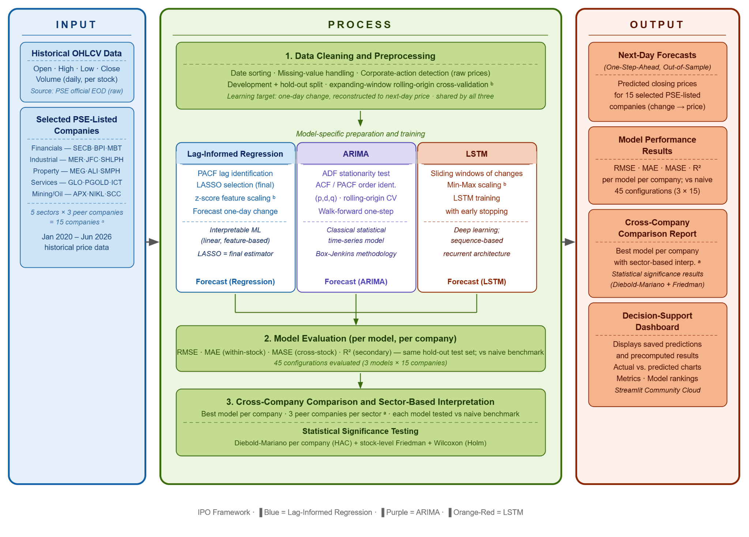
The conceptual framework may be illustrated through the following Input–Process–Output structure:

Figure 1. Conceptual Framework of the Study

Literature Synthesis Matrix
To support the systematic organization and synthesis of the reviewed literature, a Literature Review Matrix and a Literature Synthesis Matrix were prepared. The Literature Review Matrix records the relevant characteristics of each source, including its research context, objectives, data, methods, forecasting models, evaluation measures, findings, limitations, and identified research gaps. This source-level organization helped ensure that the studies cited in the chapter were reviewed consistently and that their contributions were accurately connected to the present research.

The Literature Synthesis Matrix was used to compare the reviewed studies across the major themes of the chapter, including Philippine stock-market forecasting, OHLCV-based modeling, lag-informed regression, ARIMA, LSTM, next-day prediction, chronological validation, naive benchmarking, model-performance evaluation, statistical comparison, and dashboard-based presentation. Through this thematic comparison, areas of agreement, methodological differences, recurring limitations, and opportunities for the present study were identified. The complete Literature Review Matrix, Literature Synthesis Matrix, and citation-audit records are provided in Appendix L and Appendix M.

Chapter Summary
This chapter reviewed stock-forecasting research, statistical, machine learning, and deep learning approaches, Philippine and regional market evidence, forecasting systems, educational-support tools, theoretical foundations, the conceptual framework, and the research gap addressed by the proposed capstone.

The reviewed literature establishes Lag-Informed Regression, ARIMA, and LSTM as valid but structurally different forecasting approaches. Regression provides an interpretable method for examining lagged and OHLCV-derived predictors, ARIMA represents linear autoregressive and moving-average relationships, and LSTM is designed to learn nonlinear sequential dependencies. However, the empirical evidence does not identify a universally superior model.
Some studies report advantages for advanced or hybrid methods. Rehman and Gul (2026) found that hybrid forecasting approaches performed more strongly than standalone linear and artificial-intelligence models in their emerging-market index study, while Ranjan et al. (2025) reported stronger performance from an interpretable 1D-CNN than from ARIMA and LSTM under their S&P 500 design. In contrast, Beck et al. (2025) found that complex statistical and machine learning models did not consistently outperform a naive no-change forecast for highly volatile financial series. Together, these findings demonstrate that the relative performance of a model depends on the market, target, predictor structure, validation procedure, forecast horizon, and benchmark.
The literature also supports next-day forecasting using historical market information. Vijh et al. (2020) predicted next-day closing prices for several companies using historical price variables, while Wahyuddin et al. (2025) demonstrated the importance of walk-forward validation and hyperparameter optimization in an Indonesian stock-forecasting application. These studies support the present study’s short forecasting horizon and chronological evaluation, although they differ from its OHLCV-only scope, common change-based learning target, three-model comparison, and Philippine company sample.

In the Philippine context, Casurao et al. (2024) and Sucuahi (2023) establish that sectoral movements are not uniform. Pakzad et al. (2024), Modesto et al. (2025), and Parreño (2024) demonstrate the feasibility of applying regression, sentiment-enhanced deep learning, and chaos-enhanced LSTM methods to Philippine stock data. However, previous studies commonly examine indices, sectoral relationships, individual forecasting approaches, sentiment-based predictors, or regression-oriented systems. Limited evidence compares Lag-Informed Regression, ARIMA, and LSTM across several individual PSE-listed companies using the same official data, forecasting horizon, validation structure, naive benchmark, and evaluation procedures.
The chapter further establishes that useful forecasting research requires more than producing a predicted value. Antad et al. (2023) and Pakzad et al. (2024) show that forecasting models can be implemented through web-based systems. Kothakota and Kiss (2020) demonstrate that financial visualizations combined with textual explanations can improve the assimilation of financial knowledge, while Johri et al. (2023) highlight the importance of financial literacy, technical usability, reliability, safety, risk, awareness, and perceived benefits in online stock applications. These findings support a dashboard that combines forecasting outputs with historical context, performance evidence, source transparency, understandable explanations, and responsible-use safeguards.
The Efficient Market Hypothesis and Random Walk Hypothesis explain why historical market information may offer limited forecasting value when current prices already reflect available information (Fama, 1970, 1991; Samuelson, 1965). Mean Reversion Theory and Information Lag Theory support the possibility that short-term correction, delayed adjustment, and lagged price or volume behavior may contain useful predictive signals under particular conditions (Hong & Stein, 1999; Poterba & Summers, 1988). The Adaptive Market Hypothesis explains why predictive relationships may change over time, while Sector-Specific Risk Theory supports examining companies exposed to different industry and market conditions (Fama & French, 1997; Lo, 2004).
The present study responds to the identified gaps through 15 selected companies, with three companies included from each of the Financials, Industrial, Property, Services, and Mining and Oil sectors. Lag-Informed Regression, ARIMA, and LSTM will be developed separately for every company using a common change-based target and reconstructed closing-price output. Their configurations will be selected through expanding-window rolling-origin validation and evaluated on common dates in an untouched hold-out set. A naive random-walk forecast will serve as the mandatory benchmark.
Forecasting results will be reported primarily at the individual-company level. Similarities among selected companies within the same sector may be interpreted only as sector-peer context. The validated data, forecasts, performance measures, benchmark results, statistical comparisons, source information, and model artifacts will then be integrated into an educational and analytical Next.js dashboard designed for budding traders.
Accordingly, the literature supports both components of the study: a controlled Philippine comparison of three structurally different forecasting models and the responsible presentation of the resulting analytical evidence through a transparent, understandable, and beginner-oriented computing solution.
CHAPTER III

METHODOLOGY
This chapter presents the methodology of the study. It discusses the research design, project design, stakeholder requirements analysis, data engineering and analytics pipeline, model development and evaluation, system architecture, dashboard implementation, testing and validation, deployment preparation, and documentation procedures. The methodology integrates stakeholder-centered requirements gathering, official PSE data processing, comparative forecasting, and system development into a complete BSIT Data Analytics computing solution. Each methodological component is aligned with the research objectives, research questions, and hypotheses established in Chapter I and the theoretical and conceptual foundations presented in Chapter II.

Research Design
This study employs a multi-component research and development design consisting of a quantitative comparative forecasting component, a mixed-method stakeholder requirements component, and a system development and evaluation component. These components are integrated because the study does not only compare forecasting models; it also transforms validated analytical results into an interactive computing solution designed for budding traders.
The quantitative comparative component evaluated Lag-Informed Regression, ARIMA, and LSTM under a common data scope, forecast horizon, validation structure, holdout period, and metric set. Lag-Informed Regression and LSTM estimated the one-day change and reconstructed the next-day price; ARIMA forecast the price level with internal differencing. Naive carried the origin-day closing price forward as the mandatory benchmark.
The study covers 15 selected PSE-listed companies representing five official PSE sectors, with three selected companies per sector:
- Financials: SECB, BPI, and MBT;
- Industrial: MER, JFC, and SHLPH;
- Property: MEG, ALI, and SMPH;
- Services: GLO, PGOLD, and ICT; and
- Mining and Oil: APX, NIKL, and SCC.
The individual company is the primary unit of analysis. Model performance will first be evaluated and reported separately for each stock. Sector membership will then be used as contextual information for examining whether similar results appear among the three selected peer companies. A possible sector-peer pattern will be discussed only when a comparable result is observed in at least two of the three selected companies within the same sector. Such findings will not be generalized to all companies in that sector.
The historical dataset covers January 2, 2020 to August 28, 2026 and consists of raw OHLCV values extracted from official PSE Daily Quotations Reports. Each selected company contains 1,624 validated trading-day observations, resulting in 24,360 stock-date records across the complete sample.
The cleaned dataset for each company will be partitioned chronologically into an 85% development set and a 15% final hold-out test set. The hold-out test set will remain untouched during feature engineering, transformation fitting, lag selection, order identification, model fitting, and hyperparameter selection. It will be used only after all modeling decisions have been finalized.
Model selection and hyperparameter tuning will be conducted within the development set through expanding-window rolling-origin cross-validation. The development set will be divided into six contiguous time blocks, producing five validation folds. In each fold, the training window will expand chronologically, while the immediately following block will serve as the validation period. Candidate configurations will be evaluated using their mean one-step-ahead validation RMSE across the five folds, with MAE reported as a supporting validation measure. The best configuration for each model will then be refitted using the complete development set before final evaluation on the hold-out test set.
All models will be evaluated on the common intersection of valid hold-out test dates. This ensures that Lag-Informed Regression, ARIMA, LSTM, and the naive benchmark are compared using the same forecast origins and actual observations. Feature construction, scaling, lag identification, order selection, and sequence preparation will use only information available before the date being forecast to prevent look-ahead bias and future-data leakage. Every fitted transformation will be estimated using the applicable training data only and applied unchanged to the corresponding validation or hold-out observations.
Model performance will be assessed using a canonical set of four measures. Root Mean Squared Error (RMSE) will serve as the primary metric for ranking models applied to the same company because it places greater weight on large forecast errors. Mean Absolute Error (MAE) will provide a supporting measure of the typical absolute error in Philippine pesos. Because RMSE and MAE are scale-dependent and cannot be directly compared across stocks with different price levels, Mean Absolute Scaled Error (MASE) will be used as the scale-free measure for cross-company and sector-peer comparisons. A MASE value below 1 indicates a lower scaled error than the naive reference, whereas a value equal to or above 1 indicates that the model did not outperform the reference on that descriptive measure. The coefficient of determination (R²) will be reported only as a secondary descriptive metric and will not be treated as stand-alone evidence of forecasting skill.
The first research hypothesis will evaluate differences in forecast accuracy through a two-level statistical procedure. At the within-company level, Lag-Informed Regression, ARIMA, LSTM, and the naive benchmark will be compared using pairwise Diebold–Mariano tests based on their hold-out loss-differential series. Each developed model will first be compared against the naive benchmark. Only models that significantly outperform the naive benchmark will proceed to pairwise comparisons with the other developed models. This hierarchical or gatekeeping structure prioritizes the determination of whether the more complex forecasting methods provide incremental skill beyond the random-walk benchmark.
Squared-error loss will serve as the primary Diebold–Mariano criterion because it corresponds to RMSE, while absolute-error loss will be examined as a robustness check because it corresponds to MAE. The tests will use a heteroskedasticity- and autocorrelation-consistent variance estimate and the Harvey–Leybourne–Newbold small-sample correction. Holm adjustment will be applied to the comparisons performed within each company, and a moving-block bootstrap will provide an additional robustness assessment of the forecast-loss differentials. This procedure accounts for the possibility that daily forecast errors are serially dependent and should not be treated as independent cross-sectional observations.
At the across-company level, a stock-level Friedman test will compare the performance ranks of Lag-Informed Regression, ARIMA, LSTM, and the naive benchmark using one final hold-out MASE value per model for each of the 15 selected companies. When the omnibus test identifies a statistically significant difference, paired Wilcoxon signed-rank post-hoc comparisons with Holm adjustment will be conducted. The within-company Diebold–Mariano results will provide the primary inferential evidence, while the stock-level Friedman analysis will serve as supporting evidence of systematic model-performance differences across the selected companies. Because the stocks may share common market and sector influences, the across-company procedure will be interpreted cautiously rather than assuming complete independence among the companies.
The second research hypothesis will assess whether any of the three principal forecasting models demonstrates descriptive best-model consistency across the selected companies. For each company, the principal model with the lowest final hold-out RMSE will be identified as the best-performing model, with MAE, MASE, R², naive-benchmark results, and statistical-comparison findings used as supporting information. A model will be described as consistently best-performing when it ranks first in at least 8 of the 15 selected companies. This predetermined majority criterion will be interpreted as a descriptive pattern and not as proof that the model is universally superior.
The mixed-method stakeholder requirements component combines qualitative and quantitative evidence. Eight budding traders participated in semi-structured interviews and a structured post-interview survey. The interviews were used to identify and explain stakeholder experiences, difficulties, preferences, and expected dashboard features. The survey was used as the primary standardized instrument for validating and prioritizing the requirements because all participants answered the same structured questions.
Interview data were analyzed through thematic coding, while survey responses were analyzed using frequencies, percentages, mean importance scores, positive-response percentages, and feature-priority counts. The results were integrated through a joint display and requirements-synthesis process. The same participants completed both instruments; therefore, the survey represents structured validation and prioritization within the participant group rather than independent confirmation from a separate sample.
The system development component translates the validated analytical and stakeholder requirements into a Next.js and React-based educational dashboard. The dashboard will load verified datasets, precomputed reconstructed closing-price forecasts, actual-versus-predicted values, model-performance summaries, MASE-based cross-company comparisons, naive-benchmark results, model rankings, statistical outputs, diagnostic summaries, and saved ticker-specific model artifacts. Formal model training and hyperparameter selection will not occur during normal dashboard use.
The system will be evaluated through requirements-based functional testing, usability testing, compatibility testing, performance testing, privacy verification, output verification, and responsible-use review. It is not intended to operate as a brokerage platform, execute transactions, provide automated trading instructions, or guarantee investment outcomes.

Project Design
The project design integrates stakeholder requirements, data analytics, model evaluation, and system development into a single end-to-end computing workflow. It demonstrates how official market data and stakeholder evidence are transformed into validated analytical outputs and an accessible user-facing application.
The project follows three interdependent tracks:
- Stakeholder Requirements Track
This track covers participant recruitment, interviews, survey administration, thematic analysis, descriptive analysis, evidence integration, requirement prioritization, and requirements traceability.
- Data Analytics and Forecasting Track
This track covers official PSE data acquisition, data provenance, extraction, validation, preprocessing, feature engineering, model development, chronological validation, baseline comparison, statistical testing, and model-result generation.
- System Development Track
This track covers dashboard architecture, result integration, interface design, saved-artifact loading, automated source-data validation, testing, documentation, deployment preparation, and maintenance planning.
The three tracks are connected through traceability. Stakeholder evidence informs the dashboard features and quality expectations. The research questions determine the analytical outputs required from the forecasting pipeline. The validated model results become the inputs of the dashboard. The functional and non-functional requirements then provide the basis for system testing and acceptance evaluation.
  - Methodological Framework
The methodological framework presents the complete research and development process from problem identification to final system evaluation. The process consists of five phases.

Phase 1: Research and Stakeholder Requirements
The first phase establishes the research problem, analytical gap, primary stakeholder, and system requirements. Semi-structured interviews and a structured survey are conducted with budding traders. Interview findings are coded into themes, while survey responses are summarized and prioritized. The integrated results are translated into functional requirements, non-functional requirements, acceptance criteria, and a requirements traceability matrix.

Phase 2: Official Data Acquisition and Validation
The second phase acquires historical OHLCV data from official PSE Daily Quotations Reports. The records are extracted, organized, and subjected to completeness, validity, continuity, liquidity, provenance, and material price-discontinuity checks. Only companies satisfying all approved strict data-quality criteria are retained in the final sample.
The official raw values remain preserved in an untouched data archive. Model-ready datasets and validation outputs are stored separately from the original source files.
Phase 3: Model Development and Evaluation
The third phase prepares model-specific datasets for Lag-Informed Regression, ARIMA, and LSTM. Lag-Informed Regression and LSTM estimate the next-trading-day change and reconstruct a price forecast. ARIMA models closing-price levels with internal differencing. Naive supplies the mandatory random-walk benchmark on the same target dates.
Lag-Informed Regression uses historical OHLCV-derived lagged predictors, PACF-guided lag identification, train-fitted z-score standardization, and LASSO regularization as the final estimator. ARIMA uses the differenced chronological closing-price series and follows stationarity testing, order identification, rolling-origin model selection, and residual diagnostic procedures. LSTM uses Min-Max-scaled sliding windows of historical closing-price changes to learn nonlinear sequential patterns.
Model selection and hyperparameter tuning are conducted through expanding-window rolling-origin cross-validation within the development set. The selected configurations are refitted using the complete development set and evaluated once on the untouched hold-out test set using the same valid forecast dates. Performance is measured using RMSE and MAE for within-company comparison, MASE for cross-company and sector-peer comparison, and R² as a secondary descriptive metric. Model rankings, naive-benchmark comparisons, within-company Diebold–Mariano test results, and supporting stock-level Friedman test results are generated for the 15 selected companies.

Phase 4: Result Packaging and Dashboard Integration
The fourth phase stores validated outputs in structured dashboard bundles. These may include historical data, prediction files, actual-versus-forecast results, model metrics, rankings, statistical-test outputs, next-day forecast files, source metadata, preprocessing versions, model versions, and saved model artifacts.
The Next.js dashboard loads the verified outputs rather than retraining the formal study models during normal runtime.

Phase 5: System Testing and Final Documentation
The fifth phase evaluates the completed dashboard against its requirements and acceptance criteria. Testing covers functionality, usability, readability, performance, device compatibility, privacy, output accuracy, automated source-data validation, and responsible-use presentation.
The final outputs include the validated forecasting pipeline, model artifacts, dashboard application, source code, technical documentation, requirements traceability records, data-quality reports, testing evidence, and deployment documentation.

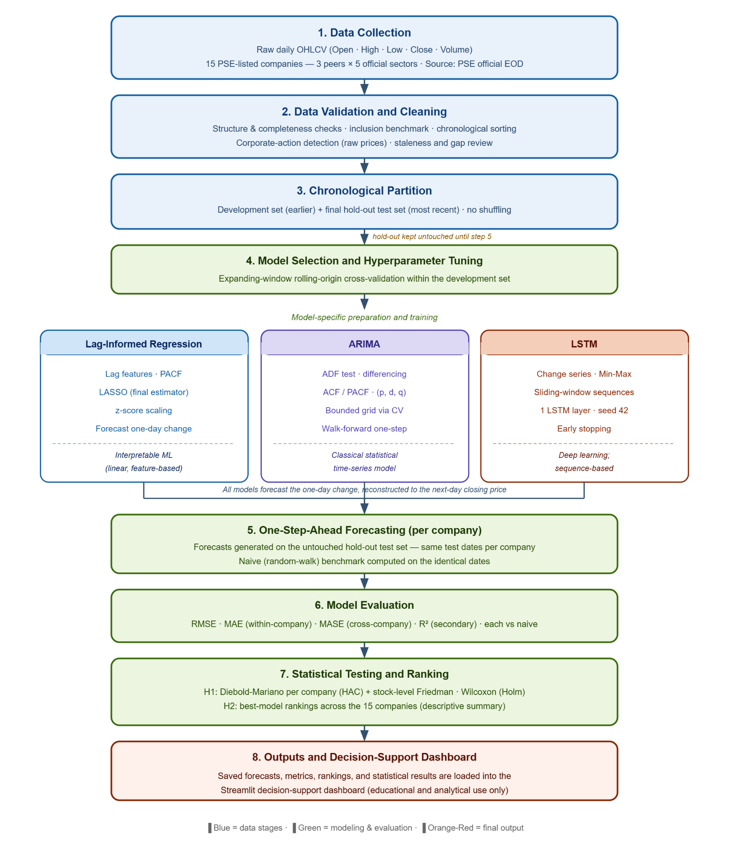

Figure 2. Methodological Framework Diagram

Figure 2. Methodological Framework Diagram

  - Operational Framework
The operational framework presents the technical flow of the proposed computing solution from data input to user-facing output. It shows how official PSE records and validated stakeholder requirements are processed, modeled, evaluated, stored, and presented through the Next.js dashboard.

The process begins with the Input and Provenance Layer, which contains the official PSE Daily Quotations Reports, extracted raw OHLCV records, company and sector information, source metadata, and validated stakeholder requirements. These inputs establish both the analytical basis of the study and the information and presentation needs of budding traders.

The data then enter the Data Engineering and Quality Layer, where records are checked for completeness, accuracy, chronology, duplicate Date–Symbol combinations, trading continuity, and logical OHLCV relationships. Validated raw observations remain unchanged in the primary formal analysis. The frozen corporate-action registry controls a separate target-date exclusion sensitivity analysis and never triggers undocumented price adjustment.

Each company’s validated series is partitioned chronologically into an 85% development set and a 15% untouched hold-out test set. Expanding-window rolling-origin cross-validation is performed within the development set for model selection and hyperparameter tuning. Feature construction, scaling, lag identification, sequence preparation, and other fitted transformations use only information available before the forecast date to prevent look-ahead bias and future-data leakage.

In the Modeling and Evaluation Layer, Lag-Informed Regression, ARIMA, and LSTM are developed separately for each of the 15 selected companies, together with the mandatory Naive random-walk benchmark. Lag-Informed Regression and LSTM reconstruct forecasts from predicted changes; ARIMA directly returns a price-level forecast after internal differencing. Every method is evaluated on the same next-trading-day closing prices.

Lag-Informed Regression uses OHLCV-derived lagged predictors, PACF-guided lag identification, train-fitted standardization, and LASSO regularization. ARIMA uses the differenced chronological closing-price series and follows stationarity assessment, order selection, walk-forward forecasting, and residual-diagnostic procedures. LSTM uses Min-Max-scaled sliding windows of historical closing-price changes to learn nonlinear sequential patterns.

The finalized models and the naive benchmark are evaluated using the same valid hold-out test dates. RMSE serves as the primary metric for ranking models applied to the same company, while MAE provides a supporting measure of absolute error in Philippine pesos. MASE is used as the scale-free measure for comparisons across companies and sector peers, and R² is reported as a secondary descriptive metric.

Within each company, Diebold–Mariano tests are used to compare the hold-out forecast-loss differentials of the principal models and the naive benchmark. The procedure includes a heteroskedasticity- and autocorrelation-consistent variance estimate, the Harvey–Leybourne–Newbold small-sample correction, Holm adjustment, and a moving-block bootstrap robustness check. Across the 15 selected companies, a supporting stock-level Friedman test compares one MASE-based result per model and company, followed by Holm-adjusted Wilcoxon signed-rank comparisons when applicable. Model rankings, benchmark findings, residual diagnostics, and finalized forecasts are then produced.

The verified outputs are saved in the Result and Artifact Storage Layer, which contains validated historical datasets, reconstructed forecast files, actual-versus-predicted values, residuals, RMSE, MAE, MASE, and R² summaries, naive-benchmark comparisons, model rankings, Diebold–Mariano results, stock-level Friedman and post-hoc results, preprocessing specifications, diagnostic outputs, ticker-specific model artifacts, artifact versions, training cutoffs, and source-data metadata.

The Dashboard and User Layer loads verified, precomputed artifacts and presents historical trends, next-session forecasts, actual-versus-predicted comparisons, model-performance summaries, Naive-benchmark results, company rankings, source and freshness information, and educational explanations. The interface cannot upload data, execute Python, train models, or revise formal results.
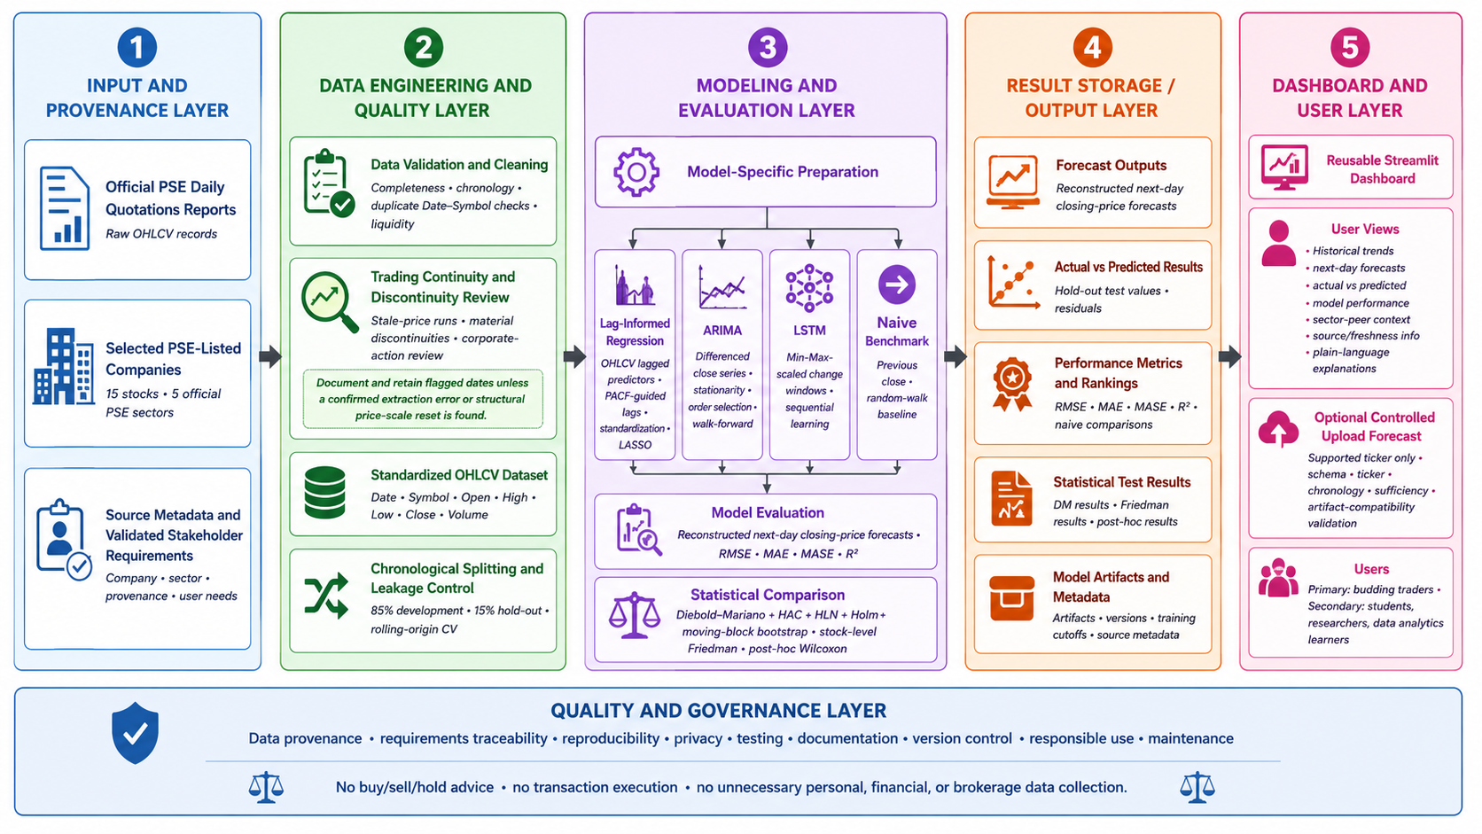
A Quality and Governance Layer applies throughout the workflow to support data provenance, requirements traceability, reproducibility, privacy, testing, documentation, version control, responsible use, and system maintenance. The dashboard will not provide buy, sell, or hold recommendations, execute transactions, guarantee investment outcomes, or collect unnecessary personal, financial, banking, or brokerage information.

Figure 3. Operational Framework Diagram

Requirement Analysis
Requirement analysis identifies the stakeholder needs, analytical outputs, system functions, quality expectations, risks, and acceptance criteria of the proposed computing solution. The requirements were derived from completed stakeholder interviews, a structured post-interview survey, the research objectives, the forecasting methodology, the official data protocol, and the intended dashboard architecture.
The completed requirements process produced 16 final stakeholder-facing requirements:
- 10 functional requirements; and
- 6 non-functional requirements.
The requirements were organized using unique identifiers, evidence sources, priorities, dashboard components, acceptance criteria, test cases, and intended objectives. A separate requirements traceability matrix connects each requirement to its stakeholder basis, system component, required data or model output, associated risk, and planned testing evidence.

  - Problem and User Needs
The proposed solution responds to connected research, analytical, and user needs.
The research concerns the limited Philippine evidence comparing Lag-Informed Regression, ARIMA, and LSTM for next-day closing-price forecasting across several individual PSE-listed companies using the same official OHLCV source, forecasting horizon, benchmark, validation procedure, and evaluation measures.
The analytical need concerns the preparation of reliable and reproducible market datasets. Official PSE records must be acquired, validated, chronologically aligned, screened for quality issues, transformed into model-specific inputs, evaluated without future-data leakage, and stored with sufficient provenance for reproduction.
The stakeholder needs concerns budding traders with zero, beginner, or intermediate stock-trading knowledge. They may have access to stock applications, websites, social media, tutorials, financial news, and charting platforms but may still find it difficult to interpret ticker symbols, OHLCV values, candlestick charts, indicators, company information, model metrics, and conflicting online opinions.
The stakeholder survey identified the lack of reliable and easy-to-understand forecasting tools as the most frequently selected challenge, reported by six of eight participants or 75%. Existing platforms being too complicated, information overload, and uncertainty regarding possible trading decisions were each reported by four participants or 50%.
Interview evidence provided further context. Participants described existing stock and charting platforms as technical, cluttered, and difficult to interpret. They commonly relied on several fragmented sources and were uncertain which information was reliable or relevant. When short-term price behavior was unclear, participants reported waiting, avoiding action, asking a more knowledgeable person, relying on intuition, or spending additional time interpreting charts.

The stakeholder evidence supports a dashboard that emphasizes the following:
- next-day forecasts as learning and research references;
- historical price and volume context;
- clear company and ticker identification;
- actual-versus-forecast comparisons;
- readable model-performance information;
- plain-language explanations;
- visible official sources and update dates;
- uncertainty and responsible-use notices;
- summary-first navigation;
- comparison and filtering controls; and
- mobile and desktop accessibility.
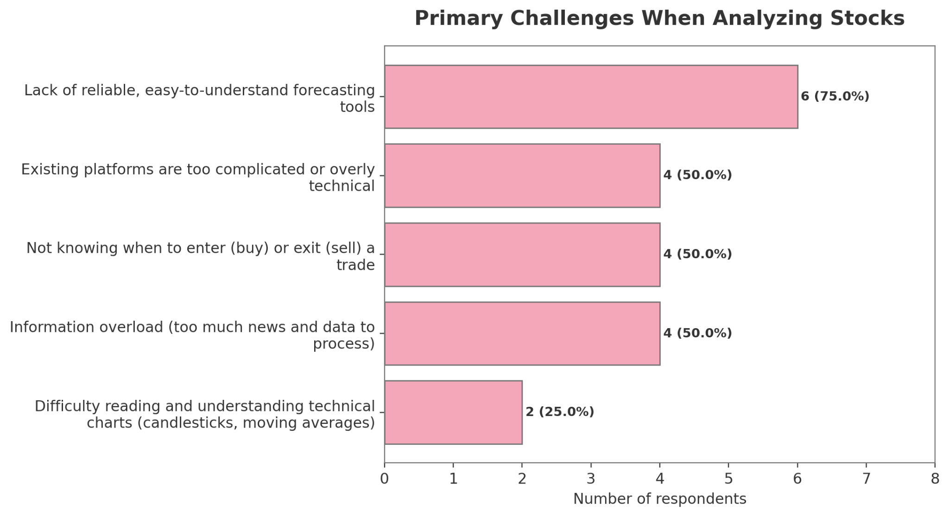
Figure 4. Primary Challenges When Analyzing Stocks

  - Requirement Gathering Method
The stakeholder requirements were gathered using a sequential interview-and-survey process.

    - Participant Selection
Eight participants were selected purposely based on the operational definition of a budding trader. Eligible participants had zero, beginner, or intermediate stock-trading knowledge and expressed an interest in learning about stocks, monitoring market behavior, or understanding forecasting tools.
Intermediate experience did not automatically exclude a participant. A participant remained eligible when the person’s practical experience was concentrated in cryptocurrency, general technical analysis, or other markets rather than direct and advanced analysis of PSE-listed companies.
Participants were assigned identifiers P01 to P08 in all analytical outputs. Their names were not used in public requirement tables or thematic summaries.
    - Semi-Structured Interviews
The interviews were conducted from July 20 to 21, 2026. The semi-structured instrument contained 18 questions covering:
- participant background and experience;
- current stock-learning practices;
- difficulties and information needs;
- short-term forecasting preferences;
- dashboard expectations;
- trust and responsible-use concerns; and
- preferred presentation and accessibility features.
Each interview lasted approximately 20 to 30 minutes. Participant consent was obtained before data collection.
The original Taglish responses were retained for evidence verification. Cleaned Taglish transcripts and semantic English translations were prepared for analysis. The English versions preserved the intended meaning rather than serving as certified literal translations.
Transcript quality was audited before coding. Unclear or uncaptured responses were identified and were not reconstructed through assumption. The interview dataset achieved an average transcript completeness of approximately 96.5%.

    - Thematic Analysis
Interview responses were segmented and assigned descriptive codes. Related codes were grouped into broader themes representing recurrent experiences, pain points, information needs, and system expectations.
The thematic analysis considered:
- the number of participants supporting a theme;
- the number of coded supporting segments;
- the interview sections in which the theme appeared;
- representative participant statements; and
- the practical implication of the theme for dashboard design.
    - Structured Post-Interview Survey
The same eight participants completed the structured survey from July 20 to 22, 2026. The survey required approximately five minutes to answer and was administered after the interviews so that the identified needs and dashboard concepts were already familiar to the participants.
The survey measured:
- stakeholder knowledge and experience;
- current stock-information sources;
- primary difficulties;
- forecasting-horizon preference;
- perceived usefulness of next-day forecasting;
- functional-requirement importance;
- non-functional-requirement importance;
- feature priorities;
- adoption barriers;
- interface preferences; and
- overall acceptance.
Survey items were analyzed through counts, percentages, mean scores, positive-response rates, and top-priority votes.
The survey served as the primary requirement-validation and prioritization instrument, while the interviews served as the qualitative requirements-elicitation and contextualization instrument.
Because the same participants completed both instruments, the survey results represent standardized validation within the stakeholder group and not independent validation from a separate participant sample.

    - Evidence Integration
Survey and interview evidence were connected through an integrated joint display. Each proposed requirement was reviewed according to:
- structured survey support;
- contextual interview support;
- convergence between the two sources;
- final interpretation;
- requirement type;
- MoSCoW priority; and
- proposed acceptance criterion.
Evidence convergence was classified as:
- strong convergence;
- moderate convergence;
- qualitative strengthening;
- survey-led; or
- limited convergence.
  - Stakeholder Profile
Seven participants, representing 87.5% of the sample, had no prior or beginner-level stock-trading knowledge. One participant, representing 12.5%, had intermediate general trading experience but limited direct experience analyzing PSE-listed companies.
This profile confirms that all eight participants met the operational definition of budding traders.
Table 2. Stakeholder Profile Summary
Profile Category | Participants | Percentage | Interpretation
No prior or beginner-level stock knowledge | 7 | 87.50% | Primary intended beginner stakeholder group
Intermediate general experience with limited PSE-specific knowledge | 1 | 12.50% | Remained eligible as a budding trader
Total | 8 | 100% | All participants satisfied the inclusion criteria

  - Interview Thematic Findings
The thematic analysis produced eight major themes.

Table 3. Interview Themes and System Implications
Theme | Main Finding | System Implication
Foundational knowledge and chart-literacy gaps | Participants experienced difficulty with candlesticks, OHLCV values, volume, indicators, and ticker context. | Present company identity, historical context, readable charts, and beginner-friendly definitions.
Information overload and platform-usability barriers | Existing platforms were described as dense, technical, cluttered, or difficult to navigate. | Use summary-first pages, progressive disclosure, simple navigation, and limited first-screen content.
Fragmented sources and trust concerns | Participants relied on social media, news, communities, friends, and online personalities and encountered conflicting opinions. | Display official sources, data cutoffs, update dates, model information, and limitations.
Short-term uncertainty and cautious decision-making | Uncertainty led participants to wait, delay analysis, seek advice, rely on intuition, or avoid acting. | Present forecasts as uncertain analytical estimates rather than trading instructions.
Historical context and beginner-education needs | Participants requested historical charts, company context, definitions, tooltips, and plain-language explanations. | Place historical and educational information beside forecast outputs.
Next-day forecasting as educational and confirmation support | Forecasts were viewed as starting points, time-saving references, second opinions, and tools for comparison with actual outcomes. | Provide next-day forecasts and actual-versus-forecast views.
Transparency, uncertainty, and responsible use | Trust depended on source visibility, update information, forecast dates, accuracy, method, uncertainty, and non-guarantee statements. | Display provenance, freshness, performance, uncertainty, and visible responsible-use notices.
Summary-first, accessible, and comparison-oriented design | Participants requested concise summaries, search, filters, comparisons, readable layouts, mobile access, and stable loading. | Provide organized navigation, responsive design, filters, and optional deeper technical views.

The themes demonstrate that the stakeholder need is not satisfied by displaying a predicted value alone. The forecast must be supported by context, performance evidence, understandable explanations, and responsible-use safeguards.

  - Survey Analysis and Requirements Validation
The survey provided the standardized basis for selecting and prioritizing the dashboard requirements.
Six of the eight participants, or 75%, selected the next trading day as the most useful forecasting horizon. Interview preferences were more varied: some participants preferred the next week or a longer period, while others were unsure. The survey therefore clarified the primary forecasting horizon after the broader interview discussion.
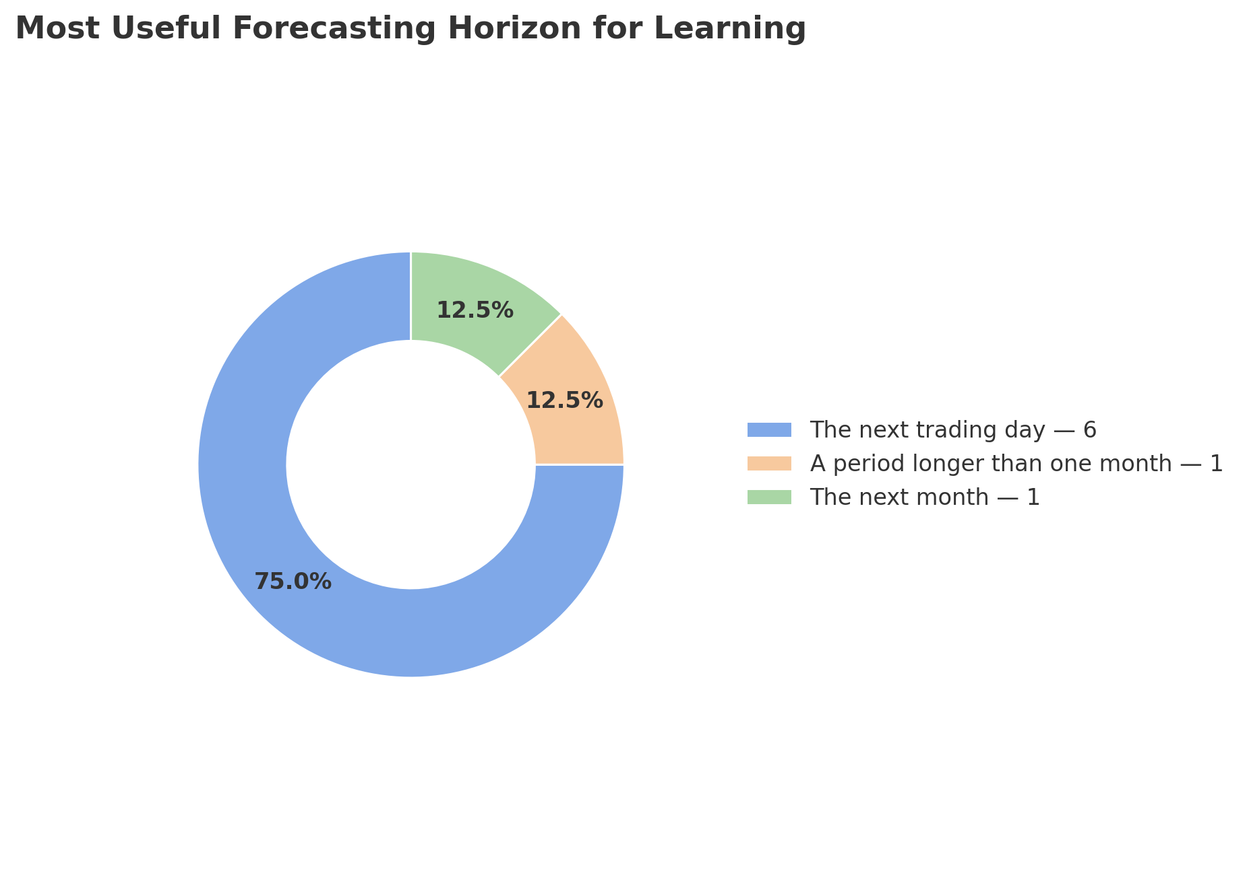
Figure 5. Most Useful Forecasting Horizon for Learning Stocks Trading
The next-day forecasting need was supported by the following survey findings:
- 87.5% considered a next-day forecast useful as a learning reference;
- 87.5% agreed that it could reduce the time spent interpreting complicated information;
- 87.5% agreed that actual-versus-forecast comparison would support learning;
- 87.5% would use the forecast as a starting point for further research rather than an automatic instruction; and
- 87.5% preferred historical information and an explanation beside the forecast.
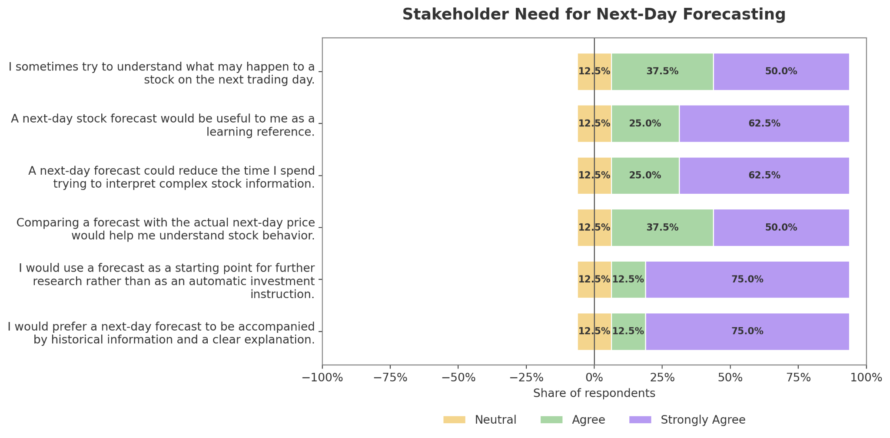
Figure 6. Stakeholder Need for Next-Day Forecasting
Historical stock charts and next-day forecasts received the strongest capability ratings. Responsible-use reminders also received strong support. Participants further prioritized company and ticker identification, historical price and volume charts, forecast outputs, actual-versus-forecast comparison, written explanations, and educational definitions.
The four overall acceptance items each received 87.5% positive support. Participants generally agreed that the dashboard could address their difficulties, function as a learning tool, be recommended to other beginners, and become more useful by combining forecasts, historical charts, explanations, and responsible-use reminders.
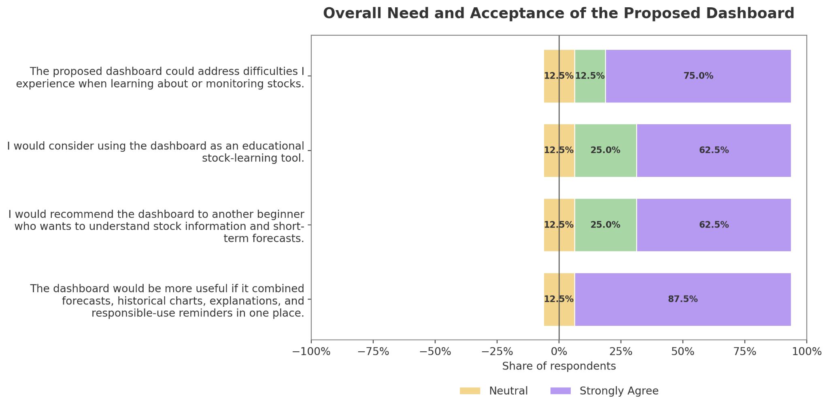
Figure 7. Overall Need and Acceptance of the Proposed Dashboard
Non-functional results showed strong support for:
- simple navigation;
- beginner-friendly language;
- readable charts and labels;
- fast loading;
- mobile and computer compatibility; and
- minimal personal-data collection.
75% percent preferred a dark visual theme, while the remaining participants preferred light mode or a device-based setting. 50% preferred a balanced summary-first presentation containing essential information with optional deeper details.
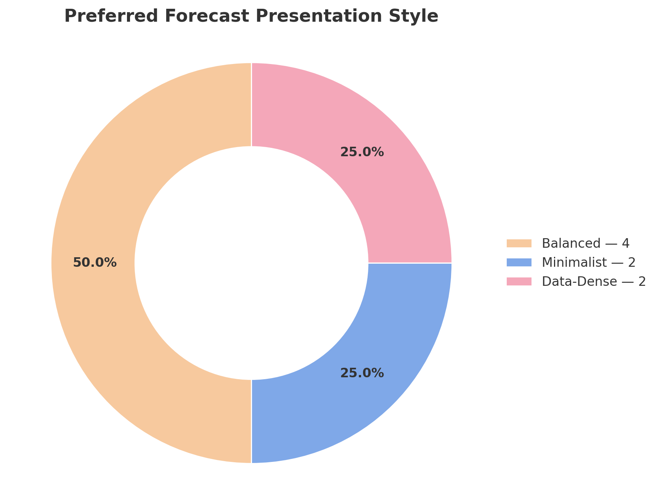
Figure 8. Preferred Forecast Presentation Style

  - Integrated Needs Assessment
The stakeholder evidence was integrated into eight major design needs.
Table 4. Integrated Needs Assessment of Budding Traders
Identified Need | Evidence Summary | Required System Response
Clear company and stock identification | Participants experienced difficulty with ticker and company context. | Display the complete company name, ticker, and official PSE sector.
Understandable historical context | Participants wanted historical price, volume, and company information before interpreting forecasts. | Provide readable historical OHLCV charts, summaries, and date filters.
Accessible next-day forecast | The next trading day was the preferred structured horizon, and forecasts were viewed as time-saving learning references. | Display a clearly labeled estimated next-day closing price.
Forecast evaluation | Participants wanted to compare forecasts with actual outcomes. | Provide actual-versus-forecast charts aligned to the same trading dates.
Company and sector-peer comparison | Participants requested options for comparing stocks and companies. | Allow comparison of the three selected peer companies within a sector.
Beginner-friendly explanations | Technical terms, charts, and metrics were difficult without guidance. | Provide tooltips, definitions, explanations, and concise interpretation notes.
Source, freshness, and transparency | Trust depended on official sources, dates, accuracy, and method information. | Display the official PSE source, data cutoff, update date, model version, and freshness status.
Responsible and accessible use | Participants wanted uncertainty notices, simple navigation, readable design, mobile access, and no direct advice. | Apply visible disclaimers, summary-first navigation, responsive design, and privacy controls.

  - Data Analytics Requirements
Data analytics requirements define the conditions that the data and modeling pipeline must satisfy independently of the dashboard’s stakeholder-facing features.

Table 5. Data Analytics Requirements
ID | Data Analytics Requirement
DAR-01 | Historical data must come from official PSE Daily Quotations Reports covering January 2, 2020 to August 28, 2026.
DAR-02 | The final dataset must contain the 15 selected stocks, with three companies from each of five official PSE sectors.
DAR-03 | Required variables must include Date, Symbol, Open, High, Low, Close, and Volume, together with sufficient source and ticker metadata.
DAR-04 | Original PSE reports and extracted raw records must remain unchanged and separate from model-ready datasets.
DAR-05 | Every selected stock must satisfy the approved completeness, OHLCV-validity, zero-volume, stale-price, liquidity, and usable-observation benchmarks.
DAR-06 | Missing trading records must not be automatically forward-filled. Unavailable dates must be classified and verified according to the official data protocol.
DAR-07 | Raw closing prices must serve as the basis for constructing the next-trading-day closing-price change and reconstructing the reported closing-price forecast. Adjusted closing prices and total-return series will not be constructed.
DAR-08 | Material price discontinuities and known corporate-event dates must be screened, verified, retained, and documented according to the approved protocol.
DAR-09 | Lagged variables, scaling parameters, model inputs, and sequences must use only information available before the forecasted date.
DAR-10 | Data must be divided chronologically into an 85% development set and a 15% untouched hold-out test set, with expanding-window rolling-origin validation conducted only within the development set.
DAR-11 | Lag-Informed Regression, ARIMA, LSTM, and the naive benchmark must be evaluated on common valid test dates using RMSE, MAE, MASE, and R².
DAR-12 | Predictions, metrics, rankings, statistical results, preprocessing specifications, model artifacts, and version metadata must be saved for reproducibility and dashboard integration.

In addition to stakeholder-derived requirements, the research objectives require the system to produce:
- model-performance summaries;
- best-model rankings;
- naive benchmark comparisons;
- statistical-test outputs;
- forecast residual information; and
- one-step-ahead out-of-sample forecasts.
These analytical outputs are mandatory components of the research pipeline even when they are not represented as separate stakeholder requirement identifiers.

  - Functional Requirements
The final functional requirements describe the capabilities directly observable by dashboard users.

Table 6. Functional Requirements of the Proposed Dashboard
ID | Functional Requirement | Priority | Dashboard Component | Acceptance Summary
FR-01 | Display the ticker, complete company name, and official PSE sector. | Must | Stock Header and Company Overview | Every supported stock page shows the correct identity information.
FR-02 | Display historical OHLCV prices and trading volume through readable charts and summaries. | Must | Data Overview and Historical Charts | The selected stock and date range produce complete and correctly labeled views.
FR-03 | Display an estimated next-day closing price together with forecast and model information. | Must | Forecast Visualization | A supported ticker displays its forecast value, forecast date, generation time, and model information.
FR-04 | Compare previously generated forecasts with the corresponding actual closing prices. | Must | Forecast Evaluation and Comparison | Actual and forecast values are visually distinguishable and aligned to identical trading dates.
FR-05 | Compare the three selected stocks belonging to the same official PSE sector. | Should | Cross-Stock Analysis | A selected sector displays its three peer companies using a common date range.
FR-06 | Provide plain-language explanations, definitions, and tooltips for stock terms, charts, forecasts, and model results. | Must | Educational Explanation Layer | Every major result has an accessible explanation or definition.
FR-07 | Display the official source, data cutoff, last update, forecast time, model version, and freshness status. | Must | Provenance and Forecast Metadata Panel | Relevant pages visibly display accurate provenance and date information.
FR-08 | Display uncertainty, limitation, and responsible-use notices on all forecast-related pages. | Must | Responsible-Use Panel | Forecast pages clearly state that results are uncertain, educational, and not investment advice.
FR-09 | Allow filtering by supported stock, sector, and historical date range. | Should | Global Dashboard Filters | All linked charts and summaries update consistently with the chosen filters.
FR-10 | Accept updated OHLCV files only for supported tickers and approved schemas. | Could | Live Forecast Status | Invalid tickers, missing fields, duplicates, null values, and unsupported stocks are rejected clearly.

The Model Performance page will additionally display RMSE, MAE, MASE, R², naive benchmark results, and model rankings because these are mandatory research outputs. Statistical results will be shown in an understandable summarized form, while technical test details may be placed in an expandable section.
The automated update workflow is restricted to the approved supported-ticker universe, schema, preprocessing versions, and deployment configurations. It produces operational forecasts separately from the frozen formal study.
Deployment forecast outputs remain separate from formal study findings. Changing the formal findings would require a separately declared experiment with new immutable evidence.
  - Non-Functional Requirements
Non-functional requirements define the expected usability, accessibility, performance, compatibility, privacy, and visual quality of the dashboard.
Table 7. Non-Functional Requirements of the Proposed Dashboard
ID | Non-Functional Requirement | Priority | Acceptance Summary
NFR-01 | Use clear, consistent, and summary-first navigation with optional deeper technical details. | Must | At least 80% of first-time test participants complete the core stock-selection, chart-viewing, and forecast-viewing tasks without assistance.
NFR-02 | Use readable charts, labels, legends, spacing, contrast, and beginner-friendly language. | Must | At least 80% of usability participants rate chart and text readability as 4 or 5 on a five-point scale.
NFR-03 | Load common pages, charts, data, and forecast artifacts efficiently. | Must | At least 90% of normal page-loading and forecast-retrieval tests complete within five seconds in the documented environment.
NFR-04 | Support representative desktop, laptop, tablet, and mobile screen sizes. | Must | Core pages remain usable without horizontal page overflow at defined mobile, tablet, and desktop viewport sizes.
NFR-05 | Provide access to core functions without account registration or unnecessary personal-data collection. | Must | Historical data, forecasts, comparisons, and explanations remain available anonymously.
NFR-06 | Provide a readable dark theme or system-aware appearance. | Should | At least 80% of usability participants rate the implemented theme’s readability and visual comfort as 4 or 5.

Reliability, reproducibility, maintainability, output integrity, and security are also treated as system-wide technical controls. These controls will be addressed through:
- saved and versioned outputs;
- source and artifact verification;
- organized project directories;
- reproducible scripts;
- documented dependencies;
- anonymous core access;
- automated data-update behavior; and
- separation of validated outputs from prototype or illustrative content.

  - Requirement Gathering Method
The final requirement set contains 16 requirements:
- 10 functional requirements; and
- 6 non-functional requirements.

Table 8. MoSCoW Priority Distribution
Priority | Functional | Non-Functional | Total
Must | 7 | 5 | 12
Should | 2 | 1 | 3
Could | 1 | 0 | 1
Total | 10 | 6 | 16

The evidence-integration assessment found:
- 11 requirements with strong survey-interview convergence;
- 1 requirement with moderate convergence;
- 1 requirement with qualitative strengthening;
- 3 survey-led requirements; and
- no requirement with limited convergence.
The moderate-convergence requirement was actual-versus-forecast comparison, which received strong structured-survey support and supporting but less widespread interview evidence.
Sector-peer comparison received qualitative strengthening. Although it received fewer priority votes in the survey, all eight interview participants provided evidence supporting comparison, options, or company context. It was therefore retained as a Should requirement.
Automated supported-ticker updates, minimal personal-data collection, and dark or system-aware appearance were derived from the documented stakeholder requirements. The final traceability matrix must map these requirements to implemented and tested functions.
  - Stakeholder-Facing Requirements Traceability Matrix
The Stakeholder-Facing Requirements Traceability Matrix ensures that every approved system requirement is supported by stakeholder or research evidence and is connected to a specific dashboard component, analytical output, acceptance criterion, and planned test. It provides a structured basis for verifying that the final system responds to the identified needs of budding traders and fulfills the research and computing objectives of the study.
The matrix also supports change control and reproducibility. Each requirement is assigned a unique identifier that remains consistent throughout system design, development, testing, and documentation. This allows the implementation status and testing evidence of every requirement to be tracked during Capstone 2. The final and more detailed Requirements Traceability Matrix can be found in Appendix H.
Table 9. Stakeholder-Facing Requirements Traceability Matrix
Req’t ID | Requirement | Basis or Evidence | Priority | System Comp. | Required Data or Model Output | Acceptance Criterion | Planned Test | Related Objective
FR-01 | Display the ticker, complete company name, and official PSE sector. | Interview findings on unfamiliar ticker symbols and company context; survey support for clear stock identification. | Must | Stock Header and Company Overview | Company master list and official PSE classification | Correct company name, ticker, and sector are shown for every supported stock. | Functional test using all 15 supported tickers | Objectives 1 and 8
FR-02 | Display historical OHLCV prices and trading volume through readable charts and summaries. | Strong interview and survey support for historical charts, price movement, and volume information. | Must | Data Overview | Validated historical OHLCV dataset | Charts and summaries correspond to the selected stock and date range. | Output verification and usability test | Objectives 2, 3, and 8
FR-03 | Display an estimated next-day closing price with relevant forecast information. | Seventy-five percent selected the next trading day as the preferred horizon; forecasts were viewed as learning references. | Must | Forecast Visualization | Saved next-day forecast, forecast date, model name, and generation timestamp | A supported ticker displays the correct forecast and accompanying metadata. | Functional and output-verification test | Objectives 4, 5, and 8
FR-04 | Compare forecasted closing prices with actual observed closing prices. | Strong survey support and moderate interview support for learning through actual-versus-forecast comparison. | Must | Forecast Evaluation | Common-date actual and prediction files | Actual and forecasted values are correctly aligned and visually distinguishable. | Data-alignment and usability test | Objectives 5 and 8
FR-05 | Compare the three selected stocks within the same official PSE sector. | Qualitative interview support for comparison, alternatives, and company context. | Should | Cross-Stock Analysis | Sector mapping, historical data, and model-performance summaries | Selecting a sector displays the three approved peer companies using comparable views. | Functional and output-verification test | Objectives 7 and 8
FR-06 | Provide plain-language explanations, definitions, and tooltips. | Interview themes on terminology, chart-literacy gaps, and technical complexity. | Must | Explanation and Help Layer | Definitions, metric explanations, and interpretation notes | Major charts, metrics, and forecasts contain accessible explanations. | Content-review and usability test | Objectives 1 and 8
FR-07 | Display the official source, data cutoff, update date, model version, and freshness status. | Stakeholder trust depended on source visibility, timeliness, and method transparency. | Must | Provenance and Metadata Panel | Source-file metadata, training cutoff, model version, and preprocessing version | Accurate provenance and freshness information appear on relevant pages. | Metadata-verification test | Objectives 2 and 8
FR-08 | Display uncertainty, limitations, and responsible-use notices. | Strong stakeholder support for transparency and avoidance of direct trading instructions. | Must | Responsible-Use Panel | Approved disclaimer and limitation statements | Forecast-related pages clearly state that outputs are uncertain and are not investment advice. | Content and visibility test | Objectives 1 and 8
FR-09 | Allow filtering by supported stock, sector, and date range. | Stakeholder preference for search, filtering, comparison, and manageable information. | Should | Global Filters | Ticker list, sector list, and historical date fields | Linked visualizations update correctly based on the selected filters. | Functional and consistency test | Objectives 3, 7, and 8
FR-10 | Accept updated OHLCV files only for supported tickers and approved schemas. | Survey support for accessible next-session forecast presentation. | Could | Live Forecast Status | Required schema, supported-ticker list, preprocessing specification, and saved model artifact | Valid files are accepted, while unsupported tickers and invalid schemas produce clear error messages. | Positive and negative automated data-update tests | Objective 8
NFR-01 | Provide clear, consistent, and summary-first navigation. | Interview and survey preference for simple navigation and optional deeper details. | Must | Entire Dashboard | Navigation structure and page hierarchy | At least 80% of test users complete core tasks without assistance. | Task-based usability test | Objective 8
NFR-02 | Maintain readable charts, labels, spacing, contrast, and language. | Strong support for beginner-friendly and readable presentation. | Must | Entire Dashboard | Chart configurations and interface text | At least 80% of test users rate readability as 4 or 5 out of 5. | Usability questionnaire and visual review | Objective 8
NFR-03 | Load normal pages and saved outputs efficiently. | Participants expressed preference for stable and fast-loading tools. | Must | Entire Dashboard | Optimized saved results and cached datasets | At least 90% of normal page loads complete within five seconds in the documented environment. | Performance test | Objective 8
NFR-04 | Support desktop, laptop, tablet, and mobile viewing. | Stakeholder preference for accessible use across devices. | Must | Entire Dashboard | Responsive layout configuration | Core pages remain usable at the defined viewport sizes without horizontal page overflow. | Cross-device and viewport test | Objective 8
NFR-05 | Avoid unnecessary registration and personal-data collection. | Survey support for privacy and minimal personal information requirements. | Must | Entire Dashboard | Anonymous system access | Core features remain accessible without user accounts or sensitive information. | Privacy and security review | Objective 8
NFR-06 | Provide a readable dark or system-aware appearance. | Seventy-five percent preferred dark mode, while others preferred light or device-based display. | Should | Entire Dashboard | Theme configuration | At least 80% of test users rate visual comfort as 4 or 5 out of 5. | Usability and theme test | Objective 8

Data Engineering and Analytics Pipeline
The data engineering and analytics pipeline describes how official Philippine Stock Exchange records are acquired, extracted, validated, standardized, and transformed into model-ready datasets and dashboard-ready outputs. It establishes a consistent and reproducible process for all 15 selected PSE-listed companies and ensures that Lag-Informed Regression, ARIMA, LSTM, and the forecasting benchmarks are developed and evaluated using traceable data and comparable time periods.
The pipeline consists of official data acquisition and archiving, automated PDF extraction, trading-date validation, stock-level quality benchmarking, data cleaning and standardization, trading-continuity assessment, material price-discontinuity screening, model-specific preparation, chronological data splitting, leakage prevention, and output generation. The official source records remain unchanged throughout the workflow, while validation reports, standardized datasets, model-ready files, predictions, metrics, and saved model artifacts are stored in separate directories.

  - Data Source and Dataset Scope
The primary data source of the study is the official PSE Daily Quotations Report, which contains end-of-day trading records for securities listed on the Philippine Stock Exchange. The reports were obtained in PDF format from the official PSE document repository and archived according to trading date. Third-party financial websites are not used as the primary source of OHLCV values.

The observation period covers January 2, 2020 to August 28, 2026. January 2, 2020 represents the first available PSE trading day within the selected starting year. The fixed endpoint of August 28, 2026 ensures that all companies are evaluated over the same completed historical period before formal model development.
The final sample consists of 15 companies from five official PSE sectors, with three selected companies per sector. Each company contains 1,624 validated trading-day observations, producing a complete dataset of 24,360 stock-date records.
Table 10. Final Dataset Scope by Official PSE Sector
Official PSE Sector | Selected Companies and Tickers | Records per Company | Total Sector Records
Financials | Security Bank Corporation (SECB), Bank of the Philippine Islands (BPI), Metropolitan Bank & Trust Company (MBT) | 1,624 | 4,746
Industrial | Manila Electric Company (MER), Jollibee Foods Corporation (JFC), Shell Pilipinas Corporation (SHLPH) | 1,624 | 4,746
Property | Megaworld Corporation (MEG), Ayala Land, Inc. (ALI), SM Prime Holdings, Inc. (SMPH) | 1,624 | 4,746
Services | Globe Telecom, Inc. (GLO), Puregold Price Club, Inc. (PGOLD), International Container Terminal Services, Inc. (ICT) | 1,624 | 4,746
Mining and Oil | Apex Mining Co., Inc. (APX), Nickel Asia Corporation (NIKL), Semirara Mining and Power Corporation (SCC) | 1,624 | 4,746
Total | 15 selected companies |  | 24,360

The individual listed company remains the primary unit of analysis. Sector membership is retained to provide peer-company context, but a result from one company will not be treated as representative of its entire sector. A possible sector-peer pattern will be discussed only when a comparable result appears in at least two of the three selected companies within the same official PSE sector.
  - Dataset Variables and Data Provenance
The extraction process preserves the variables reported in the official PSE source together with fields required for company identification, validation, and provenance. The principal modeling variables are Date, Open, High, Low, Close, and Volume. Other extracted fields are retained for quality checking, contextual analysis, and traceability but are not automatically used as model predictors.

Table 11. Extracted Variables and Their Use in the Study
Variable | Description | Use in the Study
Date | Official trading date of the record | Chronological ordering, alignment, splitting, and forecast dating
Name | Company name shown in the source report | Company identification and name-continuity checking
Symbol | Official PSE ticker | Stock identification, filtering, and file separation
Sector | Official PSE sector heading | Sector-peer grouping and contextual comparison
Bid | Reported closing bid price | Retained as contextual source information
Ask | Reported closing ask price | Retained as contextual source information
Open | Opening traded price | Historical input and candidate feature source
High | Highest traded price | Historical input and candidate feature source
Low | Lowest traded price | Historical input and candidate feature source
Close | Official raw closing price | Source variable used to derive the one-day closing-price change and to reconstruct the reported next-trading-day closing-price forecast.
Volume | Number of shares traded | Historical trading-activity input and candidate feature source
Value_PHP | Total traded peso value | Liquidity benchmarking and data-quality assessment
Net_Foreign_Buying_Selling_PHP | Reported net foreign buying or selling | Retained as contextual information but excluded from the primary OHLCV-only model inputs
Source_File | Original PSE report filename | Record-level traceability
Extraction_Status | Result of the extraction procedure | Extraction and validation control
Extraction_DateTime | Date and time when the record was extracted | Reproducibility and process documentation

The forecasting target is the raw quoted closing price reported by the PSE. Adjusted closing prices, dividend-adjusted series, and total-return measures are not constructed because the study forecasts the actual quoted closing price for the next available trading day. The same raw Close definition will be used by Lag-Informed Regression, ARIMA, LSTM, and the naive benchmark.

The downloaded PSE PDFs and extracted raw stock files remain unchanged in their designated raw-data directories. Derived datasets may contain standardized data types, canonical company names, engineered variables, scaling outputs, split indicators, and validation flags, but every derived observation remains traceable to its original source through its ticker, date, and Source_File.
  - Official Data Acquisition and PDF Extraction
Daily Quotations Report PDFs covering the fixed observation period were downloaded from the official PSE document repository and stored in a separate raw PDF archive. The reports follow a daily structure in which listed securities are grouped under their official sectors and subsectors and reported with trading values such as Bid, Ask, Open, High, Low, Close, Volume, Value, and Net Foreign Buying or Selling.
Each report was processed using a Python extraction script. The script identified the rows corresponding to the selected tickers, assigned the trading date from the report, preserved the reported sector heading, and converted the relevant values into structured stock-level records. Individual CSV files were then created for each selected ticker.

The extraction procedure standardizes the representation of dates and numeric values but does not manually rewrite valid market observations. Values containing thousands separators are converted into numeric form, while dash symbols representing unavailable fields are interpreted according to the source structure. Negative values enclosed in parentheses, such as net foreign selling, are converted into signed numeric values.

The extraction process also records the original report filename and extraction status. This makes it possible to trace each stock-date record to the exact Daily Quotations Report from which it was obtained. When an extracted value appears inconsistent, the original PDF is reviewed before any correction is considered.

Only a value confirmed as an extraction error may be corrected. Any correction must be supported by the original PSE report and documented in a separate change log containing the ticker, date, original extracted value, corrected value, reason, source file, verification reference, and final treatment.
  - Trading-Date Identification and Record Classification
The study distinguishes expected non-trading dates from actual data-quality problems. Weekends are excluded from the expected trading-date sequence because regular PSE trading does not take place on Saturdays and Sundays. Philippine holidays, exchange-wide suspensions, and other official non-trading dates are verified through available PSE notices or official market information.

An unavailable Daily Quotations Report does not automatically prove that the exchange was closed. A weekday date without an accessible report is reviewed before it is classified. When an official report exists but a selected ticker does not appear or contains no completed trading values, the case is treated as a possible stock-specific trading exception rather than an exchange-wide non-trading date.

The pipeline classifies exchange-wide non-trading dates, unavailable source reports, missing ticker rows, blank OHLCV fields, zero-volume records, repeated closing prices, and stale-price runs separately. This classification prevents all gaps from being treated as the same type of issue and avoids the creation of artificial observations for dates without a valid official record.

The expected trading-date sequence is then compared with the dates available across the selected stock files. Each candidate stock must have one valid record for every expected trading date in the common period before it may pass the strict stock-selection benchmark.

  - Stock Selection and Strict Data-Quality Benchmark
Candidate companies were evaluated using a uniform strict data-quality benchmark before final inclusion in the study. The benchmark was designed to support continuous time-series modeling, minimize dependence on imputation, and ensure that every finalized company had complete, valid, sufficiently active, and usable historical observations throughout the common study period.
The screening was not limited to the 15 companies that appear in the final sample. Across the successive validation batches, a total of 44 unique candidate companies were assessed: six from Financials, 22 from Industrial, three from Property, three from Services, and 10 from Mining and Oil. Additional candidates were screened particularly in sectors where an initially considered company did not satisfy one or more of the approved criteria.

Table 12. Strict Data-Quality Benchmark for Final Stock Inclusion
Criterion | Required Standard
Trading-date coverage | 100% of the expected 1,624 trading records
Missing expected records | 0
Null or blank OHLCV values | 0
Zero-volume observations | 0
Maximum stale closing-price run | Not more than 6 consecutive trading days
Median daily traded value | At least ₱1,000,000
Usable observations | 1,624
Invalid dates | 0
Note. A candidate company was required to satisfy all criteria simultaneously to qualify under the strict benchmark. OHLCV refers to Open, High, Low, Close, and Volume.

Trading-date coverage was calculated as follows:

For the preliminary company-selection screen, the common period ended June 30, 2026 and the expected denominator was 1,582 trading days. This threshold belongs to the historical screening stage, not to the later corrected formal data freeze.

A candidate that failed any strict criterion was not automatically repaired through forward-filling, extensive imputation, or the undocumented replacement of reported market values. Instead, additional companies from the same official PSE sector were assessed. This allowed data quality to function as a genuine stock-selection criterion rather than as a problem addressed only after the final sample had already been chosen.

The preliminary benchmark screened 44 candidates through June 30, 2026: 22 met all selection criteria and 22 failed at least one criterion. The original selection-stage counts and diagnostics are retained for traceability and were not recalculated as part of the corrected formal-results audit.

The 22 qualifying companies exceeded the number required by the approved research design. From this qualified pool, the final 15 companies were selected to satisfy the fixed scope of three companies from each of the five official PSE sectors. The remaining seven companies met the numerical data-quality requirements but were not included after the three-company allocation for their respective sectors had been completed. Complete candidate-level validation results, including the excluded candidates, qualifying alternatives, observed measurements, and failed criteria, are retained in the Data Validation and Quality Assessment Reports in Appendix J.

In the preliminary selection screen, the 15 chosen companies achieved 100% coverage of 1,582 expected trading days through June 30, 2026 and met the declared missingness, zero-volume, stale-run, and liquidity criteria. The corrected formal input audit later verified a separate frozen scope of 1,624 rows per company through August 28, 2026.

Table 13. Preliminary Strict Benchmark Results Used for Company Selection
Sector | Symbol | Records and Coverage | Missing Records (Target = 0) | Null OHLCV (Target = 0) | Zero-Vol. Days  (Target = 0) | Maximum Stale Close Run (≤ 6) | Median Daily Traded Value  (≥ ₱1M) | Final Status
Financials | SECB | 1,582 / 100% | 0 | 0 | 0 | 4 | ₱31.94M | Qualified
Financials | BPI | 1,582 / 100% | 0 | 0 | 0 | 4 | ₱190.71M | Qualified
Financials | MBT | 1,582 / 100% | 0 | 0 | 0 | 3 | ₱140.26M | Qualified
Industrial | MER | 1,582 / 100% | 0 | 0 | 0 | 4 | ₱75.49M | Qualified
Industrial | JFC | 1,582 / 100% | 0 | 0 | 0 | 4 | ₱136.93M | Qualified
Industrial | SHLPH | 1,582 / 100% | 0 | 0 | 0 | 6 | ₱2.75M | Qualified
Property | MEG | 1,582 / 100% | 0 | 0 | 0 | 4 | ₱28.11M | Qualified
Property | ALI | 1,582 / 100% | 0 | 0 | 0 | 3 | ₱302.81M | Qualified
Property | SMPH | 1,582 / 100% | 0 | 0 | 0 | 4 | ₱224.69M | Qualified
Services | GLO | 1,582 / 100% | 0 | 0 | 0 | 4 | ₱91.86M | Qualified
Services | PGOLD | 1,582 / 100% | 0 | 0 | 0 | 4 | ₱47.16M | Qualified
Services | ICT | 1,582 / 100% | 0 | 0 | 0 | 4 | ₱294.93M | Qualified
Mining and Oil | APX | 1,582 / 100% | 0 | 0 | 0 | 4 | ₱9.19M | Qualified
Mining and Oil | NIKL | 1,582 / 100% | 0 | 0 | 0 | 4 | ₱18.03M | Qualified
Mining and Oil | SCC | 1,582 / 100% | 0 | 0 | 0 | 5 | ₱41.08M | Qualified

Note. This table preserves the preliminary company-selection results through June 30, 2026. Its coverage denominator is 1,582 trading days, and its stale-run and median traded-value statistics were not recomputed by the corrected formal-results audit. The final formal input scope of 1,624 rows per company through August 28, 2026 was independently checked using chronological OHLCV validation and SHA-256 matching.

The earlier 44-company screening established the candidate universe and the final 15-company sample. Its liquidity and stale-price statistics are retained below as selection-stage evidence and were not recomputed by the corrected formal-run audit. The corrected formal input audit independently verified that each of the 15 frozen files contained 1,624 valid, chronological OHLCV rows from January 2, 2020 through August 28, 2026 and matched its declared SHA-256 hash.

  - Data Cleaning, Standardization, and CSV Data Structure
The cleaning and preprocessing stage prepares the extracted official records for model development while preserving the original values. Since the final datasets already achieved complete coverage and passed the strict benchmark, cleaning does not involve filling missing prices or removing unusual but valid market observations. Its primary functions are data-type standardization, logical validation, chronological organization, column selection, naming consistency, and preparation of separate modeling views.

Although the study does not use a relational database, it still requires a formally defined CSV data structure or schema contract. A schema is not limited to database systems. In this study, it defines the required columns, data types, uniqueness rules, value constraints, and file organization expected by the extraction scripts, modeling pipeline, automated data validator, and Next.js dashboard.

Without a consistent schema, files may use different column names, data types, date formats, or field orders, causing incorrect feature generation or dashboard loading. The CSV schema therefore functions as a data contract across the different parts of the computing solution.

Raw Extracted Structure
The raw extracted stock files preserve the broader PSE record and provenance fields. A representative extracted record may appear as follows.

Table 14. Sample Raw Extracted PSE Record
Date | Name | Symbol | Sector | Bid | Ask | Open | High | Low | Close | Volume | Value_PHP | Net_Foreign_Buying_Selling_PHP | Source_File
2020-01-02 | SECURITY BANK | SECB | Financials | 186.6 | 188 | 193 | 194.9 | 186.2 | 186.6 | 381,240 | 71,587,600 | -47,906,812 | January 02, 2020-EOD.pdf

The raw file may also contain Extraction_Status and Extraction_DateTime, which are generated by the extraction pipeline. This structure is retained because the additional fields support source verification, liquidity assessment, company identification, and auditability.

Cleaning and Standardization Procedure
The Date field is converted into a consistent ISO date format of YYYY-MM-DD, and each stock file is sorted from the earliest to the latest trading day. The combination of Symbol and Date is treated as the unique record key. Duplicate symbol-date records are reported rather than silently retained, and the final dataset contains no duplicates.

The Open, High, Low, Close, Volume, Bid, Ask, Value, and Net Foreign Buying or Selling fields are converted into appropriate numeric data types. Thousands separators and accounting-style negative values are standardized. Price values must be positive when a completed trade is reported, and Volume must be represented as a non-negative whole number.

The OHLC fields are also checked for logical consistency. The reported High should not be lower than the Open, Low, or Close, while the reported Low should not exceed the Open, High, or Close. The High must be greater than or equal to the Low. Any violation is flagged for comparison with the original PSE report and is not corrected through assumption.

Blank, dash, or non-numeric fields are catalogued before model-ready preparation. No automatic forward-fill, backward-fill, mean substitution, or linear interpolation is applied to missing OHLCV values. Creating an artificial price for a missing trading record could alter the time series and provide the models with a value that was never reported by the exchange. A missing value may be restored only when the original PSE report supplies a verifiable value.

The pipeline also verifies that each stock file contains the correct ticker and that observations have not been mixed across companies. Company-name variations are preserved in the raw files. A canonical display name may be applied only in the derived files and dashboard metadata. For SHLPH, the raw names PILIPINAS SHELL and SHELL PILIPINAS are retained, while Shell Pilipinas Corporation is used as the standardized display name. The ticker remained SHLPH, so both names form one continuous security series.

Standardized OHLCV Modeling View
After validation, the stock-level modeling view retains the seven fields required for identification and forecasting: Date, Symbol, Open, High, Low, Close, and Volume. The Symbol field is preserved even when an individual file contains only one company because it provides an additional control for confirming that the correct stock is being used during feature engineering, model training, validation, testing, artifact loading, dashboard filtering, and scheduled inference.

Table 15. Standardized OHLCV Structure After Cleaning
Date | Symbol | Open | High | Low | Close | Volume
2020-01-02 | SECB | 193 | 194.9 | 186.2 | 186.6 | 381,240

The values in the standardized record remain identical to the official values extracted from the PSE Daily Quotations Report. Cleaning does not adjust the reported OHLCV values. Instead, it removes fields that are not required as direct modeling inputs, standardizes column names and data types, verifies the stock identifier, and arranges the records chronologically.

The combination of Date and Symbol serves as the unique record key. This prevents observations from different stocks from being mixed when individual files are combined for validation, dashboard loading, or cross-stock analysis. Before any model-specific process begins, the pipeline verifies that all rows contain the expected ticker and that the ticker matches the stock assigned to the model, preprocessing specification, saved artifact, and output directory.

For the Live Forecast Status feature, the Symbol field is also required to confirm that the automatically acquired observations correspond to the ticker selected by the user. A file containing an unsupported ticker, multiple tickers, a missing ticker, or a ticker that does not match the selected saved model artifact will be rejected before prediction.

CSV Schema Contract
The standardized CSV schema defines the minimum required structure for validated stock-level datasets, model-ready base files, and supported-ticker automated updates.

Table 16. Standardized OHLCV CSV Schema Contract
Field | Required Data Type | Required
Date | Date in YYYY-MM-DD format | Yes
Symbol | String | Yes
Open | Numeric or floating-point | Yes
High | Numeric or floating-point | Yes
Low | Numeric or floating-point | Yes
Close | Numeric or floating-point | Yes
Volume | Integer | Yes

The accepted values for Symbol are limited to the 15 supported tickers: SECB, BPI, MBT, MER, JFC, SHLPH, MEG, ALI, SMPH, GLO, PGOLD, ICT, APX, NIKL, and SCC. The pipeline will validate the ticker before splitting the data or loading any model-specific preprocessing object.

The standardized schema functions as a shared data contract among the extraction scripts, validation procedures, forecasting pipeline, saved model artifacts, and Next.js dashboard. This ensures that the correct company data are consistently used throughout training, validation, testing, deployment, and scheduled inference.

Separation of Data Layers
The pipeline maintains separate storage layers rather than overwriting one CSV throughout the process. The raw PDF archive contains the original official source documents. The raw extracted layer contains the full source-derived fields and provenance information. The validated layer contains standardized and quality-checked records. The modeling layer contains the OHLCV view and model-specific features or sequences. The results layer contains predictions, metrics, rankings, and dashboard-ready outputs.

A possible project organization is:
data/
├── raw_pdfs/
├── raw_extracted/
│ ├── Financials/
│ ├── Industrial/
│ ├── Property/
│ ├── Services/
│ └── Mining_and_Oil/
├── validated/
├── model_ready/
│ ├── lag_informed_regression/
│ ├── arima/
│ └── lstm/
validation_reports/
results/
artifacts/
dashboard/

This separation allows the analytical process to be reproduced without altering the official input records. It also ensures that the dashboard reads only approved outputs instead of raw or partially processed data.

  - Trading Continuity and Stale-Price Assessment
Trading continuity is evaluated because missing observations, inactive trading, repeated closing prices, and low trading activity may affect the behavior of a time series and the interpretation of forecasting performance. The continuity assessment therefore considers expected-date coverage, missing records, Volume, daily traded value, repeated closing prices, and maximum stale-price runs.

A repeated closing price is not automatically an error. A stock may legitimately close at the same price on consecutive trading days because trading activity did not move the final quoted value. Such records remain part of the actual historical series.

However, a long sequence of unchanged closing prices may indicate limited market activity, weak price discovery, or temporary staleness. The pipeline measures the longest consecutive run during which the closing price remains unchanged. This value is used as a stock-selection indicator rather than as a reason for deleting individual records.

The preliminary selection benchmark required that the longest stale closing-price run not exceed six consecutive trading days. The values reported in this subsection belong to that earlier screening stage and are not asserted as newly recomputed formal-run diagnostics.

Volume and traded value are assessed separately from stale closing prices. A record can contain a repeated Close while still having positive Volume, so unchanged price and inactivity are not treated as identical conditions. All 15 selected stocks recorded zero zero-volume observations across the study period.

Median daily traded value is used to assess whether a company had sufficient typical trading activity rather than relying only on a small number of highly active dates. Every selected stock exceeded the ₱1,000,000 minimum median daily traded-value criterion. SHLPH, which had the longest stale run, still exceeded the required liquidity threshold and passed all other strict conditions.

The continuity results indicate that the selected datasets do not contain prolonged inactive periods that require exclusion or imputation. Valid repeated prices remain unchanged because they reflect reported market behavior. The staleness measures are retained in the validation report and may be considered when interpreting model behavior for individual companies.

  - Corporate-Action and Material Price-Discontinuity Screening
An initial price-discontinuity screen supported company selection and is retained below as historical methodology. It was superseded for the corrected formal holdout by the versioned corporate-action registry formal_corporate_actions_20250902_20260828.json. The registry contains 26 event dates across the 15 companies for September 2, 2025 through August 28, 2026 and has SHA-256 98199732d5372683c256d1e7c9b9ab1b9987b9f2a7240dbe0c43d00370d508eb.

For every stock, the script calculated the close-to-close percentage change and the opening gap from the previous trading day’s Close:
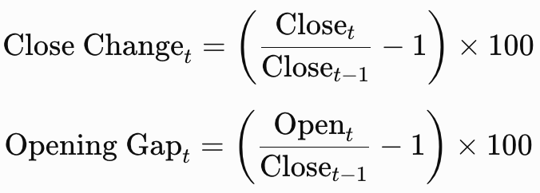

An observation was flagged when:
∣Close Changet​∣ ≥ 30% or ∣Opening Gapt​∣ ≥ 30%

The absolute-value rule covers both upward and downward discontinuities. The 30% benchmark was informed by the PSE’s reduction of the lower static price threshold from 50% to 30% as a safeguard against extraordinary individual-security price movements (Philippine Stock Exchange, 2020). The benchmark is applied uniformly as a conservative research-screening criterion and is not treated as an automatic corporate-action classifier.

The automated screening was supplemented by a review of predetermined official-event dates. These dates were included even when the corresponding price changes did not reach 30%. This step enabled rights offerings, mergers, company-name changes, share-structure events, and material company announcements to be considered explicitly.

Each documented observation was compared with the original PSE Daily Quotations Report and, when required, an official PSE or PSE EDGE disclosure. The review considered whether the event produced a permanent price-scale reset, a temporary market reaction, a naming-continuity issue, or an extraction error.

Table 17. Preliminary Selection-Stage Price-Discontinuity Review
Symbol | Reviewed Date | Close Change | Opening Gap | Event or Review Basis | Structural Reset Identified | Final Treatment
APX | 2020-10-16 | 34.84% | 49.68% | Statistical flag; event-driven mining and oil sector rally | No | Retained unchanged and flagged for interpretation
ALI | 2022-06-29 | -1.47% | 0.00% | Voting preferred share convertibility commenced | No | Retained unchanged and documented
GLO | 2022-09-16 | -2.75% | -3.49% | Stock rights offering ex-rights date | No | Retained unchanged and documented
GLO | 2022-10-28 | 0.09% | -1.72% | Additional rights shares listing or timetable date | No | Retained unchanged and documented
SHLPH | 2023-03-28 | -0.74% | 0.00% | Corporate name change reflected in PSE systems; ticker unchanged | No | Retained; raw names preserved and mapped to one canonical company
BPI | 2024-01-02 | 1.93% | 0.19% | First trading date following the BPI–Robinsons Bank merger effective date | No | Retained unchanged and documented
JFC | 2026-01-06 | 14.5% | 3.87% | Material spin-off announcement and temporary trading halt | No | Retained unchanged and documented

In the preliminary selection-stage screen, APX on October 16, 2020 was the only observation that reached the 30% statistical criterion. The raw record was retained as valid market behavior. This historical screen is distinct from the frozen 26-date corporate-action registry used for the corrected formal holdout sensitivity analysis.

Six additional predetermined dates were reviewed during preliminary company selection and remained below the screening threshold. These seven selection-stage records do not define or replace the corrected formal holdout registry.

The SHLPH review also confirmed that the security retained the same ticker throughout the study period. The raw source-reported names are preserved, while the model-ready and dashboard layers may use Shell Pilipinas Corporation as the canonical name.

The preliminary screening reviewed seven stock-date records, including one statistical flag, using the then-available selection dataset. Those preliminary counts are retained only as historical selection evidence. For the corrected formal experiment, all 15 frozen files and 24,360 company-date observations passed structural validation, and the separate versioned registry governed the 26-date holdout sensitivity analysis.

Neither the preliminary screen nor the corrected formal audit is presented as an exhaustive legal audit of every issuer disclosure. The corrected audit establishes that the formal evidence is internally consistent with its frozen registry; external disclosure completeness remains outside that acceptance claim.

The treatment of each flagged observation will depend on the verified nature of the event. Confirmed extraction or transcription errors will be corrected using the corresponding official PSE Daily Quotations Report, after which the affected validation checks and derived variables will be regenerated. Valid market observations will not be removed merely because they contain an unusually large price movement.

Confirmed stock splits, reverse stock splits, stock dividends, or similar share-structure events will be reviewed using the official ex-date, effective date, adjustment ratio, and related disclosure. These events may produce a permanent mechanical change in the price scale that makes pre-event and post-event raw prices difficult to compare directly. Because the study uses raw closing prices and does not construct an adjusted-close or total-return series, no undocumented manual adjustment will be applied. When a confirmed permanent price-scale reset materially affects continuity, the affected company will be reassessed against the study’s data-suitability criteria. Exclusion or replacement will be considered when a defensible and consistent raw-price series cannot be maintained.

Rights offerings, special distributions, share conversions, additional security listings, mergers, and similar events will be verified using their official announcement, ex-date, listing date, effective date, or other applicable event date. When the reported OHLCV values are confirmed as valid market observations and do not represent extraction errors or an unresolved permanent price-scale reset, they will be retained unchanged. The event date, event type, supporting disclosure, observed price movement, and retention decision will be documented for transparency and later interpretation. These events will not be added automatically as model predictors.

Company-name and ticker-symbol changes will be reviewed to determine whether the historical records belong to the same continuing listed entity. A company-name change with an unchanged ticker will be treated as an identity-continuity issue, and the records will be retained under the finalized company name. When the ticker changes but the listed entity remains continuous, the former and current symbols will be documented and mapped to a consistent company identifier before duplicate checks, chronological sorting, and model preparation are performed. Records from unrelated companies will not be combined solely because they use similar or previously assigned ticker symbols.

The corrected formal policy retained validated raw observations in the primary analysis and did not manually adjust market prices. It separately removed every target date listed in the frozen registry from all four models for that company, then recomputed the canonical metrics and rankings. Twenty-six event dates were excluded in this sensitivity analysis, and no company’s principal-model ranking changed. The audit confirms internal consistency with the registry but does not independently establish completeness of all external issuer disclosures.

For the final selected dataset, the preliminary review did not establish a stock split, reverse stock split, stock dividend, or other permanent structural price-scale reset requiring adjustment, exclusion, or replacement. The documented observations were confirmed as valid reported market activity or administrative corporate events rather than extraction errors. Consequently, the affected records were retained unchanged, and no documented event date was automatically excluded from feature construction, target construction, model development, or evaluation.

  - Forecast Target, Forecast Origin, and Forecast Horizon
The common evaluation target is the next-trading-day closing price. Lag-Informed Regression and LSTM estimate the one-trading-day change, ΔCt+1 = Ct+1 − Ct, and reconstruct the target-day price by adding the predicted change to the origin-day Close. ARIMA forecasts the target-day closing-price level with internal differencing.
The forecast origin is the latest complete observation available when a forecast is generated. During formal hold-out evaluation, each origin is a trading date in the chronological test sequence, and its target is the next available trading day’s actual closing price. The procedure does not assume that the next calendar date is an exchange trading day.
For the dashboard’s out-of-sample forecast, the forecast origin is the most recent complete and validated trading record available to the supported ticker. The dashboard will display the forecast-origin date and the intended forecast date when the latter can be established through the supported trading calendar.
The system does not forecast from the incomplete intraday information. All outputs are based on completed end-of-day records and are interpreted as next-trading-day estimates rather than real-time intraday predictions.

  - Model-Specific Data Preparation and Feature Engineering
After the common data-validation and chronological-partitioning procedures, separate model-ready datasets will be prepared for Lag-Informed Regression, ARIMA, LSTM, and the naive benchmark. The preparation procedures differ because the models have distinct assumptions, input structures, and scaling requirements. However, all forecasting methods will use the same forecast horizon, forecast origins, and valid hold-out test dates.

For Lag-Informed Regression and LSTM, the learning target is the one-trading-day change in closing price. ARIMA instead models the closing-price level with internal differencing. Their common evaluation output is the next-trading-day closing price:
ΔC_{t+1} = C_{t+1} – C_{t}
where C_{t} is the observed closing price at the forecast origin and ΔC_{t+1} ​ is the change from the current trading day to the next available PSE trading day. Each predicted change will be reconstructed into the corresponding next-trading-day closing-price forecast through:
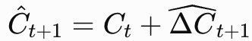
All reported evaluation metrics and dashboard forecasts will be calculated using the reconstructed closing price rather than the predicted change alone.

Lag-Informed Regression Preparation
The Lag-Informed Regression dataset will be constructed from historical returns and OHLCV-derived predictors available on or before the forecast origin. Candidate variables will include lagged daily returns, rolling averages of returns, rolling volatility, the lagged high–low trading range relative to the closing price, lagged log-transformed trading volume, and rolling volume measures.
Candidate return lags of up to 20 trading days will be examined. Partial Autocorrelation Function analysis will be applied to the applicable training series to identify potentially informative lag orders. PACF will serve only as a guide for constructing the candidate feature set and will not make the final feature-selection decision.
The candidate predictors will be standardized through z-score scaling. The scaler parameters will be estimated using the training portion of each rolling-origin fold only and then applied unchanged to the corresponding validation block. For the final hold-out evaluation, the scaler will be fitted using the complete development set and applied unchanged to the hold-out test set.
LASSO regularization will serve as the final Lag-Informed Regression estimator rather than merely as a preliminary feature-selection method. The regularization parameter will be selected through expanding-window rolling-origin cross-validation based primarily on average validation RMSE. Predictors with non-zero LASSO coefficients will form the final forecasting equation. No separate ordinary-least-squares refitting procedure will be performed after LASSO selection.

ARIMA Preparation
ARIMA uses each company’s chronologically ordered closing-price level series. Candidate differencing values are applied internally as part of the declared order-trend search. ARIMA’s output is the next-trading-day closing-price level, evaluated on the same target dates as the reconstructed Lag-Informed Regression and LSTM forecasts.
The Augmented Dickey–Fuller test will be applied to the applicable training data to support the determination of the required differencing order. Autocorrelation Function and Partial Autocorrelation Function analyses will guide the identification of plausible autoregressive and moving-average orders. Candidate (p,d,q) combinations will then be evaluated through a bounded search using expanding-window rolling-origin validation.
ARIMA will not require feature scaling. After the appropriate order is selected, forecasts of the differenced series will be converted back into closing-price levels through reverse differencing. The model will use a walk-forward, one-step-ahead procedure during the final hold-out evaluation so that each forecast is produced using only observations available at its corresponding forecast origin.

LSTM Preparation
The LSTM model will use a univariate sequence of historical one-day closing-price changes. The change series will be normalized to the range [0,1] using Min-Max scaling. The scaler will be fitted using only the applicable training data and applied unchanged to the validation and hold-out observations.
The scaled change series will be converted into input–output pairs using sliding windows. Each input sequence will contain a fixed number of previous closing-price changes, while the target will be the change for the next trading day. Candidate look-back windows and other LSTM hyperparameters will be evaluated through expanding-window rolling-origin cross-validation.
After prediction, the scaled LSTM outputs will be inverse-transformed into their original change values. Each predicted change will then be added to the most recent observed closing price to obtain the reconstructed next-trading-day closing-price forecast.

Naive Benchmark Preparation
The naive random-walk benchmark will use the most recent observed closing price as the forecast for the next trading day:
Ĉ_{t+1} = C_{t}
The naive benchmark does not require feature construction, scaling, hyperparameter selection, or model training. It will be generated for the same hold-out test dates used by Lag-Informed Regression, ARIMA, and LSTM.
The naive forecast is a mandatory benchmark rather than an optional diagnostic model. It provides a direct reference for determining whether the three principal forecasting methods demonstrate forecasting skill beyond the simple assumption that the next closing price will remain equal to the latest observed closing price.

  - Chronological Data Splitting
To obtain a stable model-selection procedure and a single unbiased final evaluation, the cleaned series for each company is partitioned chronologically into a development set and a final hold-out test set. No shuffling is applied at any stage.

The most recent 15% of each company’s observations is reserved as the final hold-out test set. It is not accessed during feature selection, scaler fitting, model configuration, order selection, hyperparameter tuning, or early stopping. It is used only after all modeling decisions have been finalized to compute the reported test metrics, benchmark comparisons, statistical comparisons, and model rankings.

The earliest 85% forms the development set. A single fixed validation period is not used because the historical period includes different market conditions, including the early-2020 disruption, the succeeding recovery, and later periods of normalization. Model selection based on only one validation interval could be overly dependent on the conditions of that particular period.

Model selection therefore uses expanding-window or rolling-origin cross-validation inside the development set. The development period is divided into six contiguous and approximately equal-width blocks. In the first fold, the model is trained using the first block and validated through one-step-ahead forecasts on the second block. Each succeeding fold adds the earlier validation block to the training history and evaluates the candidate on the next chronological block.

For fold k, where k=1,…,5:
Training Window_{k} = B₁,...,B_{k}
Validation Window_{k} = B_{k+1}

where B_{i} represents the ith contiguous development block.

Candidate configurations are ranked using their mean one-step-ahead validation RMSE across the five folds, while MAE is retained as a supporting validation measure. The procedure applies to model-specific configuration selection, including the LASSO regularization parameter, ARIMA order, and LSTM sequence and architecture settings.

The Naive random-walk benchmark requires no hyperparameter tuning and is evaluated directly on the same 243 holdout targets. Seasonal Naive is outside the frozen four-method formal comparison.

After the best configuration for each principal model is selected, the model is refitted using the entire 85% development set and evaluated once on the untouched 15% hold-out test set. All methods for a given company are compared using the same valid hold-out dates.

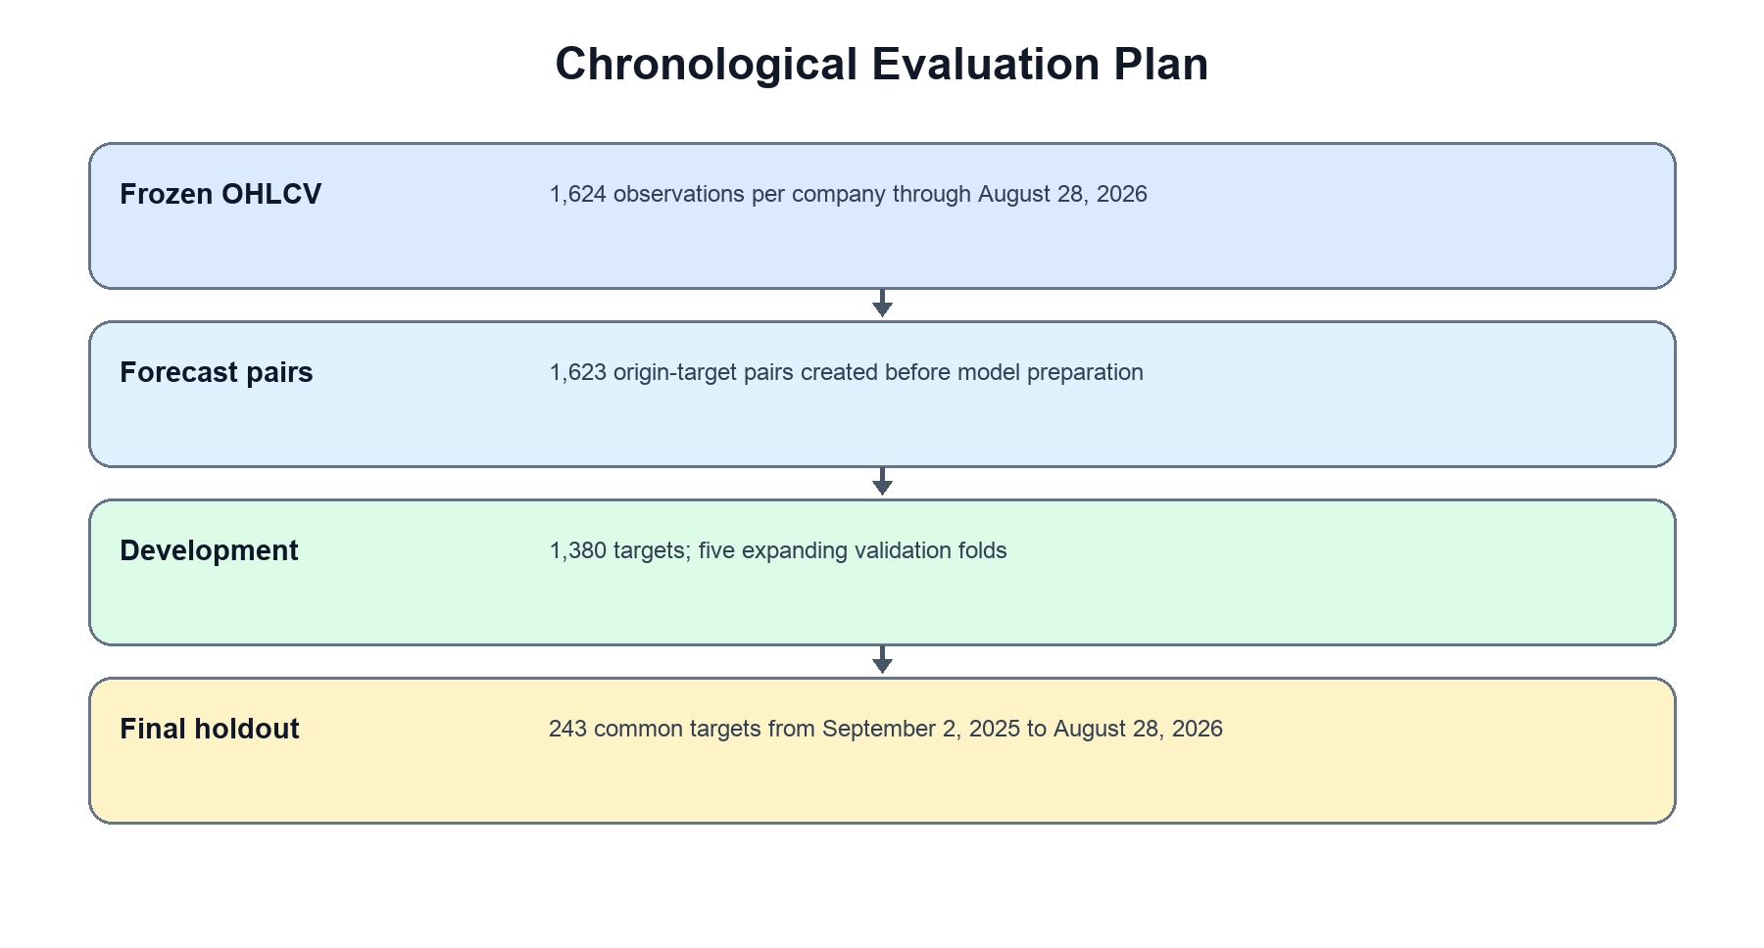
Figure 9. Chronological Data Splitting and Rolling-Origin Validation
Figure 9 shows the complete cleaned series divided into an earlier 85% development set and a later 15% untouched hold-out set. Within the development set, six consecutive blocks should be arranged as an expanding staircase. Each fold trains on all preceding blocks and validates on the immediately following block. The selected configuration is then refitted on the full development set and evaluated once on the hold-out test set.
  - Data Leakage Prevention
Data leakage prevention is enforced throughout the pipeline. No feature, transformation, configuration, or forecast is allowed to use information that would not have been available at the relevant forecast origin.

Within each rolling-origin fold, scalers are fitted using only the current training blocks. The fitted parameters are applied unchanged to the corresponding validation block. Data-dependent lag identification, feature selection, stationarity testing, and parameter estimation are likewise limited to the training history available in that fold.

For final evaluation, preprocessing transformations are refitted using only the complete development set and are applied unchanged to the hold-out test set. The hold-out observations do not influence regression feature selection, ARIMA order selection, LSTM hyperparameter selection, early stopping, or model-ranking decisions.

Each hold-out prediction is one-step ahead and uses only information preceding the forecasted date. Model configurations remain frozen once final evaluation begins, and no modeling decision is revised after the hold-out results are inspected. This time-respecting design follows recommended forecasting-evaluation practice and prevents future observations from influencing earlier predictions (Tashman, 2000).

  - Evaluation-Ready and Dashboard-Ready Outputs
After model development and final hold-out evaluation, the pipeline will export the validated analytical results into structured files for statistical analysis, documentation, reproducibility, and Next.js dashboard integration. The dashboard will load these saved outputs during normal use rather than retraining the formal study models whenever the application is opened. This design preserves the integrity of the reported results, reduces runtime processing, and ensures that users view only verified outputs produced by the controlled forecasting pipeline.

All exported files will retain the corresponding Symbol field or ticker-specific filename so that predictions, metrics, artifacts, and automatically acquired data cannot be associated with the wrong company. The exact filenames may be refined during implementation, but the output categories and required contents will remain consistent.

Evaluation-Ready Output Files
Evaluation-ready files contain the results generated from the untouched 15% hold-out test set. These files provide the basis for calculating performance metrics, comparing models, testing the hypotheses, determining model rankings, and preparing the results chapter.

Table 18. Evaluation-Ready Output Files
Output Category | Example File or Directory | Required Contents | Primary Use
Hold-out predictions | predictions/{SYMBOL}_test_predictions.csv | Forecast origin date, target date, Symbol, Actual_Close, Actual_Change, model-specific Predicted_Change, reconstructed Lag_Informed_Regression_Prediction, ARIMA_Prediction, LSTM_Prediction, and Naive_Prediction | Actual-versus-forecast analysis and metric calculation
Forecast errors | residuals/{SYMBOL}_test_residuals.csv | Date, Symbol, Model, Actual_Close, Predicted_Close, Error, Absolute_Error, and Squared_Error | Residual analysis, error visualization, and interpretation of unusual forecast dates
Model performance summary | metrics_summary.csv | Symbol, Sector, Model, RMSE, MAE, MASE, R², Test_Start, Test_End, and Test_Observations | Formal model comparison and dashboard metric display
Naive benchmark results | benchmark_results.csv | Symbol, benchmark type, RMSE, MAE, MASE, R², and comparison with each principal model | Determines whether the principal models outperform the simple random-walk benchmark
Model rankings | model_rankings.csv | Symbol, Sector, Model, RMSE_Rank, MASE, Final_Rank, and Best_Model indicator | Identifies the best-performing principal model for each company
Cross-stock summary | cross_stock_performance.csv | Symbol, Sector, best model, MASE, model rank, benchmark result, and selected supporting metrics | Company-level and sector-peer comparison
Statistical comparison results | statistical_tests/ | Test level, Symbol where applicable, test name, compared methods, loss function, DM statistic, HAC bandwidth, HLN-corrected statistic, p-value, Holm-adjusted p-value, moving-block bootstrap confidence interval and p-value, Friedman statistic, post-hoc Wilcoxon statistic, significance decision, and effect direction, as applicable | Hypothesis testing and formal statistical reporting
Validation-performance summary | rolling_validation_summary.csv | Symbol, Model, Candidate_Configuration, Fold, Validation_RMSE, Validation_MAE, and Average_RMSE | Documents model-selection results without using hold-out data
Selected configuration summary | selected_model_configurations.csv | Symbol, Model, selected parameters, average validation score, and selection basis | Reproducibility and model-development documentation
Data split summary | data_split_summary.csv | Symbol, total observations, development dates, hold-out dates, and number of validation folds | Confirms chronological partitioning and common evaluation periods

The hold-out prediction files will align all models on the same valid test dates. If a model-specific lag or sequence requirement causes the earliest possible forecast date to differ, the final comparative file will retain only the common intersection of dates for which Lag-Informed Regression, ARIMA, LSTM, and the naive benchmark all produced valid predictions.

Lag-Informed Regression and LSTM estimate the next-trading-day change in closing price and reconstruct it into a next-trading-day closing-price forecast. ARIMA models the closing-price level with internal differencing. All three methods are evaluated as next-trading-day closing-price forecasts. The hold-out prediction files will therefore retain both the predicted change, where applicable, and the reconstructed closing-price forecast to support reproducibility.

RMSE will serve as the primary within-company ranking metric. MAE will provide a supporting measure of forecast error in Philippine pesos, while MASE will support scale-free comparisons across companies and sector peers. R² will remain a secondary descriptive measure. The exported ranking files will therefore identify the lowest-RMSE principal model for each stock while preserving all supporting metrics and benchmark results for interpretation.

The complete statistical-output directory will retain the technical results of the two-level comparison procedure. Within-company files will contain the Diebold–Mariano results under squared-error and absolute-error loss, together with the HAC bandwidth, Harvey–Leybourne–Newbold correction, Holm-adjusted p-values, and moving-block bootstrap results. Across-company files will contain the stock-level Friedman result and the Holm-adjusted Wilcoxon signed-rank post-hoc comparisons when applicable.

Dashboard-Ready Data Files
Dashboard-ready files organize the verified historical data and formal evaluation results into formats that can be loaded efficiently by Next.js and React. These files may contain the same underlying information as the evaluation outputs, but they will be arranged specifically for filtering, visualization, and user-facing interpretation.

Table 19. Dashboard-Ready Output Files
Dashboard Output | Example File | Required Contents | Dashboard Use
Historical data bundle | dashboard_data/historical_ohlcv.csv | Date, Symbol, Company, Sector, Open, High, Low, Close, and Volume | Historical-data and company-detail charts
Company master data | dashboard_data/company_master.csv | Symbol, canonical company name, official sector, official subsector, and supported status | Stock selection, company headers, and sector filtering
Performance bundle | dashboard_data/model_performance.csv | Symbol, Model, RMSE, MAE, MASE, R², ranking, and benchmark comparison | Model Performance page
Forecast history | dashboard_data/forecast_history.csv | Date, Symbol, Model, Actual_Close, Predicted_Change where applicable, reconstructed Predicted_Close, and residual | Actual-versus-forecast charts
Best-model summary | dashboard_data/best_model_summary.csv | Symbol, best model, RMSE, MAE, MASE, R², and benchmark result | Summary cards and company-level model ranking
Sector-peer summary | dashboard_data/sector_peer_summary.csv | Sector, Symbol, company, MASE, model rank, benchmark result, and selected comparison fields | Cross-company and sector-peer comparison
Statistical-test summary | dashboard_data/statistical_test_summary.csv | Test level, test name, Symbol where applicable, methods compared, adjusted p-value, significance decision, effect direction, and simplified interpretation | Simplified statistical-results display
Latest forecast summary | next_day_forecasts.csv | Symbol, forecast-origin date, forecast date, model, predicted change, reconstructed predicted Close, model version, and generation timestamp | Company Detail and Live Prediction pages
Data-quality summary | dashboard_data/data_quality_summary.csv | Symbol, records, coverage, missing values, stale-run result, and liquidity status | Data provenance and quality information
Event-documentation summary | dashboard_data/event_flags.csv | Symbol, date, event type, verification result, and final treatment | Contextual notes for documented market or corporate-event dates
Dashboard configuration | dashboard_bundle.json | Page settings, available tickers, data paths, supported filters, and default selections | Centralized dashboard configuration
Explanation content | dashboard_data/explanations.json | Metric definitions, chart guidance, model limitations, statistical-test explanations, and disclaimers | Tooltips, help panels, and plain-language explanations

The historical dashboard bundle may contain all 15 stocks in one combined file because Symbol functions as the stock identifier. The dashboard will filter the data according to the user’s selected ticker, sector, and date range. The individual stock-level files will remain available for validation and reproducibility even when the interface uses a combined dataset.

The dashboard-ready statistical-test file will present simplified interpretations suitable for budding traders. The company-level results will indicate whether a model produced a statistically significant difference in forecast loss compared with the naive benchmark or another principal model. The across-company results will summarize whether systematic performance-rank differences were identified across the 15 stocks.

The complete statistical outputs—including the DM statistic, HAC bandwidth, HLN-corrected statistic, squared- and absolute-loss results, Holm-adjusted p-values, moving-block bootstrap interval and p-value, stock-level Friedman result, post-hoc Wilcoxon results, assumptions, and technical notes—will remain available in the formal evaluation directory and research documentation.

Saved Model and Preprocessing Artifacts
Selected model configurations will be saved after formal evaluation so that the dashboard can load the appropriate ticker-specific model without retraining it. The artifact format will depend on the model type and software library used.
Table 20. Expected Model and Preprocessing Artifacts
Model or Object | Example Artifact | Stored Information
Lag-Informed Regression model | {SYMBOL}_lag_regression.joblib | Fitted LASSO coefficients, intercept, selected regularization parameter, and model state
Regression feature scaler | {SYMBOL}_regression_scaler.joblib | Training-derived means and standard deviations
Regression feature specification | {SYMBOL}_regression_features.json | Selected lagged returns and OHLCV-derived predictors, lag definitions, rolling windows, and expected column order
ARIMA model | {SYMBOL}_arima.pkl | Fitted ARIMA model, selected order, differencing configuration, and model state
LSTM model | {SYMBOL}_lstm.pt | PyTorch model weights and architecture state
LSTM scaler | {SYMBOL}_lstm_scaler.joblib | Training-derived Min-Max scaling parameters for the univariate change series
LSTM configuration | {SYMBOL}_lstm_config.json | Window size, hidden units, layer settings, training configuration, and expected change-sequence shape
Naive benchmark configuration | {SYMBOL}_naive_config.json | Benchmark definition and previous-closing-price forecast rule
Artifact manifest | {SYMBOL}_artifact_manifest.json | Metadata connecting the ticker, model, preprocessing objects, versions, learning target, reported target, and training period

Each model artifact will be linked to the exact preprocessing objects required for prediction. For example, a Lag-Informed Regression artifact must be loaded together with its selected feature list and fitted scaler, while an LSTM artifact must be loaded with the correct change-sequence window definition, architecture configuration, and fitted Min-Max scaler.

The dashboard will verify the artifact manifest before prediction. A model will not be loaded when the selected ticker, expected feature schema, preprocessing version, or model version does not match the available data.

Artifact Metadata and Version Control
Every saved model package will include a metadata or manifest file to support reproducibility, freshness checking, and correct model-data matching.

Table 21. Minimum Artifact Metadata
Metadata Field | Description
symbol | Supported PSE ticker for which the artifact was trained
company_name | Canonical company name
sector | Official PSE sector
model_type | Lag-Informed Regression, ARIMA, LSTM, or benchmark
model_version | Version identifier of the trained artifact
preprocessing_version | Version of the data-preparation and transformation rules
data_start_date | Earliest observation used for development or deployment fitting
training_cutoff | Latest observation used to fit the artifact
learning_target | Next-trading-day change in closing price for the three principal models
reported_target | Reconstructed next-trading-day closing-price forecast
required_columns | Expected input columns, including Date, Symbol, Open, High, Low, Close, and Volume
selected_features | Final lagged returns and OHLCV-derived predictors required by Lag-Informed Regression, where applicable
window_size | Required LSTM change-sequence length, where applicable
model_parameters | Final selected model or architecture configuration
scaler_reference | Required scaler filename or identifier
artifact_created_at | Date and time the artifact was generated
source_data_version | Version or identifier of the validated dataset
freshness_status | Current, warning, or outdated status based on the approved operational rule

The combination of the Symbol, model_version, preprocessing_version, and source_data_version fields ensures that the dashboard uses compatible datasets and artifacts. This prevents a scaler or model trained for one company from being applied to another stock.

Formal Study Outputs and Deployment-Ready Artifacts
A clear distinction will be maintained between the outputs used for formal research reporting and the artifacts used for future dashboard inference.

Table 22. Formal Study Outputs versus Deployment-Ready Artifacts
Aspect | Formal Study Outputs | Deployment-Ready Artifacts
Primary purpose | Comparative research evaluation | Controlled dashboard forecasting
Data used | 85% development set for model selection and untouched 15% hold-out set for final evaluation | May be refitted using the complete validated historical dataset after formal evaluation
Metrics and rankings | Official reported RMSE, MAE, MASE, R², benchmark, ranking, and statistical results | Not used to replace the formal hold-out results
Model configuration | Frozen before hold-out evaluation | Uses the configuration selected during formal development
Statistical testing | Based on finalized hold-out results using the approved two-level procedure | Not repeated automatically during dashboard use
Runtime behavior | Loaded as saved predictions, metrics, statistical results, and summaries | Loaded for controlled ticker-specific inference
Effect on formal findings | Defines the study’s conclusions | Does not modify previously reported metrics, rankings, or statistical decisions

The formal test metrics, model rankings, benchmark results, and statistical decisions will remain fixed after the untouched hold-out evaluation. Refitting a selected configuration on the full validated dataset may improve its operational readiness by allowing it to use the most recent historical observations, but this deployment refit will not replace the evaluation results reported in the study.

Output Directory Structure
The output directories may be organized as follows:
results/
├── evaluation/
│ ├── predictions/
│ ├── residuals/
│ ├── metrics_summary.csv
│ ├── benchmark_results.csv
│ ├── model_rankings.csv
│ ├── cross_stock_performance.csv
│ ├── rolling_validation_summary.csv
│ ├── selected_model_configurations.csv
│ └── data_split_summary.csv
├── statistical_tests/
│ ├── dm_results.csv
│ ├── dm_bootstrap_results.csv
│ ├── friedman_results.csv
│ └── wilcoxon_posthoc_results.csv
├── next_day_forecasts/
└── dashboard_data/
├── historical_ohlcv.csv
├── company_master.csv
├── model_performance.csv
├── forecast_history.csv
├── best_model_summary.csv
├── sector_peer_summary.csv
├── statistical_test_summary.csv
├── data_quality_summary.csv
├── event_flags.csv
├── explanations.json
└── dashboard_bundle.json

artifacts/
├── SECB/
├── BPI/
├── MBT/
├── MER/
├── JFC/
├── SHLPH/
├── MEG/
├── ALI/
├── SMPH/
├── GLO/
├── PGOLD/
├── ICT/
├── APX/
├── NIKL/
└── SCC/

Each ticker-specific artifact directory will contain only the models, scalers, configurations, and metadata applicable to that company. This structure supports maintainability and reduces the risk of loading an incorrect model during dashboard inference.

Dashboard Loading and Automated Forecast Delivery
During normal dashboard use, the historical and evaluation pages will read the saved dashboard-ready files. The application will not rerun rolling-origin validation, model selection, hold-out testing, hypothesis testing, or full model training during runtime.

The Live Prediction function, when implemented, will load only the deployment-ready artifact assigned to the automatically acquired source file’s supported ticker. Before prediction, the system will validate the following:

- the file contains the required Date, Symbol, Open, High, Low, Close, and Volume columns;
- the Symbol is one of the 15 supported tickers;
- the acquired ticker matches the supported company being processed;
- all rows contain only one consistent ticker;
- dates are valid, unique by Date and Symbol, and chronologically ordered;
- OHLCV fields satisfy the approved data-type and logical-validity rules;
- the file contains sufficient historical observations for the required predictors or change-sequence window; and
- the preprocessing version and saved artifact are compatible with the acquired data structure.

Files containing an unsupported stock, mixed symbols, an incorrect schema, duplicate stock-date records, null required values, or a ticker-artifact mismatch will be rejected with a clear validation message.

After valid automated acquisition and validation, the approved deployment configuration produces a next-session forecast. The output remains separate from formal metrics, statistical tests, and research rankings.

  - Data Engineering and Analytics Pipeline Diagram
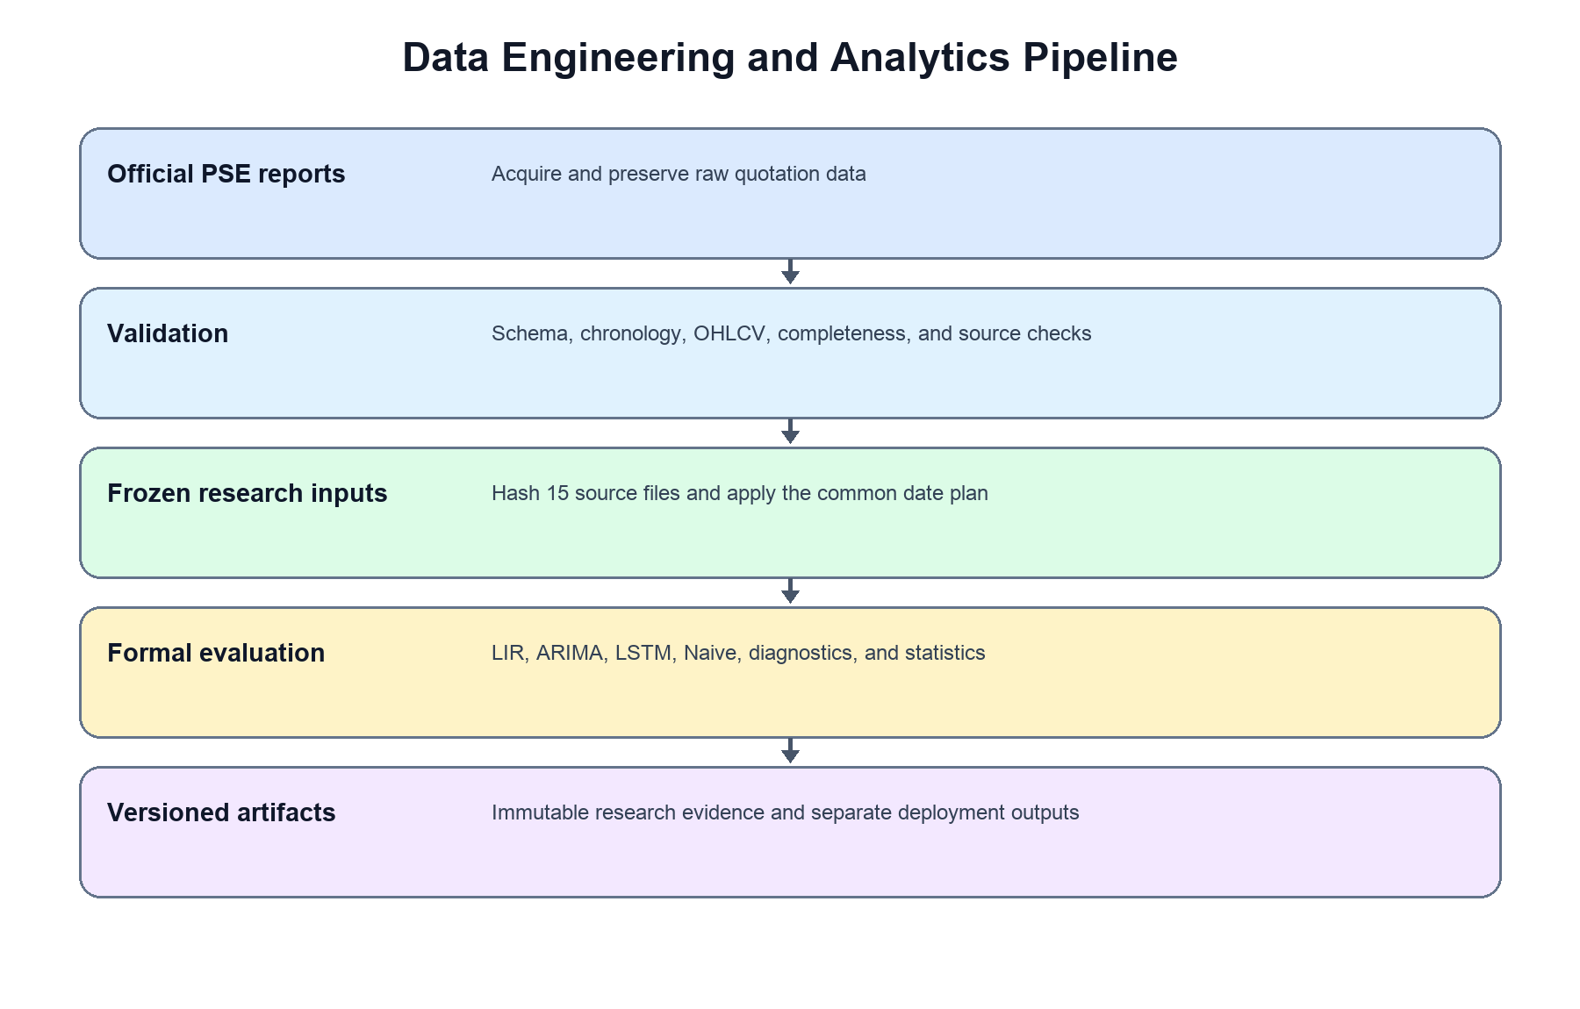
Figure 10. Data Engineering and Analytics Pipeline
The Data Engineering and Analytics Pipeline Diagram presents the researcher-controlled workflow from official source acquisition to versioned outputs. For the corrected formal experiment, validated raw observations remain in the primary analysis, while the frozen corporate-action registry defines a separate date-exclusion sensitivity analysis applied consistently to all methods.

The validated series is divided chronologically into an 85% development set and a 15% untouched holdout set. Lag-Informed Regression and LSTM prepare next-day closing-price changes; ARIMA prepares the price-level series with internal differencing; Naive carries the origin Close forward. All four outputs are aligned to identical target-day closing prices before metrics and statistical tests are computed. Versioned outputs are loaded by the Next.js dashboard rather than recomputed during normal use.

  - Reproducible Data Engineering and Analytical Controls
The data engineering workflow will be implemented using reproducible and traceable processing controls. Original PSE Daily Quotations Reports will be preserved unchanged in a dedicated source directory, while extracted raw records, validated datasets, model-ready data, and dashboard-ready outputs will be stored in separate folders. This separation prevents source files from being overwritten and allows every transformed output to be traced to its official origin.

Data extraction, cleaning, validation, target construction, feature preparation, chronological splitting, and output generation will be performed through documented Python notebooks or modular scripts rather than through undocumented manual editing. The same validation rules, field definitions, data-quality benchmarks, corporate-action screening procedures, and date-partitioning logic will be applied consistently to all 15 selected companies. Input files, processing scripts, configuration settings, and generated outputs will use standardized filenames and version identifiers.

Reproducibility will also be supported through Git and GitHub version control, documented software dependencies, fixed random seeds where applicable, saved preprocessing specifications, train-fitted scalers, selected model configurations, artifact manifests, and source-data metadata. Each major analytical output will record the associated ticker, model, training cutoff, preprocessing version, source-data version, and generation date. These controls will allow the researchers to rerun the pipeline, verify the origin of reported results, and determine which data and configurations produced each forecast, metric, ranking, and statistical result.

Model Development and Analytical Evaluation
Model development will be conducted separately for each of the 15 selected PSE-listed companies across the five sectors: SECB, BPI, and MBT (Financials–Banks); MER, JFC, and SHLPH (Industrial); MEG, ALI, and SMPH (Property); GLO, PGOLD, and ICT (Services); and APX, NIKL, and SCC (Mining and Oil). Each selected company will have three corresponding forecasting models: Lag-Informed Regression, ARIMA, and LSTM. This will result in 45 model configurations, consisting of 15 selected companies multiplied by three forecasting models. All models will be evaluated using the same chronological, rolling-origin test-set structure for each company to ensure that model performance is compared under consistent conditions
The purpose of this section is to explain how each forecasting model will be prepared, trained, evaluated, and compared. Lag-Informed Regression will represent the interpretable machine learning approach, ARIMA will represent the classical statistical time-series approach, and LSTM will represent the deep learning sequential approach. The three models will be developed under the same OHLCV-only forecasting setup, but each model will require a different preparation procedure because of differences in model assumptions, input structure, and training requirements.
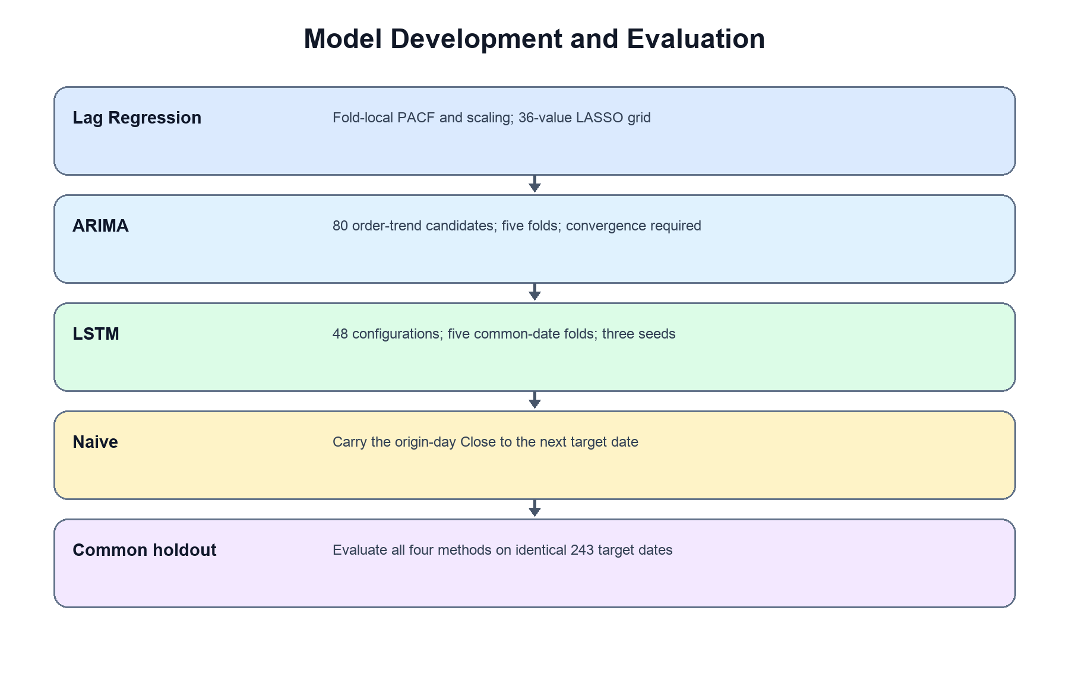
Figure 11. Model Development and Evaluation Workflow Diagram
This figure presents the separate model development pipelines used in the study. Lag-Informed Regression creates OHLCV-derived features, applies fold-local PACF to daily returns, performs fold-local scaling, and uses LASSO as the final estimator. ARIMA models closing-price levels with internal differencing and searches a bounded order-trend grid. LSTM uses univariate closing-price changes in a one-layer network. The Naive random-walk model supplies the mandatory benchmark.

  - General Modeling Setup
The cleaned OHLCV datasets were prepared separately for each selected stock. Lag-Informed Regression and LSTM forecast the one-step-ahead change in closing price and reconstruct it to the target-day price. ARIMA forecasts the closing-price level with internal differencing. Every method produces a next-trading-day closing-price forecast on the same origin and target dates. The primary analysis retains all validated observations; registered corporate-action target dates are removed only in a separate sensitivity analysis.
Lag-Informed Regression and LSTM model the one-day change because change-based targets reduce reliance on persistence in highly autocorrelated price levels. ARIMA retains its classical level-series representation and applies differencing internally according to the selected order. Fairness is established through the same forecast horizon, information cutoff, target dates, actual closing prices, and evaluation metrics. All reported outputs are next-trading-day closing-price forecasts in pesos.
The model development process will preserve chronological order to avoid data leakage.Stock price records are time-series data, so all splitting preserves time order rather than using random sampling. The data are divided chronologically into a development set and a final hold-out test set; model selection and hyperparameter tuning use expanding-window rolling-origin cross-validation within the development set, and the hold-out test set is used once for final evaluation (see Chronological Data Splitting and Rolling-Origin Validation). The same test-period observations will be used across Lag-Informed Regression, ARIMA, and LSTM for each selected stock. This setup ensures that Lag-Informed Regression, ARIMA, and LSTM are compared on the same forecasting horizon, the same data scope, the same test dates, and the same evaluation metrics, and that each is measured against the naive benchmark on those identical dates.

  - Sector-Context Separation Procedure in Model Evaluation
To address the distinction between sector context and company-specific behavior, the model evaluation stage will follow a company-first and sector-context interpretation procedure. Each forecasting model will first be evaluated separately for each of the 15 selected companies using the same rolling-origin validation design, the same forecasting horizon, and the same evaluation metrics. The primary evaluation output is therefore the performance of Lag-Informed Regression, ARIMA, and LSTM for each individual company.
After the company-level results are computed, the official PSE sector and subsector classifications are used as a contextual layer for comparison. Because each sector is represented by three peer companies rather than a single company, the study can compare performance both across sectors and among peers within the same sector. This peer structure is central to separating company-specific behavior from broader sector-peer patterns: if an unusual result or movement appears in only one company while its two sector peers behave normally, it is interpreted as possibly company-specific; if the same pattern appears across two or more peers in the same sector within the same period, it is discussed as a possible sector-peer effect rather than an isolated company event.
The study will also apply an abnormal-movement review to support this separation. During preprocessing and evaluation, records may be flagged when they show long missing-date gaps, consecutive zero-volume records, repeated closing prices, sudden price changes, unusual volatility, or large forecast errors. These flagged periods will not automatically be removed from the dataset because they may reflect real market behavior. Instead, they will be documented and reviewed during model interpretation.
When a flagged movement occurs, the interpretation will consider whether the movement appears company-specific or aligned with broader market or sector context. This is checked by comparing the company's movement with available contextual references such as the PSE index, the relevant PSE sector index, the movement of its two sector peers, trading-volume behavior, and data-quality notes. If the company shows an abnormal movement not reflected in its peers or the broader market, the result is interpreted as possibly company-specific. If the movement is consistent with its peers or the broader market, it is discussed as part of the sector or market context affecting the company.
The formal model metrics will still be computed on the untouched hold-out test set to preserve consistency across all selected companies. The discussion of results may additionally include a supplementary interpretation of flagged periods to explain whether large forecast errors were likely influenced by company-specific events, low liquidity, inactive trading, stale-price behavior, or broader market conditions. This procedure allows the study to answer the "how" of sector and company separation through a structured interpretation process rather than relying only on the sector label.

  - Lag-Informed Regression Development
Lag-Informed Regression represents the interpretable machine learning model in this study. It uses historical OHLCV-derived lag features to forecast the next-day closing price. The term lag-informed means that the regression model will not rely on arbitrary lag windows alone. Instead, lag selection will be guided by Partial Autocorrelation Function analysis and refined through LASSO regularization.
The general form of the Lag-Informed Regression model may be expressed as:

Where Ŷ_{t+1}​ is the next-day closing price reconstructed from the predicted one-day price change, β₀​ is the intercept, X_{1,t}​,X_{2,t}​,...,X_{p,t}​ denotes the lag-informed OHLCV-derived feature at time t retained after PACF identification and LASSO selection, β_{1​}, β₂​…,β_{p} are the estimated coefficient for each feature, p is the total number of features retained after LASSO regularization, and ϵ_{t} is the error term at time t.
The development of the Lag-Informed Regression model will follow these steps:
- Set the forecasting target.
The target is the next-day change in the closing price. The predicted change is reconstructed to a price level as Ŷ_{t+1} = C_{t} + ΔĈ_{t+1}, and all error metrics are computed on the reconstructed price.
- Generate candidate lag features.
Candidate features are constructed from past raw OHLCV values only, so no feature uses information dated later than the forecast origin. They include lagged daily returns at lags 1–20; rolling means of returns over 5-, 10-, and 20-day windows; rolling standard deviation of returns over 5- and 10-day windows (volatility); the lagged high–low range as a fraction of the close; and lagged log trading volume with its 5-day rolling mean. The maximum lag examined is 20 trading days.
- Identify candidate lags with PACF.
Partial Autocorrelation Function analysis is applied to the training return series to suggest which lag orders have a direct relationship with the target after controlling for shorter lags. PACF only proposes candidate lags; it does not make the final selection.
- Standardize the features.
All candidate features are standardized by z-score using parameters fitted on the training blocks only, then applied unchanged to later blocks and to the hold-out test set to prevent data leakage.
- Select features and fit with LASSO. LASSO is the final estimator rather than a filter for a second regression. The formal search evaluates 36 logarithmically spaced alpha values from 0.0001 through 1000 across five expanding development folds. Each fold recalculates PACF from its training returns, fits its own StandardScaler, and excludes alpha candidates with unconfirmed convergence. Selection minimizes mean original-scale validation RMSE. A boundary winner blocks formal acceptance until the predeclared grid is expanded. No ordinary-least-squares refit follows LASSO selection.
- Refit and generate forecasts.
The selected configuration is refitted on the full development set and used to produce one-step-ahead forecasts on the hold-out test set. Each predicted change is reconstructed to a closing price and compared with the actual closing price for the corresponding trading day.
- Evaluate model performance.
The forecasts are evaluated using RMSE and MAE for within-stock comparison and MASE for cross-stock comparison, with R² as a secondary descriptive metric, on the same test dates used for ARIMA, LSTM, and the naive benchmark.
- Save model outputs.
The model predictions, actual values, residuals, selected features, performance metrics, and ranking results are saved as dashboard-ready files.
Because this model uses explicit lag-informed predictors, it is expected to be more interpretable than ARIMA and LSTM. Its outputs can help explain which lagged OHLCV features contributed to the forecast and how well the model performed for each selected stock.

  - ARIMA Development
ARIMA will represent the classical statistical time-series model in this study. Unlike Lag-Informed Regression, which uses engineered OHLCV features, ARIMA primarily models the structure of the closing price series itself. ARIMA is composed of three main components: autoregression, differencing, and moving average. These are represented by the parameters p, d, and q.
The ARIMA model is commonly expressed as ARIMA(p,d,q), where p represents the autoregressive order, d represents the differencing order, and q represents the moving-average order. Since stock price series are typically non-stationary, differencing is applied to achieve stationarity. For first-order differencing (d = 1), this is expressed:
ΔY_{t}​=Y_{t}​−Y_{t−1}​
where ΔYt is the first-differenced series, Yt is the closing price at time t, and Yt−1 is the preceding closing price. Differencing is an internal ARIMA operation. The ADF result is retained as a stationarity diagnostic and informs interpretation; it does not uniquely set the final differencing order.
The general ARIMA form may be expressed as:
Δ^{d}Y_{t}​=c+ϕ_{1​}Δ^{d}Y_{t−1​}+...+ϕp​Δ^{d}Y_{t−p}​+θ₁​ϵ_{t−1}​+...+θ_{q​}ϵ_{t−q​}+ϵ_{t}​
where Δ^{d}Y_{t}​ represents the d-th order differenced closing price series, c is the constant term, ϕ_{1​}ϕ_{2,...,}ϕ_{p} represents autoregressive for past values of the differenced series, θ₁θ₂, …, θ_{q} are the moving-average coefficients for past forecast errors, and ϵ_{t}​ is the white noise error term. This formula shows that ARIMA uses both past values of the differenced closing price series and past forecast errors to generate future values.
The development of the ARIMA model will follow these steps:
- Prepare the closing price series.
The cleaned dataset for each selected stock will be sorted chronologically, and the closing price column will be extracted as the main time-series input for ARIMA.
- Check stationarity.
The Augmented Dickey-Fuller test will be applied to the training series to determine whether the closing price series is stationary. A stationary series has a relatively stable mean and variance over time, which is required for ARIMA modeling.
- Apply model-specific differencing. ARIMA models closing-price levels and performs the differencing implied by each candidate value of d. The final value is selected through chronological validation rather than assigned solely from the ADF result.
- Identify candidate orders and select the final model. The formal grid covers p = 0–3, d = 0–2, and q = 0–3, including (0,d,0). Trend is part of candidate identity: none and constant for d = 0, none and linear trend for d = 1, and none for d = 2. All 80 configurations are evaluated across five expanding development folds. Selection uses full-precision mean validation RMSE. An accepted candidate must produce finite forecasts and confirmed optimizer convergence in all five folds under the recorded deterministic retry policy. The final development fit must also confirm convergence.
- Forecast across the holdout by one-step state updating. The selected ARIMA order and trend are fitted once on the complete development series. At each origin, the model forecasts the next target-day Close, receives the newly revealed actual Close, and updates its state with append(actual, refit=False). Parameters are not re-estimated at each origin.
- Reconstruct the price.
Differenced forecasts are converted back to the price level by reverse differencing before evaluation, so ARIMA forecasts the same reconstructed next-day closing price as the other models.
- Compare actual and predicted values.
The ARIMA forecasts are compared with the actual closing prices in the chronological hold-out test set to show how closely the model follows the observed price movement.
- Evaluate model performance.
ARIMA performance is measured using RMSE and MAE for within-stock comparison and MASE for cross-stock comparison, with R² as a secondary descriptive metric, on the same test dates used for Lag-Informed Regression, LSTM, and the naive benchmark.
- Save model outputs.
The forecasted values, actual values, residuals, selected ARIMA order, Ljung-Box results, evaluation metrics, and ranking results will be saved for dashboard presentation and statistical comparison.
This procedure allows ARIMA to test whether selected PSE stock prices contain statistical time-series patterns that can support next-day forecasting. Since ARIMA requires stationarity, its development process includes stationarity testing, differencing, and order identification before model fitting.
  - LSTM Development
LSTM will represent the deep learning sequential model in this study. Unlike regression and ARIMA, LSTM is designed to learn patterns from ordered sequences of data. This makes it suitable for testing whether nonlinear temporal relationships exist in the selected stock price series.
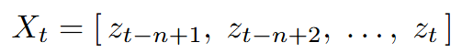
The LSTM model processes sequential inputs using memory cells and gating mechanisms. The model receives a look-back window of scaled values from the daily closing-price change series:

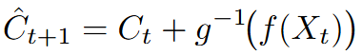
and produces a predicted next-day change, which is inverse-scaled and reconstructed to a closing price:

where X_{t} is the look-back window, z are the Min-Max-scaled daily closing-price changes over the n most recent time steps, n is the look-back window size (a tunable hyperparameter), f(·) is the learned nonlinear mapping produced by the LSTM network, g⁻¹(⋅) is the inverse Min-Max transformation, and Ct is the latest observed closing price used to reconstruct the price level. The LSTM therefore learns from a sequence of past changes rather than treating each trading day as an isolated observation.
Before training, the change values are normalized using Min-Max scaling. The normalization formula is:
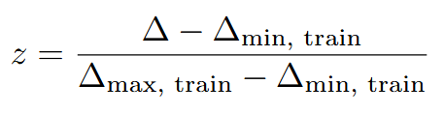

where z is the scaled change in the range [0, 1], Δ is the daily closing-price change, and Δmin,train and Δmax,train are the minimum and maximum changes in the training set. The scaler is fitted exclusively on the training data to prevent data leakage, and the same fitted parameters are applied to the validation and test sets without refitting. After the LSTM generates predictions in the scaled range, the outputs are inverse-transformed and reconstructed to peso prices before evaluation metrics are computed.
The development of the LSTM model will follow these steps:
- Prepare the univariate change series. Closing prices are ordered chronologically and converted to daily changes for the one-layer LSTM. The primary analysis retains validated corporate-action observations; a separate sensitivity analysis excludes registered event target dates consistently across all models.
- Scale the values with Min-Max scaling. Within each development fold, the scaler is fitted only on the fold-training values that precede the internal chronological stopping tail. It is then applied unchanged to the stopping and validation samples. A fresh final scaler is later fitted on every complete-development change before the fixed-epoch refit.
- Create sliding-window sequences.
The scaled series is converted into input–output pairs using a sliding-window approach: a fixed look-back window of scaled changes serves as the input sequence, and the next scaled change serves as the target output.
- Define the architecture and hyperparameters. The network has one LSTM layer followed by a linear output layer and uses Adam with mean-squared-error loss. The 48 configurations combine lookbacks 5, 10, 20, and 30; hidden sizes 25, 50, and 100; learning rates 0.01 and 0.001; and batch sizes 16 and 32. All configurations use identical validation target dates based on maximum lookback 30, five expanding folds, and tuning seeds 42, 123, and 2026. A chronological tail inside each fold-training block controls early stopping with patience 10, while the untouched fold validation block is used only for configuration scoring. Ranking uses mean original-scale RMSE across all folds and seeds; the best seed is never selected.
- Train the final LSTM model. After configuration selection, a preliminary development fit with seed 42 and a chronological stopping tail determines the fixed epoch count. The tail is excluded from preliminary scaler fitting. A fresh scaler is then fitted to every complete-development change, and a fresh model is trained on all development sequences for the fixed number of epochs using seed 42. The final holdout is evaluated only after this complete-development refit.
- Generate next-day forecasts.
The trained model produces one-step-ahead predictions on the hold-out test set. The scaled change predictions are inverse-transformed and reconstructed to closing prices (Ĉ_{t+1} = C_{t} + predicted change) before comparison with the actual values.
- Evaluate model performance.
The predicted closing prices are evaluated using RMSE and MAE for within-stock comparison and MASE for cross-stock comparison, with R² as a secondary descriptive metric, on the same test dates used for Lag-Informed Regression, ARIMA, and the naive benchmark.
- Save model outputs.
The LSTM predictions, actual values, residuals, selected configuration, training history, performance metrics, and ranking results will be saved as dashboard-ready outputs.

Table 23. LSTM Hyperparameter Search Grid
Hyperparameter | Values searched
Look-back window | 5, 10, 20, 30
Hidden units | 25, 50, 100
LSTM layers | 1 (fixed)
Optimizer | Adam (fixed)
Learning rate | 0.01, 0.001
Batch size | 16, 32
Max epochs | 200 (with early stopping)
Early-stopping patience | 10 epochs
Loss | Mean squared error (fixed)
Random seed | 42, 123, 2026 tuning; 42 final

The LSTM model tests whether a nonlinear sequence method can improve next-day forecasts. Its greater complexity does not imply better performance, so conclusions depend on the common holdout and benchmark tests.
  - Baseline Benchmark Models
The formal experiment includes the Naive random-walk benchmark. It predicts the next target-day Close as the known origin-day Close on the same 243 holdout dates used by the three principal models. This benchmark determines whether additional model complexity provides incremental forecasting skill.
The formal baseline pipeline runs the Naive random-walk model. Seasonal Naive is outside the frozen four-method research comparison and is not included in the formal statistical evidence.
The Naive benchmark procedure uses the frozen origin-target plan, carries the origin Close forward, records date-indexed predictions and errors, and applies the same canonical metrics as the principal models.
- Prepare the same chronological test set.
The baseline forecasts will be generated using the same untouched test-period observations used for Lag-Informed Regression, ARIMA, and LSTM.
- Generate Naive forecasts.
The Naive model will use the most recent available closing price as the next-day forecast.
- Do not include Seasonal Naive in the frozen formal comparison.
- Compute baseline errors.
RMSE, MAE, and R² where appropriate will be calculated for the baseline forecasts.
- Compare baseline performance with the main models.
The baseline results will be used as a diagnostic reference to determine whether the main models outperform simple benchmark alternatives.
Naive is part of the primary four-method evaluation and the benchmark-first statistical procedure. Descriptive model rankings are interpreted separately from statistical improvement over Naive.

Table 24 consolidates the finalized modeling protocol for all three models and the naive benchmark, so that the complete recipe can be reproduced from a single reference.
Table 24. Finalized Data and Modeling Protocol
Element | Lag-Informed Regression | ARIMA | LSTM | Naive
Learning target | Next-day price change | Closing-price level with internal differencing by order d | Next-day price change | –
Reported target | Reconstructed next-day close | Reconstructed next-day close | Reconstructed next-day close | Previous close
Input features | PACF-suggested lags  → LASSO-selected (max lag 20) | Own price history | Sliding window of past changes (univariate) | Last close
Scaling | z-score, train-fitted | none | Min-Max [0,1], train-fitted | none
Selection method | 36 alpha values via 5-fold rolling-origin CV | (p,d,q) 48 configurations × 5 folds × 3 seeds | 48 configurations × 5 folds × 3 seeds | none
Test forecasting | One-step-ahead, refit on development set | One-step state update with actual Close; refit=False | One-step-ahead, refit on development set | One-step-ahead
Final estimator | LASSO (L1) – final model, no OLS refit | Fixed (p,d,q) | 1 LSTM layer + linear output | Random walk
Reproducibility | Fixed λ grid, fixed folds | 80 order-trend candidates; five folds; convergence required | 48 configurations; 5 folds; 3 tuning seeds; final seed 42 | Deterministic

  - Model Evaluation Metrics
Model performance will be evaluated on the final untouched hold-out test set using a single canonical metric set applied consistently across all 45 model configurations (15 companies × 3 models) and the naive benchmark. For each selected company, every model generates one-step-ahead forecasts for the same test dates, so all metrics are computed on identical observations.
Within-company comparison. Root Mean Squared Error (RMSE) and Mean Absolute Error (MAE) are used to compare models applied to the same company. Both are scale-dependent and expressed in pesos; they are therefore compared only across models fitted to the same stock and never across stocks trading at different price levels (Hyndman & Koehler, 2006).

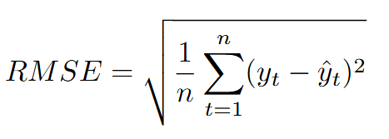

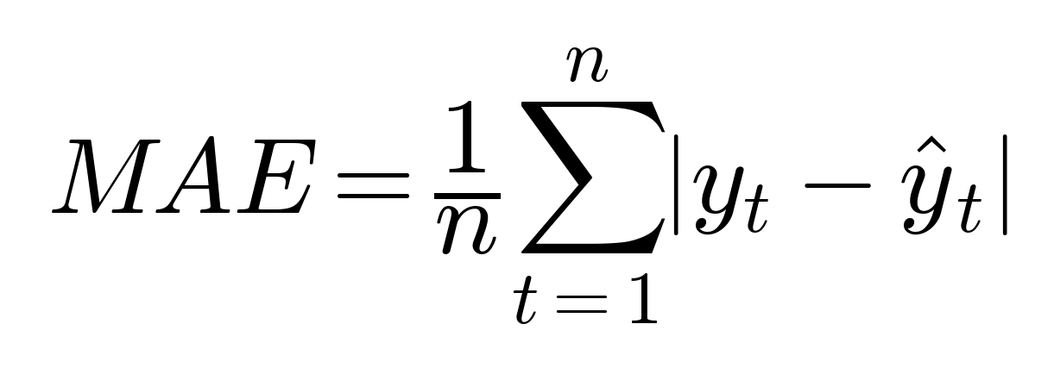

RMSE serves as the primary within-company ranking metric because it penalizes larger deviations more heavily, reflecting the practical cost of large errors in financial forecasting. MAE is reported as the typical absolute error in pesos.
Cross-company comparison. Because RMSE and MAE cannot be compared across companies with different price scales, cross-company and cross-sector comparison uses the Mean Absolute Scaled Error (MASE), a scale-free, benchmark-relative accuracy measure (Hyndman & Koehler, 2006):
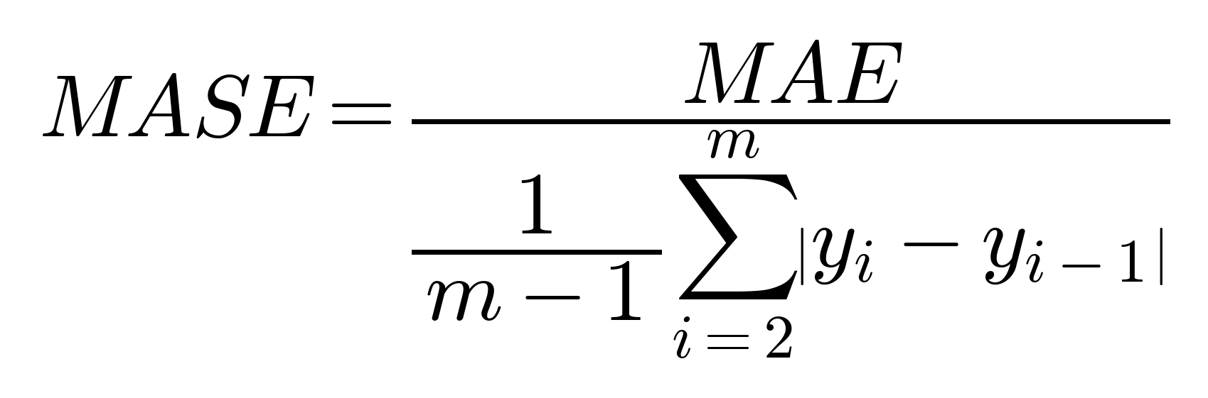

where the denominator is the mean absolute error of the one-step naive (random-walk) forecast computed on the m training observations.MASE is unit-free and benchmark-relative: MASE < 1 indicates a smaller error than the in-sample naive benchmark, MASE = 1 indicates performance equal to that benchmark, and MASE > 1 indicates a larger error (worse than naive). Because the scaling denominator is measured in-sample, the formal determination of whether a model improves on the naive forecast over the test period is made by the Diebold-Mariano test in the Statistical Treatment section, with MASE serving as the scale-free descriptive measure for cross-company comparison. MASE is appropriate for this study because PSE closing prices are strictly positive and bounded away from zero, avoiding the instability that affects percentage errors such as MAPE near small values; this percentage metrics are therefore not used.
Secondary metric. The coefficient of determination (R²) is reported only as a secondary, descriptive measure of fit. Because next-day closing prices are highly autocorrelated, even a naive forecast can attain a high R²; R² is therefore never interpreted as stand-alone evidence of forecasting skill and is read only alongside the naive-benchmark comparison (Armstrong, 2001).
Mandatory Naive benchmark. The Naive random-walk forecast, defined as ŷt+1 = yt, is evaluated on the same 243 holdout observations as the three principal models. A principal model passes the benchmark-first gate only when its one-sided squared-error Diebold–Mariano comparison against Naive remains significant after within-company Holm correction. MASE below 1 is reported as descriptive corroboration, not as a second mandatory gate. Seasonal Naive is outside the frozen formal comparison.

Table 25. Evaluation Metrics
Metric | Role | Interpretation
RMSE | Primary metric for within-company ranking | Lower values indicate better forecasting accuracy. RMSE penalizes larger errors more heavily and is expressed in pesos. It is compared only among models applied to the same stock.
MAE | Supporting metric for within-company comparison | Lower values indicate better forecasting accuracy. MAE represents the average absolute forecast error in pesos and is compared only among models applied to the same stock.
MASE | Scale-free metric for cross-company and sector-peer comparison | MASE is scale-free and benchmark-relative. A value below 1 indicates that the model outperforms the naive forecast, while a value equal to or greater than 1 indicates that it does not outperform the naive forecast.
R² | Secondary descriptive metric | Higher values indicate a better fit between predicted and actual values. However, a high R² alone does not demonstrate forecasting skill and must be interpreted together with the naive benchmark comparison.

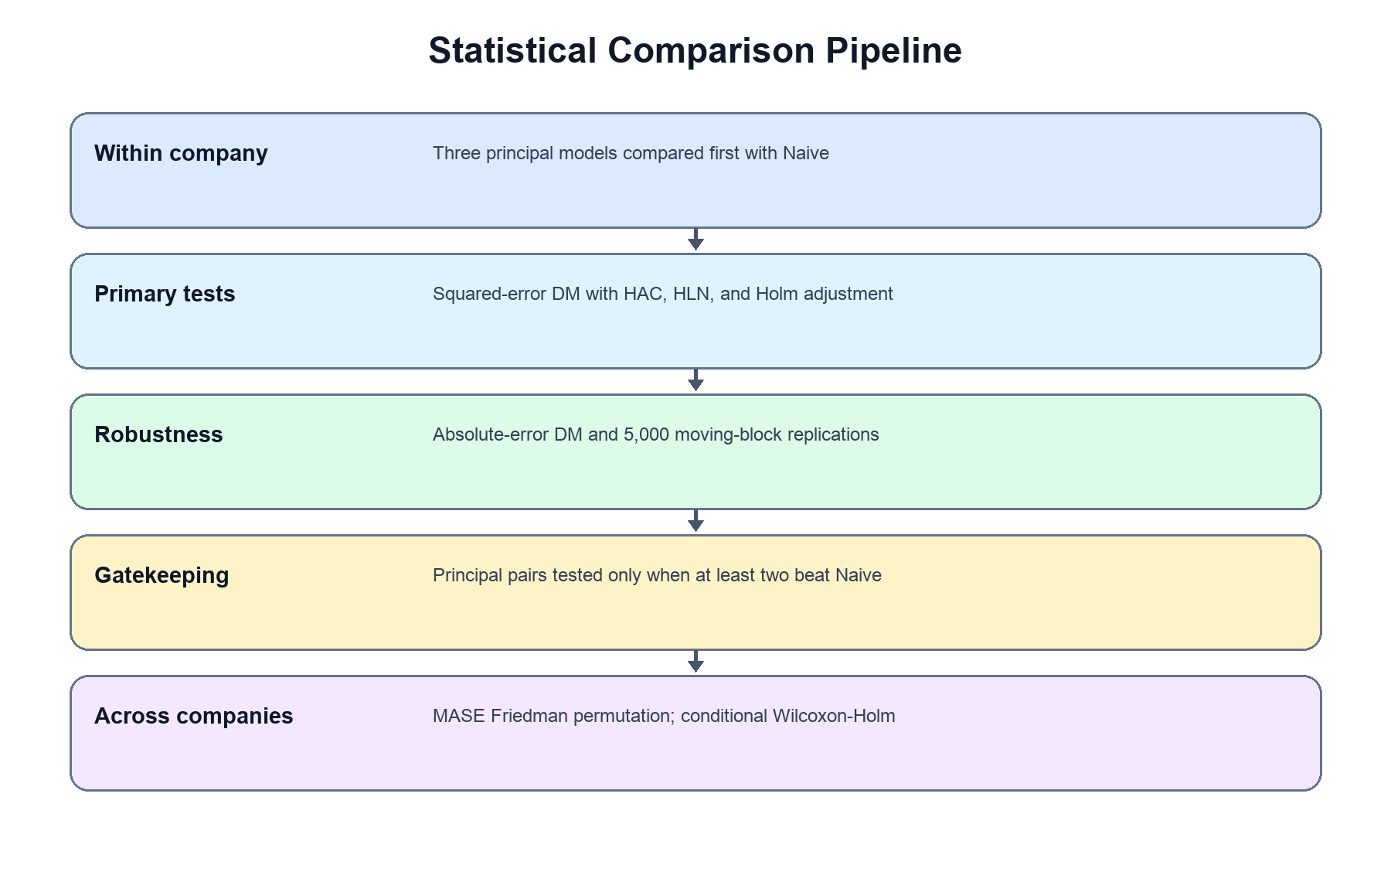
Figure 12. Model Evaluation and Statistical Comparison Pipeline
Figure 12 shows the benchmark-first formal evaluation. Stage 1 compares each principal model with Naive within each company using a one-sided squared-error Diebold–Mariano test with HAC variance, the Harvey–Leybourne–Newbold correction, and within-company Holm adjustment. Only models that pass this gate may enter Stage 2 principal-model comparison for that company. Across companies, the audit reports a Friedman test on company-level MASE and Holm-adjusted paired Wilcoxon signed-rank post-hoc tests. Descriptive RMSE, MAE, MASE, R², residual diagnostics, and rankings accompany but do not replace these inferential rules.
  - Model Diagnostics
Beyond the headline accuracy metrics, each fitted model will be accompanied by standard statistical diagnostics that support honest interpretation of the results. For ARIMA, the Augmented Dickey-Fuller test documents the stationarity decision, and the Ljung-Box test on test-set residuals checks whether temporal structure remains unexplained. For Lag-Informed Regression, the number and identity of LASSO-selected features are reported per stock, together with residual autocorrelation checks. For LSTM, the early-stopping epoch and a data-sufficiency note are reported. For all models, residual normality (Shapiro-Wilk) and volatility clustering (ARCH test) are examined; departures from normality are expected in financial data and motivate the study's use of non-parametric tests for model comparison (Demšar, 2006). Finally, every capstone model's test-set RMSE is compared against the naive baseline computed on the identical test window, and a model is flagged when it fails to improve on the baseline. These diagnostics are generated automatically by the model development workflow and saved alongside the metric outputs, ensuring that the dashboard and manuscript report identical, verifiable values.

  - Statistical Treatment
The statistical treatment evaluates whether the forecasting models differ in accuracy in a manner that respects the dependence structure of the data. Two distinct forms of dependence are relevant. First, forecast errors from neighboring trading days within a company are serially correlated, so tests that treat daily errors as independent are inappropriate. Second, the selected companies are exposed to common market and sector conditions, so their company-level results may be cross-sectionally related. The study therefore adopts a two-level procedure: within-company forecast-comparison tests that are robust to serial dependence, and an across-company comparison conducted at the company level. Because the companies share market-wide influences, cross-company independence is treated as a working approximation rather than an absolute property of the data, and the across-company test is interpreted as supporting evidence rather than as the primary inference.
Hypothesis 1: Model Forecast Error Difference
Because the two levels answer different inferential questions, the hypothesis is stated separately for each level.
Level 1 – Within-Company Hypotheses
For models A and B within company i, with loss differential di,tA,B:
- Null Hypothesis (H₀): E(di,tA,B)=0
(equal expected forecast loss within company i)
- Alternative Hypothesis (Hₐ): E(di,tA,B)≠0
(unequal expected forecast loss within company i)
Level 2 — Across-Company Hypotheses
Across the 15 companies:
- Null Hypothesis (H₀): The models have equal mean performance ranks across companies.
- Alternative Hypothesis (Hₐ): At least one model has a different mean rank across companies.
Level 1 — Within-company forecast comparison (Diebold-Mariano). For each company, models and the naive benchmark are compared pairwise using the Diebold-Mariano (DM) test (Diebold & Mariano, 1995), which evaluates whether two forecasts have equal expected loss by analyzing their loss-differential series rather than treating summary errors as independent observations. Under squared-error loss, the differential on test day t is d_t = e²_{A,t} − e²_{B,t}, where e_{A,t} = y_t − ŷ_{A,t} and e_{B,t} = y_t − ŷ_{B,t}, so that d̄ < 0 indicates model A has lower mean squared error than model B, and d̄ > 0 the reverse. The test statistic is
DM = d̄ / √( V̂(d̄) ),
where V̂(d̄) is a heteroskedasticity- and autocorrelation-consistent (HAC, Newey-West) estimate of the long-run variance of the mean loss differential,
V̂(d̄) = (1/n) [ γ̂₀ + 2 Σ_{ℓ=1}^{L} w_ℓ γ̂_ℓ ], w_ℓ = 1 − ℓ/(L+1),
with γ̂_ℓ the sample autocovariance of d_t at lag ℓ and w_ℓ the Bartlett weight. The truncation lag L is selected by a documented data-driven bandwidth rule and reported, and the conclusions are subjected to a sensitivity check across several reasonable values of L. Retaining a HAC estimator is warranted even though the forecasts are one-step and non-overlapping, because volatility clustering and residual misspecification can leave d_t serially dependent. The small-sample correction of Harvey, Leybourne, and Newbold (1997) is applied,
DM_HLN = DM · √( [ n + 1 − 2h + h(h−1)/n ] / n ), which for h = 1 reduces to DM_HLN = DM · √( (n−1)/n ),
and the statistic is referred to the Student-t distribution with n − 1 degrees of freedom.

Testing order and inferential family. To limit multiplicity and to prioritize the study's central question, a hierarchical (gatekeeping) procedure is used within each company: each developed model is first tested against the naive benchmark; only models that significantly outperform naive are then compared with one another. The comparisons conducted within a single company constitute one inferential family, and a Holm correction (Holm, 1979) is applied within each company at α = 0.05; results are therefore interpreted as company-specific evidence rather than as a single study-wide family of tests.
Loss function and robustness. Squared-error loss is used as the primary DM criterion because it aligns with RMSE, the primary within-company ranking metric. As a robustness check, the DM test is repeated under absolute-error loss, d_t = |e_{A,t}| − |e_{B,t}|, which aligns with MAE and MASE, to confirm that conclusions are stable under both large-error-sensitive and typical-error loss functions. A moving-block bootstrap of the mean loss differential is additionally reported (Künsch, 1989): the loss-differential series is centered under the null hypothesis before resampling, contiguous blocks are resampled with a block length chosen by a documented data-driven rule and checked for sensitivity, B = 5,000 replications are drawn under a fixed random seed, and a two-sided 95% bootstrap confidence interval and p-value for the mean loss differential are reported.
Level 2 — Across-company comparison (stock-level Friedman). To assess whether a model is systematically more accurate across the 15 selected companies, a Friedman test is applied at the company level using one test-set MASE value per model per company, giving 15 blocks and k treatments (the developed models, with the naive forecast added in a supplementary analysis). Applying the test at this level avoids treating serially correlated daily errors as independent observations; each company is treated as a block. Because listed companies may share common market and sector conditions, however, cross-company independence is regarded as an approximation, and this test is reported as a supporting cross-company summary rather than as the study's primary inference. The Friedman statistic,
χ²_F = [ 12 / (N k (k+1)) ] Σ_{j=1}^{k} R_j² − 3N(k+1),
is computed on unrounded MASE values with a tie correction where required; given the small number of blocks (N = 15), an exact or permutation-based p-value is used where available in preference to the asymptotic chi-square approximation. If the omnibus test is significant at α = 0.05, post-hoc comparisons follow: developed models are compared against the naive control using Holm-adjusted Wilcoxon signed-rank tests (the Bonferroni-Dunn control comparison being an equivalent alternative), and qualifying developed models are compared with one another using Holm-adjusted Wilcoxon signed-rank tests. Because a significant omnibus Friedman result establishes only that at least one method differs from another, the claim that a developed model outperforms the naive benchmark rests on these post-hoc control comparisons, not on the omnibus test. It is further noted that, with only 15 blocks, the Friedman and post-hoc procedures have limited power; a non-significant across-company result is therefore interpreted as inconclusive rather than as evidence of equal performance, and the per-company DM tests remain the primary basis for inference. A company-resampling bootstrap that resamples companies rather than trading days is identified as a more complete treatment of cross-sectional dependence and is noted as a future methodological refinement beyond the present scope.
Hypothesis 2: Best-Model Consistency Across Selected Companies
Null Hypothesis 2 (H₀₂): No forecasting model among Lag-Informed Regression, ARIMA, and LSTM ranks as the best-performing model in the majority of the selected PSE-listed companies under the same OHLCV-only next-day forecasting setup.
Alternative Hypothesis 2 (Hₐ₂): At least one forecasting model ranks as the best-performing model in the majority of the selected PSE-listed companies under the same OHLCV-only next-day forecasting setup.
Hypothesis 2 is evaluated as a descriptive ranking summary, not a formal inferential test. For each company, the model with the lowest test-set RMSE is identified as the best-performing model, with MASE, MAE, and R² used to resolve near-ties. A model is described as consistently best-performing if it ranks first in at least 8 of the 15 selected companies. Because this majority-win rule has no valid sampling distribution under serial and cross-sectional dependence, it is reported only as a descriptive characterization of the ranking pattern; the study's inferential conclusions rest on the Level-1 and Level-2 procedures above. Because each subsector is represented by three peer companies, ranking patterns are interpreted at the company and sector-representative level and are not generalized to all companies within a sector.
Software. The Friedman and Wilcoxon signed-rank tests are computed using scipy.stats.friedmanchisquare and scipy.stats.wilcoxon, with exact or permutation p-values where available. The Diebold-Mariano test is implemented with a Newey-West HAC long-run variance and the Harvey-Leybourne-Newbold correction; the moving-block bootstrap is implemented over contiguous loss-differential blocks with a fixed seed. Holm corrections are applied within each defined family of comparisons.

  - Model Output Storage
After model development and evaluation, all relevant outputs will be saved for dashboard use. These outputs will include actual versus predicted values, model performance metrics, residuals, model rankings, best-model summaries, statistical test results, and out-of-sample forecast tables. Trained model files will also be saved where practical.
The dashboard will load these saved outputs instead of retraining all models during user interaction. This supports system stability, reproducibility, and faster dashboard performance. The scheduled deployment forecasting feature, if implemented, will use saved trained model configurations and will not allow users to retrain the models directly through the dashboard.
The model training and tuning pipeline will remain an internal researcher/developer workflow used to generate validated model outputs and saved model artifacts. End users of the Next.js dashboard will not access the training algorithm directly; instead, they will interact only with the prepared dashboard views, saved results, and controlled forecast outputs.

System Design and Web Integration
This section presents the technical structure of the proposed system and explains how its analytical components are connected to the user-facing Next.js dashboard. It describes the overall architecture, major system layers, web integration workflow, and user interaction sequence that support the controlled delivery of validated forecasting results. The design emphasizes modularity, data traceability, ticker-specific processing, reproducibility, responsible use, and the separation of formal model development from dashboard-based exploration.
  - Overall System Design
The proposed computing solution follows a modular analytics-dashboard architecture that separates the formal data and forecasting pipeline from the user-facing web application. The system consists of a data source layer, data engineering and processing layer, forecasting model layer, evaluation and comparison layer, model artifact and output layer, dashboard and web integration layer, and end-user layer. This separation assigns a clear responsibility to each part of the system and supports reproducibility, testing, maintenance, and controlled updating.

Python scripts and notebooks will perform official data extraction, validation, preprocessing, model-specific preparation, model development, evaluation, statistical comparison, and output generation. The completed analytical outputs will then be saved as structured files and ticker-specific model artifacts. The Next.js application will load these approved outputs during normal use instead of repeating the complete modeling workflow whenever a user opens the dashboard.

The system will use a file-based storage architecture rather than a relational database. This design is appropriate because the application primarily reads historical datasets, prediction files, performance summaries, configuration files, explanations, and serialized model artifacts. It does not manage transactional records, user accounts, brokerage information, or continuously changing operational data that would require a database management system.
CSV files will store structured historical data, predictions, metrics, rankings, and summary tables. JSON files will store configurations, explanations, and artifact metadata. Model-specific formats such as Joblib, Pickle, or PyTorch files will store trained forecasting models, fitted scalers, selected feature specifications, and architecture configurations. Every stock-level file will retain the Symbol field or a ticker-specific filename to prevent data and model artifacts from being associated with the wrong company.

The overall system flow artifacts from being associated with the wrong company.

The overall system flow is:

Official PSE Data Sources → Data Engineering and Quality Validation → Model-Specific Preparation → Forecasting and Evaluation → Result and Artifact Storage → Next.js Web Application → Budding Trader

A distinction will be maintained between formal study outputs and deployment-ready model artifacts. Formal study outputs consist of the predictions, metrics, rankings, and statistical results generated through the approved development and untouched hold-out evaluation procedure. Deployment-ready artifacts may be used for controlled exploratory forecasting through the dashboard, but they will not replace or alter the reported formal evaluation results.

  - System Architecture
The system architecture presents the structural relationship among the official data sources, analytical processes, forecasting models, saved outputs, web application, and intended users. It shows how validated market records are transformed into model outputs and then delivered through the dashboard.
Data Source Layer
The architecture begins with the official PSE Daily Quotations Reports, which provide the historical daily market records for the 15 selected companies from January 2, 2020 to August 28, 2026. Official PSE and PSE EDGE references will also provide company names, ticker symbols, official sector classifications, corporate-event disclosures, and supporting source information.

The downloaded Daily Quotations Report PDFs will remain in an untouched source archive. Each extracted observation will retain provenance information that allows it to be traced to the corresponding official report.

Data Engineering and Processing Layer
The data engineering and processing layer will convert the official reports into validated stock-level datasets. It includes data extraction and consolidation, date parsing, Symbol verification, duplicate checking, numeric standardization, OHLC consistency validation, trading-date verification, stock-selection benchmarking, trading-continuity analysis, stale-price assessment, and corporate-action and material price-discontinuity screening.
The final standardized stock-level structure will contain:
Date, Symbol, Open, High, Low, Close, and Volume

The combination of Date and Symbol will serve as the unique stock-date identifier. This prevents observations from different companies from being mixed during preprocessing, model development, evaluation, dashboard filtering, and scheduled deployment prediction.

After validation, the data will be divided chronologically into an 85% development set and a 15% untouched hold-out test set. Expanding-window or rolling-origin validation will be performed within the development period for model-selection and configuration decisions.

Forecasting Model Layer
The forecasting model layer will prepare and develop Lag-Informed Regression, ARIMA, and LSTM separately for each supported company. A naive benchmark will also be generated to determine whether the principal models provide an improvement over a simple persistence-based forecast.

Lag-Informed Regression will use selected OHLCV-derived variables, scaling, lag identification, and LASSO-based feature selection. ARIMA will use the chronological closing-price series with its required stationarity, differencing, and order-identification procedures. LSTM will use scaled and ordered closing-price sequences created through sliding windows. Each method will produce a one-step-ahead estimate of the next trading day’s raw closing price.
Evaluation and Comparison Layer
The principal models and naive benchmark will be evaluated on common valid hold-out dates. RMSE will serve as the primary model-ranking metric, while MAE, MASE, and R² will provide supporting measures.

This layer will also perform baseline comparison, cross-model analysis, company-level ranking, and sector-peer comparison. Statistical comparison and hypothesis testing will follow the procedures specified in the finalized Model Development and Analytical Evaluation section.

The individual company will remain the main unit of analysis. Sector-peer results will be used as contextual comparisons among the three selected companies within each official PSE sector and will not be generalized automatically to all companies in that sector.

Model Artifact and Output Layer
The model artifact and output layer will store the approved analytical outputs before they are loaded into the dashboard. These outputs will include historical dashboard data, hold-out predictions, actual-versus-predicted values, residuals, RMSE, MAE, MASE, and R² summaries, benchmark comparisons, rankings, statistical summaries, next-day forecasts, data-quality reports, and event-documentation records.
The layer will also contain ticker-specific deployment artifacts, including trained models, scalers, selected features, sequence definitions, model configurations, preprocessing specifications, and artifact manifests. Each artifact manifest will identify the supported ticker, model type, training cutoff, model version, preprocessing version, source-data version, required fields, and generation timestamp.

Dashboard and Web Integration Layer
The dashboard and web integration layer will deliver the analytical outputs through the Next.js application. The current prototype contains the following primary interface modules:

Table 26. Primary Interface Modules
Module | Main Function
Home | Introduces the system, supported companies, sectors, models, forecasting horizon, and educational-use boundary
Company List | Displays the 15 supported companies and allows searching or filtering by ticker, name, and sector
Company Detail | Presents company identity, historical closing prices, next-day forecast, actual-versus-predicted results, and supporting metadata
Model Performance | Presents aggregate or company-specific RMSE, MAE, MASE, R², naive benchmark results, model rankings, and comparison charts
Live Prediction | Accepts a validated supported-ticker OHLCV file and generates an exploratory next-trading-day forecast
Learn Stocks | Explains OHLCV variables, forecasting models, evaluation metrics, limitations, and responsible use
About | Presents the research problem, methodology overview, target users, statistical rigor, and research disclaimer

Cross-stock and sector-peer comparisons may be integrated within the Model Performance module rather than displayed as a separate top-level navigation page. This keeps the navigation structure consistent with the prototype while retaining the required comparison functions.
The application will include a persistent navigation bar, company search function, educational-purpose banner, readable cards, plain-language explanations, responsive page layouts, and responsible-use notices. Budding traders are the primary users considered in the design, although students, researchers, and data analytics learners may also use the educational and research content.
End-User Layer
The end-user layer represents the budding trader who accesses the dashboard through a web browser. The user will not be required to create an account or provide brokerage credentials, banking information, or unnecessary personal data.
The user may review historical information, compare forecasting models, examine actual-versus-predicted results, learn forecasting concepts, and generate a controlled exploratory forecast for one of the supported tickers. The system will not execute trades, recommend buy, sell, or hold actions, construct portfolios, or guarantee investment outcomes.
Cross-Cutting Controls
Data provenance, requirements traceability, reproducibility, privacy, responsible-use safeguards, testing, version control, and maintenance apply across the complete architecture. Git and GitHub will support collaboration, source-code management, version history, and documentation, while a Vercel environment will host the approved application version.
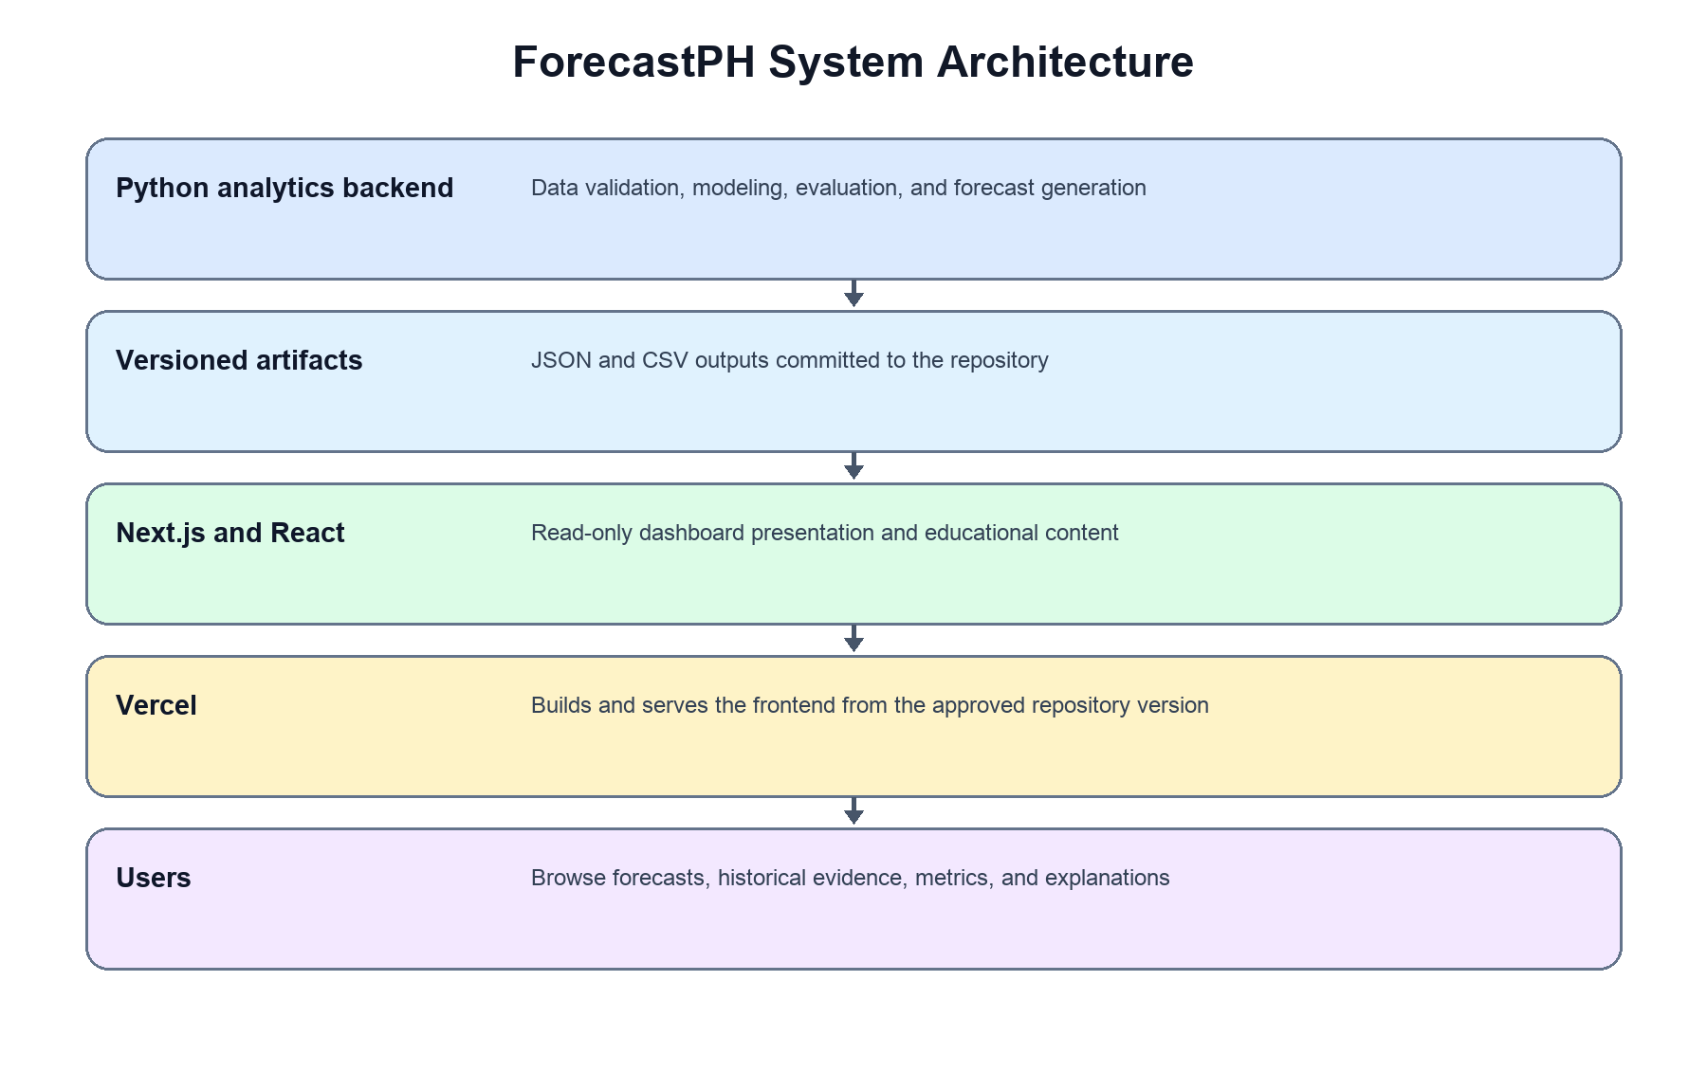
Figure 13. System Architecture Diagram

The System Architecture Diagram presents the connected analytics, artifact, frontend, hosting, and user layers. Lag-Informed Regression and LSTM model next-day closing-price changes; ARIMA models the closing-price level with internal differencing; and Naive carries the origin Close forward. All four yield price forecasts on common target dates.

Lag-Informed Regression and LSTM reconstruct target-day prices from predicted changes, while ARIMA supplies price-level forecasts after internal differencing. The architecture includes benchmark-first Diebold–Mariano tests, an across-company Friedman comparison, conditional Holm-adjusted Wilcoxon tests, diagnostics, rankings, and versioned research evidence. The Next.js dashboard reads approved artifacts and cannot train or alter the formal models.

  - Architectural Components and Notations
The architectural notations clarify how the processes, repositories, modules, users, and data flows are represented in the diagrams.

Table 27. Architectural Components and Notations
Notation | Meaning in the Proposed System
Layered container | A major architectural area containing related processes and responsibilities
Rectangle | A process, page, application module, model, or validation activity
Repository or storage block | A logical file location containing PDFs, CSVs, JSON files, model artifacts, or analytical outputs
Decision symbol | A validation condition that determines whether processing may continue
User or actor symbol | The budding trader interacting with the web application
Solid arrow | The direction of data, output, control, or user-navigation flow
Dashed arrow | An optional or controlled connection, such as loading a ticker-specific artifact for live prediction
Sequence lifeline | A system participant involved in a chronological user interaction
Note block | An explanation of an important system behavior, restriction, or responsible-use condition
Arrows from the official source layer to the data engineering layer show that raw market records must be extracted and validated before they are used in forecasting. Arrows from the forecasting layer to the evaluation layer show that generated next-day forecasts are assessed using common dates and approved performance measures.
Arrows leading to the model artifact and output layer indicate that the analytical workflow exports its results before dashboard integration. Arrows from the output repository to Next.js and React show that the application loads precomputed and verified files rather than repeating the complete model-development procedure during ordinary user interaction.
The Live Prediction workflow is represented separately because it uses approved deployment artifacts for controlled inference. It does not return automatically acquired data to the formal study pipeline, rerun rolling-origin validation, or modify the fixed hold-out results.
  - Web Integration Workflow
The web integration workflow explains how the analytical output repository, Next.js application, deployment environment, and user-facing pages are connected. Next.js and React functions as both the application interface and the Python-based presentation layer. It loads approved data files, manages selected ticker and filter states, and displays interactive charts, summaries, tables, and explanations through the user’s browser.

Application Deployment and Startup
The approved application source code, page logic, configurations, and documentation will be maintained through GitHub. A Vercel deployment environment will host the web application and publish the approved version.
When the application starts, it will load a dashboard configuration file, company master file, supported-ticker list, page content, and available output metadata. The Home page will then display the project overview, number of supported companies, official sectors, forecasting methods, next-trading-day horizon, source information, and educational-use notice.
The values currently shown in the prototype are illustrative and are intended to demonstrate interface organization. During final implementation, mock labels and synthesized values will be replaced with validated outputs derived from the official PSE Daily Quotations Reports.
Analytics Output Repository
The analytics output repository will contain four principal categories of files:
Table 28. Analytics Output Repository
Repository Category | Main Contents
Dashboard data | Historical OHLCV, company master, sector mappings, data-quality summaries, and event documentation
Evaluation results | Hold-out predictions, residuals, metrics, benchmark comparisons, rankings, and statistical summaries
Forecast outputs | Forecast origin, target date, predicted Close, selected model, generation time, and freshness status
Ticker-specific artifacts | Models, scalers, feature lists, sequence settings, configurations, and artifact manifests

A centralized data-loading and integration module will validate the required files, verify output versions, apply Symbol-based filtering, and supply the corresponding information to the requested page. This centralized approach prevents each page from independently locating or interpreting repository files and reduces the possibility of loading incompatible outputs.

Page-Level Integration
The Home page will load the study summary, supported companies, sectors, model information, source information, and quick-access links. The Company List will retrieve the company master file and allow users to search by ticker or company name and filter by official sector.

When a user selects a company, the Company Detail page will request the historical records, latest validated Close, next-day forecast, actual-versus-predicted values, model information, and source metadata associated with that Symbol. The page will not retrieve records belonging to another company.
The Model Performance page will load aggregate or company-specific performance summaries. It will present RMSE, MAE, MASE, R², naive benchmark results, comparison charts, rankings, and simplified statistical interpretations. The underlying formal results will remain fixed and will not be recalculated according to arbitrary user-selected date subsets.

The Learn Stocks page will retrieve plain-language content explaining OHLCV fields, Lag-Informed Regression, ARIMA, LSTM, forecasting metrics, model limitations, and responsible-use boundaries. The About page will display the research problem, system purpose, methodological overview, intended users, and disclaimer.

Scheduled Deployment-Forecast Workflow
The Live Prediction page explains that forecasts are generated by the scheduled backend and published as reviewed JSON artifacts. Users browse the supported companies and cannot submit files or execute model inference in the browser.
Date, Symbol, Open, High, Low, Close, and Volume

The automated source-data validation module will check whether:
- all required fields are present;
- the Symbol is supported;
- the acquired Symbol matches the ticker selected in the interface;
- only one ticker appears in the file;
- Date–Symbol combinations are unique;
- dates are valid and chronologically ordered;
- OHLCV fields are numeric, complete, and logically consistent;
- the file contains sufficient history for the required feature or sequence preparation; and
- the acquired data structure is compatible with the available preprocessing version and deployment artifact.

If the file fails any required check, processing will stop and the page will display a specific error message identifying the missing, invalid, or incompatible information.

The scheduled backend loads the approved ticker-specific preprocessing rules, configuration, and deployment artifact, validates newly acquired data, and exports a versioned next-session forecast. This operational forecast remains separate from the frozen formal experiment.

The result will display the Symbol, forecast origin, intended forecast date, predicted closing price, selected model, model version, preprocessing version, training cutoff, generation timestamp, and freshness status. The automatically acquired source file will not retrain the model, revise its hyperparameters, or replace the formal study results.

Deployment and Maintenance Integration
GitHub will support source-code management, documentation, collaboration, and controlled releases. The application will be updated only after changes to data files, model artifacts, preprocessing rules, or page logic have been validated.

The deployment structure will separate application code from large source files and development-only artifacts where necessary. File paths, expected versions, environment dependencies, and deployment instructions will be documented to allow the application to be reproduced and maintained.
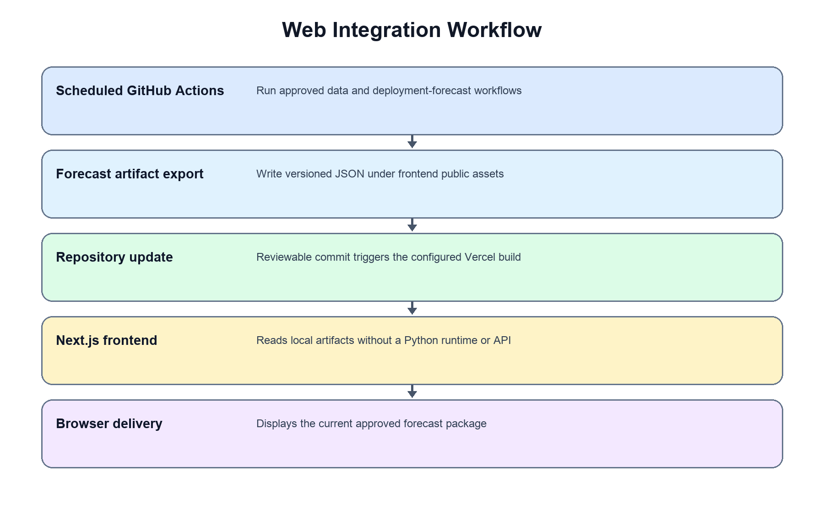
Figure 14. Web Integration Workflow Diagram
The Web Integration Workflow Diagram shows how the approved source code, deployment environment, analytics repository, and Next.js application are connected. A centralized loader retrieves validated historical data, reconstructed forecasts, RMSE, MAE, MASE, and R² results, naive-benchmark comparisons, statistical summaries, and ticker-specific artifacts before supplying them to the appropriate dashboard pages.

The Live Prediction page is a read-only explanation and status view. Scheduled backend workflows validate supported-ticker OHLCV data, generate deployment forecasts, and publish versioned artifacts. The browser does not accept files, run models, conduct formal tests, or retrain any model.

  - User Interaction Flow
The User Interaction Flow Diagram is presented as a sequence diagram because it focuses on the chronological communication among the budding trader, web interface, analytics output repository, automated source-data validation module, and artifact and inference module.
Application Access
The interaction begins when the budding trader opens the Next.js dashboard through a browser. The web interface requests the dashboard configuration, company master data, supported tickers, sectors, explanation content, and metadata from the analytics output repository. After these files are returned, the Home page displays the main navigation options, search function, project summary, and educational-purpose notice.
Formal model development is not triggered during this startup process. The system retrieves only the outputs required to present the dashboard interface.

Company Exploration
When the user opens the Company List, the interface requests the 15 supported companies and their official sector classifications. The user may search by ticker or company name or apply a sector filter.

After a company is selected, the interface requests records associated with that Symbol. The repository returns the historical OHLCV data, latest validated closing price, next-day forecast, actual-versus-predicted results, evaluation information, and source metadata. These are then displayed on the Company Detail page.

Model Performance Review
When the user opens the Model Performance page, the interface may present either the aggregate view or a company-specific view. The repository returns the approved RMSE, MAE, MASE, R², naive benchmark, ranking, and statistical summary files.
The interface then displays metric cards, comparison charts, interpretive notes, and a detailed performance table. Lower values of RMSE, MAE, and MASE indicate lower forecasting error, while R² provides supporting information on the extent to which the model captures variation in the actual closing-price series.

Educational and Research Content
When the Learn Stocks page is selected, the dashboard retrieves the educational content explaining OHLCV variables, the three forecasting models, evaluation metrics, limitations, and responsible-use guidance.
When the About page is selected, the application retrieves the project overview, research problem, methodology summary, intended users, and research disclaimer. These pages support the stakeholder requirement for understandable explanations and transparent forecasting limitations.

Live Prediction Interaction
When the user opens Live Prediction, the interface displays the required CSV fields and live forecast status information. The user selects a supported ticker and submits an updated OHLCV file.
The file and selected Symbol are sent to the automated source-data validation module. The module checks the required fields, ticker consistency, date format, duplicates, chronological order, OHLCV values, sufficient historical observations, and artifact compatibility.
An invalid file produces a validation response that identifies the failed requirements and returns the user to the company browsing page. A valid file allows the interface to request the matching model, scaler, preprocessing specification, configuration, and manifest from the artifact and inference module.
The scheduled backend verifies the ticker, data schema, freshness, preprocessing version, and compatible deployment artifact before generating a next-session forecast. The frontend displays the resulting versioned artifact without executing model code.
The user may continue navigating among the dashboard pages, select another supported company, review another model view, or select another supported company without restarting the formal analytics workflow.
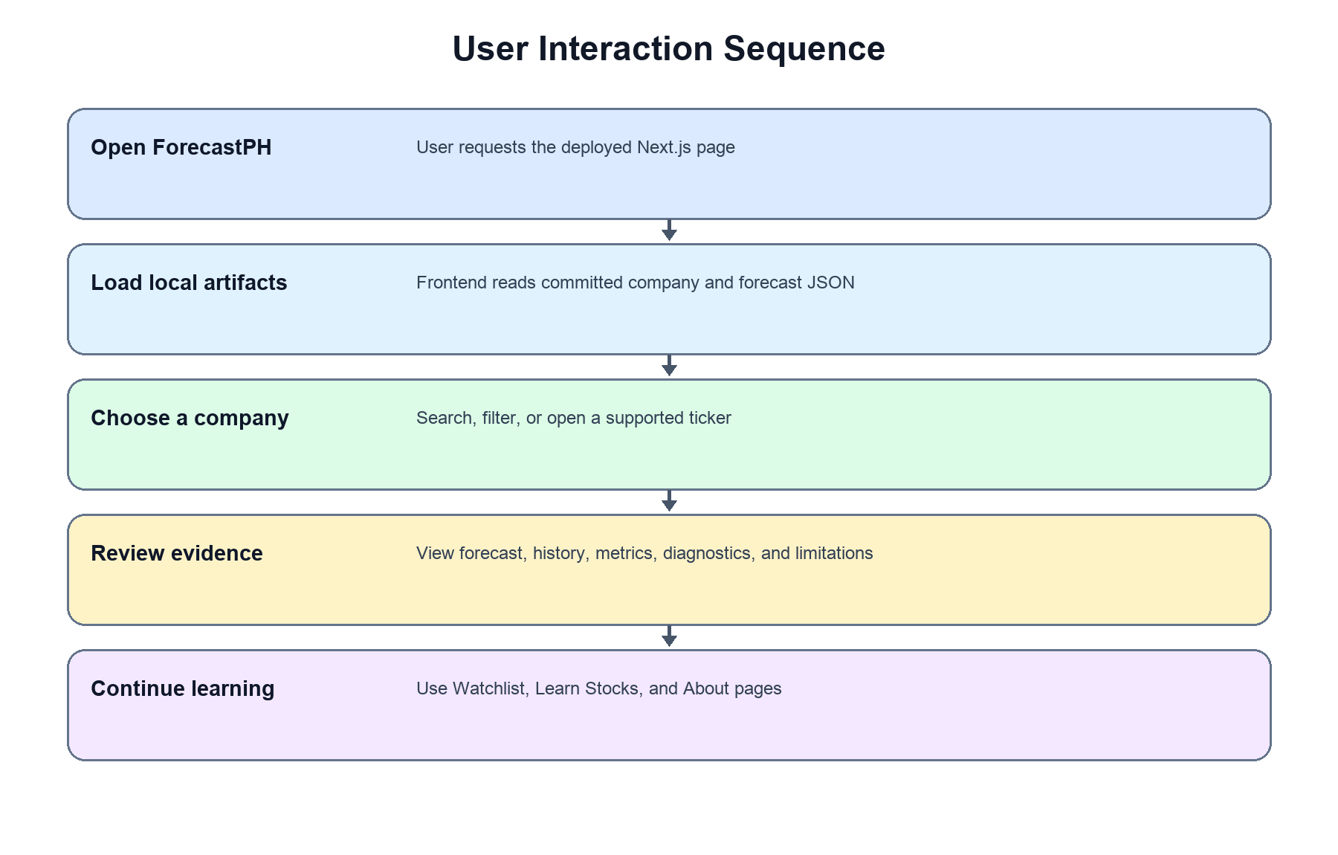
Figure 15. User Interaction Sequence Diagram
The User Interaction Sequence Diagram shows a user opening ForecastPH, loading committed artifacts, choosing a supported company, reviewing forecasts and evidence, and continuing to the educational pages. It contains no upload or browser-side training step.
The sequence emphasizes that dashboard pages retrieve validated saved outputs. Scheduled acquisition, validation, and forecast generation occur outside the browser and remain isolated from the immutable formal study evidence.

Dashboard Design and Web UI Validation
The dashboard design and web user interface validation section explains how the forecasting outputs will be presented to users through a reusable model-comparison dashboard. The dashboard will serve as the user-facing component of the capstone project. It will not replace the formal modeling pipeline; instead, it will display the validated outputs produced from the data engineering, model development, evaluation, and statistical comparison processes.
The dashboard will be designed primarily for budding traders. These users may be interested in learning about stock market behavior and exploring model-based forecasts, but they may not have programming, advanced statistical, or machine learning knowledge. Because of this, the dashboard must present technical outputs in a guided and understandable way through charts, metric cards, comparison tables, short explanations, and responsible-use notes.
The dashboard will present historical OHLCV data, model performance metrics, forecast visualizations, cross-stock comparisons, one-step-ahead out-of-sample forecasts, and controlled automated daily forecasting. It will also include disclaimers and interpretation notes to remind users that forecast outputs are uncertain and are not equivalent to trading recommendations, buy-or-sell signals, or professional financial advice.

  - Dashboard Design and Page Structure
The dashboard will use a sidebar navigation layout that allows users to move between the major pages of the system. The planned dashboard pages include Home, Company List, Company Detail, Model Performance, Live Prediction, Learn Stocks; and About. The sidebar will also contain stock and model selectors where applicable.
The page structure is designed to support the learning flow of budding traders. The Home page introduces the purpose and limitations of the dashboard. The Data Overview page helps users inspect historical stock behavior. The Model Performance page helps users compare the accuracy of the three models. The Forecast Visualization page shows actual versus predicted values and residuals. The Cross-Stock Analysis page helps users compare performance across selected sector representatives. The Out-of-Sample Forecast page presents the latest one-step-ahead forecast from the prepared dataset. The Live Forecast Status page supports exploratory forecasting using properly formatted OHLCV files and saved model artifacts.

    - Home Page
The home page introduces the purpose of the dashboard and provides quick navigation buttons to explore forecasts, make live predictions, or learn about forecasting concepts. It features summary cards that highlight the study's scope, including the expanded 15 selected PSE-listed companies across five sectors, the three forecasting models, the next-day prediction horizon, and the primary data source. It also prominently displays a responsible-use disclaimer stating that the dashboard is for educational purposes only and should not be used as financial advice
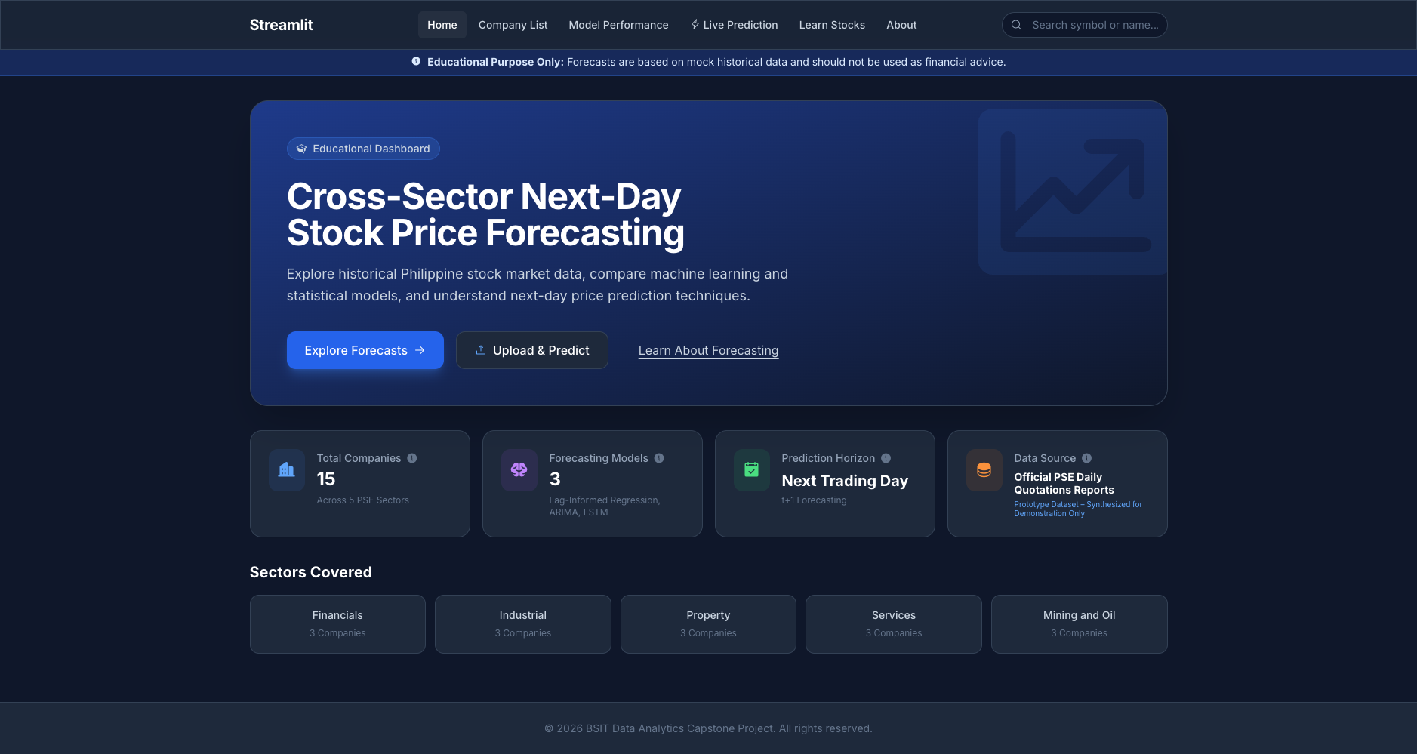
Figure 16. Home Page

    - Company List Page
The Company List page serves as the main directory where users can view and select any of the 15 included PSE-listed companies, categorized by their respective sectors. Upon selecting a specific company, the dashboard directs users to an integrated company view that displays the stock's historical closing prices, its latest closing price, and its one-step-ahead next-day forecast. To streamline the user experience, this page now also incorporates the actual versus predicted charts, allowing users to immediately visually assess model performance for that specific stock.

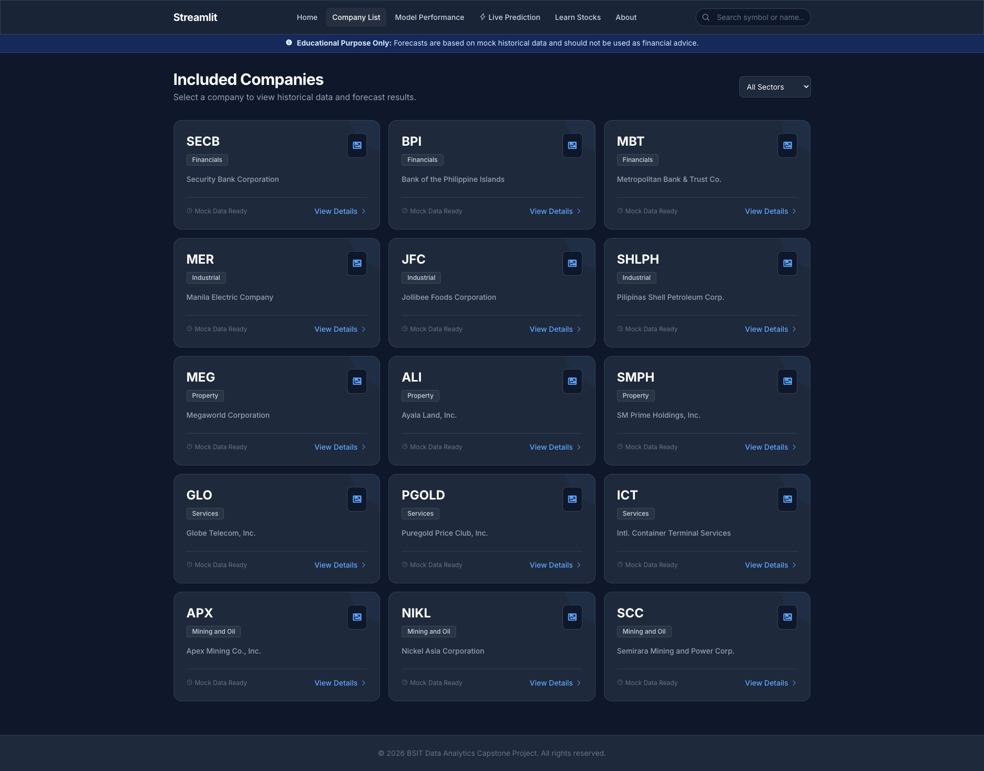
Figure 17. Company List Page
    - Model Performance Page
The Model Performance page now provides an aggregate view of model evaluation metrics across all 15 selected companies, rather than just individual stocks. It features summary cards highlighting the overall best-performing models based on RMSE, MAE, MASE, and R². Visual bar charts compare these errors side-by-side against a naive baseline, while a detailed performance table ranks Lag-Informed Regression, ARIMA, and LSTM to clearly show which model architecture performed best overall.
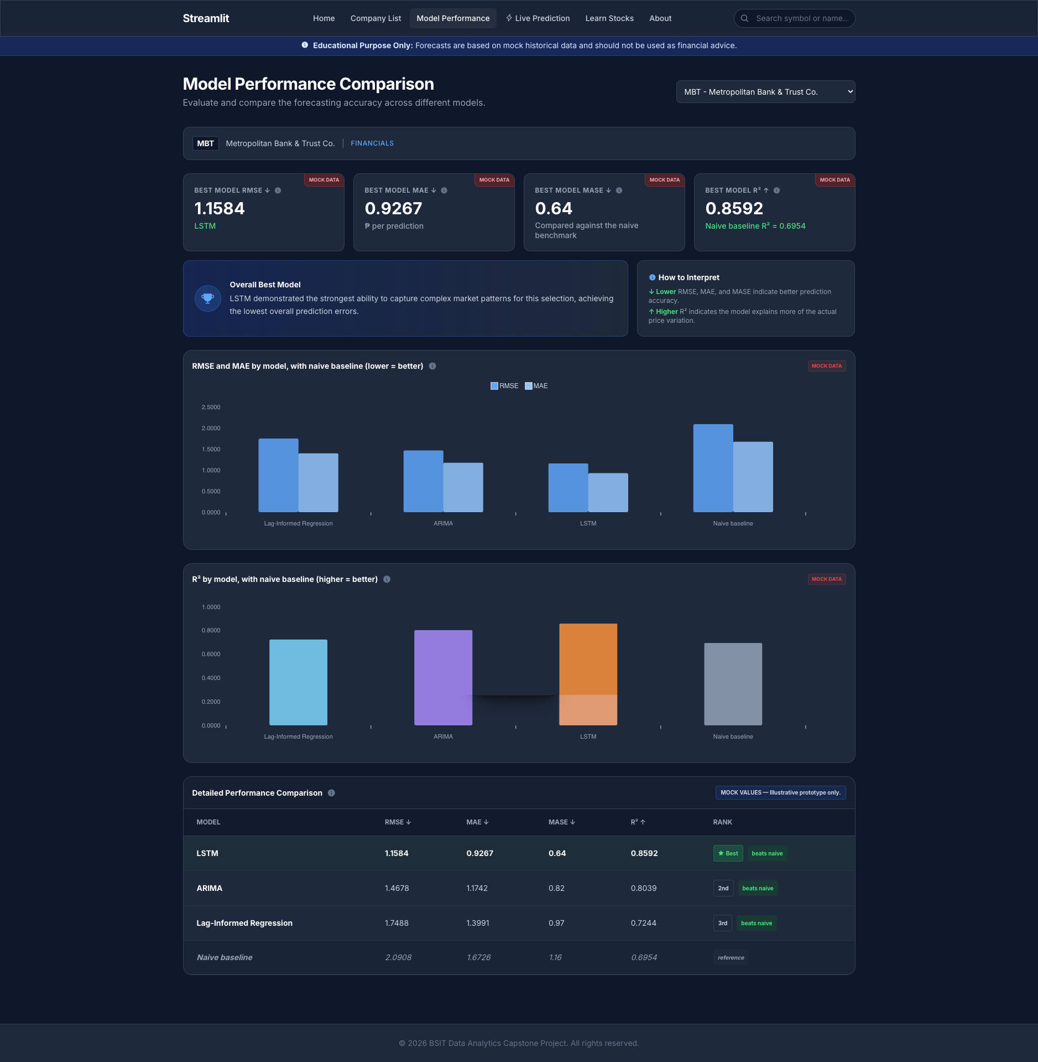
Figure 18. Model Performance Page

    - Company Historical Data and Forecast Page
The Company Historical Data and Forecast page provides a detailed, integrated view of a selected stock's behavior. It displays the stock's latest closing price alongside a line chart tracking its historical closing prices. Crucially, this page incorporates an actual versus predicted chart for the test set, allowing users to visually compare the accuracy of Lag-Informed Regression, ARIMA, and LSTM against the true stock price. It also features a Next-Day Forecast card that highlights the predicted price generated by a selected model, accompanied by an educational note reinforcing that the visualizations are for analytical education-support and do not represent real-time trading advice.
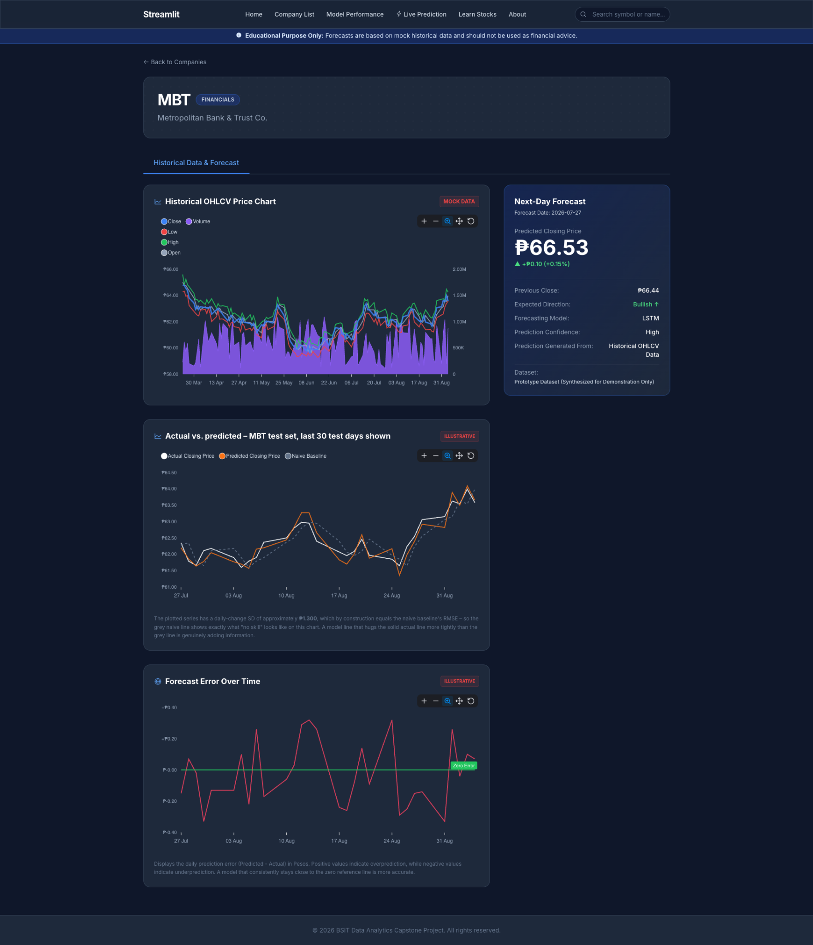
Figure 19. Company Historical Data and Forecast Page
    - Live Prediction Page
The Live Prediction page is a read-only status and guidance page. It explains that the original browser-upload prototype was retired because the deployed frontend contains no Python runtime. Users browse forecasts already generated by the scheduled backend.
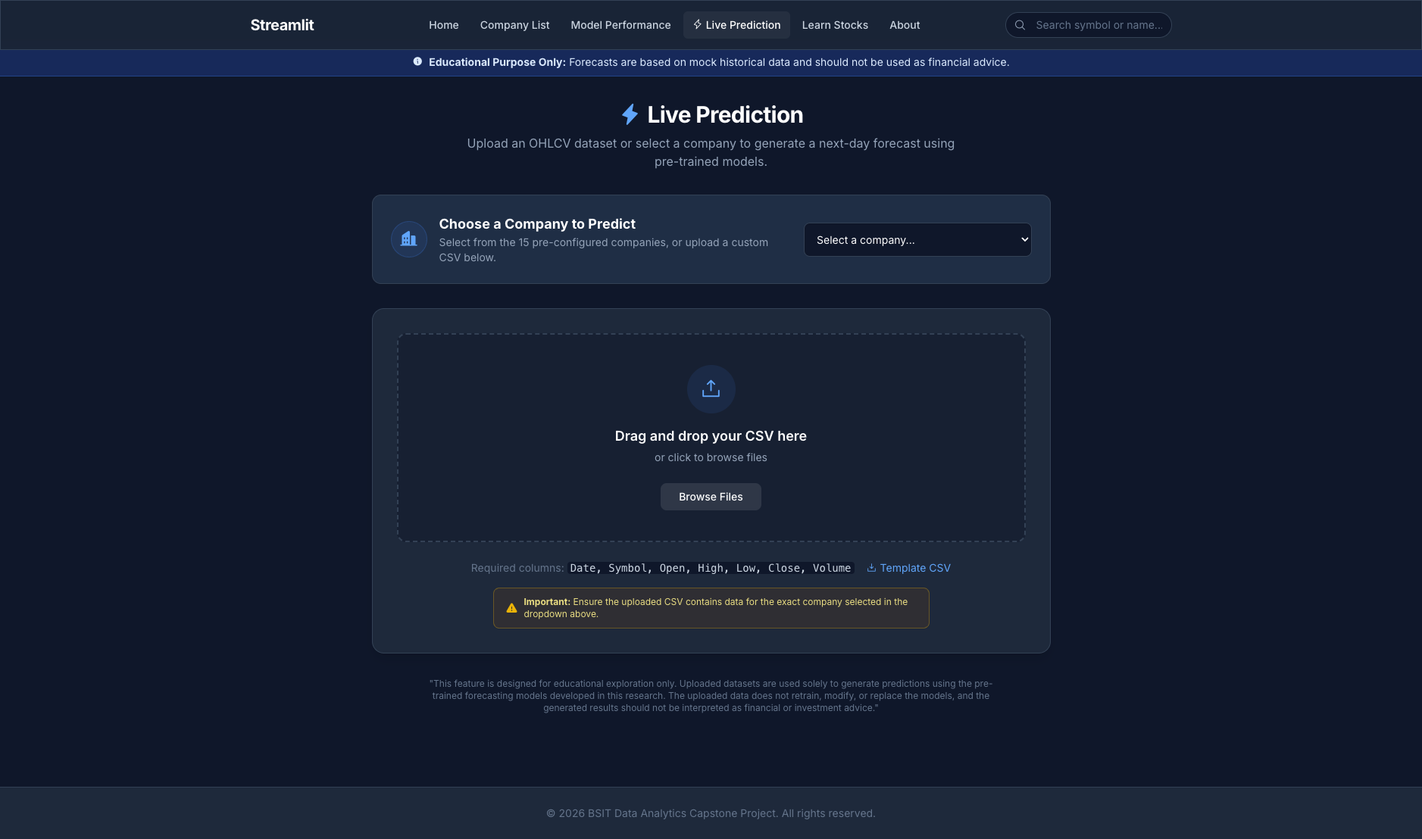
Figure 20. Live Forecast Status Page
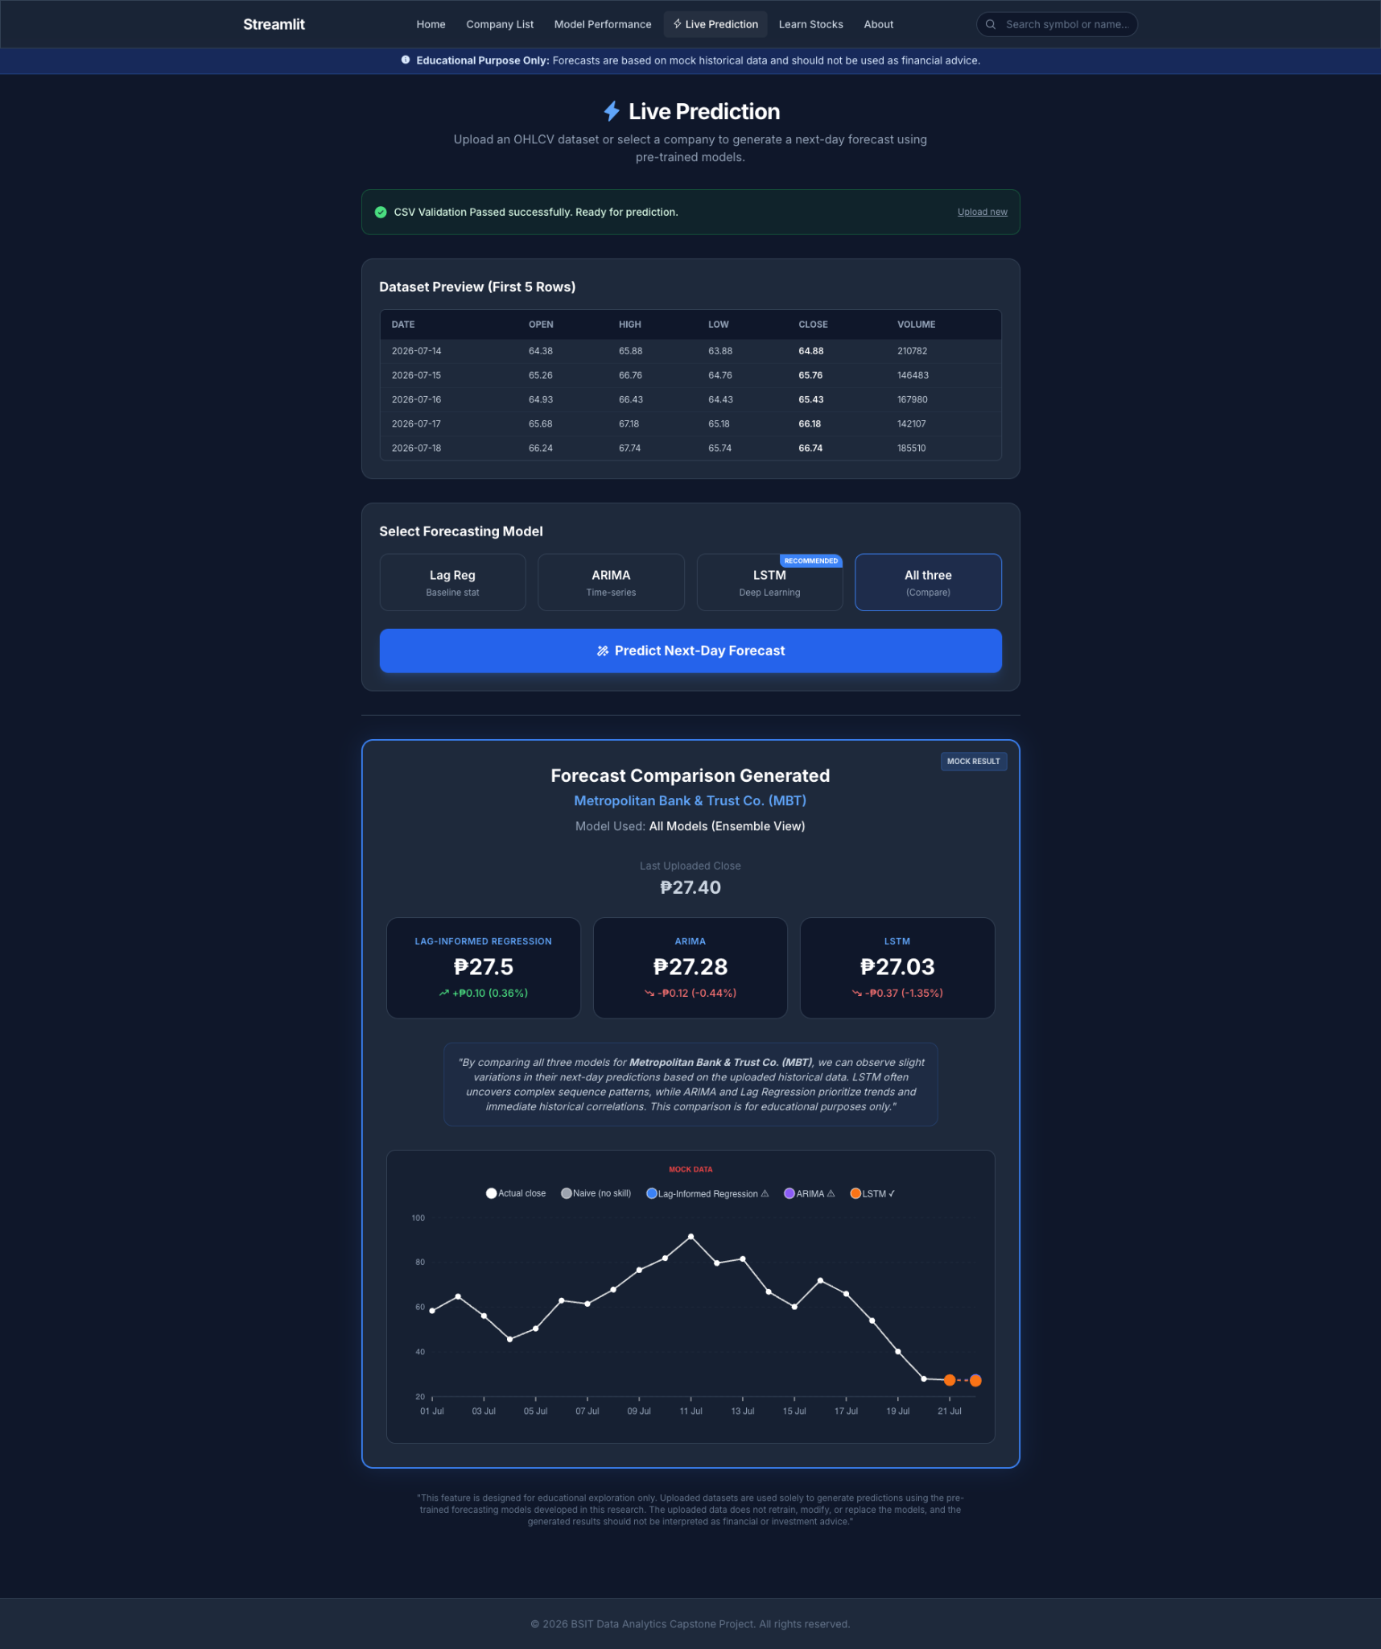
Figure 21. Superseded Live Prediction Results Prototype
    - Learn Stock Page
The Learn Stocks page serves as a beginner-friendly educational guide tailored specifically for budding traders. It breaks down the core technical concepts of the research into plain, accessible language. The page is divided into four main sections: a visual breakdown of OHLCV data, simplified explanations of the three forecasting models (framing Lag Regression as "The Pattern Spotter," ARIMA as "The Trend Tracker," and LSTM as "The Deep Thinker"), a guide on how to interpret evaluation metrics like RMSE and MASE, and a prominent disclaimer reinforcing that historical data models do not provide financial advice.

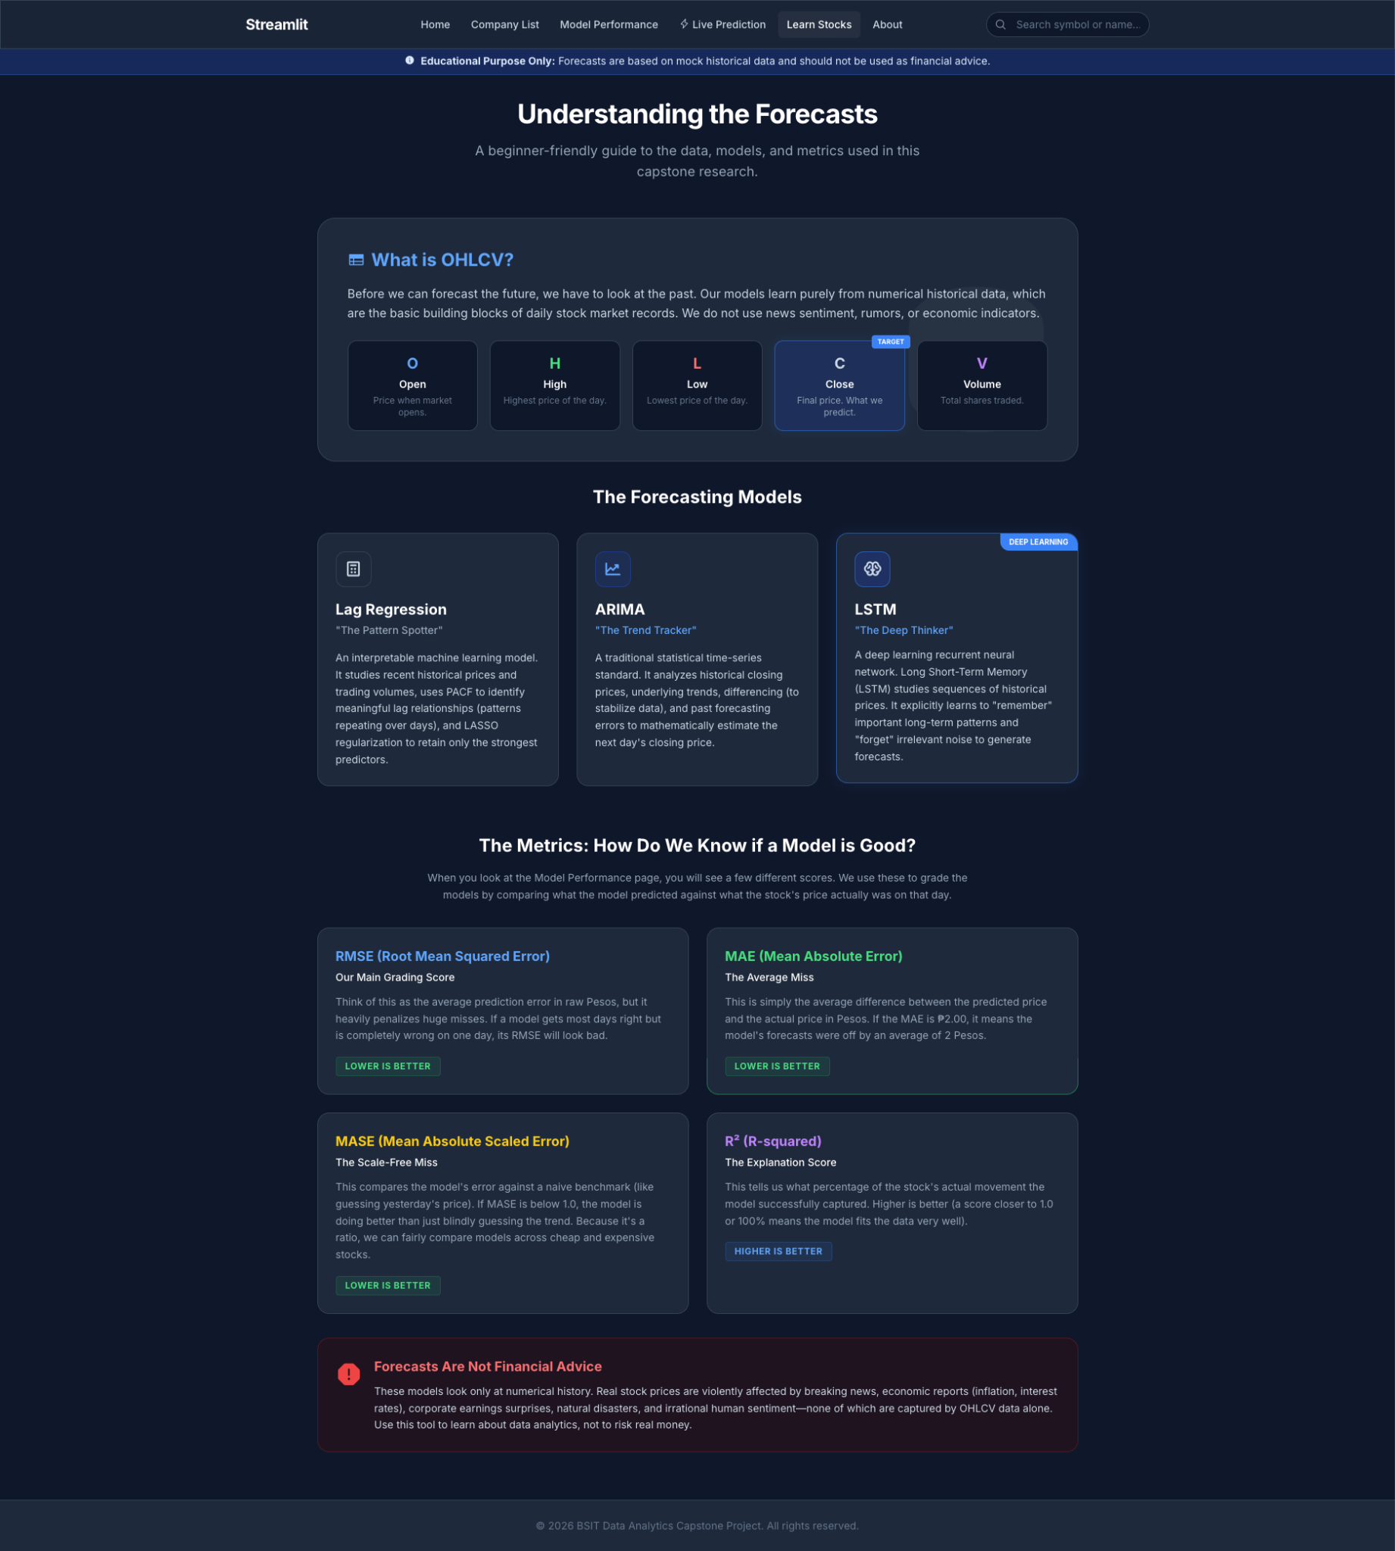
Figure 22. Learn Stocks Page

    - About the Research Page
The About the Research page provides a comprehensive overview of the capstone project. It outlines the primary research problem, noting that existing local studies often produce code-heavy outputs and lack comparative cross-sector analysis. It briefly summarizes how the system works, from historical OHLCV data collection to rigorous chronological data splitting. Additionally, the page outlines the intended target users, led by budding traders, and explains the statistical rigor behind the study, including the use of RMSE and non-parametric significance testing (Friedman and Wilcoxon tests). It prominently features a responsible-use disclaimer to reinforce that the dashboard is strictly an educational and analytical tool, not a source of financial advice.
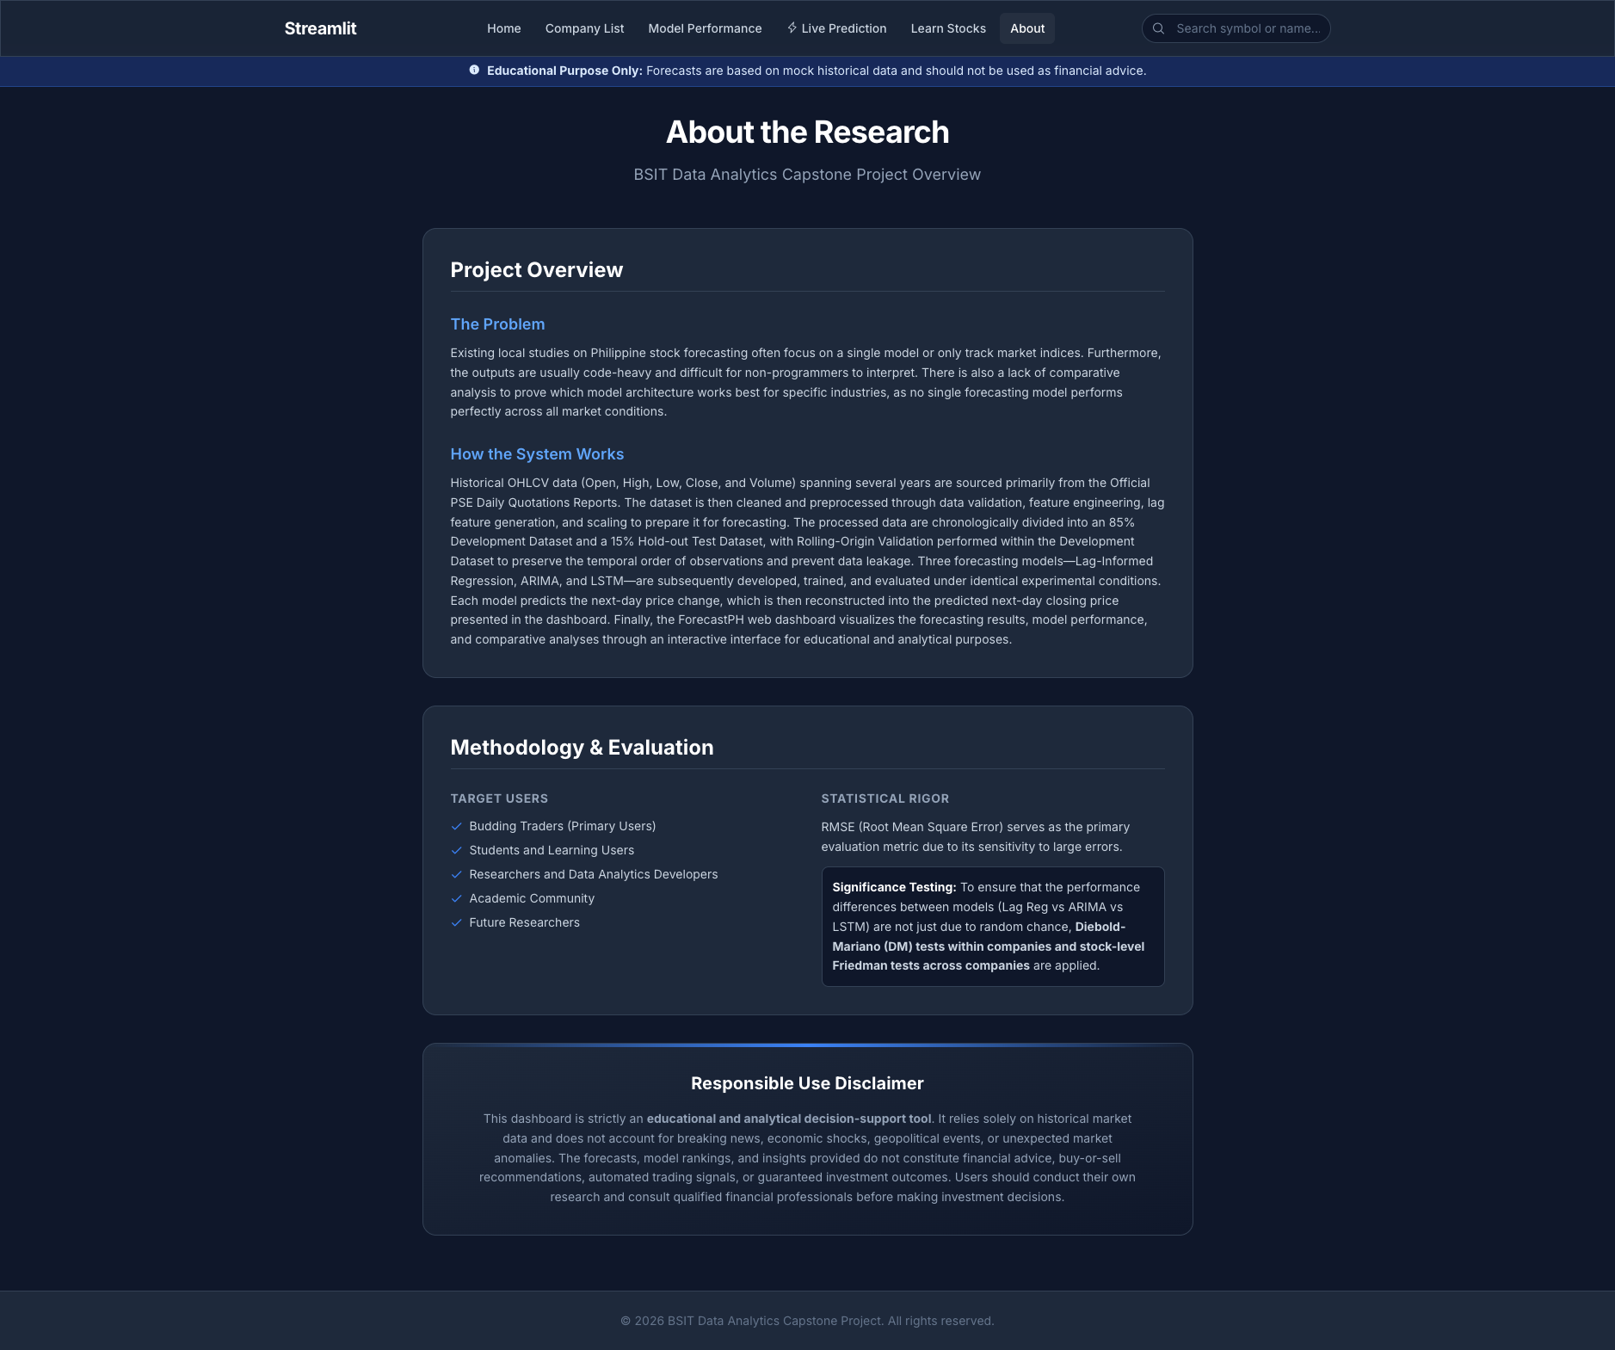
Figure 23. About the Research Page
Prototype Mobile View
The Prototype Mobile View demonstrates how the dashboard adapts its layout for smaller screens while preserving access to the core stock information, forecasts, charts, filters, explanations, and responsible-use notices. This responsive design directly addresses the stakeholder preference for convenient access across mobile and desktop devices and supports the approved requirement that essential pages remain usable without horizontal overflow. Content is arranged in a summary-first format, with readable cards, vertically stacked sections, and touch-friendly controls to help budding traders review results with minimal confusion.
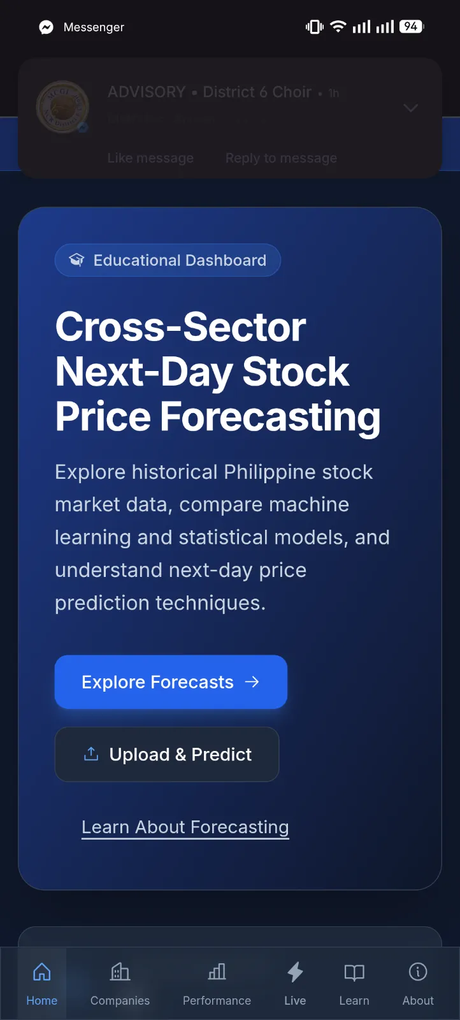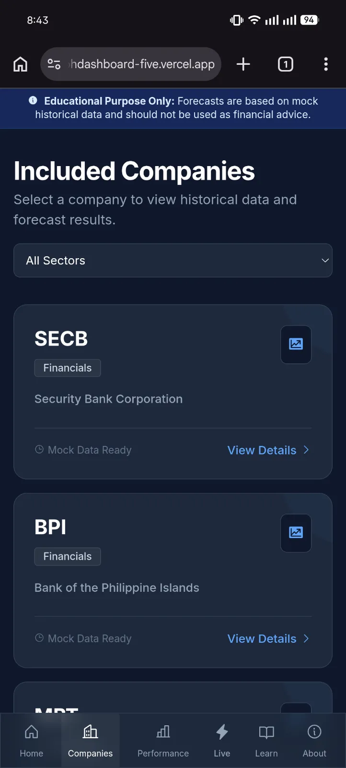
Figure 24. Mobile Views: Home and Companies Page
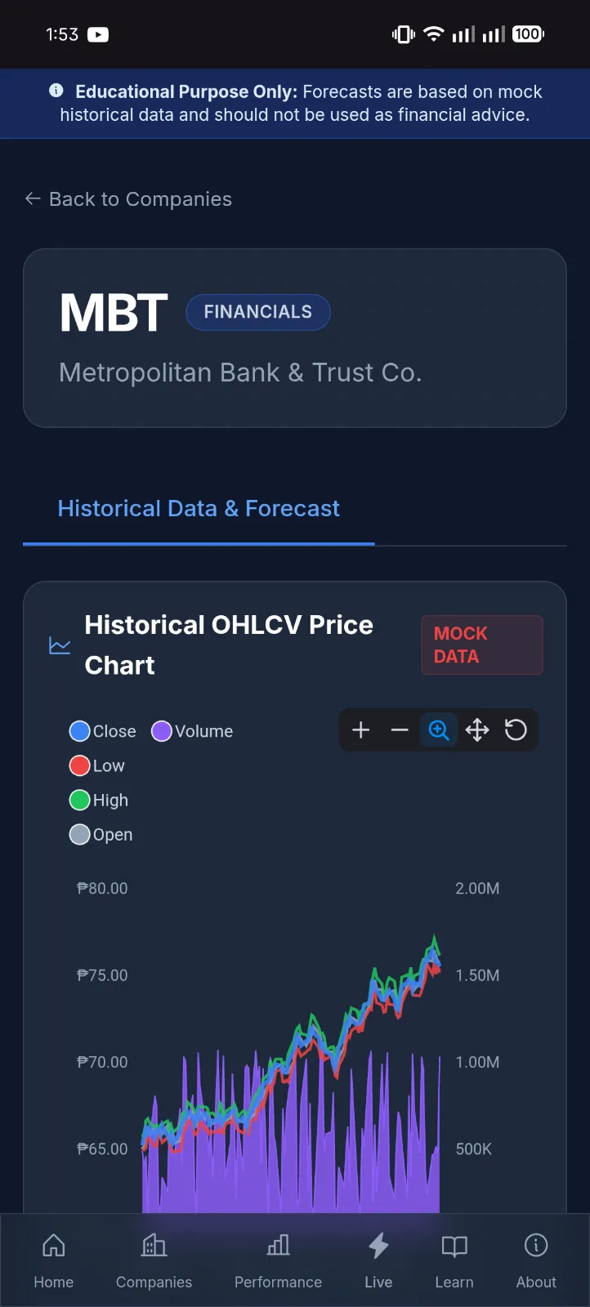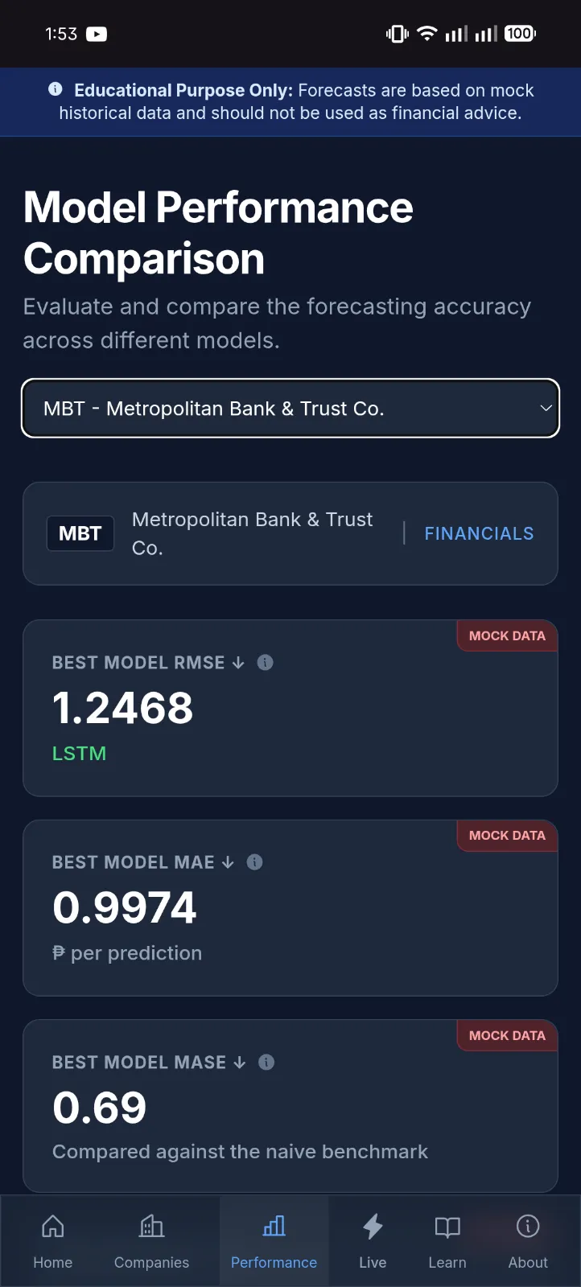
Figure 25. Mobile Views: Company Historical Data and Forecast Page & Model Performance Page
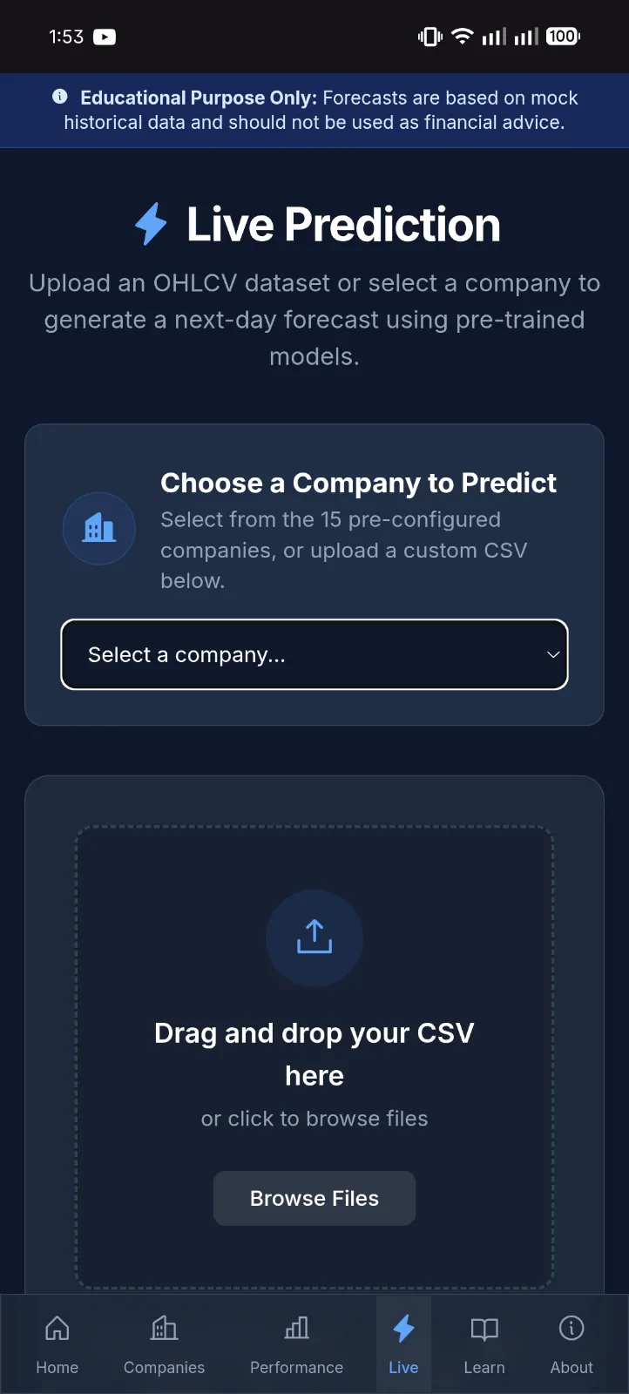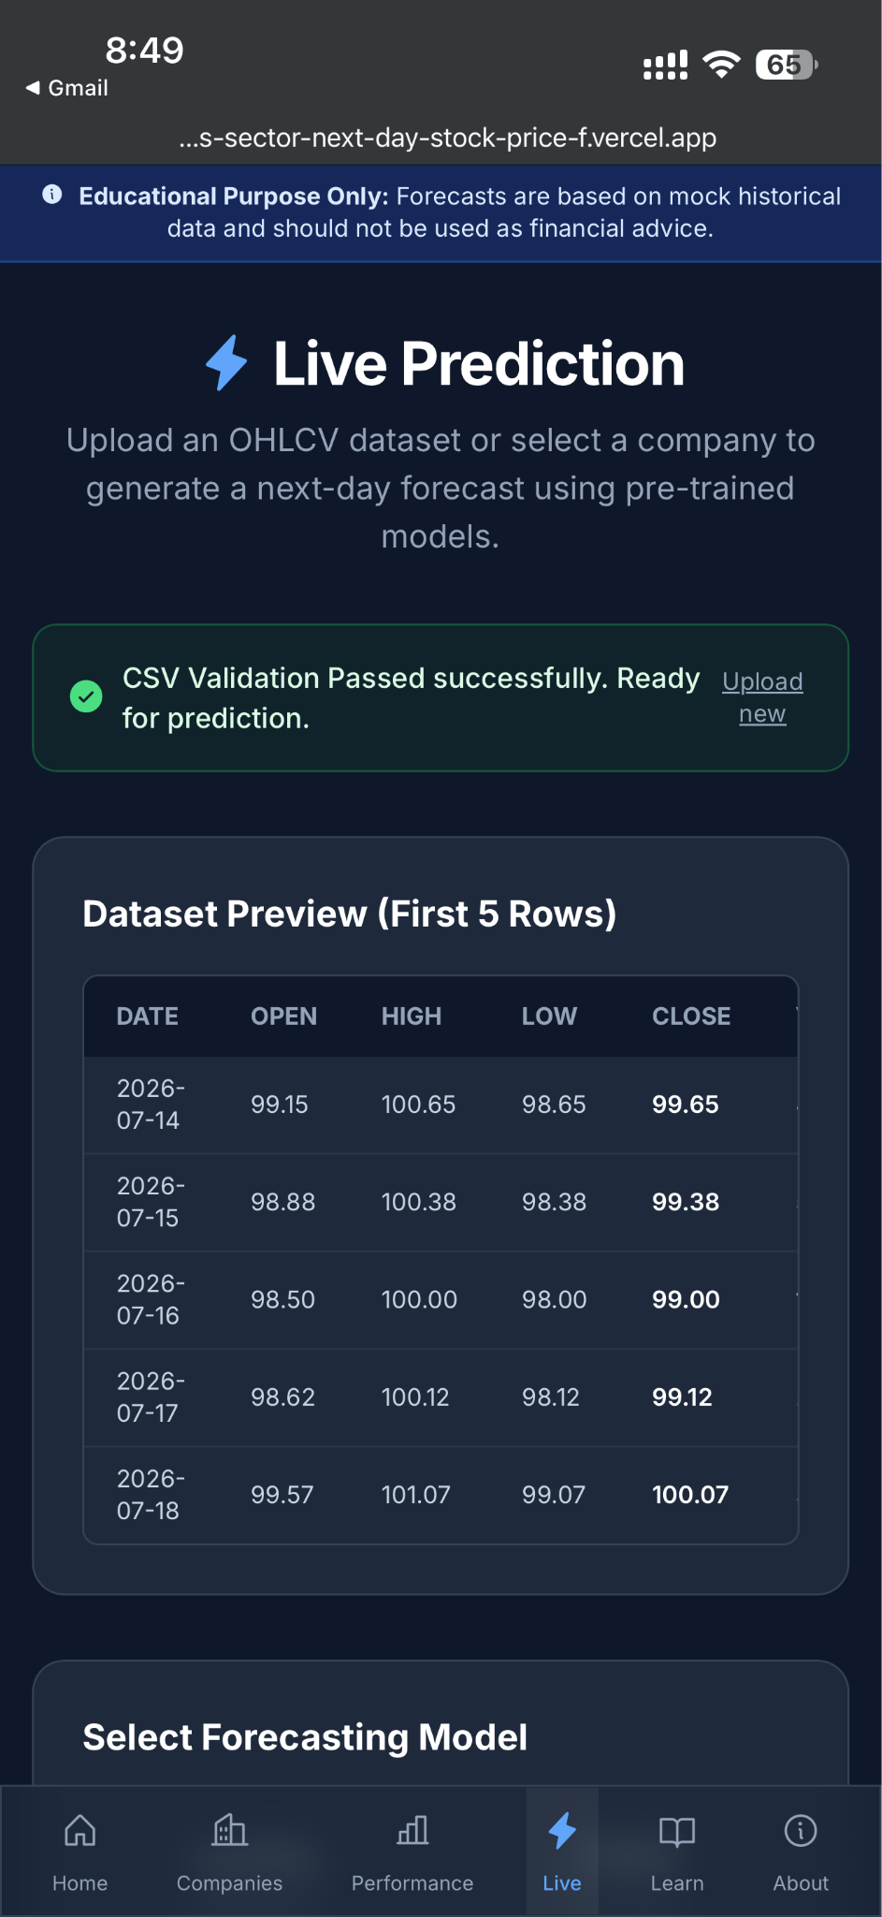
Figure 26. Prototype Mobile Views: Company Forecast and Results Pages

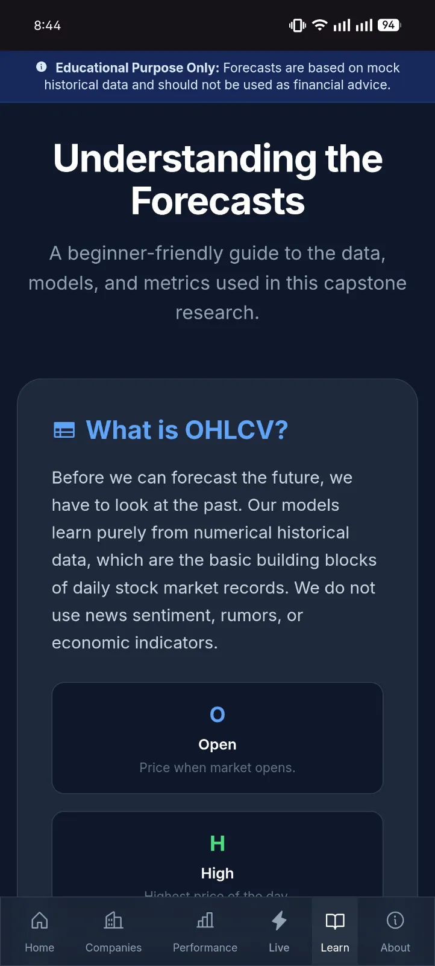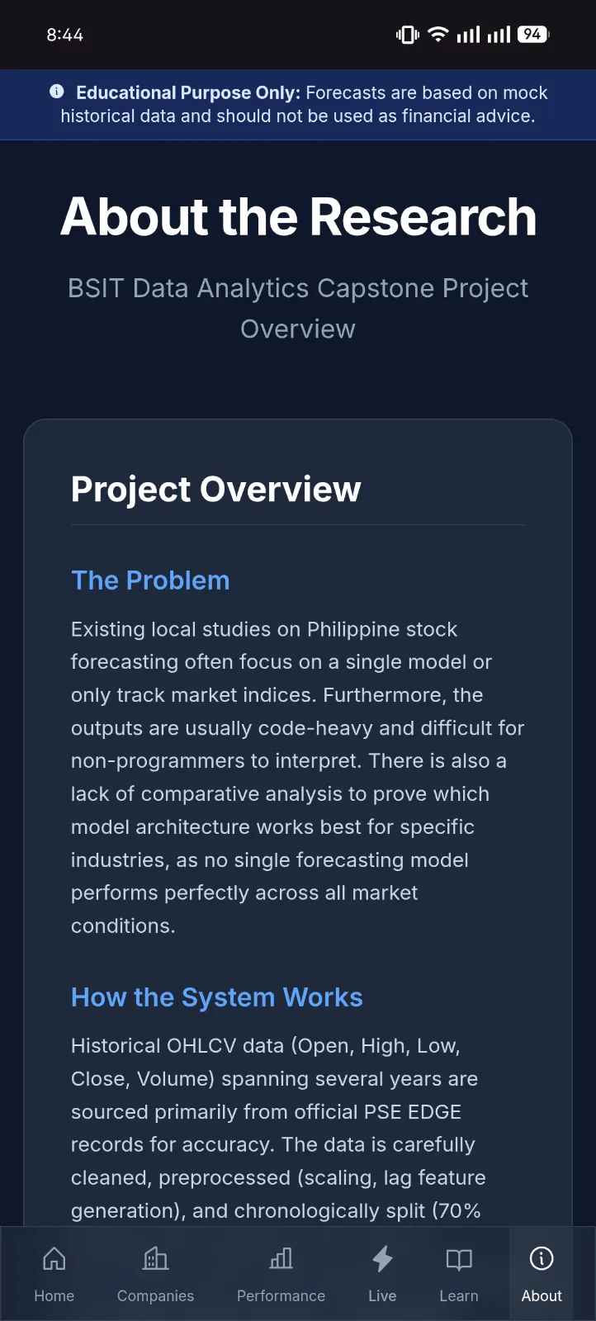
Figure 27. Mobile Views: Learn and About Pages
  - Dashboard Data Integration
The dashboard will load prepared output files and saved model artifacts generated from the formal modeling pipeline. These files include the cleaned stock CSV datasets for all 15 selected companies, model evaluation metrics, test-set predictions, statistical test results, and aggregate model rankings. To maintain system stability and reproducibility, the dashboard will not compute formal study results from raw data during runtime; instead, it relies strictly on displaying validated, precomputed outputs.
This design ensures a strict separation between formal model development and the user-facing presentation. Formal model training, tuning, and evaluation are conducted entirely offline using Python notebooks or scripts. The Next.js dashboard then reads these saved outputs to populate the historical charts, performance tables, metric summary cards, and interpretation boxes. The dashboard loads versioned forecast artifacts generated by the backend. End users cannot upload data, invoke training, or alter the formal study models.
  - UI/UX Design Considerations
The dashboard's design is directly driven by the needs and preferences gathered from budding traders. To prevent information overload—which 75% of surveyed users identified as a major barrier to adoption—the interface will use a "summary-first" and balanced presentation style. This approach prioritizes clear metric cards and plain-language explanations before offering deeper technical charts.
Based on visual preferences, the dashboard will utilize a dark mode theme, favored by 75% of respondents. The design emphasizes simple navigation, readable charts, and fast loading times, all of which were rated as highly important non-functional requirements (4.62 out of 5) by stakeholders. Finally, to ensure responsible interpretation, clear disclaimers and beginner-friendly tooltips are integrated throughout the interface so users do not mistake educational forecasts for direct investment advice

  - Web UI Evaluation and Validation
The dashboard interface will be validated for technical accuracy and stakeholder usability. Tests will verify the Home, Companies, company detail, Watchlist, Learn Stocks, About, and Live Prediction status pages; confirm that displayed metrics match versioned artifacts; and confirm that the browser cannot upload data or invoke model training.
From a stakeholder perspective, the interface will undergo usability and user acceptance testing involving budding traders or proxy users to ensure it effectively solves the information overload barriers identified in the needs assessment. Validation will confirm that users can navigate the summary-first layout, interpret the plain-language explanations, and easily locate responsible-use warnings. Based on the established non-functional requirements, the UI will be considered successfully validated if at least 80% of test users can complete core navigation tasks without assistance, and if the dashboard achieves a visual readability rating of 4 or 5 out of 5 across desktop, tablet, and mobile screens.
  - Dashboard Success Thresholds
To make dashboard evaluation measurable, success thresholds will be defined for system functionality, output integrity, usability, performance, compatibility, privacy, and stakeholder acceptance. These thresholds are based on the approved functional and non-functional requirements, the Requirements Traceability Matrix, and the findings from the stakeholder interviews and post-interview survey.

The stakeholder findings showed strong support for next-day forecasts, historical context, actual-versus-forecast comparison, plain-language explanations, official source information, responsible-use reminders, simple navigation, readable presentation, and compatibility across devices. Accordingly, the thresholds will be used during functional testing, output verification, usability testing, performance testing, compatibility testing, privacy review, and user acceptance testing to determine whether the dashboard operates correctly and can be understood by budding traders with minimal assistance.

Table 29. Dashboard and Stakeholder Success Thresholds
Evaluation Area | Success Threshold | Interpretation
Page and module availability | 100% of the implemented core dashboard pages and modules must load successfully during local and deployed testing. | Confirms that the Home, Company List and Detail, Model Performance, educational, research-information, and supported automated update modules are accessible.
Company identity accuracy (FR-01) | 100% of the 15 supported stock pages must display the correct ticker, complete company name, and official PSE sector. | Confirms that users receive the correct company and stock context.
Historical-data accuracy (FR-02) | 100% of tested historical charts and summaries must correspond to the selected stock and date range and must match the validated OHLCV records. | Confirms that historical price and volume information is displayed accurately.
Forecast-output accuracy (FR-03) | 100% of displayed next-day forecast values, forecast dates, model names, generation timestamps, and related metadata must match the approved saved forecast files. | Confirms that the dashboard presents verified forecasting outputs.
Actual-versus-forecast alignment (FR-04) | 100% of tested actual and predicted values must be aligned to identical trading dates and must be visually distinguishable. | Confirms that users can accurately compare past forecasts with observed outcomes.
Sector-peer comparison accuracy (FR-05) | 100% of tested sector selections must display the three approved peer companies assigned to that official PSE sector using comparable fields and date ranges. | Confirms that cross-company and sector-peer comparisons use the correct stock groupings.
Explanation availability (FR-06) | 100% of major forecasts, charts, model metrics, rankings, and statistical summaries must include an accessible definition, tooltip, or plain-language explanation. | Confirms that technical outputs are supported by beginner-friendly guidance.
Metric interpretation | At least 80% of usability-test participants must correctly identify that lower RMSE, MAE, and MASE values indicate lower forecast error, that MASE below 1 indicates better scaled performance than the naive reference, and that R² is a secondary descriptive metric. | Confirms that the revised model-performance explanations are understandable to budding traders.
Best-model identification | At least 80% of usability-test participants must correctly identify the best-performing principal model for a selected stock using the model-ranking information, with the lowest hold-out RMSE as the primary basis. | Confirms that model rankings and supporting metrics are presented clearly.
Provenance and freshness display (FR-07) | 100% of relevant tested pages must display the correct official source, data cutoff, update date, model version, and freshness status. | Confirms that users can verify the origin and timeliness of the displayed information.
Model freshness warning | 100% of test cases exceeding the approved freshness threshold must display a visible warning before or beside the affected forecast output. | Confirms that potentially outdated models or data are clearly identified.
Responsible-use notice (FR-08) | 100% of forecast-related pages must display an uncertainty, limitation, or responsible-use notice, and 100% of usability-test participants must be able to locate or acknowledge it. | Confirms that users understand that forecasts are uncertain, educational, and not investment advice.
Filter consistency (FR-09) | 100% of tested stock, sector, and date-range selections must update all linked charts, tables, forecasts, and summaries consistently. | Confirms that filtering does not create conflicting or mismatched outputs.
Scheduled forecast artifact loading (revised FR-10) | 100% of valid test files containing one supported ticker and the approved Date, Symbol, Open, High, Low, Close, and Volume schema must pass validation and proceed to the applicable exploratory forecasting process. | Confirms that correctly structured supported-ticker files can be processed.
Browser upload unavailability (revised FR-10) | 100% of tested files containing unsupported tickers, mixed Symbols, missing fields, duplicate Date–Symbol records, null required values, invalid OHLCV relationships, insufficient history, or incompatible artifacts must be rejected with a clear validation message. | Confirms that invalid or incompatible input cannot produce an unsupported forecast.
Navigation task completion (NFR-01) | At least 80% of first-time test participants must complete the core stock-selection, historical-chart, forecast-viewing, and model-comparison tasks without assistance. | Confirms that the summary-first navigation is usable by budding traders.
Chart and text readability (NFR-02) | At least 80% of usability-test participants must rate chart readability, labels, spacing, contrast, and beginner-friendly language as 4 or 5 on a five-point scale. | Confirms that the visual and written presentation is understandable and readable.
Page-loading performance (NFR-03) | At least 90% of normal page-loading, chart-loading, and saved forecast-retrieval tests must complete within five seconds in the documented test environment. | Confirms that the dashboard provides stable and reasonably fast access to its core outputs.
Device compatibility (NFR-04) | Core pages must remain usable without horizontal page overflow at the defined mobile, tablet, laptop, and desktop viewport sizes. All essential controls and outputs must remain visible and operable. | Confirms accessibility across the device types requested by stakeholders.
Anonymous core access and privacy (NFR-05) | 100% of core historical, forecasting, comparison, and educational functions must remain accessible without account registration or the collection of unnecessary personal, banking, brokerage, or financial information. | Confirms that the dashboard follows the approved privacy and minimal-data requirements.
Theme readability and comfort (NFR-06) | At least 80% of usability-test participants must rate the implemented dark or system-aware appearance as 4 or 5 on a five-point scale for readability and visual comfort. | Confirms that the visual theme responds to the survey preference for dark mode while remaining readable.
Output integrity | 100% of displayed historical values, forecasts, RMSE, MAE, MASE, R² values, naive-benchmark findings, rankings, and summarized statistical results must match the saved and versioned analytical output files. | Confirms that the web application does not alter, independently recalculate, or misrepresent the validated study results.
Overall user acceptance | At least 80% of usability or user-acceptance-test participants must rate the dashboard as understandable and useful for stock-learning, forecast interpretation, or further research. | Confirms stakeholder acceptance at an appropriate capstone level and is consistent with the 87.5% positive support recorded across the survey’s overall acceptance items.

The quantitative thresholds for navigation, readability, visual comfort, and general acceptance are set at 80%, consistent with the approved non-functional requirements. The performance threshold requires at least 90% of common operations to complete within five seconds, while requirements involving data correctness, metadata accuracy, disclaimers, privacy, and input validation require 100% compliance because partial compliance could produce misleading information or weaken responsible-use safeguards.
The overall user-acceptance threshold is set at 80%, while the earlier stakeholder survey produced 87.5% positive support for the dashboard’s potential usefulness, learning value, recommendability, and combined presentation of forecasts, historical charts, explanations, and responsible-use reminders. The final user-acceptance testing will determine whether the implemented dashboard maintains a comparable level of support after participants interact with the actual system.

Development Plan
The development plan defines how the proposed project will be built, tested, evaluated, and refined. Since the capstone combines data engineering, comparative forecasting, statistical analysis, and Next.js dashboard development, the project will follow an iterative development approach. This approach allows the researchers to progressively improve the official-data extraction process, data-quality pipeline, forecasting models, evaluation outputs, statistical procedures, dashboard interface, automated data-update and inference workflow, testing evidence, and technical documentation.
The updated plan retains the seven-phase structure while aligning it with the final 15-stock dataset, official PSE source, model-specific target formulations, expanding-window validation, canonical metrics, mandatory Naive benchmark, and benchmark-first statistical procedure.
  - Development Methodology
The project will use an Agile-inspired iterative development methodology. This approach is appropriate because the data pipeline, forecasting configurations, evaluation procedures, dashboard presentation, and system controls may require refinement as implementation findings become available. Instead of treating development as a single fixed sequence, the researchers will work through repeated cycles of implementation, verification, testing, and improvement.
Each iteration may focus on a specific component, such as official PSE report extraction, data-quality validation, model-specific preparation, rolling-origin validation, model evaluation, statistical testing, dashboard visualization, automated source-data validation, responsive design, or documentation. The outputs of each iteration will be reviewed against the approved methodology, requirements, acceptance criteria, and expected analytical results before the next component is finalized.
The iterative approach also supports the required separation between the formal analytics workflow and the dashboard presentation layer. Official-data processing, model development, hyperparameter selection, final hold-out evaluation, statistical testing, and result generation will be performed through controlled Python notebooks or scripts. The Next.js application will load verified datasets, saved predictions, performance summaries, statistical outputs, and ticker-specific artifacts rather than repeating the full research pipeline whenever the application is opened.
  - Development Phases
The project will be developed through seven major phases.
Phase 1: Planning and Scope Finalization
This phase includes finalizing the study scope, selected companies, official data sources, observation period, forecasting target, models, benchmark, evaluation metrics, statistical procedures, stakeholder requirements, dashboard functions, testing criteria, and deployment direction.
The study will cover 15 selected PSE-listed companies, with three peer companies representing each of five official PSE sectors:
- Financials: SECB, BPI, and MBT;
- Industrial: MER, JFC, and SHLPH;
- Property: MEG, ALI, and SMPH;
- Services: GLO, PGOLD, and ICT; and
- Mining and Oil: APX, NIKL, and SCC.
The analytical period will cover January 2, 2020 to August 28, 2026. Lag-Informed Regression, ARIMA, and LSTM will serve as the three principal forecasting models, while the naive random-walk method will serve as the mandatory benchmark.
Lag-Informed Regression and LSTM use the next-trading-day change in closing price as their learning target and reconstruct a price forecast. ARIMA models the price level with internal differencing. Their common formal evaluation target is the next-trading-day closing price.
The final web interface will be developed using Next.js and React as an educational and analytical stock-forecasting dashboard. Its design will follow the validated functional and non-functional requirements derived from the interviews, survey, research objectives, analytical protocol, and Requirements Traceability Matrix.

Phase 2: Official Data Acquisition and Validation
This phase includes acquiring the official PSE Daily Quotations Report files covering the approved study period. The original reports will be preserved in an unchanged source archive to maintain provenance and allow extracted observations to be verified against their official origin.
Historical records for the 15 selected companies will be extracted and consolidated using the following standardized fields:
Date, Symbol, Open, High, Low, Close, and Volume
Official PSE and PSE EDGE references will be used to verify ticker identity, canonical company name, official sector classification, and documented corporate or security events. Each extracted record will remain traceable to the corresponding official source report.
The extraction process will be checked for completeness, date consistency, ticker accuracy, numeric conversion, and structural consistency. The expected validated dataset contains 1,624 trading-day observations for each company and 24,360 stock-date observations across the complete sample.
Phase 3: Data Cleaning, Preprocessing, and Feature Engineering
This phase includes validating required fields, parsing dates, sorting observations chronologically, checking duplicate Date–Symbol combinations, converting OHLCV values into valid numeric formats, assessing OHLC relationships, verifying trading-date coverage, and documenting missing or unavailable observations.
Missing trading records will not be automatically forward-filled. Weekends and official non-trading dates will not be classified as missing observations. Unavailable records will be reviewed according to the approved data protocol before any treatment is considered.
Each stock will also be assessed according to the approved data-quality and modeling-suitability benchmarks, including:
- trading-date coverage;
- missing and null OHLCV records;
- zero-volume observations;
- stale closing-price runs;
- liquidity;
- valid date structure;
- sufficient usable observations; and
- trading continuity.
Corporate-action handling follows the frozen registry. The primary analysis retains all validated raw observations. The sensitivity analysis excludes every registered corporate-action target date consistently across all four methods, then recomputes canonical metrics and rankings. No manual price adjustment is applied.
After validation, model-specific preparation is performed. Lag-Informed Regression and LSTM construct next-day changes; ARIMA retains closing-price levels and applies differencing internally.
Lag-Informed Regression will use lagged returns and OHLCV-derived variables, including rolling return, volatility, price-range, and volume-related predictors. PACF analysis will guide candidate lag identification, while train-fitted z-score standardization will be applied to the predictors. LASSO regularization will serve as the final estimator and will retain predictors with non-zero coefficients.
ARIMA will use the differenced chronological closing-price series. Its preparation will include stationarity assessment, candidate order identification, bounded (p,d,q) selection, and residual diagnostic procedures.
LSTM will use a univariate series of closing-price changes. The series will be transformed using train-fitted Min-Max scaling and arranged into chronological sliding-window sequences.
The naive random-walk benchmark will use the most recent observed closing price as the next-day closing-price forecast and will not require feature engineering, scaling, or hyperparameter selection.
Each company’s dataset will be divided chronologically into an 85% development set and a 15% untouched hold-out test set. The development set will be divided into six contiguous blocks to support five-fold expanding-window rolling-origin cross-validation. No random shuffling will be performed.
Phase 4: Model Development
This phase includes developing Lag-Informed Regression, ARIMA, and LSTM separately for each of the 15 selected companies. The study will therefore produce 45 principal stock-model configurations, consisting of 15 companies multiplied by three forecasting models. A corresponding naive benchmark will also be generated for every company.
Model selection and hyperparameter tuning will be conducted using expanding-window rolling-origin cross-validation within the development set. Candidate configurations will be assessed according to their mean one-step-ahead validation RMSE across the five folds, with MAE retained as a supporting validation measure.
For Lag-Informed Regression, the regularization parameter will be selected through the rolling-origin procedure, and LASSO will remain the final fitted estimator without a secondary ordinary-least-squares refit.
For ARIMA, the differencing order and candidate autoregressive and moving-average orders will be identified from training data. The final (p,d,q) configuration will be selected using rolling-origin validation. Final test-period forecasts will use a one-step-ahead walk-forward procedure.
For LSTM, the declared 48 configurations are compared using five common-date expanding folds and seeds 42, 123, and 2026. Early stopping uses an internal training tail. The final model uses seed 42 and a fixed-epoch refit on all development sequences.
After configuration selection, each principal model will be refitted using the complete development set. The selected configurations will remain frozen before the final hold-out evaluation.
Phase 5: Model Evaluation and Statistical Testing
This phase includes evaluating the finalized model configurations and naive benchmark using the untouched hold-out test set. Lag-Informed Regression, ARIMA, LSTM, and the naive method will be compared on the common intersection of valid test dates for each company.
Lag-Informed Regression and LSTM estimate the next-trading-day change and add it to the origin-day Close. ARIMA forecasts the closing-price level with internal differencing. Formal evaluation uses the resulting next-trading-day closing-price forecasts on the same target dates.
The canonical performance measures will consist of:
- RMSE, as the primary within-company ranking metric;
- MAE, as a supporting within-company error measure;
- MASE, as the scale-free measure for cross-company and sector-peer comparison; and
- R², as a secondary descriptive metric.
Residual diagnostics will also be generated to examine residual autocorrelation, normality signals, and volatility clustering. Model-specific diagnostics will include the selected LASSO predictors, ARIMA stationarity and Ljung–Box results, and LSTM training and early-stopping information.
Statistical evaluation will use a two-level procedure.
At the within-company level, pairwise Diebold–Mariano tests will compare the models’ forecast-loss differential series. Each principal model will first be compared against the naive benchmark. Eligible principal models may then be compared with one another. Squared-error loss will serve as the primary criterion, while absolute-error loss will serve as a robustness check. The procedure will use a heteroskedasticity- and autocorrelation-consistent variance estimate, the Harvey–Leybourne–Newbold small-sample correction, Holm adjustment within each company, and a moving-block bootstrap.
At the across-company level, a stock-level Friedman test will compare one final hold-out MASE value per model and company. When a significant omnibus difference is found, Wilcoxon signed-rank post-hoc comparisons with Holm adjustment will be conducted.
The best-performing principal model for each company will be identified primarily through the lowest hold-out RMSE. MAE, MASE, R², naive-benchmark findings, and statistical results will provide supporting interpretation. A principal model may be described as consistently best-performing when it ranks first in at least 8 of the 15 selected companies; this will be interpreted as a descriptive majority pattern rather than proof of universal superiority.
Predictions, residuals, metrics, rankings, benchmark results, diagnostic outputs, Diebold–Mariano results, bootstrap findings, Friedman results, post-hoc comparisons, and selected configurations will be exported into structured evaluation-ready and dashboard-ready files.

Phase 6: Next.js and React Dashboard Development
This phase includes designing and developing the reusable Next.js and React-based educational and analytical dashboard. The dashboard will load validated and precomputed outputs rather than retraining or re-evaluating the formal study models during normal use.
The planned interface will include the following principal modules:
- Home, containing the project overview, supported companies, sectors, models, forecasting horizon, and responsible-use notice;
- Company List and Company Detail, containing company identity, historical information, next-day forecast, actual-versus-predicted results, and source metadata;
- Model Performance, containing RMSE, MAE, MASE, R², naive comparisons, model rankings, statistical summaries, and cross-company or sector-peer information;
- Learn Stocks, containing plain-language explanations of OHLCV variables, forecasting models, evaluation metrics, limitations, and responsible use;
- About, containing the research overview, methodology summary, intended users, and disclaimer; and
- Live Prediction, explaining scheduled forecast generation and directing users to supported company pages.

The dashboard will use summary-first navigation, readable metric cards, accessible charts, tooltips, explanations, responsive layouts, and visible source and freshness information. It will support representative mobile, tablet, laptop, and desktop viewing.
Saved dashboard bundles and ticker-specific deployment artifacts will be prepared so that the application can retrieve compatible outputs efficiently. Each artifact package will include the model, required scaler, feature or sequence specification, preprocessing version, model version, training cutoff, supported ticker, and source-data metadata.
The Live Prediction function will accept only supported-ticker files using the approved schema:
Date, Symbol, Open, High, Low, Close, and Volume
The backend validates ticker identity, schema, chronology, duplicates, OHLCV relationships, data sufficiency, and deployment compatibility before exporting a forecast artifact.
Operationally acquired data cannot retrain or alter the formal study models, hyperparameters, holdout metrics, or research findings.

Phase 7: Testing, Documentation, and Final Refinement
This phase includes verifying the data pipeline, model outputs, statistical procedures, saved artifacts, dashboard pages, filtering behavior, responsive layouts, and automated data-update workflow.
Functional testing will verify that all implemented requirements operate correctly. Output-verification testing will confirm that displayed historical data, forecasts, RMSE, MAE, MASE, R², rankings, benchmark results, and statistical summaries match the approved saved files.
Usability testing will examine task completion, navigation clarity, metric interpretation, best-model identification, chart readability, visual comfort, explanation usefulness, and disclaimer recognition. Performance testing will determine whether common page-loading and output-retrieval operations satisfy the approved five-second threshold. Compatibility testing will cover defined mobile, tablet, laptop, and desktop viewport sizes.
Privacy testing will confirm that the dashboard requires no registration and accepts no user files, personal information, financial information, banking information, brokerage credentials, or trading history. Responsible-use testing will verify clear uncertainty and non-advice notices.
Identified defects, inconsistencies, usability concerns, and output mismatches will be documented, corrected, and retested. Technical documentation will include the development environment, project structure, dependencies, execution instructions, artifact formats, testing evidence, user guidance, maintenance procedures, and known limitations.

  - Tools, Technologies, and Platforms
The project will use a Python-based environment for the data engineering, forecasting, evaluation, and statistical components. Next.js and React will serve as the dashboard framework.
Python will be used to:
- extract and consolidate official PSE records;
- clean and validate OHLCV datasets;
- generate model-specific variables and sequences;
- develop the three forecasting models;
- produce the naive benchmark;
- perform rolling-origin validation;
- calculate performance measures;
- conduct statistical tests and diagnostics;
- save model and preprocessing artifacts; and
- prepare evaluation-ready and dashboard-ready files.
Development notebooks and scripts will be created through Jupyter Notebook or Visual Studio Code. A validated PDF extraction library may be used to extract tables from the official PSE Daily Quotations Reports, with the extracted values checked against the source files.
Pandas and NumPy will support data manipulation and numerical processing. Scikit-learn will support z-score scaling, LASSO modeling, preprocessing, Min-Max scaling, and metric calculation. Statsmodels will support ARIMA, stationarity testing, autocorrelation analysis, and residual diagnostics. PyTorch will support LSTM development. SciPy, Statsmodels, and documented custom functions will support the Diebold–Mariano procedure, Friedman test, Wilcoxon signed-rank comparisons, bootstrap operations, and other statistical calculations.
Matplotlib and Plotly will support analytical and dashboard visualizations. Joblib, Pickle, JSON, and PyTorch artifact formats will be used where applicable to store fitted models, scalers, configurations, feature specifications, and metadata.
Next.js and React will support the dashboard interface, navigation, interactive charts, metric cards, filters, ticker search and artifact-driven views, expandable explanations, and responsive layout behavior.
Git and GitHub will support source-code management, version control, collaboration, and release documentation. Google Docs will support manuscript writing and revision, while Google Sheets or Microsoft Excel may support quick inspection of extracted files, validation logs, and output summaries. Mermaid and Lucidchart will support the preparation of the methodological, operational, pipeline, architecture, integration, model, and user-interaction diagrams.
The project will follow a separation-of-concerns approach. Python notebooks and scripts will handle the formal analytical workflow, while Next.js and React will present approved saved outputs and load compatible deployment artifacts for controlled inference.

  - Collaboration and Version Control
The researchers will use GitHub for version control and collaboration. The repository will store scripts, notebooks, configurations, dashboard files, documentation, processed datasets, model outputs, statistical results, and artifact metadata where appropriate.
Consistent naming conventions will distinguish official source files, extracted records, validated datasets, model-ready inputs, predictions, evaluation summaries, statistical results, dashboard bundles, and deployment artifacts.

A possible project folder structure is shown below:
project-root/
│
├── data/
│ ├── source_pdfs/
│ ├── extracted_raw/
│ ├── validated/
│ ├── model_ready/
│ └── metadata/
│
├── notebooks/
│ ├── 01_pse_data_extraction.ipynb
│ ├── 02_data_validation_and_screening.ipynb
│ ├── 03_target_and_feature_preparation.ipynb
│ ├── 04_lag_informed_regression.ipynb
│ ├── 05_arima_modeling.ipynb
│ ├── 06_lstm_modeling.ipynb
│ └── 07_evaluation_statistical_testing.ipynb
│
├── src/
│ ├── data/
│ ├── features/
│ ├── models/
│ ├── evaluation/
│ ├── statistics/
│ └── utilities/
│
├── results/
│ ├── evaluation/
│ │ ├── predictions/
│ │ ├── residuals/
│ │ ├── metrics_summary.csv
│ │ ├── benchmark_results.csv
│ │ ├── model_rankings.csv
│ │ ├── cross_stock_performance.csv
│ │ ├── rolling_validation_summary.csv
│ │ ├── selected_model_configurations.csv
│ │ └── data_split_summary.csv
│ │
│ ├── statistical_tests/
│ │ ├── dm_results.csv
│ │ ├── dm_bootstrap_results.csv
│ │ ├── friedman_results.csv
│ │ └── wilcoxon_posthoc_results.csv
│ │
│ ├── diagnostics/
│ ├── next_day_forecasts/
│ └── dashboard_data/
│ ├── historical_ohlcv.csv
│ ├── company_master.csv
│ ├── model_performance.csv
│ ├── forecast_history.csv
│ ├── best_model_summary.csv
│ ├── sector_peer_summary.csv
│ ├── statistical_test_summary.csv
│ ├── data_quality_summary.csv
│ ├── event_flags.csv
│ ├── explanations.json
│ └── dashboard_bundle.json
│
├── artifacts/
│ ├── SECB/
│ ├── BPI/
│ ├── MBT/
│ ├── MER/
│ ├── JFC/
│ ├── SHLPH/
│ ├── MEG/
│ ├── ALI/
│ ├── SMPH/
│ ├── GLO/
│ ├── PGOLD/
│ ├── ICT/
│ ├── APX/
│ ├── NIKL/
│ └── SCC/
│
├── dashboard/
│ ├── app.py
│ ├── pages/
│ ├── components/
│ ├── loaders/
│ ├── validators/
│ ├── assets/
│ └── configuration/
│
├── tests/
│ ├── data_tests/
│ ├── model_tests/
│ ├── output_verification/
│ ├── dashboard_tests/
│ └── data_update_tests/
│
├── docs/
│
├── requirements.txt
└── README.md

The updated structure separates official source reports, extracted raw records, validated data, model-ready datasets, formal evaluation outputs, statistical files, dashboard-ready bundles, and ticker-specific artifacts. This organization supports provenance and reproducibility because each output can be traced back through the analytical pipeline to the official PSE source records.
GitHub branches and pull requests may be used to manage concurrent development. GitHub Issues, a shared task sheet, or a project board may be used to assign responsibilities, record defects, track testing evidence, document implementation decisions, and monitor completion of the approved requirements.

Testing Plan
The testing plan defines how the researchers will verify that the data engineering pipeline, forecasting models, statistical procedures, saved artifacts, automated update workflow, and Next.js dashboard operate correctly and satisfy the approved project requirements. Because the capstone combines a comparative forecasting study with a user-facing computing solution, testing will assess both the integrity of the analytical process and the functionality, usability, and feasibility of the implemented dashboard.
The plan is aligned with the 12 Data Analytics Requirements, 10 Functional Requirements, 6 Non-Functional Requirements, Requirements Traceability Matrix, and Dashboard and Stakeholder Success Thresholds. It reflects the official PSE source, 15-company sample, model-specific target formulations, 85% development–15% holdout structure, rolling-origin validation, RMSE–MAE–MASE–R² metric set, mandatory Naive benchmark, and benchmark-first statistical procedure.
Testing will be conducted at three interconnected levels:
- Analytics-level testing, covering data validation, leakage prevention, model preparation, forecast generation, metric calculation, residual diagnostics, statistical testing, and reproducibility;
- System and integration testing, covering saved-output loading, artifact compatibility, dashboard functions, filters, charts, metadata, automated source-data validation, responsiveness, performance, privacy, and responsible-use controls; and
- Stakeholder-level testing, covering task completion, readability, metric interpretation, navigation, visual comfort, and user acceptance among budding traders or participants with a comparable user profile.
The dashboard will be evaluated based on whether it accurately and understandably presents the validated study outputs. No predetermined accuracy level will be imposed requiring a principal model to outperform the naive benchmark. A result showing that a model does not significantly improve upon the naive forecast remains a valid research finding, provided that the modeling, evaluation, and statistical procedures were implemented and reported correctly.
Testing Strategy and Requirements Traceability
Testing will follow a requirements-based approach. Every final functional and non-functional requirement will be connected to at least one test case, expected result, acceptance criterion, and item of testing evidence. Test-case identifiers will be retained throughout development so that results can be traced back to the corresponding requirement in the Requirements Traceability Matrix.
Each test record will contain:
- test-case identifier;
- related requirement;
- system version or commit;
- dataset or artifact version;
- test objective;
- prerequisites;
- test input;
- execution procedure;
- expected result;
- actual result;
- pass or fail status;
- date performed;
- tester;
- supporting screenshot, log, or output file; and
- corrective action when applicable.
Automated checks will be used where deterministic validation is possible, particularly for schemas, row counts, dates, metric calculations, artifact metadata, and saved-output comparisons. Manual testing will be used for visual presentation, navigation, responsiveness, explanation quality, disclaimer visibility, and user interaction.

Testing Entry and Exit Criteria
Formal testing will begin when:
- the official PSE source files have been collected and archived;
- the validated dataset version has been identified;
- the selected model configurations have been finalized;
- the formal hold-out predictions and statistical results have been generated;
- the dashboard can load the approved output repository;
- the relevant pages and functions have been implemented; and
- the test environment and testing datasets have been documented.
Testing will be considered complete when:
- all implemented Must requirements pass their acceptance criteria;
- all implemented Should and Could requirements are tested and their status is documented;
- all displayed values pass output-integrity verification;
- the usability, performance, compatibility, privacy, and acceptance thresholds are evaluated;
- no unresolved critical or high-severity defect remains;
- corrected components pass regression testing; and
- any remaining limitation is clearly documented before final submission.

  - Analytics-Level Testing
    - Data Source and Provenance Testing
Data source testing will verify that the historical records originate from the approved official sources and remain traceable throughout the analytical pipeline.

The testing process will confirm that:

- the primary historical source consists of the official PSE Daily Quotations Reports;
- the covered observation period is January 2, 2020 to August 28, 2026;
- the source archive preserves the original reports without modification;
- extracted records can be traced to their corresponding official report;
- the correct 15 selected tickers are included;
- each ticker is associated with the correct canonical company name and official PSE sector;
- official PSE or PSE EDGE references are used only for company identity, sector classification, and event verification where applicable.

The final ticker list to be verified is:
Table 30. Final Ticker Verification
Sector | Selected Companies
Financials | SECB, BPI, MBT
Industrial | MER, JFC, SHLPH
Property | MEG, ALI, SMPH
Services | GLO, PGOLD, ICT
Mining and Oil | APX, NIKL, SCC

    - Data Validation and Quality Testing
Data validation testing will verify that the extracted OHLCV records are complete, structurally valid, chronologically organized, and suitable for modeling.

The validation procedure will include the following checks:
- Confirm that every record contains the required fields:
- Date, Symbol, Open, High, Low, Close, and Volume
- Confirm that each company contains 1,624 validated trading-day observations.
- Confirm that the complete dataset contains 24,360 stock-date records.
- Verify that the combination of Date and Symbol is unique.
- Parse all dates using the approved format and sort the records chronologically within each ticker.
- Verify that Open, High, Low, Close, and Volume contain valid numeric values.
- Confirm that the OHLC relationships are logically valid, including:
- High is not below Open, Low, or Close;
- Low is not above Open, High, or Close; and
- required price values are positive.
- Confirm that there are no missing or null required OHLCV values.
- Identify zero-volume observations and verify that each selected stock satisfies the approved zero-volume benchmark.
- Measure repeated closing-price runs and verify that the longest stale-price run remains within the approved threshold.
- Verify the minimum liquidity and usable-observation requirements for every company.
- Confirm that weekends and official non-trading days are not incorrectly classified as missing records.
- Confirm that unavailable trading records are not automatically forward-filled.
- Compare selected observations from the beginning, middle, and end of each company’s dataset with the corresponding official PSE report.
- Generate and retain a data-quality summary containing the ticker, date range, record count, coverage result, null count, duplicate count, zero-volume result, stale-run result, liquidity result, and final status.

A dataset will pass data validation when all mandatory structural and quality checks are satisfied and no unresolved issue remains that could make the corresponding stock unsuitable for the approved modeling procedure.
    - Corporate-Action and Material-Discontinuity Testing
Corporate-action and material-discontinuity testing will verify that unusually large price movements and documented event dates are processed consistently with the approved protocol.

The tests will confirm that:

- the frozen registry file and its SHA-256 hash match the formal evidence;
- predetermined corporate or market-event dates are reviewed even when they do not exceed the statistical threshold;
- flagged observations are verified using the original PSE reports and applicable official disclosures;
- all 26 registered holdout event dates are represented in the sensitivity analysis;
- the APX movement on October 16, 2020 is retained as a genuine market movement;
- SHLPH is mapped consistently to its canonical company identity;
- the primary analysis retains validated raw observations without manual adjustment, while only the registered target dates are removed from all methods in the sensitivity analysis; and
- all 24,360 frozen company-date observations pass the declared input validation checks.

The event-documentation output will be checked for the correct ticker, date, event type, verification source, finding, and final treatment.
    - Chronological Splitting and Leakage-Prevention Testing
Chronological splitting tests will verify that the forecasting workflow preserves temporal order and prevents future information from influencing earlier forecasts.

The tests will confirm that:
- each company is divided into an earlier 85% development set and a most recent 15% untouched hold-out test set;
- the development set is divided into six contiguous time blocks;
- five expanding-window rolling-origin folds are created;
- the training portion expands across folds;
- the validation block always occurs after the corresponding training blocks;
- no random shuffling is used;
- the hold-out test set is not used in feature selection, model selection, order selection, scaling, early stopping, or hyperparameter tuning;
- all lagged variables use only dates available at or before the forecast origin;
- the regression scaler is fitted using only the applicable training data;
- the LSTM Min-Max scaler is fitted using only the applicable training data;
- validation and hold-out values are transformed using previously fitted parameters without refitting; and
- all forecasting methods are evaluated using the same common intersection of valid test dates.

Automated assertions will compare maximum training dates with minimum validation or test dates to confirm that no fold contains temporal overlap or future-data leakage.
    - Forecast-Target and Reconstruction Testing
Target-construction testing will verify the correct use of the change-based learning target.
For selected sample dates, the researchers will manually calculate:
ΔC_{t+1} = C_{t+1} – C_{t}
and compare the result with the target generated by the pipeline.
The forecast reconstruction will be verified using:


The test will confirm that:
- Lag-Informed Regression and LSTM learn the next-trading-day closing-price change, while ARIMA models the closing-price level with internal differencing;
- the forecast uses the latest observed Close from the correct forecast origin;
- the target date is the next available PSE trading date rather than the next calendar day;
- Lag-Informed Regression and LSTM changes are reconstructed into prices, while ARIMA price forecasts are evaluated directly;
- reconstructed predictions are aligned with the correct actual closing prices; and
- the dashboard displays the reconstructed forecast rather than an unreconstructed scaled or differenced value.
    - Model Development and Output Verification
Model testing will verify that Lag-Informed Regression, ARIMA, and LSTM are developed correctly for each of the 15 selected companies. This results in 45 principal stock-model configurations, together with 15 company-specific naive benchmarks.
Lag-Informed Regression Tests
Testing will confirm that:
- lagged returns and OHLCV-derived predictors are generated correctly;
- no predictor contains information from a future date;
- candidate lag orders do not exceed the approved maximum of 20 trading days;
- PACF is used as a guide for candidate lag identification;
- z-score scaling is fitted only on the applicable training data;
- the LASSO regularization parameter is selected through rolling-origin validation;
- LASSO serves as the final estimator;
- only predictors with non-zero coefficients remain in the final model;
- no secondary ordinary-least-squares refit is performed;
- the selected predictors, coefficients, scaler, validation results, and configuration are saved; and
- reconstructed predictions match the prediction output file.
ARIMA Tests
Testing will confirm that:
- the chronological closing-price series is converted into the required differenced series;
- the Augmented Dickey–Fuller test is performed using training data;
- ACF and PACF information is derived without using hold-out observations;
- candidate (p,d,q) combinations remain within the approved search bounds;
- order selection is based on rolling-origin validation;
- the selected order is frozen before final evaluation;
- walk-forward one-step-ahead forecasting is performed during the test period;
- model estimation at each origin uses only available historical observations;
- differenced forecasts are correctly reconstructed into closing-price forecasts;
- Ljung–Box diagnostic results are generated; and
- the selected order, predictions, residuals, diagnostics, and configuration are saved.

LSTM Tests
Testing will confirm that:
- the LSTM uses the univariate closing-price change series;
- Min-Max scaling is fitted only on the applicable training data;
- validation and test data use the previously fitted scaler;
- sliding-window sequences are generated chronologically;
- each sequence target immediately follows its input window;
- the selected window size and architecture match the approved search grid;
- LSTM tuning uses the predeclared seeds 42, 123, and 2026, while the final complete-development refit uses seed 42;
- the early-stopping monitor uses the chronological tail of the training sequences;
- the best weights are restored after early stopping;
- the selected configuration is refitted using the complete development set;
- predicted scaled changes are inverse-transformed correctly;
- the changes are reconstructed into closing-price forecasts; and
- model weights, scaler, configuration, training history, predictions, and residuals are saved.
Naive Benchmark Tests
Testing will confirm that:
- the naive forecast for trading day t+1 equals the observed Close on trading day t;
- no model training or scaling is applied;
- naive forecasts use the same valid test dates as the principal models;
- the naive forecast is treated as the mandatory benchmark;
- naive RMSE, MAE, MASE, and R² values are saved where applicable; and
- benchmark comparisons are displayed accurately in the dashboard.
    - Metric Calculation Testing
Metric testing will verify the correct calculation and interpretation of:
- RMSE;
- MAE;
- MASE; and
- R².
The tests will include:
- independent recalculation of selected metric values using a separate verification script or manually checked sample;
- confirmation that all metrics use the reconstructed next-day closing price;
- confirmation that RMSE and MAE are interpreted within the same company;
- verification of the in-sample naive scaling denominator used for MASE;
- confirmation that MASE is used for cross-company and sector-peer comparisons;
- confirmation that R² is labeled as a secondary descriptive measure;
- confirmation that no MAPE or sMAPE field remains in the final metric files or dashboard;
- checking the handling of missing, infinite, or undefined metric values; and
- verification that the values shown in the dashboard match the saved metric files after the approved display rounding.
RMSE will remain the primary basis for identifying the best-performing principal model within each company. A low RMSE alone will not be interpreted as evidence of incremental forecasting skill unless the corresponding model also satisfies the approved comparison with the naive benchmark.
    - Residual and Diagnostic Testing
Residual testing will verify that forecast errors are calculated consistently as:
ℯ_{t} = Y_{t} - Ŷ_{t}
The following diagnostic outputs will be checked:
- residual autocorrelation;
- ARIMA Ljung–Box results;
- normality signal or Shapiro–Wilk result where applicable;
- ARCH or volatility-clustering result;
- selected LASSO features;
- LSTM training and early-stopping information; and
- indicator showing whether the model failed to improve on the naive benchmark.
Residual files will be checked for correct dates, Symbols, model identifiers, actual values, predicted values, errors, absolute errors, and squared errors.

    - Statistical-Procedure Validation
Statistical testing will verify the correct implementation of the finalized two-level comparison procedure.

Level 1: Within-Company Diebold–Mariano Testing
For each company, the tests will confirm that:
- pairwise comparisons use forecasts from identical hold-out dates;
- each principal model is first compared with the naive benchmark;
- principal-model comparisons follow the approved gatekeeping procedure;
- the loss differential is calculated in the documented direction;
- squared-error loss is used as the primary criterion;
- absolute-error loss is used as a robustness check;
- the HAC long-run variance is calculated;
- the selected HAC bandwidth is recorded;
- the Harvey–Leybourne–Newbold small-sample correction is applied;
- the corrected statistic uses the appropriate reference distribution;
- Holm adjustment is applied within each company’s comparison family;
- the direction of the performance difference is reported correctly; and
- a principal model is identified as demonstrating incremental forecasting skill only when it significantly outperforms the naive benchmark.

Controlled verification cases will also be used. Identical forecast series should produce no meaningful expected-loss difference, while a deliberately more accurate synthetic forecast should produce a loss differential in the expected direction.

Moving-Block Bootstrap Validation
Testing will confirm that:
- the loss-differential series is centered under the null hypothesis;
- contiguous blocks are resampled;
- the documented block-length rule is used;
- 5,000 bootstrap replications are performed;
- a fixed random seed is used;
- the two-sided confidence interval is calculated;
- the bootstrap p-value is saved; and
- the bootstrap result is reported as a robustness check rather than a separate primary test.
Level 2: Across-Company Comparison
The across-company procedure will be tested to confirm that:
- one final hold-out MASE value is used per model and company;
- the input table contains all 15 selected companies;
- within-company ranks are generated correctly;
- the stock-level Friedman statistic and p-value are calculated;
- the mean rank for each model is recorded;
- post-hoc Wilcoxon signed-rank tests are performed only when the omnibus result is significant;
- Holm correction is applied to the post-hoc comparisons; and
- the across-company result is interpreted as supporting evidence rather than as proof of complete independence among stocks.

All statistical outputs displayed in the dashboard will be compared with the saved technical result files.
  - System and integration testing
    - Saved-Output and Artifact Integration Testing
Integration testing will verify that the dashboard loads the correct validated outputs and ticker-specific artifacts.

The tests will confirm that:
- the historical pages load the approved historical data bundle;
- the Model Performance page loads the saved metrics, rankings, benchmark results, and statistical summaries;
- actual-versus-predicted views load common-date forecast files;
- company and sector selections use the correct Symbol and sector mappings;
- no file belonging to one company is displayed under another ticker;
- the artifact manifest matches the selected ticker;
- the model, scaler, feature specification, sequence definition, preprocessing version, and model version are compatible;
- outdated or incompatible artifacts are rejected;
- the dashboard loads precomputed formal results during normal use;
- opening or navigating the dashboard does not rerun rolling-origin validation, hold-out testing, statistical testing, or full model training; and
- formal study outputs remain separate from exploratory deployment forecasts.
    - Dashboard Functional Testing
Dashboard functional testing will verify that every implemented user-facing component performs its intended function.

Home Page
The Home page will be tested to confirm that it displays:
- the project overview;
- the 15 supported companies;
- the five official PSE sectors;
- the three principal models;
- the next-trading-day forecasting horizon;
- the official PSE source;
- quick-access navigation; and
- the educational and responsible-use notice.

Company List and Company Detail
The tests will confirm that users can:
- view the 15 supported companies;
- search by ticker or company name;
- filter by official sector;
- select a company;
- view the correct ticker, canonical company name, and sector;
- view historical price and volume information;
- view the latest validated Close;
- view the correct next-day forecast and metadata; and
- view aligned actual-versus-predicted results.

All 15 supported stock pages will be tested.

Model Performance
Testing will confirm that the page displays:
- RMSE;
- MAE;
- MASE;
- R²;
- naive-benchmark results;
- company-level rankings;
- best-model summaries;
- simplified statistical-test interpretations; and
- cross-company or sector-peer summaries.

The aggregate view will be checked to ensure that scale-dependent RMSE and MAE values are not presented as directly comparable across stocks. Cross-company summaries should prioritize MASE, ranks, model win counts, and benchmark findings.

Learn Stocks
The page will be checked for:
- OHLCV definitions;
- explanations of Lag-Informed Regression, ARIMA, LSTM, and the naive benchmark;
- RMSE, MAE, MASE, and R² definitions;
- explanation of the next-day change and reconstructed closing price;
- model limitations;
- uncertainty guidance; and
- responsible-use explanations.

About Page
The About page will be checked for consistency with the final methodology, including:
- the 15-stock sample;
- official PSE Daily Quotations Reports;
- January 2, 2020 to August 28, 2026 coverage;
- the 85% development and 15% hold-out structure;
- rolling-origin validation;
- the change-based learning target;
- RMSE, MAE, MASE, and R²;
- the naive benchmark;
- the two-level statistical procedure; and
- the educational and analytical purpose of the system.
Global Filtering and State Testing
Stock, sector, model, and date-range controls will be tested to verify that:
- linked visualizations update consistently;
- stale values from a previous selection are not retained;
- selected filters persist only where intended;
- impossible filter combinations are handled clearly;
- reset controls return to the documented default state; and
- the displayed metadata corresponds to the selected stock and output.
    - Output-Integrity Testing
Output-integrity testing will compare the dashboard with the saved analytical files.
For each tested page, the researchers will verify that:
- historical values match the approved data bundle;
- forecast values match the forecast files;
- actual-versus-predicted values match the common-date prediction files;
- RMSE, MAE, MASE, and R² match the metric summary;
- best-model labels match the ranking file;
- naive-benchmark findings match the benchmark file;
- statistical interpretations match the saved statistical result;
- source, cutoff, version, and freshness information match the metadata; and
- rounding and formatting do not change the underlying interpretation.
A dashboard value will pass when it matches the source file after applying the same documented rounding and display-format rules.

    - Automated Forecast and Live-Status Testing
The automated update workflow will be treated as a controlled exploratory feature. It will be tested separately from the formal model-evaluation workflow.

Valid Automated Data Update Tests
A valid test file must:
- be a readable CSV;
- contain Date, Symbol, Open, High, Low, Close, and Volume;
- contain exactly one supported ticker;
- match the ticker selected in the dashboard;
- contain valid and unique Date–Symbol records;
- be sorted or capable of being safely sorted chronologically;
- contain valid numeric OHLCV values;
- contain sufficient historical observations for the selected model;
- match the expected feature or sequence schema; and
- match a compatible ticker-specific artifact and preprocessing version.

A valid scheduled source-data case should pass validation and generate a versioned deployment forecast using the approved artifact; invalid, stale, or mismatched cases must fail safely without changing formal evidence.

Invalid Automated Data Update Tests
Negative test files will include:
- an unsupported ticker;
- mixed Symbols;
- missing required columns;
- misspelled column names;
- duplicate Date–Symbol records;
- invalid dates;
- reverse or inconsistent chronology;
- null required values;
- nonnumeric price or volume entries;
- impossible OHLC relationships;
- insufficient historical records;
- an incompatible preprocessing version;
- a ticker-artifact mismatch;
- a malformed CSV;
- a non-CSV file; and
- a file above the documented automated source-file limit.

Each invalid file must be rejected with a clear message describing the error and the required correction.

Scheduled Inference and Freshness Tests
Testing will verify that:
- the correct ticker-specific model package is loaded;
- the corresponding scaler and preprocessing specification are applied;
- the automatically acquired source file does not retrain or modify the formal study model;
- the predicted change is reconstructed into a closing-price forecast;
- the forecast displays the ticker, forecast origin, target date, model version, training cutoff, and freshness status;
- the approved freshness warning appears when the threshold is exceeded;
- boundary cases immediately before, at, and after the freshness threshold behave correctly;
- the freshness warning does not modify formal study results; and
- the deployment forecast is clearly labeled as exploratory.
    - Performance Testing
Performance testing will measure the time required to load common pages, charts, saved forecasts, and model-performance outputs.
The following actions will be timed repeatedly in the documented environment:
- initial application loading;
- Home page loading;
- Company List loading;
- opening a Company Detail page;
- changing a stock filter;
- loading historical charts;
- loading the Model Performance page;
- changing a model or company selection;
- loading actual-versus-predicted charts; and
- retrieving a saved or exploratory forecast.
At least 90% of normal page-loading and forecast-retrieval tests must be completed within five seconds. Testing results will record the device, operating system, browser, connection, deployment environment, application version, and number of repetitions.
The performance requirement applies to normal operations and approved file sizes. Unusually large automated data updates, first-time deployment startup, or temporary hosting delays will be documented separately when they are outside the normal test condition.

    - Compatibility and Responsive-Layout Testing
The dashboard will be tested using representative mobile, tablet, laptop, and desktop viewports. Suggested documented test sizes include:
- mobile: 360 × 800 and 390 × 844;
- tablet: 768 × 1024;
- laptop: 1366 × 768; and
- desktop: 1920 × 1080.
The tests will verify that:
- core pages do not create horizontal page overflow;
- navigation remains accessible;
- text remains readable;
- cards and charts resize or stack appropriately;
- controls remain touch-accessible on mobile;
- tables remain usable through responsive formatting or controlled scrolling;
- responsible-use notices remain visible;
- chart labels do not overlap to the point of becoming unreadable; and
- essential information is not removed on smaller screens.
Browser testing will be conducted using the primary documented browser and at least one alternative browser where feasible.

    - Privacy and Access Testing
Privacy testing will verify that:
- core features remain available without account creation;
- users are not required to provide names, email addresses, banking information, brokerage credentials, or other sensitive financial information;
- automatically acquired source files do not require personal information;
- automatically acquired data are not retained beyond the documented processing behavior;
- no unsupported personal-data field is collected;
- error logs do not unnecessarily expose source data content; and
- the privacy and anonymous-access requirements are reflected in the interface and documentation.
    - Responsible-Use Testing
Responsible-use testing will verify that:
- forecast-related pages display uncertainty or limitation notices;
- the interface does not present buy, sell, or hold recommendations;
- the system does not generate portfolio allocations;
- forecasts are labeled as estimates rather than guaranteed outcomes;
- exploratory deployment forecasts are distinguished from formal study results;
- the disclaimer is visible and readable on mobile and desktop views; and
- users can recognize that the system is an educational and analytical dashboard rather than a brokerage or financial-advisory platform.
  - Stakeholder-level testing
    - Usability Testing
Usability testing will determine whether budding traders can understand and use the dashboard with minimal assistance. The preferred participants are the same eight budding traders who completed the requirements interviews and survey, because this supports continuity between requirement elicitation and system evaluation. When any original participant is unavailable, a replacement should satisfy the same operational profile and should be documented.
Because the same participants may be involved in requirement gathering and usability testing, the results will be interpreted as acceptance within the intended stakeholder group rather than independent validation from an external sample.
Participants will be asked to complete tasks such as:
- open the dashboard;
- locate a company using its ticker or name;
- identify the company’s official sector;
- view a historical price and volume chart;
- identify the latest available closing price;
- locate the next-trading-day forecast;
- identify the forecast origin and target date;
- compare actual and predicted values;
- locate RMSE, MAE, MASE, and R²;
- explain which model has the lowest within-company RMSE;
- explain what a MASE value below 1 means;
- identify the best-performing principal model;
- compare three sector-peer companies;
- find the official data source and training cutoff;
- locate the responsible-use disclaimer;
- explain whether the dashboard provides trading advice; and
- review a prepared valid or invalid source-data test case when the feature is implemented.

The facilitator will record:
- successful task completion;
- completion without assistance;
- errors;
- requests for clarification;
- time taken where appropriate;
- observed confusion;
- participant comments; and
- recommended interface improvements.
At least 80% of first-time participants must complete the core stock-selection, chart-viewing, forecast-viewing, and model-comparison tasks without assistance. When all eight original participants are tested, this threshold requires at least seven successful participants because six of eight would represent only 75%.

    - Readability and Metric-Interpretation Testing
Participants will rate the following using a five-point scale:
- chart readability;
- label clarity;
- text readability;
- visual contrast;
- navigation clarity;
- explanation usefulness;
- metric-card clarity;
- mobile layout readability; and
- overall visual comfort.

At least 80% of participants must rate chart and text readability as 4 or 5. The same threshold applies to the implemented dark or system-aware appearance.
Metric interpretation will be tested through short comprehension questions. At least 80% of participants must correctly identify that:
- lower RMSE and MAE indicate lower error within the selected company;
- lower MASE indicates better scale-free accuracy;
- MASE below 1 indicates a smaller scaled error than the naive reference;
- R² is a secondary descriptive measure; and
- the model with the lowest RMSE is the descriptive best-performing principal model for that stock.
    - User Acceptance Testing
User Acceptance Testing will determine whether the implemented dashboard satisfies the needs of the intended budding-trader users and the approved stakeholder requirements.
Participants will complete the major tasks and then answer an acceptance questionnaire covering:
- ease of navigation;
- usefulness of historical context;
- usefulness of the next-day forecast;
- usefulness of actual-versus-predicted comparison;
- clarity of model-performance information;
- usefulness of educational explanations;
- trust supported by source and freshness information;
- clarity of limitations and disclaimers;
- mobile and desktop usability;
- usefulness as a learning or research reference; and
- willingness to use or recommend the dashboard to another beginner.
The dashboard will satisfy the overall user-acceptance threshold when at least 80% of participants rate it as understandable and useful for stock learning, forecast interpretation, or further research. For a sample of eight participants, at least seven must provide a positive acceptance response.
The original requirements survey produced 87.5% positive support across the overall acceptance items. The final User Acceptance Test will examine whether the implemented system maintains a comparable level of support after actual interaction.
Regression Testing
Regression testing will be performed after any correction or enhancement affecting:
- data extraction;
- validation rules;
- target construction;
- model preparation;
- metric calculations;
- statistical procedures;
- output-file structure;
- dashboard data loading;
- filters;
- visualizations;
- metadata;
- automated source-data validation; or
- responsive layout.

After a defect is corrected, the original failed test case will be rerun together with related tests to verify that the change did not introduce a new error. A final regression cycle will be conducted before submission using the approved dataset, outputs, artifact versions, and deployed dashboard build.

Bug and Issue Tracking
Bugs and issues will be recorded systematically throughout development and testing. The researchers may use GitHub Issues, a shared spreadsheet, or a project board.
Each issue record will contain:
- issue identifier;
- title;
- date discovered;
- affected component;
- system and dataset version;
- steps to reproduce;
- expected behavior;
- actual behavior;
- severity;
- priority;
- assigned researcher;
- current status;
- correction applied;
- evidence of retesting; and
- resolution date.

Issues will be categorized as follows:
Table 31. Bug and Issue Tracking Criteria
Severity | Description
Critical | Produces invalid formal results, corrupts data, applies the wrong ticker or artifact, compromises privacy, or prevents the core system from operating
High | Causes a major page or required function to fail, displays materially incorrect output, or prevents completion of a Must requirement
Medium | Causes an incorrect secondary behavior, inconsistent visualization, unclear validation response, or partial feature failure
Low | Causes a minor formatting, wording, spacing, or cosmetic issue without affecting analytical correctness

No critical or high-severity issue should remain unresolved at final submission. Unresolved medium or low-severity issues must be documented as known limitations when they cannot be corrected within the development period.

Testing Evidence and Documentation
Testing evidence will be retained in organized directories, such as:
tests/
├── data_validation/
│ ├── schema_results/
│ ├── quality_reports/
│ └── source_verification/
├── model_tests/
│ ├── lag_regression/
│ ├── arima/
│ ├── lstm/
│ └── naive/
├── metric_verification/
├── statistical_validation/
├── output_verification/
├── dashboard_functional/
├── data_update_tests/
├── performance/
├── compatibility/
├── usability/
├── user_acceptance/
└── regression/

Evidence may include automated test reports, validation summaries, screenshots, browser recordings, timing logs, completed task sheets, survey responses, issue records, and signed or dated acceptance forms where appropriate.
Testing Tools and Frameworks
Table 32. Testing Tools and Frameworks
Testing Area | Tools or Frameworks | Purpose
Source and data validation | Python, Pandas, NumPy, PDF verification scripts | Verify source records, schema, counts, dates, duplicates, OHLCV logic, quality benchmarks, and provenance
Automated pipeline testing | Python assertions, unit-test framework, reproducible test fixtures | Test target construction, splitting, transformations, leakage prevention, file generation, and deterministic rules
Model verification | Scikit-learn, Statsmodels, PyTorch | Fit and verify Lag-Informed Regression, ARIMA, LSTM, and their saved outputs
Metric verification | Scikit-learn metrics and independent Python calculations | Verify RMSE, MAE, MASE, R², rankings, and benchmark summaries
Statistical validation | SciPy, Statsmodels, documented Python functions | Conduct and verify DM, HAC, HLN, moving-block bootstrap, Friedman, Wilcoxon, and Holm procedures
Artifact testing | Joblib, Pickle, JSON, PyTorch loading functions | Verify model, scaler, configuration, manifest, version, and ticker compatibility
Dashboard functional testing | Next.js development-server test runs, frontend automated testing tools, browser-based manual testing | Verify pages, filters, charts, metrics, navigation, metadata, and saved-output loading
Output-integrity testing | Pandas comparison scripts and dashboard screenshots | Confirm that displayed values match saved and versioned analytical outputs
Automated data-update testing | Pandas, schema validators, prepared positive and negative CSV fixtures | Test supported tickers, required fields, chronology, data types, sufficiency, artifact matching, and error messages
Performance testing | Python timing logs, frontend runtime logs, browser developer tools | Measure page, chart, and forecast-loading times
Compatibility testing | Browser responsive mode and representative devices | Check mobile, tablet, laptop, desktop, and browser behavior
Privacy and responsible-use review | Manual inspection and requirements checklist | Verify anonymous access, minimal data collection, disclaimers, and absence of trading instructions
Usability and acceptance testing | Task checklist, observation form, Likert-scale questionnaire | Measure task completion, readability, understanding, visual comfort, and acceptance
Bug tracking | GitHub Issues, shared spreadsheet, or project board | Record, assign, prioritize, correct, and retest defects
Version control | Git and GitHub | Preserve code history, dataset references, test evidence, and release versions

Requirements-Based Dashboard Testing Matrix
Table 33. Requirements-Based Testing Plan and Success Criteria
Requirement | Primary Test | Success Criterion
FR-01: Company identity | Test all 15 supported stocks against the company master file | 100% display the correct ticker, complete company name, and official sector
FR-02: Historical OHLCV | Compare charts and summaries with validated OHLCV records and selected date ranges | 100% of tested outputs match the selected stock and date range
FR-03: Next-day forecast | Compare forecast, date, model, and generation information with saved output files | 100% of tested values and metadata match the saved outputs
FR-04: Actual versus forecast | Compare chart points with common-date actual and prediction files | 100% of actual and forecast values are correctly aligned and distinguishable
FR-05: Sector-peer comparison | Test each of the five sectors | 100% show the correct three selected peer companies using comparable views
FR-06: Explanations | Review forecasts, charts, metrics, rankings, and statistical summaries | 100% of major outputs have an accessible explanation, tooltip, or definition
FR-07: Provenance and metadata | Compare displayed source, cutoff, update, version, and freshness fields with metadata | 100% of tested metadata fields are accurate
FR-08: Responsible-use notices | Inspect every forecast-related page and ask users to locate the notice | 100% of pages display the notice and 100% of participants can locate or acknowledge it
FR-09: Filters | Test stock, sector, model, and date-range selections | 100% of linked charts and summaries update consistently
FR-10: Live Forecast Status | Run valid, stale, missing, and malformed artifact cases | 100% of valid approved files are processed; 100% of invalid or incompatible files are rejected clearly
NFR-01: Navigation | First-time task-based usability test | At least 80%, or at least 7 of 8 participants, complete core tasks without assistance
NFR-02: Readability | Five-point usability questionnaire and visual review | At least 80% rate readability as 4 or 5
NFR-03: Performance | Repeated page and forecast retrieval timing | At least 90% complete within five seconds in the documented environment
NFR-04: Device compatibility | Test defined mobile, tablet, laptop, and desktop viewports | Core pages remain usable without horizontal page overflow
NFR-05: Anonymous access | Attempt to use all core functions without registration or sensitive information | 100% of core functions remain anonymously accessible
NFR-06: Theme comfort | Five-point visual-comfort questionnaire | At least 80% rate the implemented appearance as 4 or 5
Output integrity | Compare displayed values with saved analytical files | 100% match after documented formatting and rounding
Overall user acceptance | User Acceptance Test questionnaire | At least 80%, or at least 7 of 8 participants, rate the dashboard as understandable and useful

Overall Success Criteria
The project will be considered to have passed the testing plan when:
- the official PSE source archive and extracted records are complete and traceable;
- all 15 selected stocks satisfy the approved data-quality benchmarks;
- all 24,360 validated stock-date observations are preserved and correctly structured;
- the 85% development–15% hold-out procedure and five-fold rolling-origin validation are implemented without temporal leakage;
- 45 principal stock-model configurations and 15 naive benchmarks are generated and verified;
- change-based predictions are reconstructed correctly into next-trading-day closing prices;
- RMSE, MAE, MASE, and R² are calculated and independently verified;
- all models are evaluated on common valid hold-out dates;
- residual and model-specific diagnostics are generated;
- the two-level statistical procedure is implemented and verified;
- evaluation-ready files, dashboard-ready files, and ticker-specific artifacts are generated and versioned;
- the dashboard loads saved formal results without runtime retraining;
- all implemented Must requirements pass;
- displayed data, metrics, forecasts, rankings, benchmark results, and statistical summaries match the approved saved outputs;
- valid automated data updates are processed and invalid automated data updates are rejected clearly;
- the performance, responsive-layout, privacy, and responsible-use requirements are satisfied;
- at least 80% of usability participants complete the required core tasks and meet the interpretation and readability thresholds;
- at least 80% of participants accept the system as understandable and useful;
- no unresolved critical or high-severity defect remains; and
- the complete testing process, evidence, corrections, limitations, and final results are documented.
The success of the capstone will be based on analytical correctness, requirements compliance, transparent reporting, and usable system implementation. It will not depend on forcing any forecasting model to appear superior to the naive benchmark.

Implementation Plan
The implementation plan explains how the proposed project will be developed, integrated, deployed, documented, and maintained. It follows a structured phase-based approach to ensure that the official-data pipeline, forecasting models, statistical procedures, saved analytical outputs, Next.js dashboard, automated data-update and inference workflow, and testing activities are completed in an organized and reproducible manner.

The plan reflects the finalized 15-company scope, official PSE data source, model-specific target formulations, 85% development–15% untouched holdout structure, expanding-window validation, mandatory Naive benchmark, RMSE–MAE–MASE–R² evaluation, and benchmark-first statistical procedure. It also assigns implementation and corrective responsibilities among the four research members.

  - Implementation Approach
The project will be implemented through coordinated analytical and system-development workstreams. The analytical workstream will cover data extraction, validation, model-specific preparation, model development, hold-out evaluation, residual diagnostics, statistical testing, and output generation. The system workstream will cover dashboard development, file and artifact loading, visualization, automated deployment forecasting, responsive design, testing, deployment, and documentation.
Implementation will follow an iterative approach. Each completed component will undergo verification before it is integrated into the succeeding phase. Identified issues will be documented, assigned to the member responsible for the affected component, corrected, reviewed, and subjected to regression testing.
The following general ownership structure will guide implementation:
Table 34. Implementation Approach
Member | Primary Implementation Responsibility
Abegail Imee Enriquez | Project coordination, analytical and dashboard integration, Next.js and React development, deployment, technical documentation, and release management
Jeremiah M. Alzona | Official-data acquisition, extraction, validation, preprocessing, quality reporting, and source-provenance documentation
Michael E. Galario | Model-specific preparation, forecasting-model implementation, metric calculation, statistical testing, diagnostics, and analytical interpretation
Alvin J. Tubtub | Quality assurance, requirements verification, testing coordination, output checking, bug tracking, regression testing, and acceptance-test documentation

These assignments identify the primary owner of each component. Major outputs will still undergo review by at least one other member before they are treated as final.

  - Implementation Timeline
Table 35. Proposed Implementation Timeline and Responsibility Assignment
Phase | Main Activity | Expected Output | Primary Lead | Review or Support
1. Scope and Method Finalization | Confirm the 15 stocks, official sources, study period, target construction, models, metrics, statistical procedures, dashboard requirements, and testing criteria | Final technical protocol and approved implementation checklist | Abegail and Michael | Jeremiah and Alvin
2. Official Data Acquisition | Organize the official PSE Daily Quotations Reports and supporting PSE or PSE EDGE company, sector, and event references | Complete and unchanged source archive with provenance records | Jeremiah | Alvin
3. Extraction and Standardization | Extract and consolidate Date, Symbol, Open, High, Low, Close, and Volume for the 15 supported tickers | Standardized extracted OHLCV files | Jeremiah | Abegail and Alvin
4. Data Validation and Screening | Verify dates, Symbols, duplicates, OHLC relationships, nulls, coverage, liquidity, zero volume, stale-price runs, and event dates | Validated dataset, data-quality summary, and event-documentation file | Jeremiah | Alvin
5. Chronological Preparation | Construct the next-day change target, create the 85% development and 15% hold-out partition, and generate six development blocks and five rolling-origin folds | Model-ready chronological datasets and split summary | Michael | Jeremiah and Alvin
6. Lag-Informed Regression | Generate lagged returns and OHLCV-derived predictors, perform PACF-guided lag preparation, train-fit scaling, and select LASSO regularization | Regression configurations, selected predictors, predictions, and artifacts | Michael | Abegail
7. ARIMA Development | Conduct stationarity assessment, differencing, candidate-order search, rolling-origin selection, walk-forward forecasting, and diagnostics | Selected ARIMA orders, forecasts, residuals, and artifacts | Michael | Abegail
8. LSTM Development | Prepare Min-Max-scaled univariate change sequences, search approved hyperparameters, apply early stopping, and save final model weights | LSTM configurations, training histories, forecasts, and artifacts | Michael and Abegail | Alvin
9. Benchmark and Final Evaluation | Generate naive forecasts, reconstruct principal-model forecasts to price, calculate RMSE, MAE, MASE, and R², and compile rankings | Performance summaries, benchmark results, residuals, and best-model files | Michael | Alvin
10. Statistical Testing and Diagnostics | Conduct within-company DM tests, HAC and HLN adjustments, moving-block bootstrap, stock-level Friedman testing, and post-hoc comparisons | Verified statistical-test and diagnostic outputs | Michael | Alvin and Abegail
11. Output and Artifact Packaging | Export evaluation-ready files, dashboard-ready files, model artifacts, scalers, configurations, and version manifests | Versioned result repository and ticker-specific artifact packages | Abegail | Michael and Alvin
12. Dashboard Development | Implement the Home, Company List and Detail, Model Performance, Learn Stocks, About, and responsive mobile views | Working Next.js and React educational and analytical dashboard | Abegail | All members
13. Automated Forecast Integration | Implement supported-ticker automated data validation, artifact compatibility checks, change prediction, price reconstruction, and freshness warnings | Working exploratory Live Prediction module | Abegail | Jeremiah and Alvin
14. Comprehensive Testing | Perform analytical, functional, integration, output, artifact-loading, usability, performance, reliability, compatibility, accessibility, security, privacy, responsible-use, and deployment-readiness testing. | Completed test cases, evidence files, and defect register | Alvin | All members
15. Corrective Action and Regression Testing | Correct identified issues, verify fixes, rerun affected and related test cases, and prepare the release candidate | Corrected system with no unresolved critical or high-severity defects | Component owner; coordinated by Alvin | Assigned peer reviewer
16. Deployment and Finalization | Deploy the approved Next.js build, verify the deployed environment, complete documentation, and prepare presentation materials | Deployed system, user guide, technical guide, final manuscript, and presentation | Abegail | All members

  - Corrective-Issue Assignment and Resolution
Corrective issues will be assigned according to the component in which the defect originates. Alvin J. Tubtub will coordinate the issue register and verify that every correction has sufficient testing evidence, while the member responsible for the affected component will implement the correction.

Table 36. Corrective-Issue Responsibility Matrix
Corrective-Issue Category | Examples | Primary Corrective Owner | Verification or Review
Source and provenance issue | Missing report, incorrect source reference, untraceable observation, wrong company classification | Jeremiah | Alvin
Extraction or schema issue | Missing column, malformed value, wrong Symbol, duplicate Date–Symbol record, extraction mismatch | Jeremiah | Alvin and Abegail
Data-quality or event-screening issue | Incorrect coverage result, stale-run calculation, liquidity check, event treatment, or missing validation note | Jeremiah | Alvin
Chronological split or leakage issue | Wrong fold boundary, shuffled records, future observation used in scaling or feature preparation | Michael | Alvin and Jeremiah
Model implementation issue | Incorrect feature construction, ARIMA order procedure, LSTM sequence, inverse transformation, or forecast reconstruction | Michael | Abegail and Alvin
Metric or ranking issue | Incorrect RMSE, MAE, MASE, R², model rank, benchmark comparison, or best-model label | Michael | Alvin
Statistical-testing issue | Incorrect loss differential, HAC bandwidth, HLN correction, bootstrap result, Friedman test, or Holm adjustment | Michael | Alvin and Abegail
Saved-output or artifact issue | Wrong file format, missing metadata, mismatched scaler, incompatible artifact version, or ticker mismatch | Abegail | Michael and Alvin
Dashboard display issue | Incorrect chart, metric card, filter result, company data, forecast, or statistical summary | Abegail | Alvin
Automated source-validation issue | Invalid files accepted, unclear errors, insufficient-history check failure, or unsupported ticker processed | Abegail | Jeremiah and Alvin
Responsive-design or usability issue | Horizontal overflow, unreadable charts, confusing navigation, unclear labels, or inaccessible controls | Abegail | Alvin and stakeholder testers
Privacy or responsible-use issue | Missing disclaimer, unnecessary personal-data request, or forecast presented as trading advice | Abegail | Alvin
Deployment or dependency issue | Missing package, broken path, environment mismatch, failed application startup, or unavailable artifact | Abegail | Alvin and Jeremiah
Manuscript or documentation inconsistency | Outdated metric, stock list, source, statistical procedure, page name, or system behavior | Abegail and Michael | Alvin

Corrective-Action Procedure
Every issue identified during implementation or testing will follow this process:
- Record the issue. The defect will be entered in GitHub Issues, a shared issue register, or the approved project board.
- Classify the issue. It will be categorized by component, severity, priority, and affected requirement.
- Assign the owner. Responsibility will be assigned according to Table 36.
- Reproduce the problem. The assigned member will confirm the steps, input, expected result, and actual result.
- Implement the correction. The affected code, data file, configuration, artifact, interface, or documentation will be revised.
- Conduct peer review. Another member will inspect the correction or compare the revised output with the approved reference.
- Perform regression testing. The original failed test and related test cases will be rerun.
- Attach evidence. Screenshots, logs, comparison files, or test results will be added to the issue record.
- Close or defer the issue. The issue will be closed only after verification. Unresolved lower-severity issues will be documented as limitations.
Critical and high-severity defects must be corrected before deployment. A correction involving formal predictions, metrics, rankings, or statistical outputs will require the affected analytical outputs and linked dashboard bundles to be regenerated and reverified.
  - Resource Requirements
The project will require software, hardware, data, and human resources.
Software Requirements
The project will use a Python-based environment for data engineering, forecasting, statistical evaluation, artifact generation, and dashboard implementation. Next.js and React provide the web-based frontend, while Python provides data engineering, forecasting, evaluation, and artifact generation. Vercel hosts the frontend.
The project will require:
- Python and a reproducible virtual environment;
- Jupyter Notebook or Visual Studio Code;
- data-processing, machine-learning, statistical, and visualization libraries;
- Next.js, React, and their required dependencies;
- Git and GitHub;
- compatible browsers for desktop and mobile testing;
- documentation and spreadsheet tools; and
- Mermaid or Lucidchart for technical diagrams.
A pinned requirements.txt file or equivalent environment specification will record the tested package versions.
Hardware Requirements
The project may be developed using standard laptop or desktop computers capable of running Python, Jupyter, and Next.js and React. The dataset contains 24,360 validated stock-date observations and is manageable on ordinary development hardware.
LSTM hyperparameter selection may require more processing time than Lag-Informed Regression and ARIMA. Where local resources are insufficient, an approved cloud notebook environment such as Google Colab may be used for controlled experimentation or training. The environment, library versions, random seed, and generated artifacts must still be documented.
Storage will be required for:
- official source PDFs;
- extracted and validated CSV files;
- notebook and script versions;
- model outputs and diagnostics;
- serialized artifacts;
- dashboard assets; and
- testing evidence.
Data Requirements
The project requires official raw OHLCV records from the PSE Daily Quotations Reports for the following companies:
- Financials: SECB, BPI, and MBT;
- Industrial: MER, JFC, and SHLPH;
- Property: MEG, ALI, and SMPH;
- Services: GLO, PGOLD, and ICT; and
- Mining and Oil: APX, NIKL, and SCC.
The approved period is January 2, 2020 to August 28, 2026. Each company contains 1,624 validated trading-day observations, producing 24,360 observations across the sample.
The required analytical fields are:
Date, Symbol, Open, High, Low, Close, and Volume
Official PSE or PSE EDGE references may be used for company identity, classification, and event verification.
Human Resources
The implementation will be completed by the four research members. Work will be divided according to the responsibility assignments while retaining peer review and shared accountability.
Regular coordination meetings will be conducted to review:
- completed tasks;
- analytical outputs;
- pending dependencies;
- reported issues;
- testing status;
- documentation consistency; and
- upcoming deadlines.
GitHub, a shared tracker, and collaborative documents will support task assignment and progress monitoring.
  - Tools, Technologies, and Platforms
The project will follow separation of concerns. Python notebooks and scripts will control the formal analytical process. Next.js and React will load approved saved outputs and compatible deployment artifacts rather than performing full model selection and hold-out testing during normal use.
Table 37. Tools and Technologies for Project Implementation
Tool or Technology | Category | Purpose in the Study
Python | Programming language | Data extraction, validation, preprocessing, model development, metric calculation, statistical testing, artifact generation, and dashboard support
Jupyter Notebook / VS Code | Development environment | Development, experimentation, documentation, testing, and execution of notebooks and modular scripts
Pandas | Data-processing library | OHLCV manipulation, validation, chronological alignment, output comparison, and CSV generation
NumPy | Numerical-computing library | Numerical transformations, arrays, lag calculations, error calculations, and reproducible processing
Scikit-learn | Machine-learning library | LASSO, train-fitted scaling, Min-Max scaling, parameter search support, and metric verification
Statsmodels | Time-series and statistical library | ARIMA, ADF, ACF/PACF, Ljung–Box, residual diagnostics, and related statistical procedures
PyTorch | Deep-learning framework | LSTM architecture, training, early stopping, prediction, and model-weight storage
SciPy / documented statistical functions | Statistical tools | Friedman and Wilcoxon procedures, probability calculations, and supporting statistical validation
Bootstrap and HAC routines | Statistical implementation | Moving-block bootstrap, long-run variance estimation, DM testing, and HLN correction
Matplotlib / Plotly | Visualization libraries | Development charts, historical views, actual-versus-predicted plots, residual displays, and dashboard visuals
Next.js and React | Dashboard framework | User interface, navigation, filters, metric cards, charts, responsive content, and automated data ingestion
CSV / JSON | Data and configuration formats | Validated data, predictions, metrics, rankings, statistical results, dashboard bundles, configurations, and metadata
Joblib / Pickle / PyTorch state dictionaries | Artifact storage | Storage of LASSO models, scalers, ARIMA results, LSTM weights, and related configurations
Git and GitHub | Collaboration and version control | Code management, branches, pull requests, issue tracking, testing records, and release history
Google Docs | Manuscript preparation | Collaborative writing, revision, and final documentation
Google Sheets / Microsoft Excel | Manual inspection | Quick review of extracted data, validation summaries, metrics, and test records
Mermaid / Lucidchart | Diagramming | Preparation of methodological, pipeline, architecture, integration, model, and interaction diagrams

The project will follow a separation-of-concerns approach. Python notebooks and scripts will handle formal data processing, feature engineering, model training, model evaluation, statistical testing, and output generation. Next.js and React will serve as the final user-facing dashboard that loads prepared outputs and saved model artifacts instead of retraining all models during normal dashboard use. This improves reproducibility, reduces runtime complexity, and makes the deployed dashboard more stable and practical for academic presentation.
The deployed interface does not accept user CSV automated data updates or trigger model training. The automated backend acquires and validates supported-ticker OHLCV data, refreshes approved deployment forecasts, and exports versioned artifacts consumed by the Next.js frontend. This operational workflow cannot modify the frozen formal study results.
  - Artifact and Output Implementation
The implementation will produce two distinct categories of analytical resources.
    - Formal Study Outputs
Formal study outputs will be generated from the untouched hold-out test set and will include:
- aligned predictions and actual values;
- reconstructed next-day closing-price forecasts;
- residuals;
- RMSE, MAE, MASE, and R²;
- naive-benchmark results;
- model rankings;
- best-model summaries;
- DM test results;
- moving-block bootstrap results;
- stock-level Friedman results;
- post-hoc comparisons; and
- diagnostic files.
These outputs will define the findings of the study and will remain fixed after final evaluation unless the controlled analytical pipeline is deliberately rerun.
    - Deployment-Ready Artifacts
Deployment-ready artifacts will include:
- trained ticker-specific models;
- regression and LSTM scalers;
- selected regression features;
- ARIMA orders;
- LSTM configurations and sequence lengths;
- preprocessing specifications;
- model and source-data versions;
- training cutoffs; and
- artifact manifests.
The dashboard will verify the ticker, model version, preprocessing version, source-data version, and required schema before an artifact is loaded.

  - Dashboard Implementation
The Next.js and React-based dashboard will present the approved analytical outputs through the following primary pages:
Table 38. Dashboard Implementation
Page or Module | Main Implementation
Home | Project overview, supported stocks and sectors, forecasting horizon, model summary, source information, and responsible-use notice
Company List and Company Detail | Company search, sector filtering, historical data, latest Close, next-day forecast, and actual-versus-predicted results
Model Performance | RMSE, MAE, MASE, R², naive comparisons, rankings, statistical summaries, and sector-peer context
Learn Stocks | OHLCV, model, metric, limitation, and responsible-use explanations
About | Research overview, methodology, intended users, and disclaimers
Live Prediction | Supported-ticker artifact validation, loading, and next-session forecast presentation
The interface will use summary-first navigation, plain-language labels, accessible charts, responsive layouts, visible metadata, uncertainty notices, and dark or system-aware presentation where supported.
  - Deployment Plan
The dashboard will first be developed and tested locally. Local testing will verify:
- page loading;
- filters and session state;
- charts and tables;
- saved-output retrieval;
- artifact loading;
- automated source-data validation;
- responsive layout;
- performance;
- error handling; and
- responsible-use notices.
After local verification, a release-candidate version will be deployed in a Vercel environment. The deployed build will be connected to an approved repository version and reproducible dependency file.
The deployed dashboard will rely mainly on:
- precomputed historical and formal evaluation files;
- cached dashboard-ready bundles;
- saved statistical summaries; and
- ticker-specific model artifacts.
The deployment environment will not conduct full model training, rolling-origin validation, hold-out evaluation, or statistical testing for each user session.
A deployment checklist will verify:
- the correct repository branch or release is deployed;
- all required dependencies are available;
- file paths work in the deployed environment;
- required dashboard bundles and artifacts are present;
- all major pages load;
- the 15 supported tickers are available;
- the displayed values match the approved files;
- valid and invalid automated data updates behave correctly;
- mobile and desktop layouts remain usable; and
- the deployed version displays the correct source, cutoff, versions, freshness status, and disclaimer.
  - Evaluation and Operational Monitoring
Formal model evaluation will be completed before deployment using the untouched 15% hold-out test set. The principal models and the naive benchmark will be evaluated on common valid test dates using RMSE, MAE, MASE, and R², together with residual diagnostics, within-company Diebold–Mariano testing, and stock-level Friedman and post-hoc comparisons. These results will be saved as fixed and versioned formal study outputs and will not be recalculated automatically during ordinary dashboard use.

After deployment, operational monitoring will focus on system reliability, artifact compatibility, output integrity, model freshness, and responsible use rather than continuous automatic model retraining. The dashboard will monitor whether required data files and ticker-specific artifacts can be loaded, whether their model and preprocessing versions are compatible, whether displayed values match the approved saved outputs, and whether page-loading and forecast-retrieval times remain within the documented performance threshold.

The system will also monitor automatically acquired source files for schema validity, supported ticker identity, chronological order, duplicate records, null values, sufficient historical observations, and compatibility with the selected artifact. Validation failures, missing files, artifact mismatches, failed page loads, and other execution errors will be recorded through application logs or the project issue register without unnecessarily storing source data content or personal information.

Model freshness will be monitored using the final training cutoff stored in each artifact manifest. When newly available market data extend beyond the approved operational freshness threshold, the dashboard will display a warning indicating that the deployed model may require review, retraining, and revalidation. A freshness warning will not automatically alter the formal study results or retrain the model.

When actual closing prices become available for previously generated exploratory forecasts, they may be compared with the recorded forecasts for maintenance and diagnostic purposes. Such monitoring results will remain separate from the original hold-out findings unless the complete data engineering, model-selection, testing, and statistical-evaluation workflow is rerun under a new documented version.
  - User Guide and Documentation
The final project will include a user guide and technical documentation covering:
- project overview and system purpose;
- official data source and observation period;
- selected companies and sectors;
- dashboard navigation;
- historical chart interpretation;
- next-day change and reconstructed price forecast;
- Lag-Informed Regression, ARIMA, LSTM, and naive benchmark;
- RMSE, MAE, MASE, and R²;
- model rankings and naive comparisons;
- simplified DM, Friedman, and post-hoc results;
- actual-versus-predicted interpretation;
- sector-peer comparisons;
- required source-data format;
- automated source-data validation errors;
- source, cutoff, model-version, and freshness information;
- mobile-view guidance;
- responsible-use limitations; and
- technical instructions for future maintenance.
Documentation will clarify that the system is an educational and analytical dashboard. It does not execute trades, provide buy, sell, or hold recommendations, guarantee outcomes, or replace professional financial advice.
  - Maintenance and Future Improvements
Maintenance will follow a controlled update procedure. Historical data, models, artifacts, and dashboard outputs will not be replaced independently without verifying their compatibility.
A future data-and-model update should include:
- acquiring new official PSE reports;
- validating and appending the new observations;
- rerunning the approved quality and event-screening procedures;
- recreating model-ready inputs;
- rerunning model selection and evaluation where required;
- regenerating formal or deployment outputs;
- updating artifact manifests and training cutoffs;
- performing regression and output-integrity testing; and
- releasing a new documented system version.
The dashboard may display a warning when the latest available data exceed the declared operational freshness threshold relative to the deployment model’s training cutoff.
Potential future enhancements may include:
- additional PSE-listed companies;
- broader sector coverage;
- alternative forecasting models;
- macroeconomic or sentiment variables;
- automated official-data retrieval;
- more detailed uncertainty visualization;
- accessibility improvements; and
- additional language or explanation options.
These enhancements remain outside the present capstone scope unless they undergo the same requirements, analytical, implementation, and testing procedures applied to the current system.

Data Privacy Compliance
Data privacy compliance ensures that the project handles both market data and stakeholder research information responsibly while avoiding unnecessary collection, retention, or exposure of personal information.

  - Nature of Data Used
The primary analytical dataset will consist of publicly available historical OHLCV records for 15 selected PSE-listed companies. These records contain market information such as Date, Symbol, Open, High, Low, Close, and Volume and do not contain investor identities, trading-account information, private financial records, brokerage credentials, contact information, or other data that identify individual traders.
Limited stakeholder information was also collected through interviews and a post-interview survey involving eight budding traders. This information was used only to identify user needs, validate requirements, and guide dashboard design. Participants were assigned identifiers from P01 to P08, and their names will not be included in public requirement tables, thematic summaries, dashboard content, or research findings.

  - Data Privacy Act Consideration
The Data Privacy Act of 2012 applies to the collection, recording, storage, use, and other forms of processing of personal information. It requires personal information to be collected for legitimate and declared purposes, processed fairly and lawfully, limited to what is necessary, and retained only for as long as required for its intended purpose.
Participant consent was obtained before the stakeholder interviews and survey were conducted. Stakeholder responses will be used only for academic requirements analysis, thematic interpretation, system design, and evaluation. Participant identifiers will be used instead of names in analytical files and manuscript outputs, while access to original responses and transcripts will be limited to the researchers and authorized academic reviewers when necessary.
The dashboard will not require users to create an account, log in, submit personal details, or connect a brokerage or financial account. Its core historical, forecasting, comparison, and educational functions will remain available anonymously.

  - Data Handling and Storage
The project files will be stored in organized and access-controlled folders. Official source reports, extracted market records, validated datasets, model-ready data, stakeholder research files, model artifacts, evaluation outputs, statistical results, and dashboard-ready files will be separated to maintain privacy, provenance, and reproducibility.
Stakeholder names, consent records, original responses, and transcripts will not be stored together with public dashboard data or model outputs. Participant codes will be used in analytical summaries, and any quotation included in the manuscript will be reviewed to avoid unnecessary identifying details.
The automated backend processes only stock-market files containing the approved Date, Symbol, Open, High, Low, Close, and Volume fields. The browser interface accepts no user files or personal information.
Automatically acquired source files will be used only for schema validation and exploratory forecasting during the applicable dashboard session. They will not be added automatically to the formal research dataset, used to retrain the study models, or intentionally retained as user profiles.

  - Security and Access Controls
The dashboard will apply proportionate security controls based on its academic scope and file-based architecture. Core functions will remain anonymously accessible and will not require user accounts, passwords, brokerage credentials, banking information, or other sensitive personal or financial data. The application will not connect to brokerage platforms, execute transactions, or request permission to access a user’s trading account.
The automated data-update and inference workflow will accept only the approved file type and OHLCV schema for supported tickers. Automatically acquired source files will be checked for file format, file size, required columns, Symbol consistency, valid dates, duplicate Date–Symbol records, null values, numeric OHLCV fields, logical price relationships, sufficient history, and artifact compatibility. Unsupported files, executable content, malformed inputs, or incompatible artifacts will be rejected before forecasting.

Automatically acquired source filenames and contents are never used as executable commands or paths. Validated source files remain separate from the frozen formal evidence and are retained according to the documented operational policy.

Project credentials, deployment settings, and other secrets, when required, will not be written directly into public source-code files. They will be stored using protected environment settings or the deployment platform’s secret-management mechanism. Public repositories will exclude passwords, access tokens, personally identifiable stakeholder information, signed consent forms, and restricted research files.

Software dependencies will be documented and versioned to reduce compatibility and security risks. Changes affecting data processing, artifact loading, automated source-data validation, or dashboard behavior will undergo peer review and regression testing before release. Errors and logs will record only the information required for troubleshooting and will avoid unnecessarily exposing automatically acquired data or stakeholder information.
  - Responsible Use and Disclaimer
The dashboard will include visible uncertainty, limitation, and responsible-use notices on all forecast-related pages. It will state that the system is intended for educational and analytical purposes only and does not provide financial advice, buy, sell, or hold recommendations, portfolio-allocation guidance, automated trading instructions, or guaranteed investment outcomes.
Forecasts must be interpreted cautiously because stock prices may be affected by economic conditions, corporate events, market sentiment, policy changes, and other factors that are not represented by historical OHLCV data alone. Dashboard outputs should therefore be treated as learning and research references rather than substitutes for independent investment analysis or professional financial advice.

Necessity and Feasibility
This section explains why the proposed project is necessary and why its analytical and system components can be completed within the available technical, operational, schedule, and economic resources.

  - Necessity of the Project
The project is necessary because budding traders may have access to stock applications, charting platforms, financial news, tutorials, and social-media content while still experiencing difficulty interpreting ticker symbols, OHLCV values, historical charts, model metrics, and conflicting sources of information.
The stakeholder findings showed that six of eight participants, or 75%, identified the lack of reliable and easy-to-understand forecasting tools as a major challenge. Existing platforms being overly complicated, information overload, and uncertainty about possible trading decisions were each identified by four participants, or 50%. The interviews further described existing platforms as technical, cluttered, fragmented, and difficult for beginners to interpret.
The survey also showed that 87.5% of participants considered next-day forecasting useful as a learning reference, believed it could reduce the time required to interpret complicated information, supported actual-versus-forecast comparison, and preferred historical context and explanations beside forecast outputs.
The project responds to these needs by developing an educational and analytical dashboard that combines:
- company and ticker identification;
- historical price and volume context;
- next-trading-day closing-price forecasts;
- actual-versus-predicted comparisons;
- model-performance measures;
- naive-benchmark findings;
- company and sector-peer comparisons;
- plain-language explanations;
- source and freshness information; and
- responsible-use reminders.
The study also addresses a research need by comparing Lag-Informed Regression, ARIMA, and LSTM across 15 selected PSE-listed companies under the same official data source, next-day forecasting horizon, chronological validation process, hold-out period, benchmark, and evaluation measures.
  - Technical Feasibility
The project is technically feasible because the necessary historical data, programming tools, modeling libraries, and dashboard technologies are available.
The historical dataset will be obtained from the official PSE Daily Quotations Reports covering January 2, 2020 to August 28, 2026. The validated dataset contains 1,624 trading-day observations for each of the 15 selected companies, producing 24,360 stock-date observations. This dataset size is manageable using Python and standard data-processing tools.
Python libraries can support the complete analytical workflow. Pandas and NumPy can be used for extraction, validation, preprocessing, and data organization. Scikit-learn can support LASSO and scaling procedures. Statsmodels can support ARIMA and time-series diagnostics. PyTorch can support LSTM development. SciPy, Statsmodels, and documented statistical functions can support the Diebold–Mariano, Friedman, Wilcoxon, Holm-adjustment, and bootstrap procedures.
The Next.js and React implementation is also feasible because the formal modeling and statistical workflow will be completed separately from normal dashboard use. The dashboard will primarily load precomputed predictions, metrics, rankings, statistical summaries, historical data, and saved model artifacts. This separation reduces runtime complexity and avoids retraining all 45 principal stock-model configurations whenever the application is opened.
The automated data-update and inference workflow is technically manageable because it will be restricted to the 15 supported tickers and the approved OHLCV schema. It will use compatible saved artifacts to generate exploratory forecasts rather than developing or tuning new models during the user session.

  - Operational Feasibility
The project is operationally feasible because its implementation is divided into clearly defined activities covering official data acquisition, extraction, validation, preprocessing, model development, evaluation, statistical testing, dashboard development, testing, deployment, and documentation.
The dashboard is designed for educational and analytical use rather than real-time trading execution. It will not connect to brokerage accounts, execute transactions, produce automated trading signals, or require continuous real-time market integration. This substantially reduces the operational complexity of the system.
The requirements are also supported by a Requirements Traceability Matrix that links each approved function to its evidence source, dashboard component, required output, acceptance criterion, and planned test. This provides a practical basis for verifying whether the implemented system responds to stakeholder needs.
Formal study outputs will remain separate from exploratory deployment forecast results. Users may view scheduled forecasts for supported tickers, but they will not directly retrain the formal models or modify the reported study results.
  - Schedule Feasibility
The project is schedule-feasible because implementation can be completed through sequential and partly overlapping phases. Official-data preparation and validation can be completed before model development, while interface planning and educational-content preparation can begin while final model outputs are being generated.
Lag-Informed Regression, ARIMA, and LSTM can be developed as separate model workstreams using the same approved datasets and rolling-origin validation structure. Model evaluation and statistical testing can proceed after the selected configurations have been finalized. Dashboard integration can then use the resulting predictions, metrics, rankings, statistical summaries, and saved artifacts.
The use of precomputed formal outputs makes dashboard development and deployment more manageable because the application will not need to repeat the complete training, cross-validation, hold-out evaluation, and statistical-testing process during each user session. The phased implementation and assigned team responsibilities also allow analytical, interface, testing, and documentation activities to be distributed among the four researchers.
  - Economic Feasibility
The project is economically feasible because it can be developed primarily using free or open-source tools. Python, Pandas, NumPy, Scikit-learn, Statsmodels, PyTorch, SciPy, Next.js and React, Jupyter Notebook, Visual Studio Code, Git, GitHub, and CSV- or JSON-based storage can support the required analytical and dashboard workflows without major software-licensing costs.
The project does not require a paid market-data API, proprietary business-intelligence platform, relational database, dedicated web-development stack, or commercial model-training service for its current scope. Development and demonstration can be performed using the researchers’ existing computers, while a free or institutionally available cloud notebook may be used when additional LSTM processing capacity is necessary.
The dashboard may initially be tested locally and later deployed through a Vercel hosting environment, subject to the storage, dependency, and resource limits of the selected platform. This approach allows the computing solution to be implemented without requiring substantial financial investment.

Chapter Summary–Methodology Justification
This chapter presented the complete methodology for the proposed capstone project, including stakeholder and requirements analysis, data analytics requirements, research and system design, data engineering and forecasting procedures, dashboard architecture, development and implementation plans, testing strategy, data privacy compliance, and necessity and feasibility assessment. The methodology supports the study’s primary objective of comparing Lag-Informed Regression, ARIMA, and LSTM for next-trading-day closing-price forecasting across 15 selected PSE-listed companies representing five official PSE sectors. It also supports the stakeholder-centered objective of developing an educational and analytical dashboard for budding traders who need a clearer and more accessible way to examine historical stock behavior, review forecasts, compare model performance, understand analytical results, and recognize the uncertainty and limitations of model-based forecasts.

The analytical methodology begins with historical OHLCV data obtained from the official PSE Daily Quotations Reports covering January 2, 2020 to August 28, 2026. The study includes three selected companies from each of the Financials, Industrial, Property, Services, and Mining and Oil sectors, resulting in 1,624 trading-day observations per company and 24,360 stock-date observations across the full dataset. The original source reports will be preserved separately from extracted, validated, and model-ready records to maintain provenance and reproducibility. The data engineering process will verify ticker identity, required variables, trading-date coverage, duplicate Date–Symbol combinations, numeric validity, OHLC relationships, missing records, zero-volume observations, stale closing-price runs, liquidity, trading continuity, and sufficient usable observations. Material price discontinuities and documented corporate-event dates will also be screened, verified through official references, retained without automatic adjustment or exclusion, and recorded transparently in the analytical outputs.

The forecasting procedure preserved chronological order and prevented future-data leakage. Each company used an earlier 85% development portion and a final 15% holdout defined over target-date forecast pairs. Lag-Informed Regression and LSTM modeled next-day closing-price changes, while ARIMA modeled closing-price levels with internal differencing. Lag Regression used fold-local PACF and scaling with a 36-value alpha grid. ARIMA evaluated 80 order-trend candidates under strict five-fold convergence rules and used fixed-parameter state updates during holdout forecasting. LSTM evaluated 48 configurations on common validation target dates across five folds and seeds 42, 123, and 2026, then used a fresh fixed-epoch refit on the complete development set. Naive carried the known origin-day Close forward. All four methods were scored on the same 243 holdout target dates.
The finalized models and benchmark will be evaluated on the same common hold-out dates using RMSE as the primary within-company ranking metric, MAE as a supporting error measure, MASE as the scale-free measure for cross-company and sector-peer comparison, and R² as a secondary descriptive metric. Predictions, reconstructed closing prices, residuals, rankings, benchmark results, diagnostic information, and model configurations will be saved in structured and versioned files. Statistical comparison will follow a two-level procedure that accounts for the characteristics of daily forecast errors. Within each company, pairwise Diebold–Mariano tests will compare expected forecast loss using a heteroskedasticity- and autocorrelation-consistent variance estimate, the Harvey–Leybourne–Newbold small-sample correction, Holm-adjusted significance levels, and a moving-block bootstrap as a robustness check. Each principal model will first be compared with the naive benchmark so that incremental forecasting skill is claimed only when the developed model significantly improves upon the benchmark on identical test observations. Across the 15 companies model significantly improves upon the benchmark on identical test observations. Across the 15 companies, one MASE value per model and company will be used in a stock-level Friedman test, followed by Holm-adjusted Wilcoxon signed-rank comparisons when the omnibus difference is significant. Sector classifications will provide peer and contextual interpretation, while the company will remain the primary unit of model evaluation to avoid overstating company-specific results as general sector-wide conclusions.
The system methodology translates the validated analytical process into a stakeholder-facing Next.js dashboard. The system will load precomputed formal study results and compatible model artifacts rather than retraining, retuning, or reevaluating the complete forecasting pipeline during normal use. Its principal functions will include company and ticker identification, historical OHLCV visualization, next-day forecast presentation, actual-versus-forecast comparison, RMSE, MAE, MASE, and R² summaries, naive-benchmark findings, model rankings, statistical interpretations, sector-peer comparisons, educational explanations, source and freshness information, and visible responsible-use notices. A controlled automated update module may accept updated OHLCV files only for supported tickers and the approved schema, verify chronology, data validity, sufficient history, model compatibility, and artifact versions, and produce a clearly labeled exploratory forecast without modifying the formal study findings or allowing users to retrain the models. Responsive mobile, tablet, laptop, and desktop presentation is also incorporated because the stakeholder findings emphasized accessible navigation, readable charts, summary-first information, and convenient viewing across devices.
The development, implementation, and testing plans further demonstrate the feasibility and completeness of the proposed computing solution. Responsibilities are distributed among the researchers for official-data processing, model development, dashboard integration, quality assurance, issue correction, and documentation. Requirements-based testing will verify the data pipeline, temporal splitting, model outputs, metric calculations, statistical procedures, saved files, dashboard functions, automated update controls, loading performance, responsive behavior, privacy safeguards, usability, and user acceptance. Every functional and non-functional requirement will be connected to an acceptance criterion and planned test through the Requirements Traceability Matrix. The system will provide anonymous access to its core functions, avoid unnecessary personal-data collection, protect stakeholder interview and survey information through coded identifiers, and clearly state that forecasts are uncertain educational references rather than financial advice, trading instructions, or guaranteed outcomes.
Overall, the methodology establishes the project as more than an isolated financial forecasting experiment. It integrates official-data acquisition, data-quality engineering, reproducible preprocessing, multiple forecasting paradigms, chronological model validation, benchmark-based and statistically supported evaluation, artifact and metadata management, interactive visualization, controlled model deployment, stakeholder-derived requirements, responsive interface design, privacy safeguards, systematic testing, corrective-issue management, and responsible analytical communication. By connecting the full data lifecycle—from official source records and model-ready transformations to validated forecasts and an accessible user-facing system—the project demonstrates the design and implementation of a complete BSIT Data Analytics computing solution that applies data engineering, machine learning, time-series analysis, statistical evaluation, software integration, requirements traceability, testing, and human-centered presentation within one coherent and defensible capstone output.

CHAPTER IV

RESULTS AND DISCUSSION

Formal Experiment Overview
The corrected formal experiment compared Lag-Informed Regression, ARIMA, LSTM, and the Naive benchmark for 15 selected PSE-listed companies. Each company contributed 243 one-step-ahead forecasts covering September 2, 2025 through August 28, 2026. All four methods used identical target dates and actual closing prices. The results did not establish a consistently dominant model. Lag Regression significantly improved on Naive for ICT and MBT under the declared benchmark-first tests; ARIMA and LSTM did not pass that improvement gate for any company.
Each frozen company series contained 1,624 observations from January 2, 2020 through August 28, 2026, producing 24,360 company-date observations. The 1,623 next-day forecast pairs comprised 1,380 development targets ending September 1, 2025 and 243 holdout targets. The formal run produced 14,580 holdout prediction rows.
The acceptance audit verified all 155 protected artifact hashes, all 15 completed checkpoints, the source-data hashes, forecast-date alignment, and every Naive forecast. All 60 stored metric sets and the complete statistical output reproduced from the saved predictions. These checks establish consistency of the formal evidence. They do not independently establish completeness of external corporate-action disclosures.

Canonical Holdout Metrics
Table 4.1 reports canonical performance values. RMSE and MAE are in Philippine pesos; MASE and R² are dimensionless. Displayed values are rounded to six decimal places, while model comparison used the full-precision evidence. MASE uses one development-only denominator per company. A value below one does not by itself prove improvement over the holdout Naive benchmark.
Table 4.1 Canonical holdout metrics
Company | Model | RMSE | MAE | MASE | R²
ALI | Lag Regression | 0.461824 | 0.358838 | 0.647994 | 0.985940
ALI | ARIMA | 0.462202 | 0.359466 | 0.649126 | 0.985917
ALI | LSTM | 0.463660 | 0.362114 | 0.653910 | 0.985828
ALI | Naive | 0.462790 | 0.360082 | 0.650240 | 0.985881
APX | Lag Regression | 0.540661 | 0.398352 | 7.445837 | 0.963121
APX | ARIMA | 0.547549 | 0.407867 | 7.623689 | 0.962176
APX | LSTM | 0.542305 | 0.402417 | 7.521822 | 0.962897
APX | Naive | 0.540953 | 0.398519 | 7.448944 | 0.963082
BPI | Lag Regression | 2.326041 | 1.689330 | 1.193689 | 0.937897
BPI | ARIMA | 2.314899 | 1.682982 | 1.189204 | 0.938491
BPI | LSTM | 2.435520 | 1.835551 | 1.297010 | 0.931914
BPI | Naive | 2.363644 | 1.698354 | 1.200066 | 0.935873
GLO | Lag Regression | 26.297302 | 18.043018 | 0.590130 | 0.943033
GLO | ARIMA | 26.290010 | 18.037037 | 0.589935 | 0.943065
GLO | LSTM | 27.573587 | 19.268610 | 0.630215 | 0.937369
GLO | Naive | 26.290010 | 18.037037 | 0.589935 | 0.943065
ICT | Lag Regression | 17.648428 | 12.874807 | 3.292667 | 0.988293
ICT | ARIMA | 17.435691 | 12.857918 | 3.288348 | 0.988574
ICT | LSTM | 17.407644 | 12.687147 | 3.244674 | 0.988610
ICT | Naive | 17.732978 | 12.963786 | 3.315423 | 0.988181
JFC | Lag Regression | 4.037364 | 2.854610 | 0.872969 | 0.982646
JFC | ARIMA | 4.051790 | 2.857434 | 0.873833 | 0.982522
JFC | LSTM | 4.152090 | 2.956039 | 0.903987 | 0.981646
JFC | Naive | 4.034716 | 2.851852 | 0.872126 | 0.982669
MBT | Lag Regression | 1.155558 | 0.852592 | 1.054091 | 0.860259
MBT | ARIMA | 1.146625 | 0.848532 | 1.049073 | 0.862411
MBT | LSTM | 1.154074 | 0.863362 | 1.067407 | 0.860618
MBT | Naive | 1.165899 | 0.860082 | 1.063352 | 0.857747
MEG | Lag Regression | 0.027705 | 0.019861 | 0.528699 | 0.922204
MEG | ARIMA | 0.027725 | 0.019980 | 0.531887 | 0.922090
MEG | LSTM | 0.028421 | 0.021143 | 0.562846 | 0.918128
MEG | Naive | 0.027644 | 0.019465 | 0.518166 | 0.922545
MER | Lag Regression | 10.089510 | 7.158533 | 1.502795 | 0.938409
MER | ARIMA | 10.276873 | 7.187860 | 1.508952 | 0.936100
MER | LSTM | 10.285031 | 7.213746 | 1.514386 | 0.935999
MER | Naive | 10.153955 | 7.261728 | 1.524459 | 0.937620
NIKL | Lag Regression | 0.151742 | 0.112017 | 1.232136 | 0.944437
NIKL | ARIMA | 0.151775 | 0.112183 | 1.233960 | 0.944413
NIKL | LSTM | 0.152097 | 0.112813 | 1.240887 | 0.944177
NIKL | Naive | 0.151744 | 0.112016 | 1.232127 | 0.944435
PGOLD | Lag Regression | 0.860882 | 0.634098 | 1.273827 | 0.897928
PGOLD | ARIMA | 0.859415 | 0.632908 | 1.271435 | 0.898276
PGOLD | LSTM | 0.864189 | 0.637594 | 1.280849 | 0.897143
PGOLD | Naive | 0.860872 | 0.633951 | 1.273531 | 0.897931
SCC | Lag Regression | 0.790923 | 0.464243 | 1.207325 | 0.970833
SCC | ARIMA | 0.790114 | 0.462305 | 1.202284 | 0.970892
SCC | LSTM | 0.791401 | 0.462398 | 1.202527 | 0.970797
SCC | Naive | 0.790114 | 0.462305 | 1.202284 | 0.970892
SECB | Lag Regression | 0.990407 | 0.725871 | 0.533501 | 0.897281
SECB | ARIMA | 0.979271 | 0.709388 | 0.521387 | 0.899578
SECB | LSTM | 0.984843 | 0.722544 | 0.531056 | 0.898432
SECB | Naive | 0.979680 | 0.709053 | 0.521141 | 0.899494
SHLPH | Lag Regression | 0.311960 | 0.184146 | 1.005264 | 0.976441
SHLPH | ARIMA | 0.310804 | 0.186799 | 1.019752 | 0.976616
SHLPH | LSTM | 0.311097 | 0.186933 | 1.020480 | 0.976572
SHLPH | Naive | 0.310919 | 0.181893 | 0.992968 | 0.976598
SMPH | Lag Regression | 0.415493 | 0.299057 | 0.557137 | 0.955926
SMPH | ARIMA | 0.416930 | 0.299587 | 0.558124 | 0.955621
SMPH | LSTM | 0.427910 | 0.306745 | 0.571459 | 0.953252
SMPH | Naive | 0.422738 | 0.303128 | 0.564720 | 0.954375

Company-Level Benchmark Comparisons
Adjusted p-values in Table 4.2 refer to squared-error Diebold-Mariano tests with Holm correction across the three model-versus-Naive comparisons within each company. Statistical improvement requires both a lower mean loss and an adjusted p-value below 0.05. The procedure does not apply one correction across all 15 companies.
Table 4.2 Company-level comparisons with Naive
Company | Lowest RMSE | LIR p | ARIMA p | LSTM p | Significant improvement
ALI | Lag Regression | 0.161469 | 0.101285 | 0.353499 | None
APX | Lag Regression | 0.694464 | 0.694464 | 0.747060 | None
BPI | ARIMA | 0.181543 | 0.247957 | 0.247957 | None
GLO | ARIMA / Naive | 1.000000 | 1.000000 | 0.016720 | None
ICT | LSTM | 0.041762 | 0.285980 | 0.157693 | Lag Regression
JFC | Naive | 0.324091 | 0.432730 | 0.027423 | None
MBT | ARIMA | 0.002594 | 0.095311 | 0.408407 | Lag Regression
MEG | Naive | 0.783467 | 0.783467 | 0.024175 | None
MER | Lag Regression | 1.000000 | 1.000000 | 1.000000 | None
NIKL | Lag Regression | 1.000000 | 1.000000 | 0.885210 | None
PGOLD | ARIMA | 1.000000 | 1.000000 | 1.000000 | None
SCC | ARIMA / Naive | 0.411111 | 1.000000 | 1.000000 | None
SECB | ARIMA | 0.649872 | 0.900440 | 0.900440 | None
SHLPH | ARIMA | 1.000000 | 1.000000 | 1.000000 | None
SMPH | Lag Regression | 0.265450 | 0.284759 | 0.457792 | None

Among the three principal models, Lag Regression and ARIMA each obtained the lowest RMSE for seven companies, while LSTM ranked first for ICT. No principal model reached the predeclared eight-of-fifteen consistency threshold. When Naive was included, Lag Regression and ARIMA each recorded five outright wins, LSTM recorded one, Naive recorded two, and ARIMA tied Naive for GLO and SCC. For those two companies, the selected ARIMA(0,1,0) specification generated the same forecasts as Naive.
Lag Regression passed the squared-error improvement gate for ICT (adjusted p = 0.041762) and MBT (adjusted p = 0.002594). Absolute-error tests supported both improvements. LSTM had significantly higher squared-error loss than Naive for GLO, JFC, and MEG. No company had two eligible principal models, so the conditional second-stage principal-model comparisons were correctly skipped. Their absence does not establish equivalence among the principal models.

Across-Company Results
Table 4.3 Across-company omnibus results
Comparison | Result
Friedman statistic on MASE | 13.013514
Permutation p-value | 0.004300
Permutation count | 10000
Conditional Wilcoxon post-hoc | Executed
Significant Holm-adjusted pairs | None

Table 4.4 Holm-adjusted Wilcoxon comparisons
Model pair | Adjusted p-value
arima vs lstm | 0.254883
arima vs naive | 1.000000
lag_reg vs arima | 1.000000
lag_reg vs lstm | 0.061523
lag_reg vs naive | 1.000000
lstm vs naive | 0.127869

The significant omnibus result indicates different rank behavior among the four methods in this sample. However, no individual post-hoc pair remained significant after Holm correction. The smallest adjusted value was 0.061523 for Lag Regression versus LSTM. The evidence therefore does not identify a statistically established pairwise winner across companies. Because the companies share market conditions, this analysis is supporting evidence rather than proof based on fully independent datasets.

Selected Model Configurations
Table 4.5 reports the frozen configurations. LSTM entries give lookback, hidden units, learning rate, and batch size. ARIMA trend codes are n for none, c for constant, and t for linear trend. Epochs refer to the fixed complete-development refit.
Table 4.5 Selected model configurations
Company | LASSO alpha | Features | ARIMA | LSTM configuration | Epochs
ALI | 0.1 | 0 | (1, 0, 0); n | 10 / 25 / 0.01 / 32 | 4
APX | 0.01 | 0 | (1, 1, 1); n | 5 / 100 / 0.01 / 32 | 21
BPI | 0.1 | 2 | (1, 1, 1); n | 30 / 25 / 0.01 / 16 | 8
GLO | 15.848932 | 0 | (0, 1, 0); n | 10 / 25 / 0.001 / 32 | 10
ICT | 0.39810717 | 3 | (1, 1, 1); t | 30 / 25 / 0.001 / 16 | 47
JFC | 1.5848932 | 0 | (1, 0, 0); c | 20 / 25 / 0.001 / 32 | 65
MBT | 0.1 | 1 | (2, 1, 0); n | 30 / 25 / 0.001 / 16 | 51
MEG | 0.015848932 | 0 | (1, 0, 0); n | 30 / 25 / 0.001 / 16 | 2
MER | 0.39810717 | 3 | (3, 1, 2); t | 10 / 50 / 0.01 / 16 | 43
NIKL | 0.025118864 | 0 | (1, 0, 0); n | 10 / 25 / 0.001 / 32 | 8
PGOLD | 0.15848932 | 0 | (1, 1, 0); n | 5 / 25 / 0.01 / 16 | 5
SCC | 0.15848932 | 0 | (0, 1, 0); n | 30 / 25 / 0.001 / 32 | 14
SECB | 0.25118864 | 1 | (1, 0, 0); n | 20 / 25 / 0.001 / 16 | 2
SHLPH | 0.15848932 | 0 | (0, 1, 3); t | 10 / 25 / 0.001 / 16 | 11
SMPH | 0.039810717 | 3 | (1, 0, 1); n | 10 / 25 / 0.01 / 16 | 11

Every company retained evidence for 48 LSTM configurations, five folds, and three seeds, corresponding to 720 tuning fits per company and 10,800 across the study. Validation dates were common across lookbacks, and final fitting used seed 42. Every LASSO search evaluated 36 alpha candidates from 0.0001 to 1000; no selected alpha lay at a boundary. Nine regressions retained no nonzero feature coefficients and therefore predicted a constant change through the fitted intercept. The report should not claim that technical indicators contributed to every final regression.

Corporate-Action Sensitivity and Diagnostics
The primary analysis retained every validated raw quoted closing-price observation. The registered sensitivity analysis excluded 26 company-specific event target dates. The recomputed sensitivity metrics matched the stored outputs, and the lowest-RMSE model or tie remained unchanged for all companies. This establishes stability of the descriptive ranking to the registered dates, but it does not independently establish the completeness of external disclosures or re-test all inferential conclusions after exclusion.
Shapiro-Wilk tests rejected normality for all principal models in 14 companies, with ALI as the exception. ARCH tests indicated changing error variance for all principal models in ICT, PGOLD, and SCC, and for LSTM in BPI. None of the recorded Lag Regression or ARIMA Ljung-Box tests rejected at the five-percent level. Failure to reject does not prove independence. The HAC-adjusted comparisons and moving-block bootstrap address aspects of serial dependence.

Interpretation and Study Limitations
Model complexity did not guarantee stronger forecasts. Naive remained competitive, and many RMSE differences were small. High closing-price R² values do not establish forecasting skill because the benchmark also obtained high values. The defensible conclusion is that significant improvement was company-specific and limited under the declared tests.
The findings describe fixed models on the frozen historical holdout. Selecting a live deployment model from these rankings does not provide an independent performance estimate for the selected policy. Prospective forecasts are needed for that purpose. Any additional analysis chosen after observing these results must be identified as exploratory and cannot be presented as a predeclared formal procedure.
The formal run was FORMAL_CORRECTED_20260828_02 at code commit bfb33b8c184c87cc8828af5529410da94addd71c. The source-data commit was 2e72058057f5ba2ef903147c8390c3f05f41ffe3. The downloaded archive SHA-256 was 2b2ed0ca6b88ea6cfef5ac14013440da1c7c55c1d9f9640e04a595fdafca5d24, and the corporate-action registry SHA-256 was 98199732d5372683c256d1e7c9b9ab1b9987b9f2a7240dbe0c43d00370d508eb.

REFERENCES
- Ahammad, I., Sarkar, W. A., Meem, F. A., Ferdus, J., Ahmed, M. K., Rahman, M. R., Sultana, R., & Islam, M. S. (2024). Advancing stock market predictions with time series analysis including LSTM and ARIMA. Cloud Computing and Data Science, 5(2), 226–241. https://doi.org/10.37256/ccds.5220244470
- Antad, S., Khandelwal, S., Khandelwal, A., Khandare, R., Khandave, P., Khangar, D., & Khanke, R. (2023). Stock price prediction website using linear regression—A machine learning algorithm. ITM Web of Conferences, 56, Article 05016. https://doi.org/10.1051/itmconf/20235605016
- Armstrong, J.S. (2001). Evaluating Forecasting Methods. In: Armstrong, J.S. (eds) Principles of Forecasting. International Series in Operations Research & Management Science, vol 30. Springer, Boston, MA. https://doi.org/10.1007/978-0-306-47630-3_20
- Ataman, G., & Kahraman, S. (2022). Stock market prediction in BRICS countries using linear regression and artificial neural network hybrid models. The Singapore Economic Review, 67(2), 635–653. https://doi.org/10.1142/S0217590821500521
- Bangko Sentral ng Pilipinas. (2022). 2021 Financial inclusion survey. https://www.bsp.gov.ph/Pages/InclusiveFinance/Financial-Inclusion-Survey.aspx
- Beck, N., Dovern, J., & Vogl, S. (2025). Mind the naive forecast! A rigorous evaluation of forecasting models for time series with low predictability. Applied Intelligence, 55, Article 396. https://doi.org/10.1007/s10489-025-06268-w
- Box, G. E. P., Jenkins, G. M., Reinsel, G. C., & Ljung, G. M. (2015). Time series analysis: Forecasting and control (5th ed.). Wiley.
- Brealey, R. A., Myers, S. C., & Allen, F. (2020). Principles of corporate finance (13th ed.). McGraw-Hill.
- Casurao, A. E. Sr., Arca, X. E. N., Carreon, A. D. P., Gemeniano, P. J. T., Guillen, W. A. M., Mabunga, T. G., Otial, F. S., Titong, A. S., & Yanga, N. Z. M. (2024). Analyzing correlations of price movements among the six Philippine Stock Exchange indices (2019–2023): A framework for enhanced technical analysis. https://luxveritatis.ust-legazpi.edu.ph/wp-content/uploads/2024/10/REVISED-PAPER.-CASURAO.pdf
- Chatterjee, A., Bhowmick, H., & Sen, J. (2021). Stock price prediction using time series, econometric, machine learning, and deep learning models. arXiv. https://arxiv.org/abs/2111.01137
- Chen, P., Boukouvalas, Z., & Corizzo, R. (2024). A deep fusion model for stock market prediction with news headlines and time series data. Neural Computing and Applications, 36, 21229–21271. https://doi.org/10.1007/s00521-024-10303-1
- Dadhich, M., Pahwa, M. S., Jain, V., & Doshi, R. (2021). Predictive models for stock market index using stochastic time series ARIMA modeling in emerging economy. In Advances in mechanical engineering (pp. 281–290). Springer. https://doi.org/10.1007/978-981-16-0942-8_26
- Delantar, E. (2023). Philippine stock market: What value does the selected market information hold for Filipino investors? DLSU Business Notes and Briefings, 11(2). https://animorepository.dlsu.edu.ph/res_cbrd/15
- Demšar, J. (2006). Statistical comparisons of classifiers over multiple data sets. Journal of Machine Learning Research, 7, 1–30. https://www.jmlr.org/papers/v7/demsar06a.html
- Dickey, D. A., & Fuller, W. A. (1979). Distribution of the estimators for autoregressive time series with a unit root. Journal of the American Statistical Association, 74(366), 427–431. https://doi.org/10.2307/2284333
- Diebold, F. X., & Mariano, R. S. (1995). Comparing predictive accuracy. Journal of Business & Economic Statistics, 13(3), 253–263. https://doi.org/10.1080/07350015.1995.10524599
- Fama, E. F. (1970). Efficient capital markets: A review of theory and empirical work. The Journal of Finance, 25(2), 383–417. https://doi.org/10.2307/2325486
- Fama, E. F. (1991). Efficient capital markets: II. The Journal of Finance, 46(5), 1575–1617. https://doi.org/10.1111/j.1540-6261.1991.tb04636.x
- Fama, E. F., & French, K. R. (1997). Industry costs of equity. Journal of Financial Economics, 43(2), 153–193. https://doi.org/10.1016/S0304-405X(96)00896-3
- Fischer, T., & Krauss, C. (2018). Deep learning with long short-term memory networks for financial market predictions. European Journal of Operational Research, 270(2), 654-669. https://doi.org/10.1016/j.ejor.2017.11.054
- Granger, C. W. J., & Newbold, P. (1974). Spurious regressions in econometrics. Journal of Econometrics, 2(2), 111–120. https://doi.org/10.1016/0304-4076(74)90034-7
- Harvey, D. I., Leybourne, S. J., & Newbold, P. (1997). Testing the equality of prediction mean squared errors. International Journal of Forecasting, 13(2), 281–291. https://doi.org/10.1016/S0169-2070(96)00719-4
- He, M., Hao, X., Zhang, Y., & Meng, F. (2021). Forecasting stock return volatility using a robust regression model. Journal of Forecasting, 40(8), 1463–1478. https://doi.org/10.1002/for.2779
- Hochreiter, S., & Schmidhuber, J. (1997). Long short-term memory. Neural Computation, 9(8), 1735–1780. https://doi.org/10.1162/neco.1997.9.8.1735
- Holm, S. (1979). A simple sequentially rejective multiple test procedure. Scandinavian Journal of Statistics, 6(2), 65–70.
- Hong, H., & Stein, J. C. (1999). A unified theory of underreaction, momentum trading, and overreaction in asset markets. The Journal of Finance, 54(6), 2143–2184. https://doi.org/10.1111/0022-1082.00184
- Hyndman, R. J., & Koehler, A. B. (2006). Another look at measures of forecast accuracy. International Journal of Forecasting, 22(4), 679–688. https://doi.org/10.1016/j.ijforecast.2006.03.001
- Johri, A., Wasiq, M., Kaur, H., & Asif, M. (2023). Assessment of users’ adoption behaviour for stock market investment through online applications. Heliyon, 9(9), Article e19524. https://doi.org/10.1016/j.heliyon.2023.e19524
- Kothakota, M. G., & Kiss, D. E. (2020). Use of visualization tools to improve financial knowledge: An experimental approach. Journal of Financial Counseling and Planning, 31(2), 193–208. https://doi.org/10.1891/JFCP-18-00070
- Lo, A. W. (2004). The adaptive markets hypothesis: Market efficiency from an evolutionary perspective. Journal of Portfolio Management, 30(5), 15–29. https://doi.org/10.3905/jpm.2004.442611
- Malkiel, B. G. (2003). The efficient market hypothesis and its critics. Journal of Economic Perspectives, 17(1), 59–82. https://doi.org/10.1257/089533003321164958
- Mashadihasanli, T. (2022). Stock market price forecasting using the ARIMA model: An application to Istanbul, Turkiye. Journal of Economic Policy Researches, 9(2), 439–454. https://doi.org/10.26650/JEPR1056771
- Modesto, M. C., Tiu, V., & Pepito, G. (2025). Predicting the Philippine stock market using lagged news sentiments with FinBERT and Bi-LSTM. In 2025 16th International Conference on Software Engineering and Service Science (ICSESS). IEEE. https://doi.org/10.1109/ICSESS67729.2025.11380807
- Newey, W. K., & West, K. D. (1987). A simple, positive semi-definite, heteroskedasticity and autocorrelation consistent covariance matrix. Econometrica, 55(3), 703–708. https://doi.org/10.2307/1913610
- Organisation for Economic Co-operation and Development. (2024). OECD capital market review of the Philippines 2024. OECD Publishing. https://doi.org/10.1787/1d56e494-en
- Pabuccu, H., & Barbu, A. (2023). Feature selection with annealing for forecasting financial time series. arXiv. https://arxiv.org/abs/2303.02223
- Pakzad, A. E., Africa, A. D. M., Agulto, R. P., Dulay, A. E., & Velasco, N. O. M. (2024). Predicting Philippine stock market prices using linear regression models in Linux with C++. In 2024 IEEE 16th International Conference on Humanoid, Nanotechnology, Information Technology, Communication and Control, Environment, and Management (HNICEM). IEEE. https://doi.org/10.1109/HNICEM64917.2024.11258818
- Panwar, B., Dhuriya, G., Johri, P., Yadav, S. S., & Johri, A. (2021). Stock market prediction using linear regression and SVM. In 2021 International Conference on Advance Computing and Innovative Technologies in Engineering (ICACITE). IEEE. https://doi.org/10.1109/ICACITE51222.2021.9404733
- Parreño, S. J. (2024). Chaos theory enhanced LSTM model of the Philippine Stock Exchange Index. SN Computer Science, 5, Article 779. https://doi.org/10.1007/s42979-024-03160-1
- Philippine Stock Exchange. (2020, March 21). PSE reduces the lower static threshold of share prices. https://www.pse.com.ph/pse-reduces-lower-static-threshold-of-share-prices/
- Philippine Stock Exchange. (2023). The Philippine Stock Exchange: History. https://corporate.pse.com.ph/about-pse/corporate-profile/history/
- Philippine Stock Exchange. (2025). PSE market statistics: Investor accounts 2025. https://www.pse.com.ph/market-statistics/
- Philippine Stock Exchange. (2026). Company list. PSE EDGE. Retrieved July 23, 2026, from https://edge.pse.com.ph/companyDirectory/form.do
- Poterba, J. M., & Summers, L. H. (1988). Mean reversion in stock prices: Evidence and implications. Journal of Financial Economics, 22(1), 27–59. https://doi.org/10.1016/0304-405X(88)90021-9
- Rahman, M., & Kumar, V. (2025). Deep learning in stock market forecasting: A comparative study. In Computational intelligence, cyber security and computational models. https://doi.org/10.1007/978-3-031-88297-5_1
- Ranjan, P., Itani, R., & Faccia, A. (2025). An interpretable 1D-CNN framework for stock price forecasting: A comparative study with LSTM and ARIMA. FinTech, 4(4), Article 63. https://doi.org/10.3390/fintech4040063
- Rehman, M. S. U., & Gul, F. (2026). Intelligent forecasting in emerging markets: A comparison of AI, linear, and hybrid forecasting models at Pakistan Stock Exchange. Future Business Journal, 12, Article 110. https://doi.org/10.1186/s43093-026-00812-x
- Rouf, N., Malik, M. B., Arif, T., Sharma, S., Singh, S., Aich, S., & Kim, H. C. (2021). Stock market prediction using machine learning techniques: A decade survey on methodologies, recent developments, and future directions. Electronics, 10(21), Article 2717. https://doi.org/10.3390/electronics10212717
- Samuelson, P. A. (1965). Proof that properly anticipated prices fluctuate randomly. Industrial Management Review, 6(2), 41–49. https://www.scirp.org/reference/referencespapers?referenceid=1473652
- Sangeetha, J. M., & Alfia, K. J. (2024). Financial stock market forecast using evaluated linear regression based machine learning technique. Measurement: Sensors, 31, Article 100950. https://doi.org/10.1016/j.measen.2023.100950
- Sen, J., Mondal, S., & Mehtab, S. (2021). Analysis of sectoral profitability of the Indian stock market using an LSTM regression model. arXiv. https://arxiv.org/abs/2111.04976
- Singh, G. (2022). Machine learning models in stock market prediction. arXiv. https://arxiv.org/abs/2202.09359
- Sucuahi, W. T. (2023). Predicting long-run and short-run movement of sectoral index: Evidence from Philippine stock market. International Journal of Financial Research, 14(3), 1–13. https://doi.org/10.5430/ijfr.v14n2p18
- Tashman, L. J. (2000). Out-of-sample tests of forecasting accuracy: an analysis and review. International Journal of Forecasting, 16(4), 437–450. https://doi.org/10.1016/s0169-2070(00)00065-0
- Tibshirani, R. (1996). Regression shrinkage and selection via the lasso. Journal of the Royal Statistical Society: Series B (Methodological), 58(1), 267–288. https://doi.org/10.1111/j.2517-6161.1996.tb02080.x
- Vijh, M., Chandola, D., Tikkiwal, V. A., & Kumar, A. (2020). Stock closing price prediction using machine learning techniques. Procedia Computer Science, 167, 599–606. https://doi.org/10.1016/j.procs.2020.03.326
- Wahyuddin, E. P., Caraka, R. E., Kurniawan, R., Caesarendra, W., Gio, P. U., & Pardamean, B. (2025). Improved LSTM hyperparameters alongside sentiment walk-forward validation for time series prediction. Journal of Open Innovation: Technology, Market, and Complexity, 11(1), Article 100458. https://doi.org/10.1016/j.joitmc.2024.100458
- Zhang, C., Sjarif, N. A., & Ibrahim, R. (2024). Deep learning models for price forecasting of financial time series: A review of recent advancements: 2020–2022. WIREs Data Mining and Knowledge Discovery, 14(1), Article e1519. https://doi.org/10.1002/widm.1519

APPENDICES

Appendix A: Link to Prototype
- Access the working prototype here: https://cross-sector-next-day-stock-price-f.vercel.app/
- Prototype design files and screenshots: Prototype Screenshots

Appendix B: Disclosure of Artificial Intelligence Tools Used in Research

Disclosure of Artificial Intelligence Tools Used in Research

The authors of this paper, Abegail Imee R. Enriquez, Alvin J. Tubtub, Jeremiah M. Alzona, Michael E. Galario, from section H3103, enrolled in MO-IT200D1 - Capstone 1 for Term 3, under the supervision of their adviser, John Edmon A. Alcomendas, disclose the use of the following Artificial Intelligence (AI) Research tools in this Capstone Paper, titled Cross-Sector Next-Day Stock Price Forecasting of Selected PSE-Listed Companies: A Comparative Study of Lag-Informed Regression, ARIMA, and LSTM, that is supportive and ethical, consistent to the guidelines issued by the school:

AI Tool | Specific Use/Purpose | AI-aided Sections/Chapters
ChatGPT | Grammar improvement, sentence restructuring, and academic tone enhancement | All important chapters - final editing
Gemini | Research source, simplify explanation and step-by-step process | Literature Review, Methodology, Related Works
Claude | Code explanation and troubleshooting guidance | Prototype development and technical documentation
ChatGPT | Outline and planning; technical documentation formatting | Project outline and planning, Appendices Structure

Further, this is to certify the following:
- No AI tools were used to generate original arguments, research gap analysis, hypothesis, data analysis, conclusions, or recommendations. The authors understand that thesis/feasibility and capstone projects showcase original content.
- No confidential and/or privileged information was uploaded for AI use or training, including data collected, interview clips, or any other similar items.
- No AI-generated content was fully lifted and without verification. The authors recognize the supportive nature of AI Research tools and certify their ethical use.
- AI Research tools used are limited and supportive, e.g., enhancement of sentence structure, improving phrasing, etc.
- If requested by the faculty adviser, attachments of the full prompts and responses of the AI tool shall be included in the appendix.

The authors assume full responsibility and accountability for the accuracy, originality, and quality whether for course requirements of this course, publication, or any other academic use bearing the name of both the authors and the institution.

Signed:

Abegail Imee R. Enriquez
Alvin J. Tubtub
Jeremiah M. Alzona
Michael E. Galario

Conforme:
John Edmon A. Alcomendas

Appendix C: Stakeholder Interview Guide
This appendix contains the final semi-structured interview instrument used to gather the experiences, challenges, preferences, trust concerns, and dashboard expectations of budding traders.
Interview guide and administration materials:
- Interview Script: INTERVIEW SCRIPT
- Canva Deck for Google Meet: https://canva.link/8nx10ncztka5w6p
- Recorded Interview Views: Recorded video

The semi-structured interviews were conducted to identify the experiences, difficulties, information needs, trust concerns, and dashboard preferences of the intended users, particularly in relation to stock interpretation, forecasting outputs, historical context, model performance, and responsible use. Participants were eligible when they had zero, beginner, or intermediate stock-trading knowledge and expressed an interest in learning about stocks, monitoring market behavior, or understanding forecasting tools; individuals with intermediate general trading experience remained eligible when they had limited direct experience analyzing PSE-listed companies. The interviews were conducted from July 20 to 21, 2026, with each session lasting approximately 20 to 30 minutes.

Appendix D: Participant Consent and Data Privacy Documents
This appendix contains the documents used to inform participants about the purpose of the research, the voluntary nature of participation, the intended use of their responses, and the measures applied to protect their privacy.
Consent and privacy documents:
- Signed Informed Consent Forms: Informed Consent Forms_Signed
- Signed Research Participation Request Letter: Research Participation Request Letters_Signed

Appendix E: Interview Transcripts and Thematic Analysis
This appendix contains the anonymized interview evidence used to identify stakeholder needs and establish the qualitative basis of the system requirements.
Anonymized transcripts and thematic-analysis files:
- Interview Transcripts: Interview Transcript
- Thematic-Analysis Files:
  - 02_Interview_Thematic_Analysis_Final.ipynb
  - interview_thematic_outputs
Unclear or uncaptured responses must remain identified as unavailable and should not be reconstructed through assumption.

Appendix F: Post-Interview Survey Instrument
This appendix contains the structured survey administered to the eight interview participants after the interviews.
Survey instrument:
- Survey Questionaire Link: https://docs.google.com/forms/d/e/1FAIpQLScojdttJ53sAn-6qshtsmqSRTkvGhJs0bPm88K2KUbmfBh2Kw/viewform?usp=sharing&ouid=110519973232496038299

Appendix G: Survey Results and Stakeholder Evidence Integration
This appendix contains the anonymized survey dataset, computed results, charts, and the integrated comparison of interview and survey findings.
Survey results and integrated stakeholder-analysis files:
- Python Script for EDA and Processing:
  - 01_Post_Interview_Survey_EDA_and_Requirements_Analysis.ipynb
- Response Spreadsheet: Post-Interview Survey Questionnaire (Responses)
- Copies of Responses (PDF): Survey Responses_PDF
- Survey EDA Analysis and Reports: survey_eda_outputs

Appendix H: Requirements Analysis and Traceability Documents
This appendix contains the detailed supporting documents used to translate stakeholder and research needs into functional, non-functional, and data analytics requirements.
Requirements-analysis files:
- Python Script for Requirements Analysis: 03_Stakeholder_Findings_Integration.ipynb
- Stakeholder Integrated Results & Outputs: integrated_stakeholder_outputs
- Requirements Traceability Matrix: [05] Requirements Tracability Matrix

Appendix I: Official Data Sources and Dataset Documentation
This appendix contains the documentation supporting the origin, structure, extraction, and organization of the official historical stock-market dataset.
Official data and dataset-documentation files:
- Python Script for Downloading DQR PDF from PSE: PSE_PDF_Downloader.py
- Official PSE Daily Quotations Reports (PDFs): RAW DATA: Daily Quotations Report (January 2020-June 2026)

Appendix J: Data Validation and Quality Assessment Reports
This appendix contains the complete evidence showing that every selected company satisfies the approved data-quality and modeling-suitability benchmarks.
Data-validation and quality-report files:
- Python Scripts:
  - Extraction & Validation: official_final_extract_2020_2026_pse_stocks.py
  - Benchmarking: benchmark_final_selected_stocks_2020_2026.py
- PSE-Extracted Raw CSVs: pse_extracted_2020_2026_raw
- Benchmarking Results: final_selected_stocks

The final report confirms the validated observation count of 1,624 trading dates per company and 24,360 stock-date observations in total.

Appendix K: Corporate-Action and Material Price-Discontinuity Screening Report
This appendix contains the complete Corporate-Action and Material Price-Discontinuity Screening Report used to examine unusual price movements and documented company or security events.
Corporate-action and material-discontinuity screening report:
- Report Summary: Corporate_Action_and_Material_Price_Discontinuity_Screening_Report.docx
- Python Script for PSE Corporate Action Screening: pse_corporate_action_screening_30pct.py
- Corporate Action Screening Test Results: corporate_action_screening

Appendix L: Literature Synthesis Matrix
This appendix presents the detailed source-by-source review used in developing Chapter II. It summarizes each study’s objectives, data, methods, forecasting models, evaluation measures, findings, limitations, and relevance to the present research. It also includes citation-audit information to support the accuracy, consistency, and traceability of the references used in the manuscript.
Literature Synthesis Matrix Table:
[06] Literature Synthesis & Comparison Matrix (Tab 1)

Appendix M: Literature Comparison Matrix
This appendix presents the thematic comparison and integration of the reviewed literature. It organizes the studies according to major topics such as Philippine stock-market forecasting, Lag-Informed Regression, ARIMA, LSTM, chronological validation, benchmarking, evaluation metrics, statistical comparison, and dashboard presentation. The matrix highlights common findings, methodological differences, recurring limitations, and the research gaps addressed by the present study.
Literature Comparison Matrix Table:
[06] Literature Synthesis & Comparison Matrix (Tab 2)

