TEST_MAIN

CONSTRUCTOR:

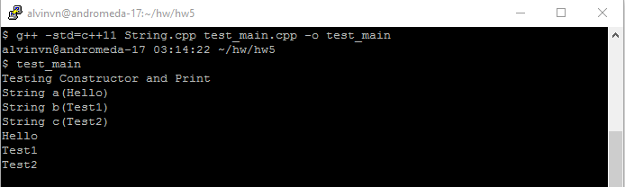

ASSIGNMENT OPERATOR =

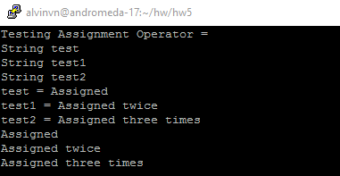

OPERATOR INDEX []

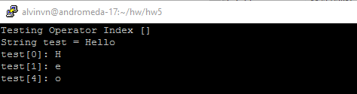

SIZE

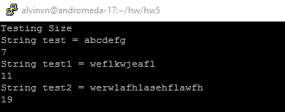

BOOLEAN FUNCTIONS == AND <

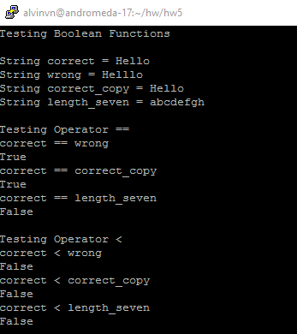

INDEXOF

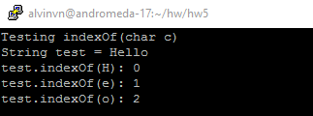

ADDITION + AND +=

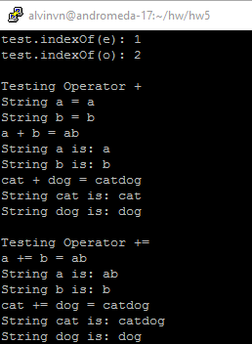

REVERSE

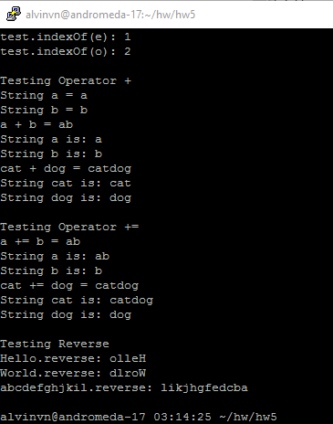

VALGRIND FOR TEST_MAIN

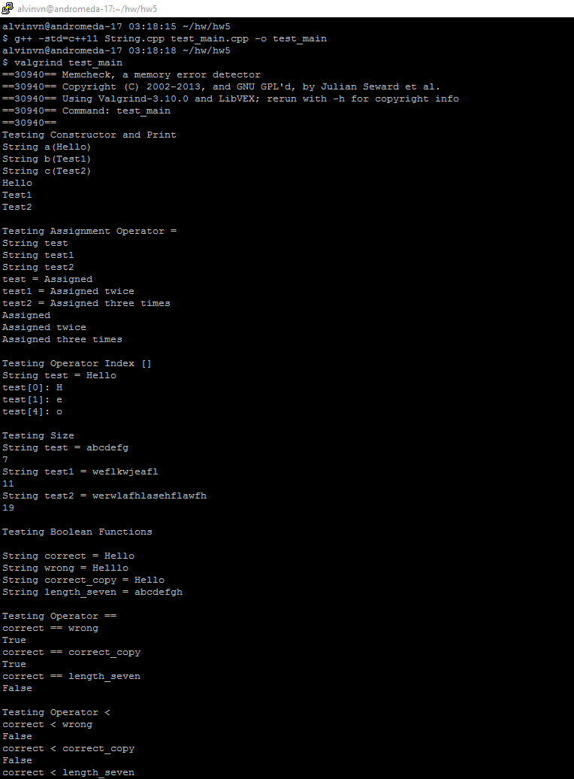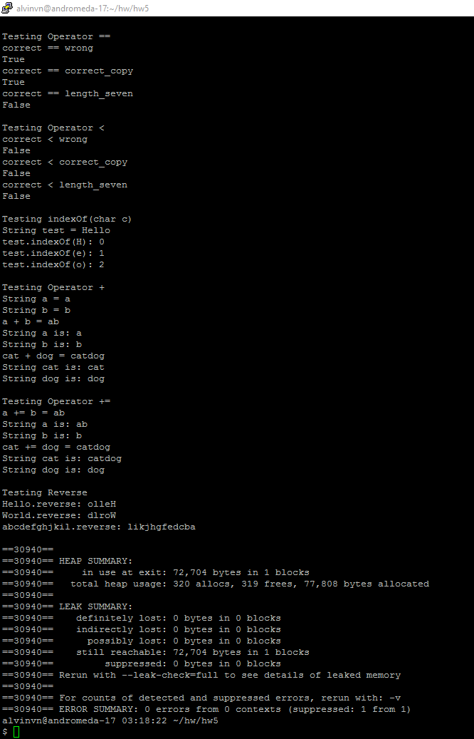

STANDARD_MAIN

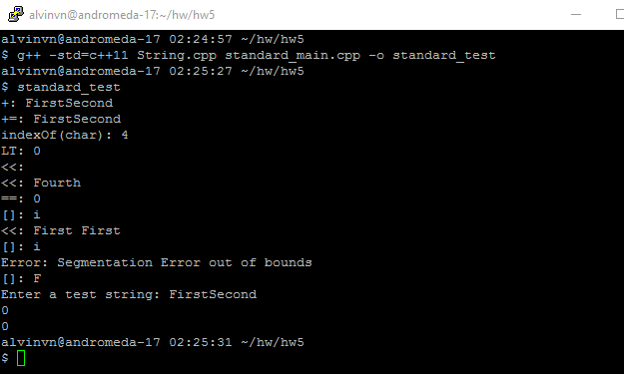

VALGRIND FOR STANDARD_MAIN

