Table of Contents

1,remove old version 1

2,Install apache2.4.6 1

3,install mysql-5.7.11 1

4,install php-5.6.18 3

5,check 4

6,other 5

# 1,remove old version

sudo yum remove httpd mysql

# 2,Install apache2.4.6

sudo yum install gcc-c++

tar xf apr-1.5.2.tar.gz

cd apr-1.5.2

sudo mkdir /usr/local/apr

sudo ./configure --prefix=/usr/local/apr

sudo make

sudo make install

sudo mkdir /usr/local/apr-util

cd ..

tar xf apr-util-1.5.4.tar.gz

cd apr-util-1.5.4

sudo ./configure --prefix=/usr/local/apr-util --with-apr=/usr/local/apr/bin/apr-1-config

sudo make

sudo make install

cd ..

tar xf pcre-8.37.tar.gz

cd pcre-8.37

sudo mkdir /usr/local/pcre

sudo ./configure --prefix=/usr/local/pcre --with-apr=/usr/local/apr/bin/apr-1-config

sudo make

sudo make install

cd ..

tar xf httpd-2.4.6.tar.gz

cd httpd-2.4.6

sudo yum install pcre pcre-devel

sudo ./configure --prefix=/usr/local/apache --with-pcre=/usr/local/pcre --with-apr=/usr/local/apr --with-apr-util=/usr/local/apr-util

sudo make

sudo make install

# 3,install mysql-5.7.11

cd ..

tar xf boost_1_59_0.tar.gz

sudo mv boost_1_59_0 /usr/local/boost

tar xf mysql-5.7.11.tar.gz

cd mysql-5.7.11

sudo yum install gcc gcc-c++ gcc-g77 autoconf automake zlib**\*** fiex**\*** libxml**\*** ncurses-devel libmcrypt**\*** libtool-ltdl-devel**\*** make cmake

cmake -DCMAKE_INSTALL_PREFIX=/usr/local/mysql \

-DCMAKE_INSTALL_PREFIX=/usr/local/mysql \

-DMYSQL_DATADIR=/usr/local/mysql/data \

-DSYSCONFDIR=/etc \

-DWITH_MYISAM_STORAGE_ENGINE=1 \

-DWITH_INNOBASE_STORAGE_ENGINE=1 \

-DWITH_MEMORY_STORAGE_ENGINE=1 \

-DWITH_READLINE=1 \

-DMYSQL_UNIX_ADDR=/var/lib/mysql/mysql.sock \

-DMYSQL_TCP_PORT=3306 \

-DENABLED_LOCAL_INFILE=1 \

-DWITH_PARTITION_STORAGE_ENGINE=1 \

-DEXTRA_CHARSETS=all \

-DDEFAULT_CHARSET=utf8 \

-DDEFAULT_COLLATION=utf8_general_ci \

-DWITH_BOOST=/usr/local/boost

sudo make

sudo make install

useradd mysql

sudo mkdir -p /usr/local/mysql/data

sudo chown -R mysql:mysql /usr/local/mysql/

sudo vi /etc/my.cnf

[mysqld]

datadir=/usr/local/mysql/data

socket=/var/lib/mysql/mysql.sock

user=mysql

# Disabling symbolic-links is recommended to prevent assorted security risks

symbolic-links=0

[mysqld_safe]

log-error=/var/log/mysqld.log

pid-file=/var/run/mysqld/mysqld.pid

sudo /usr/local/mysql/bin/mysqld --initialize-insecure --user=mysql --datadir=/usr/local/mysql/data/ --basedir=/usr/local/mysql/ --explicit_defaults_for_timestamp

sudo cp /usr/local/mysql/support-files/mysql.server /etc/init.d/mysqld

sudo /etc/init.d/mysqld start

echo "export PATH=/usr/local/mysql/bin:$PATH" >> /etc/profile

source /etc/profile

mysql -u root

# 4,install php-5.6.18

cd /usr/local/mysql/lib/

sudo ln -s libmysqlclient.so.20.2.0 libmysqlclient_r.so

cd –

cd ..

tar xf php-5.6.18.tar.gz

cd php-5.6.18

sudo yum install libxml2-devel libpng-devel libjpeg-turbo-devel freetype freetype-devel

#sudo ./configure --prefix=/usr/local/apache/php --with-apxs2=/usr/local/apache/bin/apxs --with-config-file-path=/usr/local/apache/php --enable-sigchild --with-mysql=/usr/local/mysql --enable-mbstring

./configure --prefix=/usr/local/apache/php --with-apxs2=/usr/local/apache/bin/apxs --with-config-file-path=/usr/local/apache/php --enable-sigchild --with-mysql=/usr/local/mysql --enable-mbstring --enable-sockets --with-freetype-dir --with-png-dir --with-jpeg-dir --with-gd --enable-bcmath --with-gettext --enable-embedded-mysqli --with-mysqli=/usr/local/mysql/bin/mysql_config --with-config-file-path=/usr/local/apache/php/ --with-mhash --with-mcrypt=/usr/local/libmcrypt/ --enable-gd-native-ttf --with-zlib

sudo make

sudo make test

sudo make install

sudo vi /usr/local/apache/conf/httpd.conf

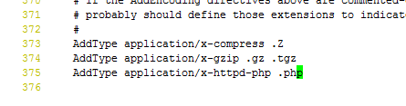

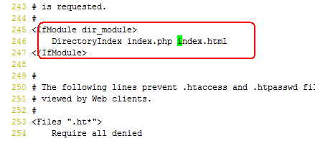

vi /usr/local/apache/htdocs/index.php

<?php

phpinfo();

?>

sudo /usr/local/apache/bin/apachectl start

[root@zabbix ~]# cat /usr/local/apache/php/php.ini

post_max_size = 20M

max_execution_time = 300

date.timezone = Asia/Shanghai

always_populate_raw_post_data = -1

cat >> /usr/local/apache/php/php.ini<<EOF

post_max_size = 20M

max_execution_time = 300

date.timezone = Asia/Shanghai

always_populate_raw_post_data = -1

EOF

# 5,check

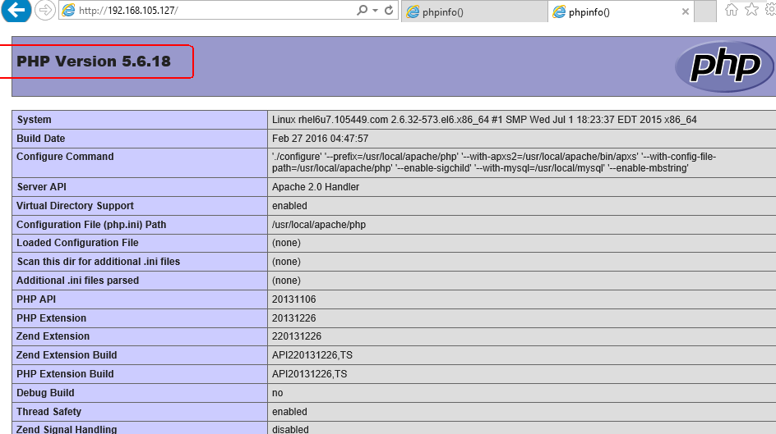

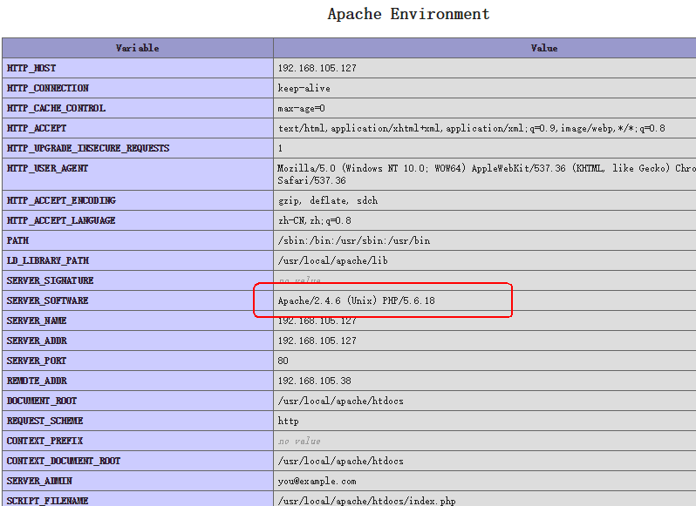

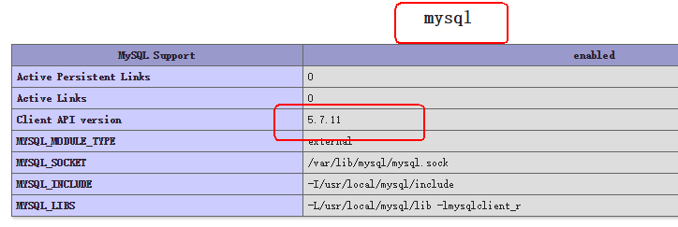

# 6,service dir

Apache dir:/usr/local/apache

Apache index dir: /usr/local/apache/htdocs/

Apache config dir :/usr/local/apache/conf

Mysql dir:/usr/local/mysql

Mysql datadir:/usr/local/mysql/data

Php dir:/usr/local/apache/php

1. Yum install net-snmp* curl libcurl-devel ipmitool net-snmp-devel OpenIPMI OpenIPMI-devel rpm-build curl curl-devel

./configure --prefix=/usr/local/zabbix --enable-server --enable-agent --with-mysql --enable-ipv6 --with-net-snmp --with-libcurl --with-libxml2

#make && make install

#mkdir /usr/local/apache/htdocs/zabbix

cp -a frontends/php/.* /usr/local/apache/htdocs/zabbix/

mysql -e " create database zabbix character set utf8; "

mysql -e " grant all privileges on zabbix.* to zabbix@localhost identified by 'zabbix';"

mysql -e " flush privileges"

[root@zabbix zabbix-3.0.4]# mysql zabbix < database/mysql/schema.sql

[root@zabbix zabbix-3.0.4]# mysql zabbix < database/mysql/images.sql

[root@zabbix zabbix-3.0.4]# mysql zabbix < database/mysql/data.sql

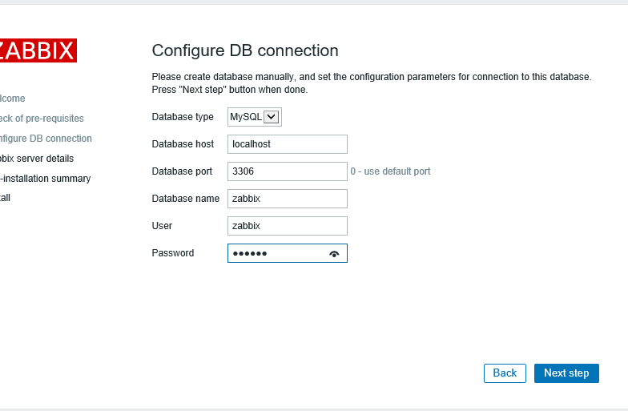

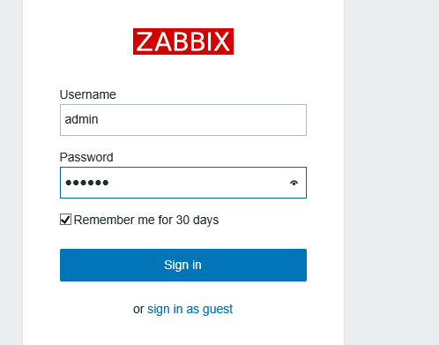

ln -s /usr/local/mysql/lib/libmysqlclient.so.20 /usr/lib64/

[root@zabbix zabbix-3.0.4]# cp misc/init.d/fedora/core/zabbix_* /etc/init.d/

ln -s /usr/local/zabbix/sbin/zabbix_server /usr/local/sbin/

# vim /usr/local/zabbix/etc/zabbix_server.conf

ListenPort=10051

DBHost=127.0.0.1

DBName=zabbix

DBPassword=zabbix

[root@zabbix zabbix-3.0.4]# /etc/init.d/zabbix_server start

Starting zabbix_server: [ OK ]

cp /usr/local/zabbix/sbin/zabbix_agentd /usr/local/sbin/

cp misc/init.d/fedora/core/zabbix_agentd /etc/init.d/zabbix_agentd

[root@zabbix zabbix-3.0.4]# cat /usr/local/zabbix/alertscripts/sendmail.sh

#!/bin/bash

day=`date +%Y%m%d_%H%M`

log_dir=/usr/local/zabbix/share/zabbix/alertscripts/log

name=`echo $1 |awk -F@ '{print $1}'`

function redirect_log ()

{

log_file=$log_dir/mail_${day}_$name.log

log_err=$log_dir/mail_${day}_$name.err.log

mkdir -p $log_dir

exec 1>$log_file

exec 2>$log_err

} # ---------- end of function redirect_log ----------

redirect_log

echo "$3" | sed s/'\r'//g | mailx -s "$2" $1

[ $? -eq 0 ] && echo "mailto:$1 sub:$2 content:$3 Successfull." || echo [mailto:$1 sub:$2 content:$3 Failed.](mailto:$1%20sub:$2%20content:$3%20Failed.)

[root@zabbix zabbix-3.0.4]# tail -10 /etc/mail.rc

fwdretain subject date from to

# For Linux and BSD, this should be set.

set bsdcompat

set from=zabbix@bluedot.com.cn

set smtp=smtp.mxhichina.com

set smtp-auth-user=zabbix@bluedot.com.cn

set smtp-auth-password=xxxxxxxx

set smtp-auth=login

添加vcenter到zabbix监控时，在macros里添加{$PASSWORD} = Password_169 {$URL}= <https://10.150.88.161/sdk> {$USERNAME} = [administrator@vsphere.local](mailto:administrator@vsphere.local)

监控vcenter 时 需要在zabbix server的配置为文件里添加

StartVMwareCollectors=5

VMwareFrequency=60

VMwareCacheSize=8