 | 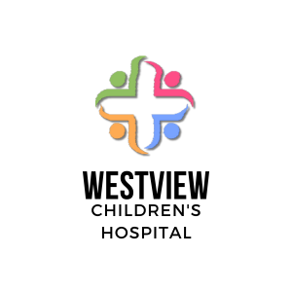  About Us

Topics
- Who We Are
- Mission, Vision & Values
- Hospital Capacity
- Patient Safety & Quality

Who We Are
Westview Children’s Hospital is a leader in general and specialized Click to view a list of hospital programs. and is the foremost teaching and research facility for children’s health.

Mission, Vision & Values

Mission
Provide the highest quality of health care through caring, leading and learning together

Vision
Facilitate state-wide solutions for excellence in children’s health

Values

Respect People
We treat people as individuals with unique beliefs, values, lived experiences and cultural norms. We request, listen to and respond to suggestions for improvement. Patients and families are at the center of all we do.

Be Compassionate
Whether it's caring for a patient, family member or colleague, being compassionate is fundamental to the work we do. We care about the health and well-being of one another and those we serve.

Respect Diversity
We are dedicated to creating a culture where all patients, families, clinicians, researchers, staff, and communities feel empowered and supported. We are committed to working together to support health equity. Our formal Declaration on Equity, Diversity and Inclusivity is our guiding compass in making this goal a reality.

Cultivate Partnerships
Our state-wide scope means we foster partnerships wherever possible to improve health outcomes. We collaborate with each other, those we serve and regional, state, and national colleagues. We believe cultivating partnerships also means supporting patients and their families to make the healthcare decisions that are right for them.

Serve with Purpose
Our shared drive to make meaningful improvements in care helps to guide our services. We believe that making a difference in the lives of others is our legacy.

Hospital Capacity
With more than 30 clinical departments and 170 specialized clinical programs, Westview Children’s Hospital is one of the largest pediatric medical centers in the western United States. We provide a complete range of health care services for children of all ages.

Patient Safety & Quality
At Westview Children’s Hospital, we believe that caring for your child is both a privilege and a responsibility. We are committed to providing the best possible care to every patient and family, and to raising the bar for the quality and safety of pediatric health care across the state. We constantly measure our performance to continuously improve what we do. We also work hard to make sure that practices reflect the latest science, while responding to the unique needs, preferences, and values of our patients and families.
The Program for Patient Safety and Quality supports improvement work throughout Westview Children’s Hospital. The team includes physician leaders, improvement consultants, patient safety reviewers, clinical effectiveness experts, and many others.

Westview Children’s Hospital | 62 Hood Point Road | Tacoma, WA 98404
(253) 555-5490 | info@westview.cengage.com | www.westview.cengage.com

