**ISEM2006 Assignment**

**Your Name: YU Fengfei Student ID: 21251215**

1. Write your answer code on and submit a **Microsoft word** or **PDF file** (5 points will be deducted if your file is not in these file formats). You may want to check your code on Python, but do not submit your script file.
2. Name your file LastName_FirstName_StudentID, for example Doe_Jane_2012256
3. The assignment will be graded based on:

**Accuracy**: whether the code achieves the objectives.

**Readability**: whether the code is clean, well-formatted, and easily readable. Please use ‘#’ to add comments and to make it clear what your code is for.

Question 1. Write Python code to print the result below. ‘longorshort()’ is a function that you define. It should take **a list** as an input. A long word is defined when it has more than 5 letters.

图形用户界面, 文本, 应用程序, 电子邮件

AI 生成的内容可能不正确。

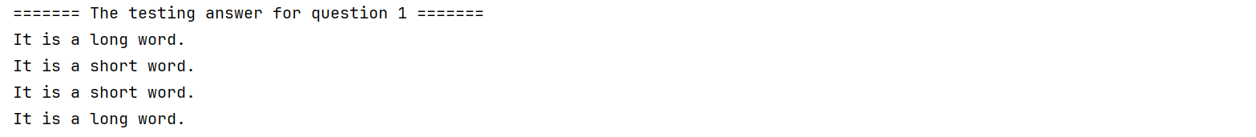

Question 2. Create a function that displays ‘A’ for grades greater than or equal to 80, ‘B’ for grades in the range 70-79, ‘C’ for grades 60-69 and ‘F’ for all other grades.

图形用户界面, 文本, 应用程序, 电子邮件

AI 生成的内容可能不正确。

背景图案

AI 生成的内容可能不正确。

Question 3. Write Python code to print the result below. ‘classifyme()’ is a function that you define. It should take **a list** as an input.

图形用户界面, 文本, 应用程序, 电子邮件

AI 生成的内容可能不正确。

背景图案

AI 生成的内容可能不正确。

Question 4. Write Python code to return **a list** shown as below. ‘greater()’ is a function that you define. It should take **a list** as an input.

图形用户界面, 文本, 应用程序

AI 生成的内容可能不正确。

背景图案

AI 生成的内容可能不正确。