Forg3t Protocol Avalanche Phase 2 Evidence Artifacts
Reviewer-ready DOCX package generated from repository evidence, live Edge Function responses, exports, and screenshots. Generated 2026-05-25.
Boundary
This document does not claim enterprise pilot completion, customer attestation, legal approval, production deployment beyond verified public routes, or recorded demo completion. Founder-only evidence requirements are marked explicitly.

Key Live Links
Public verify page: https://buildgames.forg3t.io/verify/212a028eabcac5e2c3458cc9f219259d
Public verify API: https://xewxfsdrtqpthkpbhbzp.supabase.co/functions/v1/verify-evidence?token=212a028eabcac5e2c3458cc9f219259d
Snowtrace transaction: https://snowtrace.io/tx/0x7af8b0376079571f2a4ff46ff76e6cdfb27f710ea4b2434c41bfdf25a167e7be
Snowtrace contract: https://snowtrace.io/address/0x20E772a60CEE7D8E6706E698B129FD917c3936bf

Canonical Evidence IDs
Field | Value
Project ID | 0c7643e1-471f-4b04-848c-329c39f77143
Job ID | 9a2a77cf-4b09-4f59-be04-c18b08b137bd
Evidence ID | 608a427f-25c1-4f43-b3e7-d9a86ff33801
Public verify token | 212a028eabcac5e2c3458cc9f219259d
Avalanche network | mainnet
Chain ID | 43114
Block number | 86276105
Contract address | 0x20E772a60CEE7D8E6706E698B129FD917c3936bf

Checklist Matrix
Each checklist item below maps to a generated proof card, screenshot, API response, export file, log file, or Founder Evidence Required boundary.
Checklist Item | Status | Primary Artifact | Supporting Evidence
Live Avalanche transaction link | Done | generated-images/01-live-avalanche-transaction.svg | screenshots/snowtrace-transaction.png, api/anchor-status.json
Explorer screenshot | Done | screenshots/snowtrace-transaction.png | screenshots/snowtrace-contract.png
Job detail evidence | Done | generated-images/02-job-detail-proof.svg | api/job-detail.json
Evidence detail evidence | Done | generated-images/03-evidence-detail-proof.svg | api/authenticated-verify-evidence.json
Public verify page screenshot | Done | screenshots/public-verify-page.png | generated-images/04-public-verify-proof.svg
Drag and drop verification base UI | Done | screenshots/public-verify-page.png | generated-images/05-drag-drop-json-valid.svg
JSON valid verification | Done | generated-images/05-drag-drop-json-valid.svg | exports/forg3t-evidence-bundle.valid.json, api/verify-upload-json-valid-response.json
JSON mismatch verification | Done | generated-images/06-drag-drop-json-mismatch.svg | exports/forg3t-evidence-bundle.mismatch.json, api/verify-upload-json-mismatch-response.json
PDF verification | Done | generated-images/07-drag-drop-pdf-valid.svg | exports/forg3t-evidence-export.pdf, api/verify-upload-pdf-valid-response.json
Unsupported file state | Done | generated-images/08-drag-drop-unsupported-file.svg | api/verify-upload-unsupported-file-response.json
JSON export | Done | exports/forg3t-evidence-export.json | generated-images/09-json-export.svg, api/report-export-json-response.json
CSV export | Done | exports/forg3t-evidence-export.csv | generated-images/10-csv-export.svg, api/report-export-csv-response.json
PDF export | Done | exports/forg3t-evidence-export.pdf | generated-images/11-pdf-export.svg, api/report-pdf-hash-commit.json
Pipeline run screenshot/proof | Done | generated-images/12-pipeline-run.svg | api/pipeline-run.json, api/pipeline-detail-with-runs.json
Admin role proof | Done | generated-images/13-admin-role-proof.svg | api/project-access-memberships.json
SDK/API smoke output | Done | generated-images/14-sdk-smoke-output.svg | logs/phase2-smoke.log
Build, test, audit logs | Done | generated-images/15-build-test-audit-logs.svg | logs/npm-test.log, logs/npm-build.log, logs/npm-audit.log, logs/contracts-compile.log, logs/contracts-audit.log
Generic HTTP integration smoke | Done | generated-images/16-generic-http-integration-smoke.svg | api/integration-create-generic-http.json, api/integration-test-generic-http.json
Production dashboard bundle check | Resolved | generated-images/17-production-login-env-risk.svg | api/production-bundle-env-check.json
Pilot evidence memo | Founder Evidence Required | generated-images/18-founder-pilot-evidence-required.svg | Founder must provide external memo if claiming pilot progress.
Customer or partner confirmation | Founder Evidence Required | generated-images/19-customer-confirmation-required.svg | Founder must provide external confirmation if available.
Recorded demo video | Founder Evidence Required | generated-images/20-demo-video-required.svg | Founder must record or provide demo link separately.

Production Bundle Check
Production Bundle Check
No service-role-looking JWT string was detected in the checked production bundle artifact.

Primary Screenshots
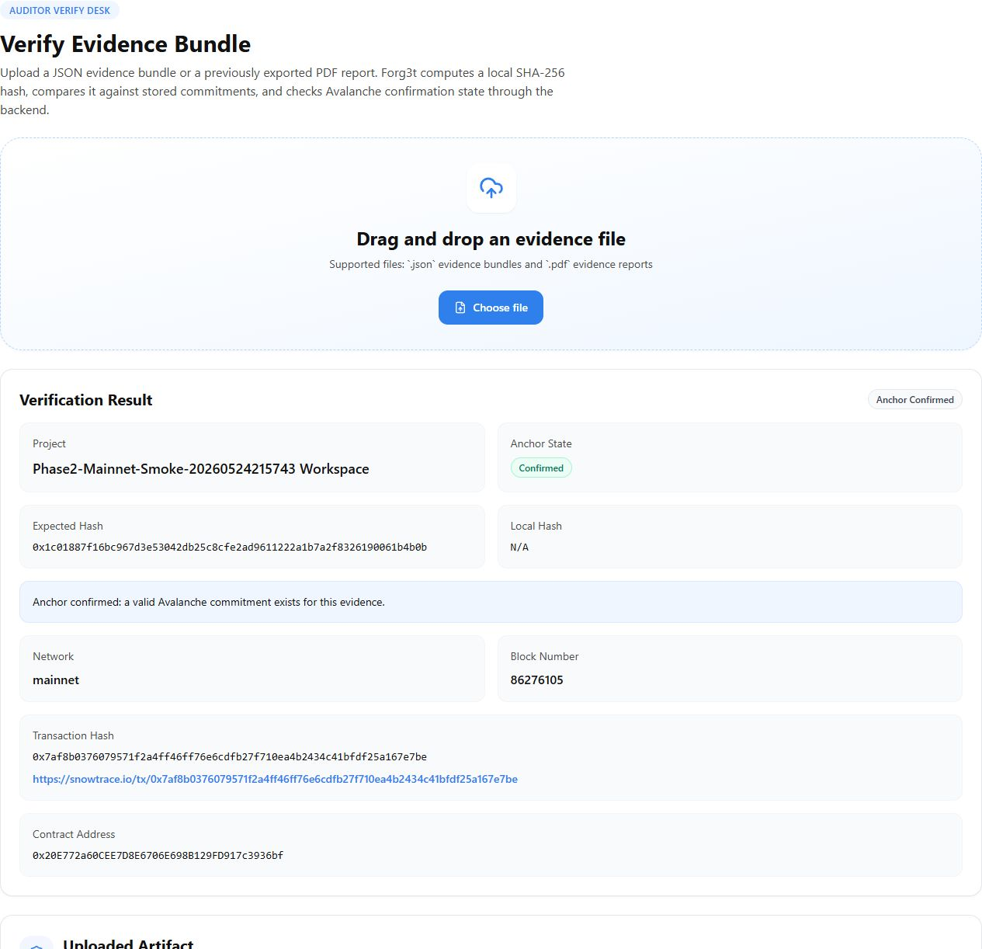
Public verify page showing confirmed anchor state.
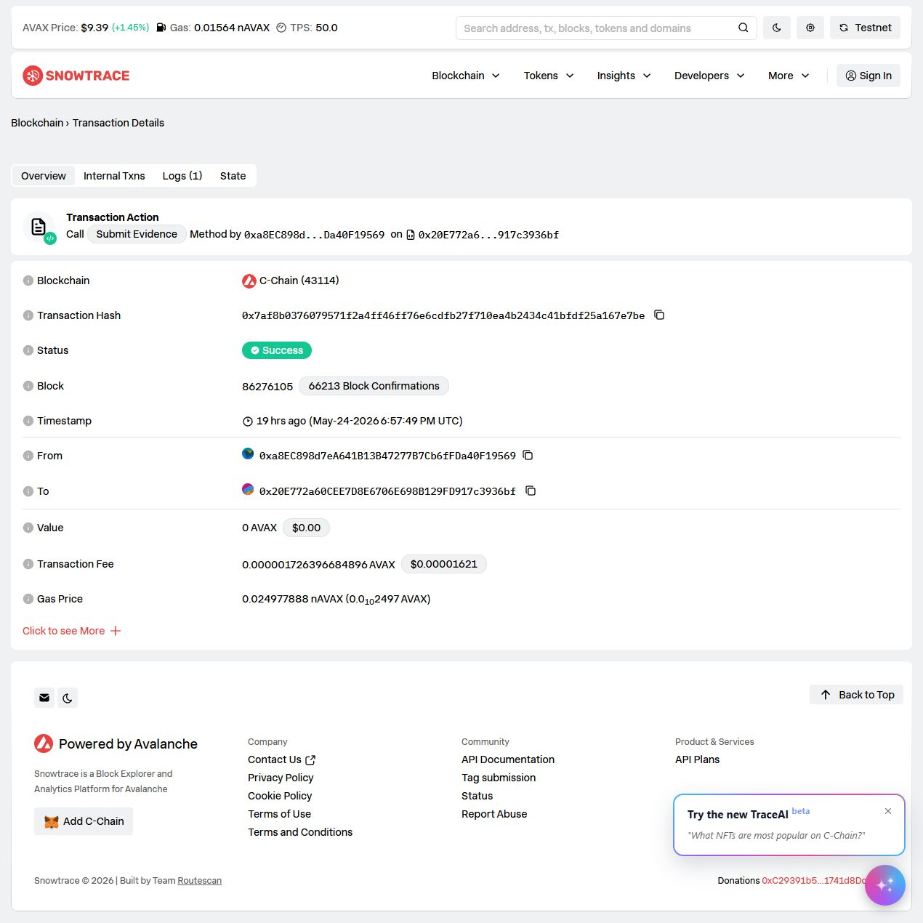
Snowtrace transaction page for the Avalanche mainnet anchor.
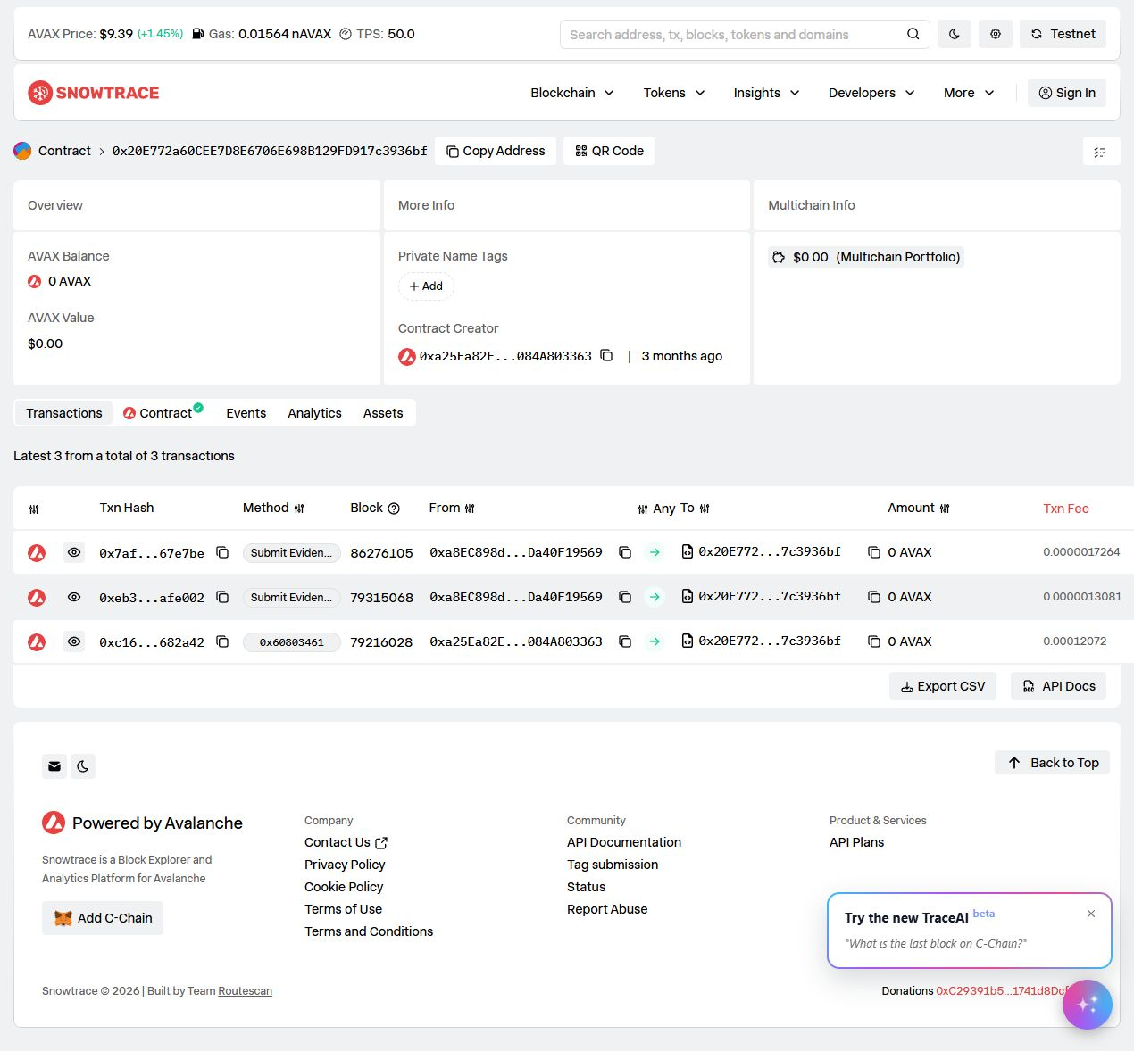
Snowtrace contract page for the evidence anchor contract.
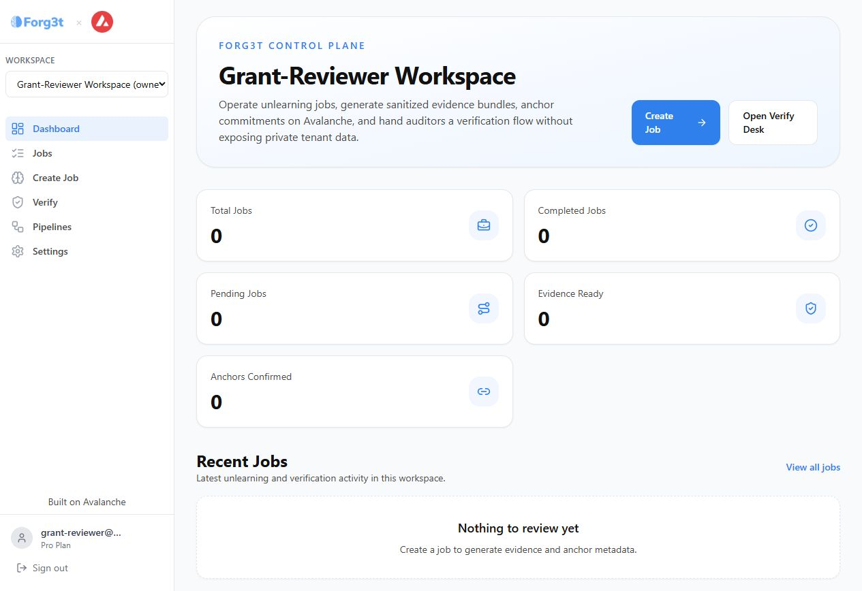
Local dashboard overview using the reviewer account and live Supabase backend.

Generated Proof Cards
The following proof cards summarize each checklist item. Source SVG files remain in generated-images; DOCX-embedded PNG renders are in generated-images-png.
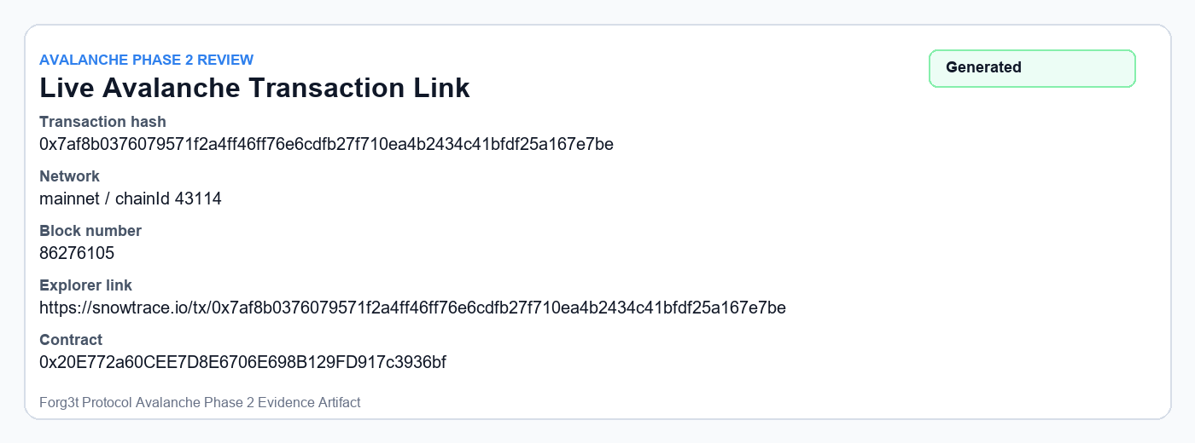
01 Live Avalanche Transaction
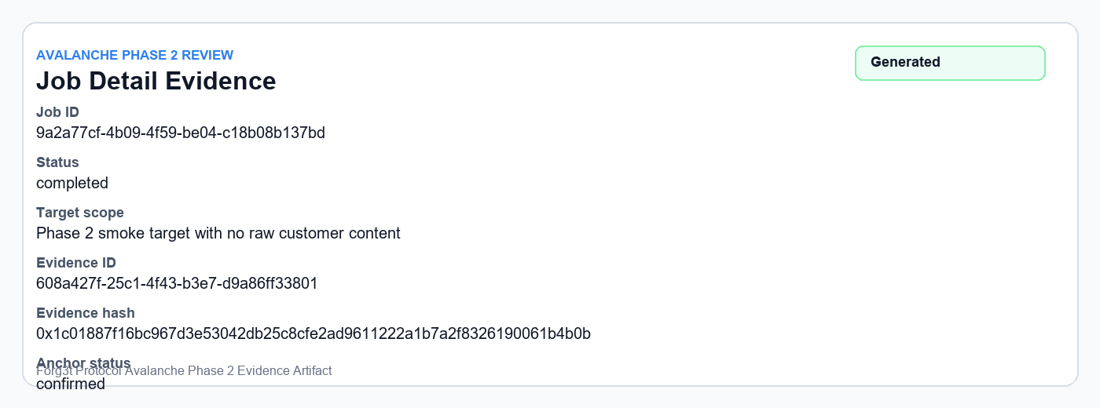
02 Job Detail Proof
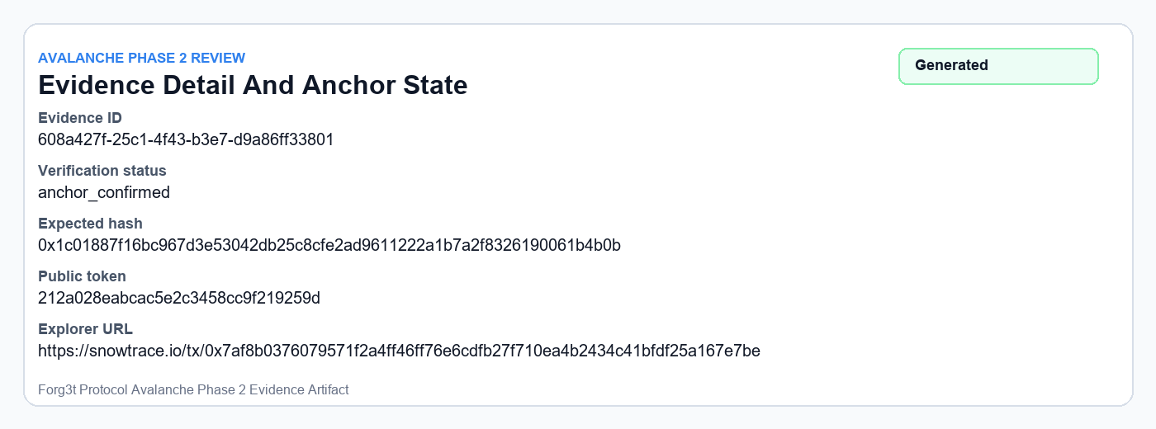
03 Evidence Detail Proof
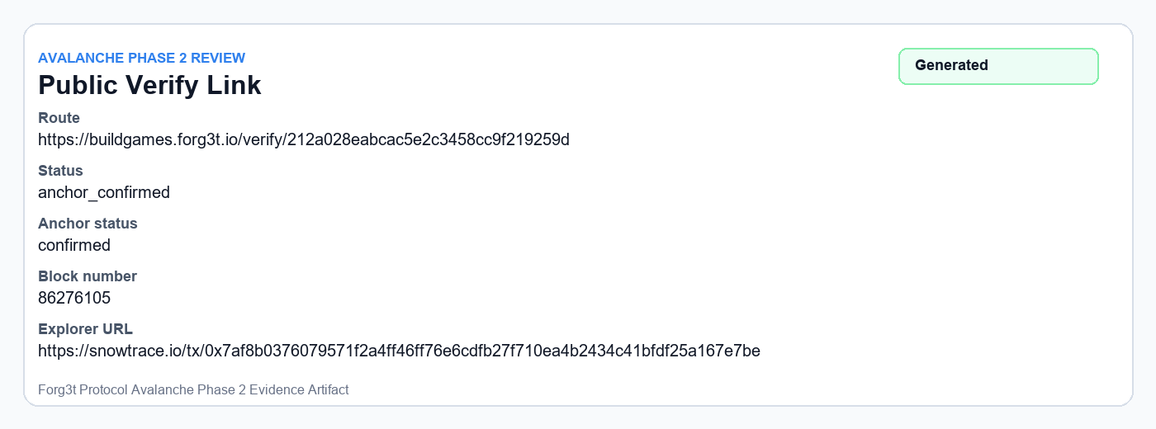
04 Public Verify Proof
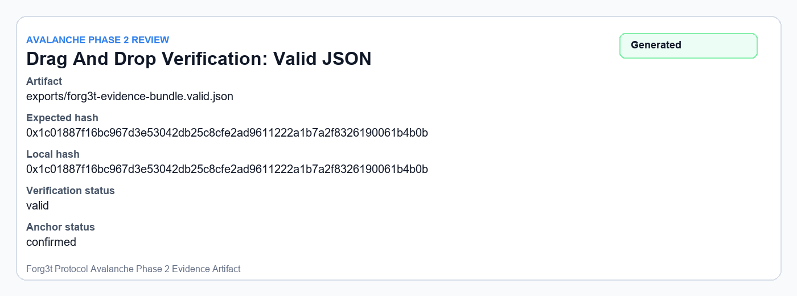
05 Drag Drop Json Valid
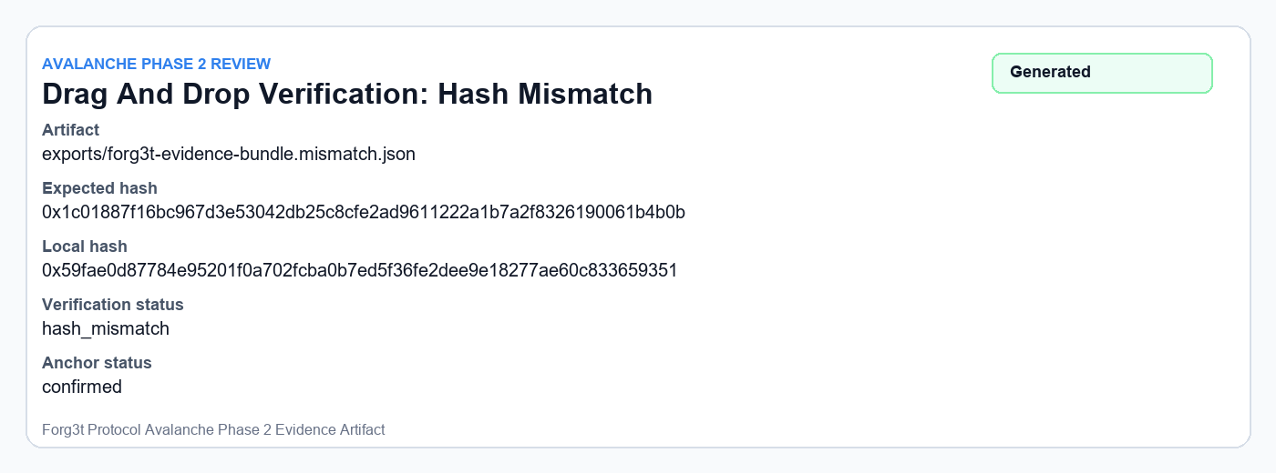
06 Drag Drop Json Mismatch
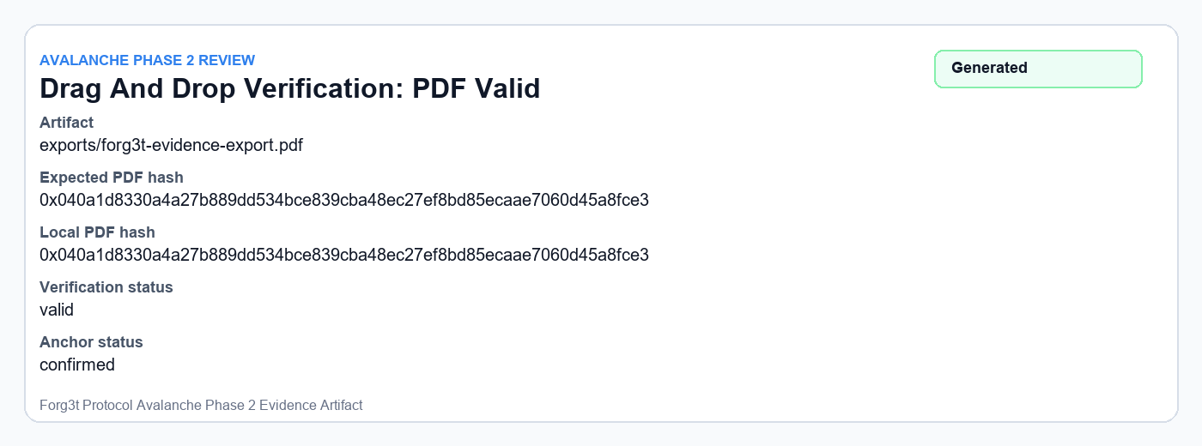
07 Drag Drop Pdf Valid
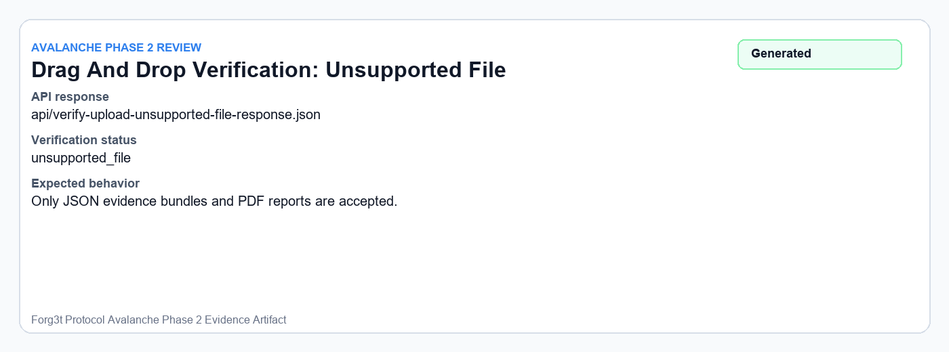
08 Drag Drop Unsupported File
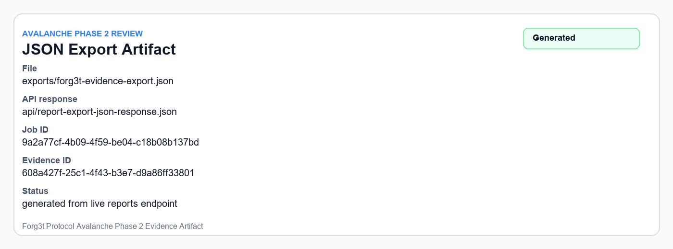
09 Json Export
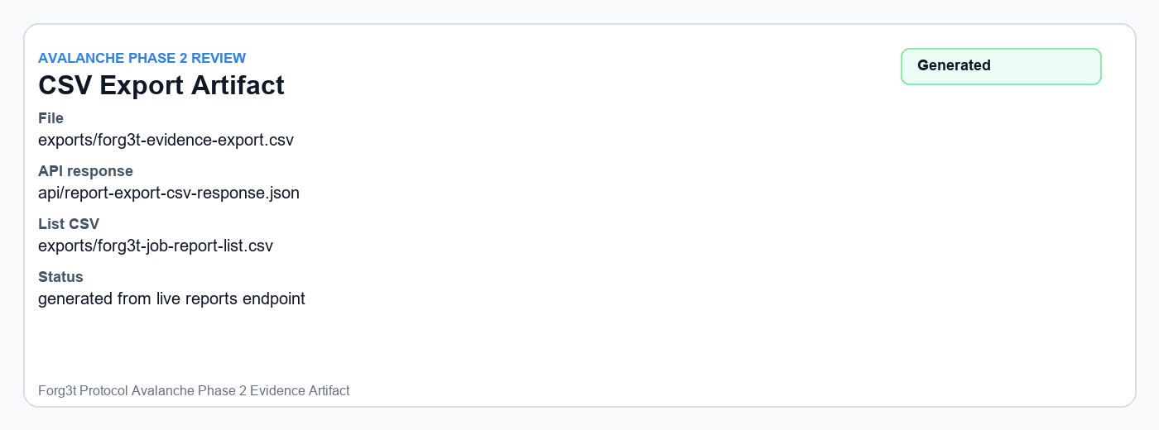
10 Csv Export
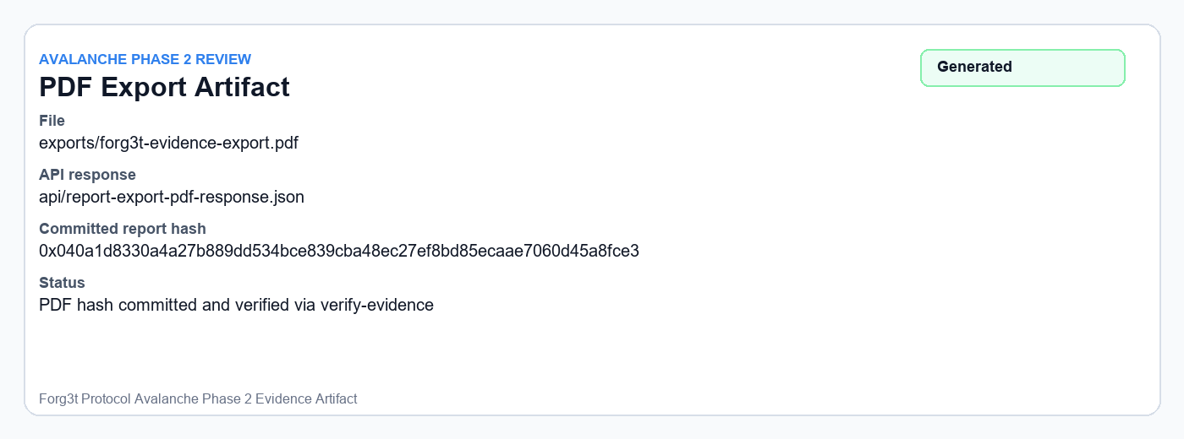
11 Pdf Export
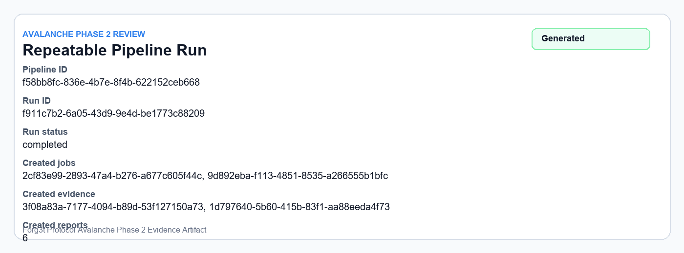
12 Pipeline Run
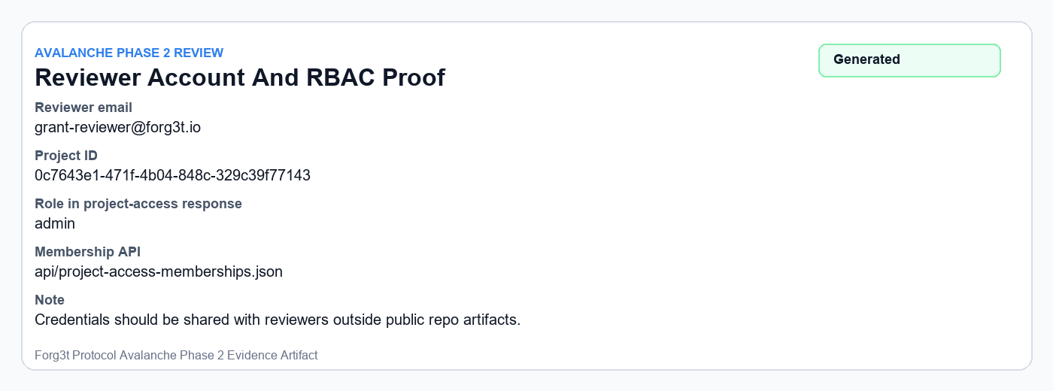
13 Admin Role Proof
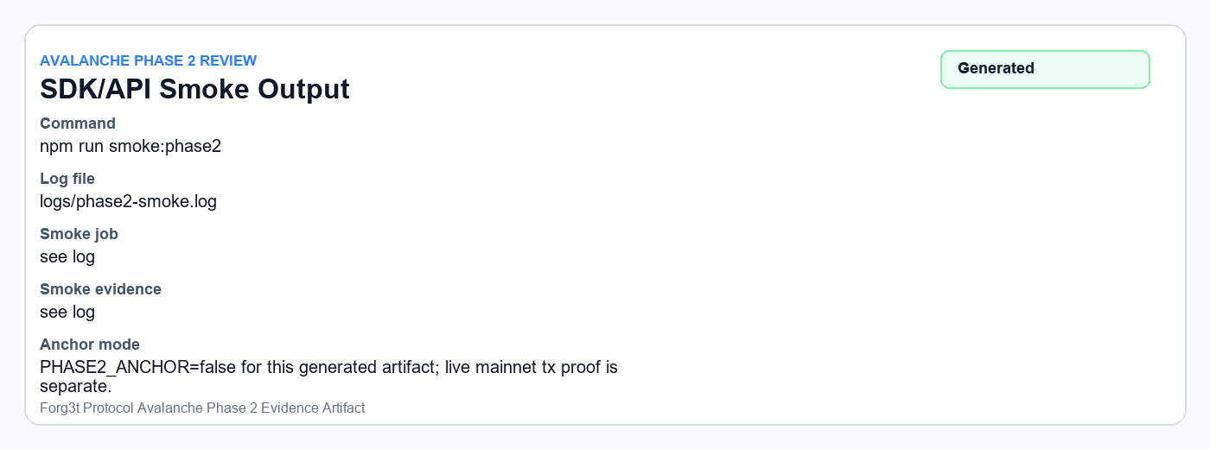
14 Sdk Smoke Output
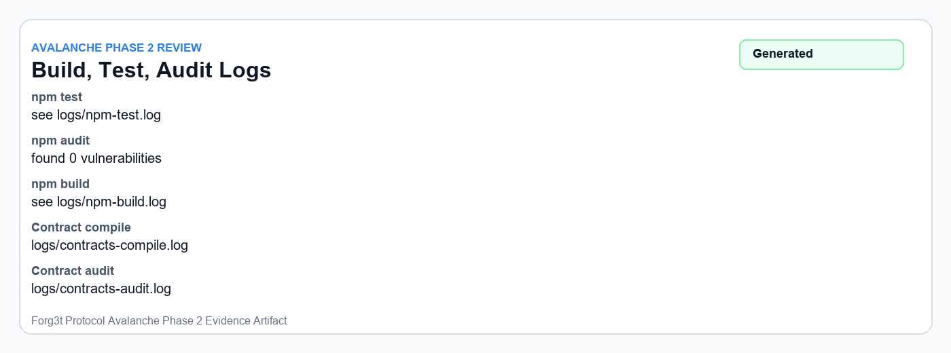
15 Build Test Audit Logs
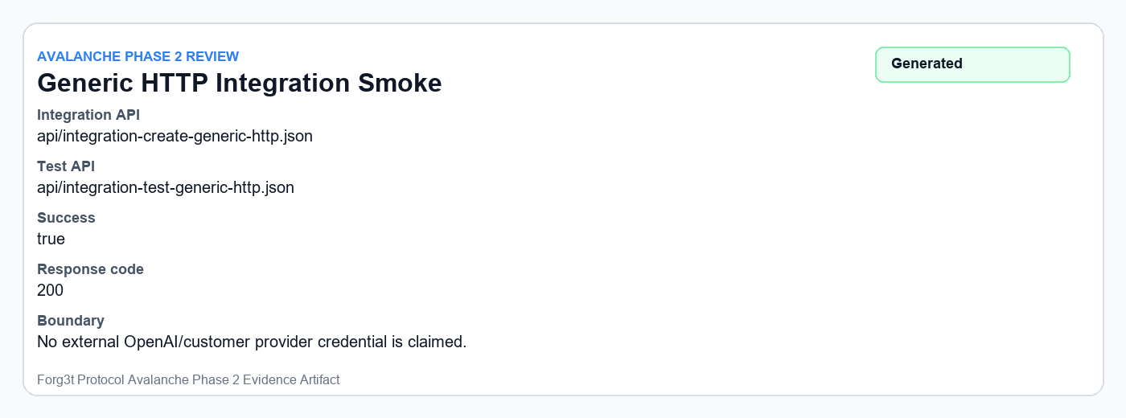
16 Generic Http Integration Smoke
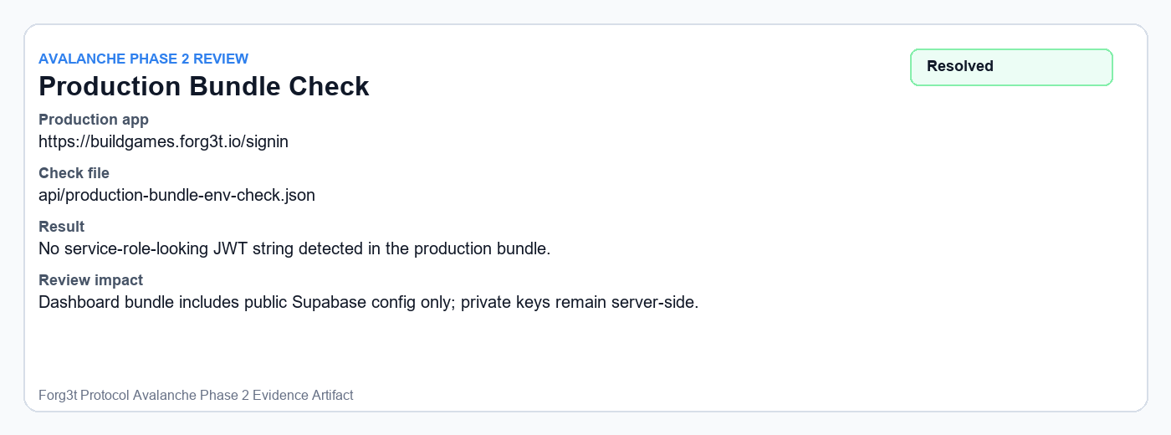
17 Production Login Env Risk
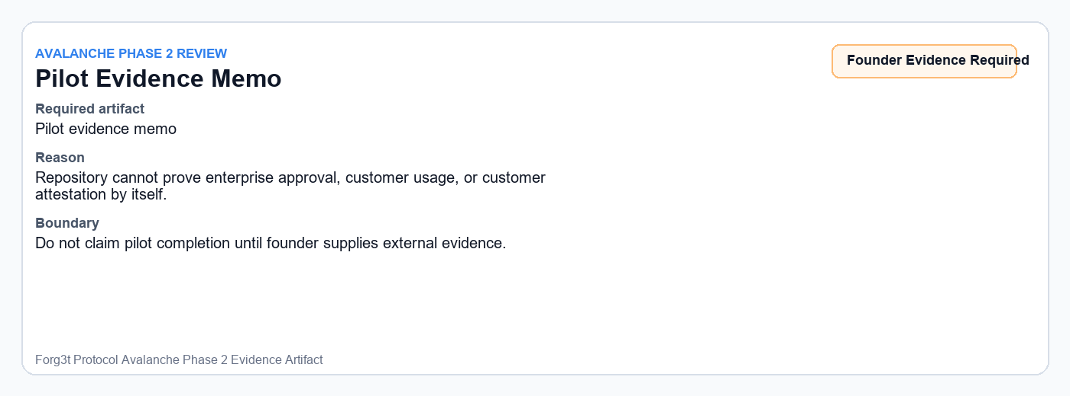
18 Founder Pilot Evidence Required
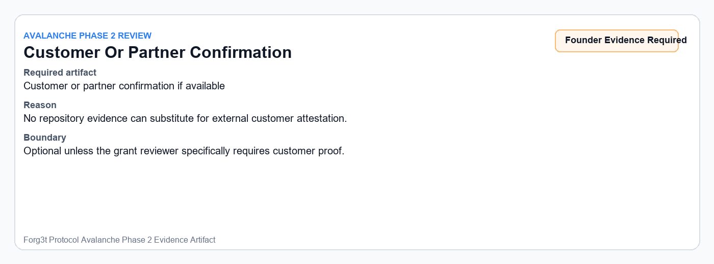
19 Customer Confirmation Required
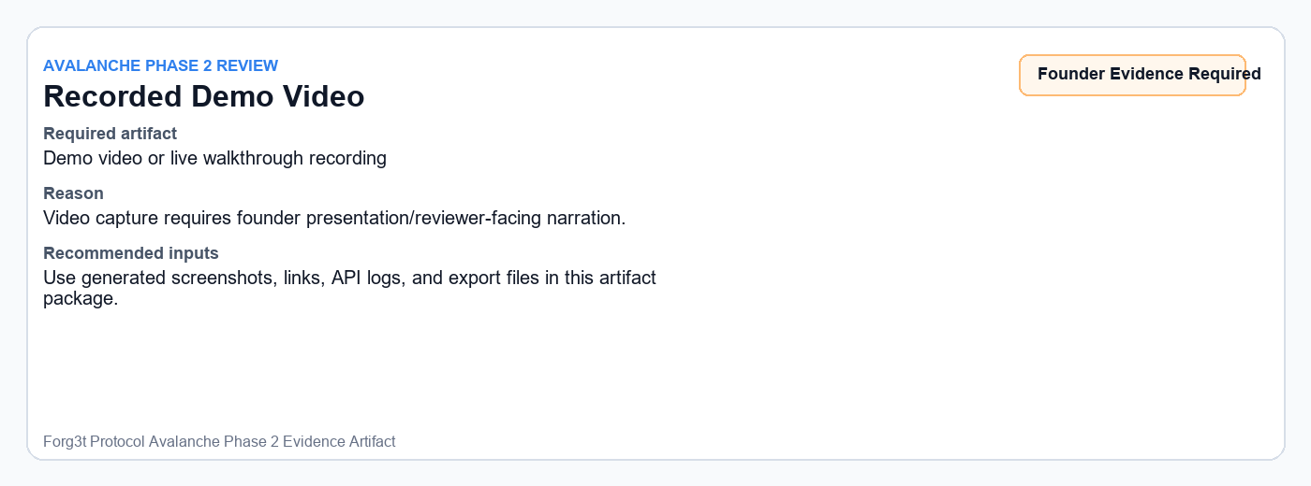
20 Demo Video Required

Export And Log Artifacts
Field | Value
JSON export | docs/grant-review/evidence-artifacts/exports/forg3t-evidence-export.json
CSV export | docs/grant-review/evidence-artifacts/exports/forg3t-evidence-export.csv
PDF export | docs/grant-review/evidence-artifacts/exports/forg3t-evidence-export.pdf
Phase 2 smoke log | docs/grant-review/evidence-artifacts/logs/phase2-smoke.log
npm test log | docs/grant-review/evidence-artifacts/logs/npm-test.log
npm build log | docs/grant-review/evidence-artifacts/logs/npm-build.log
npm audit log | docs/grant-review/evidence-artifacts/logs/npm-audit.log
Contract compile log | docs/grant-review/evidence-artifacts/logs/contracts-compile.log
Contract audit log | docs/grant-review/evidence-artifacts/logs/contracts-audit.log

Commands Used
npm test
npm run lint
npm run build
npm audit
cd contracts && npm run compile
cd contracts && npm audit
npm run smoke:phase2

Founder Evidence Required
The repository cannot independently provide external human evidence. Before submitting a final grant review package, the founder should provide these items if they are being claimed:
- Pilot evidence memo
- Customer or partner confirmation, if available
- Recorded demo or walkthrough video, if requested by the grant manager
- Any enterprise approval, customer usage proof, or sales/procurement material that is not present in the repository

