
FORG3T PROTOCOL
Black-box Suppression Quick Test Guide
Simple reviewer workflow for buildgames.forg3t.io

Live app | https://buildgames.forg3t.io
Primary route | /dashboard -> Black-box
Prepared | June 5, 2026

Important scope note
This reviewer flow demonstrates AI suppression, not full AI unlearning. To test AI unlearning workflows, email investment@forg3t.io.

Quick Path
Step | Action | What to use
1 | Create account | Go to buildgames.forg3t.io/signup and sign up with email + password.
2 | Choose plan | Select Enterprise on the onboarding screen, then continue.
3 | Open Black-box | From Dashboard, click Black-box in the sidebar or quick card.
4 | Get OpenAI values | Create/copy an API key and copy an Assistant ID from the OpenAI Platform.
5 | Run test | Paste values, use synthetic scope text, then run the suppression test.
6 | Review evidence | Open Jobs / Evidence to inspect status, verification, exports, and any anchor metadata.

Reviewer Instructions

1. Sign up and choose Enterprise
Open the live app and create a new account. After signup, the onboarding page asks for a package. Choose Enterprise, then continue to the dashboard.
Signup link: https://buildgames.forg3t.io/signup
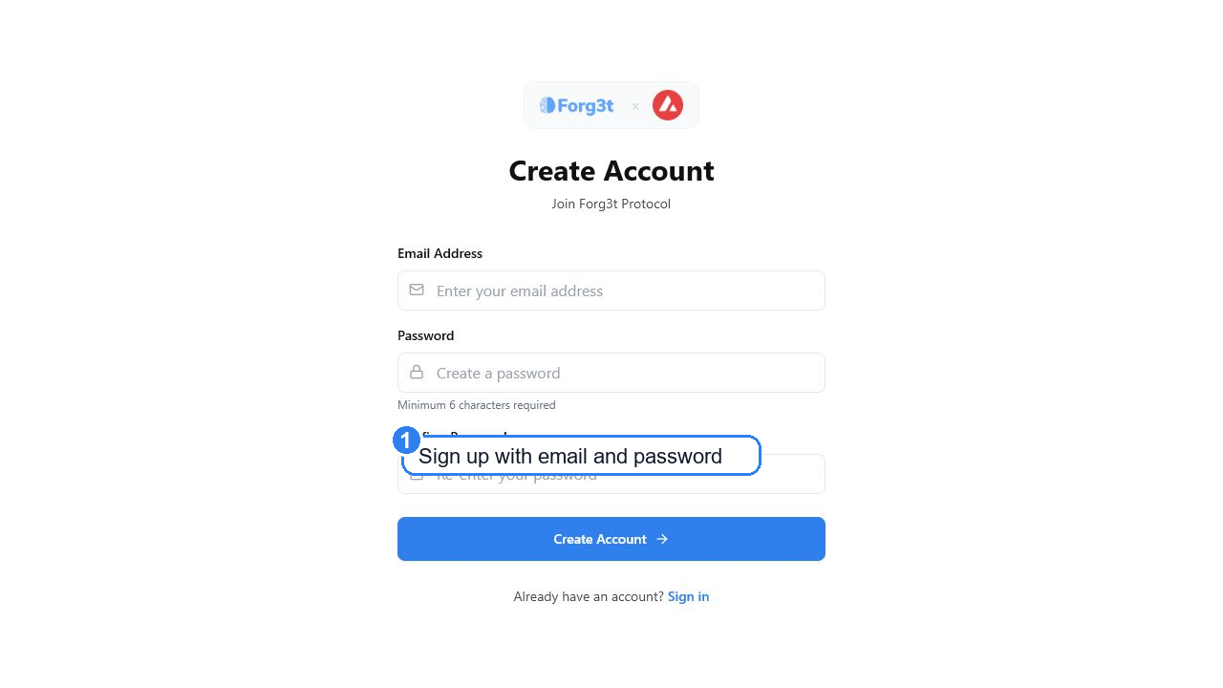
Screenshot 1 - Create a Forg3t account.
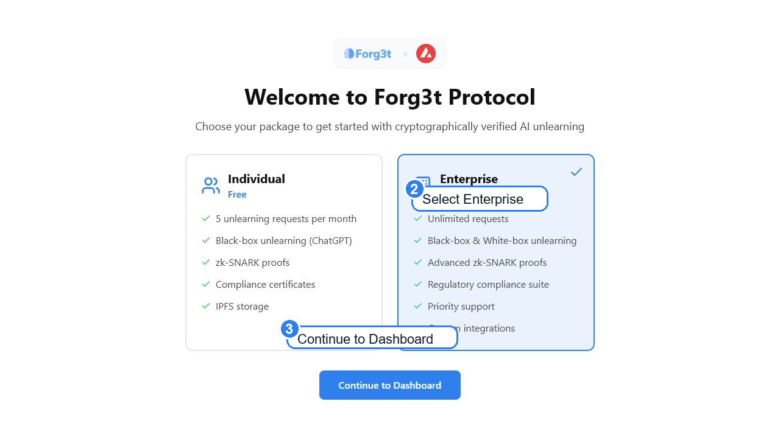
Screenshot 2 - Select the Enterprise package during onboarding.

2. Open Black-box from the Dashboard
After onboarding, land on the dashboard. Click Black-box from the left navigation or from the dashboard quick action card.
Dashboard link after sign-in: https://buildgames.forg3t.io/dashboard
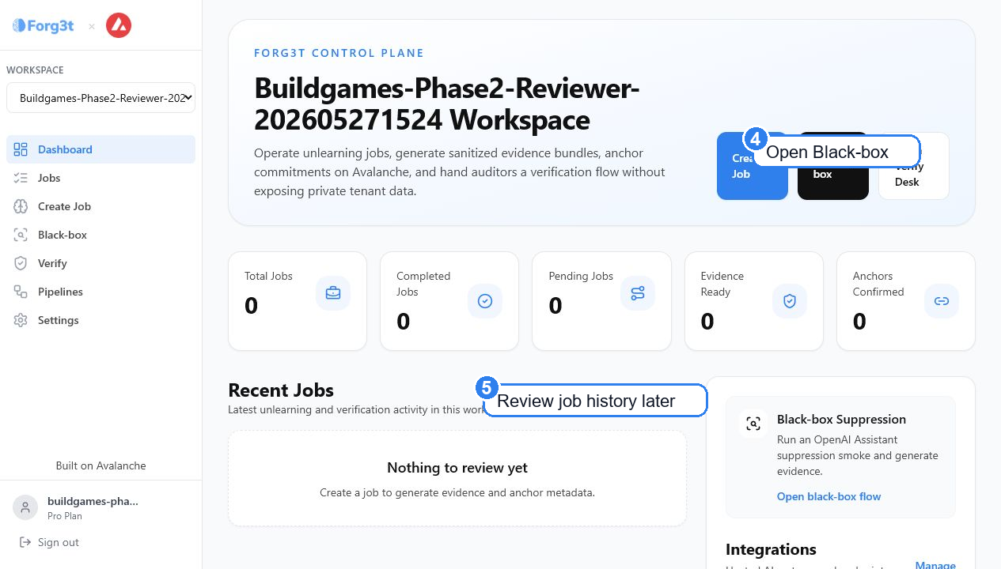
Screenshot 3 - Reviewer dashboard with job history and Black-box entry point.

3. Get the OpenAI values
Before running the test, collect two values from the OpenAI Platform. Keep both private and do not paste them into public documents.
Value | Where to get it | Format / note
API key | https://platform.openai.com/api-keys | Starts with sk-...
Assistant ID | https://platform.openai.com/assistants | Starts with asst_...
If OpenAI asks you to sign in, complete the sign-in first, then reopen the same two links.
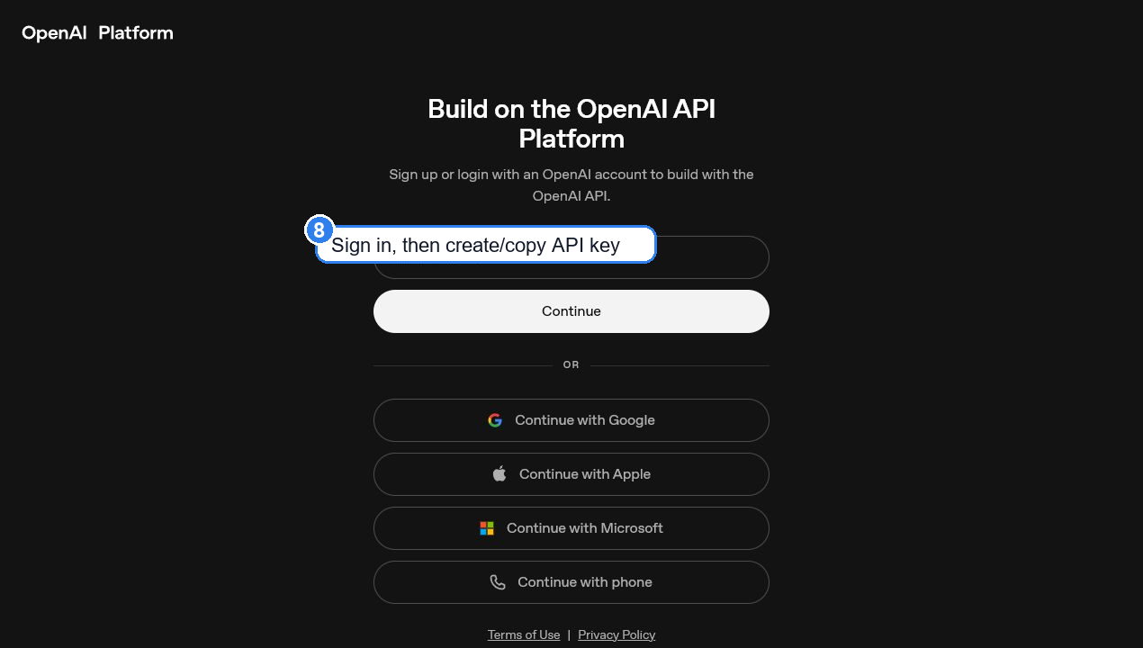
Screenshot 4 - OpenAI Platform sign-in appears before the API keys page if you are not already signed in.
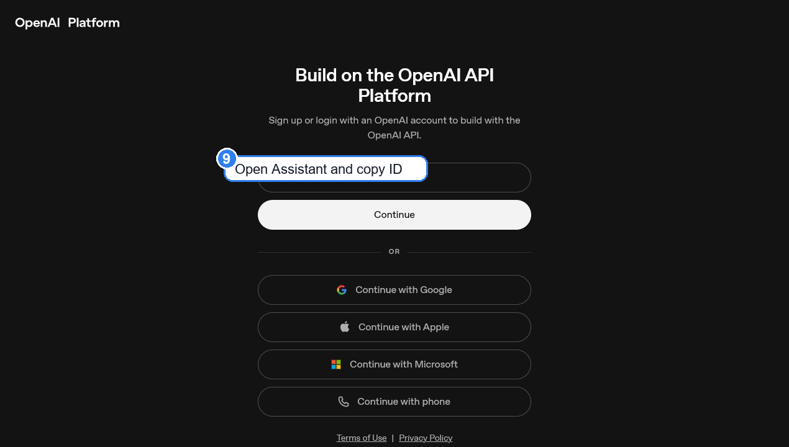
Screenshot 5 - OpenAI Platform sign-in appears before the Assistants page if you are not already signed in.

4. Run the sample suppression test
Return to Forg3t Black-box. Paste the OpenAI values into the assistant setup area, then use a synthetic request. Do not use private customer data for this quick test.
Black-box link: https://buildgames.forg3t.io/black-box
Integration name | OpenAI Assistant
Assistant ID | asst_...
API key | sk-...
Request reason | GDPR erasure / sentiment minimization review
Target scope summary | Suppress responses about the fictional user Ada Mercer in this assistant. Use synthetic test prompts only.
Then click Save and select assistant, complete the request fields, and run the Black-box suppression workflow.
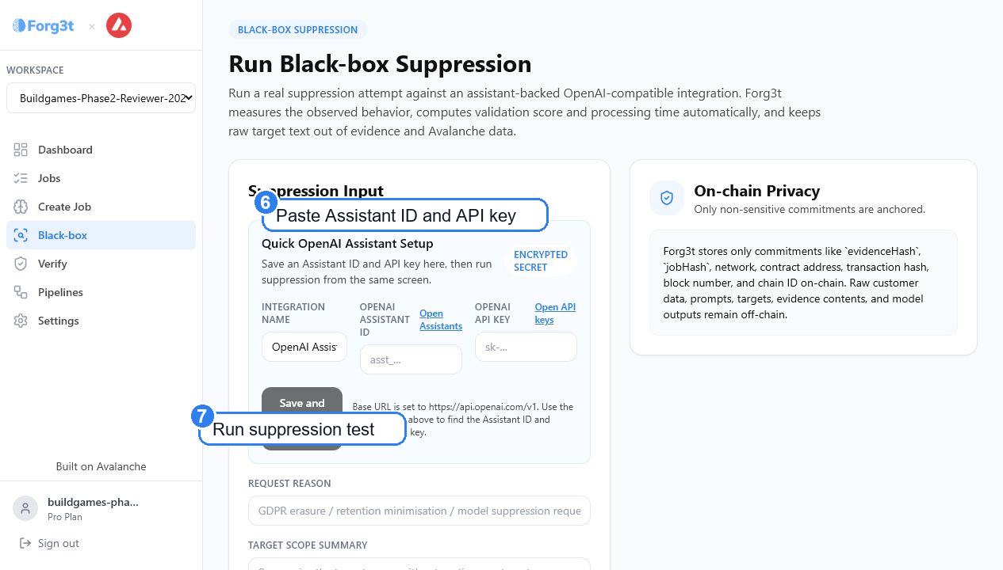
Screenshot 6 - Black-box suppression screen with OpenAI-compatible assistant setup and request fields.

5. Confirm the result
After the run, open Jobs or Evidence. A reviewer should be able to see job status, evidence detail, verification/export access, and anchor metadata when anchoring is enabled for the workspace.
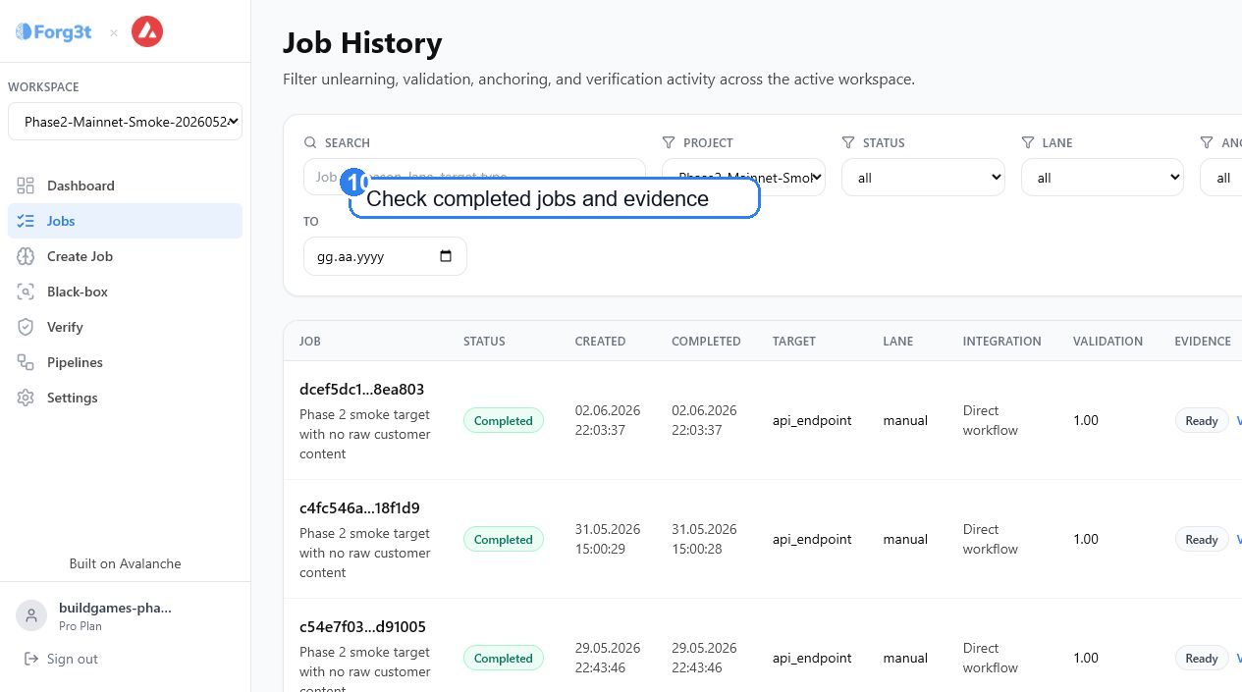
Screenshot 7 - Populated job history and evidence review surface from the Phase 2 reviewer workflow.

Expected outcome
- The reviewer can create or access an Enterprise workspace.
- The reviewer can open Black-box from the dashboard.
- The reviewer can configure an OpenAI-compatible assistant using an API key and Assistant ID.
- The reviewer can run a synthetic suppression request without exposing private data.
- The reviewer can inspect resulting job/evidence records and export or verify available reports.
Reviewer boundary
This quick test is for AI suppression behavior through an observable OpenAI-compatible assistant. It should not be represented as proof that a provider changed model weights or completed full AI unlearning.

