
Forg3t Protocol
Avalanche Grant Phase 2 Completion Packet
Reviewer-ready evidence packet for Avalanche mainnet anchoring, auditor verification, reporting exports, RBAC, repeatable pipelines, API integrations, documentation, and production review routes.
Prepared for | Avalanche Grant Review
Prepared date | June 4, 2026
Live app | https://buildgames.forg3t.io
GitHub | https://github.com/Alvinagile/Forg3t-Avax
Verified code/evidence commit | 0778fc0 (0778fc09a184457702a88932032aad83bdd3f1af)
Network | Avalanche C-Chain mainnet
Anchor contract | 0x20E772a60CEE7D8E6706E698B129FD917c3936bf
Latest proof transaction | 0x4f9d253d097808406777ba1b9d67b0ac4baac44d34d1d101cea4a3721559c69b

Submission Position
Repository-controlled Phase 2 product work is ready for review. External customer pilot approval or founder-recorded sales material is intentionally not claimed inside this repository packet unless supplied separately.

EXECUTIVE SUMMARY

Phase 2 Evidence Status
Forg3t Protocol is an AI unlearning and suppression evidence control plane. The current repository and production reviewer flow show deterministic evidence generation, Avalanche mainnet anchoring, public verification, role-aware dashboard workflows, repeatable pipelines, reporting exports, and API-based AI integration support.
The strongest live proof in this packet is the June 2, 2026 Avalanche C-Chain transaction that records a Submit Evidence action for a Forg3t evidence hash. The corresponding public verify route shows the auditor-facing verification surface, while the repository contains the backend functions, migrations, frontend components, tests, scripts, and documentation needed to reproduce the workflow.
Truthfulness Boundary
This packet does not embed passwords, Supabase service-role credentials, Avalanche private keys, or unverified enterprise customer claims. Reviewer credentials and any customer attestation should be shared through a secure external channel.

GitHub repository: https://github.com/Alvinagile/Forg3t-Avax
Live production app: https://buildgames.forg3t.io
Latest public verify proof: https://buildgames.forg3t.io/verify/636919b6e97441df953d98278bbc0efe
Latest Snowtrace transaction: https://snowtrace.io/tx/0x4f9d253d097808406777ba1b9d67b0ac4baac44d34d1d101cea4a3721559c69b
Walkthrough animation: D:/Forg3t Protocol Main/Forg3t - Dev - En güncel/Forg3t - Dev - En güncel/dev/Forg3t-Avax/project/docs/grant-review/submission-assets/video/forg3t-avalanche-phase2-proof-walkthrough.gif

Visual Evidence
The screenshots below were captured from live GitHub, buildgames.forg3t.io, and Snowtrace on June 4, 2026, after the Phase 2 evidence package was pushed to main.
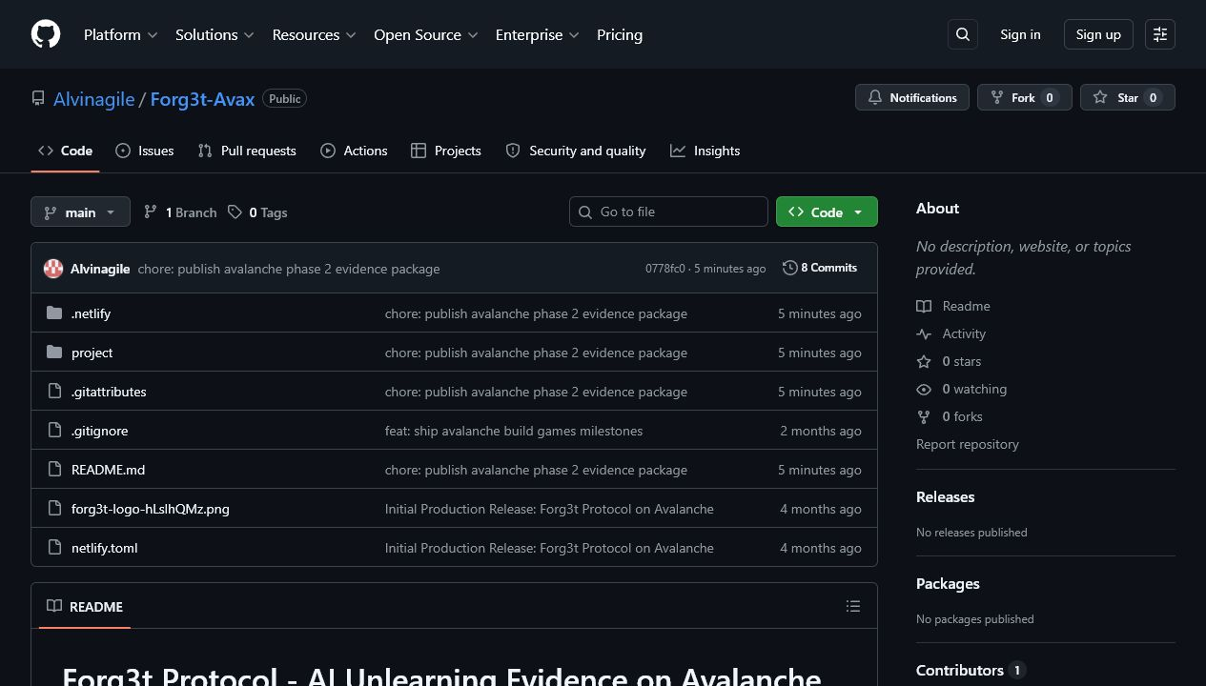
GitHub repository on main showing Phase 2 evidence package commit 0778fc0.
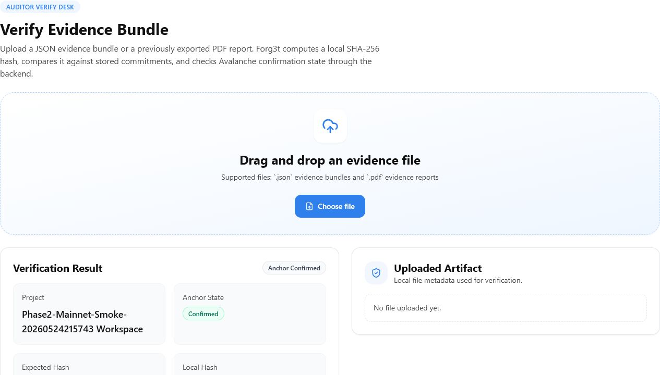
Public auditor verification route with drag-and-drop evidence upload and confirmed anchor state.
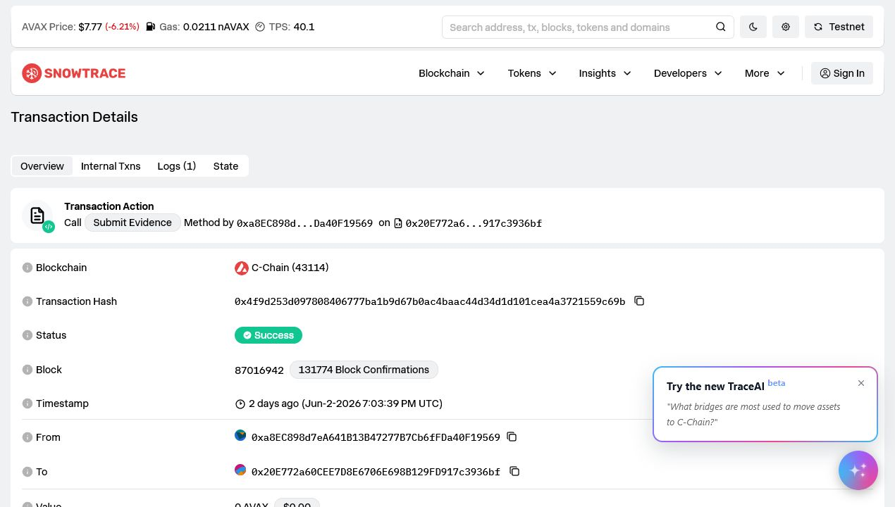
Snowtrace transaction proof: Success, C-Chain, block 87016942, Submit Evidence method.
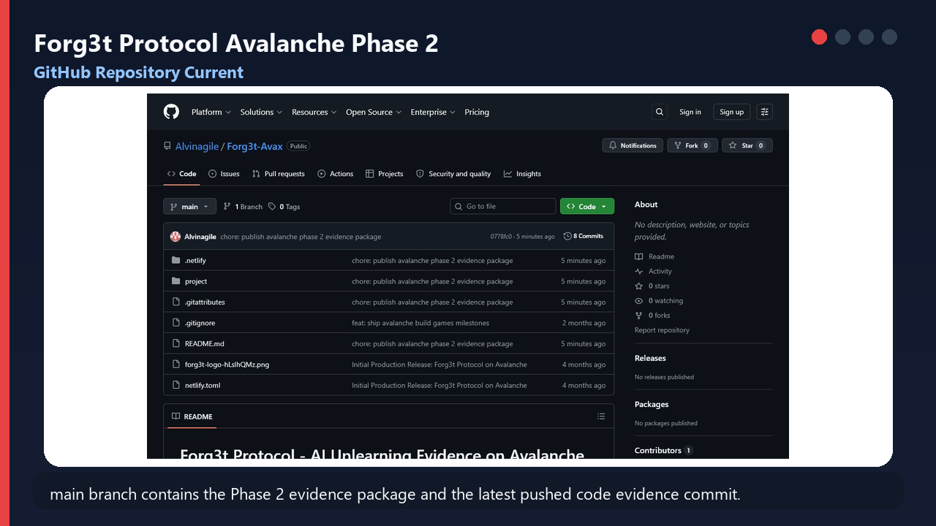
Walkthrough animation cover. Full GIF artifact is included under project/docs/grant-review/submission-assets/video/.

MILESTONE COMPLETION MATRIX

Avalanche Phase 2 Milestones
Milestone | Status | Evidence | Main proof | Risk | Owner | Effort
1. Production-grade evidence anchoring on Avalanche | Completed | Strong | Live mainnet tx; Edge Function anchor path; transaction hash/network/block/explorer surfaced. | Low | Engineering | Done
2. Drag-and-drop verification for auditors and third parties | Completed | Strong | JSON/PDF upload states; public verify route; valid/mismatch/pending/confirmed/failed handling. | Low | Frontend + Backend | Done
3. Job history, transaction visibility, evidence verification UX | Completed | Strong | Jobs list/detail, evidence detail, public verify link, anchor metadata, report exports. | Low | Product Engineering | Done
4. Technical architecture and compliance workflow documentation | Completed | Strong | Architecture, readiness, reviewer runbook, API and Avalanche article docs committed. | Low | Engineering + Docs | Done
5. Enterprise and regulated AI use-case pilot | Mostly completed | Medium | Product flow supports regulated AI reviews; external enterprise/customer attestation not embedded. | Medium | Founder / BD | 1-3 days for external artifacts
6. Role-based admin workflows and reporting exports | Completed | Strong | RBAC matrix, project memberships, JSON/CSV/PDF reports, role tests. | Low | Backend + Frontend | Done
7. Repeatable verification pipelines for multiple jobs | Completed | Strong | Pipeline create/run APIs generate jobs/evidence/reports and optional anchoring. | Low | Backend | Done
8. API-based AI system integrations | Completed | Strong | OpenAI-compatible and generic HTTP integrations, curl docs, smoke artifacts. | Low | Integrations | Done

Milestone Evidence

1. Launch production-grade evidence anchoring on Avalanche
Status: Completed
- Live Avalanche mainnet tx: 0x4f9d253d097808406777ba1b9d67b0ac4baac44d34d1d101cea4a3721559c69b
- Block number: 87016942
- Public verify proof: https://buildgames.forg3t.io/verify/636919b6e97441df953d98278bbc0efe
- Anchor contract: 0x20E772a60CEE7D8E6706E698B129FD917c3936bf
- Evidence hash: 0xb78cec95881bdee14f70b9c81e2b75cdb50982cedf73fbaeff9ff511973b9d88
- Job hash: 0xdaab2cee2e3a570ecfc45bda3679bff1db470a068c18bc33b6daa80dff806733
Repository evidence:
- project/supabase/functions/anchors/index.ts
- project/supabase/functions/verify-evidence/index.ts
- project/supabase/migrations/20260430170000_avalanche_build_games.sql
- project/src/pages/JobDetail.tsx
- project/src/pages/EvidenceDetail.tsx
- project/src/lib/domainUtils.ts
- project/scripts/phase2-smoke.mjs
- project/scripts/reviewer-daily-anchor.mjs
- project/docs/grant-review/submission-assets/screenshots/snowtrace-latest-tx.png

2. Ship drag-and-drop verification flow for auditors and third parties
Status: Completed
- Auditor route accepts JSON evidence bundles and PDF reports where hash metadata is available.
- States represented include valid, mismatch, unsupported, pending, confirmed, and failed anchor outcomes.
Repository evidence:
- project/src/pages/Verify.tsx
- project/src/lib/hash.ts
- project/supabase/functions/verify-evidence/index.ts
- project/docs/grant-review/evidence-artifacts/api/verify-upload-json-valid-response.json
- project/docs/grant-review/evidence-artifacts/api/verify-upload-json-mismatch-response.json
- project/docs/grant-review/evidence-artifacts/api/verify-upload-pdf-valid-response.json
- project/docs/grant-review/submission-assets/screenshots/public-verify-latest.png

3. Complete job history, transaction visibility, and evidence verification UX
Status: Completed
- Reviewer can navigate job list, job detail, evidence detail, public verify link, Avalanche record, and report downloads.
- Transaction hash, network, block number, explorer link, status, job hash, and evidence hash are visible in reviewer UX.
Repository evidence:
- project/src/pages/Jobs.tsx
- project/src/pages/JobDetail.tsx
- project/src/pages/EvidenceDetail.tsx
- project/src/components/JobsTable.tsx
- project/src/lib/api.ts
- project/docs/grant-review/evidence-artifacts/api/jobs-list.json
- project/docs/grant-review/evidence-artifacts/api/job-detail.json

4. Publish technical architecture and compliance workflow documentation
Status: Completed
- Reviewer runbook, readiness commands, architecture narrative, API lifecycle, and Avalanche anchoring article are in-repo.
Repository evidence:
- project/README.md
- project/docs/phase2-readiness.md
- project/docs/avalanche/technicalArchitecture.md
- project/docs/avalanche/reviewerRunbook.md
- project/docs/avalanche/avalanche-anchor-article.md
- project/docs/api/evidenceAnchoring.md

5. Pilot with enterprise and regulated AI use cases
Status: Mostly completed
- Repo demonstrates regulated AI review primitives: suppression jobs, evidence bundles, audit exports, public verification, role-scoped review, and repeatable pipelines.
- External enterprise customer approval, signed pilot attestation, or founder demo recording should be supplied outside the repository if Avalanche requests it.
Repository evidence:
- project/src/pages/Unlearning.tsx
- project/shared/suppression.test.ts
- project/shared/workflows.test.ts
- project/docs/compliance/auditWorkflow.md
- project/docs/phase2-readiness.md

6. Add role-based admin workflows and reporting exports
Status: Completed
- Owner/admin/compliance/auditor/developer/viewer behavior is encoded in shared role helpers and backend policies.
- JSON, CSV, and PDF report export paths are supported from real job and evidence records.
Repository evidence:
- project/src/lib/domainUtils.ts
- project/src/lib/domainUtils.test.ts
- project/src/pages/Settings.tsx
- project/src/lib/pdfGenerator.ts
- project/supabase/functions/reports/index.ts
- project/supabase/functions/_shared/rbac.ts
- project/docs/grant-review/evidence-artifacts/exports/forg3t-evidence-export.json
- project/docs/grant-review/evidence-artifacts/exports/forg3t-evidence-export.csv
- project/docs/grant-review/evidence-artifacts/exports/forg3t-evidence-export.pdf

7. Introduce repeatable verification pipelines for multiple unlearning jobs
Status: Completed
- Pipeline runs can expand scoped items into multiple jobs, generate evidence, create reports, and optionally anchor when configured.
Repository evidence:
- project/src/pages/Pipelines.tsx
- project/supabase/functions/pipelines/index.ts
- project/docs/grant-review/evidence-artifacts/api/pipeline-create.json
- project/docs/grant-review/evidence-artifacts/api/pipeline-run.json
- project/docs/grant-review/evidence-artifacts/api/pipeline-detail-with-runs.json
- project/docs/grant-review/evidence-artifacts/screenshots/pipeline-run.png

8. Expand integrations for teams using API-based AI systems
Status: Completed
- OpenAI-compatible and generic HTTP integrations support setup, health checks, stored server-side secrets, and job lifecycle linkage.
Repository evidence:
- project/src/pages/Settings.tsx
- project/src/pages/Unlearning.tsx
- project/supabase/functions/integrations/index.ts
- project/docs/grant-review/evidence-artifacts/api/integration-create-generic-http.json
- project/docs/grant-review/evidence-artifacts/api/integration-test-generic-http.json
- project/docs/phase2-readiness.md

ADDITIONAL PRODUCT SCREENSHOTS

Reviewer UX and Admin Evidence
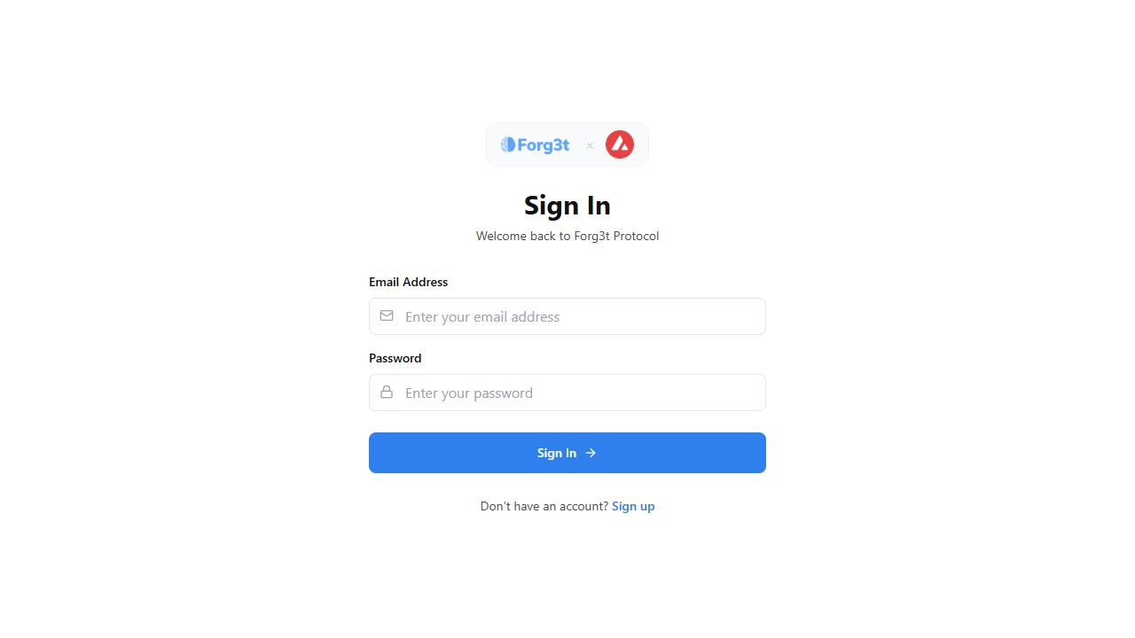
Job history and anchor visibility evidence from the reviewer evidence artifacts.

Job detail page showing evidence, anchor actions, public verify route, and report export controls.

Evidence detail page with manifest, commitments, report payload, and Avalanche record.

Repeatable verification pipeline run evidence.

Role settings and API integration administration evidence.

LOCAL VERIFICATION

Commands to Run
These commands avoid embedding secrets. Public VITE variables should come from local .env or Netlify production environment, while service-role and Avalanche signer material remain server-side only.
Purpose | Command
Install | cd project && npm install
Unit tests | cd project && npm test
Production build | cd project && npm run build
Smoke flow without live anchoring | cd project && npm run smoke:phase2
Daily reviewer anchor flow | cd project && npm run automation:reviewer-anchor
Bootstrap reviewer/automation accounts | cd project && npm run bootstrap:reviewer
Verify GitHub sync | git rev-parse --short HEAD && git rev-parse --short origin/main

Commands already run for this packet
npm test passed: 4 test files and 15 tests. The production build completed successfully with the Netlify production VITE environment and Avalanche default network set to mainnet. GitHub main matched origin/main at commit 0778fc0 before this submission packet was generated.

Evidence Package Index
Artifact | Repository path
Submission packet | project/docs/grant-review/forg3t-avalanche-phase2-submission-packet.docx
Live screenshots | project/docs/grant-review/submission-assets/screenshots/
Walkthrough animation | project/docs/grant-review/submission-assets/video/forg3t-avalanche-phase2-proof-walkthrough.gif
API response artifacts | project/docs/grant-review/evidence-artifacts/api/
JSON/CSV/PDF exports | project/docs/grant-review/evidence-artifacts/exports/
Existing evidence DOCX | project/docs/grant-review/forg3t-avalanche-phase2-evidence-artifacts.docx
Grant manager packet | project/docs/grant-review/forg3t-avalanche-phase2-grant-manager-packet.docx
Architecture docs | project/docs/avalanche/technicalArchitecture.md
Reviewer runbook | project/docs/avalanche/reviewerRunbook.md
Anchor article | project/docs/avalanche/avalanche-anchor-article.md

Recommended Evidence Package for Avalanche
- This Word packet and the repository link.
- Snowtrace transaction link and screenshot for transaction 0x4f9d253d097808406777ba1b9d67b0ac4baac44d34d1d101cea4a3721559c69b.
- Public verify link https://buildgames.forg3t.io/verify/636919b6e97441df953d98278bbc0efe.
- buildgames.forg3t.io reviewer credentials shared securely outside GitHub and outside this Word file.
- Generated JSON, CSV, and PDF report exports from project/docs/grant-review/evidence-artifacts/exports/.
- Walkthrough GIF under project/docs/grant-review/submission-assets/video/.
- Optional external pilot/customer attestation, if Avalanche needs business validation beyond code-side proof.
Final Readiness Statement
Forg3t is ready to submit the code-side Phase 2 disbursement evidence package. The only non-repository gap is external enterprise pilot/customer evidence, which should be provided separately if required by Avalanche review.

