ITAM Onboarding: Walkthrough, User Guide and Training
Oct 16, 2026 · @My Name Is Eyram Dad

Why use ITAM onboarding
ITAM onboarding gives every new starter the same complete, recorded set-up: one record, a 39-item checklist, a 9-session induction plan, equipment linked to the person, and (with the Trust Hub) security training that starts and closes itself. Nothing depends on someone remembering an email.
Who | What you gain | How the product delivers it
New starter | Works from day one: accounts, equipment and access are ready, and the first weeks are planned. | Checklist covers Active Directory, email, Business Central, shared folders and credentials; induction sessions are scheduled with dates and facilitators.
HR | One place to start and track every joiner; no chasing by email. | One form creates the record; a progress bar and status show how far each person is; HR paperwork items are tracked with an owner.
IT team | A consistent procedure, so no step is missed and no account is created without approval. | The 30 IT items follow your account-creation SOP (DAS/IT-SOP/G/008): signed form first, unique username, forced password change, secure credential handover.
Line manager | Clear sign-off point and a visible induction plan. | A manager sign-off item on access rights, and a Department Induction session owned by the line manager.
Security and audit | Evidence of who did what and when, and least-privilege access that matches an approved form. | Each completed item records who completed it, the date and a note; equipment is linked to the person by username and employee ID; the Trust Hub seals the activity in a tamper-evident log.
Management | A live count of joiners in progress and completed, and a way to spot stalled onboardings. | The onboarding list shows total, in progress, completed and this-month figures, with a progress bar for each person.
What changes in daily work
Without a system | With ITAM onboarding
Requests by email, phone call or WhatsApp; steps forgotten | One record, one checklist, each item has an owner
"Is her laptop ready?" asked in the corridor | Equipment shown on the joiner's page, linked by username
Passwords passed around informally | A defined secure handover step and a first-login password change
Security training depends on someone reminding the starter | The Hub enrols the joiner automatically and ticks the checklist when they pass
Hard to prove to an auditor that onboarding was controlled | Completed-by, date and notes on every item, plus the audit trail
Aligned with recognised controls
The process supports ISO/IEC 27001:2022 controls on asset inventory and return (A.5.9, A.5.11), identity and access (A.5.16, A.5.18), and awareness training (A.6.3), and the Ghana Data Protection Act briefing is built into the IT Security checklist. The Trust Hub's compliance score tracks several of these automatically.
Measuring the benefit
Decide a baseline before you start, then track:
- Days from start date to a 100% checklist
- Share of joiners with accounts and equipment ready on day one
- Share of joiners who finish security training within the 5-day deadline
- Items still open after the first week, and which team owns them

Who does what
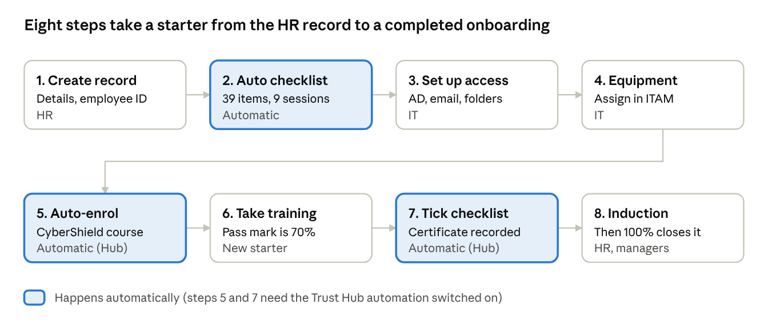
onboarding journey: 8 steps, 4 owners
HR starts the record; ITAM builds the checklist by itself; IT does the technical set-up and issues equipment; the Trust Hub enrols the starter in security training and records the certificate; HR and the line manager run the induction. Every item on the checklist also carries its own owner (IT, HR or Manager), so each team sees what is theirs.

Step-by-step walkthrough
This walkthrough follows one new starter, Kwame Asante, a Sales Executive, from the HR request to a completed record. The screens are from a training copy with demo data.
Before you begin
- ☐ You can sign in to ITAM with the role admin, IT manager, IT staff or HR. Read-only users can view onboarding records but cannot create or change them.
- ☐ The supervisor has completed the User Account Creation Form for the starter.
- ☐ You have the starter's full name, job title, department, site, start date, manager's name and username, and employee ID (HR number).

Step 1. Open Onboarding
- Sign in to ITAM (directly, or from the Trust Hub with single sign-on).
- In the left menu choose Onboarding. HR users find it under HR Portal; IT users find it under Operations.
- You see the list of every onboarding record, with four counters: Total Records, In Progress, Completed and This Month.

Step 2. Start the record (HR)
- Choose New Onboarding (top right).
- Fill in the form. Fields marked with an asterisk are required.
- Enter the Employee ID. It is optional, but it is the most reliable way to match the person across ITAM, CyberShield and Active Directory.
- Leave the AD username and email empty if they do not exist yet; IT completes them later.
- Choose Create Onboarding Record.
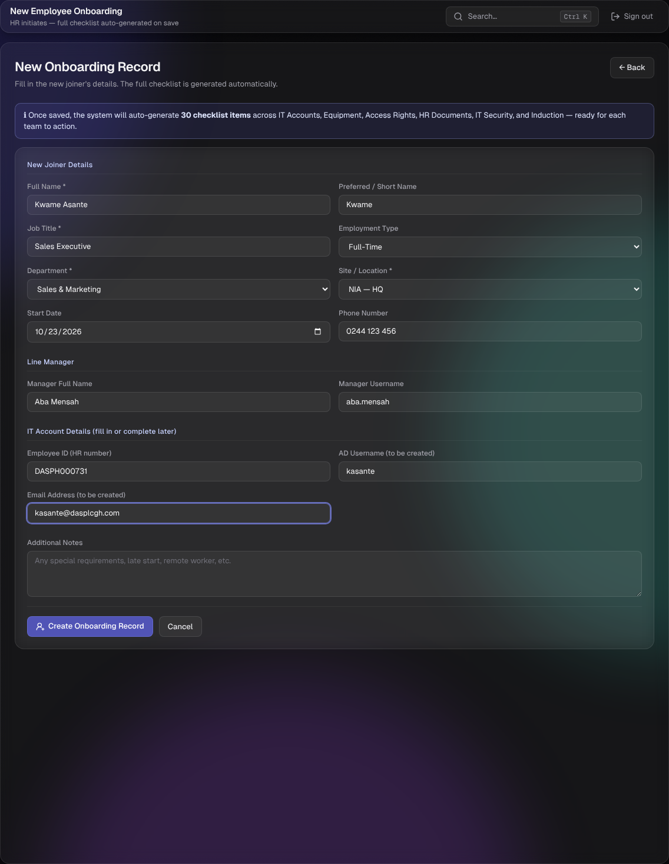
The note at the top of the form tells you what will be created: 39 checklist items and a 9-session induction schedule.

Step 3. Check the new record
The record opens straight away. Overall Progress is 0% and the status is In Progress. Tiles show each category with how many items are done, and below them are the joiner's details, the equipment panel, the checklists and the induction schedule.
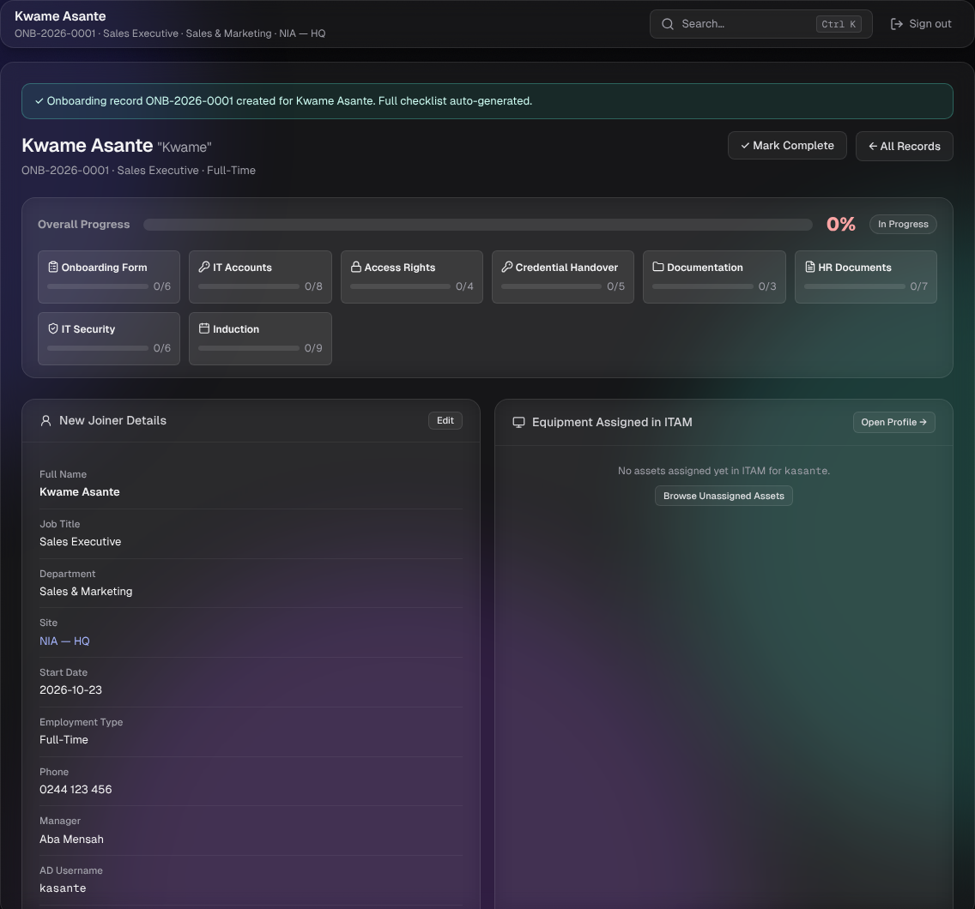

Step 4. Work the Onboarding Form items
These six items make sure nothing is created without approval: receive the form, check it is complete, confirm both signatures, assign a unique username (first initial plus last name, for example kasante), and file the form. Do not create accounts until the signatures are confirmed.
- Press the green tick to mark an item complete in one click.
- Press the pencil to choose another status (Pending, In Progress, Complete or N/A) and add a note, then Save.

Step 5. Create the accounts (IT)
Work through IT Accounts: Active Directory account, security group, forced password change, Microsoft 365 email, signature and teams, and, if required, a Business Central user. Add a short note where it helps, for example "Waiting for M365 licence", and use N/A for anything this person does not need, such as Business Central. N/A items are left out of the progress calculation.
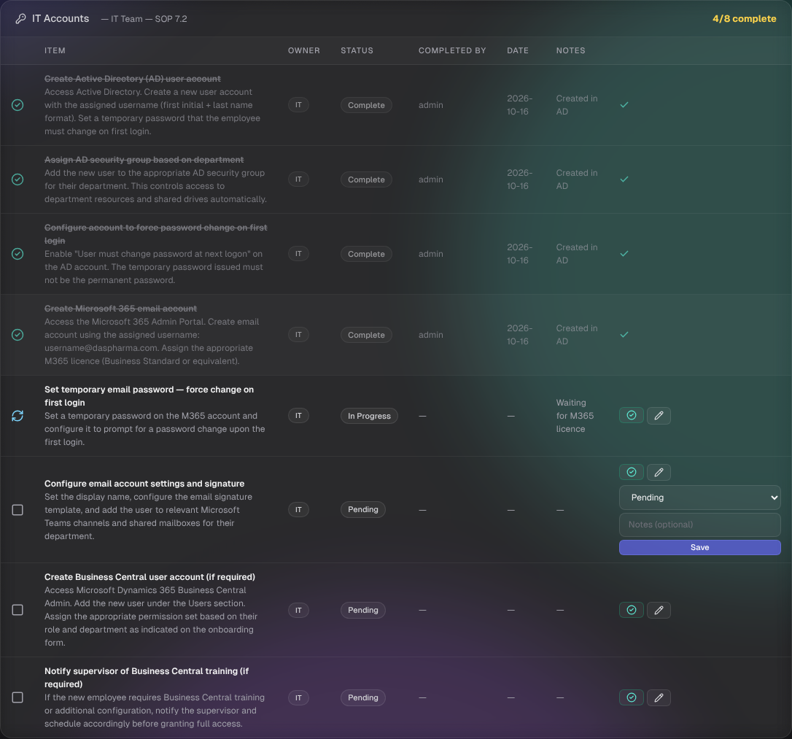
Each completed item records who completed it and when, which is what an auditor will want to see.
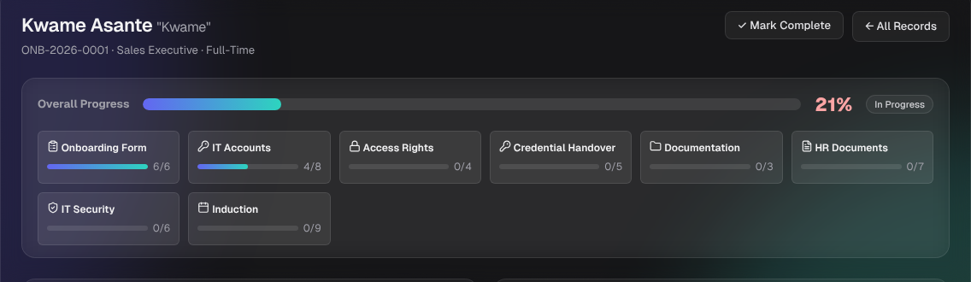

Step 6. Record the account details
When the username and email exist, press Edit on the New Joiner Details card, fill in AD Username and Email Address, and choose Save. You can also update the start date, phone, manager and notes here. The AD username matters: it is how ITAM finds the starter's equipment.
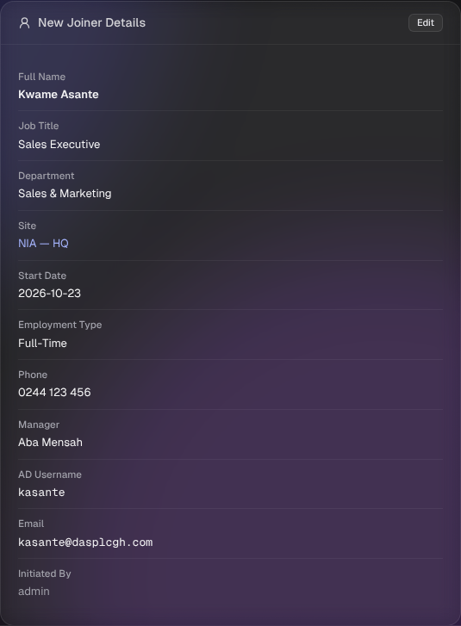

Step 7. Issue equipment
- Open the asset (from the Asset Register or Unassigned Pool) and use the Assign Asset panel.
- Enter the username (the same AD username), the full name and, whenever you can, the Employee ID. Choose the location and department, then assign.
- Return to the onboarding record. The Equipment Assigned in ITAM panel now lists the laptop.
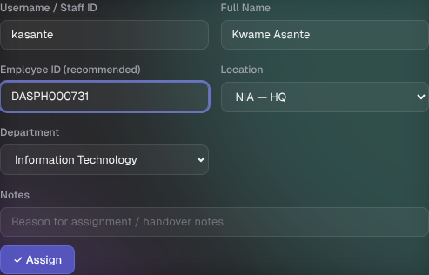
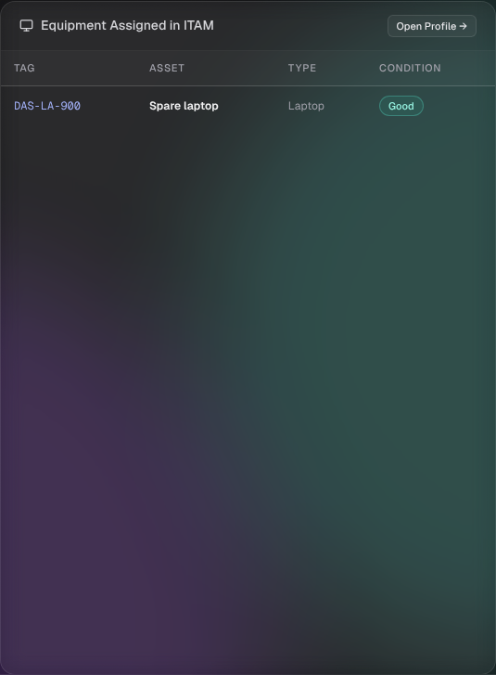

Step 8. Hand over credentials and brief the starter
Complete Access Rights (shared folders, a final cross-check against the signed form, and the supervisor's sign-off) and Credential Handover (a secure credentials document, delivery in person or through a secure channel, the instruction to change every temporary password on first login, the security and acceptable-use briefing, and the helpdesk contact). Never send passwords by plain email or WhatsApp.

Step 9. Schedule the induction
In the Induction Schedule, press Edit on each session, set the date and time, add a note and change the status to Scheduled, In Progress, Completed or Cancelled. The nine sessions are Welcome and Company Overview, HR Policies and Benefits, IT Systems and Tools, Health and Safety, Finance and Expenses, Quality and Compliance, Department Induction (run by the line manager), Site Tour and the Day 30 Check-In.
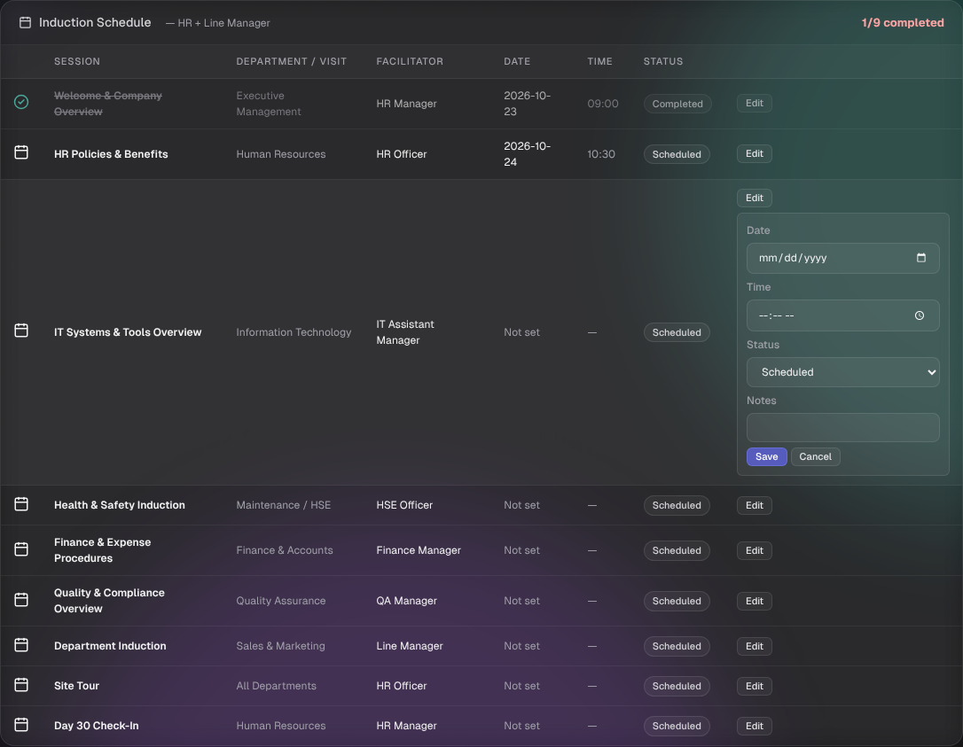

Step 10. Security training (automatic)
If the Trust Hub automation is on, the starter is enrolled in CyberShield without anyone lifting a finger, and when they pass, the checklist item Phishing and email security awareness briefing is ticked with their certificate number. The next chapter shows exactly how.

Step 11. Finish
When every applicable checklist item is Complete and every induction session is Completed (or Cancelled), progress reaches 100% and the record closes itself. A record raised in error can be withdrawn with the red Cancel button. You can also press Mark Complete at the top of the record. Cancelled sessions and N/A items do not hold the record open.

Step 12. Review the list
Back on Onboarding, the list shows each joiner with a progress bar and status. Use the search box (name, job title, department or reference) and the status filter to find people.
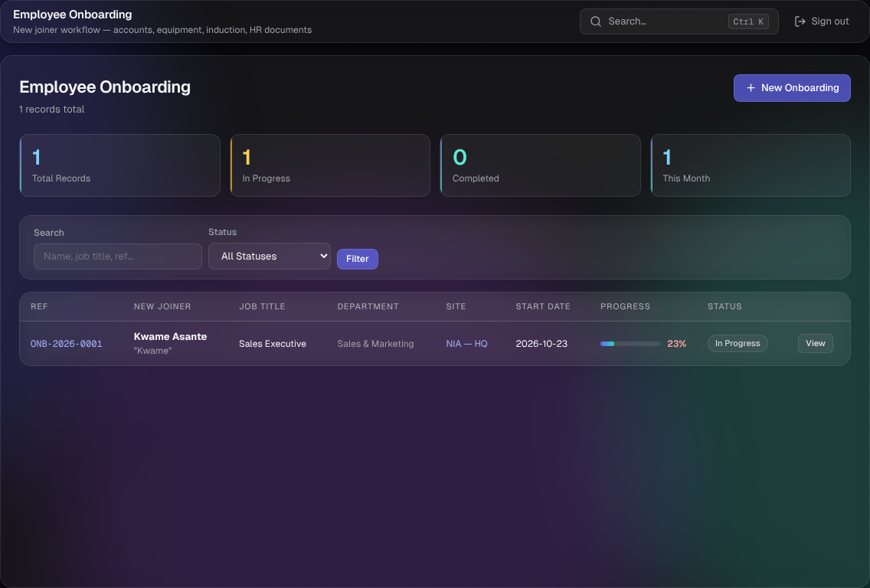

Screen-by-screen user manual

Who can do what
ITAM role | Onboarding menu | View records | Create a record and update checklist, induction and details
Admin | Operations | Yes | Yes
IT manager | Operations | Yes | Yes
IT staff | Operations | Yes | Yes
HR | HR Portal (a shorter menu: Onboarding, New Onboarding, People and Assets) | Yes | Yes
Read-only | Operations | Yes | No: the actions are refused with a "no permission" message

The onboarding list
- Counters: Total Records, In Progress, Completed, This Month.
- Search matches name, job title, department or reference (for example ONB-2026-0001).
- Status filter: In Progress, Completed or Cancelled.
- Columns: Ref, New Joiner, Job Title, Department, Site, Start Date, Progress (bar and percentage) and Status. Press View to open a record.
- New Onboarding starts a new record.

The new-joiner form
Field | Required | What to enter
Full Name | Yes | The legal name as HR holds it. This is also how the person is matched if no employee ID exists, so spell it consistently.
Preferred / Short Name | No | The name people use, shown in quotes on the record.
Job Title | Yes | For example Sales Executive.
Employment Type | No | Full-Time (default), Part-Time, Contract, Intern or Temporary.
Department | Yes | Pick from the list. It also sets the department for the Department Induction session.
Site / Location | Yes | Pick from the list of sites.
Start Date | No | The first working day.
Phone Number | No | Contact number.
Manager Full Name, Manager Username | No | The line manager.
Employee ID (HR number) | No, recommended | The most reliable way to match the person across systems, and to find the right account in Active Directory.
AD Username (to be created) | No | First initial plus surname, for example kasante. Can be added later.
Email Address (to be created) | No | Can be added later.
Additional Notes | No | Special requirements, a late start, remote working.
If a required field is empty you get a message and the form keeps what you typed.

The onboarding record
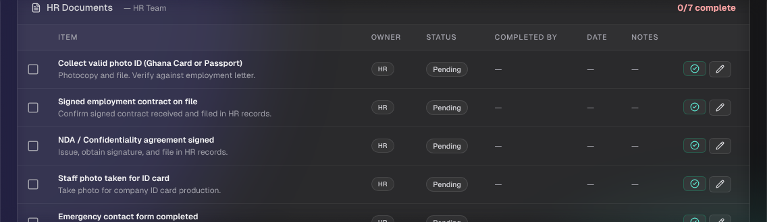
Header. The starter's name, preferred name, reference, job title and employment type. Mark Complete (shown while the record is In Progress) closes the record after you confirm. All Records returns to the list.
Overall Progress. The bar combines the checklist and the induction schedule. It is red below 60%, amber from 60% and green at 100%. When it reaches 100% the record is marked Completed automatically.
Category tiles. Each tile shows done over total for one checklist category and for Induction.
New Joiner Details. Shows the name, job title, department, site, start date, employment type, phone, manager, AD username, email and who initiated the record. Edit lets you change AD username, email, phone, start date, manager name and username, and notes. Name, job title, department and site are fixed once created.
Equipment Assigned in ITAM. Lists every asset currently assigned to the starter's AD username, with Open Profile for the full people page. If no AD username is set, it tells you to set one. Browse Unassigned takes you to the pool of available equipment.
Checklist sections. One card per category. Columns: Item, Owner, Status, Completed By, Date and Notes. The tick marks an item complete. The pencil opens a small form to choose a status and add a note.
Induction Schedule. One row per session with the department to visit, facilitator, date, time and status. Edit sets the date, time, status and notes.

Statuses
Applies to | Values | Notes
Checklist item | Pending, In Progress, Complete, N/A | Only Complete counts as done. N/A removes the item from the total, so it never blocks 100%.
Induction session | Scheduled, In Progress, Completed, Cancelled | Only Completed counts as done. Cancelled removes the session from the total.
Onboarding record | In Progress, Completed, Cancelled | Completed happens automatically at 100%, or with Mark Complete. Cancelled is set with the red Cancel button, for a record raised in error. It stays in the list so the history is complete.

Finding things quickly
Press Ctrl+K (Cmd+K on a Mac) anywhere in ITAM to open the search palette. Type a page name to jump there, or a name, tag or serial number to search assets and people.

The checklist in detail
Every new record is created with 39 checklist items in 7 categories and 9 induction sessions. They follow the company SOP for user account creation (DAS/IT-SOP/G/008). Each item has an owner so every team sees its own work.
Category | Items | Owners | What it covers
Onboarding Form | 6 | HR 1, IT 5 | Paperwork that authorises the accounts: the supervisor's signed request, the new starter's signature, a unique username, and filing.
IT Accounts | 8 | IT 8 | Creating the starter's identities: Active Directory, Microsoft 365 email and, if needed, Business Central.
Access Rights | 4 | IT 3, Manager 1 | Network folders and permissions, a final cross-check against the signed form, and the supervisor's sign-off.
Credential Handover | 5 | IT 5 | Handing over usernames and temporary passwords safely, with password and support guidance.
Documentation | 3 | IT 3 | Recording what was created: IT directory, equipment in ITAM and filing.
HR Documents | 7 | HR 7 | HR paperwork: ID, contract, NDA, photo, emergency contact, payroll and SSNIT details.
IT Security | 6 | IT 6 | Policies and briefings the starter must acknowledge, including the security awareness briefing that CyberShield completes.
Total | 39 | IT 30, HR 8, Manager 1
Onboarding Form
# | Item | Owner
1 | Receive completed onboarding form from supervisor | HR
2 | Verify all required fields are completed on the form | IT
3 | Confirm form is signed by supervisor | IT
4 | Confirm form is signed by new employee | IT
5 | Assign unique username (first initial + last name) | IT
6 | File the completed onboarding form | IT
IT Accounts
# | Item | Owner
1 | Create Active Directory (AD) user account | IT
2 | Assign AD security group based on department | IT
3 | Configure account to force password change on first login | IT
4 | Create Microsoft 365 email account | IT
5 | Set temporary email password and force change on first login | IT
6 | Configure email account settings and signature | IT
7 | Create Business Central user account (if required) | IT
8 | Notify supervisor of Business Central training (if required) | IT
Access Rights
# | Item | Owner
1 | Determine network shared folder access required | IT
2 | Assign permissions to relevant network shared folders | IT
3 | Final review: verify all accounts match the onboarding form | IT
4 | Line manager / supervisor access sign-off | Manager
Credential Handover
# | Item | Owner
1 | Prepare secure credentials document | IT
2 | Deliver credentials in person or via secure channel | IT
3 | Instruct employee to change all temporary passwords on first login | IT
4 | Brief employee on IT security and acceptable use policies | IT
5 | Provide IT helpdesk contact details | IT
Documentation
# | Item | Owner
1 | Update IT employee directory with new account details | IT
2 | Record equipment assigned in ITAM | IT
3 | Confirm all documentation filed and record-keeping complete | IT
HR Documents
# | Item | Owner
1 | Collect valid photo ID (Ghana Card or Passport) | HR
2 | Signed employment contract on file | HR
3 | NDA / Confidentiality agreement signed | HR
4 | Staff photo taken for ID card | HR
5 | Emergency contact form completed | HR
6 | Bank account details submitted for payroll | HR
7 | SSNIT number recorded | HR
IT Security
# | Item | Owner
1 | IT Security Policy read and acknowledged | IT
2 | Acceptable Use Policy (AUP) signed | IT
3 | Password policy briefing completed | IT
4 | Phishing and email security awareness briefing (ticked automatically by CyberShield) | IT
5 | Data handling and Ghana Data Protection Act briefing | IT
6 | IT Security acknowledgement form signed and filed | IT
Induction schedule (9 sessions)
# | Session | Where | Facilitator
1 | Welcome and Company Overview | Executive Management | HR Manager
2 | HR Policies and Benefits | Human Resources | HR Officer
3 | IT Systems and Tools Overview | Information Technology | IT Assistant Manager
4 | Health and Safety Induction | Maintenance / HSE | HSE Officer
5 | Finance and Expense Procedures | Finance and Accounts | Finance Manager
6 | Quality and Compliance Overview | Quality Assurance | QA Manager
7 | Department Induction | The starter's own department | Line Manager
8 | Site Tour | All departments | HR Officer
9 | Day 30 Check-In | Human Resources | HR Manager
The checklist wording comes from the application. If your procedure changes, ask your administrator to update the default checklist.

Security training: the Trust Hub and CyberShield
Onboarding on its own tracks the training item by hand. With the Trust Hub automation switched on, two things happen without anyone clicking.
- The starter is enrolled in CyberShield. The Hub reads the new onboarding record and creates their training record with a 5-day deadline. Their line manager receives the assignment notice.
- The checklist ticks itself. When the starter passes the assessment (70% or more), the Hub marks Phishing and email security awareness briefing as Complete, with the certificate number and score in the notes, and records "CyberShield (via Trust Hub)" as the person who completed it.

For the starter
Open the CyberShield address you are given, enter your full name exactly as HR has it, your employee ID and your department, and choose Cybersecurity Onboarding. Because the Hub has already enrolled you, typing the same name continues your prepared record instead of starting a second one. Complete the seven modules, take the assessment, and save or print your certificate.

For HR and IT: watching it happen
Open the Trust Hub and choose Onboarding and offboarding. The Joiners table shows each starter, their ITAM status, their training status and how they were matched. Preview (no changes) shows what the next run would do. Run now does it immediately. A run also happens automatically on the schedule your administrator set.
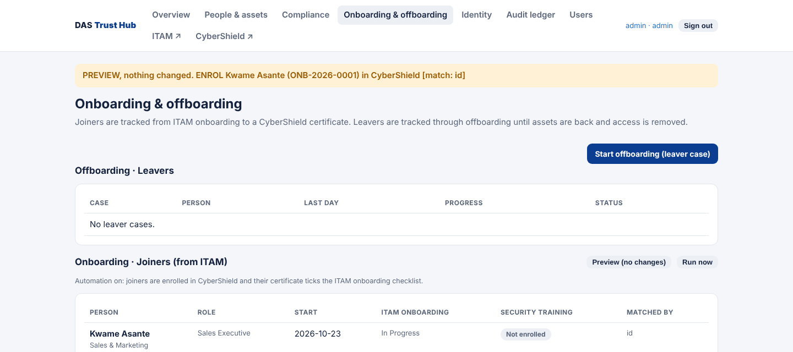
After the starter passes, the table shows them as Trained.
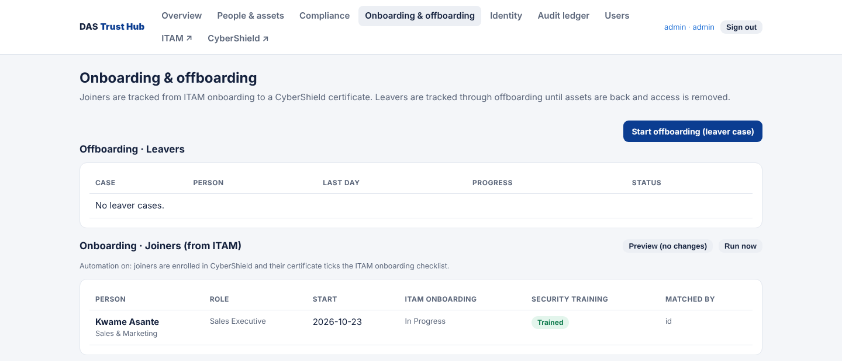
Back in ITAM, the item is ticked, with the certificate recorded and the progress bar updated.
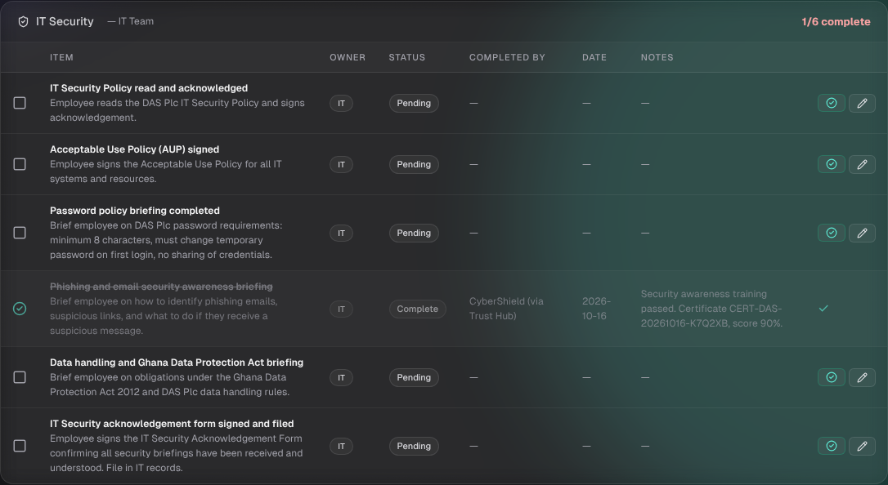

What to check if it does not happen
Symptom | Likely cause and fix
The joiner stays Not enrolled | Automation may be off (the Hub page says so), or the onboarding record is not In Progress. Ask your administrator to check the integration token, or enrol them by asking the starter to start training themselves.
Enrolled twice | The starter typed a different spelling of their name. Standardise names and always record the employee ID.
Matched by "name" instead of "id" | Add the employee ID on the onboarding record.
Checklist item not ticked after a pass | The starter's CyberShield record may be under another name. Check the Identity page in the Hub, then press Run now.
Two people share a name | The Hub will not match them automatically. Confirm each person's employee ID on the Identity page.
If the automation is off, simply tick the item yourself after the starter shows you their certificate. Nothing else changes.

Training programme
A half-day workshop (about 3.5 hours) that takes HR officers, IT staff and line managers from "I have not used it" to creating and completing a real onboarding record unaided.

Learning outcomes
By the end, each participant can:
- Explain why onboarding runs through ITAM and what each team is responsible for.
- Create an onboarding record with the right details, including the employee ID.
- Work the checklist: complete items, add notes and use N/A correctly.
- Record account details and issue equipment so it appears on the joiner's record.
- Schedule and complete induction sessions.
- Explain how security training is enrolled and recorded, and what to do if it is not.
- Recognise common mistakes and fix them.

Who and what you need
Item | Detail
Participants | 6 to 10 per group: HR, IT staff and line managers (see the shorter tracks below)
Trainer | Someone who has completed all of the exercises, ideally from IT or HR
Environment | A training copy of the platform with demo data, never the live system. The platform includes a demo-data script (python scripts/seed_demo.py demo-data) and run_all.py --data demo-data
Accounts | One ITAM login per participant with the role they will use (HR, IT staff or IT manager), created in User Management. Remove them after training.
Equipment | One computer per one or two participants, a projector, printed copies of the Quick Reference
Practice people | Fictitious starters only, for example Efua Quaye, Yaw Boakye, Adwoa Tetteh
Trainer checklist, one week before
- ☐ Training copy running and reachable from the room
- ☐ Participant accounts created and tested
- ☐ Two spare unassigned laptops in the demo register
- ☐ Trust Hub running with automation on, if you will demonstrate step 5 (otherwise skip that exercise)
- ☐ Quick Reference printed, one per participant

Agenda
Time | Session | Method
0:00 to 0:15 | Welcome and why onboarding matters: the benefits chapter and the journey diagram | Talk and discussion
0:15 to 0:35 | Tour of ITAM: menu, roles, the onboarding list, the search palette (Ctrl+K) | Trainer demo
0:35 to 1:05 | Live walkthrough of steps 1 to 6 with one fictitious starter | Trainer demo, participants follow
1:05 to 1:15 | Break
1:15 to 2:00 | Hands-on exercises 1 to 4 | Individual or pairs
2:00 to 2:25 | Security training and the Trust Hub: exercise 5 | Demo, then pairs
2:25 to 2:45 | Troubleshooting scenarios: exercise 6 | Small groups
2:45 to 3:15 | Knowledge check and discussion of answers | Individual, then together
3:15 to 3:30 | Competency sign-off and feedback | Trainer observes

Hands-on exercises
Exercise 1. Create a joiner (15 minutes)
Create a record for a fictitious Sales Executive. Fill in every required field, add a manager, an employee ID such as DASPH000901, an AD username in the form first initial plus surname, and an email.
Expected result: you land on the new record at 0% progress with a reference like ONB-2026-0002. The note on the form said 39 items and 9 sessions were created; confirm by counting the tiles.
Exercise 2. Work the checklist (20 minutes)
- Tick the six Onboarding Form items using the green tick.
- Under IT Accounts, complete the first three items and add the note "Created in AD" to one of them using the pencil.
- Mark the two Business Central items N/A with the note "Not required for this role".
- Set one item to In Progress with a note.
Expected result: the progress bar rises; the N/A items show greyed out; the notes and "Completed by" and date appear on each item. Ask the group: what would happen to the percentage if N/A counted as not done? (It would never reach 100%.)
Exercise 3. Account details and equipment (15 minutes)
- On New Joiner Details, press Edit, set the AD username and email, and Save.
- Open a spare laptop in the Asset Register and assign it using the same username, the full name and the employee ID.
- Return to the onboarding record and check the Equipment Assigned in ITAM panel.
- Deliberately mis-type the username on a second assignment and see what happens to the panel.
Expected result: the laptop appears only when the usernames match exactly. This is why the AD username must be recorded once and reused.
Exercise 4. Induction (10 minutes)
Schedule the first three sessions with dates and times, complete the first, cancel the second with a note, and leave the third scheduled.
Expected result: the Induction tile shows the first session as done and the cancelled session no longer counts.
Exercise 5. Security training and the Hub (25 minutes)
- In the Hub, open Onboarding and offboarding, find your starter and press Preview (no changes). Read the plan, then press Run now.
- Open CyberShield as the starter would: use the same name, choose Cybersecurity Onboarding, and note the deadline.
- Trainer: complete the course and assessment as the starter (the pass mark is 70%), press Run now again, and show the ticked item in ITAM with its certificate note.
Expected result: the checklist item Phishing and email security awareness briefing shows Complete, completed by "CyberShield (via Trust Hub)", with the certificate number in the notes. If the Hub is not available, tick the item by hand and discuss the benefit of the automation.
Exercise 6. Troubleshooting scenarios (20 minutes)
In groups of three, decide what to do.
Scenario | Answer
A starter shows "Not enrolled" a week after their start date. | Check that automation is on and the record is In Progress; use Preview, then Run now; or ask the starter to start the course themselves.
The record is stuck at 97%. | Filter the checklist for anything not Complete or N/A, and check the induction table for sessions still Scheduled or In Progress. Complete, mark N/A or cancel as appropriate.
Two staff are both called Kwame Asante. | Make sure each has an employee ID. The Hub will not match an ambiguous name; confirm each on the Identity page.
A laptop was assigned but does not appear on the joiner's record. | The username on the asset does not exactly match the AD username on the record. Correct one of them.
A read-only colleague cannot create a record. | That is intended. They need the HR, IT staff, IT manager or admin role.

Shorter tracks
Audience | Length | Focus
HR officers | 90 minutes | Steps 1 to 3 and 9 to 12, exercises 1 and 4, the HR Documents category, reading progress
IT staff | 2 hours | Steps 4 to 8, exercises 2, 3 and 5, credential handover rules, equipment linking
Line managers | 30 minutes | The journey diagram, the sign-off item, the induction schedule, how to see progress
Auditors | 30 minutes | Completed-by, date and notes on each item, the audit trail, the compliance report

Trainer notes
- Open with the benefit, not the buttons: nothing forgotten, everything recorded, ready on day one.
- Repeat three messages: record the employee ID, record the AD username once and reuse it, and never send passwords by plain email or WhatsApp.
- Let people make the mistake in a safe place (the mis-typed username in exercise 3), then fix it together.
- Keep it real. Use the grade and department names from your company.
- Reset the training copy afterwards: delete the practice records and participant accounts, or restore the training database from a backup.

Knowledge check
Fourteen questions, about 20 minutes. Participants answer in writing first; the trainer then goes through the answers. A score of 12 or more shows the group is ready to use the system.
# | Question | Answer
1 | Which ITAM roles can create an onboarding record and update the checklist? | Admin, IT manager, IT staff and HR. Read-only users can only view.
2 | How many checklist items and induction sessions does a new record create? | 39 checklist items in 7 categories, and 9 induction sessions.
3 | What is the difference between the green tick and the pencil on a checklist item? | The tick marks the item Complete in one click. The pencil lets you choose another status (Pending, In Progress, Complete, N/A) and add a note.
4 | When should an item be marked N/A, and what does that do to progress? | When it does not apply to this starter, for example a Business Central account they will not need. Add a note saying why. N/A items are left out of the total, so they never block 100%.
5 | Why enter the employee ID and the AD username? | The employee ID is the most reliable way to match the person across ITAM, CyberShield and Active Directory. The AD username is how ITAM finds the person's equipment.
6 | What is the username format? | First initial plus surname, for example kasante. Check it is unique in Active Directory.
7 | What must be confirmed before accounts are created? | The onboarding form is complete and signed by both the supervisor and the new employee.
8 | How must credentials be delivered? | In person where possible, otherwise through a secure channel. Never by plain email or WhatsApp. The starter must change every temporary password at first login.
9 | How do you make a laptop appear on the joiner's record? | Assign it from the asset page using the same username as the AD username on the record.
10 | When does a record become Completed? | When every applicable checklist item is Complete and every induction session is Completed or Cancelled (100%), or when someone presses Mark Complete.
11 | How does the security awareness item get ticked? | Automatically by the Trust Hub when the starter passes CyberShield with 70% or more, with the certificate in the notes. If automation is off, tick it by hand.
12 | What are the CyberShield pass mark and deadline? | 70% to pass, and 5 days from starting.
13 | Two staff have the same name. What protects against a mix-up? | Employee IDs. The Hub never matches an ambiguous name automatically; HR confirms each person on the Identity page.
14 | Who owns the item "Line manager / supervisor access sign-off"? | The manager (the only checklist item with a Manager owner).

Competency sign-off
The trainer watches each participant do the task on the training copy and ticks it. A participant is signed off for their role when every task in their column is ticked.
Core skills (everyone)
- ☐ Signs in, finds Onboarding in the menu for their role, and uses the search and status filter
- ☐ Reads the progress bar, category tiles and statuses correctly
- ☐ Explains what N/A, Complete and In Progress mean and how they affect progress
- ☐ Uses Ctrl+K to find a page or an asset
HR skills
- ☐ Creates a record with all required fields and the employee ID
- ☐ Completes the HR Documents items with notes
- ☐ Edits the joiner's start date and manager details
- ☐ Schedules, completes and cancels induction sessions
- ☐ Starts or checks security training in the Trust Hub using Preview and Run now
IT skills
- ☐ Verifies the signed form before creating accounts
- ☐ Completes the IT Accounts, Access Rights and Credential Handover items with useful notes
- ☐ Records the AD username and email on the joiner
- ☐ Assigns equipment with matching username and employee ID, and confirms it appears on the record
- ☐ States the rules for delivering credentials securely
Line manager skills
- ☐ Finds a direct report's record and reads its progress
- ☐ Completes the access sign-off item and runs the Department Induction session
Troubleshooting
- ☐ Diagnoses "not enrolled", "record stuck below 100%" and "equipment not showing" without help
Participant | Role | Knowledge check score | Trainer | Date

Good practice and common mistakes
Good practice
- Start the record as soon as HR confirms the hire, ideally a week or more before the start date, so access and equipment are ready on day one.
- Always enter the employee ID and, once it exists, the AD username. Reuse the same spelling everywhere.
- Write a short note whenever an item is not a straight tick: "Waiting for M365 licence", "Not required for this role".
- Mark an item N/A only with a reason, never just to make the bar reach 100%.
- Do not create accounts before both signatures on the form are confirmed.
- Review the list weekly. Anyone below 100% after their start date needs a look.
Common mistakes and how to fix them
Mistake | Effect | Do this instead
Different spelling of the name in ITAM and CyberShield | The starter can be enrolled twice, or the certificate cannot be matched | Use the same name, record the employee ID, and confirm identities in the Hub
Typing the AD username differently on the asset and the record | Equipment does not appear on the joiner's page | Copy the username from the record when assigning equipment
Leaving items on Pending that do not apply | The record never reaches 100% | Mark them N/A with a note
Sending credentials by plain email or WhatsApp | A security breach and a failed checklist item | Hand them over in person or through a secure channel
Ticking items in advance | The audit trail shows work that was not done | Tick when the work is done, with a note
Creating a second record for the same person | Two checklists, confusing progress | Search the list first. If a duplicate exists, press Cancel on the extra one and work only on the other.
Problems with access
What you see | Why and what to do
"You do not have permission to perform this action" | Your ITAM role cannot create or change onboarding records. Ask your administrator for the HR, IT staff or IT manager role.
Onboarding is missing from the menu | HR users see a shorter HR Portal menu; IT users find it under Operations. If it is missing, check your role.
The record cannot be reopened after it is completed | There is no reopen button. Ask your administrator.
There is no delete button | Records are kept for the audit trail. Use the Cancel button at the top of a record raised in error; it stays in the list as Cancelled.

Quick reference
The ten-minute routine for each new starter
- HR: Onboarding, New Onboarding, fill in the form including the employee ID, Create.
- IT: Onboarding Form items: confirm both signatures, assign the username, file the form.
- IT: IT Accounts and Access Rights items. Add notes. Use N/A where it does not apply.
- IT: On the record, Edit New Joiner Details and enter the AD username and email.
- IT: Assign equipment from the asset page with the same username and the employee ID.
- IT: Credential Handover: secure delivery, first-login password change, security briefing, helpdesk details.
- HR and managers: schedule the nine induction sessions; manager signs off access.
- Automatic: the Hub enrols the starter in CyberShield and ticks the awareness item when they pass.
- Everyone: watch the progress bar. At 100% the record closes itself.
Buttons
Button | What it does
Green tick | Marks the checklist item Complete
Pencil | Choose a status and add a note, then Save
Edit (joiner card) | Update AD username, email, phone, start date, manager, notes
Edit (induction row) | Set date, time, status and notes for a session
Mark Complete | Closes the record as Completed. The red Cancel button beside it withdraws a record raised in error.
Ctrl+K | Search pages, assets and people
Statuses
Checklist item | Induction session | Record
Pending, In Progress, Complete, N/A | Scheduled, In Progress, Completed, Cancelled | In Progress, Completed
Rules to remember
- Signed form before accounts.
- Username is first initial plus surname, for example kasante.
- Never send passwords by plain email or WhatsApp.
- Training: 70% to pass, 5 days to complete.
- Enter the employee ID every time.
Who to ask
IT helpdesk: IThelpdesk@dasplcgh.com. For access to the Trust Hub or changes to roles, ask your system administrator.

