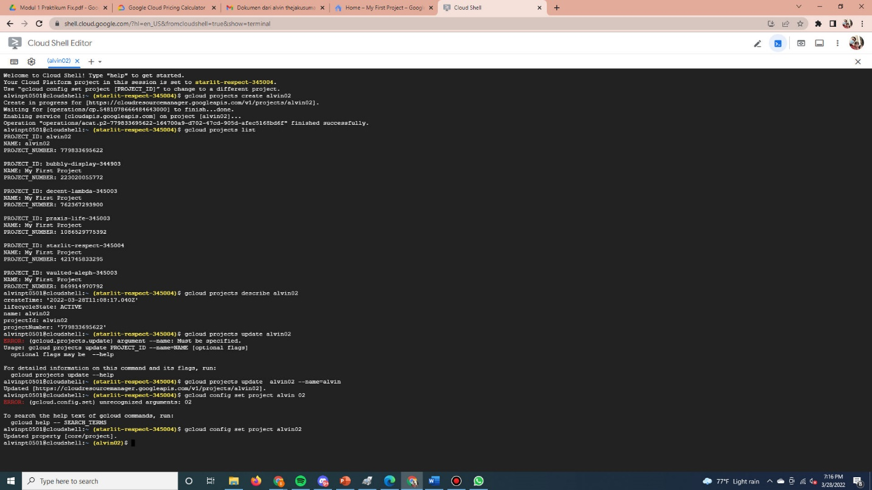

No.2

No.3

Estimasi Biaya :

Biaya untuk Hongkong = USD 1.15

Biaya untuk Singapore = USD 0.00

Biaya untuk Tokyo = USD 471.04